**PRACTICAL: 3**

**AIM:**

Create a React page that displays a Welcome message with the current local date and time which changes every second. Use the React JSX concept.

Note: Use the setInterval function to update the time.

**THEORY:**

This React application displays a welcome message along with the current local date and time. It uses React functional components and hooks (useState and useEffect) to manage and update time dynamically. The setInterval function is used to update the time every second. JSX is used to render HTML-like syntax within JavaScript. This simple project demonstrates real-time rendering and state management in React.

**CODE:**

|  |
| --- |
| import React, { useState, useEffect } from 'react';  function WelcomePage() {  const [currentTime, setCurrentTime] = useState(new Date());  useEffect(() => {  const timer = setInterval(() => {  setCurrentTime(new Date());  }, 1000);  return () => clearInterval(timer);  }, []);  return (  <div style={{ padding: '20px', fontFamily: 'Arial' }}>  <h1>Welcome to CHARUSAT!!!!</h1>  <h2>It is {currentTime.toLocaleDateString()}</h2>  <h2>It is {currentTime.toLocaleTimeString()}</h2>  </div>  );  }  export default WelcomePage;  **APP.js:**  import React from 'react';  import WelcomePage from './WelcomePage';  function App() {  return (  <div>  <WelcomePage />  </div>  );  }  export default App; |

**OUTPUT:**

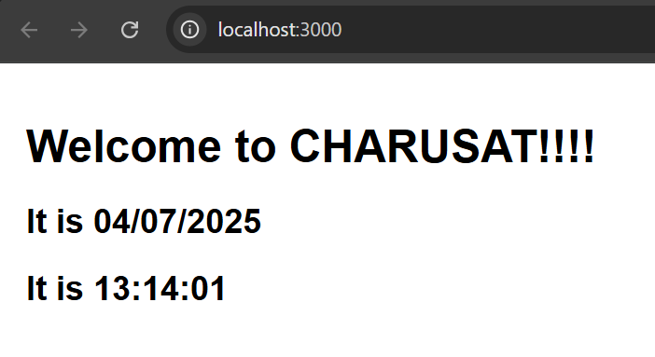

**LATEST APPLICATIONS:**

* **Social Media Platforms** – React powers dynamic feeds and real-time interactions in apps like Facebook and Instagram.
* **E-Commerce Sites** – Platforms like Amazon and Flipkart use React for fast, responsive user interfaces.
* **Streaming Services** – Netflix uses React for smooth navigation and optimized user experience.
* **Chat Applications** – Apps like Slack and Discord use React to handle real-time messaging efficiently.
* **Online Learning Platforms** – Websites like Coursera and Udemy use React to manage courses and dashboards.
* **Healthcare Portals** – React is used in telemedicine and patient portals for managing appointments and data.

**LEARNING OUTCOME:**

* Learned how to create a dynamic React component using JSX.
* Understood the use of useState and useEffect hooks for state and lifecycle management.
* Implemented setInterval to update time in real-time.
* Gained practical experience in structuring and running a React application.
* Improved skills in building interactive and responsive UIs with React.

**REFERENCES:**

1. React Official Documentation – <https://reactjs.org/>
2. MDN Web Docs – JavaScript setInterval() – <https://developer.mozilla.org/en-US/docs/Web/API/setInterval>
3. W3Schools – React JS Tutorial – <https://www.w3schools.com/react/>
4. GeeksforGeeks – Introduction to ReactJS – <https://www.geeksforgeeks.org/reactjs-introduction/>