**PRACTICAL: 4**

**AIM:**

Create a Counter App that includes the functionality of Increment, Decrement, Reset, and Increment Five. The app also has two text boxes for first and surname names, the contents of which are shown as text on the same page. Utilize the React Hooks idea

**THEORY:**

This React application is a simple counter and input form that demonstrates the use of **React Hooks** (useState) to manage component state. It allows users to increment, decrement, reset, and increment the counter by 5. Additionally, it captures and displays user-entered first and last names dynamically. The component re-renders in real-time as the state updates. This project highlights how React can be used to create responsive, interactive UIs with minimal code.

**CODE:**

|  |
| --- |
| import React**,** { useState } from 'react'**;**  function CounterApp() {    const [count**,** setCount] **=** useState(0)**;**    const [firstName**,** setFirstName] **=** useState('')**;**    const [lastName**,** setLastName] **=** useState('')**;**    const increment **=** () **=>** setCount(**prev** **=>** prev **+** 1)**;**    const decrement **=** () **=>** setCount(**prev** **=>** prev **-** 1)**;**    const reset **=** () **=>** setCount(0)**;**    const incrementFive **=** () **=>** setCount(**prev** **=>** prev **+** 5)**;**  **return** (      <div style**=**{{ textAlign**:** 'center'**,** padding**:** '30px'**,** fontFamily**:** 'Arial' }}>        <h1>Count: {count}</h1>        <div>          <button onClick**=**{reset}>Reset</button>          <button onClick**=**{increment}>Increment</button>          <button onClick**=**{decrement}>Decrement</button>          <button onClick**=**{incrementFive}>Increment 5</button>        </div>        <h1 style**=**{{ marginTop**:** '40px' }}>Welcome to CHARUSAT!!!</h1>        <div style**=**{{ marginTop**:** '20px' }}>          <label>            First Name:            <input              type**=**"text"              value**=**{firstName}              onChange**=**{**e** **=>** setFirstName(e**.**target**.**value)}              style**=**{{ marginLeft**:** '10px' }}            />          </label>          <br /><br />          <label>            Last Name:            <input              type**=**"text"              value**=**{lastName}              onChange**=**{**e** **=>** setLastName(e**.**target**.**value)}              style**=**{{ marginLeft**:** '10px' }}            />          </label>        </div>        <div style**=**{{ marginTop**:** '30px' }}>          <p><strong>First Name:</strong> {firstName}</p>          <p><strong>Last Name:</strong> {lastName}</p>        </div>      </div>    )**;**  }  export **default** CounterApp**;**  **APP.js:**  import React from 'react'**;**  import CounterApp from './CounterApp'**;**  function App() {  **return** (      <div>        <CounterApp />      </div>    )**;**  }  export **default** App**;** |

**OUTPUT:**

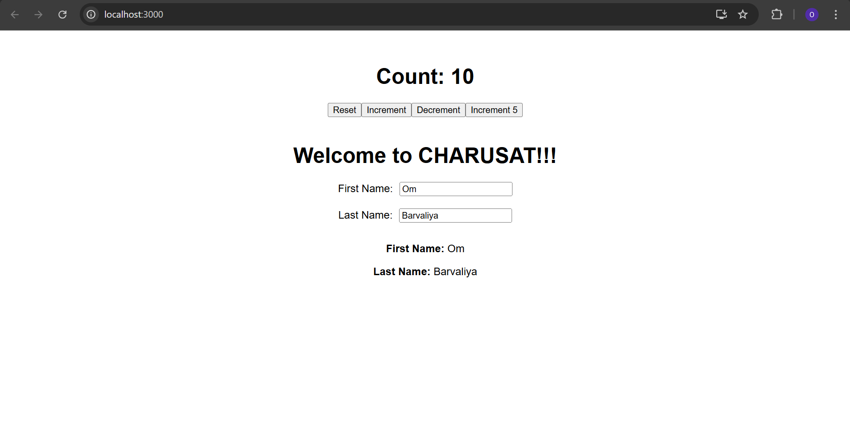

**LATEST APPLICATIONS:**

* Form-based Dashboards – Admin panels use similar logic for editing and updating data.
* Interactive Web Tools – Online calculators and counters use the same principles.
* User Registration Forms – Real-time input handling is used in modern signup pages.
* E-commerce Product Counters – Used in cart systems to adjust item quantities.
* Fitness Trackers – Steps or reps counters are often implemented like this.
* Education Apps – Quiz counters or name-entry interfaces in learning platforms.

**LEARNING OUTCOME:**

* Learned how to manage state using useState hook in React.
* Built a functional counter with multiple operations (increment, decrement, reset).
* Implemented real-time form handling and data display.
* Understood re-rendering and event handling in React components.
* Gained hands-on experience in building dynamic and interactive UI components.

**REFERENCES:**

• MDN Web Docs – Handling Events in JavaScript – <https://developer.mozilla.org/en-US/docs/Web/Events>

• FreeCodeCamp – React Hook Examples – <https://www.freecodecamp.org/news/an-introduction-to-react-hooks/>

• GeeksforGeeks – Counter App using React – <https://www.geeksforgeeks.org/how-to-create-a-counter-app-using-react/>