**Question 1 (15 Marks)**

**Code**

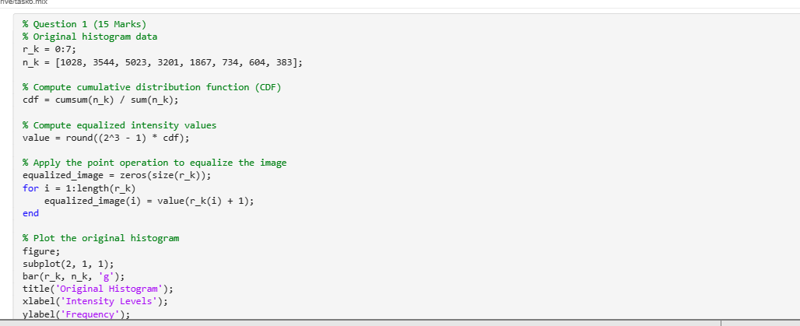

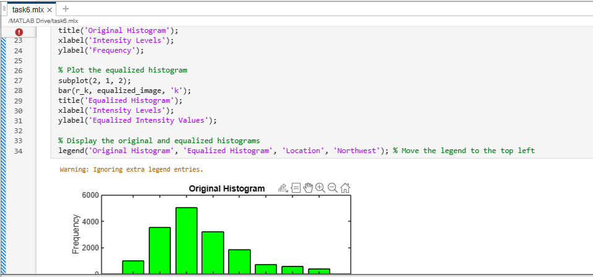

**output**

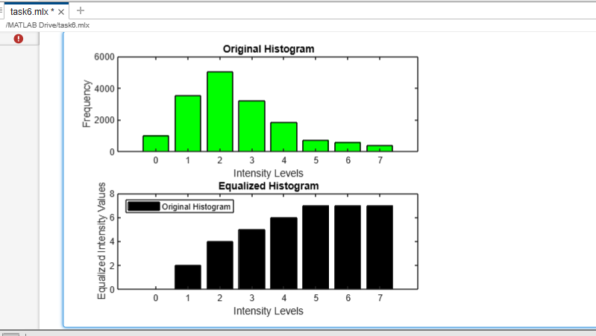

**Question 2 (15 Marks)**

**Code**

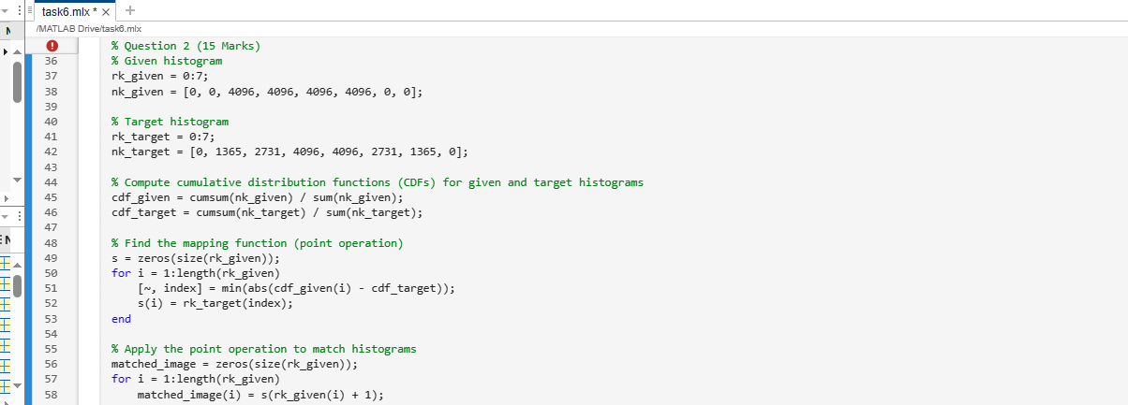

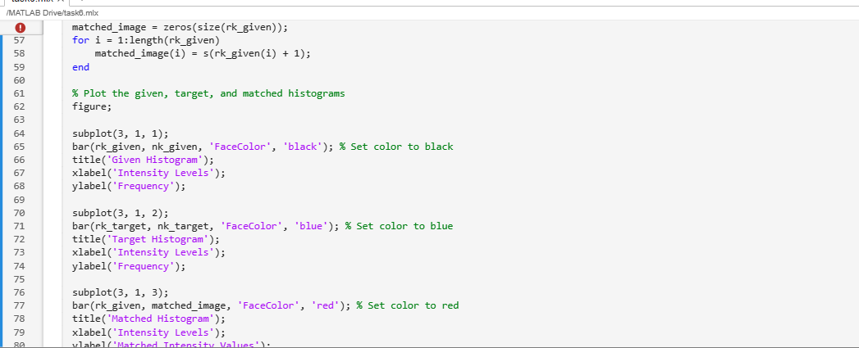

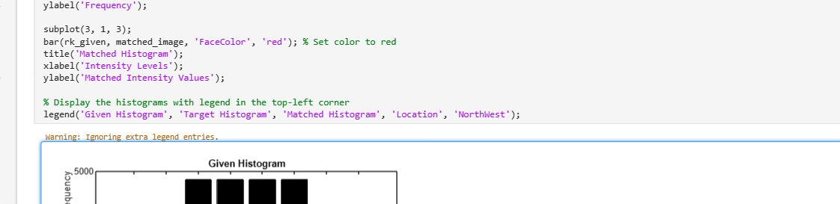

**Output**

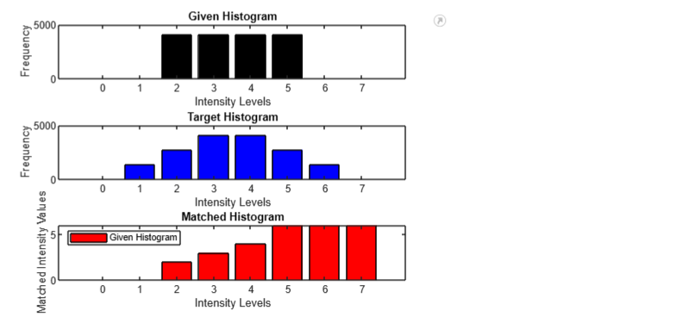

**Comment**

The center of the original histogram has a high concentration of pixels with intensities of 2 ,3, 4 or 5. With pixels having a larger range of intensities, the target histogram is more equally dispersed.

**Question 3 (50 Marks)**

**Part a**

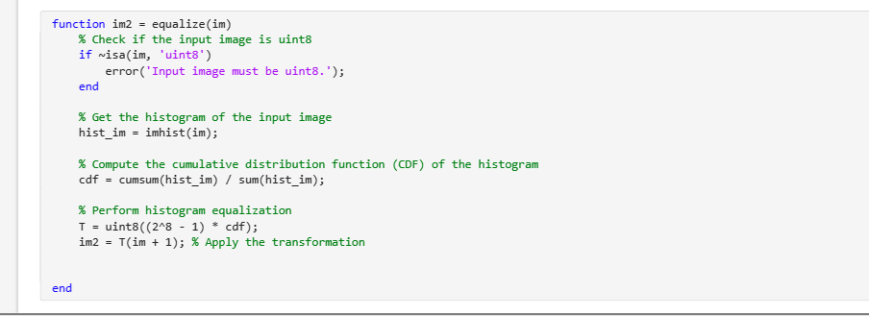

**Part b**

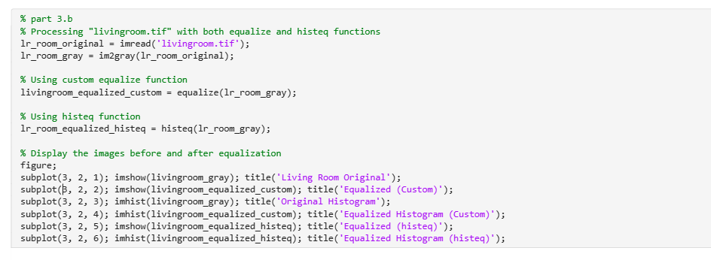

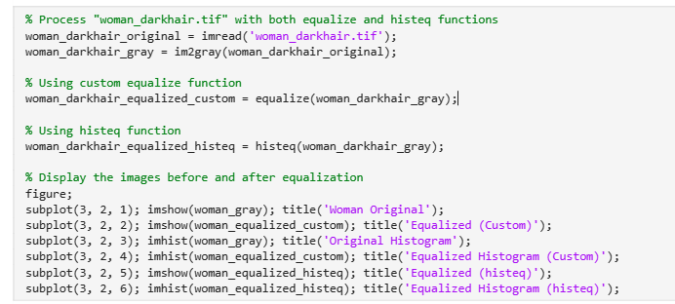

**Output**

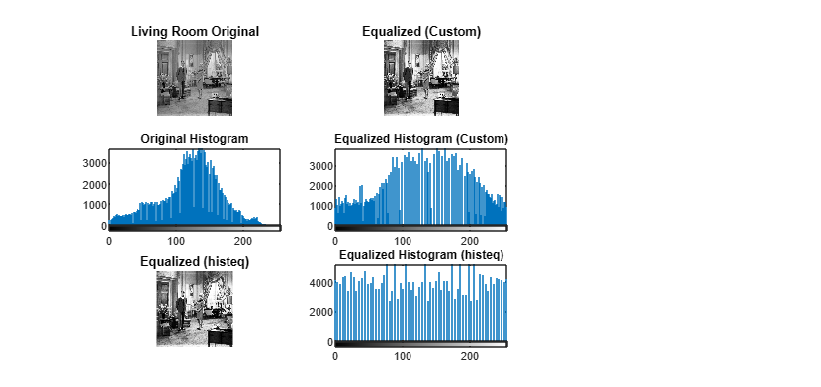

**Comment**

The original image has a lot of detail in the shadows and is extremely dark. With more clarity in the highlights, the equalized image is much brighter. This is because the image's intensity levels have been spread out and made more evenly distributed using the histogram equalization procedure.

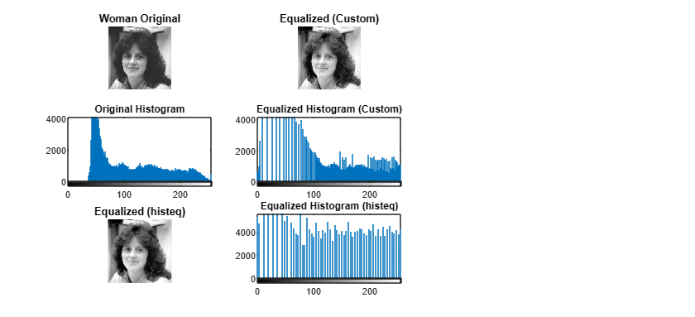

**Comment**

Since the lower intensity values of the original histogram have a high peak, the majority of the pixels in the image are black. The equalized histogram is substantially flatter, demonstrating a more uniform distribution of the intensity values.

**Question 4 (20 Marks)**

**code**

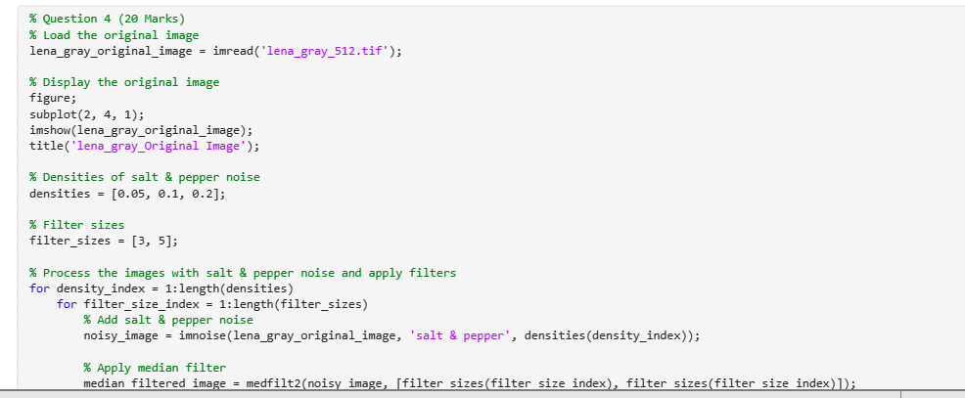

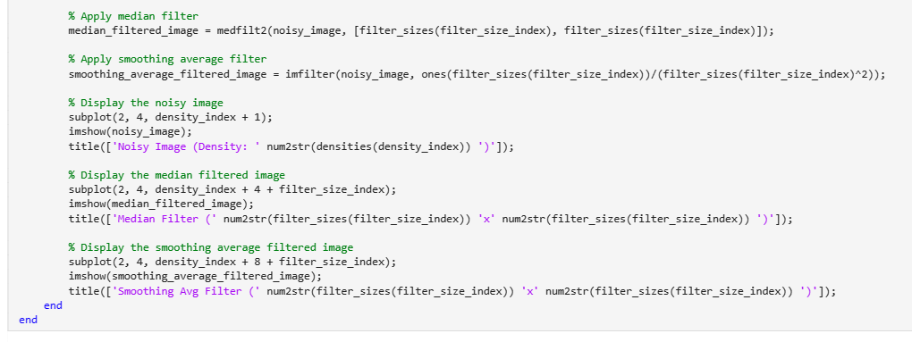

**Output**

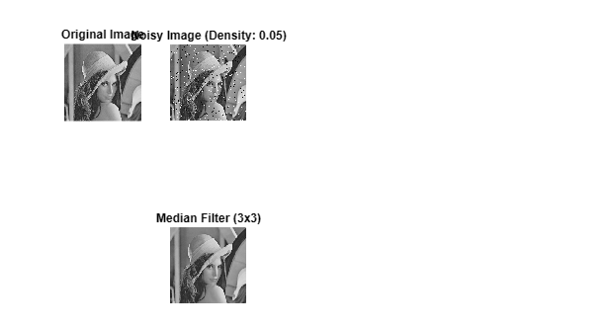

**Comment**

The median filter performs better than the smoothed average filter at removing "salt and pepper noise." This is due to the fact that the median filter replaces out each pixel for the median value of its neighbors, which is less susceptible to noise. On the other hand, the smoothing average filter substitutes each pixel with the average value of its neighbors, which is more susceptible to noise.