AUTOMATED BOTTLE VISUAL INSPECTION SYSTEM (ABVIS)
AI-based defect detection and PLC-controlled rejection for a bottle conveyor

A project report submitted in partial fulfilment of the requirements for the degree of
Bachelor of Technology in Robotics & Automation Engineering

Submitted by
[Student name 1 - roll no.]
[Student name 2 - roll no.]
[Student name 3 - roll no.]

Under the guidance of
[Guide name, designation]

[Department of Robotics & Automation Engineering]
[College / Institute name, City]
[University name]
Academic year 2026-27

Certificate
This is to certify that the project entitled "Automated Bottle Visual Inspection System (ABVIS)" is a bona fide work carried out by [student names] in partial fulfilment of the requirements for the award of the degree of Bachelor of Technology in Robotics & Automation Engineering of [University name] during the academic year 2026-27.
[Guide] [Head of Department] [External examiner]

Declaration
We declare that this report is our own work, that the results reported are those produced by the system described, and that every result obtained with simulated or fake hardware is labelled as such.

Acknowledgement
[Thank the guide, the department, the laboratory staff and anyone who supplied hardware or bottles.]

Abstract
Manual inspection of filled bottles is slow and inconsistent. ABVIS is a machine-vision inspection station for a 250 ml water-bottle conveyor. A photo-eye triggers a Delta DVP-SS2 PLC, the PLC signals a Windows PC over Modbus ASCII, and the PC captures frames from two USB cameras taken strictly after the trigger. Two AI models examine them: a multi-label EfficientNet classifier that scores eight defect classes, and a YOLOv8 detector that locates the bottle, cap and label. A rule-based decision engine votes the evidence over several frames and cameras into one PASS, REJECT or FAULT per bottle. The PC answers the PLC with a PASS or REJECT bit timed so that the PLC fires the pneumatic reject cylinder when that bottle arrives. Every bottle is recorded in an SQLite production database.
On held-out test data the best classifier (EfficientNet-B0) reached a macro-F1 of 0.949 with zero defective bottles passed, and the YOLOv8s detector reached a test mAP50 of 0.979. The control software passes 18 of 18 automated self-tests against a simulated PLC. A first real-line trial (200 bottles) and a test on real production-camera frames exposed what laboratory scores hide: a domain gap between the training images and the production camera, decision thresholds that collapse to 0.05, and a one-bottle PLC handshake that left 78 % of bottles uninspected. The report documents the system, the results, these failures, and an industrial upgrade plan.
Keywords: machine vision, quality inspection, EfficientNet, YOLOv8, multi-label classification, PLC, Modbus, conveyor reject system.

Table of Contents
Right-click > Update field
(In Word: right-click the table above and choose Update Field to fill in page numbers.)

1. Introduction

1.1 Background
Bottling lines check every container for a missing or tilted cap, a damaged or skewed label, a damaged or skewed bottle, and a wrong fill level. Human inspectors tire, disagree and cannot keep up with line speed. Machine vision replaces them with cameras, lighting and software that decide on every unit and remove the bad ones automatically.

1.2 What ABVIS is
ABVIS is one Windows desktop application plus a PLC program. The application labels images, trains the AI, manages model versions, runs the inspection line, talks to the PLC, raises alarms and keeps the production record. The PLC owns the conveyor, the reject delay and the reject cylinder. The first product is the 250 ml Bisleri water bottle.
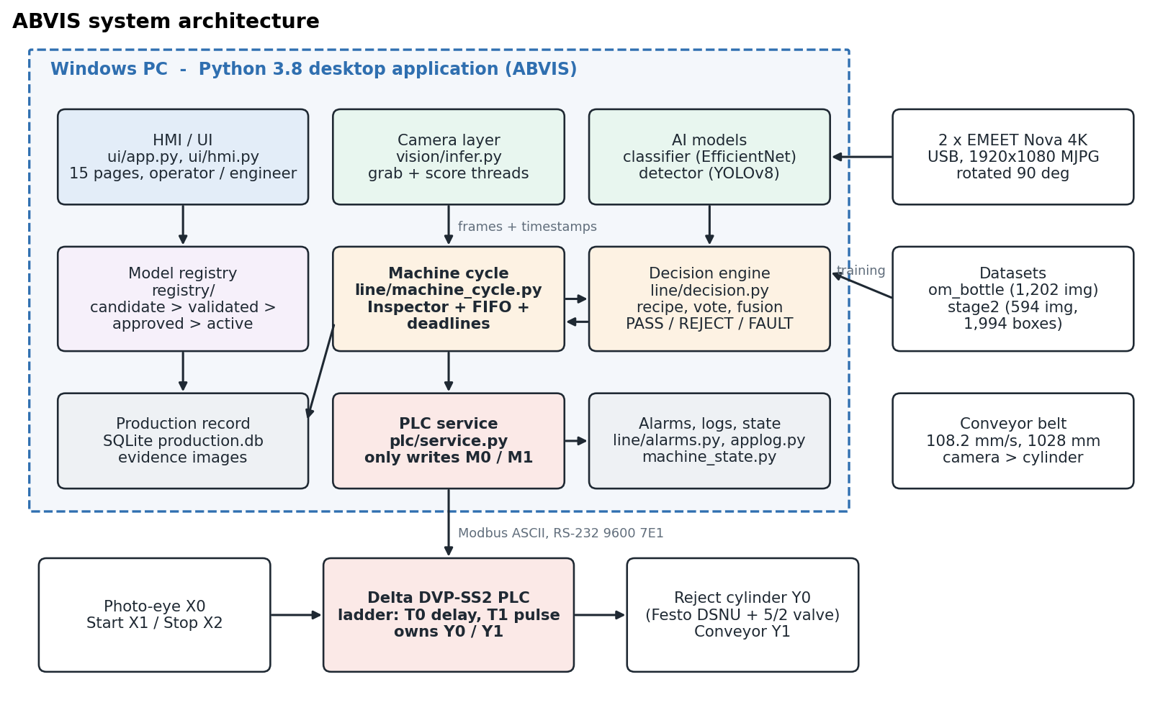
Figure 1: ABVIS system architecture

1.3 Design principle: unknown is never good
A broken camera, a crashed model, a stale frame or a bottle no camera saw becomes FAULT, and a FAULT bottle is rejected by default. The PC never switches an output directly: it only writes a PASS (M0) or REJECT (M1) bit, and the PLC does the rest.

1.4 Organisation of the report
- Chapter 2 reviews the techniques used.
- Chapters 3-4: problem, objectives and requirements.
- Chapters 5-6: architecture, hardware and PLC.
- Chapter 7: datasets.
- Chapter 8: AI model development.
- Chapter 9: decision engine and machine cycle.
- Chapter 10: software implementation.
- Chapter 11: testing and results.
- Chapters 12-15: discussion, limitations, conclusion and future work.

2. Literature Review and Technical Background

2.1 Convolutional classifiers
Residual networks (ResNet) made very deep CNNs trainable through skip connections [2]. EfficientNet scales depth, width and input resolution together, giving higher accuracy per FLOP [1]. MobileNetV3 targets low-latency devices [3]. ConvNeXt modernises the plain CNN with transformer-era design choices [4]. All five are available in torchvision with ImageNet-pretrained weights [10], so a small in-domain dataset can be used for fine-tuning rather than training from scratch.

2.2 Multi-label classification
Defects are not mutually exclusive: a bottle can be skewed and have a damaged label. Each defect therefore gets its own sigmoid output and binary cross-entropy loss, with a per-class positive weight to counter class imbalance. Each output needs its own decision threshold.

2.3 Object detection
YOLO detectors predict boxes and classes in one forward pass [5]. Ultralytics YOLOv8 [6] is used here in its nano (3.0 M parameters) and small (11.1 M) sizes. Detection quality is reported as mean average precision at IoU 0.5 (mAP50) and averaged over IoU 0.5-0.95 (mAP50-95), as in COCO [13].

2.4 Training and calibration
Models are optimised with AdamW [11] and a cosine learning-rate schedule [12]. Raw network scores are often over-confident. Temperature scaling [7] calibrates them so that a 0.9 means about 90 % in practice. This matters for an industrial accept/reject threshold.

2.5 PLC and industrial communication
The Delta DVP-SS2 is programmed in ladder logic (IEC 61131-3 [14]) with ISPSoft [9]. The PC exchanges bits with it over Modbus [8] (ASCII framing, LRC check, RS-232). Safety functions such as the emergency stop must be hardwired and follow ISO 13849-1 [15]. They must not depend on PC software.

3. Problem Statement and Objectives

3.1 Problem statement
Design and build an automated station that inspects every bottle on a conveyor, detects cap, label, body and fill-level defects, removes defective bottles with a pneumatic cylinder at the right moment, never passes a bottle it could not inspect, and keeps a traceable record of every decision.

3.2 Objectives
- Build a labelled multi-label dataset of bottle defects with a leak-free, scene-based split.
- Train and compare several CNN classifiers and select one on a held-out test set.
- Build and train a component detector (bottle, cap, label) for presence checks such as a missing cap.
- Build a decision engine that turns multi-frame, multi-camera evidence into PASS / REJECT / FAULT.
- Integrate the PLC: trigger, PASS/REJECT handshake and time-based reject scheduling without an encoder.
- Provide an operator HMI, alarms, model registry and a production database.
- Verify everything with automated self-tests, then run a first trial on the real line and report it honestly.

3.3 Scope
In scope: one product (250 ml bottle), two cameras, one reject station, time-based tracking. Out of scope for this stage: encoder tracking, multi-product changeover, segmentation-based label measurement and certified safety functions.

4. System Requirements

4.1 Hardware
Table 1: Hardware used
Component | Specification
PC | 12th Gen Intel Core i7-12700H (14 cores / 20 threads), 16 GB RAM, Windows 11
GPU | NVIDIA GeForce RTX 3050 Laptop GPU, 4 GB VRAM
Cameras | 2 x EMEET SmartCam Nova 4K (USB, UVC), 1920x1080 MJPG, mounted rotated 90 deg
PLC | Delta DVP-SS2 series, programmed in ISPSoft; RS-232 COM port, Modbus ASCII 9600 7E1, station 1
Sensor | Photoelectric bottle sensor on X0; start / stop push buttons on X1 / X2
Actuator | Festo DSNU pneumatic cylinder with 5/2 solenoid valve on Y0; conveyor motor on Y1
Conveyor | Measured belt speed 108.2 mm/s; photo-eye to reject cylinder 1028 mm

4.2 Software
Table 2: Software stack
Package | Version | Use
Python | 3.8.0 | application runtime
PyTorch / torchvision | 2.4.1+cu124 / 0.19.1+cu124 | classifier
Ultralytics | 8.1.0 | YOLOv8 detector
OpenCV | 4.13.0 | camera capture, image processing
CustomTkinter | 6.0.0 | desktop HMI
Pillow / NumPy | 10.4.0 / 1.24.3 | images, arrays
pyserial | 3.5 | real PLC link
psutil | 7.2.2 | system monitoring
SQLite | built-in | production database
ISPSoft | Delta | PLC ladder programming / simulator

4.3 Functional requirements
- Label images, manage defect classes and import datasets.
- Train, evaluate and version AI models.
- Capture frames after each PLC trigger from one or more cameras.
- Decide PASS / REJECT / FAULT per bottle and answer the PLC once per trigger.
- Schedule the reject so the cylinder fires when the bottle reaches it; never fire a late reject.
- Show one stable verdict per bottle to the operator; hide engineering detail in operator mode.
- Record every bottle, alarm and run; export CSV and reports.

4.4 Non-functional requirements
- Safety: unknown is FAULT; FAULT is rejected; the PC never writes PLC outputs.
- Timing: the verdict must be ready before trigger + travel - T0.
- Traceability: every decision carries the model ids, timings and evidence image.
- Robustness: a camera, model or link failure produces FAULT and an alarm, not a crash.

5. System Architecture
The software is a single Python process organised in packages. Figure 1 shows the components; Table 5 lists the packages and their size.
Table 3: Code organisation (about 28,000 lines of Python)
Package | Lines | Responsibility
vision/ | 6,609 | dataset, training, inference (Camera, Model), YOLO detector, calibration, verdict, annotation
line/ | 3,852 | decision engine, machine cycle, tracking, machine state, alarms, production store, logs
registry/ | 991 | model registry, benchmarking, activation gates
ui/ | 9,241 | main window, HMI pages, theme, charts, annotation studio
plc/ | 3,871 | Modbus protocol, address map, client, PLC service, ladder decoder and simulator, tests
tools/ | 402 | self-check runner, migration, camera planner
stage2_dataset/ | 2,557 | detection dataset preparation, export, validation

5.1 Data flow for one bottle
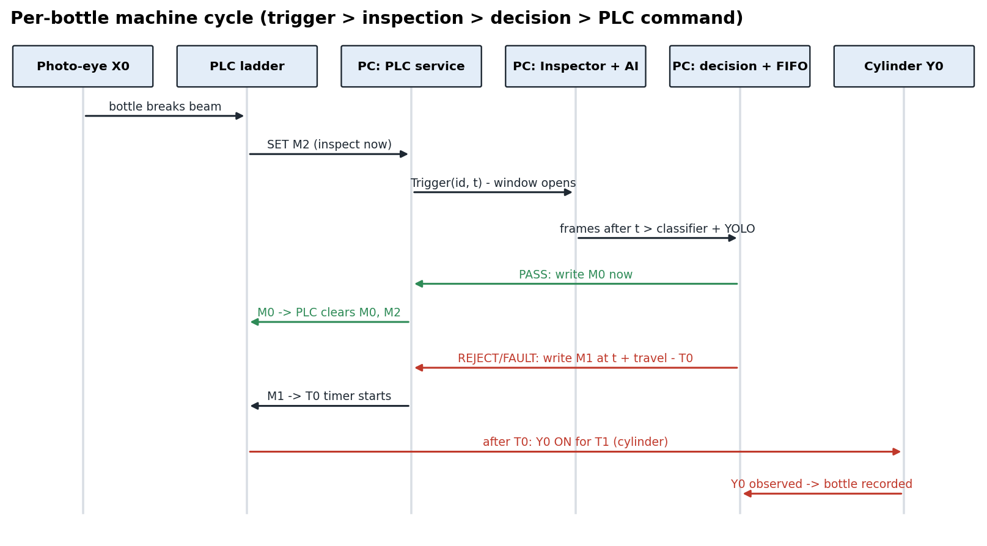
Figure 2: Per-bottle machine cycle

5.2 Threads and timing
- Tk main thread: all widgets; background work reports through a queue drained every 60 ms.
- Camera grab thread (one per camera): reads frames, stamps them, keeps the last 12.
- Camera score thread: live-view scoring only (about 15 Hz).
- PLC service thread: the only owner of the serial / TCP link; polls M2/X0, writes M0/M1.
- Machine-cycle thread: collects frames per bottle, runs the AI, decides and keeps the FIFO deadlines.
- Evidence writer: saves images without delaying any PLC command.

5.3 Machine states
One function (line/machine_state.py) derives the machine state for every screen: OFFLINE, NOT_READY, READY, INITIALIZING, RUNNING, INSPECTING, STOPPING, FAULT, E_STOP and COMMUNICATION_FAULT. START is enabled only in READY, when the PLC is connected and in RUN, cameras and models are present, timing is valid and the E-stop is released.

6. Hardware and PLC Integration

6.1 PLC I/O map
Table 4: PLC device map (plc/address_map.py)
Device | Meaning | Who writes it
X0 | Photo-eye: bottle at the inspection station | field (read-only)
X1 / X2 | Start / stop push buttons (SET / RESET Y1) | field (read-only)
M2 | PLC to PC: inspection trigger (bottle ready) | PLC ladder
M0 | PC to PLC: PASS command (PLC self-clears) | PC - the only way to pass
M1 | PC to PLC: REJECT command (held through the reject cycle) | PC - the only way to reject
T0 | Delay from M1 to the cylinder firing | PLC timer
T1 | Reject pulse length | PLC timer
Y0 | Reject solenoid valve / cylinder | PLC only - the PC never writes Y
Y1 | Conveyor motor | PLC only
C0 / C1 | PASS / REJECT counters | PLC

6.2 Communication
plc/protocol.py builds Modbus ASCII frames with an LRC checksum. plc/client.py offers a TCP transport (the ISPSoft simulator on 127.0.0.1:10002) and a serial transport (the real PLC). plc/service.py is the single owner of the link. It enforces the command rules: one answer per trigger, the trigger marked answered before the write, no retries, preconditions (M2 = 1, M0 = M1 = 0) re-read just before writing, and success = the PLC clearing the command bit.

6.3 Reject timing without an encoder
travel time = distance (camera to cylinder) / belt speed = 1028 mm / 108.2 mm/s = 9.5 s. The PC sends M1 at trigger + travel - T0, and the PLC fires Y0 after T0, so the cylinder fires at trigger + travel. A REJECT that would be later than reject_tolerance_s (0.3 s) is not fired. It is answered with M0, recorded as FAULT, and an alarm tells the operator to remove the bottle by hand.

6.4 Ladder verification
plc/ladder_check.py decodes the ISPSoft project (a binary header followed by a raw deflate stream) and checks 13 requirements. plc/ladder_sim.py executes the decoded networks in a scan simulator against 14 scenarios. Result: the structure (trigger, PASS, REJECT, single Y0 pulse, conveyor start/stop) is correct. The timers differ from the intended contract, and the ladder lacks an E-stop input, a PC-answer timeout and a multi-bottle queue.

7. Dataset and Data Preparation

7.1 Classification dataset
Project om_bottle holds 1202 images, 1167 of them reviewed. labels.csv is the single source of truth (one row per image, one column per defect). The images are consecutive frames of about 106 physical bottle passes ('scenes'), so the real sample size is the number of scenes.
Table 5: Classification dataset per class
Class | Reviewed images | Distinct scenes
damaged_bottle | 319 | 25
damaged_label | 229 | 21
skewed_bottle | 167 | 17
tilt_cap | 145 | 18
water_level | 112 | 12
good | 72 | 8
skewed_label | 71 | 8
missing_label | 30 | 2
missing_cap | 22 | white bg, 1 session
Total reviewed | 1167 | ~106

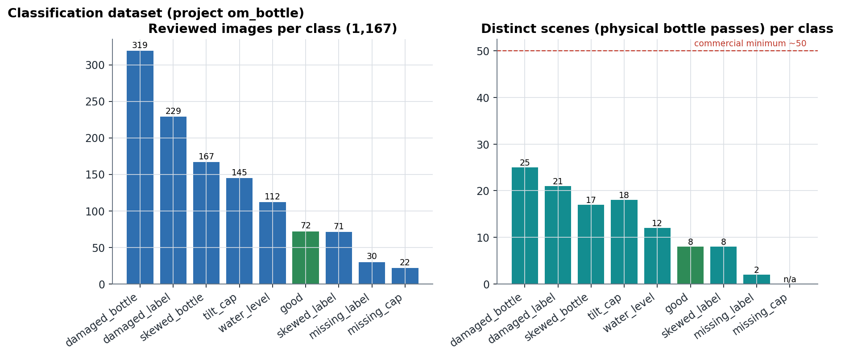
Figure 3: Images and distinct scenes per class
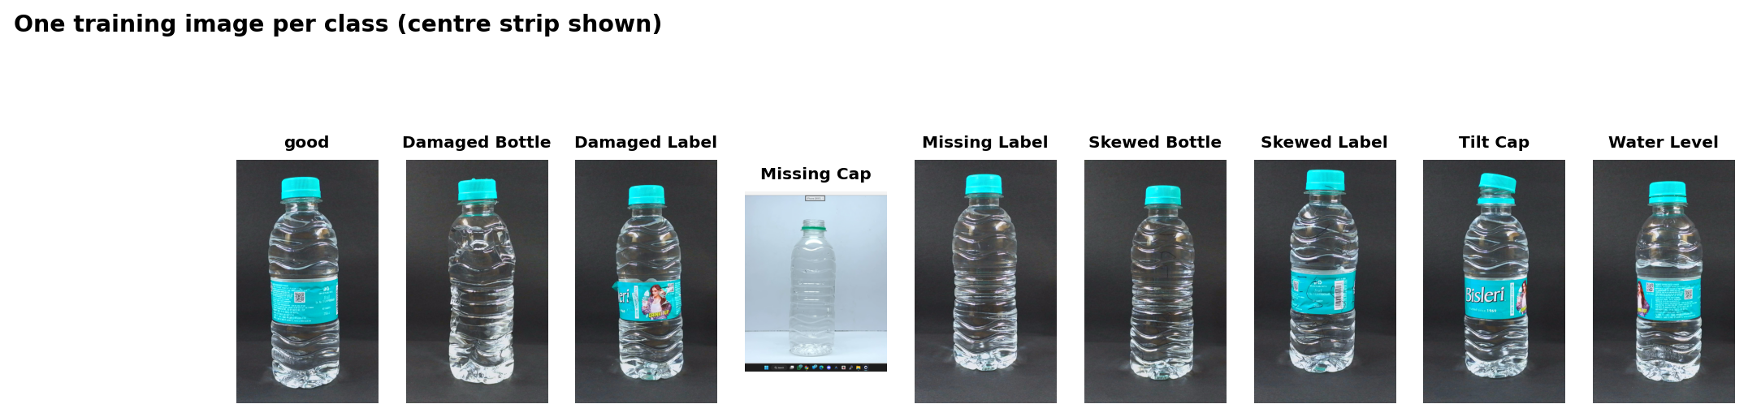
Figure 4: Example training image for each class

7.2 Leak-free splitting
A random split would put near-identical frames of the same bottle in both training and test and report false accuracy. Frames are grouped into scenes by image similarity, and whole scenes go to train, validation or test (about 70 / 15 / 15). The test set is scored once, after every training decision. A stricter 'leak-free' test subset removes images that a cross-folder hash audit linked to training scenes.

7.3 Pre-processing
A region of interest (ROI) is measured once from Sobel edge energy, because the clear bottle is nearly as dark as the backdrop. The crop is letterboxed and centre-cropped to a tall 192 x 448 input that keeps the meniscus and label detail. Training and inference share one crop function (dataset.model_input), and the crop cache is lossless PNG (JPEG shifted water-level scores by ~0.15). Augmentation: ±5 deg rotation, ±3 % scale, brightness/contrast. No horizontal flip, because it would mirror label text and invert skew.

7.4 Detection dataset
stage2_dataset holds 594 reviewed images with 1,994 boxes of three classes (bottle, cap, label). Split v3 (scene-based) has 453 train, 89 validation and 52 test images. The v3 split moved the only full-bottle missing-cap scene into training, so missing-cap detection cannot be validated on the v3 test set.

7.5 Dataset limitations found
- Only 72 good images from 8 scenes; missing_label from 2 scenes.
- No image carries more than one defect, although the model is multi-label.
- The 22 missing-cap images are the only white-background images, which invites a background shortcut.
- All images are 2537 x 1927 from another camera and set-up; the production camera differs (Figure 6).
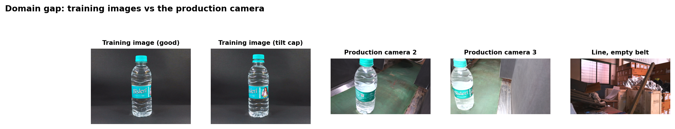
Figure 5: Training images vs frames from the production camera

8. AI Model Development

8.1 Stage 1: multi-label defect classifier
Backbone pretrained on ImageNet, final layer replaced by one linear output per defect, sigmoid activation. Loss: BCEWithLogitsLoss with pos_weight = clip(negatives / positives, 1, 50) per class. Optimiser AdamW (lr 3e-4, weight decay 1e-4), cosine schedule, mixed precision on GPU, batch 32, 25 epochs. Good images and operator-corrected 'hard examples' are oversampled by a weighted sampler (x5 and x3). The epoch with the best validation macro-F1 is kept, and each class's threshold is chosen on validation.

8.2 Training runs
Table 6: Training of the current models (2026-10-08)
Model | Architecture | Epochs run / max | Kept epoch | Train img | Val img | Batch | LR | Time | Device
20261008-081732 | EfficientNet-B0 | 25 / 25 | 12 | 689 | 232 | 32 | 0.0003 | 4.5 min | cuda
20261008-082510 | ResNet18 | 25 / 25 | 3 | 689 | 232 | 32 | 0.0003 | 7.5 min | cuda
20261008-083257 | EfficientNet-B1 | 25 / 25 | 5 | 689 | 232 | 32 | 0.0003 | 7.7 min | cuda
20261008-083918 | MobileNetV3-Small | 25 / 25 | 24 | 689 | 232 | 32 | 0.0003 | 3.2 min | cuda
20261008-090538 | ConvNeXt-Tiny | 25 / 25 | 2 | 689 | 232 | 32 | 0.0003 | 26.2 min | cuda
YOLOv8n v3 | YOLOv8 (Ultralytics 8.1.0) | 48 / 80 | 28 | 453 | 89 | 8 | auto (SGD/AdamW) | 22.5 min | cuda
YOLOv8s v3 | YOLOv8 (Ultralytics 8.1.0) | 80 / 80 | 70 | 453 | 89 | 8 | auto (SGD/AdamW) | 48.7 min | cuda

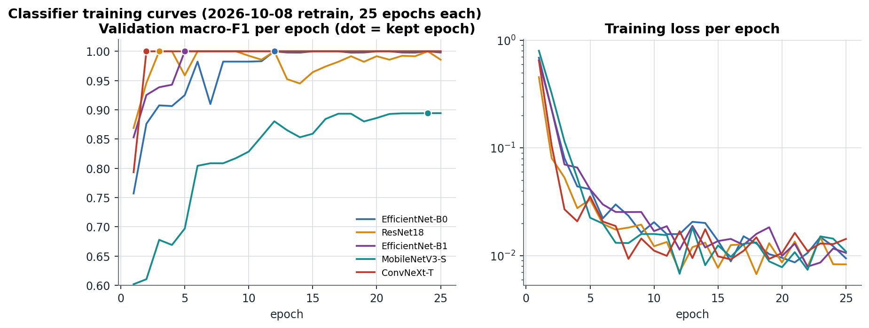
Figure 6: Classifier training curves
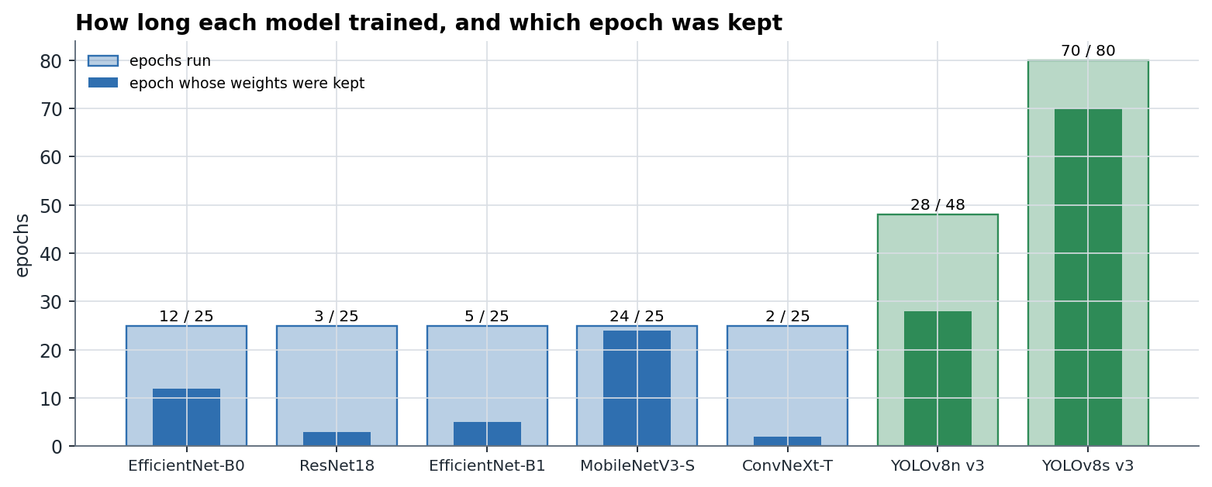
Figure 7: Epochs run and epoch kept for every current model
Validation macro-F1 reaches 1.000 by epoch ~12 for every architecture, so the validation set cannot separate epochs or thresholds. Extra epochs on this data only memorise the training scenes further.
Table 7: Earlier classifier checkpoints (archived)
Checkpoint | Architecture | Epochs | Kept epoch | Train img | Time | Device
20260918-120030 | ResNet18 | 1 / 1 | not recorded | 879 | 1.4 min | cpu
20260918-191743 | EfficientNet-B0 | 25 / 25 | not recorded | 879 | 42.3 min | cpu
20260918-220502 | EfficientNet-B1 | 25 / 25 | not recorded | 879 | 70.1 min | cpu
20260919-000152 | MobileNetV3-Small | 25 / 25 | not recorded | 879 | 10.6 min | cpu
20260919-101315 | ConvNeXt-Tiny | 25 / 25 | not recorded | 879 | 602.6 min | cpu
20260919-164511 | EfficientNet-B0 | 25 / 25 | not recorded | 685 | 3.6 min | cuda
20260919-222031 | EfficientNet-B1 | 25 / 25 | not recorded | 685 | 7.6 min | cuda
20260920-102102 | MobileNetV3-Small | 25 / 25 | not recorded | 685 | 3.2 min | cuda
20260920-110121 | ResNet18 | 8 / 25 | 3 | 685 | 2.4 min | cuda
20261003-101425 | ConvNeXt-Tiny | 25 / 25 | 2 | 685 | 9.2 min | cuda
20261004-100320 | ResNet18 | 25 / 25 | 4 | 685 | 7.2 min | cuda
20261005-171833 | EfficientNet-B0 | 25 / 25 | 8 | 698 | 19.7 min | cuda

8.3 Stage 2: component detector
YOLOv8n and YOLOv8s were fine-tuned from COCO weights on split v3: 640 px input, batch 8, at most 80 epochs, early stop after 20 epochs without improvement, mosaic, HSV and horizontal-flip augmentation, and workers = 0 (more workers exhausted the 16 GB machine). The best epoch is chosen on validation, and test is evaluated once. YOLOv8s was still improving at epoch 80 (best epoch 70), so it is under-trained.
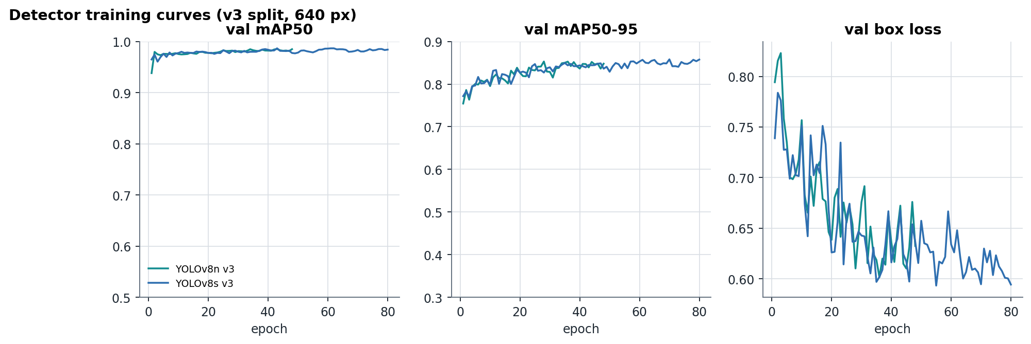
Figure 8: Detector training curves
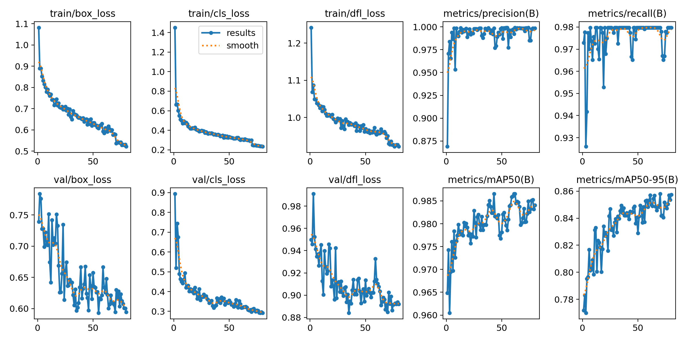
Figure 9: Ultralytics training summary for YOLOv8s v3

8.4 Stage 3: segmentation
A segmentation interface exists (vision/segment.py) and 546 label polygons are seeded, but none is reviewed and no segmentation model is trained. Any recipe that requires segmentation therefore returns FAULT.

8.5 Model lifecycle
Training never puts a model into production. A new model is a CANDIDATE. It becomes VALIDATED only with a held-out test result, a written real-camera check and a background-shortcut check; then APPROVED, then ACTIVE. The previous model is ARCHIVED and can be rolled back. Gates: good bottles rejected ≤ 2 %, defective bottles passed ≤ 1 %, at least 30 + 30 real-camera bottles.

9. Decision Engine and Machine Cycle

9.1 Per-frame findings
- Classifier: a defect is found when its score ≥ its threshold; empty or NaN scores are FAULT.
- Detector + recipe: one bottle is chosen (upright aspect ≥ 1.3, area ≥ 2 %, nearest the station centre). A required part (cap near the top, label in the middle) that is not found in its zone becomes missing_cap / missing_label. A part outside its zone becomes cap_misplaced.
- No bottle in a frame: that frame does not vote; no bottle in any frame is FAULT.

9.2 Vote and fusion
Per camera, a defect must appear in a majority of the bottle's frames. Cameras are fused FAULT > REJECT > PASS, so a bottle passes only if every camera saw it and found it good.

9.3 Safety latch and alarms
STOP, an E-stop status input, three consecutive FAULT bottles or a crash latch the line. While latched no M0/M1 is sent and every trigger becomes a FAULT 'not answered' bottle. Coded alarms carry a severity, a message and an operator action, and RESET FAULT acknowledges them. The hardware E-stop must cut power independently.

9.4 Camera layer and timestamps
Each frame is stamped with time.monotonic() as soon as cap.read() returns and given a per-session sequence number. The Inspector uses only frames stamped strictly after the bottle's window opens, and stops at the next bottle's window. Frames or scores older than 1.0 s are FAULT. The analysis in Chapter 11 shows that the stamp is consistent but not exact.
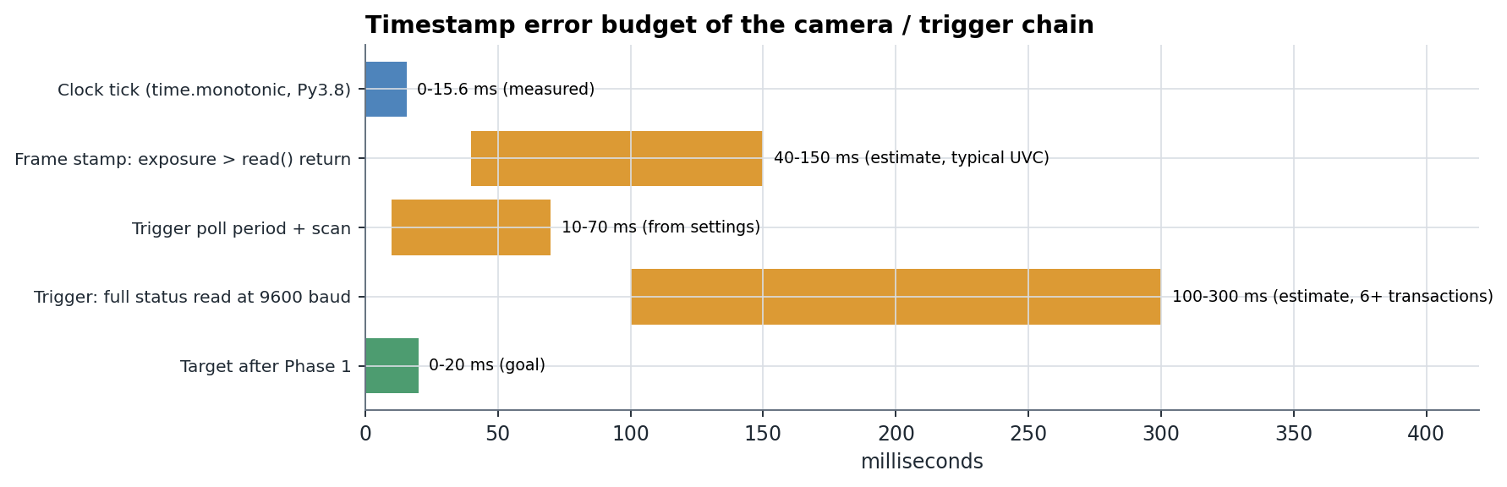
Figure 10: Timestamp error budget of the camera / trigger chain

10. Software Implementation

10.1 The application
Table 8: Application pages (15)
Group | Pages | Purpose
PRODUCTION | Production, History, Database, Health | operator screens: run the line, shifts, records, system health
DATA | Label, Defects, Annotate, Data health | labelling, defect classes, boxes and proposals, dataset checks
MODEL | Train, Analysis, Models | training, evaluation, model registry
ENGINEERING | Live, Machine, Camera | tuning view, PLC connection and test, camera benchmark
SYSTEM | Settings | text size, theme, evidence policy, engineer PIN

Operator mode shows only the PRODUCTION group and one stable verdict per bottle (GOOD, DEFECT: <name>, FAULT). Engineer mode shows every page and the commissioning tools.
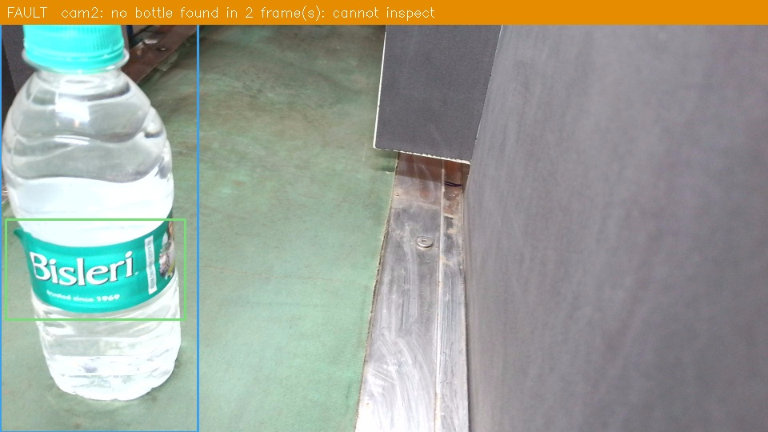
Figure 11: Inspection overlay produced by the application (TEST INSPECTION, camera 3)

10.2 Production database
SQLite, one file per product (projects/<slug>/production/production.db). Tables: runs (job, product, model ids, recipe, settings), inspections (one row per bottle: result, defects, confidence, PLC status, timings, evidence path) and alarms. Rows are only appended. CSV and printable reports are exported from the Database page.

10.3 Logging
Seven rotating event logs (app, camera, ai, plc, machine, alarm, production): one line per event, never one per frame. They are searchable from the Health page.

11. Testing and Results
Every result in this chapter states its evidence: SELF-TEST (software with a fake PLC / cameras / models), HELD-OUT TEST (images never used for training or selection), REAL CAMERA (frames from the production cameras) or REAL LINE (the physical conveyor and PLC).

11.1 Software self-tests (SELF-TEST)
Table 9: Automated self-tests: 18 of 18 pass (CPU, 2026-10-13)
Self-test (python selfcheck.py) | Result | Time
Decision engine | PASS | 2.3 s
Machine cycle | PASS | 16.6 s
Time tracking | PASS | 0.1 s
Machine state | PASS | 0.1 s
Alarms | PASS | 0.1 s
Production record | PASS | 2.1 s
Event logs | PASS | 0.1 s
Model registry | PASS | 0.3 s
PLC protocol | PASS | 2.3 s
PLC service | PASS | 11.0 s
PLC commissioning window | PASS | 4.3 s
Ladder decoder | PASS | 0.1 s
Ladder simulator | PASS | 3.6 s
Active learning | PASS | 2.0 s
Stable verdict | PASS | 0.1 s
Production export | PASS | 2.1 s
Threshold calibration | PASS | 0.2 s
Model activation gates | PASS | 1.0 s

The machine-cycle test drives the full trigger, inspection, decision, FIFO and PLC-command loop against a scan-by-scan emulation of the decoded ladder, including staggered camera stations, association faults, late rejects and the SQLite record.

11.2 Classifier results (HELD-OUT TEST)
Table 10: Classifier held-out test results
Checkpoint | Architecture | F1 full | F1 leak-free | Precision | Recall | PASS/REJECT acc | False PASS | False REJECT | ms/img
20261008-081732 | EfficientNet-B0 | 0.939 | 0.949 | 0.927 | 0.974 | 0.960 | 0 | 9 | 8.4
20261008-082510 | ResNet18 | 0.754 | 0.877 | 0.795 | 1.000 | 0.956 | 0 | 10 | 4.4
20261008-083257 | EfficientNet-B1 | 0.690 | 0.821 | 0.788 | 0.864 | 0.858 | 18 | 14 | 13.2
20261008-083918 | MobileNetV3-Small | 0.829 | 0.902 | 0.891 | 0.941 | 0.911 | 10 | 10 | 7.1
20261008-090538 | ConvNeXt-Tiny | 0.795 | 0.920 | 0.866 | 1.000 | 0.916 | 0 | 19 | 9.2
20260919-164511 (active) | EfficientNet-B0 | 0.935 | 0.956 | 0.923 | 1.000 | 0.954 | 0 | 10 | 32.8

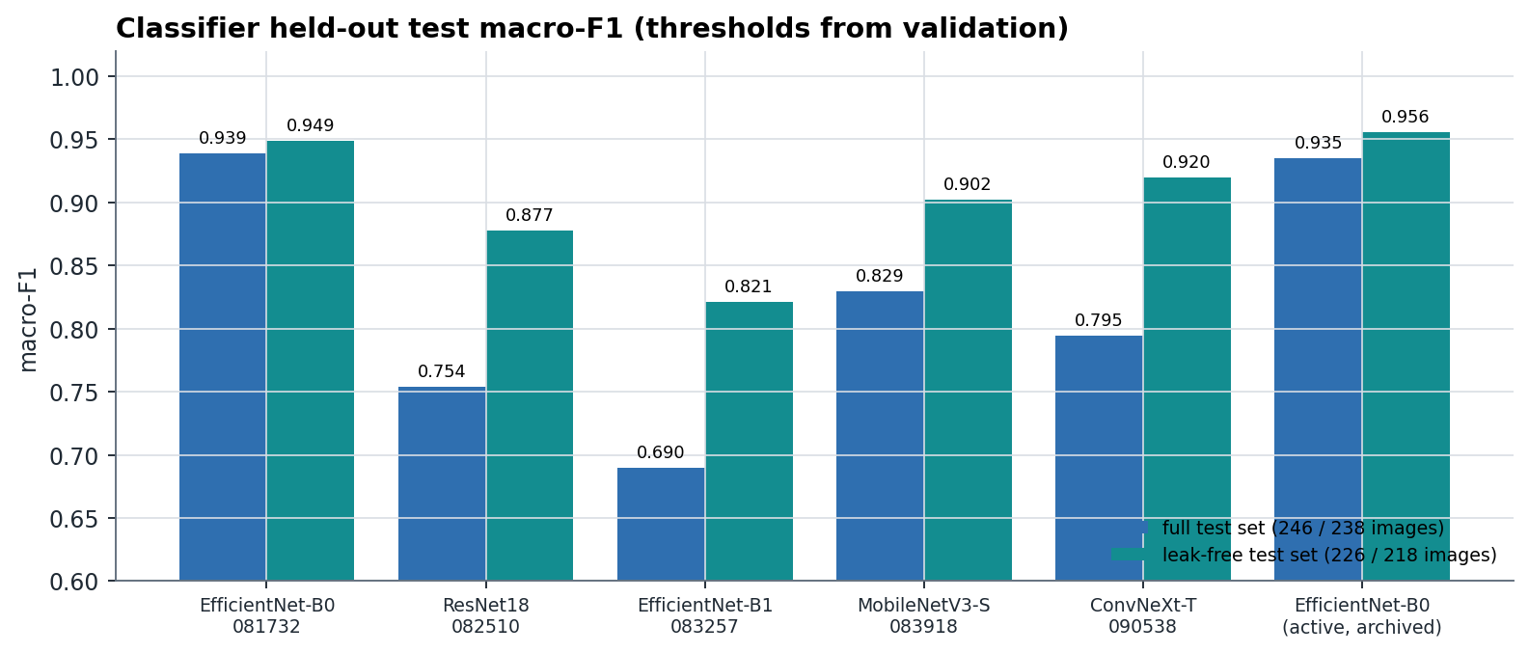
Figure 12: Classifier test macro-F1
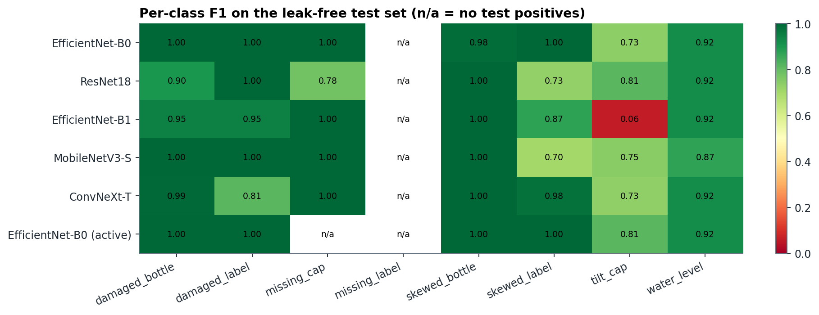
Figure 13: Per-class F1 on the leak-free test set
Table 11: EfficientNet-B0 (20261008-081732) per-class results, leak-free test set
Defect | Test positives | Threshold | Precision | Recall | F1 | TP | FP | FN
damaged_bottle | 64 | 0.1 | 1.000 | 1.000 | 1.000 | 64 | 0 | 0
damaged_label | 35 | 0.75 | 1.000 | 1.000 | 1.000 | 35 | 0 | 0
missing_cap | 7 | 0.05 | 1.000 | 1.000 | 1.000 | 7 | 0 | 0
missing_label | 0 | 0.5 | - | - | - | - | - | no test positives
skewed_bottle | 32 | 0.05 | 0.970 | 1.000 | 0.985 | 32 | 1 | 0
skewed_label | 24 | 0.05 | 1.000 | 1.000 | 1.000 | 24 | 0 | 0
tilt_cap | 22 | 0.55 | 0.667 | 0.818 | 0.735 | 18 | 9 | 4
water_level | 23 | 0.05 | 0.852 | 1.000 | 0.920 | 23 | 4 | 0

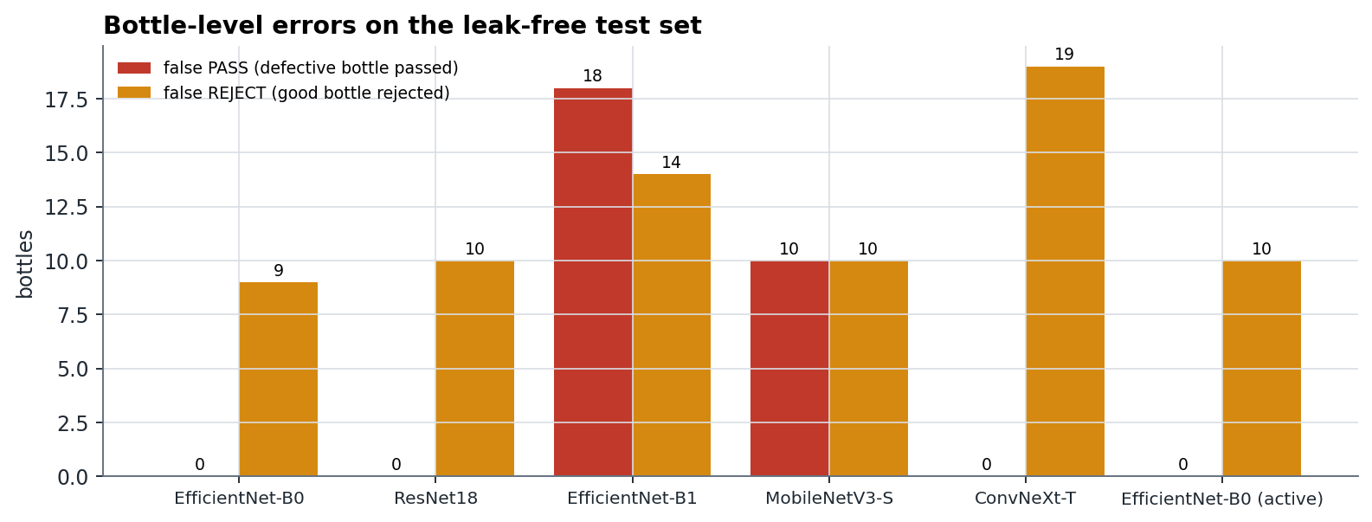
Figure 14: Bottle-level errors on the leak-free test set
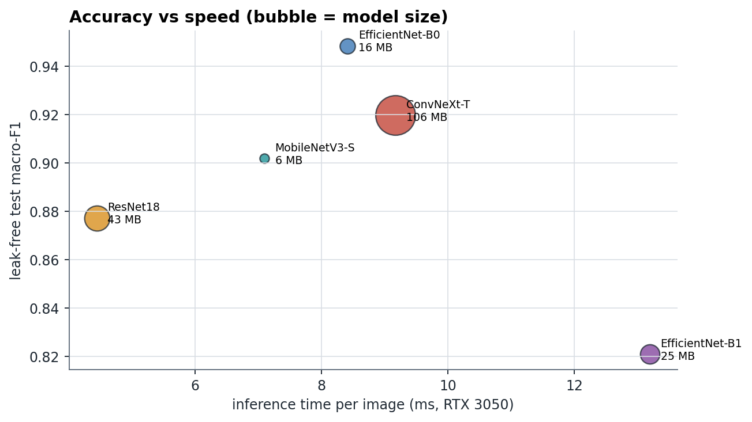
Figure 15: Accuracy vs inference time and model size
EfficientNet-B0 is the best classifier: it has the highest macro-F1 and no defective bottle passed. tilt_cap is the weakest class for every architecture (F1 ≈ 0.73). A global image score is a poor measure of a small angular change; a geometric measurement is better (Chapter 15).
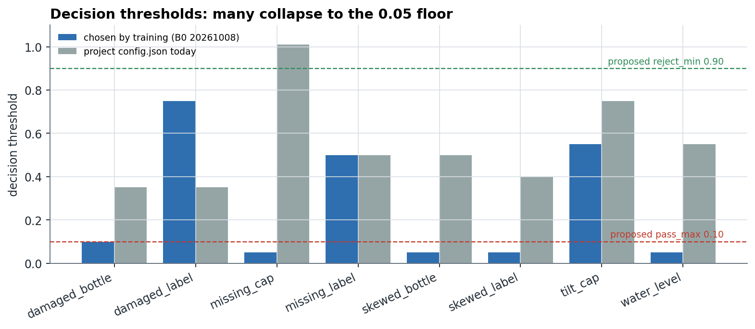
Figure 16: Decision thresholds chosen by training vs the proposed three-zone limits
Many thresholds are 0.05. Validation is perfectly separable, and the threshold search returns the first, i.e. lowest, of the tied best values. Thresholds this low make the classifier fire on any unfamiliar image (Section 11.5).

11.3 Detector results (HELD-OUT TEST)
Table 12: Detector candidates, validation and test
Candidate | Params | Size | Val mAP50 | Val mAP50-95 | Test mAP50 | Test mAP50-95 | Test P | Test R | GPU ms
YOLOv8n v3 | 3.0 M | 6.23 MB | 0.982 | 0.853 | 0.971 | 0.803 | 0.959 | 0.983 | 13.8
YOLOv8s v3 | 11.1 M | 22.5 MB | 0.984 | 0.859 | 0.979 | 0.818 | 0.974 | 0.997 | 10.9

Table 13: Detector per-class test results
Candidate | Class | Precision | Recall | mAP50 | mAP50-95
YOLOv8n v3 | bottle | 0.996 | 1.000 | 0.995 | 0.844
YOLOv8n v3 | cap | 0.987 | 1.000 | 0.995 | 0.983
YOLOv8n v3 | label | 0.893 | 0.948 | 0.924 | 0.581
YOLOv8s v3 | bottle | 0.999 | 1.000 | 0.995 | 0.846
YOLOv8s v3 | cap | 0.990 | 1.000 | 0.995 | 0.988
YOLOv8s v3 | label | 0.931 | 0.990 | 0.947 | 0.620

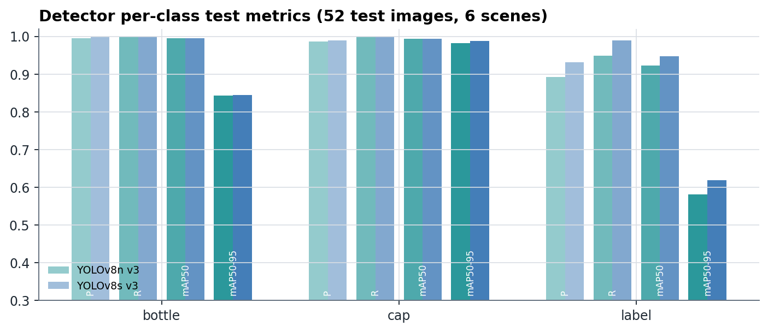
Figure 17: Detector per-class test metrics
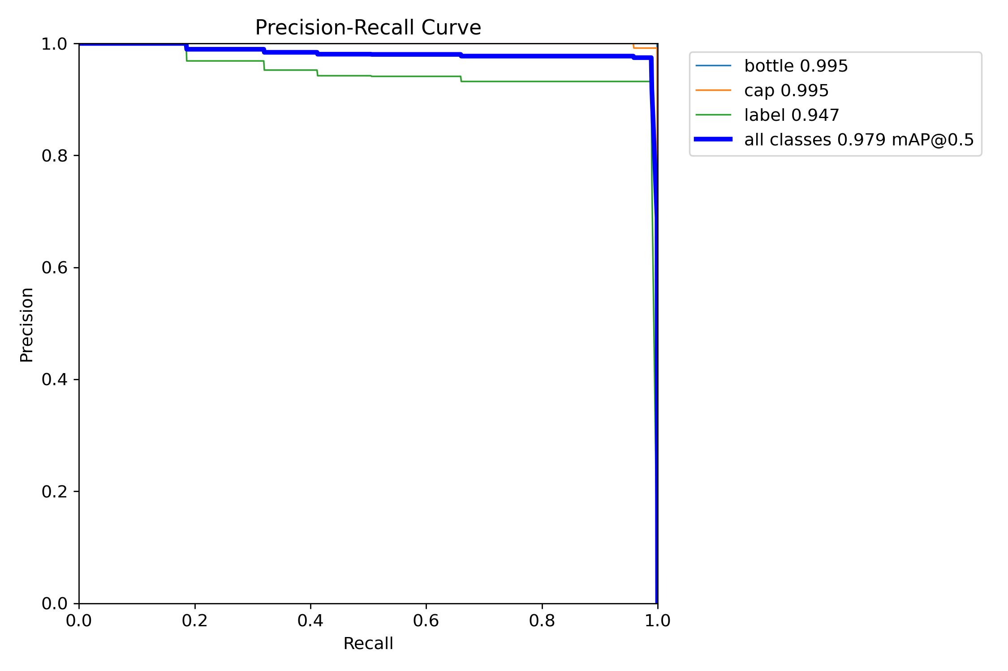
Figure 18: Precision-recall curve, YOLOv8s v3, test split
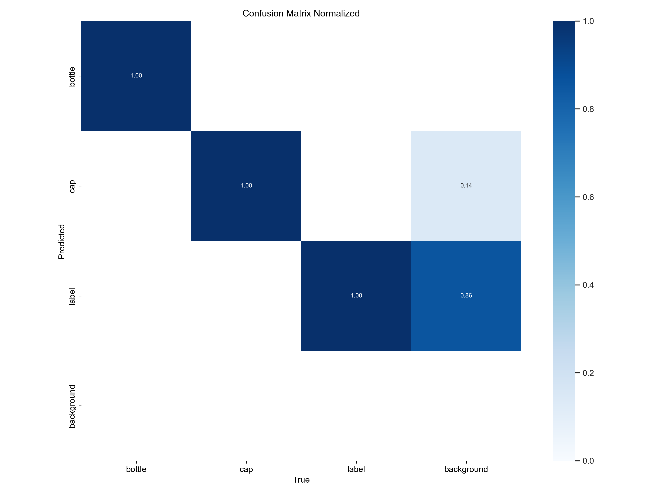
Figure 19: Normalised confusion matrix, YOLOv8s v3, test split

11.4 Missing-cap test
Detectors v1 and v2 called the green tamper ring a cap (~0.70 confidence) and missed all 12 full-bottle missing-cap images. v3 trained on that scene, so its result on them is not proof. A classifier trained on the white-background missing-cap images learned 'white background = missing cap' (25 of 25 capped white-background bottles flagged) and was rejected.
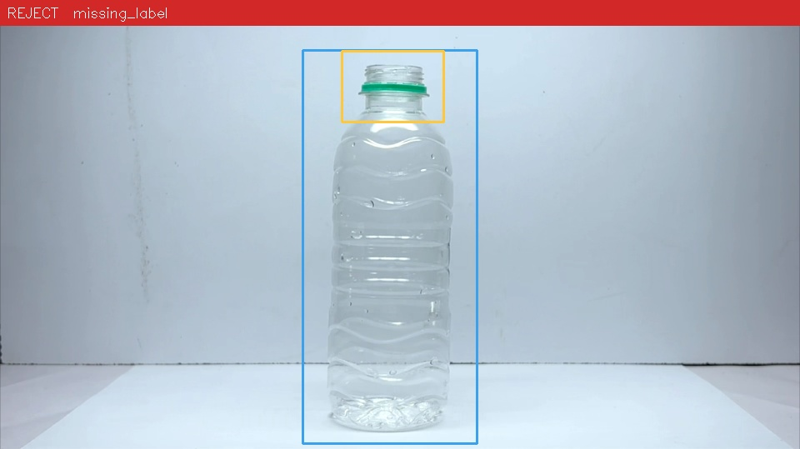
Figure 20: Missing-cap test image with detector output (v1)

11.5 Real production-camera frames (REAL CAMERA)
Every model was run on 33 frames from the EMEET production cameras: bottles on the conveyor, the empty belt, an empty desk and a cable close-up. None shows a defective bottle.
Table 14: Classifiers on real production-camera frames
Classifier | Architecture | Real frames called defective | Defects per frame
20261008-081732 | EfficientNet-B0 | 33 / 33 | 2.5
20261008-082510 | ResNet18 | 33 / 33 | 1.5
20261008-083257 | EfficientNet-B1 | 33 / 33 | 4.2
20261008-083918 | MobileNetV3-Small | 33 / 33 | 4.9
20261008-090538 | ConvNeXt-Tiny | 33 / 33 | 3.1

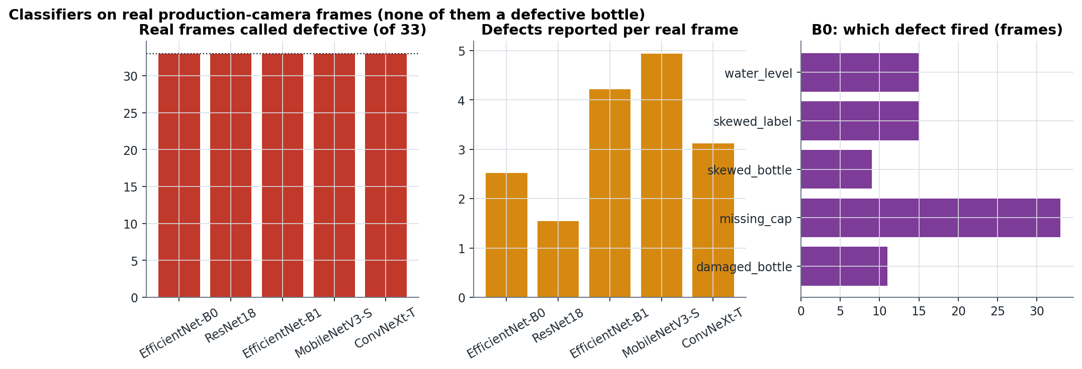
Figure 21: Classifiers on real production-camera frames
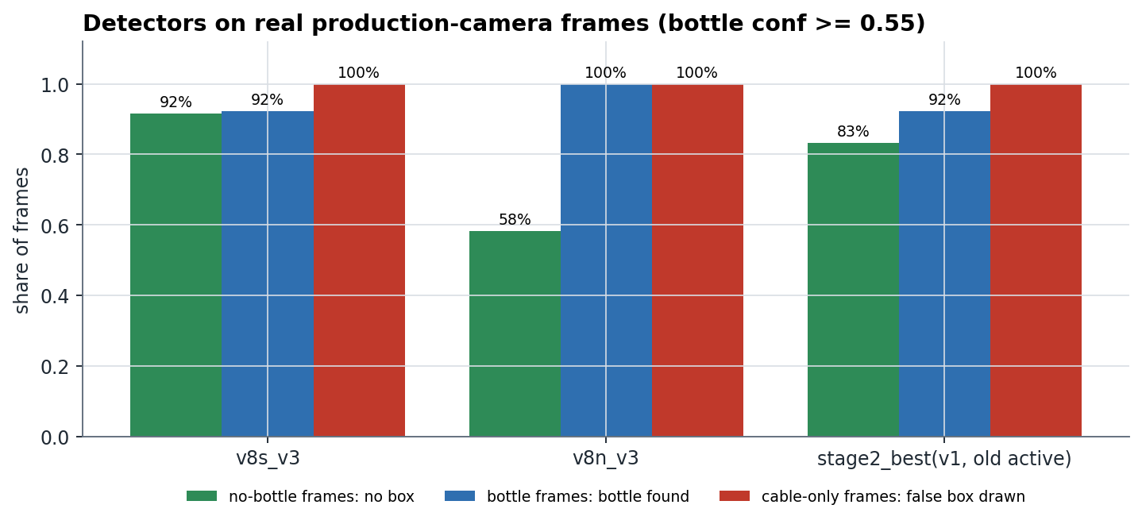
Figure 22: Detectors on real production-camera frames
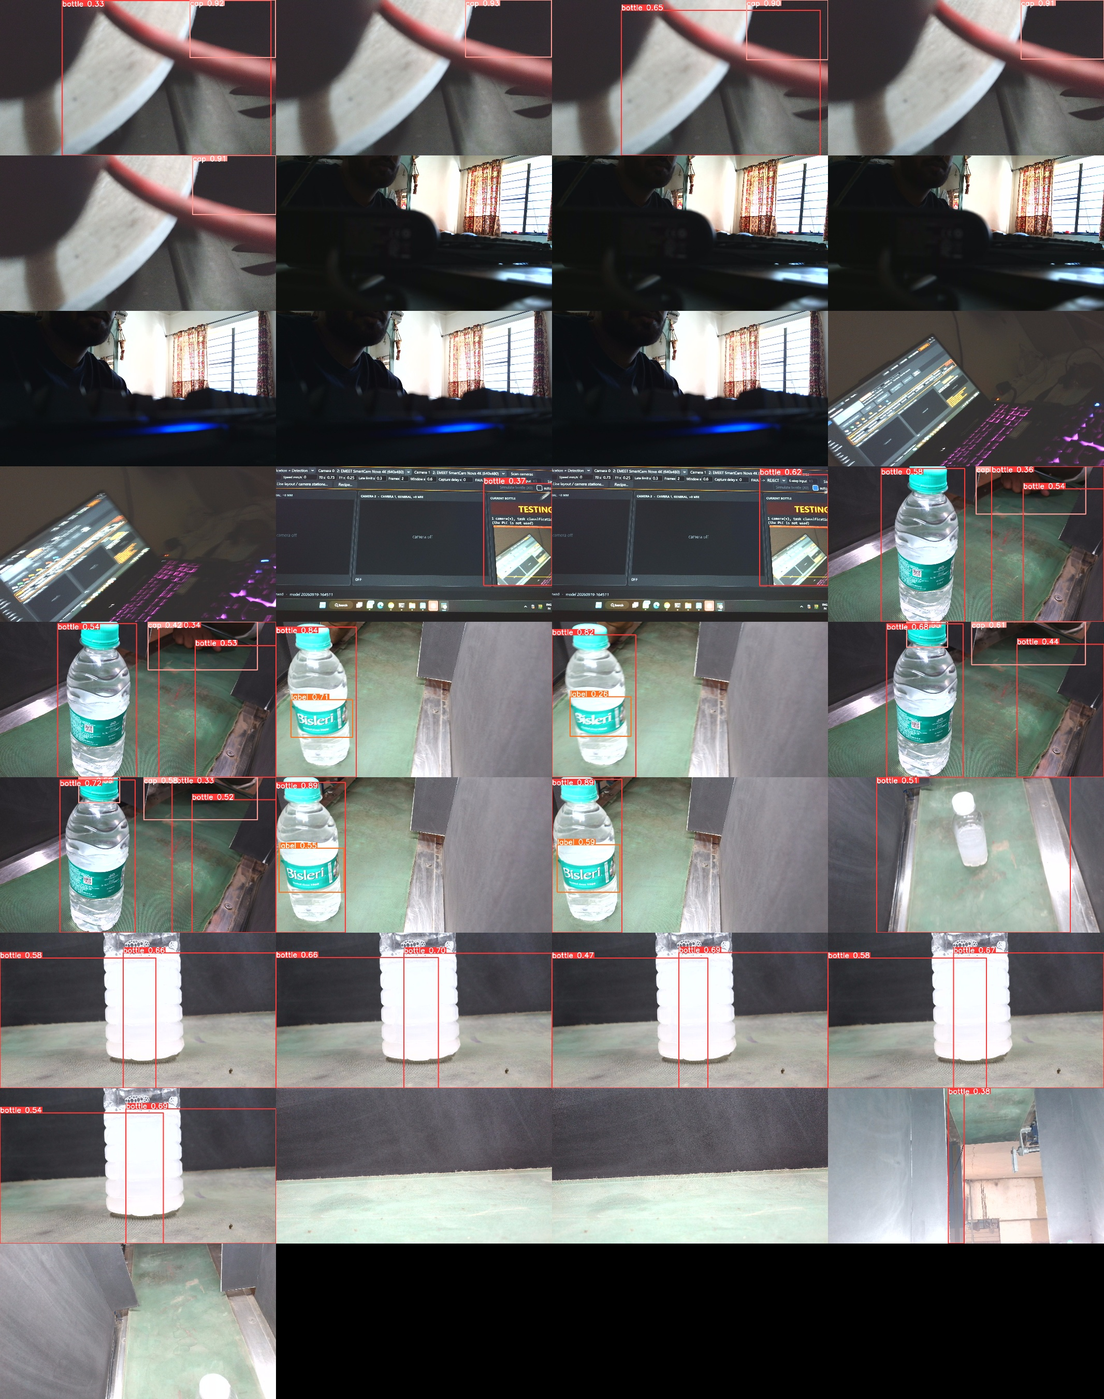
Figure 23: YOLOv8s v3 detections on all 33 real frames
Every classifier calls every real frame defective, including empty scenes (EfficientNet-B0 reports missing_cap on all of them). YOLOv8s v3 behaves best: no boxes on empty scenes and the bottle found at 0.82-0.89. But it often misses the cap (cut off at the top edge of camera 2's view), draws a 0.92 'cap' on a red cable, and puts low-confidence 'bottle' boxes on the metal guide rail.

11.6 First real-line trial (REAL LINE)
Table 15: Real-line trial, 2026-10-06/07 (production.db, 200 bottles)
Outcome / reason | Bottles | Share
Not inspected: M2 still ON (previous bottle unanswered) | 156 | 78 %
No bottle found by the detector | 13 | 6 %
Not inspected: M1 reject cycle masks the trigger | 11 | 6 %
Line halted after 3 consecutive FAULTs | 7 | 4 %
Camera fault / other | 6 | 3 %
REJECT (several defects reported) | 4 | 2 %
Stale trigger at line start | 3 | 2 %

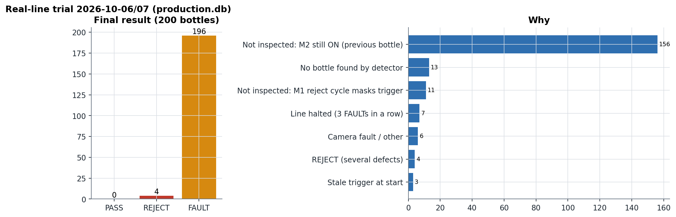
Figure 24: Real-line trial outcomes
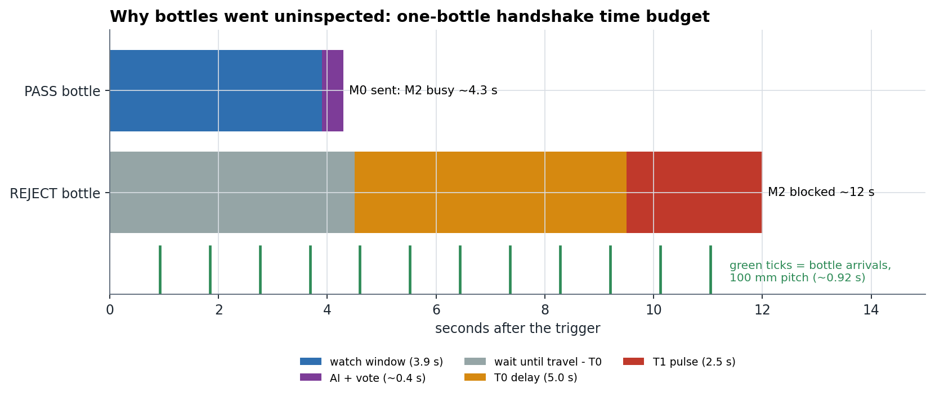
Figure 25: Time budget of the one-bottle PLC handshake
167 of 200 bottles were never inspected: the ladder raises a new trigger only after the previous bottle is answered, and a REJECT holds M1 for T0 + T1. With a 3.9 s watch window, a 4.5 s reject dispatch and T0 + T1 = 7.5 s, the station handles at most ~14 bottles/min if all are good and ~5/min with rejects, against one bottle every ~0.9 s on the belt. The safety design worked as intended: every uninspected bottle was recorded as FAULT, and the latch halted the line after three consecutive FAULTs.

11.7 Summary of results
Table 16: Results summary
Area | Result | Evidence
Control software | 18 / 18 self-tests pass | SELF-TEST
Best classifier (EfficientNet-B0) | macro-F1 0.949, 0 false PASS, 9 false REJECT of 226 | HELD-OUT TEST
Best detector (YOLOv8s v3) | mAP50 0.979, mAP50-95 0.818 | HELD-OUT TEST
Classifiers on the production camera | 33 / 33 frames called defective | REAL CAMERA
Detector on the production camera | bottles found, empty scenes clean; caps unreliable | REAL CAMERA
Real line | 0 PASS / 4 REJECT / 196 FAULT; 167 not inspected | REAL LINE

12. Discussion and Failure Analysis
Table 17: Failure analysis
Failure | Root cause | Remedy
Classifier flags every real frame | domain gap (camera, background, framing) + thresholds at 0.05 + fixed ROI from a landscape frame applied to a portrait frame | production-camera data; detector-guided crop; calibrated, target-based thresholds
Validation saturates at 1.000 | near-duplicate frames, too few scenes | split by physical bottle; production-camera validation
tilt_cap weakest class | small angle, global score | angle measurement from oriented boxes / keypoints
Detector misses caps / false caps | few production frames; cap clipped at frame edge | re-aim camera; add production data and negatives
78 % uninspected | one-bottle handshake + long window + reject dispatch delay | PLC-side bottle FIFO; window ≤ 0.5 s
Timestamps not exact | 15.6 ms clock; stamp after read(); trigger after serial reply | perf_counter clock, bracketed stamps, LED latency test, hardware-triggered cameras
fault_action set to PASS | commissioning setting left on | REJECT; START refuses PASS outside monitor-only mode

Lesson: laboratory metrics (F1 0.95, mAP 0.98) measure how well a model fits its own image distribution. They say nothing about a new camera. The decisive tests were the real-camera frames and the real-line trial. The safety architecture (FAULT by default, the halt latch, no late rejects, a full record) behaved correctly even though the models did not.

13. Limitations
- The models are not validated on the production camera; the classifier is not usable on it today.
- The dataset is small in independent bottles (~111 scenes) and single-label only.
- Missing-cap and missing-label detection are not validated.
- Webcams are rolling-shutter, autofocus devices, and two share one USB 2.0 hub (one 1080p stream).
- Timing is time-based (no encoder); camera and trigger latencies are not yet measured.
- The PLC ladder handles one bottle at a time and lacks an E-stop input and a PC-answer timeout.
- Python 3.8 is past end of life; the inspection core runs inside the desktop UI process.

14. Conclusion
ABVIS delivers a complete inspection-station software stack: dataset tooling, two trained AI models with honest held-out evaluation, a model registry with activation gates, a decision engine, a deadline-driven machine cycle, a PLC link with strict command rules, an operator HMI, alarms and a traceable production database. All 18 self-tests pass against a simulated PLC. On held-out data the classifier reaches macro-F1 0.949 and the detector mAP50 0.979.
The first real-line trial and the real-camera test show that the system is not yet ready for production. The models must be retrained on production-camera images, the decision thresholds must become calibrated and confidence-based, and the PLC must track several bottles at once. The project identified each of these precisely, with evidence, and Chapter 15 sets out the plan.

15. Future Work: Industrial Upgrade Plan
Table 18: Upgrade phases (full detail: INDUSTRIAL_UPGRADE_PLAN.md)
Phase | Work | Done when
0 - Safe and consistent | fault_action REJECT; restore or activate models; remove live threshold shift; fix launcher; archive old models by dataset version | START checklist green with safe settings
1 - Exact timing, confident decisions | perf_counter clock; bracketed frame/trigger stamps; fast trigger poll; AI off the deadline thread; LED latency test; three-zone decision with calibrated scores; production-camera data collection | trigger latency p99 < 60 ms; ≥ 2,000 good + ≥ 300 per defect
2 - Throughput and localisation | PLC bottle FIFO; window ≤ 0.5 s; detector v4 with defect classes (cap_tilted, neck_bare, label_damaged, label_skewed, bottle_damaged, fill_line); detector-guided classifier crop; YOLOv8s 200 epochs at 960 px | 60 bottles/min in simulation; escape rate ≤ 0.1 % on production test
3 - Industrial hardware | global-shutter hardware-triggered cameras, lighting enclosure, encoder, reject-confirm sensor, E-stop input, Modbus TCP, heartbeat watchdog | latency and gates re-measured on new hardware
4 - Measurement and validation | angle and fill-level measurement (OBB / pose), IQ/OQ/PQ, repeatability study, shift-start challenge bottles, Windows service, Python upgrade | commercial acceptance

15.1 Three-zone confidence decision
Each defect gets two limits on its calibrated score. Above reject_min (≈ 0.90) it is a confident defect. Below pass_max (≈ 0.10) it is confidently absent. In between, the bottle is UNSURE and is rejected and counted separately. A bottle passes only if every defect is confidently absent in ≥ 80 % of its frames and the detector sees the bottle (≥ 0.80) and its parts (≥ 0.70). Acceptance targets: escape rate ≤ 0.1 %, false reject ≤ 1 %, unsure ≤ 2 %.

15.2 Defect localisation
New detector classes mark where each defect is. Annotations are bootstrapped from the existing component boxes and image labels (e.g. the cap box of a tilt_cap image becomes cap_tilted) and then reviewed by a person. Fill level and tilt become measurements in millimetres and degrees, which a QA engineer can tune and audit.

References
- M. Tan and Q. V. Le, "EfficientNet: Rethinking Model Scaling for Convolutional Neural Networks," ICML, 2019.
- K. He, X. Zhang, S. Ren and J. Sun, "Deep Residual Learning for Image Recognition," CVPR, 2016.
- A. Howard et al., "Searching for MobileNetV3," ICCV, 2019.
- Z. Liu et al., "A ConvNet for the 2020s," CVPR, 2022.
- J. Redmon, S. Divvala, R. Girshick and A. Farhadi, "You Only Look Once: Unified, Real-Time Object Detection," CVPR, 2016.
- G. Jocher, A. Chaurasia and J. Qiu, "Ultralytics YOLOv8," 2023. https://github.com/ultralytics/ultralytics
- C. Guo, G. Pleiss, Y. Sun and K. Q. Weinberger, "On Calibration of Modern Neural Networks," ICML, 2017.
- Modbus Organization, "MODBUS Application Protocol Specification V1.1b3," 2012.
- Delta Electronics, "DVP-ES2/EX2/SS2/SA2/SX2/SE/TP Operation Manual - Programming."
- J. Deng et al., "ImageNet: A Large-Scale Hierarchical Image Database," CVPR, 2009.
- I. Loshchilov and F. Hutter, "Decoupled Weight Decay Regularization," ICLR, 2019.
- I. Loshchilov and F. Hutter, "SGDR: Stochastic Gradient Descent with Warm Restarts," ICLR, 2017.
- T.-Y. Lin et al., "Microsoft COCO: Common Objects in Context," ECCV, 2014.
- IEC 61131-3, "Programmable controllers - Part 3: Programming languages."
- ISO 13849-1, "Safety of machinery - Safety-related parts of control systems."

Appendix A: Key settings
Table 19: Configuration used in the trial
Setting | Value in trial | Meaning / recommended
inspection_to_reject_mm / conveyor_mm_s | 1028 / 108.2 | travel 9.5 s (measured)
plc_t0_s / plc_t1_s | 5.0 / 2.5 | must equal the ladder's T0 / T1
inspect_frames / inspect_window_s | 13 / 3.9 | recommend 3-5 frames in ≤ 0.5 s
fault_action | PASS | must be REJECT
threshold_shift | -0.3 | remove (thresholds come from the activated model)
decision_rules.det_min_conf_by_class | bottle 0.2, cap 0.2, label 0.4 | bottle 0.80, cap 0.70, label 0.70
line_cameras / rotate | [2, 3] / 90 deg | lock focus, exposure and white balance as well

Appendix B: How to run
- pip install torch torchvision --index-url https://download.pytorch.org/whl/cu124
- pip install -r requirements.txt ultralytics==8.1.0 pyserial comtypes psutil
- python -m vision.calibrate (once per product)
- python gui.py (the application)
- python selfcheck.py [--full] (all self-tests)
- python -m vision.train --epochs 25 --arch efficientnet_b0 (train a candidate)
- python -m registry.model_bench yolo --model yolov8s.pt --data v3 --workers 0 (train a detector)

Appendix C: Glossary
Table 20: Glossary
Term | Meaning
Scene | one physical bottle pass recorded as consecutive frames
Macro-F1 | unweighted mean of per-class F1 (harmonic mean of precision and recall)
mAP50 / mAP50-95 | mean average precision at IoU 0.5 / averaged over IoU 0.5-0.95
False PASS (escape) | defective bottle passed: the error that reaches the customer
False REJECT | good bottle rejected: costs product, not quality
FAULT | the system cannot vouch for the bottle; rejected by default
Recipe | the definition of a complete product: anchor (bottle) and required parts in zones
Candidate | a trained model not yet approved for production

Appendix D: Figure and data sources
All figures are generated by FINAL_YEAR_BLACKBOOK/20_Final_Report/_make_figures.py from the metrics files, the production database and data/real_camera_model_check.json (produced by data/real_camera_model_check.py on 2026-10-13). YOLO plots come from Ultralytics (19_Retrain_2026-10-08). Screenshots of the application pages should be added to 13_Screenshots/ before submission.

