ABVIS - Automated Bottle Visual Inspection System
Final project review pack: review summary, presentation slides, demo script and viva preparation
[Students] | [Guide] | [Department, College] | 2026-27
Right-click > Update field

Part A - Final Review Summary

A.1 One-paragraph summary
ABVIS is an AI machine-vision station that inspects 250 ml bottles on a conveyor and makes a PLC reject the bad ones. It combines an EfficientNet defect classifier, a YOLOv8 component detector, a voting decision engine and a Delta PLC handshake over Modbus. It also includes an operator HMI, a model registry and a production database. On held-out data the classifier scores macro-F1 0.949 (0 defective bottles passed) and the detector mAP50 0.979, and the control software passes 18/18 self-tests. A real trial and a real-camera test showed a camera domain gap, collapsed thresholds and a PLC throughput limit. All three are diagnosed, with a phased plan to industrial grade.

A.2 Objectives vs achievement
Table 1: Objectives
Objective | Status | Evidence
Leak-free multi-label dataset | Done (limited size) | 1167 reviewed images, ~106 scenes, scene split
Compare classifiers, select on test | Done | 5 architectures; EfficientNet-B0 selected
Component detector | Done | YOLOv8s v3 test mAP50 0.979
Decision engine (vote, fusion, FAULT) | Done | self-tests
PLC integration and reject timing | Done in simulation; read-only on the real PLC; trial run | ladder simulator S1-S14, trial
HMI, alarms, registry, database | Done | 15 pages, SQLite record of 200 bottles
Validated on the real line | Not yet | trial: 0 PASS / 4 REJECT / 196 FAULT

A.3 Key numbers
Table 2: Key numbers
Metric | Value
Classifier test macro-F1 (EfficientNet-B0, leak-free) | 0.949
Classifier false PASS / false REJECT (226 test bottles) | 0 / 9
Classifier inference | 8.4 ms/image (RTX 3050)
Detector test mAP50 / mAP50-95 (YOLOv8s v3) | 0.979 / 0.818
Detector inference | 10.9 ms/image
Software self-tests | 18 / 18 pass
Code base | ~28,000 lines Python, 7 packages
Real-camera frames called defective by classifiers | 33 / 33 (every model)
Real-line trial | 200 bottles: 0 PASS, 4 REJECT, 196 FAULT (167 not inspected)

A.4 Contributions
- A complete, safety-first inspection architecture: unknown is FAULT, no late rejects, a single PLC owner.
- Honest evaluation: scene-based leak-free splits, a test set used once, real-camera and real-line evidence.
- A model registry with activation gates and rollback.
- PLC ladder decoding and scan simulation to test the PLC program against the software contract.
- A diagnosis of why laboratory accuracy did not transfer, with a measurable upgrade plan.

Part B - Presentation (slide by slide)
20 slides, about 15-18 minutes. Each slide lists its title, on-screen points, the figure to show and what to say.

Slide 1: Title
- ABVIS - Automated Bottle Visual Inspection System
- AI defect detection + PLC-controlled rejection
- [Students] - [Guide] - [Department, College]
Speaker notes: Introduce the team and the one-line idea: a camera inspects every bottle and a cylinder removes the bad ones.

Slide 2: Problem
- Manual inspection is slow, tiring and inconsistent
- Defects: missing / tilted cap, damaged / skewed / missing label, damaged / skewed bottle, fill level
- Goal: inspect every bottle, reject bad ones, never pass an uninspected bottle
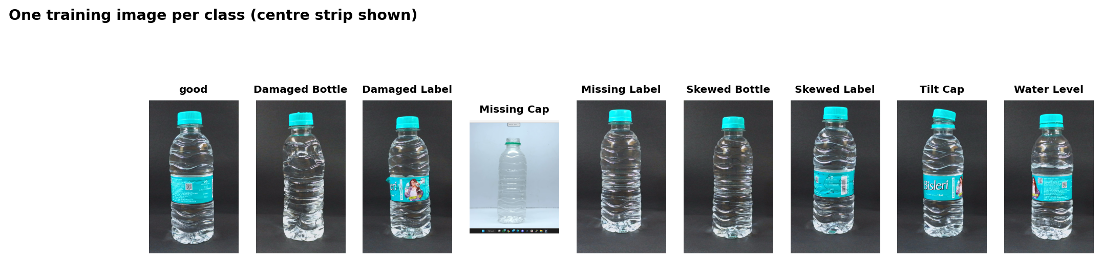
Figure 1: Slide 2 visual
Speaker notes: Show the eight defect classes on real bottles.

Slide 3: Objectives
- Dataset with leak-free split
- Classifier + detector
- Decision engine
- PLC integration and reject timing
- HMI, registry, database
- Validate on the real line
Speaker notes: These are the seven objectives; the review summary table shows which are done.

Slide 4: System architecture
- PC: HMI, cameras, AI, decision, machine cycle, PLC service, database
- PLC: owns conveyor, T0 delay, T1 pulse, cylinder
- Modbus ASCII over RS-232
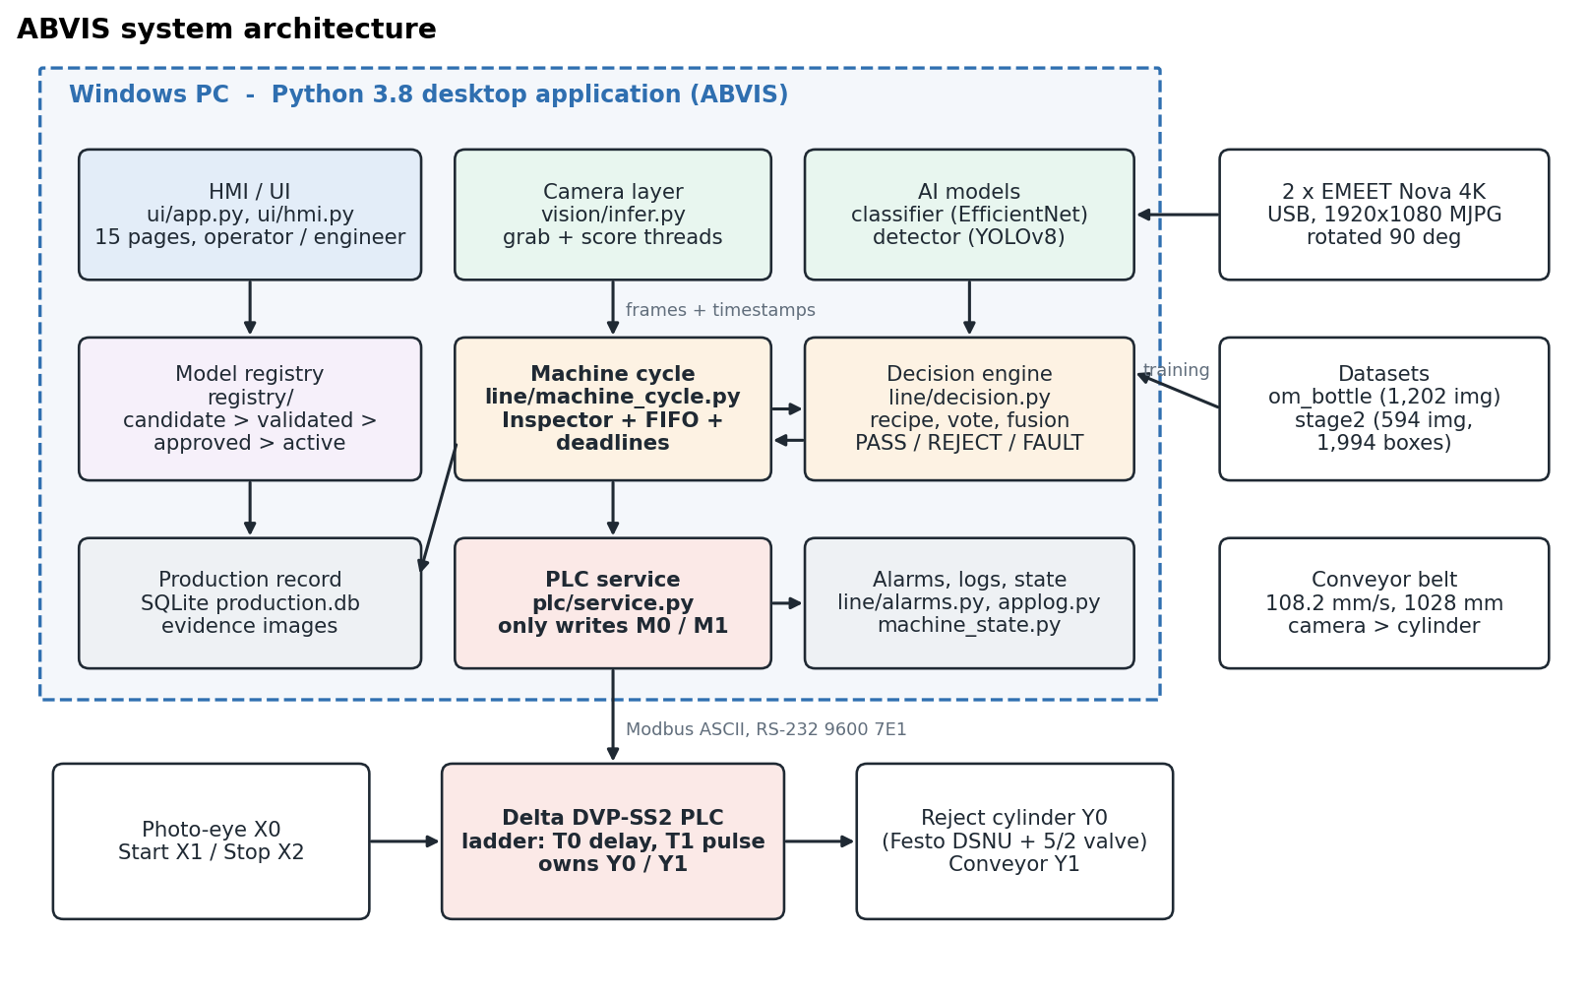
Figure 2: Slide 4 visual
Speaker notes: Walk left to right: cameras > AI > decision > PLC > cylinder. Stress: the PC never writes an output.

Slide 5: Machine cycle
- X0 > M2 trigger > frames after trigger > AI > vote
- PASS: M0 now
- REJECT: M1 at trigger + travel - T0 > PLC fires Y0
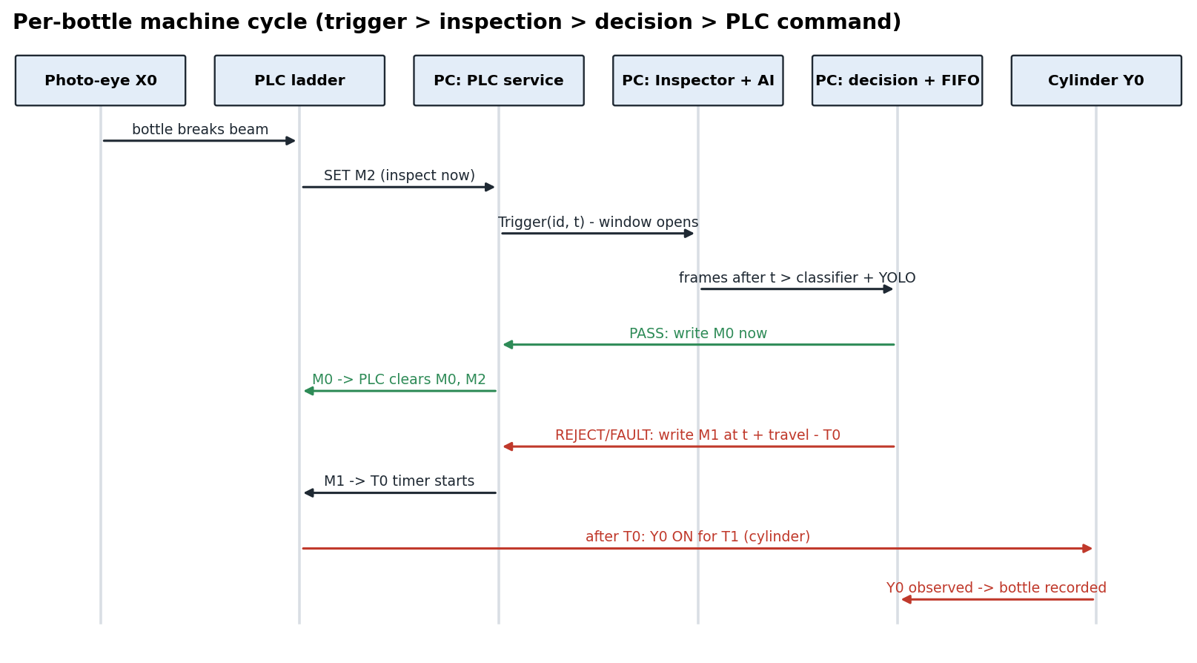
Figure 3: Slide 5 visual
Speaker notes: Explain time-based tracking: travel 9.5 s from the measured distance and belt speed.

Slide 6: Hardware
- Delta DVP-SS2 PLC, photo-eye, Festo cylinder + 5/2 valve
- 2 x EMEET Nova 4K cameras
- i7-12700H, RTX 3050 4 GB
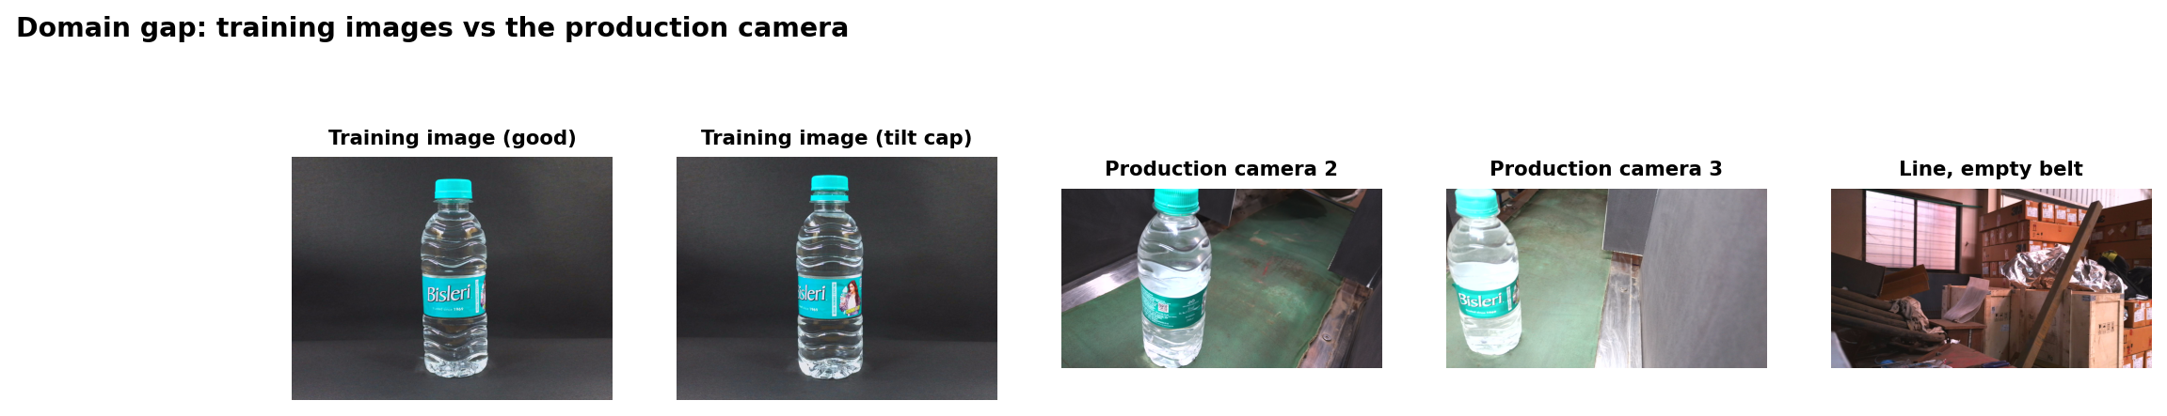
Figure 4: Slide 6 visual
Speaker notes: Show the real station frames next to the training images.

Slide 7: Dataset
- 1167 reviewed images, ~106 scenes
- Scene-based split: no near-duplicates across sets
- Detection: 594 images, 1,994 boxes
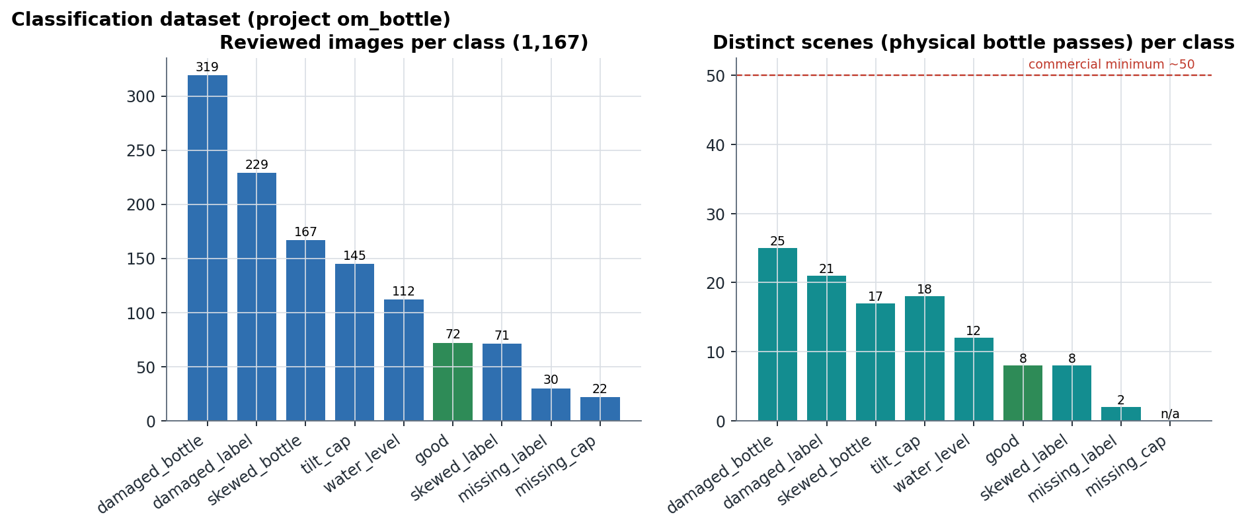
Figure 5: Slide 7 visual
Speaker notes: Explain why scenes, not images, are the real sample size.

Slide 8: Classifier
- EfficientNet-B0 + 4 other backbones, multi-label sigmoid
- BCE + pos_weight, AdamW, cosine, 25 epochs
- Weighted sampling for good bottles and hard examples
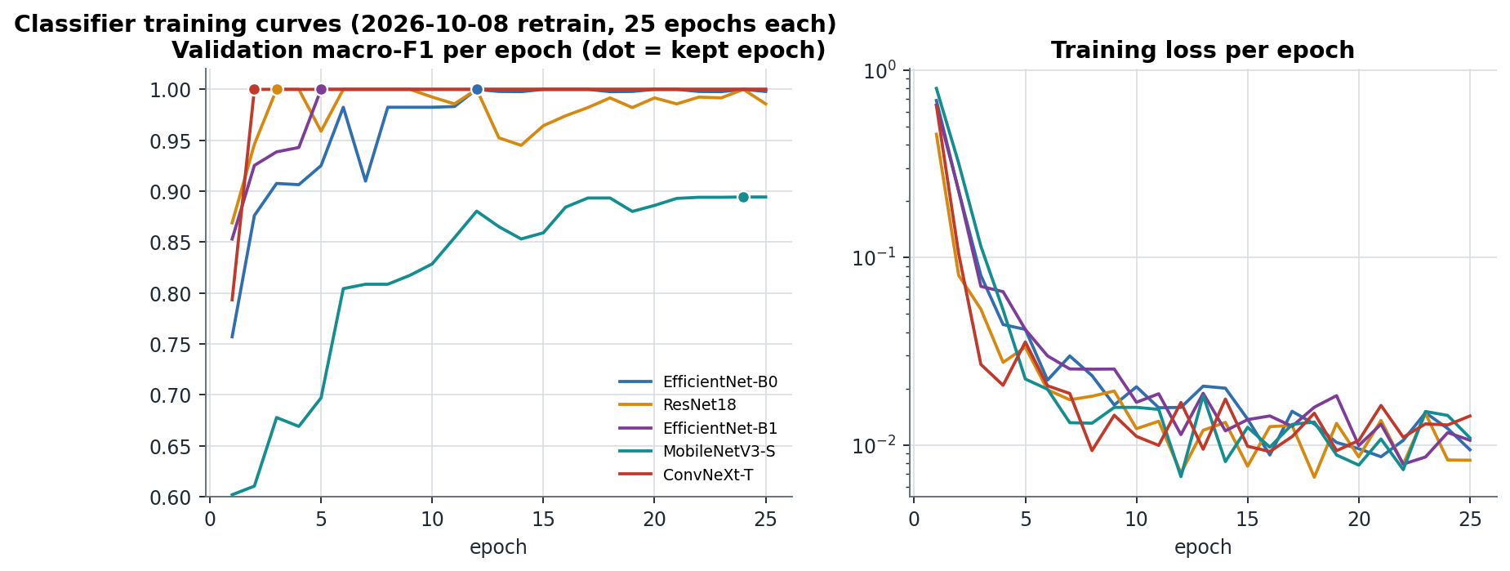
Figure 6: Slide 8 visual
Speaker notes: Point out that validation saturates at 1.0 early: the data, not the epochs, is the limit.

Slide 9: Classifier results
- Best: EfficientNet-B0, test macro-F1 0.949
- 0 defective bottles passed, 9 good rejected (226)
- Weakest class: tilt_cap
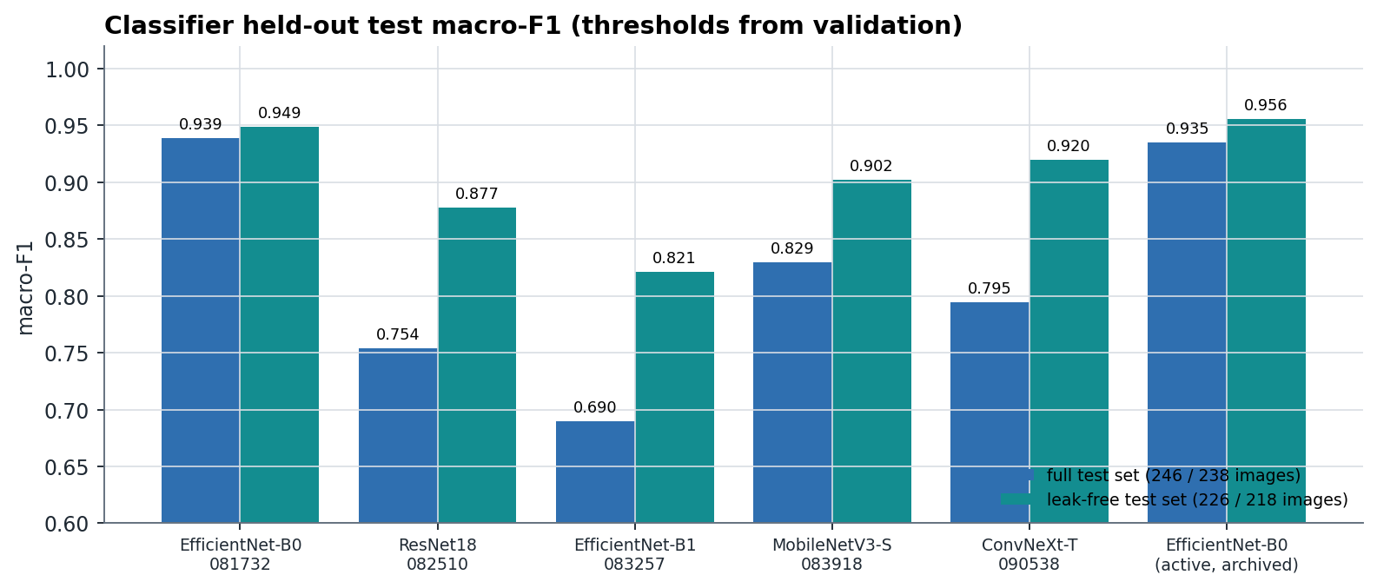
Figure 7: Slide 9 visual
Speaker notes: Compare architectures; justify B0 by accuracy, zero escapes and speed.

Slide 10: Per-class view
- Most classes ≈ 1.0 F1
- tilt_cap ≈ 0.73 for every model
- missing_label: no test positives
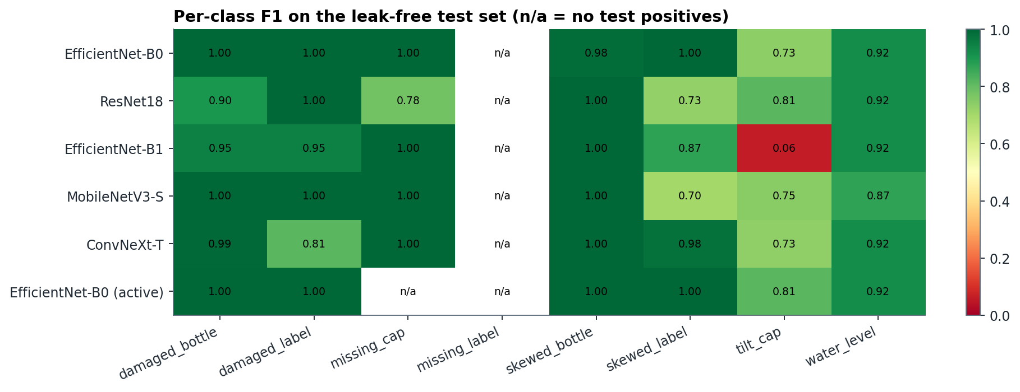
Figure 8: Slide 10 visual
Speaker notes: A global score is weak for small angles; measurement is the fix.

Slide 11: Detector
- YOLOv8n / YOLOv8s on bottle, cap, label
- YOLOv8s test mAP50 0.979
- YOLOv8s still improving at epoch 80
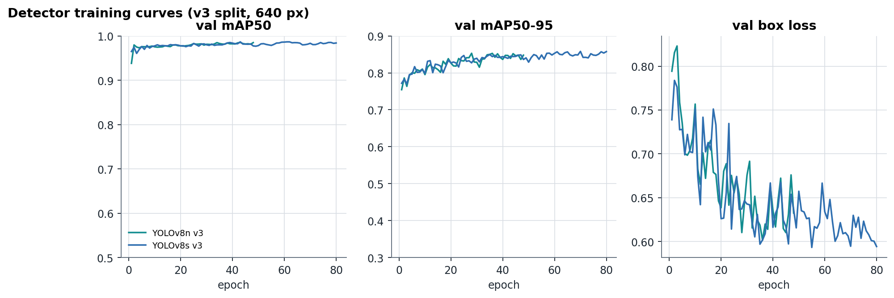
Figure 9: Slide 11 visual
Speaker notes: Explain mAP50 and mAP50-95; label is the hardest class.

Slide 12: Detector quality
- Per-class precision / recall / mAP
- PR curve and confusion matrix
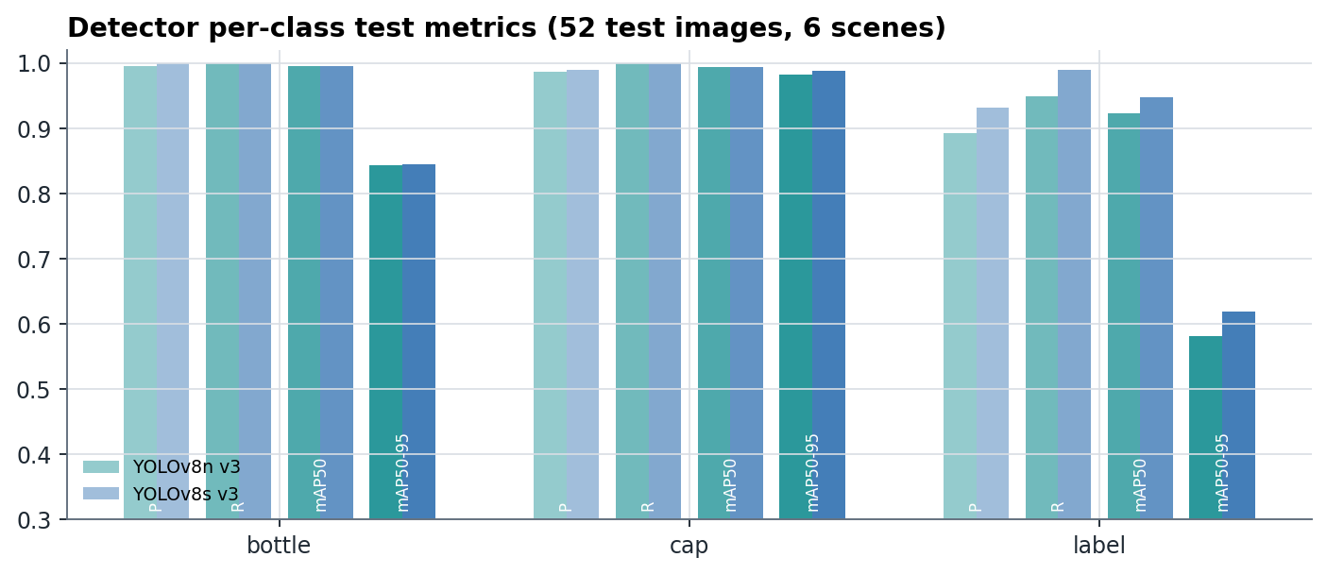
Figure 10: Slide 12 visual
Speaker notes: Highlight the label mAP50-95 (0.62): box edges of a wrap-around label are ambiguous.

Slide 13: Decision engine and safety
- Recipe: required parts in zones
- Majority vote over frames; FAULT > REJECT > PASS
- Unknown is FAULT; FAULT rejected; late reject never fired; halt latch
Speaker notes: This is what keeps the line safe even when the AI is wrong.

Slide 14: Software
- 15-page HMI, operator / engineer modes
- Model registry: candidate > validated > approved > active
- SQLite production record, alarms, logs
- 18 / 18 self-tests
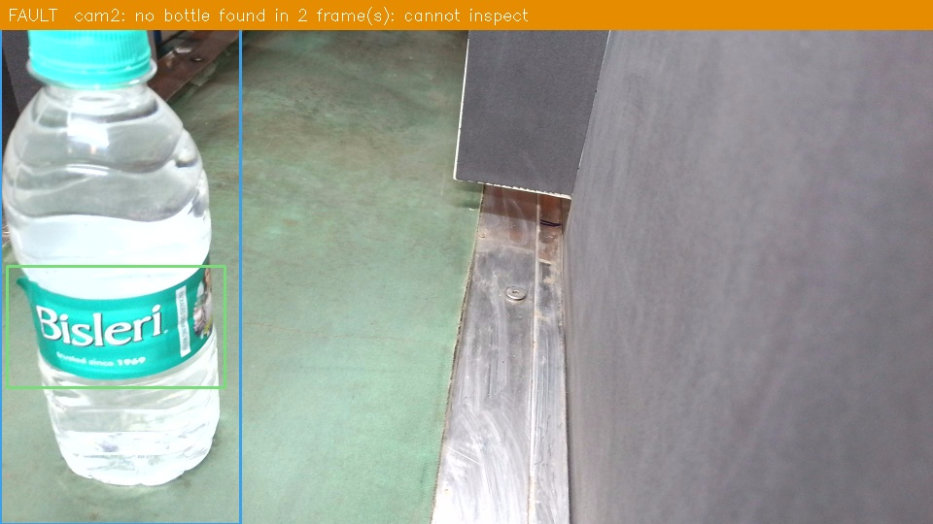
Figure 11: Slide 14 visual
Speaker notes: Show a screenshot or the live demo.

Slide 15: Real-camera test
- Classifiers: 33 / 33 real frames called defective
- Detector: bottles found, empty scenes clean, caps unreliable
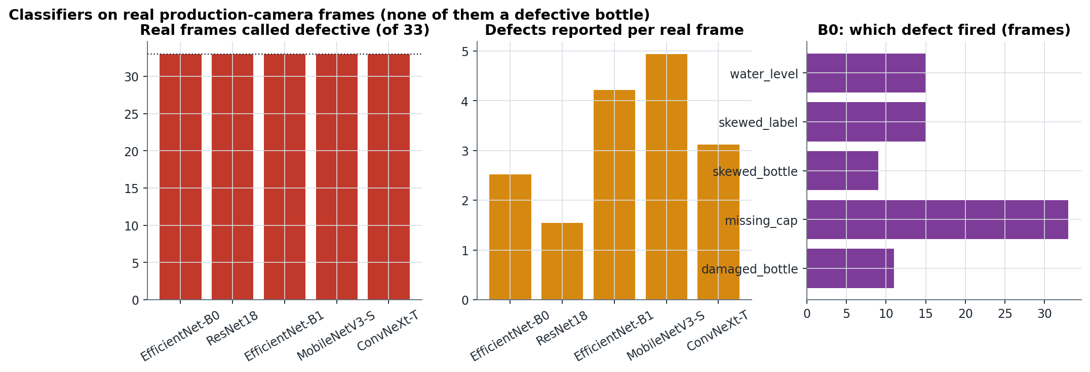
Figure 12: Slide 15 visual
Speaker notes: The domain gap: lab accuracy did not transfer to the new camera.

Slide 16: Real-line trial
- 200 bottles: 0 PASS, 4 REJECT, 196 FAULT
- 167 not inspected: one-bottle PLC handshake
- Safety worked: everything uninspected recorded as FAULT
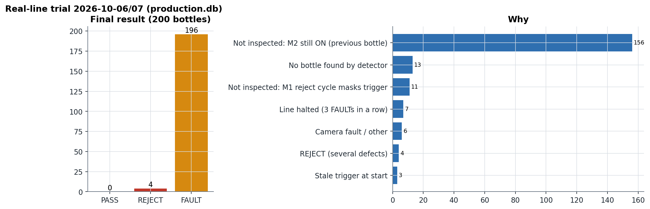
Figure 13: Slide 16 visual
Speaker notes: Present honestly: the failure is understood and measurable.

Slide 17: Root causes
- Domain gap + thresholds at 0.05
- One-bottle handshake + long window
- Timestamps not exact (15.6 ms clock, serial latency)
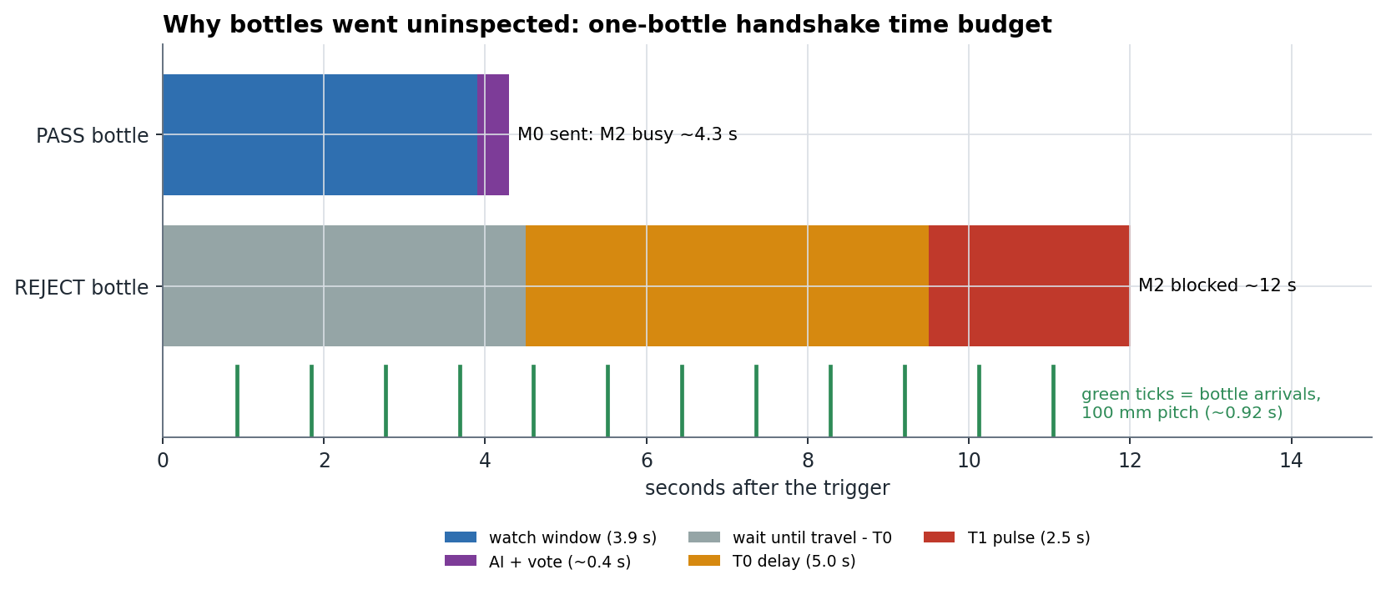
Figure 14: Slide 17 visual
Speaker notes: Walk through the time budget bar chart.

Slide 18: Upgrade plan
- Phase 0 safe settings
- Phase 1 exact timing + three-zone confidence + real data
- Phase 2 PLC FIFO + defect localisation
- Phase 3 industrial cameras, encoder
- Phase 4 measurement, validation
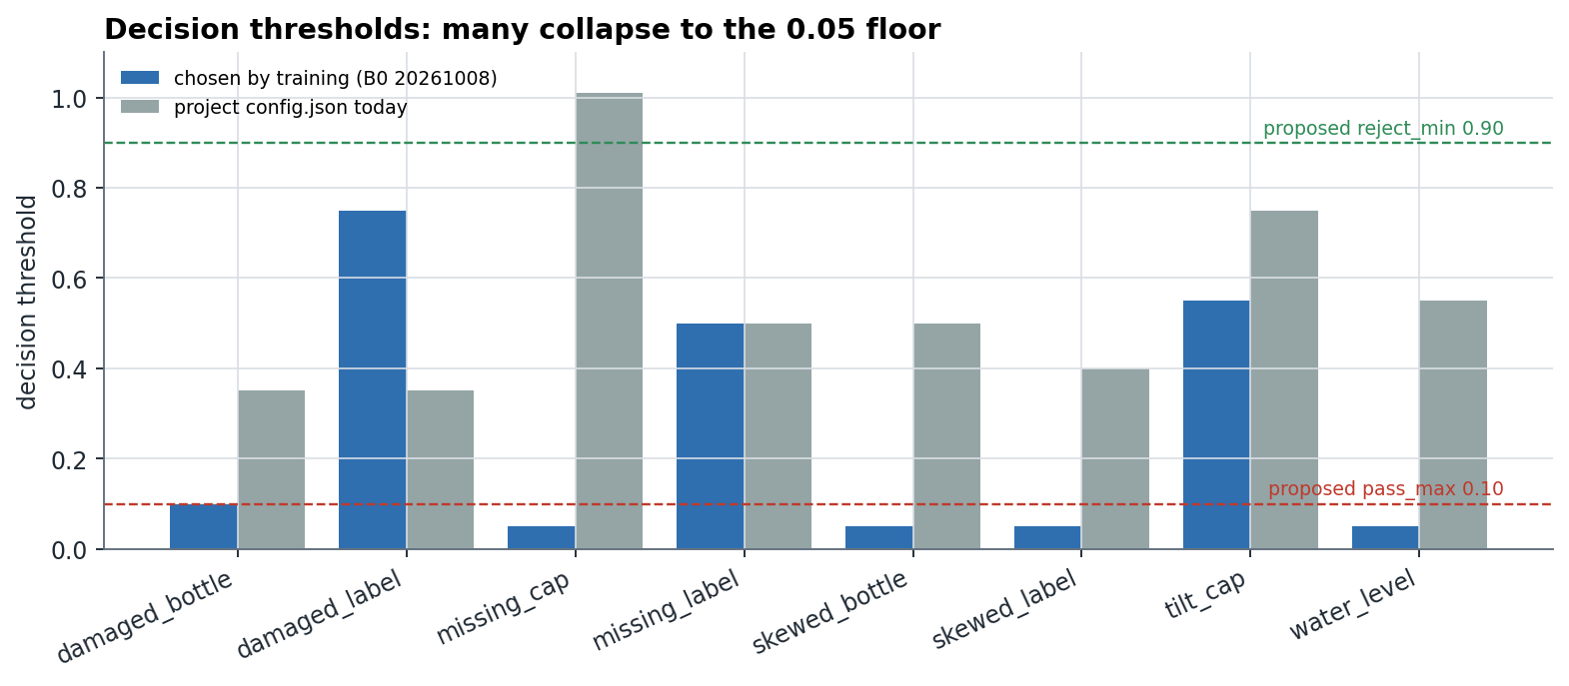
Figure 15: Slide 18 visual
Speaker notes: Explain the three-zone decision: confident defect / confident good / unsure > reject.

Slide 19: Conclusion
- Complete, safety-first inspection stack built and tested
- Strong held-out results
- Real-world gaps found with evidence and a plan to close them
Speaker notes: End on what was learned: real validation decides, not lab scores.

Slide 20: Questions
- Thank you
Speaker notes: Have backup slides ready: dataset split, PLC I/O map, timing formula.

Part C - Live Demo Script (no hardware needed)
- Launch: python gui.py. The app opens in OPERATOR mode on the Production page.
- Switch to ENGINEER mode (header button). Show the page groups.
- Machine page: connect to the ISPSoft simulator (TCP 127.0.0.1:10002), or explain the real COM link.
- Production > engineer row > Simulation check: run 'Check the LADDER' (14 scenarios) and 'Check the SOFTWARE' (self-tests).
- Production > TEST INSPECTION on a saved image: show the verdict and the overlay.
- Label page: show labels.csv-backed labelling and the inbox. Annotate page: show boxes and proposals.
- Models page: show the CANDIDATE > ACTIVE lifecycle and gates.
- Database page: open the trial records, export the CSV report.
- Terminal backup: python selfcheck.py (18/18 pass in about 2 minutes).

Part D - Viva Questions and Answers
Q: Why multi-label instead of multi-class?
A: Defects can co-occur (a skewed bottle with a damaged label). One sigmoid per defect allows any combination; softmax would force exactly one.
Q: Why split by scene?
A: Images are consecutive video frames. A random split puts near-duplicates of one bottle in train and test and inflates accuracy. Whole scenes go to one split only.
Q: Why did you choose EfficientNet-B0?
A: Highest held-out macro-F1 (0.949), zero defective bottles passed, and 8.4 ms per image.
Q: What is macro-F1 and why not accuracy?
A: The mean of per-class F1. Accuracy is misleading under imbalance: always answering 'no defect' scores high accuracy while missing every defect.
Q: Why both a classifier and a detector?
A: The classifier judges appearance (damage, skew, fill). The detector judges presence and position of parts (a missing cap is a bottle without a cap box).
Q: What is mAP50?
A: Mean average precision when a predicted box counts as correct at IoU ≥ 0.5 with the true box; mAP50-95 averages IoU thresholds 0.5 to 0.95 and rewards tight boxes.
Q: How is the reject timed without an encoder?
A: Travel time = distance / measured belt speed. The PC sends M1 at trigger + travel - T0; the PLC waits T0 and fires the cylinder exactly when the bottle arrives.
Q: What happens if the camera or model fails?
A: The bottle becomes FAULT and is rejected by default; three FAULTs in a row halt the line; an alarm explains why.
Q: Why does the PC never write PLC outputs?
A: Outputs are owned by the deterministic PLC. The PC only answers PASS or REJECT, so a PC crash cannot fire or block the cylinder directly.
Q: Why did the classifier fail on the real camera?
A: Domain gap: different camera, background, framing and crop; and thresholds at 0.05 that fire on any unfamiliar image.
Q: Why were 78 % of bottles uninspected?
A: The ladder accepts a new trigger only after the previous bottle is answered; the window and reject cycle made each bottle occupy the PLC for 4-12 s while bottles arrive every ~0.9 s.
Q: Would more epochs help?
A: Not for the classifier: validation was already perfect at epoch ~12, so it would only memorise. Yes for YOLOv8s, which was still improving at epoch 80, but after adding production-camera data.
Q: How will you reach high confidence?
A: Calibrate scores (temperature scaling), use two limits per defect (confident defect / confident good) and reject the unsure middle; gate production on escape rate ≤ 0.1 %.
Q: How accurate are your timestamps?
A: Consistent but not exact: the Windows monotonic clock in Python 3.8 ticks every 15.6 ms, frames are stamped after read() returns, and the trigger after the serial reply. The plan switches to perf_counter, brackets each stamp and measures latency with an LED test.
Q: What is the role of the model registry?
A: No trained model reaches production until it passes a held-out test, a real-camera check and a shortcut check, and is approved; every activation is logged and reversible.
Q: How do you add a new product?
A: Images + labels, a detector trained on its parts, and a recipe in config.json; no code changes.

Part E - Checklist before the review
- Fill names, roll numbers, guide and college on the title pages.
- Add application screenshots (Production, Label, Models, Database) to the black book.
- Set fault_action to REJECT before any live demo with the PLC.
- Print the results summary table and the upgrade-plan table as handouts.
- Rehearse the real-trial slides: present them as findings, not failures.

