ABVIS
AI-Based Bottle Visual Inspection System

Production-Ready Software Plan and Process Flow
Black book chapter / annex

Prepared 14 October 2026
Status labels used throughout: DONE (software, self-tested with fakes), SOFTWARE (work that needs no hardware), SIMULATOR (proven against the PLC simulator / ladder emulation), PHYSICAL (proven on the real machine). Nothing in this document is evidence that a hardware test has passed.

Contents
Right-click > Update field

1. Purpose and approach
This chapter sets out how the ABVIS software will be completed to a production-ready standard, and how it will then be proven on the physical inspection machine. It is the working plan for the final phase of the project and the reference for what “finished” means.
The approach is software first, hardware second. Every part of the system that can be built and proven without the machine (settings, PLC protocol, AI pipeline, reporting, fault handling) is completed and verified in software and in the PLC simulator first. The physical commissioning then has one job: to confirm on the real conveyor what the software has already shown in simulation. This keeps time on the machine short, keeps people away from moving parts while software is still changing, and makes every hardware test answer one clear question.
Production-ready is declared only after physical proof. The software can be frozen before the hardware work, but the system is called production-ready (release v1.0) only after a filmed end-to-end cycle (one good bottle PASS, one defective bottle REJECT) and after a validated model meets the acceptance gates in Section 7 on images from the production camera.

The order of work follows the project's guiding principle: first prove the bottle-inspection machine, then harden and validate the bottle AI, then generalise the proven components into a universal inspection platform.

2. Where the project stands today
The software core is built. On 14 October 2026 the quick self-check suite passed 22/22 (every check runs with fake cameras, fake models and a scan-by-scan emulation of the PLC ladder). One real-line trial was recorded earlier: 18 runs, 200 bottles: 0 PASS, 4 REJECT, 196 FAULT (production.db). The trial did what a trial should: it exposed the two limits that this plan removes.
Table 1: Current status by area
Area | Status | Evidence level
Desktop application: 15 pages, operator and engineer modes | Implemented | SOFTWARE (GUI self-test)
Machine cycle: trigger, per-bottle FIFO, deadlines, one result per bottle | Implemented | SOFTWARE + ladder emulation
Decision engine: recipe, three-zone thresholds, frame vote, camera fusion | Implemented | SOFTWARE
PLC service: Modbus ASCII, single owner, only M0 / M1 written | Implemented | SIMULATOR; read-only real link (user-stated)
Safety latch, coded alarms, event logs, machine state | Implemented | SOFTWARE
Production record: SQLite, CSV, evidence images, History / Database pages | Implemented | SOFTWARE
Model registry: candidate > validated > approved > active, rollback | Implemented | SOFTWARE
Real-line trial | 200 bottles, 196 FAULT | PHYSICAL (shows the limits below)
Classifier and detector accuracy on the production camera | Not yet adequate | Good on own test sets; fails off-domain
Complete physical PASS / REJECT cycle with the cylinder | Not proven | -
Excel workbook export | Not implemented | CSV + printable report exist
Segmentation | Interface only, no trained model | -

2.1 The two limits found on the real line
- Throughput: the PLC handles one bottle at a time. The ladder has one trigger bit (M2) and one reject timer pair (T0/T1). While a bottle waits for its answer, or while a reject is in progress, the next bottle's trigger is masked. Most trial bottles were therefore recorded as FAULT “not inspected”. Software cannot recover a trigger the PLC never exposes; the fix is a new PLC protocol (Phase B).
- Domain gap: the models were trained on a different camera. The classifier was trained on a black backdrop and the detector on webcam-viewer screenshots. On the EMEET production cameras their scores fall into the uncertain band. The fix is data from the production camera (Phase F), not more training epochs.

2.2 Configuration found today that must change before production
Table 2: Settings to correct
Setting (settings.json) | Value today | Required for production
fault_action | PASS | REJECT (a fault must never become a PASS)
threshold_shift / threshold_overrides | -0.3 / 7 overrides | removed: thresholds come from the activated model
decision_rules.det_min_conf_by_class | bottle 0.2, cap 0.2, label 0.4 | validated values from the production-camera test set
plc_com | COM10 | the real PLC port, pinned by adapter identity
conveyor_mm_s / inspection_to_reject_mm | 108.2 / 1028.0 | measured with the speed calibration wizard (timestamped record)
plc_t0_s / plc_t1_s | 5.0 / 2.5 | equal to the presets in the program loaded in the PLC

3. Overall plan
Figure 1 shows the plan as a process flow. Phase A comes first because every later phase depends on a safe, consistent baseline. Phases B, C and D are independent software streams that can run side by side. A software freeze gate closes the software work; only then does hardware commissioning start. Each gate has an explicit “No” path: the work loops back rather than moving on with a known problem.
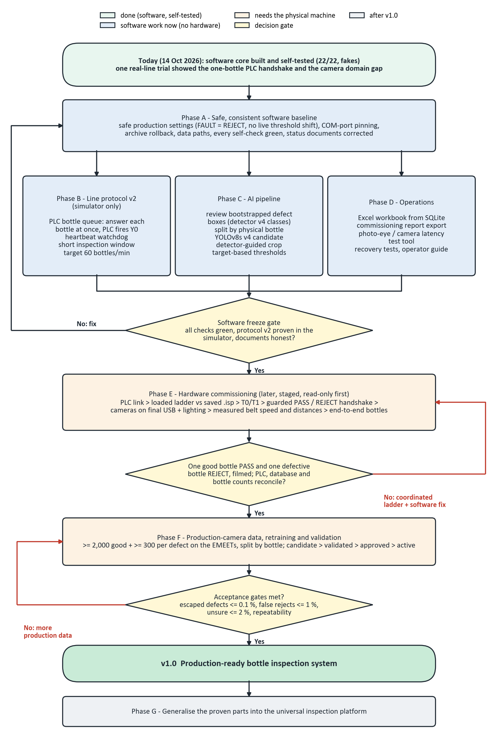
Figure 1: Overall plan: software phases, freeze gate, hardware commissioning, validation and release

4. Software phases (no hardware needed)

Phase A - Safe, consistent software baseline
Table 3: Phase A tasks
# | Task | Done when
A1 | Restore safe production settings: fault_action REJECT; remove the live threshold shift, threshold overrides and lowered detector gates from the production path (allowed only in a logged commissioning mode). | Start checklist passes with the model's own thresholds; self-test asserts it
A2 | Decide on the 22 white-background missing-cap images (they taught a background shortcut). | missing_cap examples come only from the production setup
A3 | Model registry lists models_archive and can roll back to it; Stage 2 data.yaml files use valid paths. | Registry self-test covers archive rollback; export validation passes
A4 | Pin the PLC serial port by adapter identity; the GUI never silently rewrites plc_com. | Wrong port is refused with a clear message
A5 | Full verification (selfcheck --full including the GUI self-test) and status documents corrected (FEATURE_STATUS, CURRENT_SYSTEM, README, CLAUDE.md). | All checks green; documents match code

Phase B - Line protocol v2 (simulator only)
The present handshake answers one bottle at a time. Protocol v2 lets the PC answer every bottle at once and lets the PLC keep its own queue of pending rejects and fire the cylinder itself. The ladder belongs to the PLC owner and is never edited by the software project: both sides are designed together, proven in the scan simulator, and enabled on the real PLC only after the ladder change is made and tested.
Table 4: Phase B tasks
# | Task | Done when
B1 | Write the protocol v2 specification: per-bottle id and verdict, PLC reject queue (shift register or data-register ring), acknowledgement, fault behaviour; list the rungs in PLC_LADDER_REQUIREMENTS.md. | Reviewed by the project team and the PLC owner
B2 | Implement v2 in the ladder emulation, the ladder scan simulator, PLCService and MachineCycle behind a protocol setting; v1 remains the default. | 60 bottles/min in simulation, 0 untriggered bottles; all v1 tests still pass
B3 | Heartbeat watchdog in both directions (PC toggles a bit; the PLC stops or rejects if it stops). | Simulated PC freeze leads to a safe PLC state
B4 | Inspection window no longer than bottle pitch / belt speed (about 0.3-0.5 s, 3-5 frames). | No association faults at 100 mm pitch in simulation

Phase C - AI pipeline
Table 5: Phase C tasks
# | Task | Done when
C1 | Review the 389 bootstrapped defect boxes and draw the remaining region boxes (about 12 hours of human review). | Every image accepted by a person
C2 | Detector v4 dataset: annotations, split by physical bottle, export, validation. | Export validation passes; no bottle in two splits
C3 | Train a YOLOv8s v4 candidate (one training job at a time on the 4 GB GPU). | Candidate registered with provenance; never auto-activated
C4 | Detector-guided crop for the classifier through the single shared preprocessing path. | Training and live inference produce identical crops
C5 | Target-based thresholds (defect recall >= 99.5 %, good-bottle false alarms <= 1 %) and the acceptance gates of Section 7 in the registry. | Gates enforced at validation

These models remain candidates: they still carry the domain gap until Phase F adds production-camera data.

Phase D - Operations, traceability and reporting
Table 6: Phase D tasks
# | Task | Done when
D1 | Excel workbook generated from a consistent SQLite snapshot: Production_Log, PLC_Log, Alarm_Log, Shift_Report, Model_Performance. Runs downstream; never in the reject timing loop. | Workbook totals equal database totals
D2 | Commissioning report export: every test labelled SOFTWARE / SIMULATOR / PHYSICAL with timestamps. | One-click report from the Health page
D3 | Photo-eye and camera latency test tool, ready to run on the machine; Start warns without a recent measurement. | Tool self-tested with fakes
D4 | Recovery tests with fakes: application restart mid-run, PLC disconnect and reconnect, camera unplug, full disk. | No bottle silently passes in any case
D5 | Operator quick-reference guide for the Production page. | Reviewed by an operator

Software freeze gate
- selfcheck --full green, including the GUI self-test;
- protocol v2 proven in the scan simulator at the target rate, with v1 still passing;
- status documents match the code and settings; every claim carries its evidence label.

5. Target per-bottle production process
Figure 2 is the process every bottle follows once the line is running. It is the behaviour the software already implements and the behaviour the hardware commissioning must confirm. Two properties matter most: one inspection id and one final result per physical bottle, and no path from a fault to a PASS.
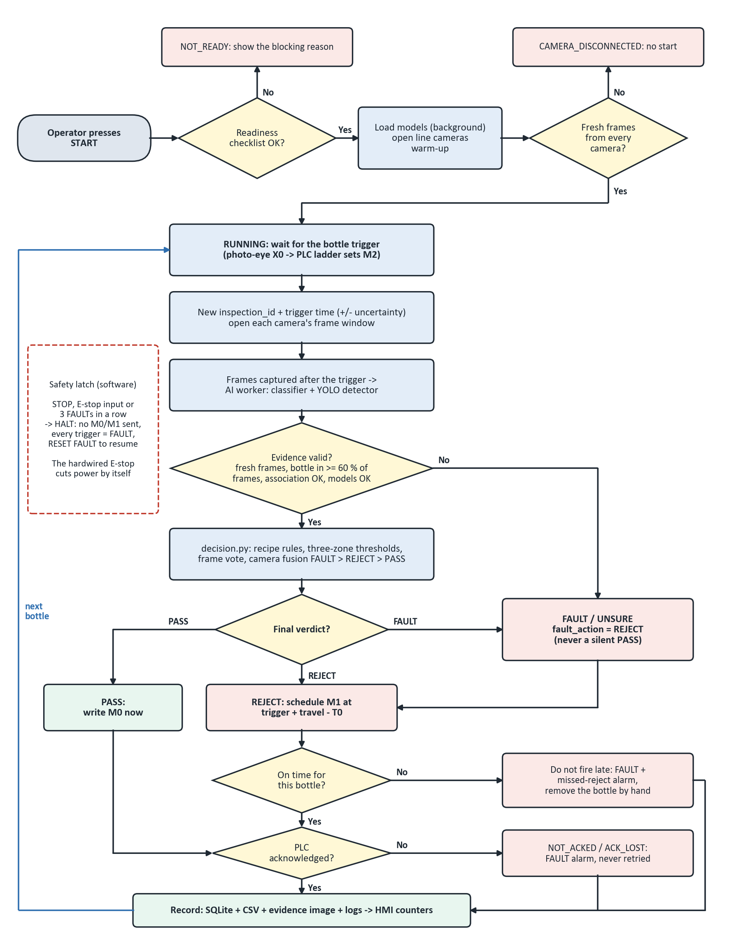
Figure 2: Per-bottle production flow with every fault branch
Table 7: Fault rules (none of them can produce a PASS)
Situation | System response
Readiness checklist fails (PLC, models, cameras, timing, safety settings) | Start refused, reason shown
A camera gives no fresh frame at start | CAMERA_DISCONNECTED, no start
Stale frame, too few bottle frames, model error, uncertain association | FAULT -> physically rejected
Score between the pass and reject limits (unsure) | FAULT (UNSURE), counted as its own KPI
REJECT decided too late to reach the right bottle | Not fired; FAULT + missed-reject alarm
PLC does not acknowledge a command | FAULT alarm; the command is never retried blindly
STOP, E-stop input or 3 FAULTs in a row | HALT latch: no commands sent, triggers recorded as FAULT
X0 rises but the PLC exposes no trigger | Bottle recorded as NOT INSPECTED (FAULT)

6. Hardware commissioning (later)
Hardware work starts after the software freeze. Each stage is read-only or guarded until the stage before it has passed, and every result is recorded with the label PHYSICAL.
Table 8: Hardware commissioning stages
Stage | What is proven | Acceptance
E0 Inspect and freeze | Back up configuration and PLC files; compare the program loaded in the PLC with the saved .isp | Loaded ladder known; differences listed
E1 Read-only PLC link | Real COM port, 9600 7E1 station 1, PLC RUN, X/M/Y/T/C read; photo-eye -> X0 -> M2 | Every photo-eye pass seen once; latency recorded
E2 Timers | T0/T1 presets and timer base agreed with measured distance, belt speed and cylinder stroke | Ladder and settings equal; reviewed change
E3 Guarded handshake | Armed M0 (PASS) and M1 (REJECT) with the actuator isolated per the technician's procedure | M2/M1 clear, counters step, Y0 pulse timed
E4 Cameras | Both EMEETs on the final USB layout, enclosure and lighting; focus, exposure, ROI locked | Resolution, FPS and frame age measured together
E5 Timing | Belt speed (>= 3 runs), photo-eye-to-camera and -to-cylinder distances, cylinder response | Calibration record saved; schedule matches
E6 End-to-end | Good -> PASS; defective -> REJECT; alternating sequence; fault injection; long run | Physical bottles = database = PLC counters

Safety: the software HALT latch is not an emergency stop. The hardwired E-stop and guarding are verified independently, and no reject is fired until the timer behaviour is confirmed. Python never writes the conveyor or cylinder outputs (Y0/Y1); the PLC owns them.

7. Model and data lifecycle, and the acceptance gates
Figure 3 shows how a model reaches production and how production feeds the next model. Training never activates a model by itself; every activation passes the gates below and is logged with a rollback path.
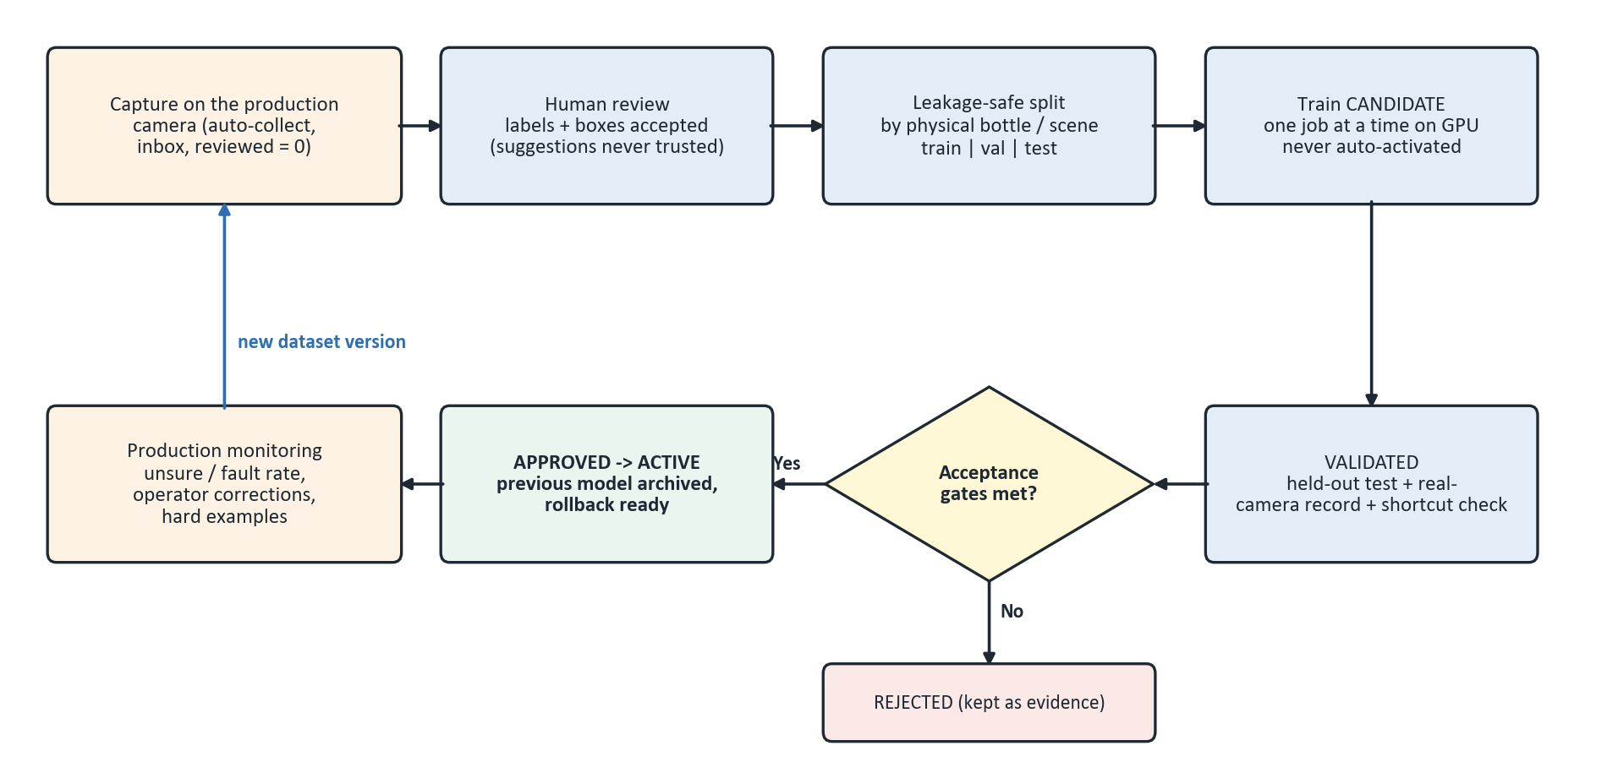
Figure 3: Data and model lifecycle
Table 9: Acceptance gates for model activation
Metric | Gate (production-camera test set, bottles never seen in training)
Defective bottles passed (escape rate) | <= 0.1 %
Good bottles rejected (false reject) | <= 1 %
Unsure rate | <= 2 %
Repeatability | same bottle x 50 passes -> same verdict >= 49 times
Per-defect recall | >= 99 % for every class with >= 100 test presentations
Shortcut check | no background or lighting shortcut (e.g. white background = defect)

Data target for Phase F: at least 2,000 good and 300 per defect presentations captured on the final cameras, enclosure and lighting, split by physical bottle so no bottle appears in two splits.

8. Definition of production-ready (release v1.0)
- Software freeze gate passed (Section 4).
- All hardware commissioning stages E0-E6 passed and recorded as PHYSICAL.
- Filmed end-to-end cycle: one known-good bottle PASS and one known-defective bottle REJECT by the cylinder.
- Active classifier and detector meet the acceptance gates of Section 7 on production-camera data.
- A long stability run reconciles physical bottles, database rows, CSV rows and PLC counters exactly.
- Every fault case in the fault-rules table (Section 5) demonstrated on the machine without a single silent PASS.
- Status documents and this chapter updated with the physical evidence.

9. Risks and mitigations
Table 10: Risks
Risk | Mitigation
One-bottle PLC handshake limits throughput | Protocol v2 (Phase B); until then, spaced bottles at low speed
Models fail on the production camera (domain gap) | Production-camera data and retraining (Phase F)
Two webcams share USB bandwidth; rolling shutter on a moving belt | Separate USB controllers, measured modes; industrial cameras after v1.0
Program in the PLC differs from the saved file; timer presets unknown | Stage E0 comparison before any reject
4 GB GPU and 16 GB RAM limit training | One training job at a time; data-loader workers limited
Python 3.8 is end-of-life | Upgrade after v1.0, not during commissioning
Scope growth before the machine works | Platform work (Phase G) only after v1.0

10. Decisions needed
- Approve the Phase A settings changes (fault_action, threshold shift, detector gates).
- Remove the white-background missing-cap images from the classifier dataset.
- Protocol v2 form (shift register or data-register ring) and who changes the ladder.
- Add the openpyxl dependency for the Excel workbook (not installed today).
- Target bottle (250 ml or 1 litre) and the defects v1.0 must demonstrate.
- Camera hardware budget: keep the webcams for v1.0 or move to industrial cameras.

11. Engineering rules that govern every phase
- One application, one repository; PLCService is the only owner of the PLC link.
- The PLC owns the physical outputs; Python never writes Y0 or Y1.
- No camera, model, timing or communication fault may become a PASS.
- One inspection id and one final result per physical bottle, from fresh frames only.
- No model is activated automatically; splits are leakage-safe; screenshot metrics are not production evidence.
- PLC protocol changes are made on both sides together; I/O addresses and timer values are never guessed.
- Tests never touch real production data, settings, labels or active models.
- Every result states whether it came from software, the simulator or the physical machine.

Appendix A - Software self-check result
Command: python selfcheck.py (CPU). Result: 22/22. All checks use fakes; none is a hardware test.
Check | Time | Result
Inspection clock | 0.1s | OK
Decision engine | 20.2s | OK
Machine cycle | 18.3s | OK
Time tracking | 0.1s | OK
Machine state | 0.1s | OK
Alarms | 0.1s | OK
Production record | 2.8s | OK
Event logs | 0.1s | OK
Model registry | 0.3s | OK
PLC protocol | 2.4s | OK
PLC service | 11.5s | OK
PLC commissioning window | 4.3s | OK
Ladder decoder | 0.1s | OK
Ladder simulator | 4.7s | OK
Active learning | 2.6s | OK
Stable verdict | 0.1s | OK
Production export | 2.8s | OK
Threshold calibration | 0.3s | OK
Model activation gates | 1.5s | OK
Defect box bootstrap | 2.7s | OK
Model archive | 0.1s | OK
Annotation export | 0.1s | OK

Appendix B - Rebuilding this chapter
python FINAL_YEAR_BLACKBOOK/21_Production_Software_Plan/_make_flowcharts.py
python FINAL_YEAR_BLACKBOOK/21_Production_Software_Plan/_build_plan_doc.py
In Word, right-click the table of contents and choose Update Field.

