**Python**

Om Ghanshyam Bhamare

SE A 3

Github: https://github.com/ombhamare4/Python-SEM4.git

**Assignment 2**

Q1]A Python program to copy an image file into another file.

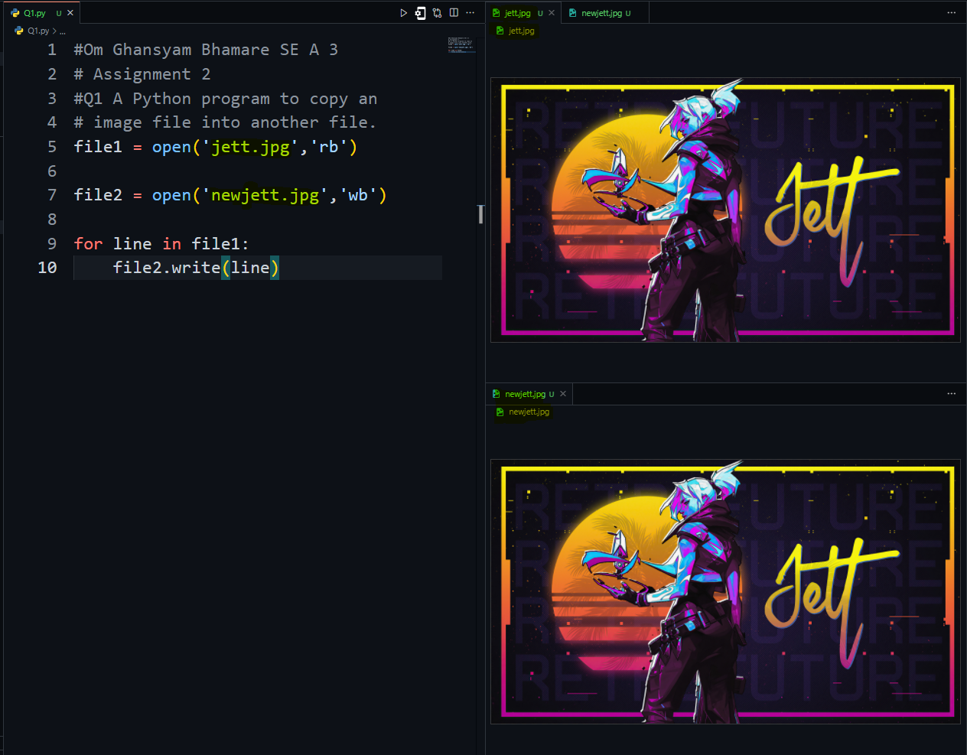

Q2] A Python program to append data to an existing file and then displaying the entire file.

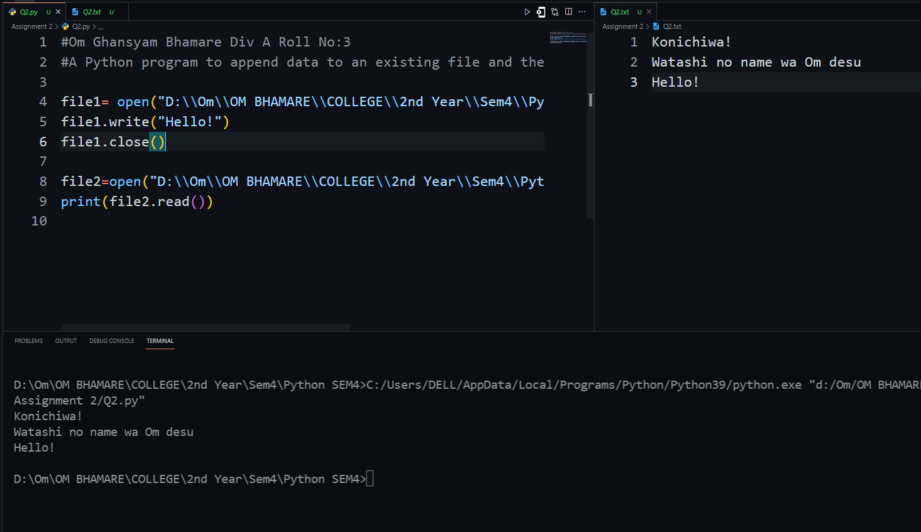

Q4] A Python program to remove a sub directory that is inside another dictionar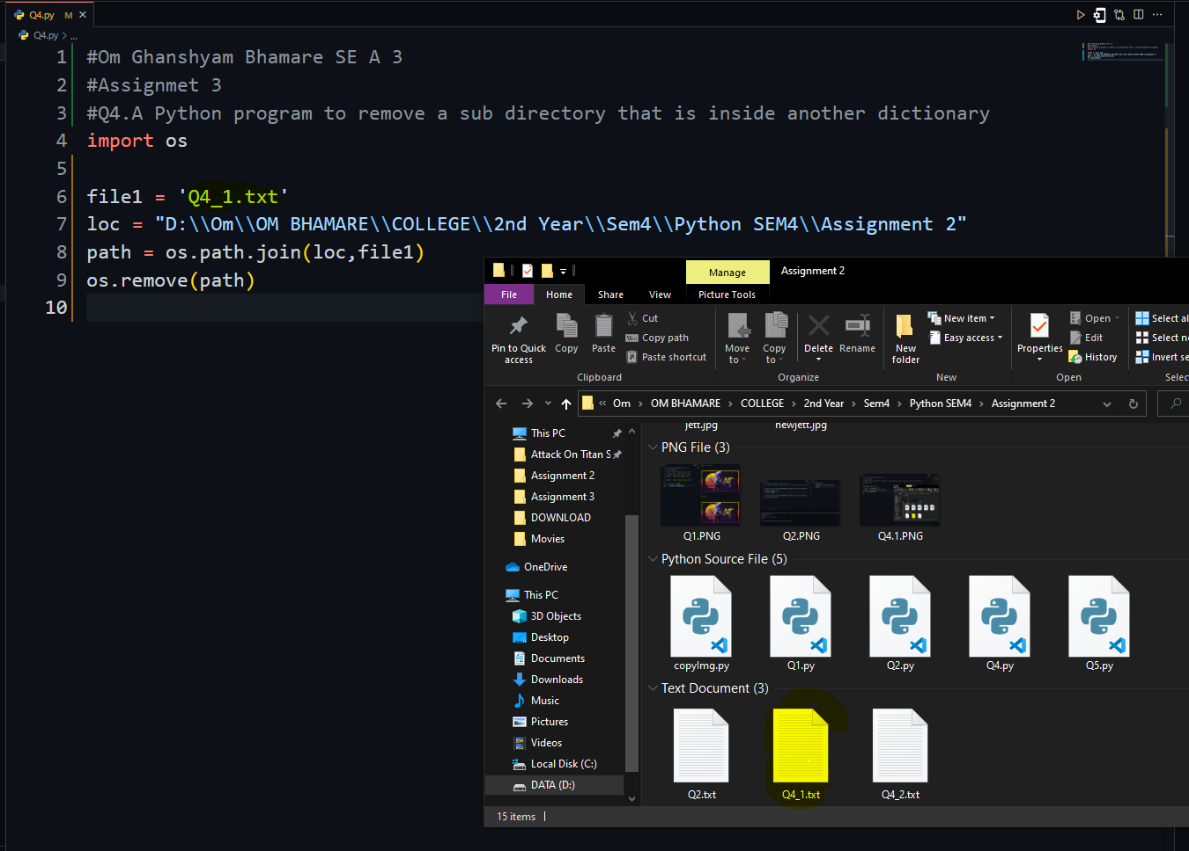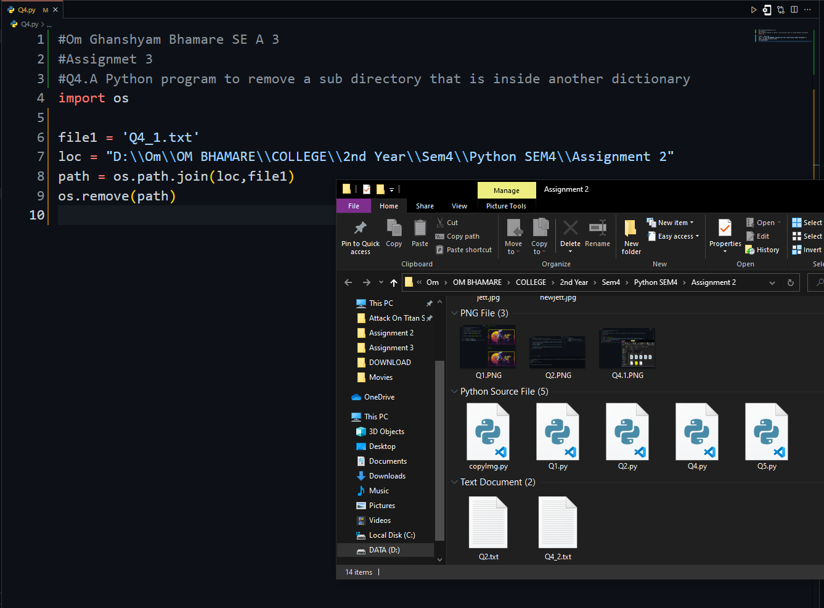

Q5] A Python program to rename a dictionary

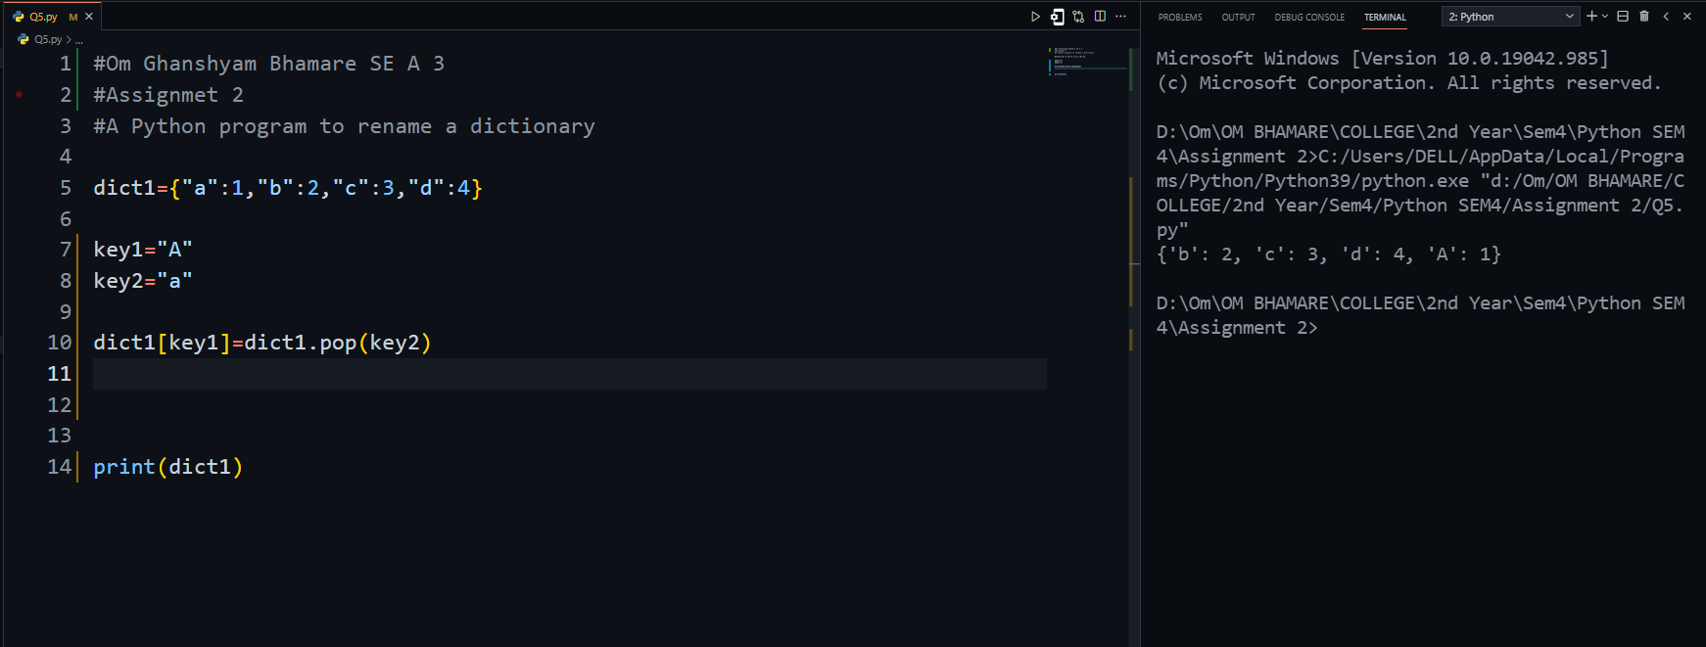

Q6] A Python program to create a package using data structures for a linked list and perform and use all the operations.

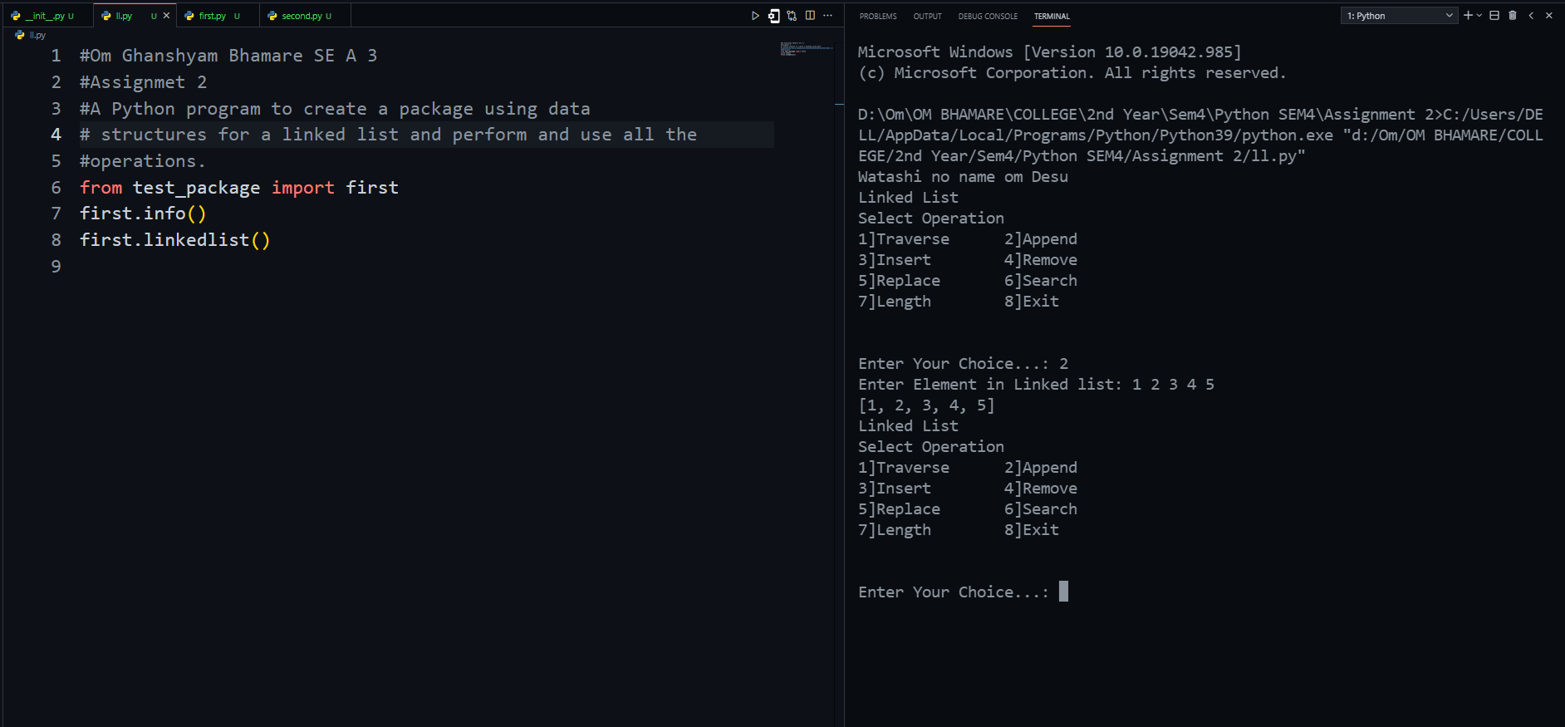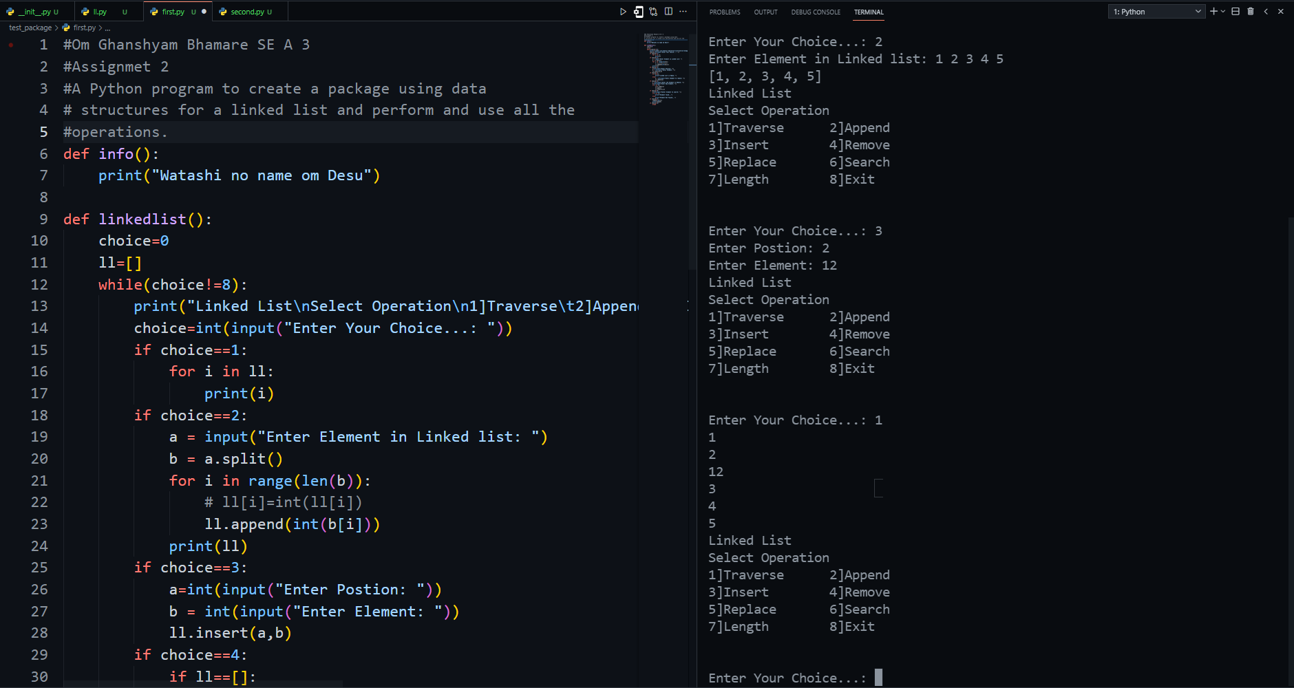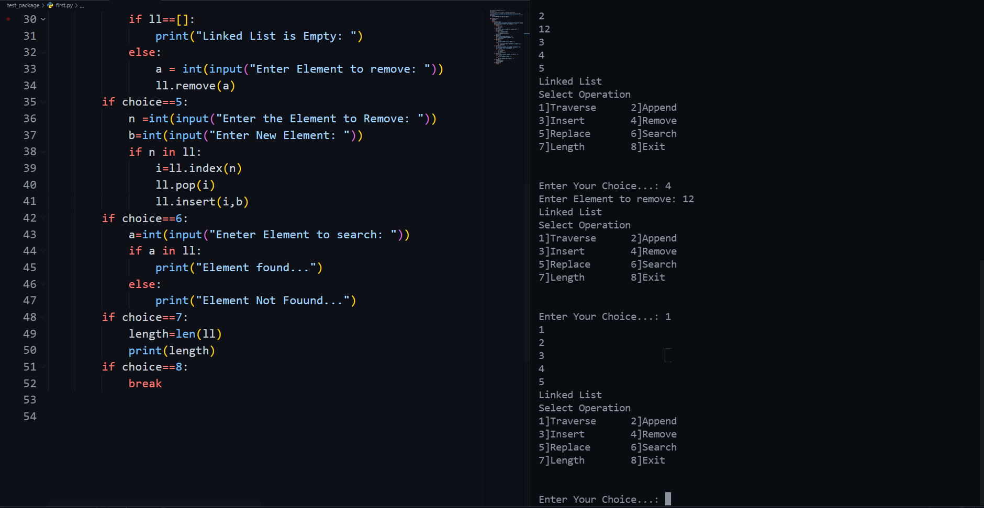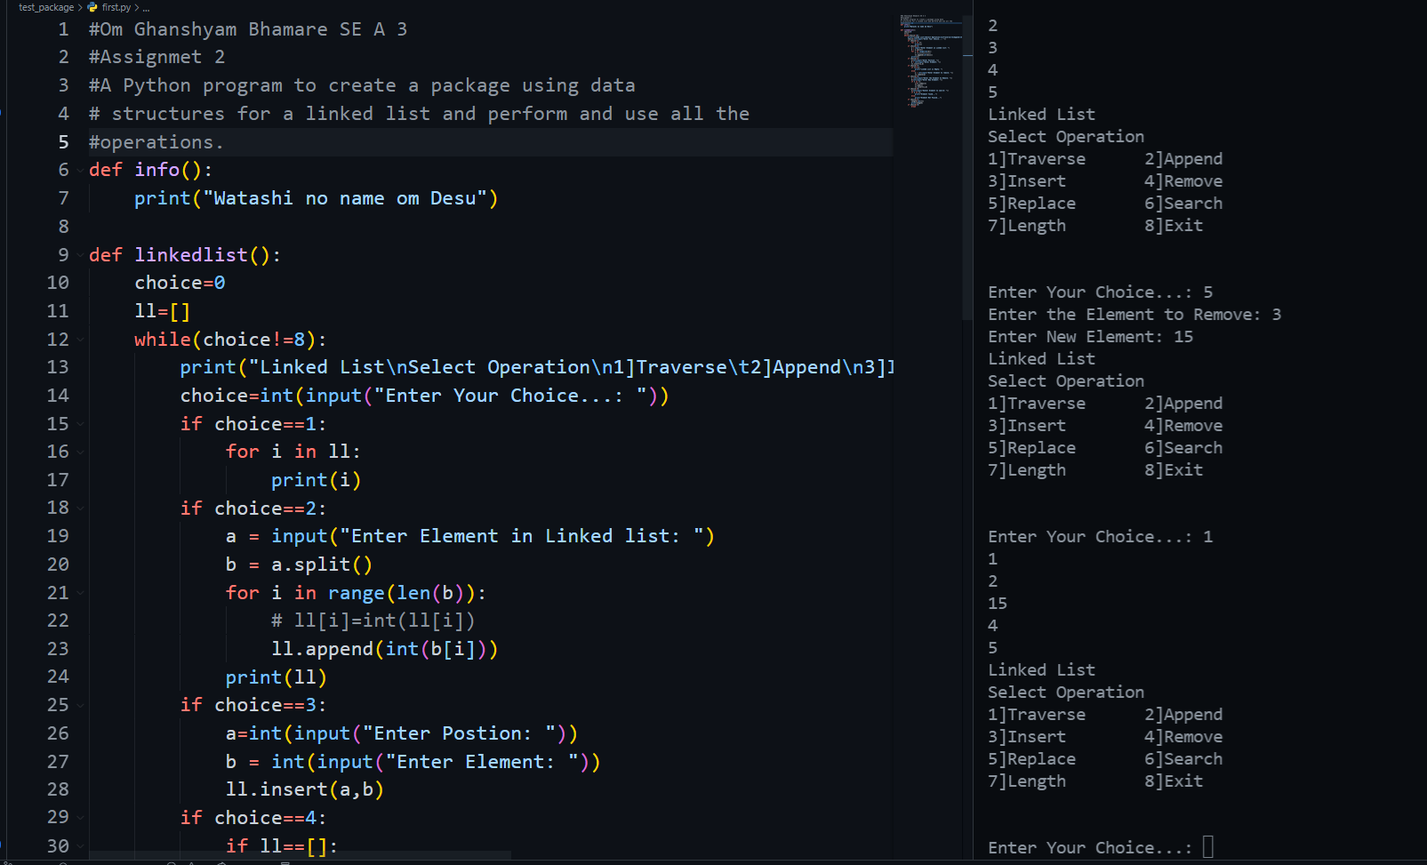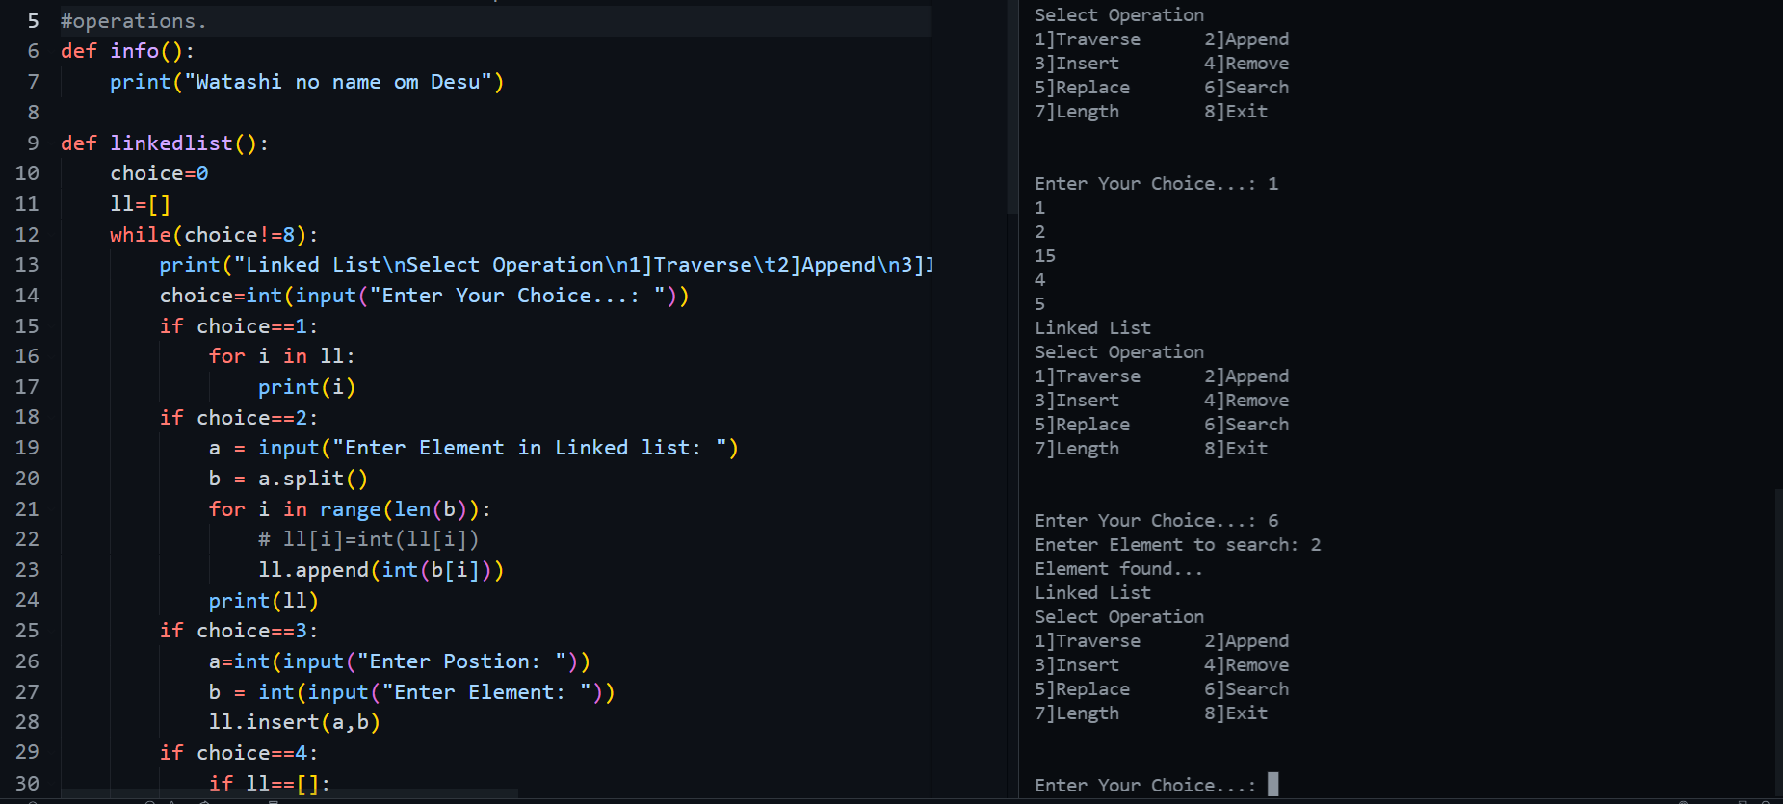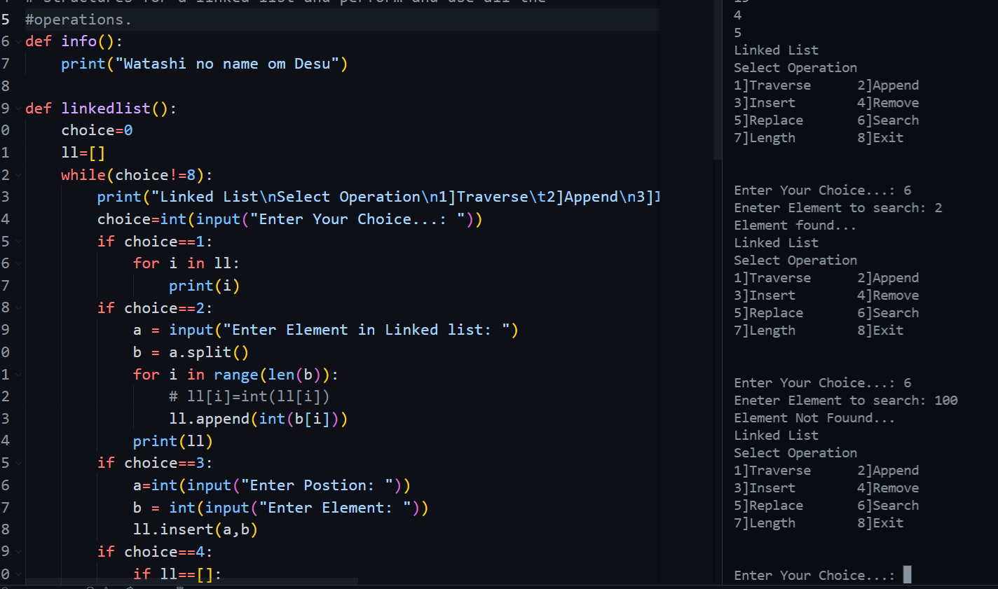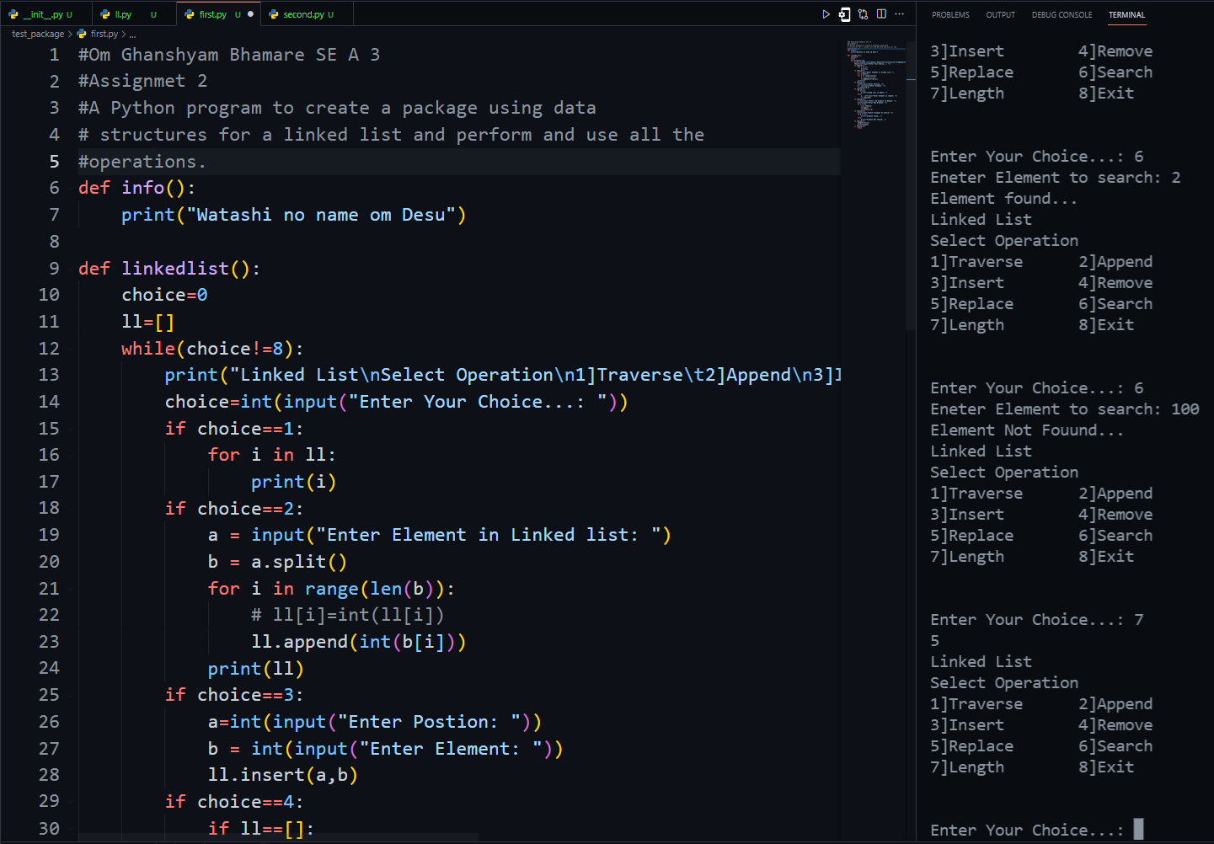

Q7] A Python program where two threads are acting on the same method to allot a berth for the passenger

