**Python**

Om Ghanshyam Bhamare

Dib: A Roll No:3

**Exp 8**

**Accounts/urls.py**

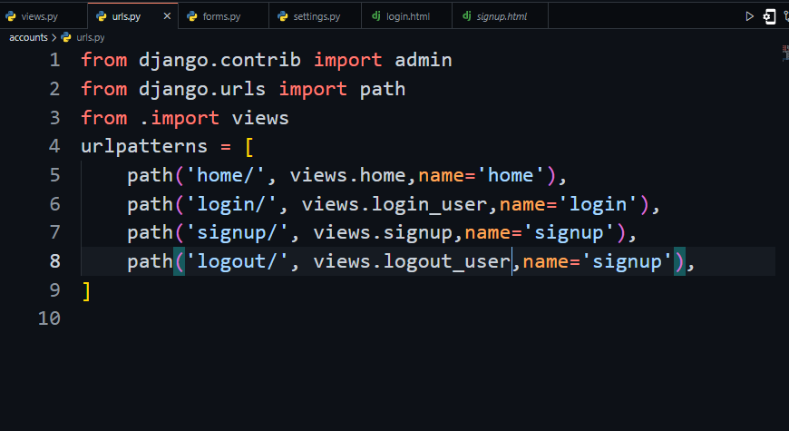

**Accounts/views.py**

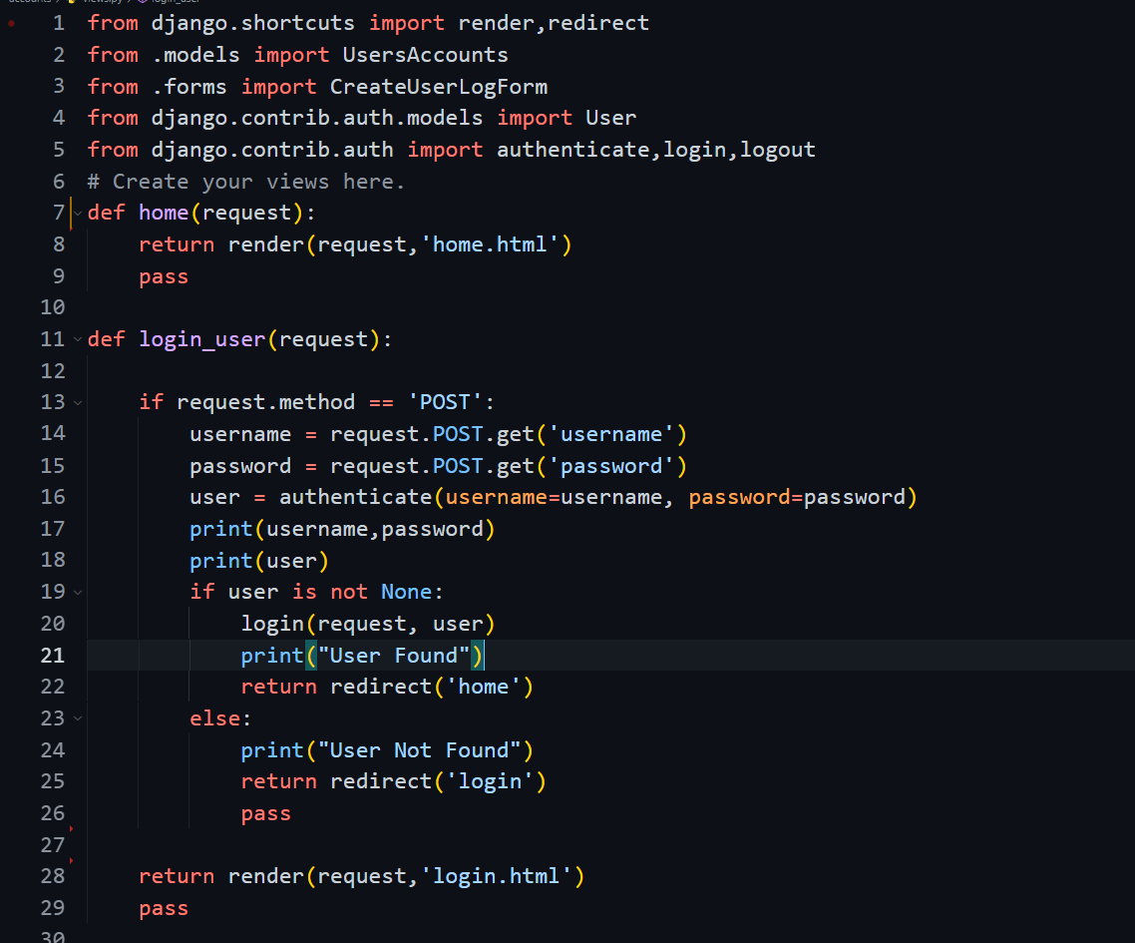

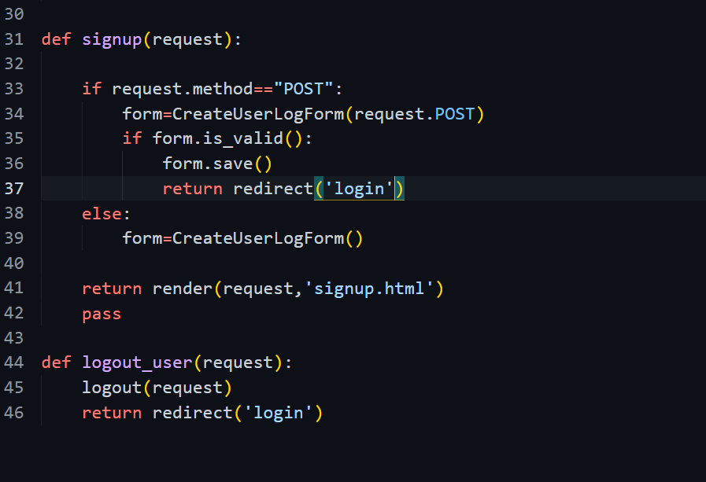

**Accounts/forms.py**

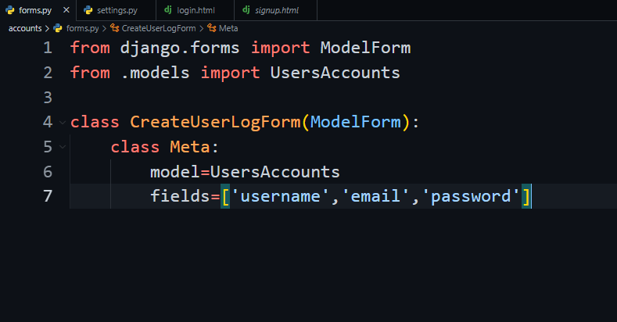

**Accounts/model.py**

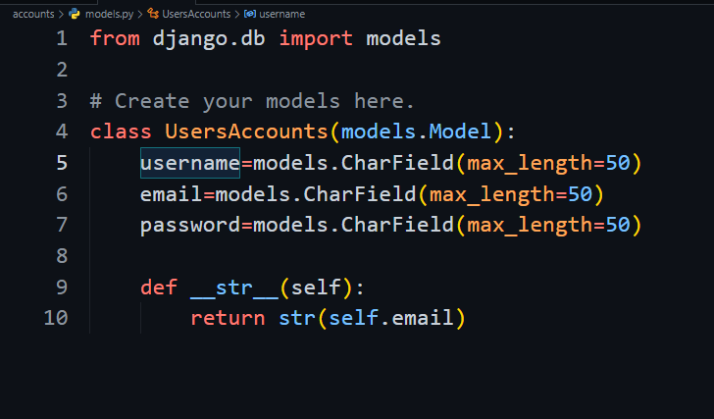

<http://127.0.0.1:8000/accounts/login/>

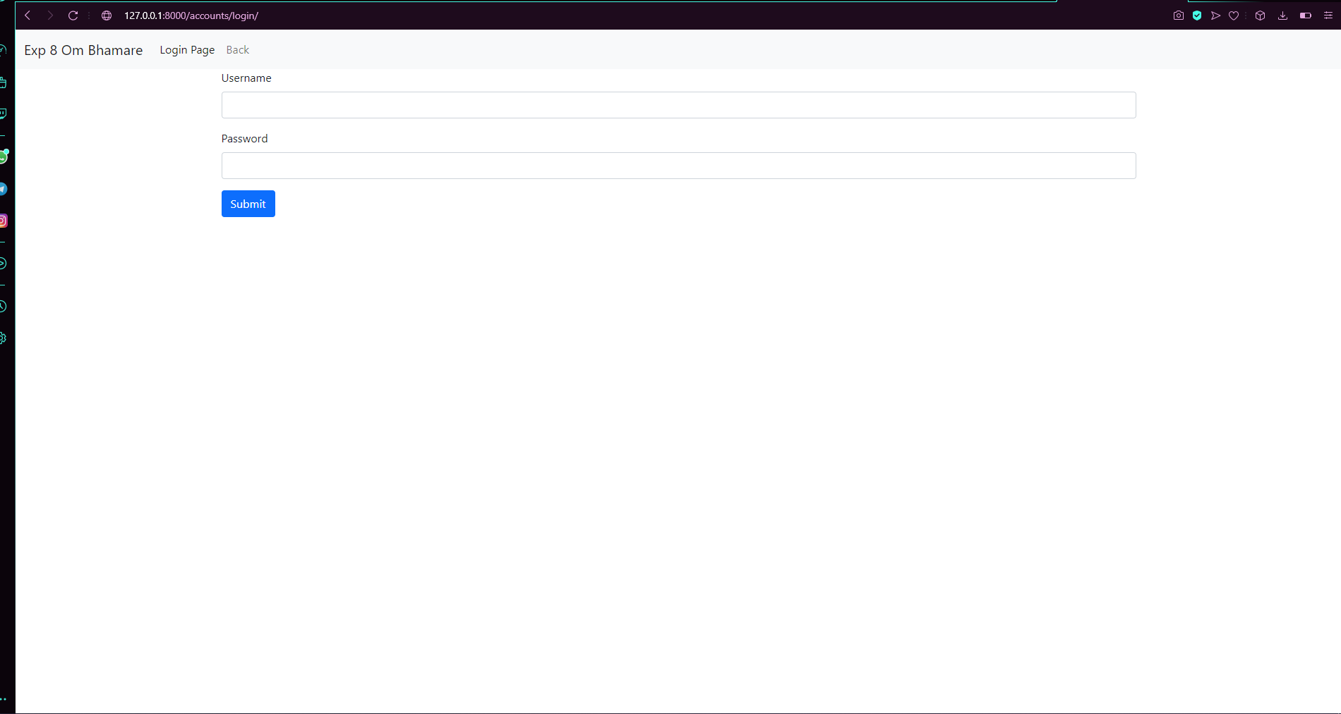

<http://127.0.0.1:8000/accounts/signup/>

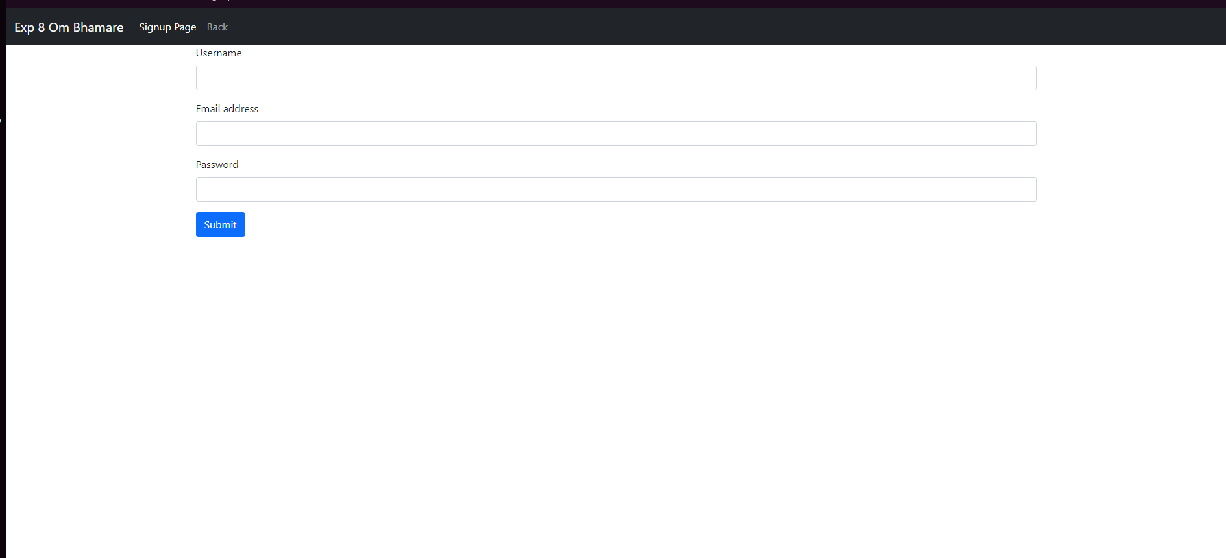

<http://127.0.0.1:8000/admin/>

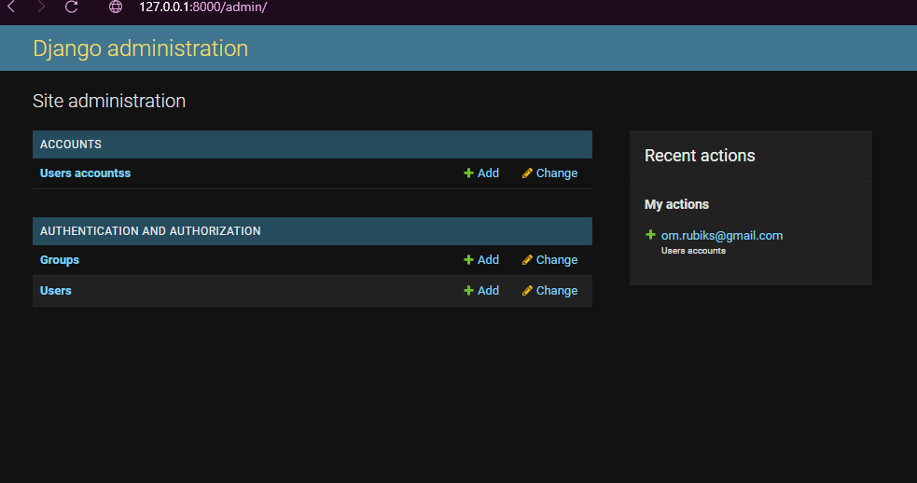

<http://127.0.0.1:8000/admin/accounts/usersaccounts/>

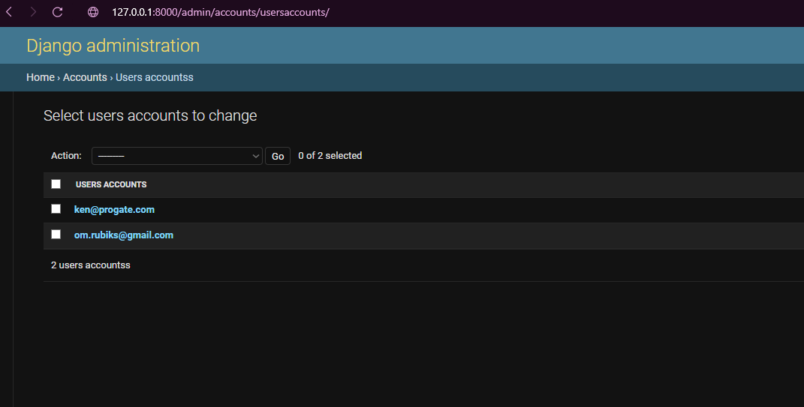

**Github:**

https://github.com/ombhamare4/03_Exp8.git