Mini-Project Report on

**Time Lock Wallet**

**Blockchain Lab/B.E./Sem VII**

**Lalit Manoj Barad   EU1192084 (4) [B] [B1]**

**Om Ghanshyam Bhamare  EU1192003 (5) [B] [B1]**

**Aman Manoj Kumar Lohani  EU1192035 (19) [B] [B1]**

Under the guidance of

**Mrs.Angelin Florence**

**(Assistant Professor)**



**Department of Computer Engineering**

**St. John College of Engineering and Management, Palghar**

**University of Mumbai**

2022–2023

**CERTIFICATE**

This is to certify that the B.E. Blockchain Lab mini-project entitled **“ Time Lock Wallet”** is a bonafide work of “**Lalit Manoj Barad EU1192084 (4) [B]” , “Om Ghanshyam Bhamare  EU1192003 (5) [B]”,** and **“Aman Manoj Kumar Lohani  EU1192035 (19) [B]”**submitted to University of Mumbai in partial fulfilment of the requirement for the award of the degree of **“Computer Engineering”** during the academic year 2022–2023.

**Mrs.Angelin Florence**

Guide

# B.E. Blockchain Mini-Project Report Approval

This mini-project synopsis entitled **Time Lock Wallet** by **Lalit Manoj Barad, Om Ghanshyam Bhamare , Aman Manoj Kumar Lohani** is approved for the degree of ***Computer Engineering*** from ***University of Mumbai***.

###### Examiners

1.---------------------------------------------

2.---------------------------------------------

Date: Place:Palghar

# Declaration

###### **We declare that this written submission represents our ideas in our own words and where others’ ideas or words have been included, we have adequately cited and referenced the original sources. We also declare that we have adhered to all principles of academic honesty and integrity and have not misrepresented or fabricated or falsified any idea/data/fact/source in our submission. We understand that any violation of the above will be cause for disciplinary action by the Institute and can also evoke penal action from the sources which have thus not been properly cited or from whom proper permission has not been taken when needed.**

---------------------------------------

                                                  Signature

**Lalit Manoj Barad (EU1192084)**

---------------------------------------

                                                  Signature

**Om Ghanshyam Bhamare (EU1192003)**

---------------------------------------

                                                  Signature

**Aman Manoj Kumar Lohani  (EU1192035)**

Date:

**Table of Contents**

|  |  |  |
| --- | --- | --- |
|  | **Abstract** | **v** |
|  | **List of Figures** | **vii** |
|  | **List of Tables** | **viii** |
|  | **List of Abbreviations** | **ix** |
| **Chapter 1** | **Introduction** | **1** |
| **Chapter 2** | **Review of Literature** | 2 |
| **Chapter 3** | **Requirement Analysis** | 3 |
| **Chapter 4** | **Report on Present Investigation** | 4 |
|  | 4.1 Proposed System | 5 |
|  | 4.1.1 Block diagram of Proposed System | 6 |
|  | 4.2 Implementation |  |
|  | 4.2.2 Screenshots of the output with description | 7 |
| **Chapter 5** | **Res Results and Discussion** | 8 |
| **Chapter 6** | **Conconclusion** | 9 |
|  | **References** | 10 |

**List of Figures**

|  |  |  |
| --- | --- | --- |
| **Figure No.** | **Figure Name** | **Page No.** |
| 4.1 | Fig1 | 4 |
| 4.2 | Fig2 | 5 |
| 4.2 | Fig3 | 5 |
| 4.2 | Fig4 | 6 |
| 4.2 | Fig5 | 6 |
| 4.2 | Fig6 | 7 |
| 4.2 | Fig7 | 7 |

**List of Tables**

|  |  |  |
| --- | --- | --- |
| **Table No.** | **Table Name** | **Page No.** |
| 3.1 |  | 11 |

**Abstract**

The idea behind time-locked wallets is to lock the funds for a set period of time. The amount locked in the wallet can only withdrawn when the set date is passed and only by the authorized person/beneficiary.

**Chapter 1**

**Introduction**

A time lock wallet would be a wallet that would keep users crypto assets locked for a certain amount of time. That means user won’t be able to withdraw their crypto assets even if user want to do so.

User can use such wallets for multiple reasons. But one of the biggest applications of this time lock wallet is to prevent user from selling your crypto assets on the crash of the market.

When the market crashes people tend to sell their crypto due to the fear of losing all their invested money.

But if user want to make some really high profit in crypto he/she need to be able to hold it for a very long time.

1

**Chapter 2**

**Review of Literature**

1. Time Lock Wallet -Introduction to Smart Contracts

Time-locked Wallets are becoming a good solution for both a large corporation and an individual. They allow you to create deposits in really good conditions, create a stable financial fund that is completely protected from outside influences.

1. Time-locked Wallets: An Introduction to Ethereum Smart Contracts

Ethereum in particular, offering smart contract capabilities, opens the doors to new ideas that can be implemented in a distributed, immutable, and trustless fashion.

2

**Chapter 3**

**Requirement Analysis**

1 . Smart Contracts

A smart contract is a computer program or a transaction protocol that is intended to automatically execute, control or document legally-relevant events and actions according to the terms of a contract or an agreement.

2 . Metamask

MetaMask is a popular cryptocurrency wallet known for its ease of use, availability on both desktops and mobile devices, the ability to buy, send, and receive cryptocurrency from within the wallet, and collect non-fungible tokens (NFTs) across two blockchains

3. Solidity Programming

It's used to create smart contracts that implement business logic and generate a chain of transaction records in the blockchain system.

3

**Chapter 4**

**Report on Present Investigation**

**4.1 Proposed System**

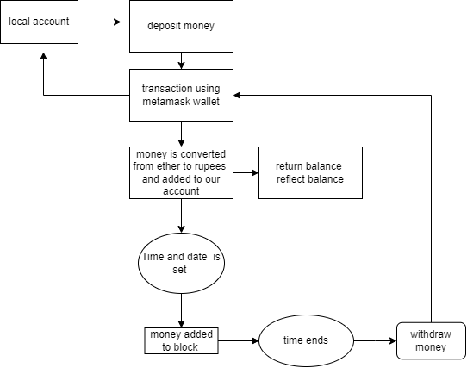

User is able to deposit a specified amount of ETH, to be locked up for a certain specified time period.

**Fig 1**

4

**4.2 Implementation**

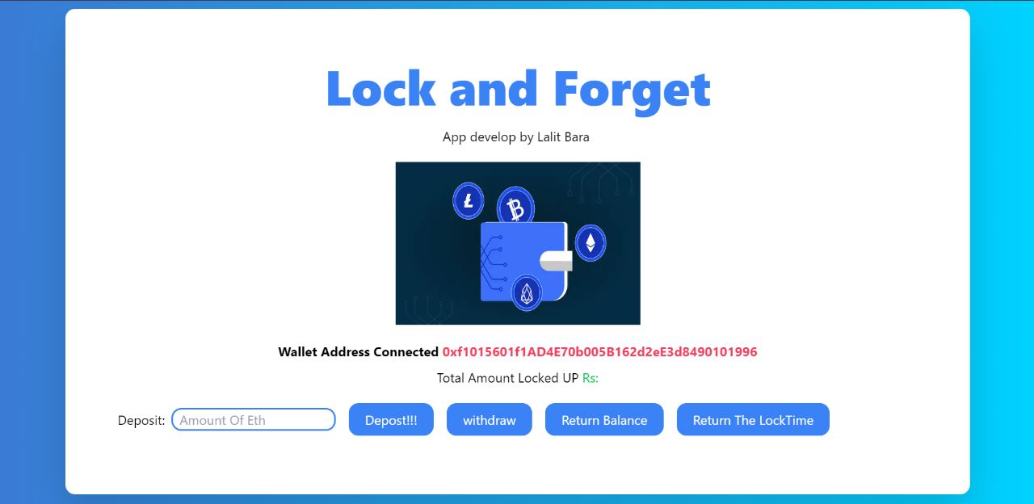

**5**

**Fig 2**

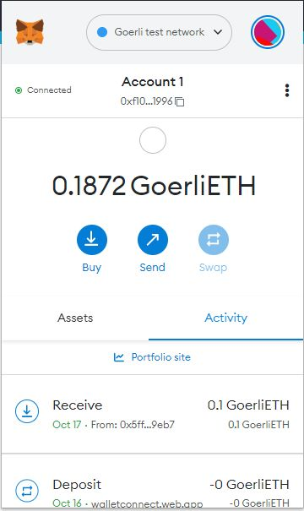

**Fig 3**

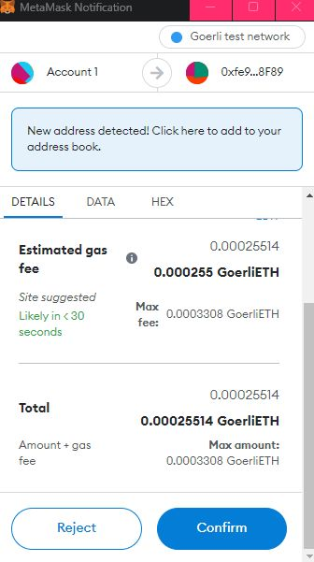

**Fig 4**

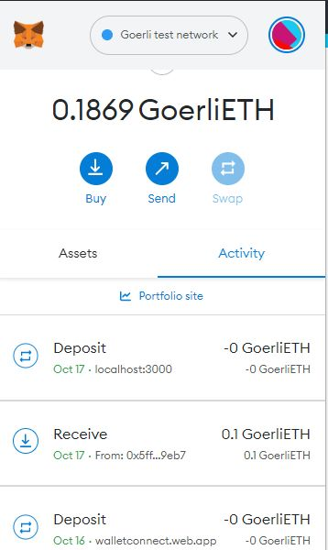

**Fig 5**

**6**

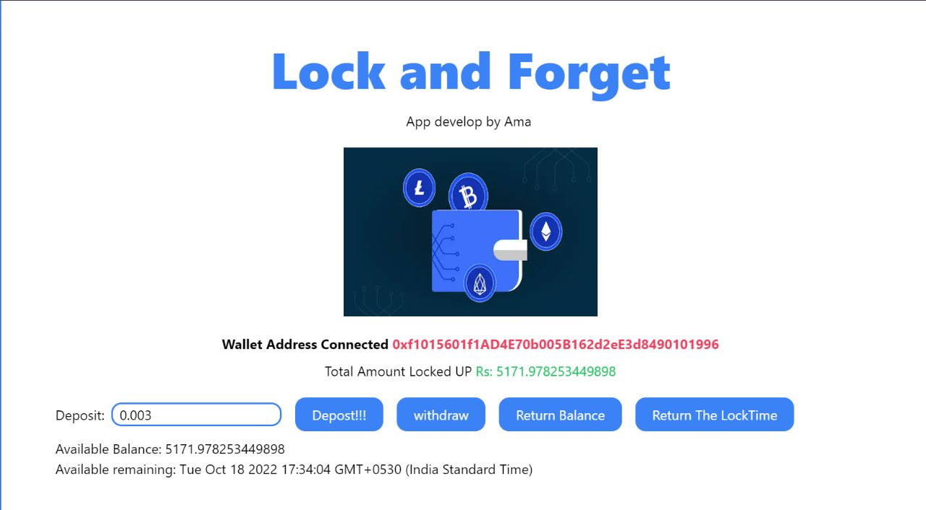

**7**

**Fig 7**

**Fig 6**

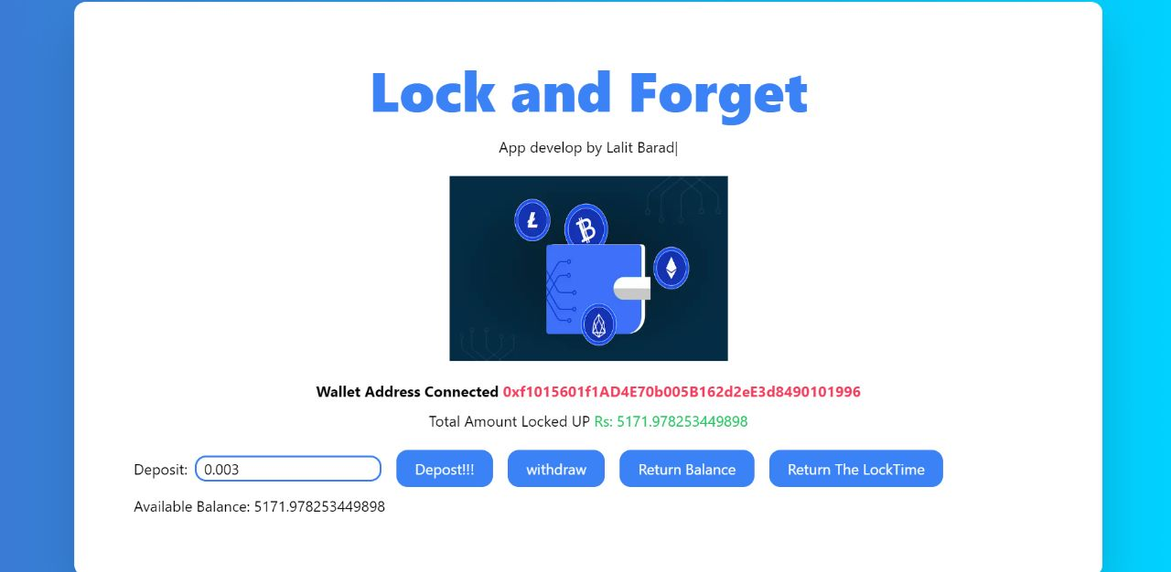

**Chapter 5**

**Results and Discussion**

1. We Successfully locked our Crypto Wallet Ether using metamask ,solidity .
2. We can claim or withdraw our ether after the time ends

**8**

**Chapter 6**

**Conclusion**

Time-locked Wallets are becoming a good solution for both a large corporation and an individual. They allow you to create deposits in really good conditions, create a stable financial fund that is completely protected from outside influences.

The advantages of smart contract are that they can be installed both on active accounts that constantly conduct transactions and on those that are used exclusively as accumulative ones.

**9**

**References**

1. <https://www.toptal.com/ethereum-smart-contract/time-locked-wallet-truffle-tutorial>
2. <https://devqode.com/blog/time-locked-wallets-an-introduction-to-smart-contracts/>
3. <https://www.investopedia.com/terms/h/hashed-timelock-contract.asp#:~:text=What%20Is%20a%20Timelock%20Contract,specific%20payment%20times%20are%20needed>.
4. <https://blog.openzeppelin.com/protect-your-users-with-smart-contract-timelocks/>

**10**