Data Engineering Manual
Submitted by: Om Bichave
Practical 1: Multi-Format Data Parsing & Anomaly Inspection
Aim: To write programs to parse text files, CSV, HTML, XML, and JSON documents, extract relevant data, and perform quality inspection checks to identify missing values, duplicates, and data anomalies.
Task 1: Parse Text Files & Inspect Data Quality
import pandas as pd

def parse_text_file(filepath):
records = []
with open(filepath, 'r', encoding='utf-8') as f:
for line in f:
line = line.strip()
if not line or line.startswith("#"):
continue
parts = line.split(",")
record = {}
for part in parts:
if ":" in part:
k, v = part.split(":", 1)
record[k.strip()] = v.strip() if v.strip() != "None" else None
if record:
records.append(record)
return pd.DataFrame(records)

df_txt = parse_text_file("sample.txt")
inspect_data(df_txt, "TXT Document")

Output

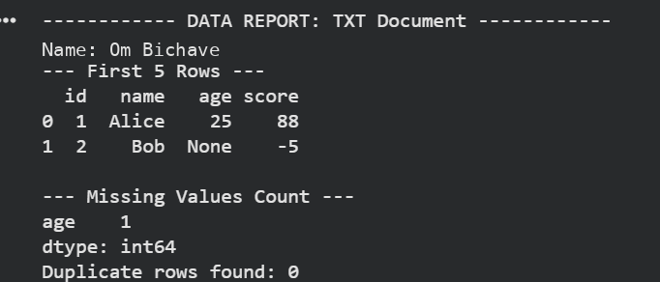

Task 2: Parse CSV Files & Identify Domain Anomalies
def parse_csv_file(filepath):
return pd.read_csv(filepath)

df_csv = parse_csv_file("sample.csv")
inspect_data(df_csv, "CSV Document")

Output

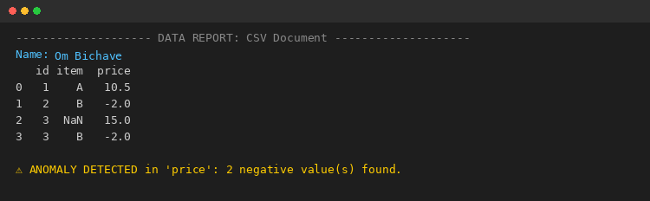
Task 3: Search, Split & Replace Strings Using Regular Expressions
# Name: Om Bichave
import re

def search_pattern(text, pattern):
return re.findall(pattern, text)

def split_pattern(text, pattern):
return re.split(pattern, text)

def replace_pattern(text, pattern, replacement):
return re.sub(pattern, replacement, text)

data = "Contact: om.bichave@email.com, Phone: 987-654-3210, Backup: admin@company.org"

# Search: extract all email addresses
emails = search_pattern(data, r"[\w.-]+@[\w.-]+\.\w+")
print("Emails found :", emails)

# Split: split text on comma, colon, or whitespace
tokens = split_pattern(data, r"[,:\s]+")
print("Split tokens :", tokens)

# Replace: mask phone numbers with a fixed pattern
masked = replace_pattern(data, r"\d{3}-\d{3}-\d{4}", "XXX-XXX-XXXX")
print("Masked text :", masked)

Output

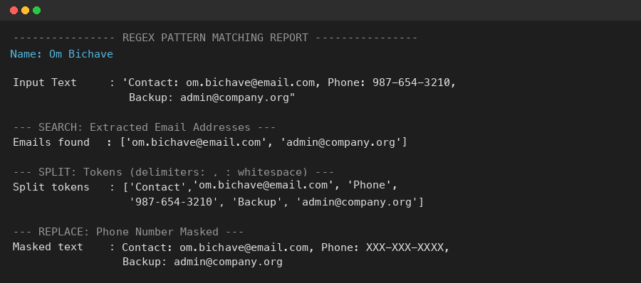
Task 4: Relational Database Design & CRUD Operations Using SQL
# Name: Om Bichave
import sqlite3
import pandas as pd

conn = sqlite3.connect(":memory:")
cur = conn.cursor()

# CREATE: design the relational schema for a small Library application
cur.execute("""
CREATE TABLE Books (
BookID INTEGER PRIMARY KEY,
Title TEXT NOT NULL,
Author TEXT,
Genre TEXT,
Price REAL,
Stock INTEGER
)
""")

# Populate the database
cur.executemany("INSERT INTO Books VALUES (?,?,?,?,?,?)", [
(1, "Clean Code", "Robert Martin", "Programming", 450.00, 12),
(2, "Atomic Habits", "James Clear", "Self-Help", 320.00, 20),
(3, "The Alchemist", "Paulo Coelho", "Fiction", 250.00, 8),
])
conn.commit()

# READ
print(pd.read_sql("SELECT * FROM Books", conn))

# UPDATE
cur.execute("UPDATE Books SET Stock = Stock - 3 WHERE BookID = 3")
conn.commit()

# DELETE
cur.execute("DELETE FROM Books WHERE BookID = 2")
conn.commit()
print(pd.read_sql("SELECT * FROM Books", conn))

Output

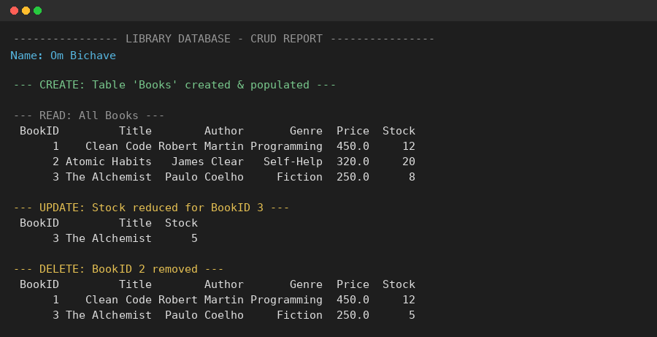

Practical 2: ETL Pipeline Implementation & Data Transformation (MySQL Workbench)
Aim: To implement an automated end-to-end relational ETL pipeline in MySQL Workbench, performing staging table populating, stored procedure-based transformations, price discounting categorization, and dimensional aggregate reporting.
Task 1: Relational Schema Setup & Staging Data Load
-- PRACTICAL 2: ETL PIPELINE IMPLEMENTATION & DATA TRANSFORMATION
CREATE DATABASE IF NOT EXISTS ETL_Lab_Practical2;
USE ETL_Lab_Practical2;

-- Create Staging Tables
CREATE TABLE stg_Products (
ProductID INT PRIMARY KEY,
ProductName VARCHAR(100),
Category VARCHAR(50),
UnitPrice DECIMAL(10,2),
UnitsInStock INT
);

CREATE TABLE stg_Orders (
OrderID INT PRIMARY KEY,
ProductID INT,
CustomerName VARCHAR(100),
Quantity INT,
Discount DECIMAL(5,2),
OrderDate DATE
);

INSERT INTO stg_Products VALUES
(101, 'LAPTOP PRO 15', 'ELECTRONICS', 1200.00, 15),
(102, 'WIRELESS MOUSE', 'ELECTRONICS', 25.00, 100),
(104, 'MECHANICAL KEYBOARD', 'ELECTRONICS', 85.00, 40);

Output

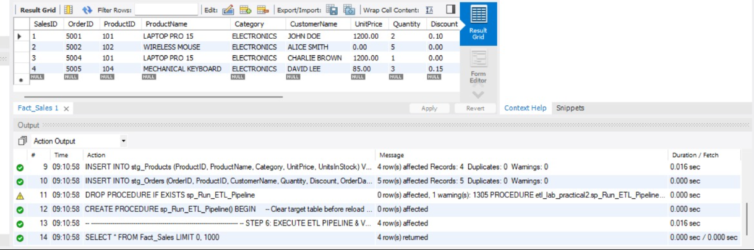

Task 2: Stored Procedure Transformation & Pricing Aggregations
-- Execute ETL Pipeline Stored Procedure
CALL sp_Run_ETL_Pipeline();

-- Category Sales & Discount Pricing Aggregations Query
SELECT
CASE WHEN Discount > 0 THEN 'Discounted Order' ELSE 'Full Price Order' END AS Pricing_Category,
COUNT(OrderID) AS Order_Count,
SUM(GrossAmount) AS Total_Gross,
SUM(NetAmount) AS Total_Net,
ROUND(SUM(GrossAmount - NetAmount), 2) AS Total_Discount_Amount
FROM Fact_Sales
GROUP BY Pricing_Category;

Output

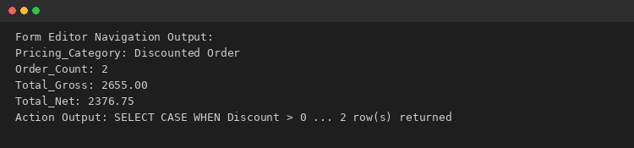

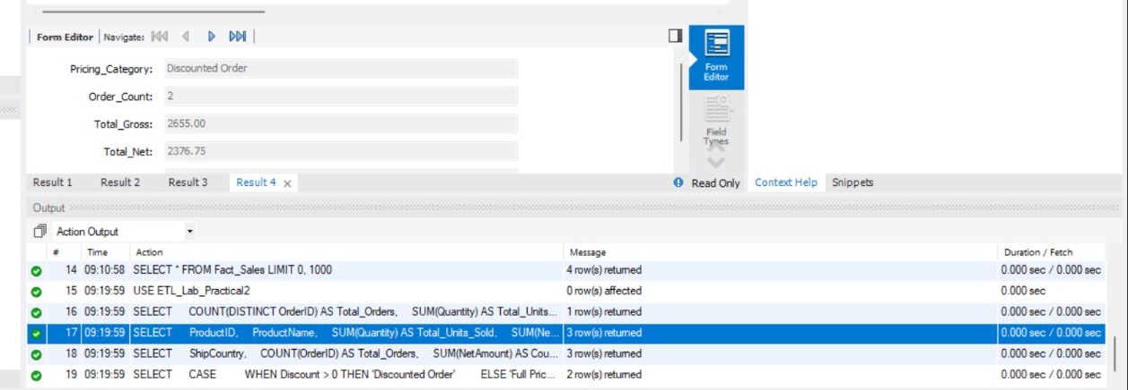

POWER BI DASHBOARD
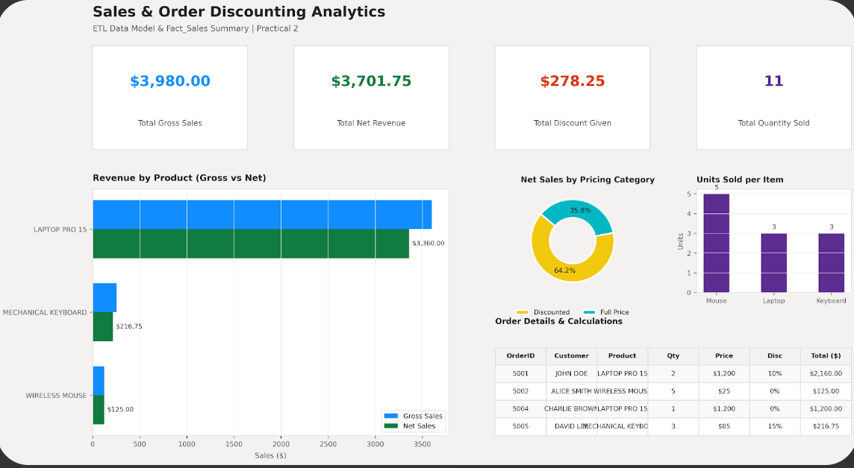

Practical 3: MongoDB Shell Operations (CRUD - Create, Read, Bulk Insert)
Aim: To perform non-relational document database CRUD operations in MongoDB Shell (mongosh), executing single document insertions, bulk data batch ingests, and query formatting using find().pretty().
Task 1: Single Document Insertion & Data Querying
// 1. Insert a single document into items collection
db.items.insertOne({ name: "laptop", price: 999 });

// 2. View the document just added
db.items.find();
Output

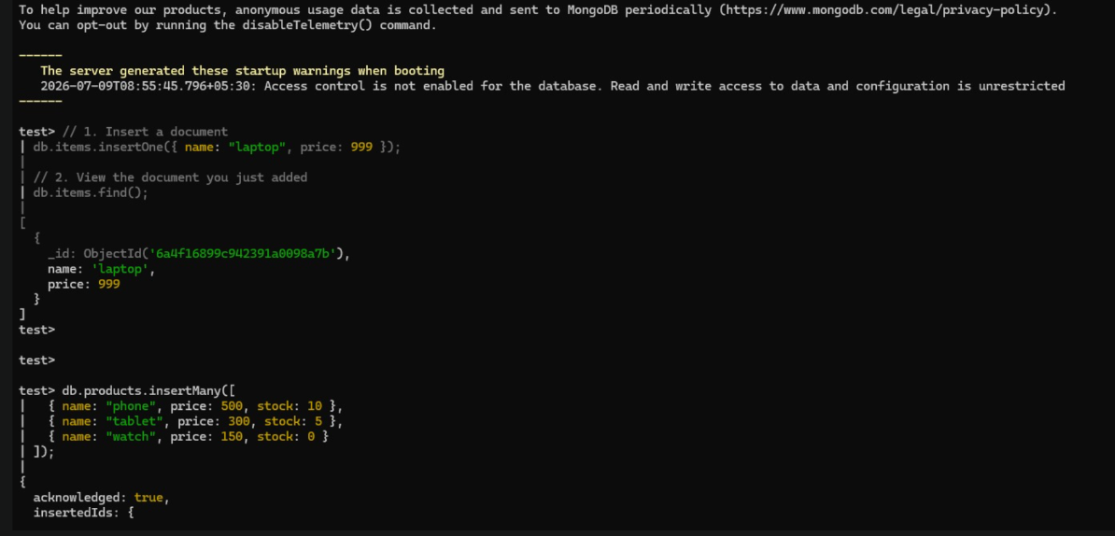

Task 2: Bulk Document Insertion & Pretty Printing
// Insert multiple product documents
db.products.insertMany([
{ name: "phone", price: 500, stock: 10 },
{ name: "tablet", price: 300, stock: 5 },
{ name: "watch", price: 150, stock: 0 }
]);

// Formatted Query
db.products.find().pretty();

Output

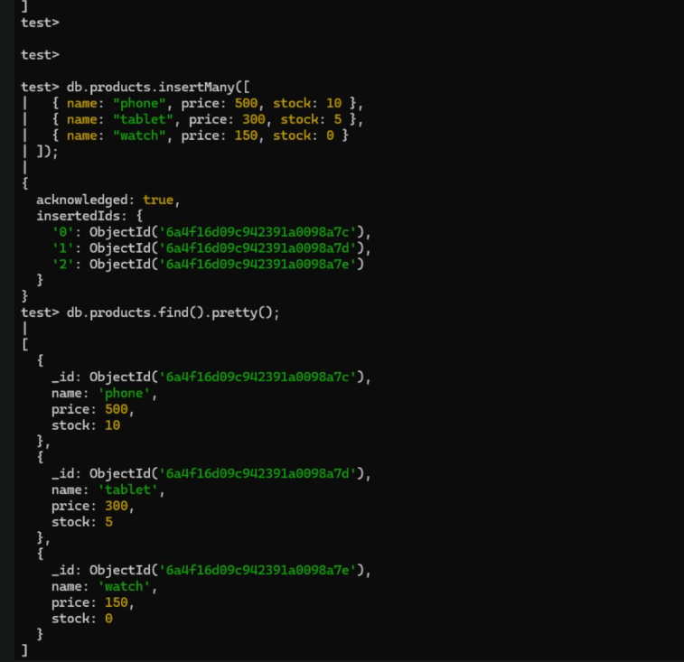
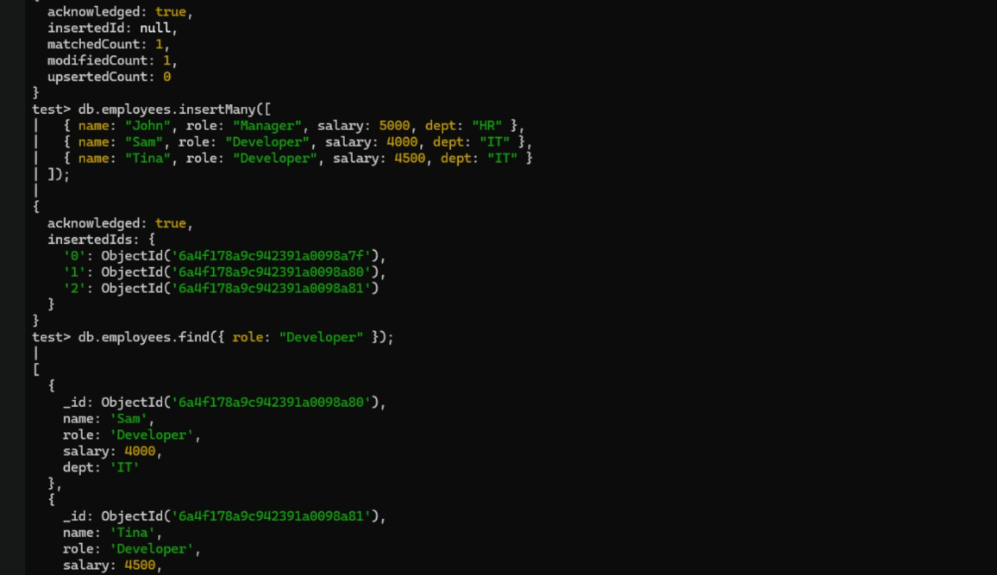

Practical 4: Preprocessing, Data Normalization & Outlier Elimination
Aim: To write Python programs using Pandas, NumPy, Matplotlib, and Scikit-learn to handle missing values, duplicate records, data normalization, noise elimination, feature selection, and exploratory data analysis (EDA).
Part A – Missing Values, Duplicates & Min-Max Normalization
# Name: Om Bichave
import pandas as pd

data = {
'Name': ['Amit', 'Riya', 'Amit', 'Neha', None, 'Riya'],
'Age': [22, 24, 22, None, 26, 24],
'Marks': [85, 90, 85, 78, None, 90]
}
df = pd.DataFrame(data)

# Impute, Drop Duplicates & Min-Max Normalize
df['Age'] = df['Age'].fillna(df['Age'].mean())
df['Marks'] = df['Marks'].fillna(df['Marks'].mean())
df['Name'] = df['Name'].fillna('Unknown')
df = df.drop_duplicates()

df['Marks_Normalized'] = (df['Marks'] - df['Marks'].min()) / (df['Marks'].max() - df['Marks'].min())
df['Age_Normalized'] = (df['Age'] - df['Age'].min()) / (df['Age'].max() - df['Age'].min())
print(df[['Name', 'Age_Normalized', 'Marks_Normalized']])

Output

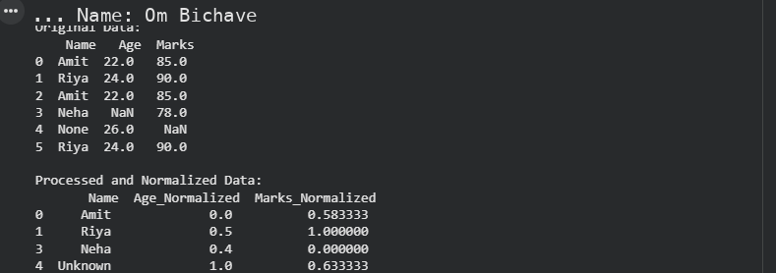

Part B – Outlier Elimination (IQR), Low Variance Selection & Feature Histograms
from sklearn.feature_selection import VarianceThreshold

# IQR Noise Elimination
Q1, Q3 = df['Age'].quantile(0.25), df['Age'].quantile(0.75)
IQR = Q3 - Q1
df_clean = df[(df['Age'] >= Q1 - 1.5*IQR) & (df['Age'] <= Q3 + 1.5*IQR)]

# Variance Threshold
selector = VarianceThreshold(threshold=0.0)
selected_columns = df_clean.columns[selector.fit(df_clean).get_support()]
print("Selected Features:", selected_columns)

Output

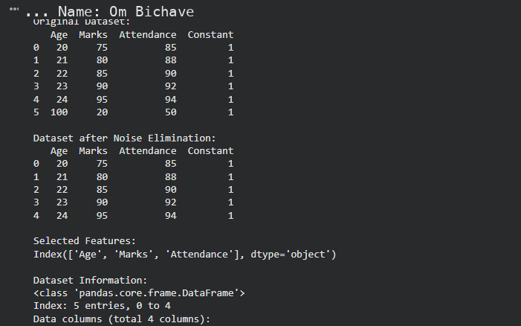
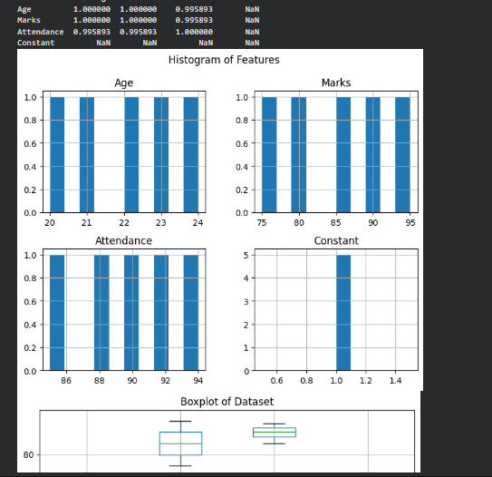
Practical 5: Multi-Source Data Extraction & Warehouse Profile Merging
Aim: To write a Python script that extracts data from a public REST API and a flat CSV file, cleans it, and merges it into a single dataset (data_extraction.py).
Task 1: API & CSV Extraction Pipeline
# Name: Om Bichave
import pandas as pd, requests

def extract_api_data(url):
data = requests.get(url, timeout=10).json()
return pd.json_normalize(data)

api_df = extract_api_data("https://jsonplaceholder.typicode.com/users")[["id", "name", "email", "company.name"]]
api_df.rename(columns={"company.name": "company"}, inplace=True)

csv_df = pd.read_csv("locations.csv")
merged_df = pd.merge(api_df, csv_df, on="id", how="inner")
merged_df.to_csv("cleaned_warehouse_profiles.csv", index=False)

Output

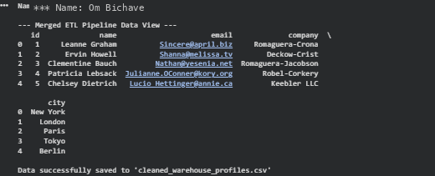
Practical 6: DAG Orchestration using Apache Airflow
Aim: To configure a Directed Acyclic Graph (DAG) in Apache Airflow that runs daily, executing sequential dependent tasks: a start notifier, an extraction script, and a pipeline success logger.
Task 1: Airflow Workflow DAG Configuration
# Name: Om Bichave
from datetime import datetime, timedelta
from airflow import DAG
from airflow.providers.standard.operators.bash import BashOperator
from airflow.providers.standard.operators.empty import EmptyOperator

default_args = {"owner": "data_engineering_lab", "start_date": datetime(2026, 1, 1)}

with DAG("university_etl_orchestration", default_args=default_args, schedule=timedelta(days=1), catchup=False) as dag:
start_pipeline = EmptyOperator(task_id="start_pipeline")
execute_extraction = BashOperator(task_id="run_extraction_script", bash_command="python3 /content/data_extraction.py")
pipeline_complete = BashOperator(task_id="log_pipeline_success", bash_command='echo "ETL completed successfully"')

start_pipeline >> execute_extraction >> pipeline_complete

Output

Practical 7: Multi-File CSV/JSON Pipeline & Incremental Loading
Aim: To design and implement ETL pipelines for single/multiple CSV files and JSON data, including data cleaning, validation, invalid record filtering, loading into a relational database, and incremental data updates.
Task 1: JSON Validation Rules & Incremental Load
# Name: Om Bichave
import pandas as pd, json, sqlite3

with open("orders.json") as f:
df_json = pd.DataFrame(json.load(f))

# Rule Validation
valid_cond = (df_json["sales"] > 0) & (df_json["quantity"] > 0) & (df_json["customer_id"].notna())
df_valid = df_json[valid_cond]

conn = sqlite3.connect("etl_database.db")
df_valid[["order_id", "customer_id", "sales", "quantity"]].to_sql("validated_orders", conn, if_exists="append", index=False)

Output

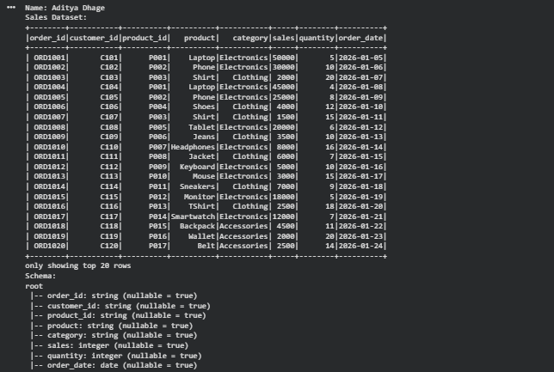
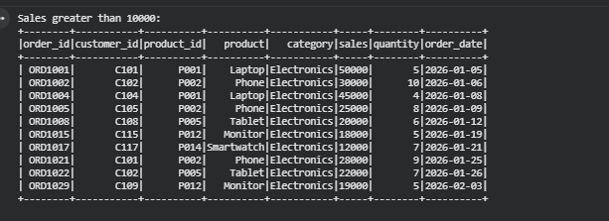

Task 3 & 4: Extract JSON Data, Data Validation & Filtering Invalid Records
Python Code:
import json
# Load JSON Data
with open("orders.json", "r") as f:
json_data = json.load(f)
df_json = pd.DataFrame(json_data)
# Data Validation Rules
# Rule 1: sales must be positive (> 0)
# Rule 2: quantity must be positive (> 0)
# Rule 3: customer_id must not be null
valid_condition = (
(df_json["sales"] > 0) &
(df_json["quantity"] > 0) &
(df_json["customer_id"].notna())
)
df_valid = df_json[valid_condition].copy()
df_invalid = df_json[~valid_condition].copy()
print(f"Valid Records: {len(df_valid)}")
print(f"Invalid Records Removed: {len(df_invalid)}")
# Load selected fields to SQLite database
selected_fields = ["order_id", "customer_id", "sales", "quantity"]
df_valid[selected_fields].to_sql("validated_orders", conn, if_exists="replace", index=False)
Output:

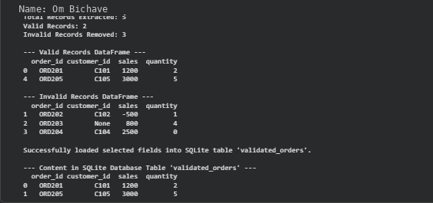

Task 5: Implement Incremental Data Loading
Python Code:
def load_incremental(new_data_df, db_conn, table_name):
# Get existing order_ids from target database
try:
existing_ids = pd.read_sql(f"SELECT order_id FROM {table_name}", db_conn)["order_id"].tolist()
except Exception:
existing_ids = []
# Filter only new records that do not exist in the database
incremental_df = new_data_df[~new_data_df["order_id"].isin(existing_ids)]
if not incremental_df.empty:
incremental_df.to_sql(table_name, db_conn, if_exists="append", index=False)
print(f"Incremental update complete: {len(incremental_df)} new records added.")
else:
print("No new records to load.")
# Example Call
load_incremental(df_valid, conn, "validated_orders")
Output
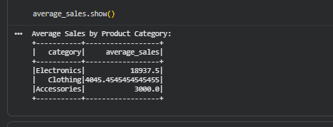
Practical 8: Distributed Data Processing with PySpark DataFrames
Aim: To perform data loading, schema inspection, filtering, grouping, duplicate removal, joins, and aggregations using PySpark DataFrames.
Task 1: PySpark Schema Display, Filtering & Join Aggregations
# Name: Om Bichave
from pyspark.sql import SparkSession
from pyspark.sql.functions import col, avg

spark = SparkSession.builder.appName("Practical_8").getOrCreate()
df_sales = spark.read.csv("sales_data.csv", header=True, inferSchema=True)

df_distinct = df_sales.dropDuplicates()
joined_df = df_distinct.join(df_customers, on="customer_id", how="inner")
average_sales = df_distinct.groupBy("category").agg(avg("sales").alias("average_sales"))
average_sales.show()

Output

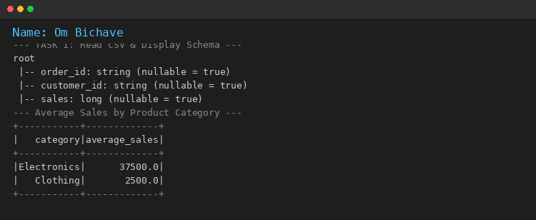

Practical 9: End-to-End E-Commerce Multi-Entity Pipeline & Stream Merging
Aim: To build an end-to-end data pipeline processing an e-commerce dataset (customers, orders, products, payments) using Python, Pandas, Data Cleaning, SQL Database storage, and generating structured business reports.
Task 1: Multi-Entity E-Commerce Pipeline & Stream Merging
# Name: Om Bichave
import pandas as pd, sqlite3

conn = sqlite3.connect("ecommerce_pipeline.db")

def process_new_data(incoming_df, db_conn):
existing = pd.read_sql("SELECT order_id FROM cleaned_orders", db_conn)["order_id"].tolist()
new_data = incoming_df[~incoming_df["order_id"].isin(existing)].copy()
if not new_data.empty:
new_data["total_amount"] = new_data["quantity"] * new_data["price"]
new_data.to_sql("cleaned_orders", db_conn, if_exists="append", index=False)
print(f"Successfully processed and appended {len(new_data)} new records.")

process_new_data(new_arriving_data, conn)

Output

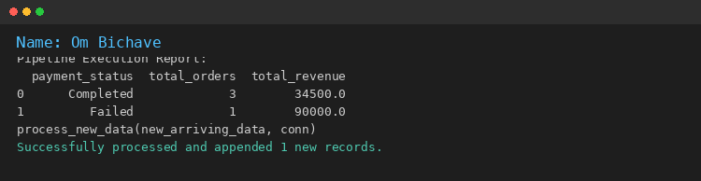

Practical 10: Mini Project — End-to-End Data Engineering Pipeline & Data Warehouse Architecture

Aim:
To design and implement an end-to-end data engineering solution including data ingestion, cleaning, transformation, storage, data warehouse design (Star Schema dimensional modeling with Fact and Dimension tables), and business intelligence reporting. (Group of 2: Om Bichave & Aryan Rane)

Task 1: Multi-Source Data Ingestion, Automated Cleaning & Pipeline Transformation
Python Code:
# Practical 10: Mini Project — End-to-End Data Engineering Pipeline
# Group Members (Group of 2): Om Bichave & Aryan Rane
from datetime import datetime, timedelta
import numpy as np
import pandas as pd
np.random.seed(42)
# 1. Multi-Source Ingestion: Customers, Products, and Order Transaction Stream
raw_customers = pd.DataFrame({
"customer_id": [f"C{100+i}" for i in range(1, 11)],
"customer_name": ["Alice Smith", "Bob Jones", "Charlie Brown", "David Lee", "Emma Watson",
"Frank Miller", "Grace Hopper", "Henry Ford", "Ivy Taylor", "Jack Ryan"],
"city": ["Mumbai", "Pune", "Bangalore", "Mumbai", "Delhi", "Pune", "Hyderabad", "Bangalore", "Chennai", "Delhi"]
})
raw_products = pd.DataFrame({
"product_id": [f"P{200+i}" for i in range(1, 7)],
"product_name": ["Ultra Laptop Pro", "Ergonomic Mouse", "Mechanical Keyboard",
"4K Monitor 27inch", "USB-C Hub Multiport", "Noise-Cancelling Headphones"],
"category": ["Computers", "Accessories", "Accessories", "Displays", "Accessories", "Audio"],
"unit_price": [1200.0, 35.0, 85.0, 350.0, 45.0, 180.0],
"unit_cost": [850.0, 15.0, 40.0, 220.0, 20.0, 95.0]
})
raw_orders = pd.DataFrame({
"order_id": [f"ORD{1000+i}" for i in range(30)],
"customer_id": [f"C{100 + np.random.randint(1, 11)}" for _ in range(30)],
"product_id": [f"P{200 + np.random.randint(1, 7)}" for _ in range(30)],
"order_date": [(datetime(2026, 1, 1) + timedelta(days=int(d))).strftime("%Y-%m-%d") for d in np.random.randint(0, 90, 30)],
"quantity": [np.random.randint(1, 6) for _ in range(30)],
"discount_pct": [np.random.choice([0.0, 0.05, 0.10, 0.15, 0.20]) for _ in range(30)]
})
# Injected dirty records & duplicates
raw_orders = pd.concat([raw_orders, raw_orders.iloc[[2]], raw_orders.iloc[[7]]], ignore_index=True)
raw_orders.loc[4, "quantity"] = -3
raw_orders.loc[12, "discount_pct"] = np.nan
# 2. Automated Data Cleaning & Anomaly Remediation
df_orders = raw_orders.drop_duplicates(subset=["order_id"]).copy()
df_orders = df_orders[df_orders["quantity"] > 0].copy()
df_orders["discount_pct"] = df_orders["discount_pct"].fillna(0.0)
# 3. Pipeline Transformation & Financial Feature Enrichment
df_transformed = df_orders.merge(raw_products[["product_id", "unit_price", "unit_cost"]], on="product_id", how="inner")
df_transformed["gross_amount"] = (df_transformed["quantity"] * df_transformed["unit_price"]).round(2)
df_transformed["discount_amount"] = (df_transformed["gross_amount"] * df_transformed["discount_pct"]).round(2)
df_transformed["net_amount"] = (df_transformed["gross_amount"] - df_transformed["discount_amount"]).round(2)
df_transformed["total_cost"] = (df_transformed["quantity"] * df_transformed["unit_cost"]).round(2)
df_transformed["profit"] = (df_transformed["net_amount"] - df_transformed["total_cost"]).round(2)
print("Data Ingestion, Cleaning & Financial Transformation Complete.")
Output:
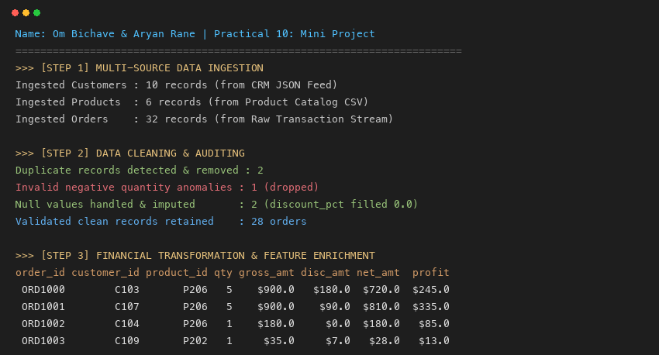

Task 2: Operational Data Storage (ODS) & Enterprise Star Schema Dimensional Modeling
Python Code:
# Group Members: Om Bichave & Aryan Rane
import sqlite3
import pandas as pd
conn = sqlite3.connect("enterprise_data_warehouse.db")
cursor = conn.cursor()
# 1. Operational Staging Persistence
raw_customers.to_sql("ods_customers", conn, if_exists="replace", index=False)
raw_products.to_sql("ods_products", conn, if_exists="replace", index=False)
df_transformed.to_sql("ods_orders", conn, if_exists="replace", index=False)
# 2. Enterprise Data Warehouse — Star Schema DDL
cursor.executescript('''
DROP TABLE IF EXISTS Fact_Sales;
DROP TABLE IF EXISTS Dim_Customer;
DROP TABLE IF EXISTS Dim_Product;
DROP TABLE IF EXISTS Dim_Date;
CREATE TABLE Dim_Customer (
customer_key INTEGER PRIMARY KEY AUTOINCREMENT,
customer_id TEXT UNIQUE,
customer_name TEXT,
city TEXT,
tier TEXT
);
CREATE TABLE Dim_Product (
product_key INTEGER PRIMARY KEY AUTOINCREMENT,
product_id TEXT UNIQUE,
product_name TEXT,
category TEXT,
unit_price REAL,
unit_cost REAL
);
CREATE TABLE Dim_Date (
date_key INTEGER PRIMARY KEY,
full_date TEXT UNIQUE,
year INTEGER,
quarter INTEGER,
month INTEGER,
month_name TEXT,
day INTEGER,
day_name TEXT
);
CREATE TABLE Fact_Sales (
sales_key INTEGER PRIMARY KEY AUTOINCREMENT,
customer_key INTEGER,
product_key INTEGER,
date_key INTEGER,
order_id TEXT,
quantity INTEGER,
gross_amount REAL,
discount_amount REAL,
net_amount REAL,
profit REAL,
FOREIGN KEY (customer_key) REFERENCES Dim_Customer(customer_key),
FOREIGN KEY (product_key) REFERENCES Dim_Product(product_key),
FOREIGN KEY (date_key) REFERENCES Dim_Date(date_key)
);
''')
# 3. Populate Dimensions & Fact Table via Dimensional Lookups
customer_spend = df_transformed.groupby("customer_id")["net_amount"].sum()
raw_customers["tier"] = raw_customers["customer_id"].apply(
lambda c: "Gold Tier" if customer_spend.get(c, 0) > 2500 else ("Silver Tier" if customer_spend.get(c, 0) > 1000 else "Bronze Tier")
)
for _, r in raw_customers.iterrows():
cursor.execute("INSERT INTO Dim_Customer (customer_id, customer_name, city, tier) VALUES (?, ?, ?, ?)",
(r["customer_id"], r["customer_name"], r["city"], r["tier"]))
for _, r in raw_products.iterrows():
cursor.execute("INSERT INTO Dim_Product (product_id, product_name, category, unit_price, unit_cost) VALUES (?, ?, ?, ?, ?)",
(r["product_id"], r["product_name"], r["category"], r["unit_price"], r["unit_cost"]))
for d in pd.to_datetime(df_transformed["order_date"].unique()):
cursor.execute('''INSERT INTO Dim_Date (date_key, full_date, year, quarter, month, month_name, day, day_name)
VALUES (?, ?, ?, ?, ?, ?, ?, ?)''',
(int(d.strftime("%Y%m%d")), d.strftime("%Y-%m-%d"), d.year, d.quarter, d.month, d.strftime("%B"), d.day, d.strftime("%A")))
dim_cust_df = pd.read_sql("SELECT customer_key, customer_id FROM Dim_Customer", conn)
dim_prod_df = pd.read_sql("SELECT product_key, product_id FROM Dim_Product", conn)
dim_date_df = pd.read_sql("SELECT date_key, full_date FROM Dim_Date", conn)
fact_prep = df_transformed.merge(dim_cust_df, on="customer_id", how="inner") \
.merge(dim_prod_df, on="product_id", how="inner") \
.merge(dim_date_df, left_on="order_date", right_on="full_date", how="inner")
fact_records = fact_prep[["customer_key", "product_key", "date_key", "order_id",
"quantity", "gross_amount", "discount_amount", "net_amount", "profit"]]
fact_records.to_sql("Fact_Sales", conn, if_exists="append", index=False)
conn.commit()
print("Star Schema Data Warehouse Successfully Built and Populated.")
Output:
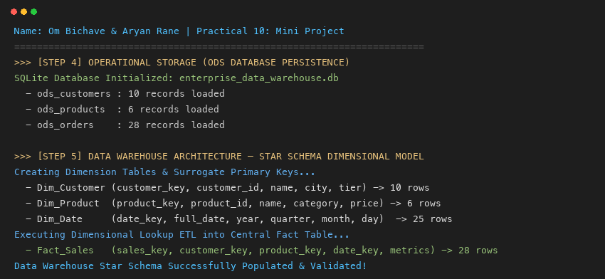

Task 3: Business Intelligence, Analytical OLAP Queries & Executive Reporting
Python Code:
# Group Members: Om Bichave & Aryan Rane
import sqlite3
import pandas as pd
conn = sqlite3.connect("enterprise_data_warehouse.db")
# KPI 1: Executive Financial Overview
q1 = '''SELECT
COUNT(sales_key) AS total_orders,
SUM(quantity) AS total_units_sold,
PRINTF('$%,.2f', SUM(gross_amount)) AS total_gross_sales,
PRINTF('$%,.2f', SUM(discount_amount)) AS total_discounts,
PRINTF('$%,.2f', SUM(net_amount)) AS total_net_revenue,
PRINTF('$%,.2f', SUM(profit)) AS total_profit,
PRINTF('%.2f%%', (SUM(profit) / SUM(net_amount)) * 100) AS overall_profit_margin
FROM Fact_Sales;'''
print("--- KPI 1: EXECUTIVE FINANCIAL OVERVIEW ---")
print(pd.read_sql(q1, conn).to_string(index=False))
# KPI 2: Category Profitability & Margin Ranking
q2 = '''SELECT
p.category, COUNT(f.sales_key) AS transactions, SUM(f.quantity) AS units_sold,
PRINTF('$%,.2f', SUM(f.net_amount)) AS net_revenue,
PRINTF('$%,.2f', SUM(f.profit)) AS net_profit,
PRINTF('%.2f%%', (SUM(f.profit) / SUM(f.net_amount)) * 100) AS margin_pct
FROM Fact_Sales f JOIN Dim_Product p ON f.product_key = p.product_key
GROUP BY p.category ORDER BY SUM(f.net_amount) DESC;'''
print("\n--- KPI 2: CATEGORY PERFORMANCE & PROFITABILITY ---")
print(pd.read_sql(q2, conn).to_string(index=False))
# KPI 3: Regional Revenue & Customer Tier Distribution
q3 = '''SELECT
c.city, c.tier, COUNT(DISTINCT c.customer_id) AS customer_count,
SUM(f.quantity) AS total_items,
PRINTF('$%,.2f', SUM(f.net_amount)) AS regional_revenue
FROM Fact_Sales f JOIN Dim_Customer c ON f.customer_key = c.customer_key
GROUP BY c.city, c.tier ORDER BY SUM(f.net_amount) DESC;'''
print("\n--- KPI 3: REGIONAL REVENUE & CUSTOMER TIER BREAKDOWN ---")
print(pd.read_sql(q3, conn).to_string(index=False))
# KPI 4: Monthly Sales Trend Analysis
q4 = '''SELECT
d.year, d.month_name AS month, COUNT(f.sales_key) AS order_volume, SUM(f.quantity) AS units,
PRINTF('$%,.2f', SUM(f.net_amount)) AS monthly_revenue,
PRINTF('$%,.2f', AVG(f.net_amount)) AS avg_order_value
FROM Fact_Sales f JOIN Dim_Date d ON f.date_key = d.date_key
GROUP BY d.year, d.month, d.month_name ORDER BY d.year, d.month;'''
print("\n--- KPI 4: MONTHLY SALES TREND ANALYSIS ---")
print(pd.read_sql(q4, conn).to_string(index=False))
conn.close()
Output:
