F3K
FUTURE 3000
ARCH-01 PANEL TEE
TECHNICAL GARMENT DEVELOPMENT

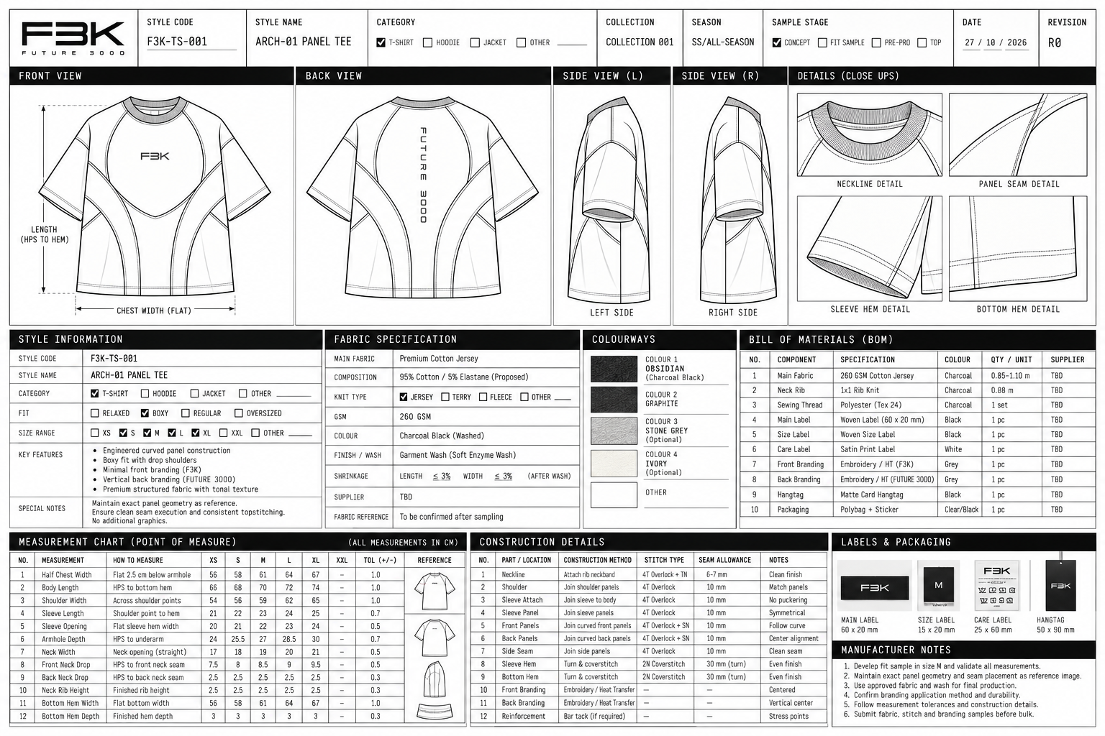
STYLE CODE F3K-TS-001 | COLLECTION 001 (PROVISIONAL) | REVISION R0
Development document • All specifications provisional until sample and supplier validation

1. Design Intent & Reference Analysis
ARCH-01 is a structured, boxy short-sleeve T-shirt defined by curved engineered panel seams, a substantial ribbed crew neckline, relaxed dropped-shoulder sleeves, a restrained F3K front mark, and vertical FUTURE 3000 branding on the back. The construction is intended to carry the design identity; avoid adding decorative graphics or unreferenced panels.
Field | Specification | Status
Style code | F3K-TS-001 | Provisional identifier
Style name | ARCH-01 PANEL TEE | Proposed
Category | T-shirt | Reference-derived
Fit | Boxy, structured oversized; controlled volume | Proposed
Size range | S, M, L, XL | Development range
Collection / season | Collection 001 / Core | Provisional
Sample stage / revision | Concept to S0 fit sample / R0 | Current development stage
Primary colour | Obsidian / charcoal black | Reference-derived
Branding | F3K centered on front; FUTURE 3000 vertically on back | Visible in reference

Observed Design Features vs. Items Requiring Confirmation
Observed from reference | Inferred / pending confirmation
Dark charcoal/black fabric with subtle tonal surface texture | Exact fibre composition, knit structure, GSM and texture method
Curved panel lines on front and back | Exact panel count, seam allowance and panel pattern geometry
Ribbed crew neck and short sleeves | Rib blend, finished recovery and exact dimensions
Centered F3K front mark | Embroidery vs. transfer, stitch density and final artwork size
Vertical FUTURE 3000 back branding | Application method, exact letter spacing and placement measurements
Dropped shoulder and broad body proportions | Finished garment measurements; image alone cannot establish exact dimensions

2. Silhouette & Fit Direction
- Boxy body with controlled width and a balanced, not excessively long, body length.
- Dropped shoulder with a deliberate shoulder line; avoid an uncontrolled, shapeless oversized fit.
- Relaxed sleeve volume with a substantial sleeve opening.
- Structured drape suitable for an architectural panelled silhouette.
- Substantial ribbed crew neck that retains shape after laundering.
- Keep front and back panel geometry consistent with the supplied reference; do not silently redesign the garment.

3. Fabric Specification
Parameter | Proposed specification | Status / validation
Main fabric | Premium cotton single jersey | Proposed; swatch required
Composition | 95% cotton / 5% elastane | Proposal only; compare with 100% cotton
Knit type | Single jersey | Proposed
Target GSM | 260 GSM | Starting target, not confirmed
Hand feel | Dense, smooth, substantial, low cling | Evaluate physically
Drape / structure | Structured body with controlled volume | Fit-sample check
Colour | Charcoal black / washed black | Approve against physical swatch
Finish / wash | Piece wash or garment wash, subject to sample | Method to be confirmed
Surface texture | Subtle tonal texture visible in reference | Determine if knit texture, jacquard, embossing or other finish
Shrinkage | Target ≤3% lengthwise and widthwise after agreed wash test | Acceptance target only; not a test result
Colourfastness | Test wash, rubbing and perspiration fastness | Pending laboratory/supplier confirmation
Supplier / fabric reference | To be sourced / assign after swatch approval | Unconfirmed

Fabric decision note: begin with a 260 GSM cotton jersey sample to assess the intended structure. If the reference texture is essential, test a textured knit or validated surface treatment. Cotton terry may be considered as an alternative, but its looped surface can change the appearance and bulk at panel joins.

4. Finished-Garment Measurement Chart — S to XL
All dimensions are in centimetres and refer to the finished garment laid flat unless otherwise stated. M is the proposed base size. Values are provisional development targets, not factory-approved specifications. Tolerance is proposed as ± the stated value.
No. | Point of measurement | How to measure | S | M | L | XL | Tol. ±
1 | Half chest width | Flat, 2.5 cm below armhole; edge to edge | 58 | 61 | 64 | 67 | 1.0
2 | Body length (HPS) | High point shoulder at neck seam to bottom edge | 68 | 70 | 72 | 74 | 1.0
3 | Shoulder width | Across outer shoulder points | 56 | 59 | 62 | 65 | 1.0
4 | Sleeve length | Shoulder point to sleeve hem along upper sleeve | 22 | 23 | 24 | 25 | 0.7
5 | Sleeve opening width | Flat, straight across sleeve hem | 21 | 22 | 23 | 24 | 0.5
6 | Armhole depth | Vertical from HPS level to underarm level | 25.5 | 27 | 28.5 | 30 | 0.7
7 | Neck opening width | Straight across neck opening at seam line | 18 | 19 | 20 | 21 | 0.5
8 | Front neck drop | HPS level to lowest front neck seam point | 8 | 8.5 | 9 | 9.5 | 0.5
9 | Back neck drop | HPS level to lowest back neck seam point | 2.5 | 2.5 | 2.5 | 2.5 | 0.3
10 | Neck rib finished height | Attachment seam to outer rib edge | 2.5 | 2.5 | 2.5 | 2.5 | 0.3
11 | Bottom hem width | Flat, straight across bottom edge | 58 | 61 | 64 | 67 | 1.0
12 | Bottom hem depth | Visible finished hem band depth | 3 | 3 | 3 | 3 | 0.3
13 | Bicep width | Flat across sleeve near armhole, perpendicular to sleeve axis | 23 | 24 | 25 | 26 | 0.7
14 | Shoulder drop | Vertical drop from HPS level to outer shoulder/sleeve junction | 10 | 11 | 12 | 13 | 0.7

Additional Construction / Branding Measurements
No. | Measurement | How to measure | S | M | L | XL | Tol. ±
15 | Front panel width | Central front panel at chest level; provisional layout target | 30 | 32 | 34 | 36 | 0.7
16 | Back panel width | Central back panel at chest level; provisional layout target | 30 | 32 | 34 | 36 | 0.7
17 | Side panel width | One side panel at chest level | 8 | 8.5 | 9 | 9.5 | 0.5
18 | Sleeve hem depth | Finished visible sleeve hem band | 3 | 3 | 3 | 3 | 0.3
19 | Front logo width | Maximum bounding width of F3K mark | 6 | 6 | 6.5 | 6.5 | 0.3
20 | Back lettering width | Maximum width of vertical FUTURE 3000 artwork | 2.5 | 2.5 | 2.5 | 2.5 | 0.3

Measurement note: the panel-width targets must be reconciled with actual seam paths and pattern geometry. The photograph does not establish exact measurements. Shoulder/armhole/sleeve reference points must be standardised by the pattern maker before grading.

5. Construction Details
No. | Part / location | Construction method | Stitch type | Seam allowance | Notes
1 | Shoulder seams | Join front and back shoulder seams | 4-thread overlock where appropriate | 10 mm | Validate at sample stage
2 | Neckline / neckband | Attach rib evenly; control stretch | 4-thread overlock; optional twin-needle topstitch | 6–7 mm attachment allowance | Test recovery
3 | Sleeve attachment | Join sleeve to armhole / engineered curve | 4-thread overlock | 10 mm | Match notches; avoid puckering
4 | Front panels | Join curved engineered panels | 4-thread overlock; optional single-needle topstitch | 10 mm | Preserve reference geometry
5 | Back panels | Join curved back panels | 4-thread overlock; optional single-needle topstitch | 10 mm | Keep vertical branding zone centered
6 | Side seams | Join front and back body | 4-thread overlock | 10 mm | Maintain straight side profile
7 | Bottom hem | Turn up and secure | Two-needle coverstitch | 30 mm internal turn-up (proposed) | Confirm visible hem depth separately
8 | Sleeve hem | Turn up and secure | Two-needle coverstitch | 30 mm internal turn-up (proposed) | Keep both sleeves symmetrical
9 | Front logo | Embroidery or suitable transfer | TBD after artwork/method selection | N/A | Test wash and abrasion
10 | Back lettering | Vertical FUTURE 3000 application | TBD after method selection | N/A | Confirm spacing and durability
11 | Reinforcement | Secure stress points if needed | Bar tack or backtack | N/A | Only where functionally required

Important hem distinction: 30 mm is a proposed internal turn-up allowance. The visible finished hem band is separately targeted at 3 cm only if the pattern and construction method support it; confirm this on the sample.

6. Colourways
Colourway | Fabric target | Branding / stitch | Status
01 — Obsidian | Charcoal black / washed black | Tonal silver-grey branding; matching charcoal seams | Primary, supported by reference
02 — Graphite | Deep graphite grey | Pale grey branding; tonal graphite seams | Proposed additional colourway

Pantone references are not assigned. Approve physical swatches and lab dips under controlled lighting before locking a colour standard. Do not treat screen colour as an approved production reference.

7. Bill of Materials (BOM)
No. | Component | Specification | Colour | Qty per garment | Supplier / status
1 | Main fabric | 260 GSM cotton jersey, proposed | Charcoal | 0.85–1.10 m* | To source; marker validation required
2 | Neck rib | Recovery-tested rib knit | Charcoal | Approx. 0.08 m* | To source
3 | Sewing thread | Polyester thread suitable for knit construction | Matching | Factory usage | To confirm
4 | Main label | Woven or printed; 60 × 20 mm proposed | Black/grey | 1 pc | Artwork pending
5 | Size label | S / M / L / XL identifier | Black/grey | 1 pc | Pending
6 | Care label | Fibre, care and legally required details | Neutral | 1 pc | Pending
7 | Front branding | F3K logo application | Silver-grey | 1 application | Method pending
8 | Back branding | Vertical FUTURE 3000 lettering | Silver-grey | 1 application | Method pending
9 | Garment bag | Protective bag, if required | Clear/neutral | 1 pc | Optional
10 | Hangtag | Minimal matte card | Black/grey | 1 set | Optional

*Fabric usage is a planning estimate only. Final consumption requires graded pattern pieces, usable fabric width, marker efficiency and cutting allowance. Supplier, fabric reference and confirmed test results are not yet available.

8. Labels & Packaging
Component | Proposed dimension | Placement | Specification / status
Main label | 60 × 20 mm | Inside back neck | Minimal F3K wordmark; soft woven or printed label; artwork pending
Size label | Approx. 15 × 20 mm | Adjacent to main label | Separate S/M/L/XL identifier; pending
Care label | Approx. 25 × 60 mm | Inside left side seam | Soft printed label; legal care/fibre content pending
Hangtag | Approx. 50 × 90 mm | Attached near neck label | Matte black stock, restrained branding; optional
Packaging | Fit to folded garment | Outer packaging | Protective, low-visual-noise packaging; confirm requirement

9. Branding & Placement Notes
- Front: centered F3K mark on the central chest panel, matching the supplied reference. Proposed maximum width: 6–6.5 cm depending on size.
- Back: FUTURE 3000 lettering arranged vertically on the center-back panel. Proposed maximum width: 2.5 cm; confirm exact length, spacing and orientation against artwork.
- Use a restrained silver-grey/tonal finish. Confirm the application method through a sample; do not assume embroidery or heat transfer until tested.
- Ensure panel seams do not distort the logo or interfere with the center-back lettering.

10. Technical Review, Risks & Validation
Check | Required validation | Approval gate
Panel geometry | Match seam curves, panel intersections and symmetry to reference; confirm panel count in pattern | Before S0 approval
Fit / grading | Check chest, body length, shoulder drop, armhole, sleeve width and neckline on M sample; then grade S/L/XL | Before S1
Fabric / texture | Confirm GSM, composition, hand feel, surface texture and wash behaviour from swatches and tests | Before S1
Shrinkage | Wash and measure before/after using agreed care method | Before pre-production
Seam finish | Test curved seams for puckering, seam bulk and stitch appearance | S0 / S1
Branding durability | Check artwork size, placement, wash and abrasion durability | Before pre-production
Colour | Approve physical swatch/lab dip under controlled lighting | Before bulk
BOM / consumption | Validate fabric usage using final graded marker and confirm supplier details | Before costing / bulk
Labels / compliance | Approve final label artwork and legally required care information | Before bulk

11. Recommended Sampling Sequence
Stage | Purpose | Required output
S0 — First prototype | Validate silhouette, panel construction, fabric weight and neckline | Physical sample + measurement review
S1 — Revised prototype | Correct fit, seam alignment, branding placement and finish | Revised sample + updated measurements
S2 — Pre-production sample | Verify final materials, grading, labels and construction | Approved PP sample + signed-off spec
Bulk approval | Proceed only after all critical checks pass | Approved materials, pattern, BOM and production spec

12. Assumptions & Open Items
- No verified garment measurements or physical sample were supplied; all dimensions are proposed and require fit validation.
- Exact fabric composition, surface texture method, supplier, fabric reference and confirmed shrinkage are unknown.
- Exact panel count, pattern geometry, seam allowances and construction order must be confirmed by the pattern maker.
- Pantone references and final logo artwork/application methods are not approved.
- All measurements refer to finished garment dimensions unless explicitly noted; do not use them as body measurements.
- The technical drawing is a development flat reconstructed from the reference, not a validated sewing pattern or graded pattern set.

F3K — FUTURE 3000 | ARCH-01 PANEL TEE | END OF TECHNICAL DEVELOPMENT DOCUMENT

