F3K
FUTURE 3000

SANCTUM TEE
TECHNICAL GARMENT DEVELOPMENT
STYLE CODE F3K-C001-SAN-01 | COLLECTION 001 | REVISION R0
Development document • All specifications provisional until sample and supplier validation
STYLE CODE | STYLE NAME | CATEGORY | COLLECTION | SAMPLE STAGE | REVISION
F3K-C001-SAN-01 | SANCTUM TEE | T-shirt | Collection 001 | Concept / S0 | R0

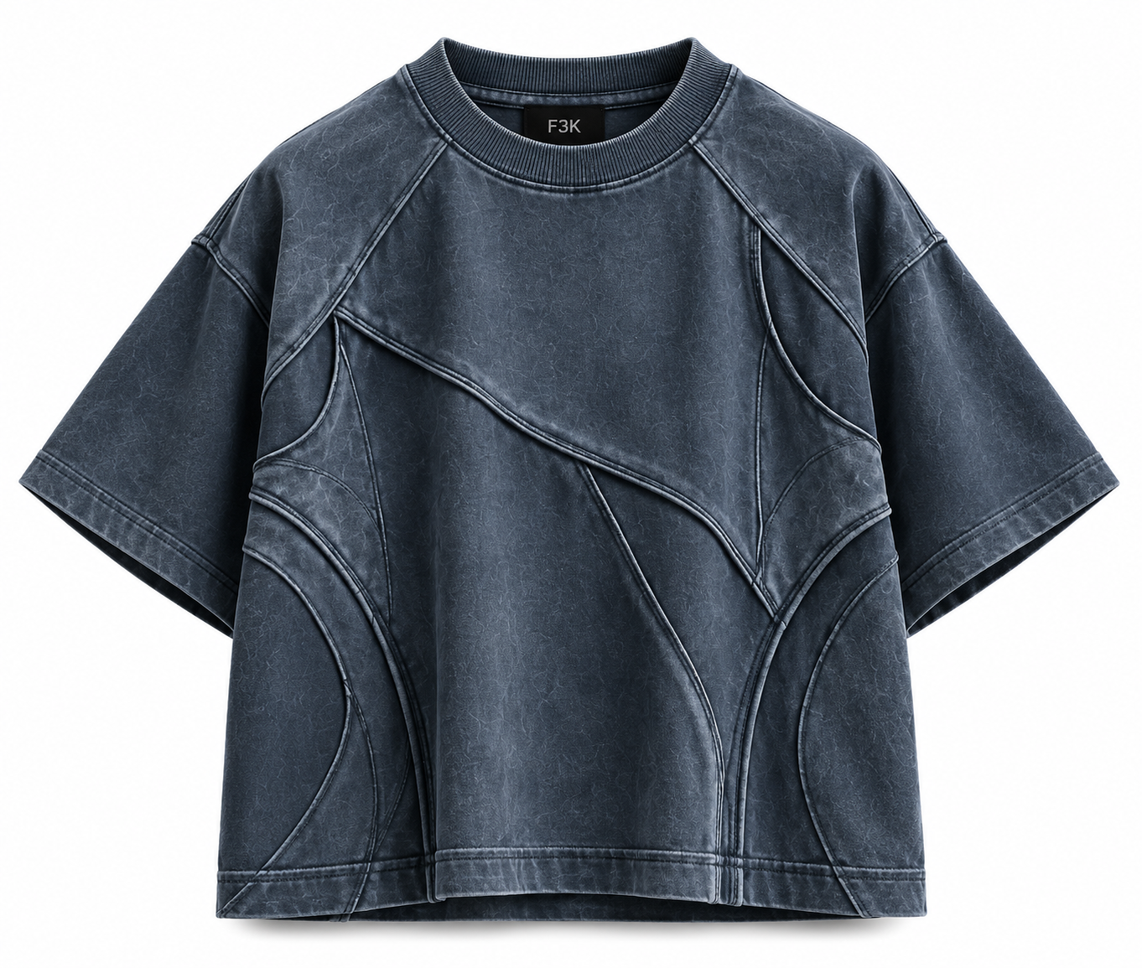  FRONT VIEW — CONCEPT REFERENCE | 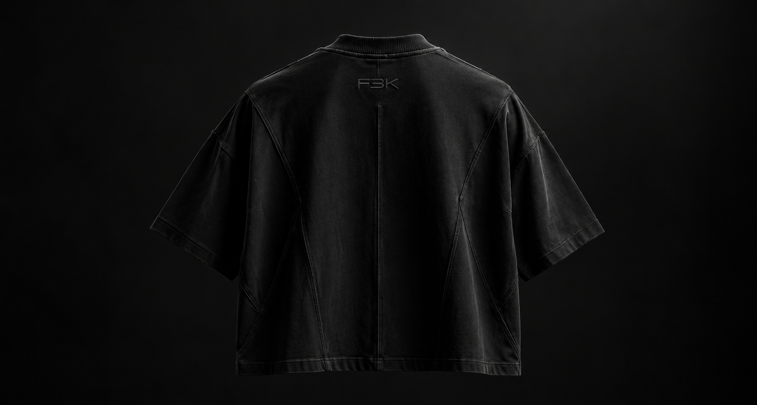  BACK VIEW — CONCEPT REFERENCE
Reference imagery communicates appearance only. The technical flat, pattern pieces and sample must be validated before production.

1. Design Intent & Reference Analysis
SANCTUM is a structured, boxy, short-sleeve T-shirt defined by curved engineered panel seams, a clean crew neckline, broad relaxed sleeves, and a washed blue-charcoal surface. Its identity is carried by the cut-and-sew geometry and tonal texture rather than loud graphics. The back uses a central vertical seam and balanced curved panel architecture. Remove the extra short stitch/line marked on the supplied back reference; it is not part of the approved intended seam map.
FIELD | SPECIFICATION | STATUS
Style code | F3K-C001-SAN-01 | Provisional identifier
Style name | SANCTUM TEE | Proposed
Category | Short-sleeve T-shirt | Reference-derived
Fit | Boxy, structured oversized; controlled volume | Proposed
Size range | S, M, L, XL | Development range
Collection / season | Collection 001 / Core | Provisional
Primary colour | Washed slate blue / blue-charcoal | Reference-derived
Branding | Minimal; no exterior graphic assumed unless separately approved | Confirm final application
Construction identity | Curved and vertical cut-and-sew panels; visible seam definition | Reference-derived

Observed features vs. items requiring confirmation
OBSERVED FROM REFERENCE | INFERRED / PENDING CONFIRMATION
Washed charcoal-blue surface with tonal fading | Exact dye / wash process and colour standard
Curved panel lines across front and back | Panel count, exact pattern geometry and seam allowance
Central vertical back seam | Final seam construction and topstitching
Wide short sleeves and boxy body | Finished garment measurements and grading
Crew neck with rib finish | Rib composition, recovery and dimensions
No additional short stitch at the marked lower-left back area | Confirm final tech flat has that unwanted line removed

2. Silhouette & Fit Direction
- Boxy body with controlled width and balanced body length; avoid an excessively long or shapeless fit.
- Relaxed shoulder and broad sleeve volume. Final shoulder/sleeve construction must be resolved in the pattern, not inferred from the image alone.
- Curved panels should follow the reference and remain symmetrical where intended.
- Maintain a clean, substantial crew neckline that recovers after laundering.
- Architectural seam construction should be the main visual feature; no unapproved extra seams, stitch lines or graphics.
- Check bulk at curved intersections and prevent puckering, twisting and uneven panel tension.

3. Fabric Specification
PARAMETER | PROPOSED SPECIFICATION | STATUS / VALIDATION
Main fabric | Premium cotton single jersey | Proposed; swatch required
Composition | 100% cotton as first option; compare 95% cotton / 5% elastane only if recovery requires it | Not confirmed
Knit type | Single jersey | Proposed
Target GSM | 260 GSM | Starting target; not confirmed
Hand feel | Dense, smooth, substantial, low cling | Evaluate physically
Drape / structure | Structured body with controlled volume | Fit-sample check
Colour | Washed slate blue / blue-charcoal | Approve physical swatch
Finish / wash | Garment wash or piece wash, method to be selected after testing | Pending
Surface texture | Subtle washed tonal variation; no uncontrolled damage or distressing | Confirm process
Shrinkage | Target ≤3% lengthwise and widthwise after agreed wash test | Acceptance target only; not a result
Colourfastness | Test wash, rubbing and perspiration fastness | Pending supplier/lab validation
Supplier / fabric reference | To be sourced after swatch approval | Unconfirmed

Fabric decision note: start with a 260 GSM cotton jersey sample and assess structure, seam bulk and wash behaviour. Cotton terry may be evaluated as an alternative, but it can change the surface appearance and increase bulk at panel joins.

4. Finished-Garment Measurement Chart — S to XL
All dimensions are centimetres, measured on the finished garment laid flat unless noted. M is the proposed base size. These are provisional development targets—not factory-approved measurements. Validate the M sample, then revise grading before release.
NO. | POINT OF MEASUREMENT | HOW TO MEASURE | S | M | L | XL | TOL. ±
1 | Half chest width | Flat, 2.5 cm below armhole; edge to edge | 56 | 59 | 62 | 65 | ±1.0
2 | Body length (HPS) | High point shoulder at neck seam to bottom edge | 68 | 70 | 72 | 74 | ±1.0
3 | Shoulder width | Across outer shoulder points; confirm pattern endpoints | 54 | 57 | 60 | 63 | ±1.0
4 | Sleeve length | Shoulder point to sleeve hem along upper sleeve | 22 | 23 | 24 | 25 | ±0.7
5 | Sleeve opening width | Flat, straight across sleeve hem | 21 | 22 | 23 | 24 | ±0.5
6 | Armhole depth | Vertical from shoulder reference level to underarm | 25 | 26.5 | 28 | 29.5 | ±0.7
7 | Neck opening width | Straight across neckline at seam line | 18 | 19 | 20 | 21 | ±0.5
8 | Front neck drop | Reference HPS level to lowest front neck seam | 8 | 8.5 | 9 | 9.5 | ±0.5
9 | Back neck drop | Reference level to lowest back neck seam | 2.5 | 2.5 | 2.5 | 2.5 | ±0.3
10 | Neck rib finished height | Attachment seam to outer rib edge | 2.5 | 2.5 | 2.5 | 2.5 | ±0.3
11 | Bottom hem width | Flat, straight across bottom edge | 56 | 59 | 62 | 65 | ±1.0
12 | Bottom hem depth | Visible finished hem band | 3 | 3 | 3 | 3 | ±0.3
13 | Bicep width | Flat across sleeve near armhole, perpendicular to sleeve axis | 23 | 24 | 25 | 26 | ±0.7
14 | Shoulder drop | Vertical drop from HPS reference to shoulder/sleeve junction | 10 | 11 | 12 | 13 | ±0.7

HPS = high point shoulder. If the final pattern uses raglan or modified sleeve geometry, the pattern maker must define consistent measurement endpoints. Reconcile all panel widths with actual seam paths.

Additional Construction / Branding Measurements
NO. | MEASUREMENT | HOW TO MEASURE | S | M | L | XL | TOL. ±
15 | Central front panel width | At chest level; provisional layout target | 30 | 32 | 34 | 36 | ±0.7
16 | Central back panel width | At chest level; provisional layout target | 30 | 32 | 34 | 36 | ±0.7
17 | Side panel width | One side panel at chest level | 8 | 8.5 | 9 | 9.5 | ±0.5
18 | Sleeve hem depth | Finished visible sleeve hem band | 3 | 3 | 3 | 3 | ±0.3
19 | Visible logo size | No exterior logo assumed; measure only if approved | TBD | TBD | TBD | TBD | TBD

5. Construction Details
NO. | PART / LOCATION | CONSTRUCTION METHOD | STITCH TYPE | SEAM ALLOWANCE | NOTES
1 | Shoulder / upper seams | Join shoulder and upper panels according to approved pattern | 4-thread overlock where appropriate | 10 mm proposed | Validate on sample
2 | Neckline / neckband | Attach rib evenly; control stretch and recovery | 4-thread overlock; optional twin-needle topstitch | 6–7 mm proposed | Test recovery after wash
3 | Sleeve attachment | Join sleeve to armhole / engineered curve | 4-thread overlock | 10 mm proposed | Match notches; prevent puckering
4 | Front curved panels | Join shaped panels following approved seam map | 4-thread overlock; optional single-needle topstitch | 10 mm proposed | Preserve reference geometry
5 | Back centre seam | Join centre-back panels if retained in approved pattern | 4-thread overlock; optional topstitch | 10 mm proposed | Keep vertical line straight
6 | Back curved / lower panels | Join curved panels to centre and side pieces | 4-thread overlock; optional topstitch | 10 mm proposed | Match intersections accurately
7 | Side seams | Join front and back body edges | 4-thread overlock | 10 mm proposed | Maintain straight side profile
8 | Bottom hem | Turn up and secure | Two-needle coverstitch | 30 mm internal turn-up proposed | Confirm visible hem depth separately
9 | Sleeve hem | Turn up and secure | Two-needle coverstitch | 30 mm internal turn-up proposed | Keep sleeves symmetrical
10 | Internal finishing | Secure and trim seam allowances | Factory-standard knit finishing | N/A | Avoid bulky seam junctions
11 | Unwanted marked stitch | Do not include the extra short line shown on the marked reference | Not applicable | Not applicable | Remove from final seam map / flat

Seam allowance and stitch settings are proposals for discussion with the sample room. Confirm machine suitability, stitch density, seam stretch and wash performance before locking the specification.

Seam map rules
- Every visible line must be identified as a true panel join, topstitch, fold or other named operation.
- Panel joins must correspond to separate pattern pieces; do not imitate seams with print or surface marks.
- Mark seam start/end points, notches and intersections on the final technical flat.
- Do not add decorative or redundant stitch lines beyond the approved reference.
- Use matching thread unless contrast stitching is explicitly approved.
- Test curved seams for puckering, seam bulk, twisting and stitch breakage after washing.

6. Colourways
COLOURWAY | FABRIC TARGET | STITCH / FINISH | STATUS
01 — Slate / Charcoal | Washed slate blue / blue-charcoal | Tonal charcoal seams; muted washed highlights | Primary concept reference
02 — Obsidian | Washed black / deep charcoal | Tonal black seams | Optional alternate; not approved

Pantone references are not assigned. Approve a physical swatch or lab dip under controlled lighting. Screen colours and concept renders are not production colour standards.

7. Bill of Materials (BOM)
NO. | COMPONENT | SPECIFICATION | COLOUR | QTY / GARMENT | SUPPLIER / STATUS
1 | Main fabric | 260 GSM cotton jersey, proposed | Slate / charcoal | 0.85–1.10 m* | To source
2 | Neck rib | Recovery-tested rib knit | Colour matched | Approx. 0.08 m* | To source
3 | Sewing thread | Knit-suitable polyester thread | Matching | Factory usage | To confirm
4 | Main label | F3K label; 60 × 20 mm proposed | Black / grey | 1 pc | Artwork pending
5 | Size label | S / M / L / XL identifier | Neutral | 1 pc | Pending
6 | Care label | Fibre, care and legally required details | Neutral | 1 pc | Pending
7 | Exterior branding | None assumed for Sanctum unless approved separately | N/A | N/A | Confirm
8 | Garment bag | Protective bag if required | Clear / neutral | 1 pc | Optional
9 | Hangtag | Minimal matte card if required | Black / grey | 1 set | Optional

*Fabric usage is planning-only. Final consumption depends on graded pattern pieces, usable fabric width, marker efficiency, shrinkage and cutting allowance. Confirm after marker development.

8. Labels & Packaging
COMPONENT | PROPOSED DIMENSION | PLACEMENT | SPECIFICATION / STATUS
Main label | 60 × 20 mm | Inside back neck | Minimal F3K wordmark; soft woven or printed label; artwork pending
Size label | Approx. 15 × 20 mm | Adjacent to main label | Separate S / M / L / XL identifier
Care label | Approx. 25 × 60 mm | Inside side seam | Final fibre and care content pending
Hangtag | Approx. 50 × 90 mm | Near neck label | Optional, matte stock, restrained branding
Packaging | Fit to folded garment | Outer packaging | Low-visual-noise protective packaging; confirm requirement

9. Branding & Placement Notes
- Sanctum's primary visual identity is the panel architecture and washed surface; avoid adding an exterior logo by default.
- Use a clean internal F3K neck label, subject to final artwork and dimensions.
- If an exterior logo is later approved, specify size, placement, application method and durability separately before sampling.
- Do not allow labels or branding to interfere with panel seams, neckline recovery or wearer comfort.

10. Technical Review, Risks & Validation
CHECK | REQUIRED VALIDATION | APPROVAL GATE
Panel geometry | Match curves, intersections and symmetry to reference; remove marked extra stitch | Before S0 approval
Fit / grading | Check chest, body length, shoulder, armhole, sleeve and neckline on M sample; then grade S/L/XL | Before S1
Fabric / texture | Confirm GSM, composition, hand feel, wash finish and surface behaviour | Before S1
Shrinkage | Measure before and after agreed wash method | Before pre-production
Seam finish | Test curves for puckering, seam bulk and stitch appearance | S0 / S1
Colour | Approve physical swatch under controlled lighting | Before bulk
BOM / consumption | Validate with final graded marker and supplier quotes | Before costing / bulk
Labels / compliance | Approve label artwork and required care information | Before bulk

11. Recommended Sampling Sequence
STAGE | PURPOSE | REQUIRED OUTPUT
S0 — First prototype | Validate silhouette, panel construction, fabric weight, neckline and wash appearance | Physical sample + measurement review
S1 — Revised prototype | Correct fit, seam alignment, seam bulk and finishing | Revised sample + updated POM chart
S2 — Pre-production sample | Verify final materials, grading, labels and construction | Approved PP sample + signed-off specification
Bulk approval | Proceed only after all critical checks pass | Approved materials, patterns, BOM and production spec

12. Assumptions & Open Items
- No physical fit sample or verified garment measurements were supplied; all POM values are proposed and require fit validation.
- Exact fibre composition, fabric supplier, washed finish and confirmed shrinkage are unknown.
- Exact panel count, pattern geometry, seam allowances and construction order must be confirmed by the pattern maker.
- Colour standards and final label artwork are not approved.
- The unwanted short stitch marked on the supplied back image must be absent from the final flat and sample.
- Measurements refer to finished garment dimensions unless noted; they are not body measurements.
- The technical illustrations and concept photographs are development references, not validated sewing patterns or graded pattern sets.
F3K — FUTURE 3000 | SANCTUM TEE | END OF TECHNICAL DEVELOPMENT DOCUMENT

