|  |
| --- |
| Abbott Laboratories |
| Daily Maintenance Alert Algorithm Design Document |
| Alinity ci Immunoassay Analyzer |
|  |
|  |
| **Global Service Business Operations** |
| **3/29/2019** |

|  |
| --- |
|  |

Table of Contents

1. Purpose 2

2. Introduction 2

2.1 Scope 2

2.2 Notification Profile 2

2.3 Overview 4

3. Data 4

3.1 Source 4

4. Alert 5

4.1 Current Thresholds Set in System Software 5

4.2 An Automated Algorithm to Monitor Daily Maintenance 5

4.3 Root Cause 6

4.4 Recommended Action 7

5. Benefits / Return on Investment 7

# Purpose

To implement a Predictive Health Notification (PHN) for ALINITY Clinical Chemistry (CC) and Immunoassay (IA) Analyzers that will monitor daily maintenance procedures at a serial-number level.

# 2. Introduction

## 2.1 Scope

This document describes the recommended specifications for Daily Maintenance Fail alerts for the ALINITY IA and CC analyzers.

## 2.2 Notification Profile

|  |  |
| --- | --- |
| PHN Descriptor | Daily Maintenance Fail |
| Platform | Alinity ci |
| Data Source | Maintenance Logs / Abbott Link / IDA |
| IDA Table(s) |  |
| IDA Table Fields |  |
| Notification | Daily Report / Instrument Serial Number |
| Analysis Frequency | Daily |
| Flag Criteria | 2 or more days with failed daily maintenance and > 0 PATIENT samples attempted. |
| Recommended Action | Complete daily maintenance / establish root cause for continued failures / service instrument |

## 2.3 Overview

To ensure optimal system performance, a *daily maintenance procedure* is outlined for both the IA and CC analyzers.

For the CC system, daily maintenance (M&D 5501) includes:

* Flush the water lines of the sample, reagent and cuvette washer
* Change water in the water bath
* Add water bath additive
* Wash ICT module with ICT cleaning fluid and ICT reference solution
* Drain and fill ICT reference cup
* Wash the sample and reagent probes and the mixers with Acid Probe Wash and Detergent A
* Clean the sample probe, R2 probe and mixers.

For the IA systems, daily maintenance (M&D 2500) includes:

* Clean and condition sample pipettor probe
* Clean wash zone 1 probes and wash zone 2 probes with 0.5% sodium hypochlorite solution
* Flush and prime the Pre-Trigger Solution and the Trigger Solution

Failure to complete daily maintenance can lead to a variety of undesirable conditions, including air bubbles in tubing, particulate matter in water bath, dirty (contaminated) pipettor probes, and others. The daily maintenance procedures were specifically designed to enhance the reliability of the instrument and its results.

Unfortunately, daily maintenance is sometimes neglected, either because the customer elects to cancel the maintenance procedure (‘user cancel’), or because some ongoing instrument issue prevents the daily maintenance procedure from completing (‘failed’). Customers are able to run assays and report results despite these conditions.

The algorithm outlined herein defines a rule-set for monitoring customer’s adherence to the daily maintenance procedure at a serial-number level.

# Data

## 3.1 Source

The Daily Maintenance information is collected at the conclusion of daily maintenance. The data is sent to the ODR. The data goes from ODR to the IDAQOWNER IDA via the AbbottLink connection and is stored in the table: ICQ_MNDHistory

3.2 Fields Needed

Data fields that are included in the ICQ_MNDHistory table that are used in this PHN include the following:

**Table 4a. Alinity ci Activity Table Columns Needed**

|  |  |
| --- | --- |
| Table Field Name | Definition |
| ProcedureType | M&D Procedure Name, Maintenance = 0 |
| ProcedureNumber | Daily Maintenance Procedure Number  IA = 2500 CC = 5501 |
| ProcedureCategory | Daily = 14 |
| CompletionStatus | Fail = 1 |
| LOGDATE | The data and time stamp recorded when the result data is recorded in ODR. |

Data fields that are included in the ICQ_ Results that are used in this PHN include the following:

**Table 4b. Alinity ci Activity Table Columns Needed**

|  |  |
| --- | --- |
| Table Field Name | Definition |
| ProcedureType | M&D Procedure Name, Maintenance = 0 |
| ProcedureNumber | Daily Maintenance Procedure Number  IA = 2500 CC = 5501 |

**Maintenance Logs**

Maintenance logs are downloaded and parsed by AbbottLink daily. The relevant procedure codes for

this algorithm are 2500 for IA instruments and 5501 for CC instruments. The MNDHistory

table in IDA stores a year’s worth of maintenance procedures, but the RESULT field (having

‘Complete’,’User Canceled’, or ‘Failed’) is presented in the local language of the region the Instrument

resides. Fortunately, the AbbottLink DRM table ‘AED_MAINTENANCE’ also stores maintenance log

data, but with a RESULT field having only ‘PASS’ or ‘FAIL’ regardless of the local language. This

algorithm uses the DRM database for maintenance logs to avoid translation.

**Test Counts**

The IDA tables RESULTS_CC and RESULTS_IA are used to compute the number of tests Instruments are reporting after failed or user canceled daily maintenance. As explained below, this is to ensure instruments with failed daily maintenance are only flagged if they are actively reporting tests. If no tests are recorded, the instrument is not flagged. If querying from DRM, the table ‘ASSAYCOUNT’ in schema ‘CPR’ supersedes IDA tables.

**AbbottLink last contact**

The AbbottLink DRM database tables ‘DEVICE_CONTACT’ is used to ensure that instruments are currently able to upload to the IDA database. Instruments with failed daily maintenance are flagged only if it is certain that AbbottLink connectivity remains. If the last contact date is not recent, we cannot be sure that a daily maintenance has in fact been completed but not reported to IDA.

**Error messages**

The IDA table ‘MESSAGES’ stores error codes thrown by instruments, along with their time-stamp. The algorithm accesses this table to pull the error codes surrounding the last available failed or user canceled daily maintenance (+ 10 minutes around the time stamp of failed daily maintenance). This data is used to determine the most likely root cause for failed daily maintenance so that service professionals can better diagnose and solve the issue. If using DRM , the table AED_NOTIFICATION supersedes the IDA ‘MESSAGES’, as DRM tables are updated in real-time while IDA is updated daily.

# Alert

## 4.1 Current Thresholds Set in System Software

There are currently no alerts other than those immediately visible to the customer. Abbott representatives can access this data by pulling log files directly from AbbottLink, but this is a painstaking process and not a feasible solution.

## 4.2 An Automated Algorithm to Monitor Daily Maintenance

The algorithm follows the process as outlined below:

1. First, the algorithm identifies instruments whose last 2500 or 5501 daily maintenance message did *not* end in a completion. The below demonstrates this case for one example instrument, but in practice, all instruments are analyzed simultaneously. Because some instruments receive daily maintenance infrequently, and because we cannot be sure when the last completed daily maintenance occurred, the algorithm pulls maintenance logs for the last 60 days.

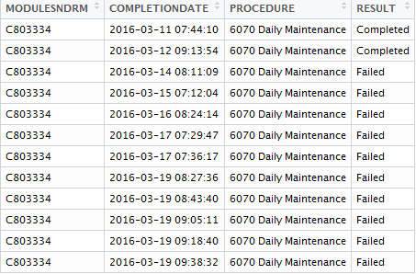

1. Second, the algorithm quantifies the extent of failed daily maintenance by calculating the number of days with Fail/User Cancel:The number of unique dates that experience a Fail or User cancel message since the last Completed daily maintenance. To be flagged, an Instrument must have > 1 day with attempted, but not completed daily maintenance. This will ignore Instruments that have just had a failed daily maintenance, or Instruments that had a failed daily maintenance in the past, but have stopped running. Anecdotal evidence suggests that many of these instruments recover and complete daily maintenance the next day; those that do not will still be flagged 24 hours later.
2. Third, the algorithm executes customized SQL queries to determine how many tests, if any, have been reported during the entire period of incomplete daily maintenance. For each instrument, the query counts REPLICATEIDs with PATIENT results beginning with the exact time stamp of the first failed/incomplete daily maintenance up until midnight of the current day. To be flagged, an instrument must have > 0 PATIENT results. In this way, instruments that are experiencing issues but not actively running are ignored.
3. Fourth, the algorithm executes additional customized SQL queries to pull error codes in the + 10 minutes surrounding the last failed/canceled daily maintenance. The below demonstrates the most common error codes for a set of instruments with failed daily maintenance (the 5 most common are displayed in the columns ‘EC1’ to ‘EC5’.

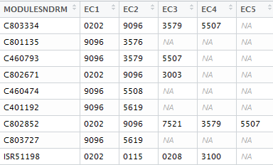

Please note that the error codes were queried and analyzed during algorithm development, but are *not* currently planned for use in production, due to limitations of the notification platform. However, the-end user is encouraged to manually examine error codes around daily maintenance failure and refer to the associated KM article for related information.

1. Finally, the AbbottLink last contact date is queried. To be flagged, an instrument must have had contact in the last day. Those that have not are ignored, as daily maintenance may have been completed but not reported to the database.

## 4.3 Root Cause

The error codes surrounding a failed daily maintenance can aid in determining root cause. Some error codes are common, but innocuous. For example, error code 9096 is defined in the Architect operations manual as below:

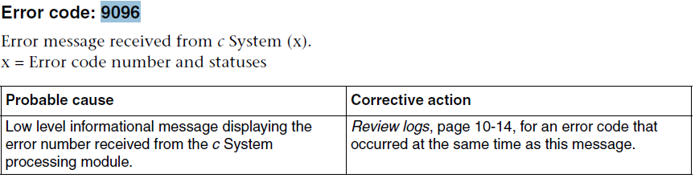

Others are much more descriptive; for example error code 7521 suggests water bath issues:

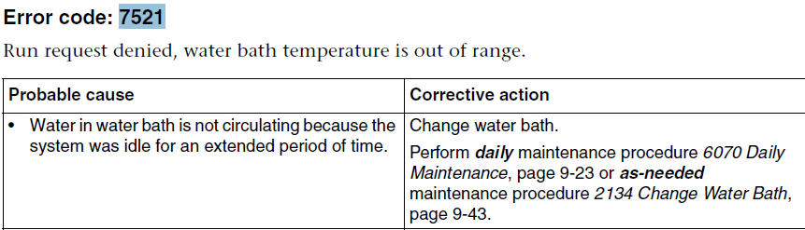

A mapping of error codes, probable root cause, and recommended action can be found in the associated Knowledge Management (KM) article.

## 4.4 Recommended Action

A Predictive Health Notification can be sent then received by either the Service Organization or by a Customer. The recommendation for either party taking action is to:

1. Complete daily maintenance, if possible
2. Refer to the associated KM article for probable root cause and recommended action