DUNGA TECHNOLOGIES CRM
Progress & Technical Documentation Report — 05 September 2026

1. Overview of Work Completed
A. Official Logo & Branding Updates
- Dunga Technologies Identity: Integrated official logo (DUNGA TECH LOGO-01.png) across all CRM headers, sidebars, and PDFs.
- Login Portals Cleanup: Removed text headings above forms on all login pages (/login, /employee/login, /developer/login).
- Prominent Logo Display: Increased logo size to 96px (h-24) (70% larger) for bold, clear visibility above Email and Password inputs.
B. Complete PDF Engine & Downloads
- Instant Generation: Upgraded PDF generation engine to output crisp, downloadable PDFs in < 150ms directly inside browser viewer.
- Estimation & Proposal PDF: Generated for project proposals with budget, deliverables, and milestone timelines.
- Master Project Contract PDF: Generated upon project conversion / final agreement.
- Payment Receipt PDF: Generated for every payment installment item in the financial breakdown.
C. 19-Section Dunga Technologies Project Development Agreement (Ver 1.0)
- 1. Agreement Overview — Terms between Dunga Technologies ('Service Provider') and Client.
- 2. Client Information — Customer Name, Company Name, Phone, Email, Project Number, Project Name, Address.
- 3. Project Information — Category, Delivery Time, Support Period, Total Cost, Advance Paid, Balance Amount, Scope.
- 4. Services Offered — 14 Service Areas (Web, Mobile Apps, Software, ERP, CRM, E-Commerce, Digital Marketing, SEO, SMM, Ads, Branding, Hosting, Support).
- 5. Payment Terms & Milestone Conditions
- 6. Late Payment Policy & Suspension Rights
- 7. Change Request Policy for Additional Scope
- 8. Delivery Timeline & Commencement Date
- 9. Maintenance & Support Terms
- 10. Intellectual Property & Source Code Ownership Transfer
- 11. Confidentiality Obligations
- 12. Digital Marketing Disclaimer
- 13. Website & Software Disclaimer
- 14. Cancellation & Refund Policy
- 15. Limitation of Liability
- 16. Legal Compliance
- 17. Dispute Resolution & Jurisdiction
- 18. Termination Notice
- 19. Acceptance & Signatures — Client Signature Box & Authorized Signatory Dunga Technologies box with Company Seal.
2. Visual Previews of Generated PDFs
A. Payment Receipt PDF Preview (1 Page)
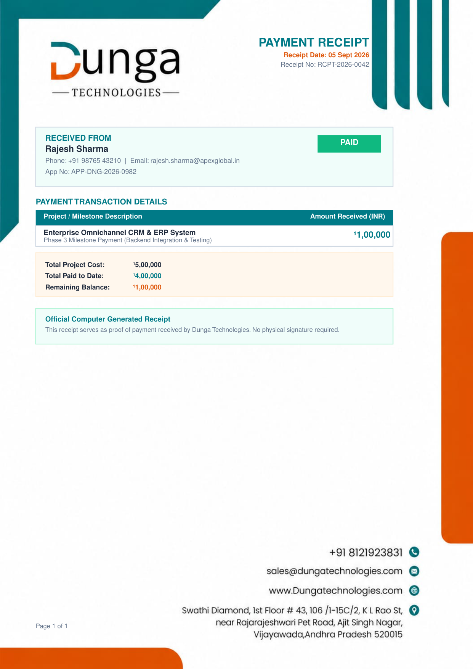
B. Master Project Contract PDF — Overview & Scope (Page 1)
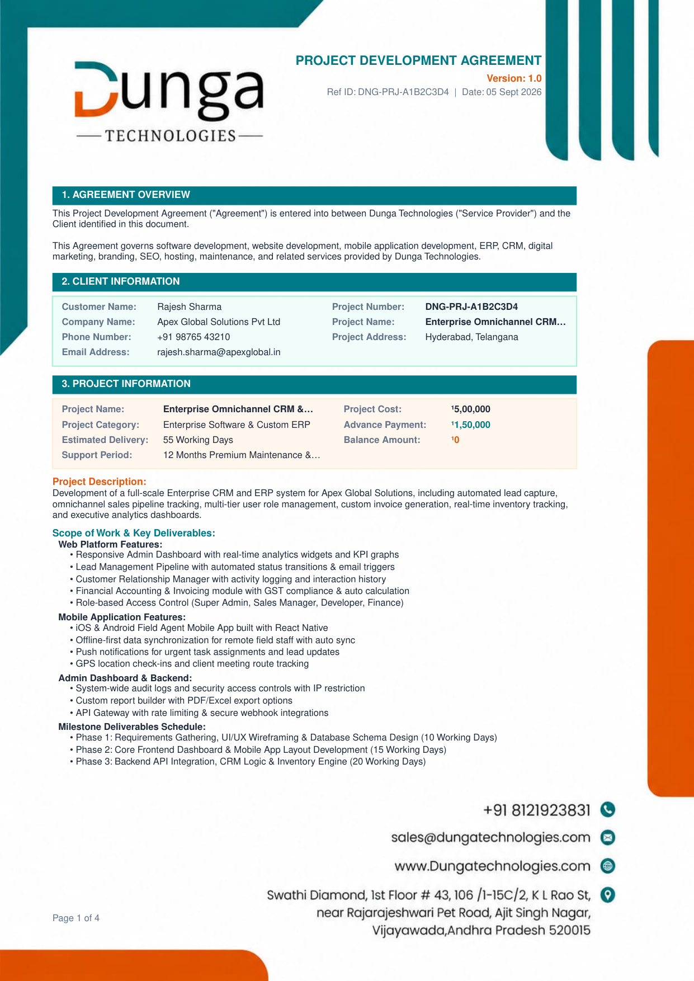
C. Master Project Contract PDF — Acceptance & Signatures (Page 3)
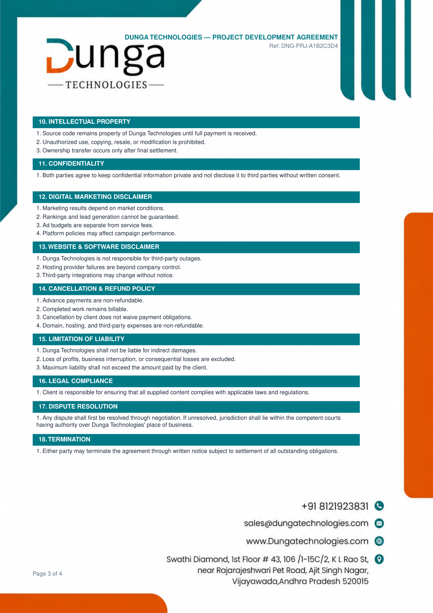
3. How to Access & Download PDFs in the System
PDF Document Type | Where to Access in CRM
Estimation & Proposal PDF | Go to Estimation page (/estimation) or Customer Details page (/customers/[id]) -> Click View PDF.
Master Project Contract PDF | Go to Project Details page (/projects/[id]) or Customer Details page (/customers/[id]) -> Click View Contract PDF.
Payment Receipt PDF | Go to Project Details page (/projects/[id]) -> Under Cost Summary & Financial Breakdown -> Payment Breakdown, click Receipt PDF.

