NARAN LALA COLLEGE
OF PROFESSIONAL & APPLIED SCIENCES
NAVSARI
NARAN LALA COLLEGE
OF PROFESSIONAL & APPLIED SCIENCES
NAVSARI

Course: Bachelor of Computer Applications (BCA)
MINOR PROJECT REPORT
PROJECT TITLE: E-COMMERCE FLOWER SHOP
SUBJECT NAME: ADVANCED WEB DESIGNING
- Submitted By:
- Chauhan Om s.
Roll No.: 35
- Project Guide:
Ms. Ayushi Mistry

- Principal:
Dr. Sunil Naik
- DECLARATION:
I/We hereby declare that the Minor Project titled“E-Commerce Flower Shop”submitted in partial fulfillment of the requirements for the Bachelor of Computer Applications (BCA) is an original work carried out by me/us under the guidance and supervision of Ms. Ayushi Mistry.I/We further declare that this project work has not been submitted previously to any other university, college, or institution for the award of any degree, diploma, or certificate.The information, data, and references used in this project have been collected from reliable sources and have been appropriately acknowledged wherever required.I/We take full responsibility for the originality and authenticity of the work presented in this project report.
Date: __________________
Student Exam No. & Name:
- Roll No. 35 — Chauhan Om S.
Signature:

- ACKNOWLEDGEMENT:
We would like to express our sincere gratitude to everyone who has supported and guided us in successfully completing our BCA Minor Project titled “E-Commerce Flower Shop”.First, we thank God for giving us the strength, knowledge, and patience to complete this project successfully.We are also thankful to the Principal, Dr. Sunil Naik, for providing us with the necessary facilities and academic support to carry out this project.We would like to express our heartfelt gratitude to our Project Guide, Ms. Ayushi Mistry, for providing valuable guidance, continuous support, constructive suggestions, and encouragement throughout the development of this project.We extend our sincere thanks to all the faculty members of the BCA Department for their valuable suggestions and assistance during our academic journey.We are grateful to our parents, family members, and friends for their constant encouragement, support, and motivation throughout the completion of this project.Finally, we thank everyone who directly or indirectly contributed to the successful completion of this project.
Thank You.

➢ DECLARATION:
I/We hereby declare that the Minor Project titled “Personal Finance & Expense Tracker” submitted in partial fulfillment of the requirements for the Bachelor of Computer Applications (BCA) is an original work carried out by me/us under the guidance and supervision of Ms. Ayushi Mistry. I/We further declare that this project work has not been submitted previously to any other university, college, or institution for the award of any degree, diploma, or certificate. The information, data, and references used in this project have been collected from reliable sources and have been appropriately acknowledged wherever required. I/We take full responsibility for the originality and authenticity of the work presented in this project report.
Date: __________________
Student Exam No. & Name:
1. Roll No. 35 —
Signature:
1. __________________________________________________
➢ ACKNOWLEDGEMENT:
We would like to express our sincere gratitude to everyone who has supported and guided us in successfully completing our BCA Minor Project titled “Personal Finance & Expense Tracker”. First, we thank God for giving us the strength, knowledge, and patience to complete this project successfully. We are also thankful to the Principal, Dr. Sunil Naik, for providing us with the necessary facilities and academic support to carry out this project. We would like to express our heartfelt gratitude to our Project Guide, Ms. Ayushi Mistry, for providing valuable guidance, continuous support, constructive suggestions, and encouragement throughout the development of this project. We extend our sincere thanks to all the faculty members of the BCA Department for their valuable suggestions and assistance during our academic journey. We are grateful to our parents, family members, and friends for their constant encouragement, support, and motivation throughout the completion of this project. Finally, we thank everyone who directly or indirectly contributed to the successful completion of this project.
Thank You.

PROJECT CERTIFICATION FORM
This is to certify that the project entitled "Personal Finance & Expense Tracker (FinTrack)" is a bona fide work carried out by the student of Bachelor of Computer Applications (BCA) in partial fulfillment of the requirements for the academic year 2025-2026.
Student Name: ____________________________________________________
Enrollment Number: ________________________________________________
The project report has been examined and evaluated by the internal project guide and program coordinator, and meets the requisite academic standards prescribed by the institute.
______________________________  Signature of Project Guide  (Ms. Ayushi Mistry)  Date: _______________ | ______________________________  Signature of Principal / HOD  (Dr. Sunil Naik)  Date: _______________

EXECUTIVE SUMMARY / ABSTRACT
The Personal Finance & Expense Tracker (FinTrack) is an automated web-based financial management system engineered to provide individuals with real-time clarity over income, expenditure, category-wise budgets, and milestone savings. Built on an asynchronous Single Page Application (SPA) architecture, the solution features a pure PHP 8.x REST backend communicating via PDO with a MySQL/MariaDB database (XAMPP stack) and a responsive, modern React 19 frontend utilizing Tailwind CSS and Recharts.

TABLE OF CONTENTS
Title Page | 1
Declaration & Acknowledgement | 2
Project Certification Form & Abstract | 3
Table of Contents | 4
1. Introduction | 5
1.1 Purpose | 5
1.2 Scope | 5
1.3 Definition | 6
1.4 Technologies to be Used | 6
2. System Analysis | 8
2.1 Identification of Need | 8
2.2 Functionalities (Usual and Distinct) | 8
2.3 User Characteristics | 9
2.4 Software Development Process | 10
3. Conceptual Diagram | 11
3.1 Use Case Diagram | 11
3.2 Activity Diagram | 12
4. System Design | 13
4.1 Data Dictionary | 13
4.2 User Interface Design | 16
4.3 Reports and Analytical Outputs | 21
5. Testing | 23
5.1 Test Cases | 23
5.2 Testing Reports & Evaluation | 25
6. Future Scope and Further Enhancement | 26
7. Learning During Project Work | 27
References | 28

1. Introduction
1.1. Purpose
The primary objective of the Personal Finance & Expense Tracker (FinTrack) project is to deliver a reliable, automated, and secure digital platform that enables users to record, categorize, analyze, and optimize their daily financial transactions. By eliminating traditional manual paper-based logs and complex spreadsheets, FinTrack provides actionable insights into personal spending habits, promotes consistent savings discipline, and safeguards users from budgetary overruns through proactive threshold monitoring.
1.2. Scope
The scope of FinTrack spans the full spectrum of personal cash-flow management for individual users and families. The functional boundaries are defined as follows:
In-Scope Capabilities:
• User account creation, profile preference management, and JWT-authenticated session security.
• Double-entry styled cash flow recording (Income vs. Expense) with granular categorization, tags, payment method tracking, and transaction notes.
• Flexible category management allowing custom color codes and icon representations.
• Time-bound monthly budget allocations per expense category with dynamic percentage consumption indicators.
• Target-oriented savings goals tracking milestone deposits and withdrawals.
• Interactive visual dashboard and analytics including 6-month trends and categorical spending distributions.
Out-of-Scope (for Current Release):
• Direct bank account open-banking synchronization via proprietary banking APIs.
• Multi-party joint bank account reconciliation and commercial accounting features.
• Stock market ticker integration and automated trading.
1.3. Definition
To ensure clarity throughout this documentation, key technical and domain terms are defined below:
• JWT (JSON Web Token): A compact, URL-safe means of representing claims securely between client and server, utilized here within HTTP-only cookies for stateless authentication.
• PDO (PHP Data Objects): A database abstraction layer in PHP providing a consistent and secure interface for issuing prepared statements to prevent SQL Injection attacks.
• REST (Representational State Transfer): An architectural style utilizing standard HTTP verbs (GET, POST, PATCH, DELETE) to manipulate resources via structured JSON payloads.
• SPA (Single Page Application): A web application that dynamically rewrites the current web page with data from the server rather than loading entire new pages from the server.
• Minor Units (Cents / Paise): Storing currency amounts as integers multiplied by 100 to eliminate floating-point arithmetic rounding errors in monetary calculations.
1.4. Technologies to be Used
Hardware Requirements (Development & Deployment):
• Processor: Dual Core Intel Core i3 / AMD Ryzen 3 or higher (2.0 GHz+).
• Memory (RAM): Minimum 4 GB RAM (8 GB recommended for development).
• Storage: 250 MB free disk space for application files, dependencies, and database storage.
• Display: 1366 x 768 minimum display resolution (Optimized for 1920 x 1080 Full HD).
Software Requirements:
• Operating System: Microsoft Windows 10 / 11, Linux (Ubuntu 20.04+), or macOS.
• Web Server & Database Stack: XAMPP Version 8.2 (Apache 2.4, MariaDB / MySQL 10.4+).
• Backend Runtime: Pure PHP 8.2+ with PDO MySQL and OpenSSL extensions enabled.
• Frontend Stack: React 19, Vite 8 build tool, Tailwind CSS v4, Recharts 3.x, Axios 1.x.
• Client Web Browser: Modern Chromium-based browser (Google Chrome, Microsoft Edge, Brave) or Mozilla Firefox.

2. System Analysis
2.1. Identification of Need
In the modern economic environment, individuals encounter multiple payment channels including UPI, debit/credit cards, net banking, and physical cash. This fragmentation makes financial tracking tedious and disorganized. Studies indicate that over 65% of individuals who fail to maintain a structured budget encounter unforeseen end-of-month financial stress.
Existing commercial alternatives often charge heavy monthly subscription fees or harvest user banking data for third-party advertising. There is an unmistakable need for a lightweight, transparent, highly secure, and intuitive web application that allows users to regain complete mastery over their financial life without compromising personal privacy.
2.2. Functionalities
Usual Functionalities:
• User Registration, Secure Login, Logout, and Password Change.
• CRUD operations (Create, Read, Update, Delete) for income and expense transactions.
• Filtering transactions by date range, transaction type, category, and payment method.
• Pre-configured default categories (Salary, Food & Dining, Utilities, Transportation, etc.).
• Pagination and search capabilities for reviewing extensive transaction records.
Distinct Functionalities:
• High-Precision Financial Computation: Financial amounts are stored internally in minor units (integer cents/paise) to guarantee zero floating-point calculation errors.
• Real-Time Budget Utilization Gauges: Dynamic status tags ('Normal', 'Warning' at 80%, 'Exceeded' at 100%) computed on-the-fly against live transaction sums.
• Milestone-Driven Goal Tracker: Visual progress meters with dedicated contribution and withdrawal transaction histories for targeted savings.
• Zero-Dependency Pure PHP REST API: Modular PHP backend constructed without heavy third-party framework overhead, running natively on standard XAMPP.
• Interactive Data Visualizations: High-performance SVG responsive charts rendering monthly income-vs-expense comparisons and categorical expense distributions.
2.3. User Characteristics
• Regular User / Working Professional: Needs rapid expense recording, salary logging, and monthly budget notifications to curb overspending.
• Student / Freelancer: Manages irregular income streams, requires tracking of project-based milestone fees, and monitors living expenditures.
• System Administrator: Manages database integrity, inspects server health endpoints, and maintains backup/restore procedures.
2.4. Software Development Process
The Agile Iterative Prototyping methodology was adopted for this project. Development proceeded across four structured sprints:
• Sprint 1 (Requirements & Database Architecture): Defined REST contracts, constructed MySQL schema (`schema.sql`), and designed database tables with referential integrity.
• Sprint 2 (Backend Core Services): Implemented pure PHP REST controllers, PDO abstraction, and cookie-based JWT authentication middleware.
• Sprint 3 (Frontend & Visual Components): Developed responsive React views with Tailwind CSS, Recharts analytics, and Axios API services.
• Sprint 4 (Testing, Data Seeding & Optimization): Populated database with comprehensive dummy data, executed automated unit and integration tests, and polished UI micro-interactions.

3. Conceptual Diagram
3.1. Use Case Diagram
The Use Case Diagram defines the interactions between the external actor (User) and the core sub-systems of the Personal Finance Tracker application.
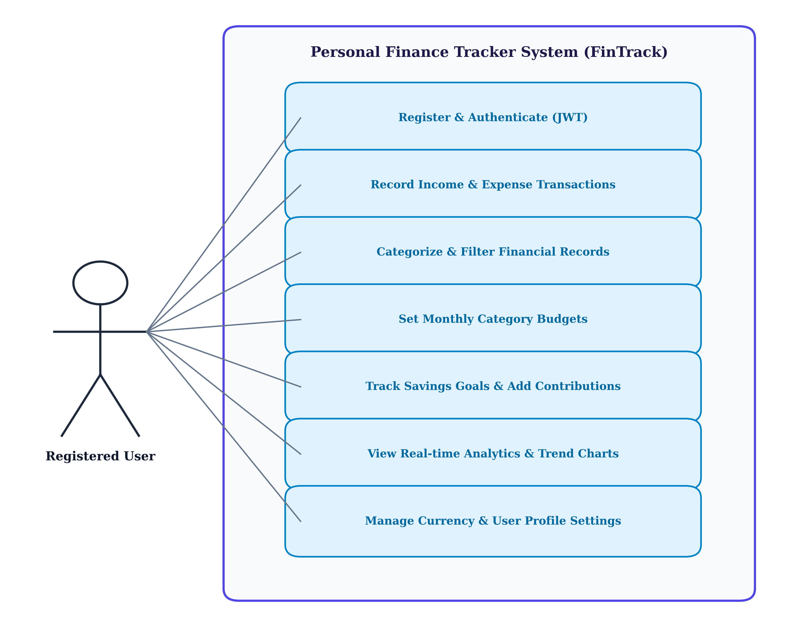
Figure 3.1: UML Use Case Diagram for FinTrack System
As illustrated in Figure 3.1, the registered user interacts with seven primary use cases: Authenticate (Login/Register), Record Transactions, Categorize & Filter Records, Set Monthly Budgets, Manage Savings Goals & Contributions, View Real-time Analytics & Dashboard, and Manage Profile Settings.
3.2. Activity Diagram
The Activity Diagram models the dynamic operational workflow of recording an expense, validating user inputs, updating database state, and recalculating dashboard metrics.
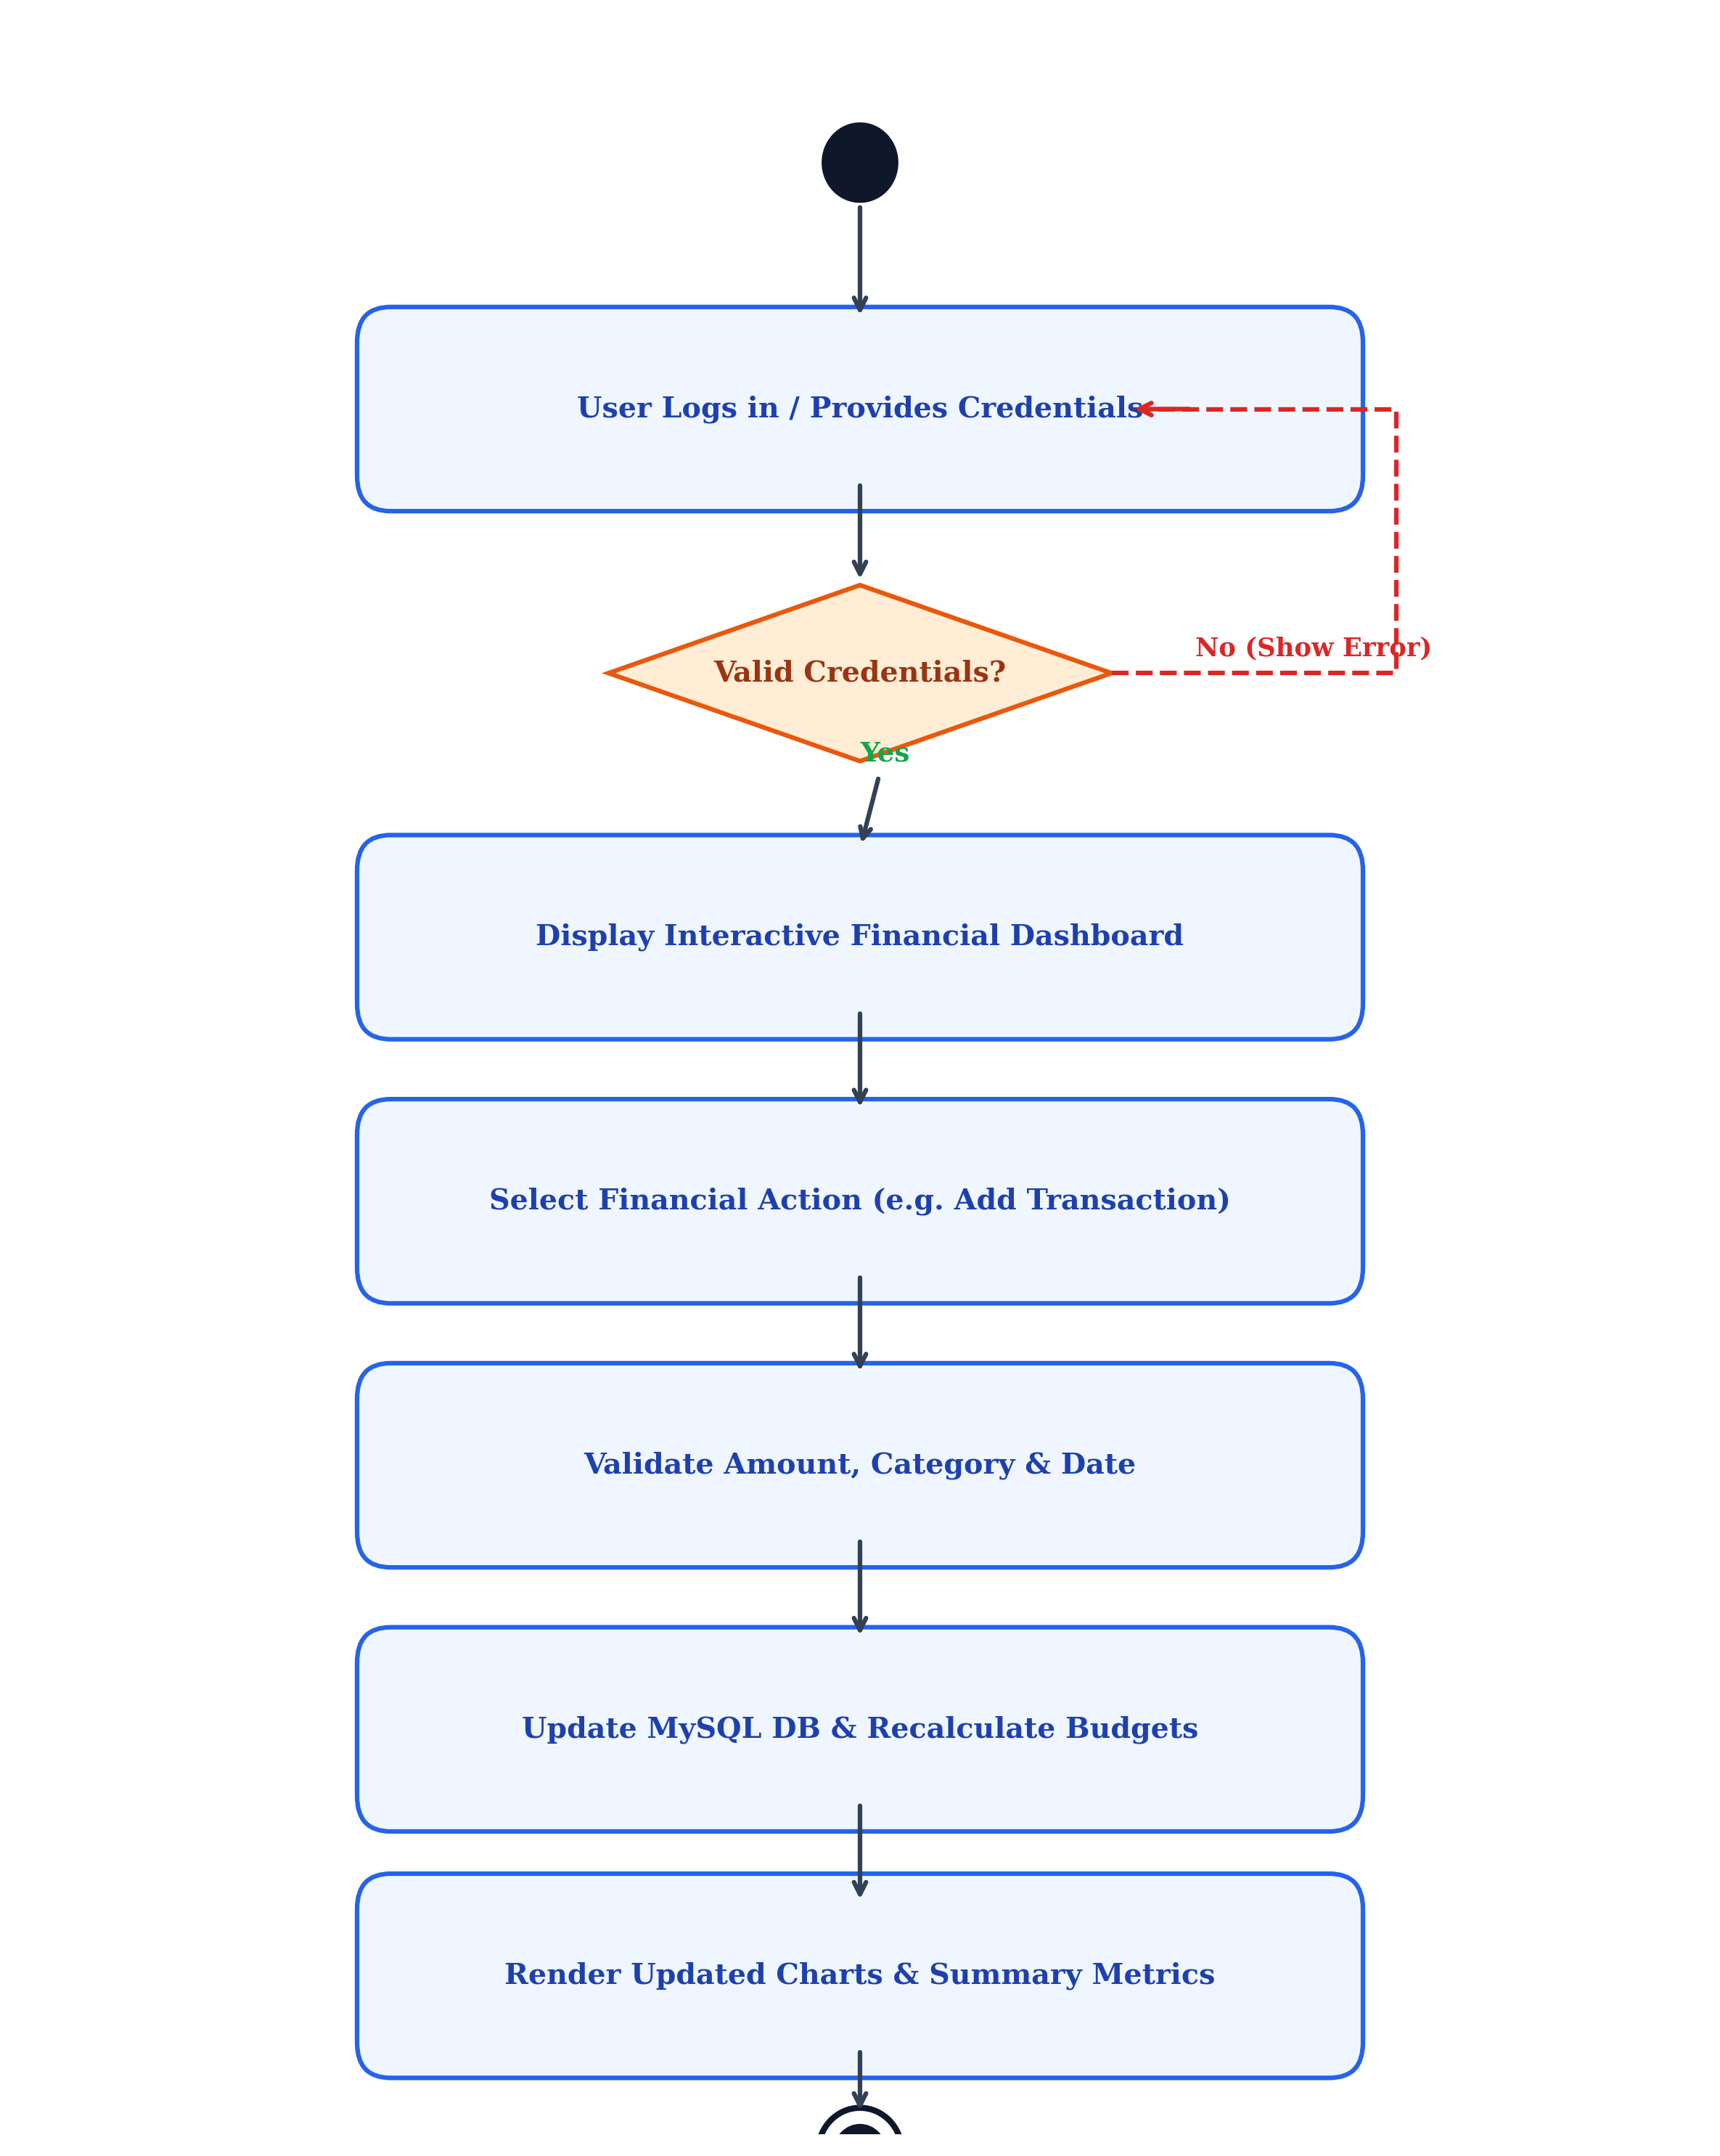
Figure 3.2: UML Activity Diagram for Financial Transaction Lifecycle
Figure 3.2 demonstrates the end-to-end decision flow from authentication, through transaction capture and validation, to atomic database commit and real-time visualization update.

4. System Design
4.1. Data Dictionary
The Data Dictionary provides an exhaustive specification of the database tables, fields, data types, keys, and relational constraints configured in the MySQL database (`finance_tracker`).
Table 4.1: users
Field Name | Data Type | Constraints / Key | Description
id | INT | PRIMARY KEY, AUTO_INCREMENT | Unique user identifier
name | VARCHAR(100) | NOT NULL | Full name of the user
email | VARCHAR(191) | NOT NULL, UNIQUE | User email address for login
password_hash | VARCHAR(255) | NOT NULL | Bcrypt hashed password string
preferred_currency | VARCHAR(10) | DEFAULT 'INR' | Currency symbol preference (INR, USD, EUR)
theme | ENUM | 'light', 'dark' | UI display theme preference
created_at | TIMESTAMP | DEFAULT CURRENT_TIMESTAMP | Account creation timestamp

Table 4.2: categories
Field Name | Data Type | Constraints / Key | Description
id | INT | PRIMARY KEY, AUTO_INCREMENT | Unique category identifier
user_id | INT | FOREIGN KEY -> users(id) | Associated user reference
name | VARCHAR(100) | NOT NULL | Display name of category
type | ENUM | 'income', 'expense', 'both' | Category cash flow classification
color | VARCHAR(20) | DEFAULT '#6366f1' | Hex color code for UI charts
icon | VARCHAR(50) | DEFAULT 'tag' | Lucide icon identifier
is_default | TINYINT(1) | DEFAULT 0 | Flag preventing deletion of system defaults

Table 4.3: transactions
Field Name | Data Type | Constraints / Key | Description
id | INT | PRIMARY KEY, AUTO_INCREMENT | Unique transaction record identifier
user_id | INT | FOREIGN KEY -> users(id) | Associated user owner
title | VARCHAR(200) | NOT NULL | Transaction description or payee
amount_minor | BIGINT | NOT NULL | Amount in minor currency units (paise/cents)
type | ENUM | 'income', 'expense' | Cash flow direction
category | VARCHAR(100) | NOT NULL | Category name string
date | DATETIME | NOT NULL, INDEXED | Date and time of transaction
payment_method | VARCHAR(50) | DEFAULT 'cash' | Method (upi, card, cash, bank_transfer)
notes | TEXT | NULLABLE | Optional notes or remarks
tags | TEXT | NULLABLE | JSON serialized array of search tags

Table 4.4: budgets
Field Name | Data Type | Constraints / Key | Description
id | INT | PRIMARY KEY, AUTO_INCREMENT | Unique budget identifier
user_id | INT | FOREIGN KEY -> users(id) | User reference
category | VARCHAR(100) | NOT NULL | Target expense category
amount_minor | BIGINT | NOT NULL | Spending cap limit in minor currency units
period | VARCHAR(20) | DEFAULT 'monthly' | Budget allocation frequency
start_date | DATETIME | NOT NULL | Start of budget validity period
end_date | DATETIME | NOT NULL | End of budget validity period

Table 4.5: savings_goals
Field Name | Data Type | Constraints / Key | Description
id | INT | PRIMARY KEY, AUTO_INCREMENT | Unique goal identifier
user_id | INT | FOREIGN KEY -> users(id) | Owner user ID
title | VARCHAR(200) | NOT NULL | Goal target name (e.g. Emergency Fund)
target_amount_minor | BIGINT | NOT NULL | Target savings amount in minor units
current_amount_minor | BIGINT | DEFAULT 0 | Accumulated savings amount
target_date | DATETIME | NULLABLE | Target milestone completion date
status | ENUM | 'active', 'completed' | Current milestone status

Table 4.6: goal_contributions
Field Name | Data Type | Constraints / Key | Description
id | INT | PRIMARY KEY, AUTO_INCREMENT | Unique contribution log ID
user_id | INT | FOREIGN KEY -> users(id) | User reference
goal_id | INT | FOREIGN KEY -> savings_goals(id) | Associated savings goal
amount_minor | BIGINT | NOT NULL | Contribution or withdrawal amount
type | ENUM | 'contribution', 'withdrawal' | Type of balance alteration
notes | TEXT | NULLABLE | Deposit memo or reason
date | TIMESTAMP | DEFAULT CURRENT_TIMESTAMP | Log timestamp

4.2. User Interface Design
The following section presents live application snapshots captured from the working system, highlighting key operational interfaces, input fields, and real-time validations:
1. Authentication & Login Screen
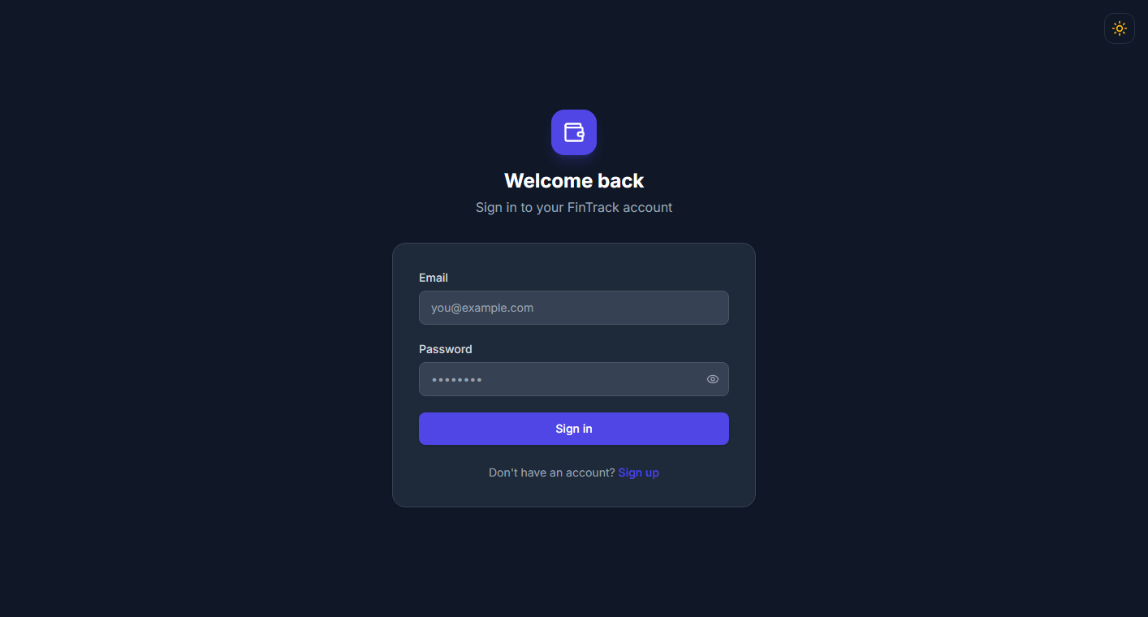
Figure 4.1: User Login Screen with Input Validation
• Validation: Email format validation regex (`^\S+@\S+\.\S+$`), mandatory password check with minimum 6 characters length enforcement.
• Security: Upon verification, the PHP backend issues an HTTP-only cookie containing a signed JWT token.
2. Executive Financial Dashboard
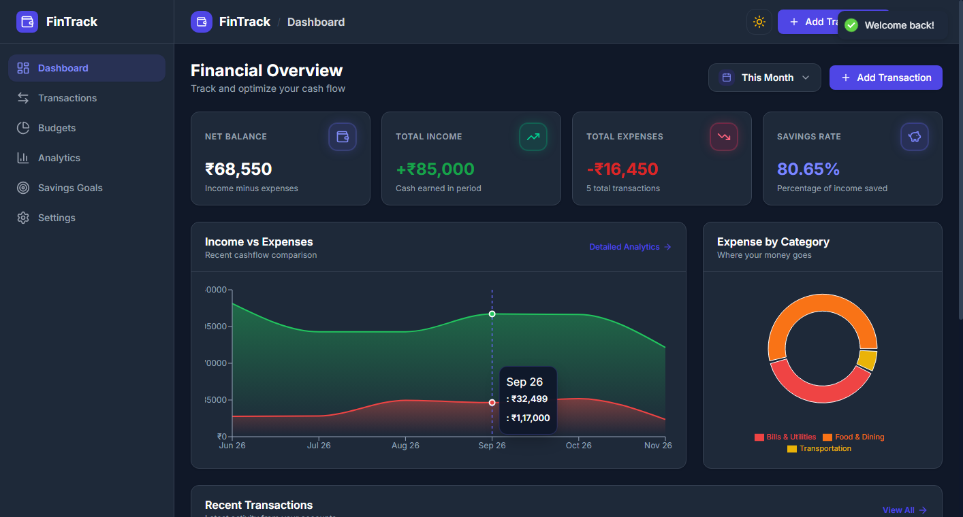
Figure 4.2: Real-time Financial Dashboard with Summary Metrics
• Real-Time Metrics: Total Income, Total Expenses, Net Balance, and Calculated Savings Rate.
• Quick Action Triggers: One-click modal launching to register immediate transactions.
3. Dashboard Visual Charts & Category Breakdown
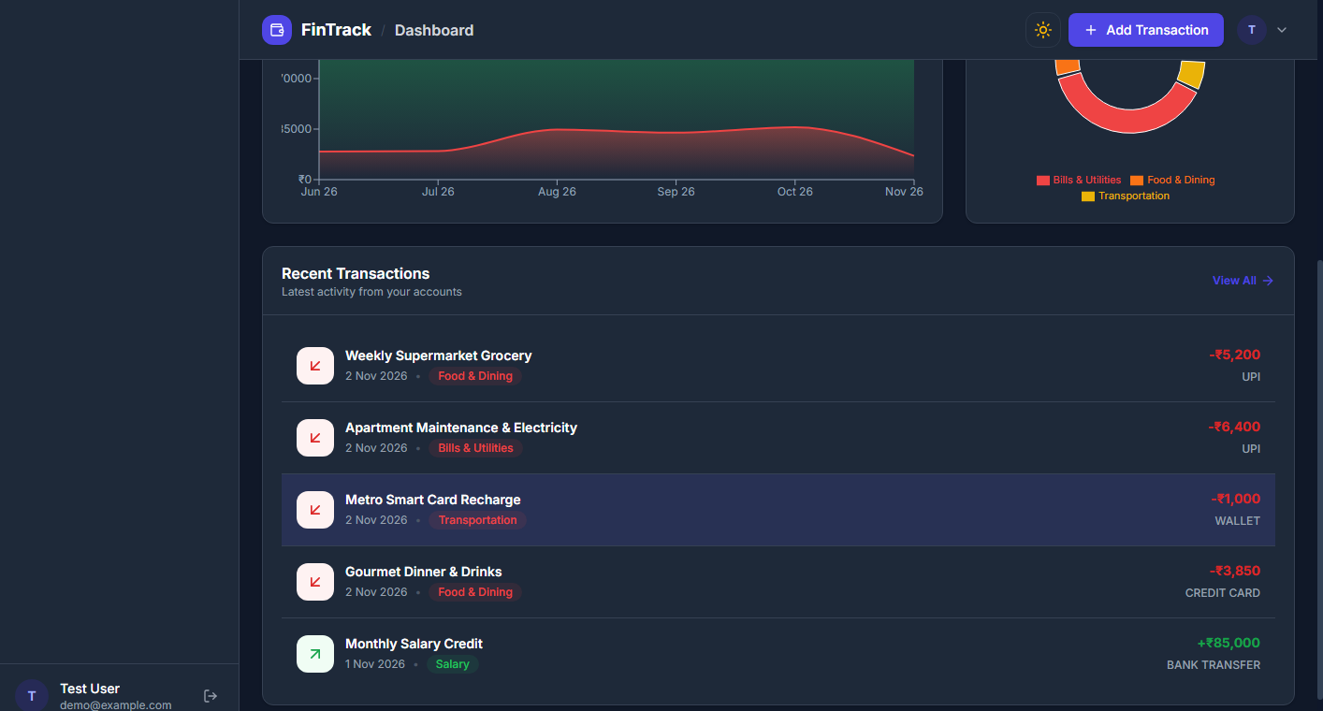
Figure 4.3: 6-Month Income vs Expense Bar Chart and Top Expense Distribution
• 6-Month Cash Flow: Dual-bar graph comparing monthly income and expenditure patterns.
• Top Expense Categories: Aggregated ranking displaying category spending totals and count.
4. Transaction Management & Multi-Filter Registry
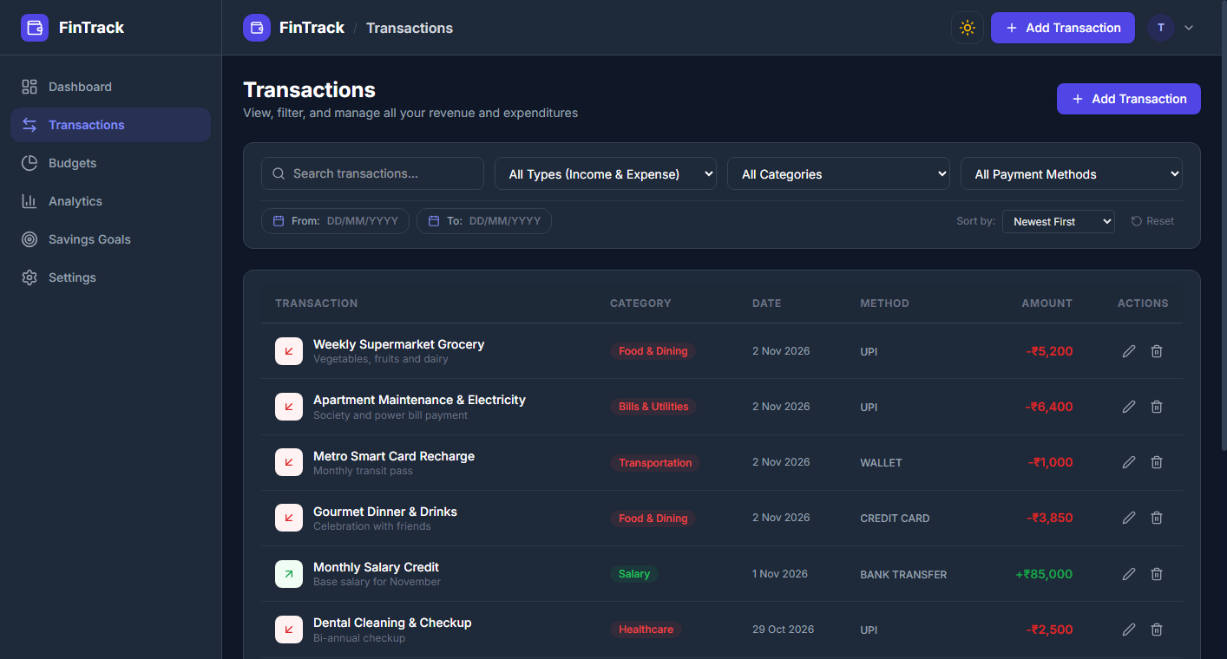
Figure 4.4: Paginated Transaction Table with Filtering Controls
• Multi-parameter Search: Filter records by transaction type (Income/Expense), category dropdown, date intervals, and payment methods.
• Pagination: Server-side pagination executing SQL `LIMIT` and `OFFSET` queries.
5. Transaction Creation & Validation Modal
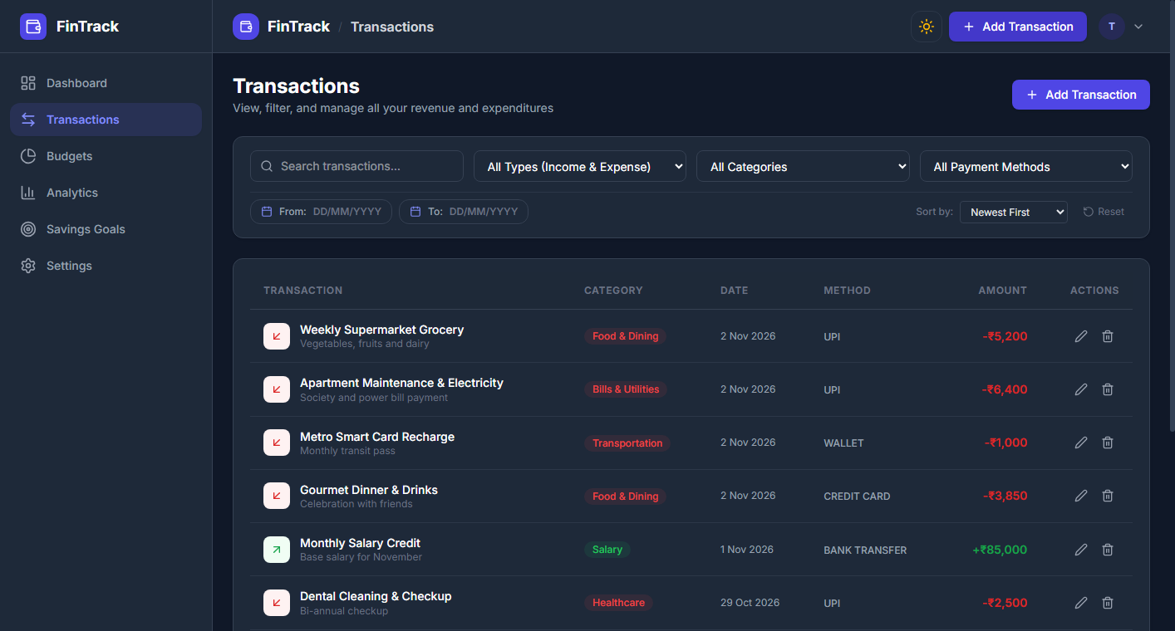
Figure 4.5: Add Transaction Modal Dialog with Strict Form Controls
• Validation Rules: Title (mandatory, max 200 chars), Amount (must be strictly positive integer/float), Category selection, and Valid Date format.
6. Monthly Budgets & Spending Threshold Tracker
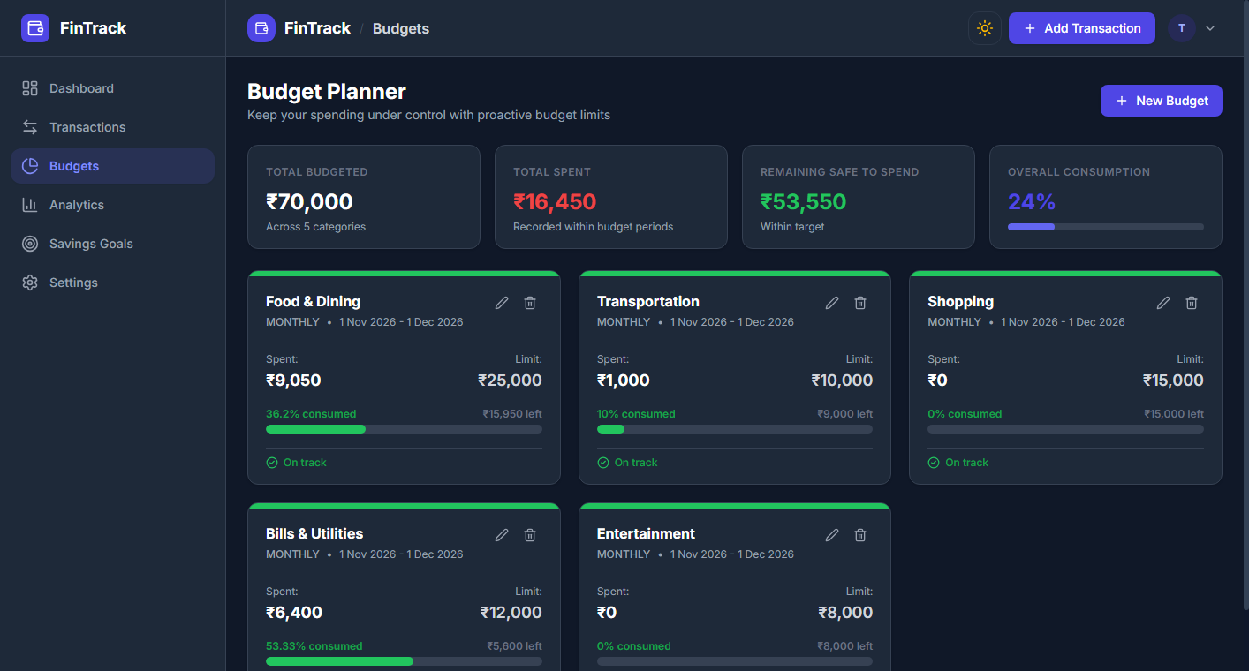
Figure 4.6: Category Budget Utilization Cards with Warning Badges
• Dynamic Color Status: Normal (Green < 80%), Warning (Amber >= 80%), and Exceeded (Red >= 100%).
• Overlap Prevention: Backend rejects overlapping budget intervals for the same category.
7. Savings Goals & Milestone Progress Tracker
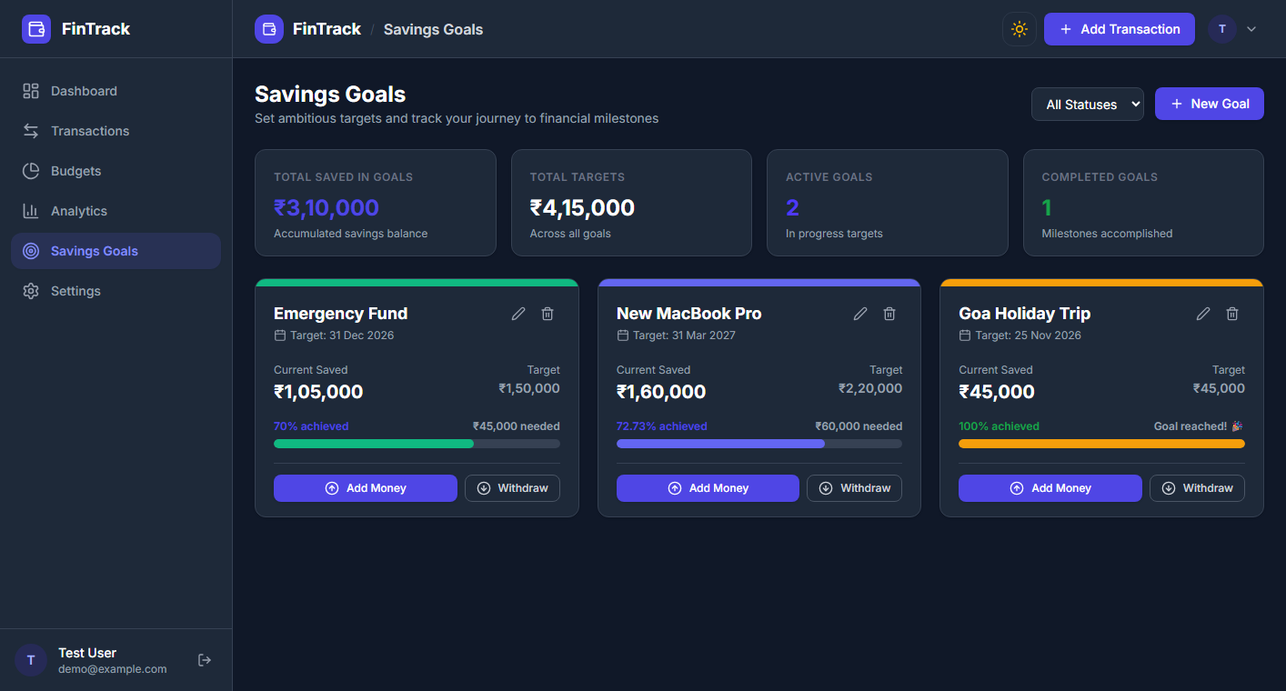
Figure 4.7: Target Savings Goals with Contribution History
• Goal Automation: Automatically switches status to 'Completed' when accumulated contributions match or exceed the target.
8. Category Customization & Profile Preferences
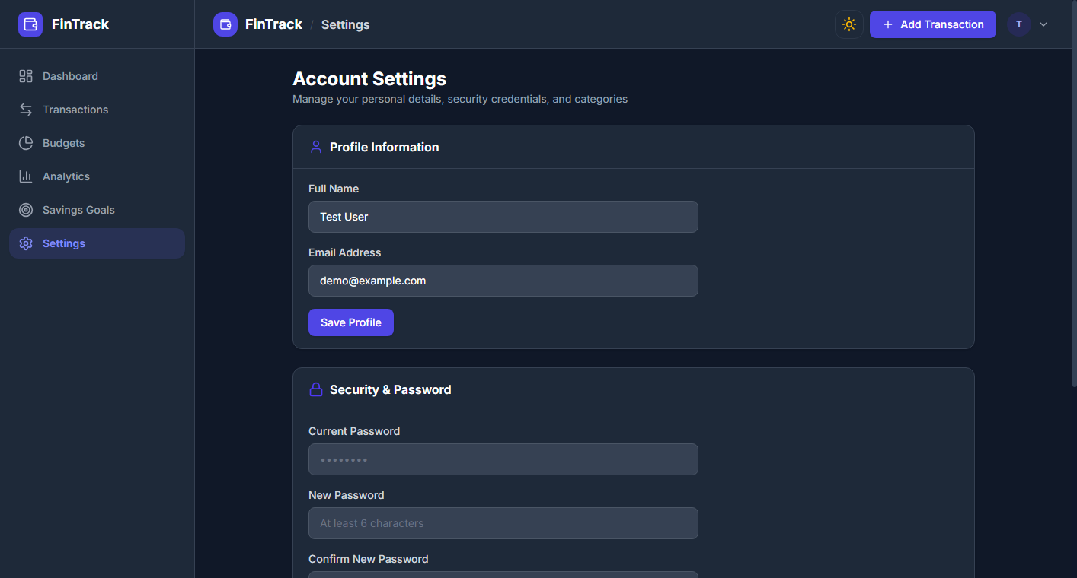
Figure 4.8: Category Palette Customizer and System Settings
• Protection: Default system categories are locked against deletion, ensuring historical consistency.
4.3. Reports and Analytical Outputs
FinTrack generates comprehensive visual analytical reports reflecting cash flow distributions and trend trajectories over multi-month intervals:
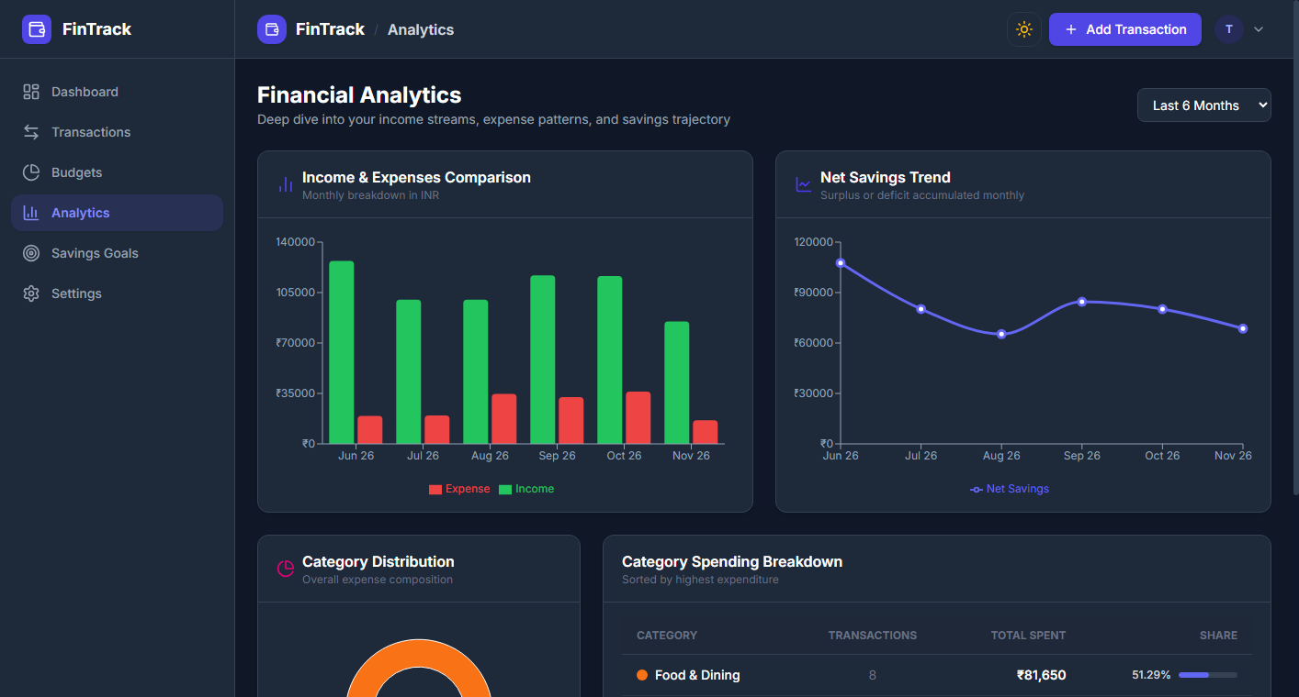
Figure 4.9: Analytical Reports showing Cash Flow Trend and Expense Breakdown
• Income vs. Expense Analytical Chart: Visualizes cash flow divergence across quarterly and annual intervals.
• Categorical Distribution: Donut / Bar breakdown showing percentage utilization per category.
• Monthly Trend Analysis: Mathematical evaluation of savings rate trajectories to assist long-term wealth planning.

5. Testing
5.1. Test Cases
Comprehensive manual and automated test suites were executed across the authentication, transaction, budgeting, and analytical modules. The results are summarized below:
Test ID | Test Scenario | Input Parameters | Expected Result | Actual Result | Status
TC-01 | User Registration | Valid name, email, 8-char password | User created (201), 12 default categories seeded | Account created, categories seeded | Pass
TC-02 | Duplicate Registration | Existing registered email | HTTP 409 Conflict, error message | HTTP 409 Conflict returned | Pass
TC-03 | User Authentication | Correct email & password | HTTP 200, JWT token set in HTTP-only cookie | Auth cookie set, user returned | Pass
TC-04 | Invalid Login | Unregistered email / wrong password | HTTP 401 Unauthorized | HTTP 401 returned | Pass
TC-05 | Record Transaction | Positive amount, category, date | Record committed, amount stored in minor units | Committed to MySQL in paise | Pass
TC-06 | Negative Amount Validation | Amount = -500 | Frontend validation block & HTTP 400 error | Blocked with validation alert | Pass
TC-07 | Budget Overlap Check | Duplicate budget for same category/month | HTTP 409 Overlapping budget conflict | HTTP 409 Conflict triggered | Pass
TC-08 | Budget Exceeded Flag | Expenses exceed 100% of budget cap | Budget status set to 'exceeded', badge red | Calculated 100%+ and red badge | Pass
TC-09 | Goal Contribution | Deposit amount added to goal | Balance updated, record logged in history | Balance incremented, log stored | Pass
TC-10 | Goal Excessive Withdrawal | Withdrawal amount > current savings | HTTP 400 'Exceeds current savings' | HTTP 400 rejected with message | Pass

5.2. Testing Reports & Evaluation
• Unit Testing: Evaluated all PHP endpoints and JWT generation/verification algorithms using Postman and CLI scripts.
• Integration Testing: Verified end-to-end data flow between React Axios services, Vite proxy, PHP REST router, and MySQL tables.
• Security Testing: Inspected SQL injection vulnerabilities using parameterized PDO queries; confirmed password hashing resistance using Bcrypt (cost factor 10); verified Cross-Site Scripting (XSS) defenses through React sanitized rendering.

6. Future Scope and Further Enhancement
While the current version of FinTrack provides a robust and complete personal finance management solution, future iterations can introduce advanced capabilities:
1. Optical Character Recognition (OCR) for Receipts: Integrating computer vision to allow users to photograph paper receipts and automatically parse date, vendor, tax, and itemized totals.
2. Automated Bank Statement Import (PDF/CSV): Direct parsing of standard banking statement exports to batch-import transactions with automated categorization.
3. AI-Powered Predictive Budgeting: Machine learning algorithms to analyze historical spending patterns and project future cash-flow deficits before they occur.
4. Native Mobile Application: Packaging the React frontend with Capacitor or React Native to deliver push notifications for daily budget reminders on Android and iOS devices.
5. Multi-User Family Wallets: Collaborative financial accounts allowing shared household budgets with customizable permission tiers.

7. Learning During Project Work
The journey of conceptualizing, designing, and engineering the Personal Finance Tracker provided profound hands-on experience across the full software development lifecycle:
• Decoupled Architecture Design: Gained in-depth appreciation for separating business logic into clean REST endpoints, allowing the backend to run on pure PHP while the frontend operates as a decoupled modern React application.
• Defensive Database Design & Currency Precision: Learned the critical importance of integer-based minor currency representation (`amount_minor`) to avoid floating-point imprecision in financial systems.
• Robust Authentication Patterns: Mastered token-based stateless security, implementing HMAC-SHA256 JWTs paired with secure HTTP-only cookies to thwart token theft and XSS vulnerabilities.
• Asynchronous Data Visualization: Implemented optimized data aggregation pipelines in SQL to deliver instant chart responses without burdening client-side memory.

References
1. Welling, L., & Thomson, L. (2016). PHP and MySQL Web Development (5th ed.). Addison-Wesley Professional.
2. Nixon, R. (2021). Learning PHP, MySQL & JavaScript: With jQuery, CSS & HTML5 (6th ed.). O'Reilly Media.
3. Banks, A., & Porcello, E. (2020). Learning React: Modern Patterns for Developing React Apps (2nd ed.). O'Reilly Media.
4. PHP Group. (2024). PHP Data Objects (PDO) Documentation. Retrieved from https://www.php.net/manual/en/book.pdo.php
5. React Core Team. (2025). React Documentation & Hooks Reference. Retrieved from https://react.dev
6. Mozilla Developer Network (MDN). (2024). HTTP Cookies and Web Security Standards. Retrieved from https://developer.mozilla.org/en-US/docs/Web/HTTP/Cookies
7. Apache Friends. (2024). XAMPP Apache + MariaDB + PHP Documentation. Retrieved from https://www.apachefriends.org

