Rapid Document Conversion using AWS

Abstract
This project implements a serverless document conversion system using AWS. Documents uploaded to Amazon S3 are automatically processed using AWS Lambda and Amazon Textract to extract text and store the output in another S3 bucket.

Architecture Overview
User → S3 Input Bucket → Lambda → Amazon Textract → S3 Output Bucket

[Insert Architecture Diagram Screenshot Here]

Step 1: Create S3 Input Bucket
Purpose: Store uploaded documents and trigger Lambda.

Steps:
1. Open AWS Console
2. Go to S3 → Create bucket
3. Bucket name: rapid-doc-input-123
4. Region: us-east-1
5. Keep Block Public Access enabled
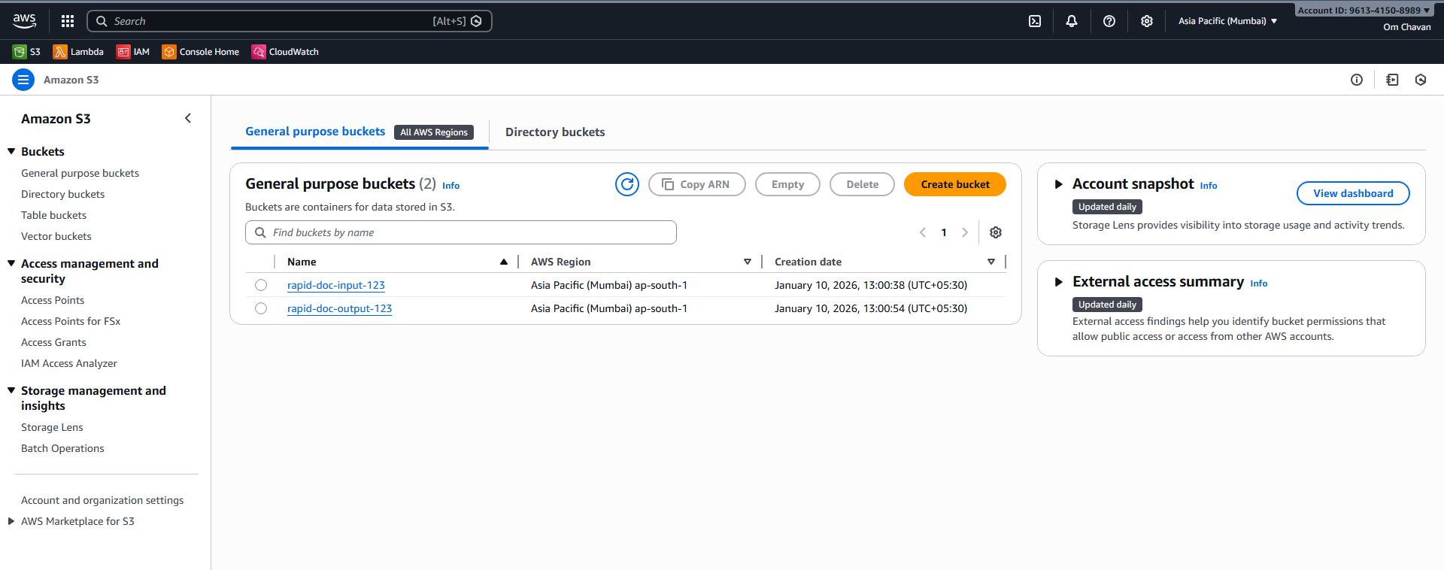

Step 2: Create S3 Output Bucket
Purpose: Store extracted text files.

Steps:
1. Go to S3 → Create bucket
2. Bucket name: rapid-doc-output-123
3. Same region as input bucket
1]

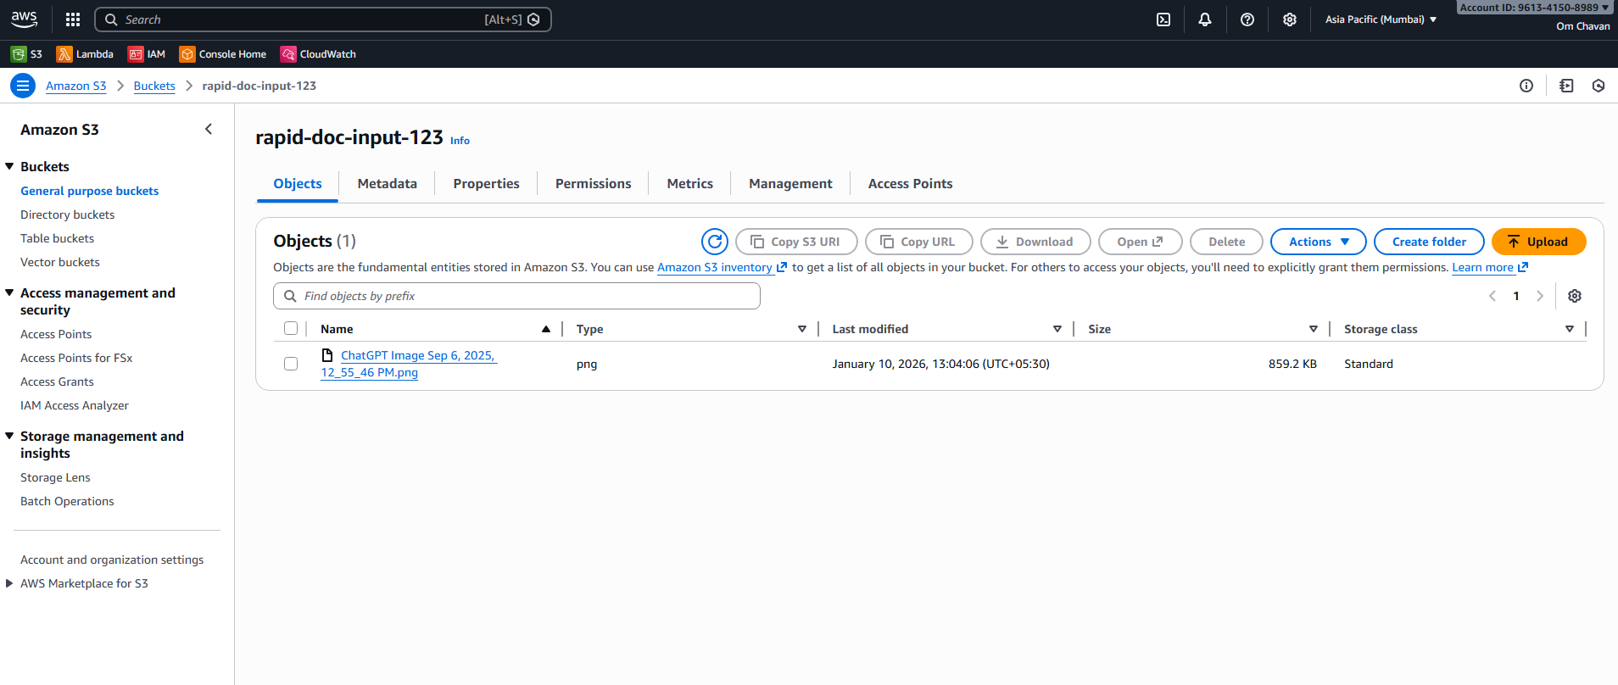
2) 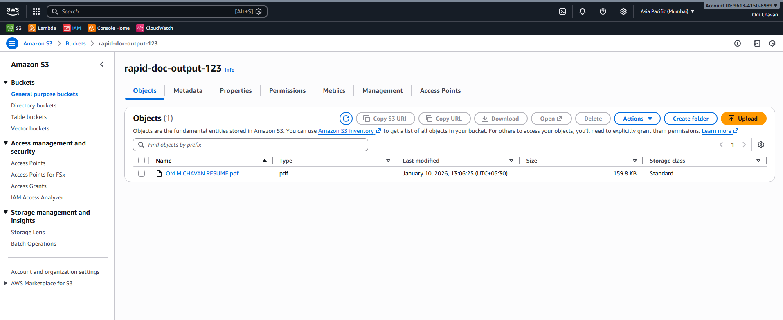

Step 3: Create IAM Role
Purpose: Allow Lambda to access S3, Textract, and CloudWatch.

Steps:
1. Open IAM → Roles → Create role
2. Select AWS service → Lambda
3. Attach policies:
- AmazonS3FullAccess
- AmazonTextractFullAccess
- CloudWatchLogsFullAccess
4. Role name: RapidDocumentLambdaRole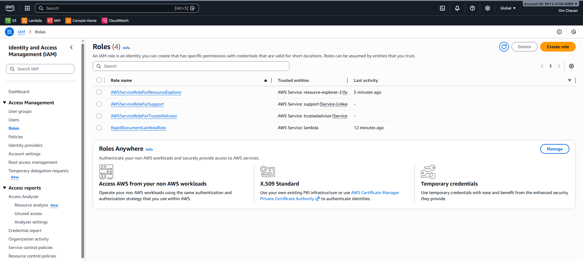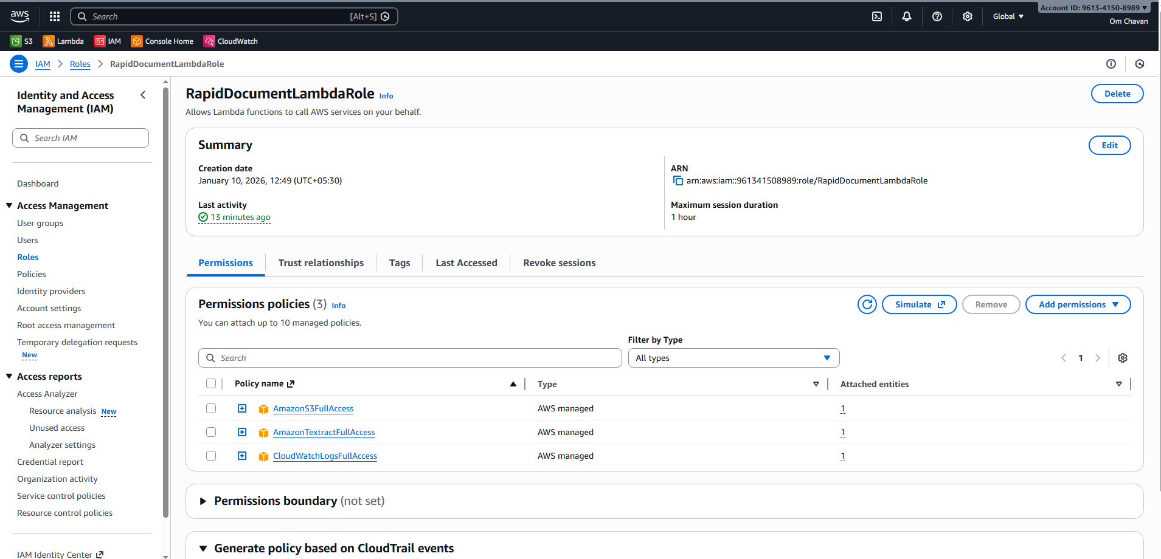

Step 4: Create Lambda Function
Purpose: Execute document conversion logic.

Steps:
1. Go to AWS Lambda → Create function
2. Function name: RapidDocumentConversion
3. Runtime: Python 3.9
4. Select existing role: RapidDocumentLambdaRole

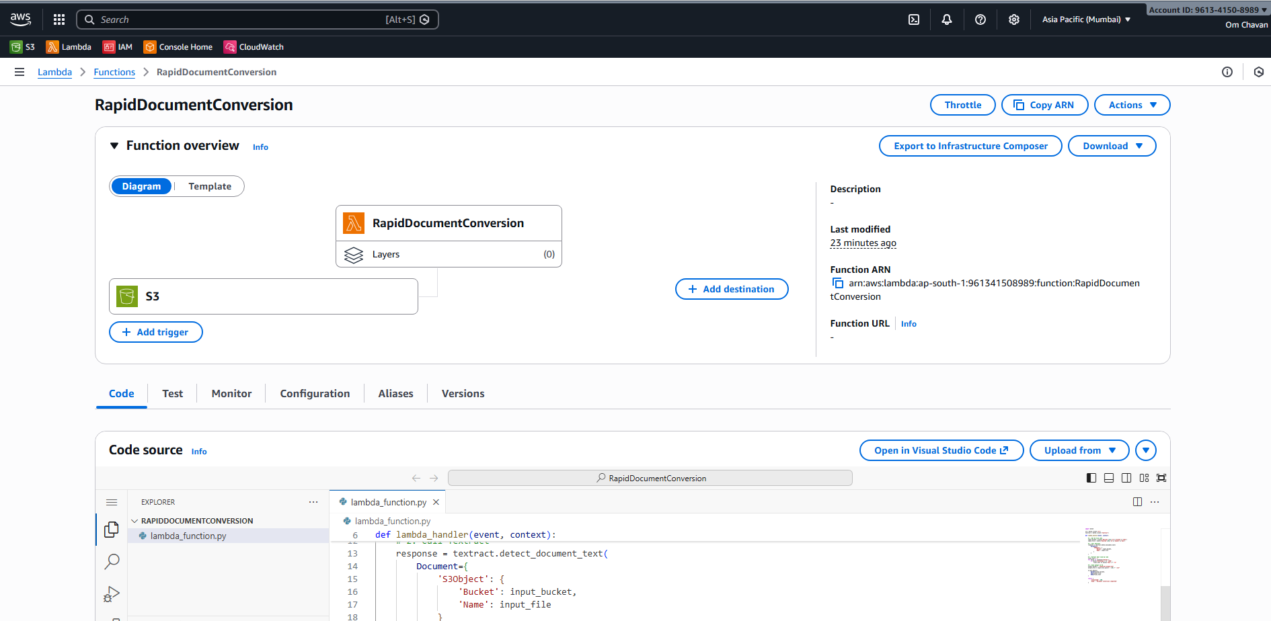

2) Python 10.0
import boto3
s3 = boto3.client('s3')
textract = boto3.client('textract')
def lambda_handler(event, context):
# 1. Get S3 file info
input_bucket = event['Records'][0]['s3']['bucket']['name']
input_file = event['Records'][0]['s3']['object']['key']
# 2. Call Textract
response = textract.detect_document_text(
Document={
'S3Object': {
'Bucket': input_bucket,
'Name': input_file
}
}
)
# 3. Extract text line by line
final_text = ""
for block in response['Blocks']:
if block['BlockType'] == 'LINE':
final_text += block['Text'] + "\n"
# 4. Save output to S3
output_bucket = "rapid-doc-output-123"
output_file = input_file.split('.')[0] + ".txt"
s3.put_object(
Bucket=output_bucket,
Key=output_file,
Body=final_text
)
return {
'statusCode': 200,
'body': 'Document conversion completed'
}

Step 5: Configure Lambda Settings
Purpose: Ensure enough execution time and memory.

Settings:
- Timeout: 1 minute
- Memory: 512 MB

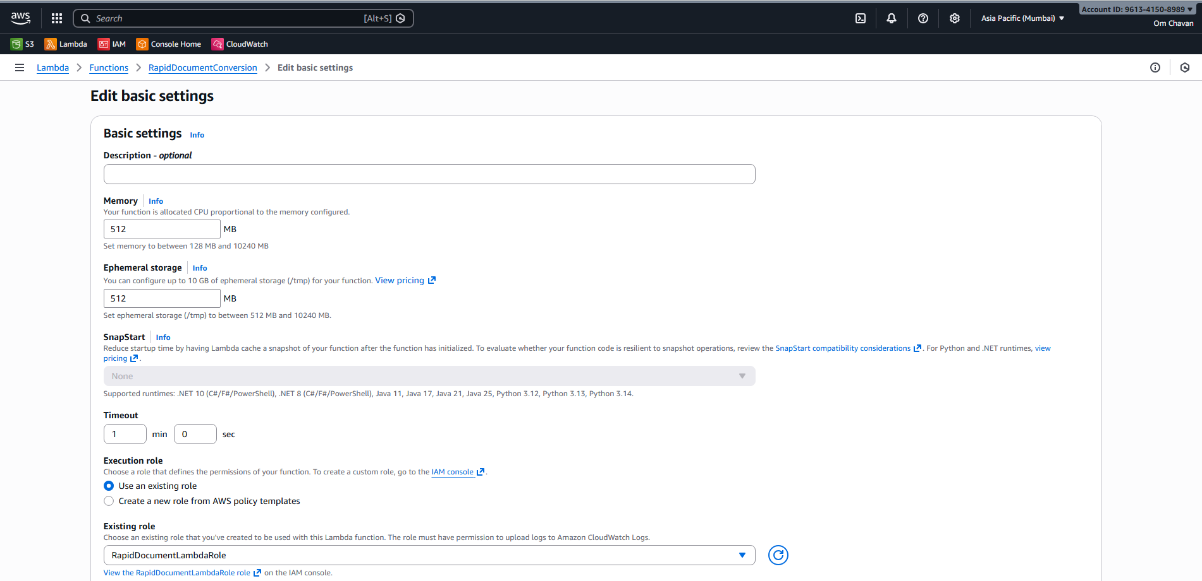

6: Add Step Lambda Code
Purpose: Extract text using Textract and store output in S3.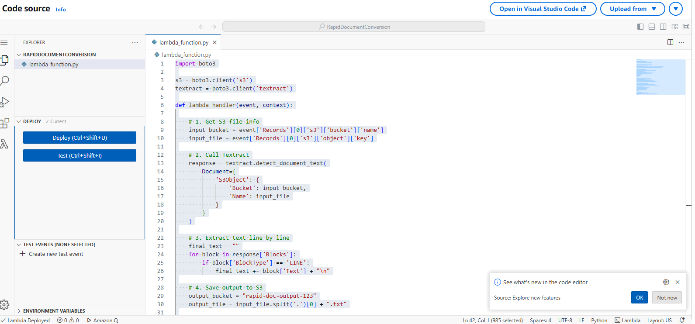

Step 7: Configure S3 Trigger
Purpose: Automatically trigger Lambda on file upload.

Steps:
1. Open Lambda → Add Trigger
2. Select S3
3. Bucket: rapid-doc-input-123
4. Event type: PUT

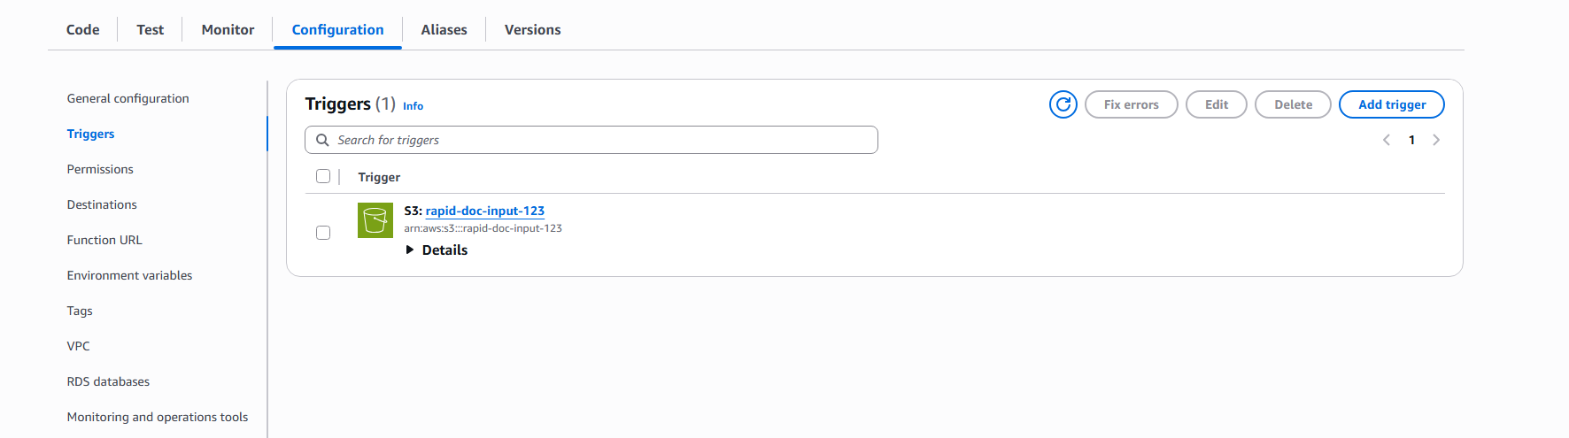

Step 8: Upload Test Document
Steps:
1. Go to S3 Input Bucket
2. Upload PDF / JPG / PNG file

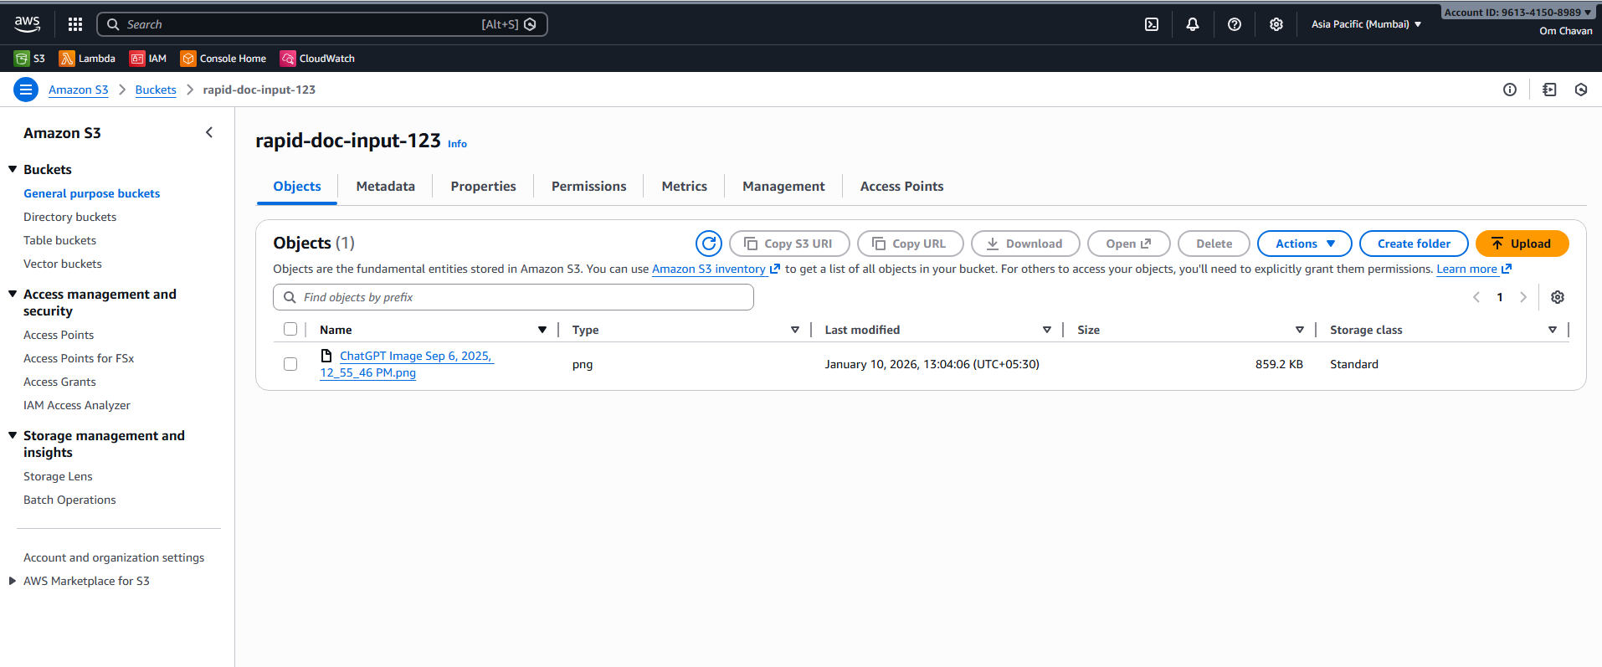

Step 9: Verify Output
Steps:
1. Open S3 Output Bucket
2. Download generated .txt file

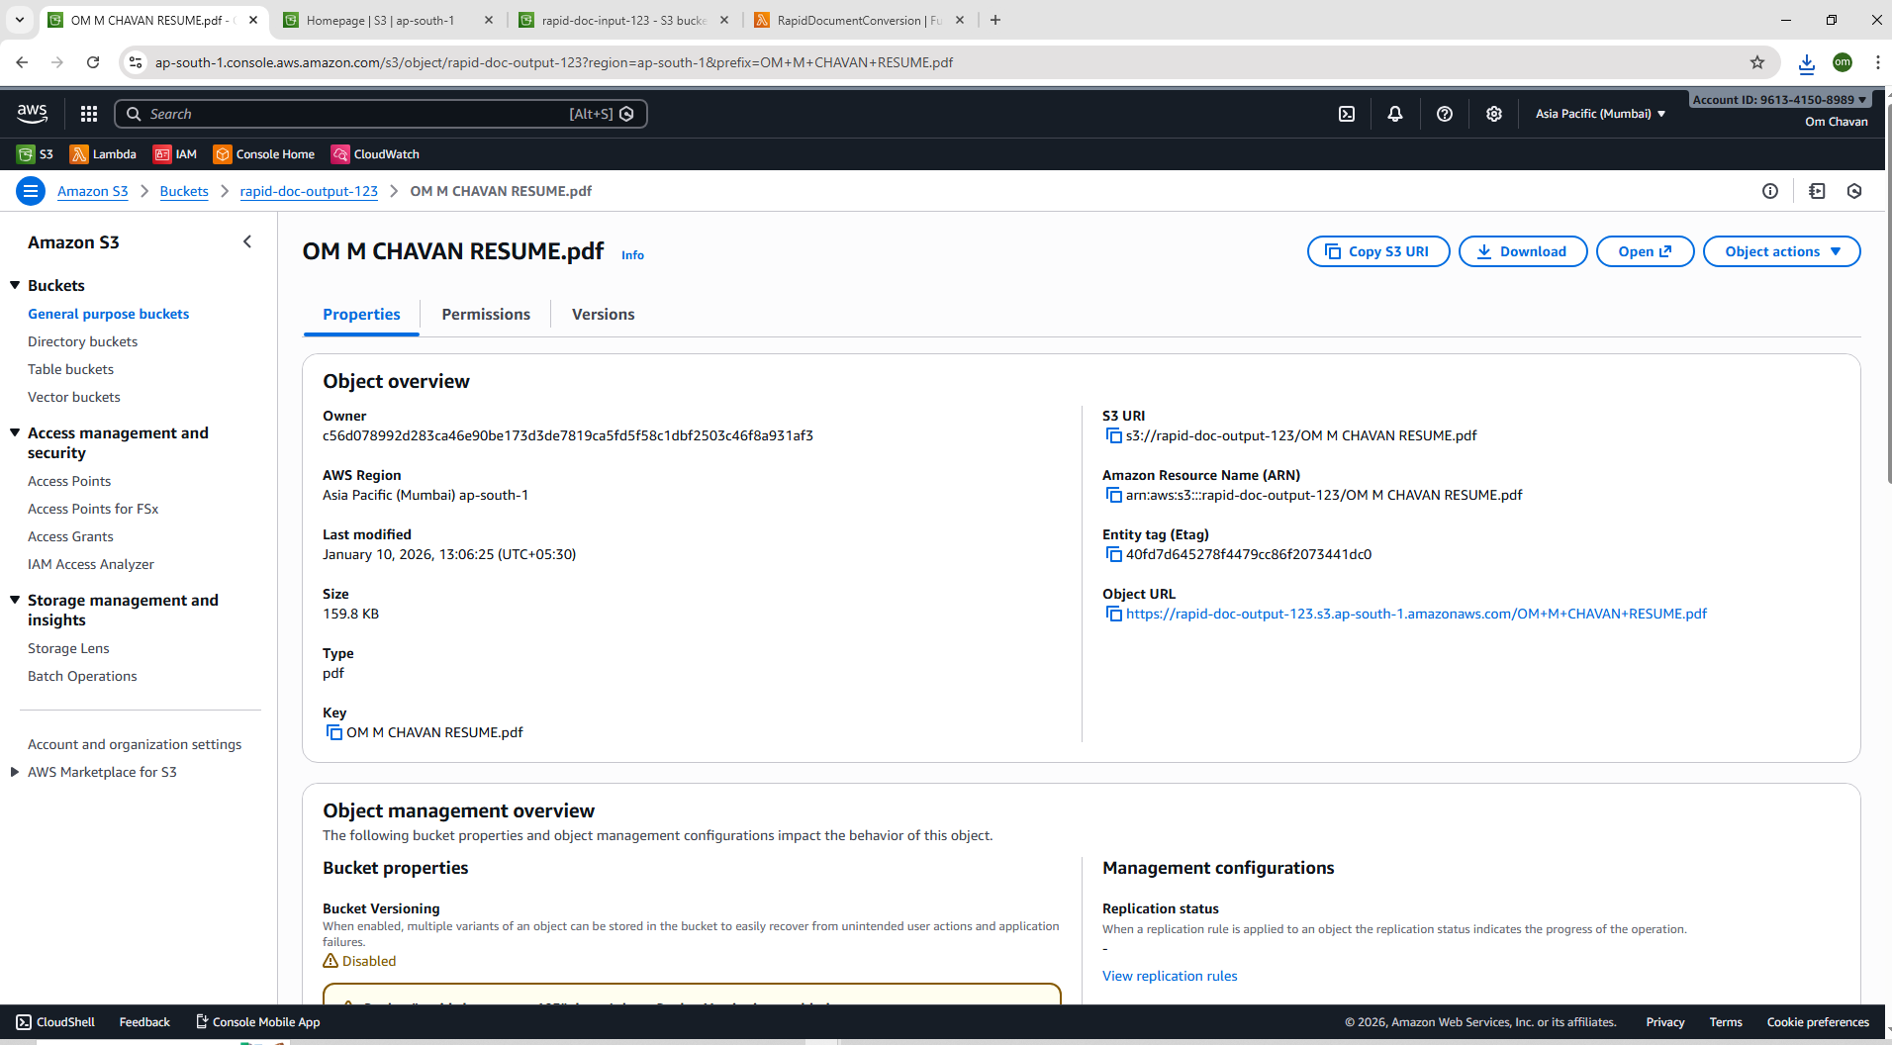

Conclusion
The project successfully demonstrates an automated, serverless document conversion system using AWS services with scalability, security, and minimal operational overhead.

