SP2 – Indian IT Sector Stock Price Analysis

Course: FAC413
Student: Om Chitlangia

Roll no. 2410110917

Instructor – Dr. Jaideep Ghosh

Data Window: January 3, 2023 – June 28, 2024
Data Source: Yahoo Finance (via Python yfinance)
GitHub - https://github.com/omchitlangia/IT-STOCKS-ANALYSIS

1. Introduction
This study analyzes the daily closing prices of four major Indian IT sector companies, HCL Technologies, Infosys, Tata Consultancy Services (TCS), and Wipro, over the period from January 3, 2023, to June 28, 2024. The objective is to examine price behavior, volatility, temporal trends, and comovement across firms using descriptive statistics and correlation analysis.

2. Data Collection and Cleaning
Daily closing price data were collected using Python from Yahoo Finance. To ensure a perfectly balanced panel, only trading dates common to all four firms were retained; any date missing data for at least one firm was removed for all firms. Corporate actions were examined, and no stock split events were found within the study window.
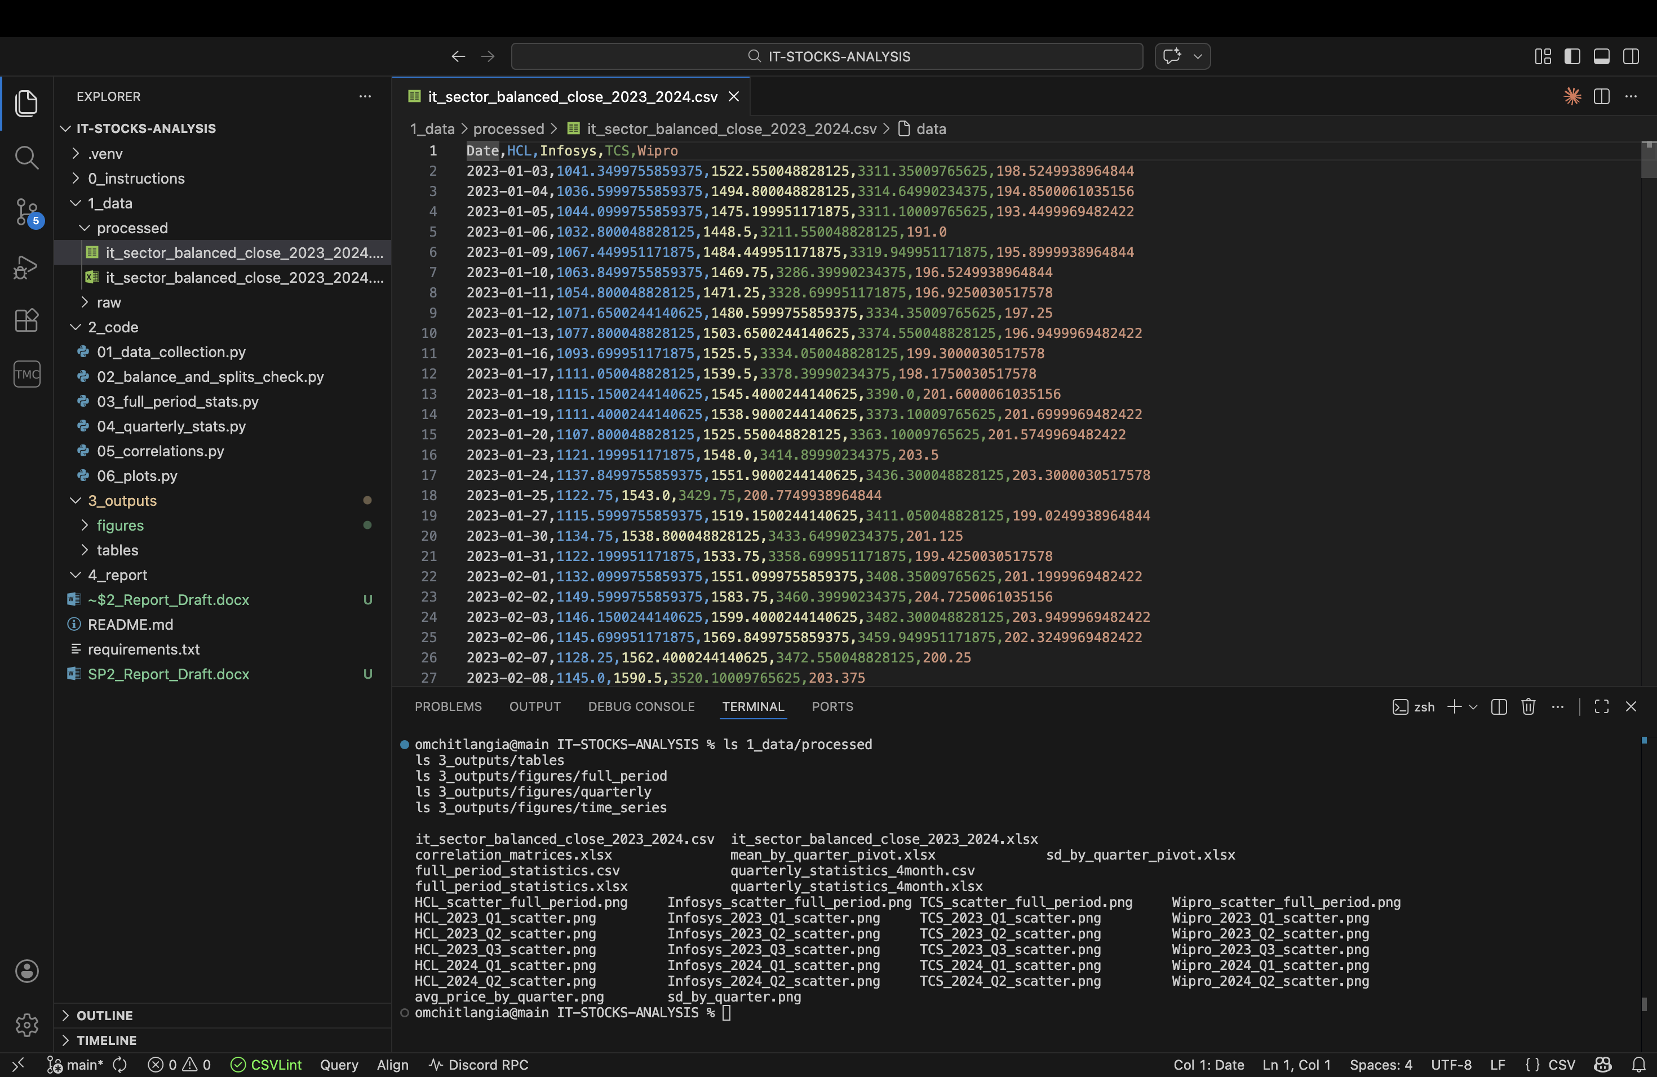

3. Full-Period Descriptive Statistics
For the full sample period, key descriptive statistics were computed for each company, including mean, standard deviation, median, mode, range, quartiles, interquartile range, coefficient of variation, and the average slope of prices over time. Scatterplots of daily prices illustrate overall trends and dispersion.
Company | N (days) | Mean | SD | Median | Mode | Min | Max | Range
HCL | 364 | 1284.975 | 187.2839 | 1255.675 | 1063.85 | 1032.8 | 1686.4 | 653.6
Infosys | 364 | 1457.879 | 114.2167 | 1454.375 | 1414.45 | 1223.4 | 1729.45 | 506.0499
TCS | 364 | 3564.547 | 289.8056 | 3489.65 | 3220.7 | 3089.6 | 4219.25 | 1129.65
Wipro | 364 | 213.3174 | 22.23852 | 204.3125 | 191.15 | 178.1 | 271.5 | 93.39999
Full period descriptive statistics
Company | Q1 | Q2 (Median) | Q3 | IQR | Coeff. of Variation (SD/Mean) | Avg Slope (₹/day)
HCL | 1121.062 | 1255.675 | 1441.5 | 320.4375 | 0.145749 | 0.996243
INFOSYS | 1389.087 | 1454.375 | 1532.588 | 143.5 | 0.078344 | 0.257729
TCS | 3330.3 | 3489.65 | 3831.737 | 501.4375 | 0.081302 | 1.526754
WIPRO | 196.8187 | 204.3125 | 231.0125 | 34.19375 | 0.104251 | 0.111953
Full period Quartiles table / Slope
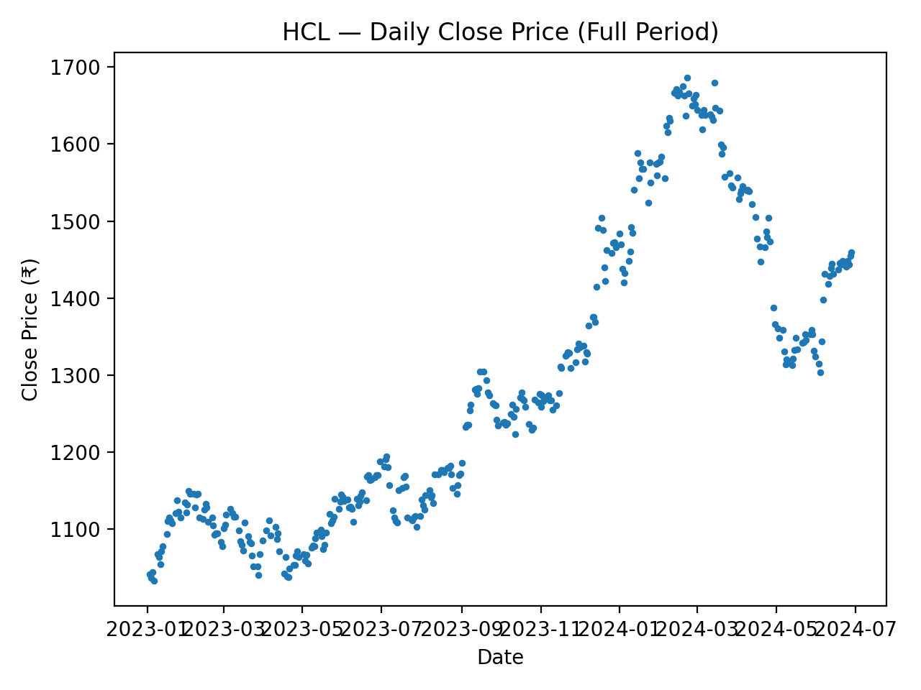

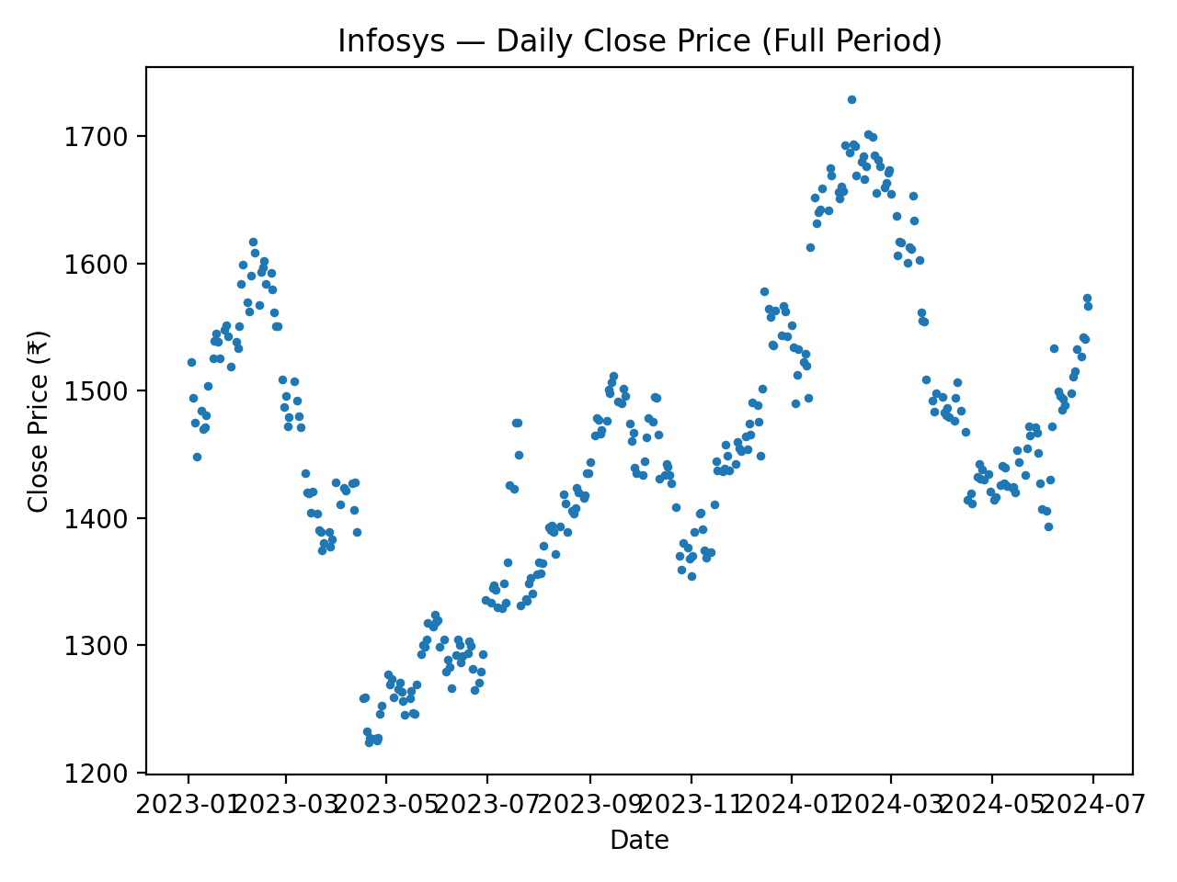
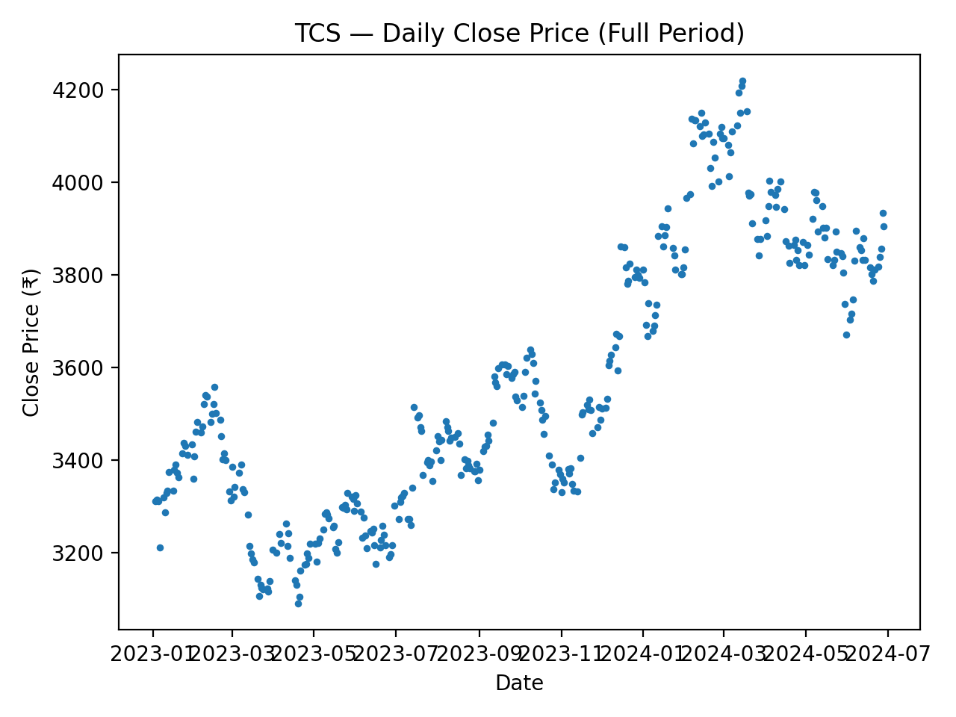

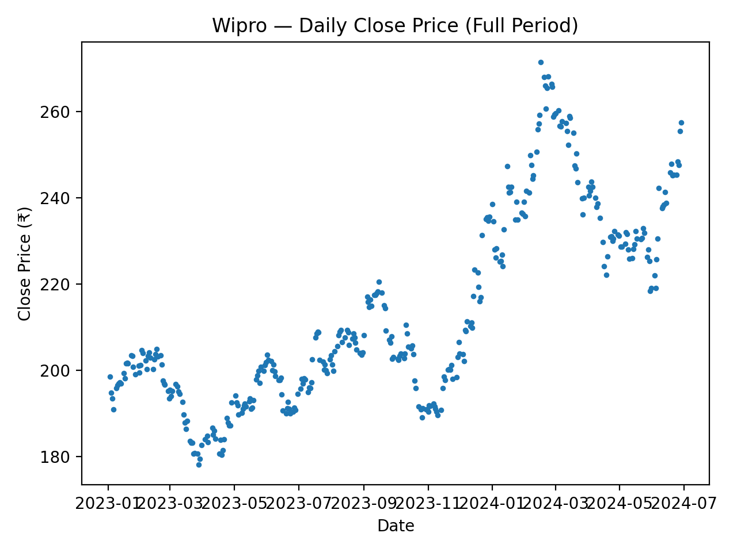

Overall, TCS exhibited the highest average price level, while Wipro traded at significantly lower levels. Relative volatility, as measured by the coefficient of variation, varied across firms, indicating differences in risk profiles.

4. Quarterly Analysis (4-Month Quarters)
The data were divided into approximate four-month quarters to capture temporal variation. Within each quarter, the same set of descriptive statistics and time-series slopes were computed. Quarterly scatterplots reveal changes in price trends and volatility across periods.

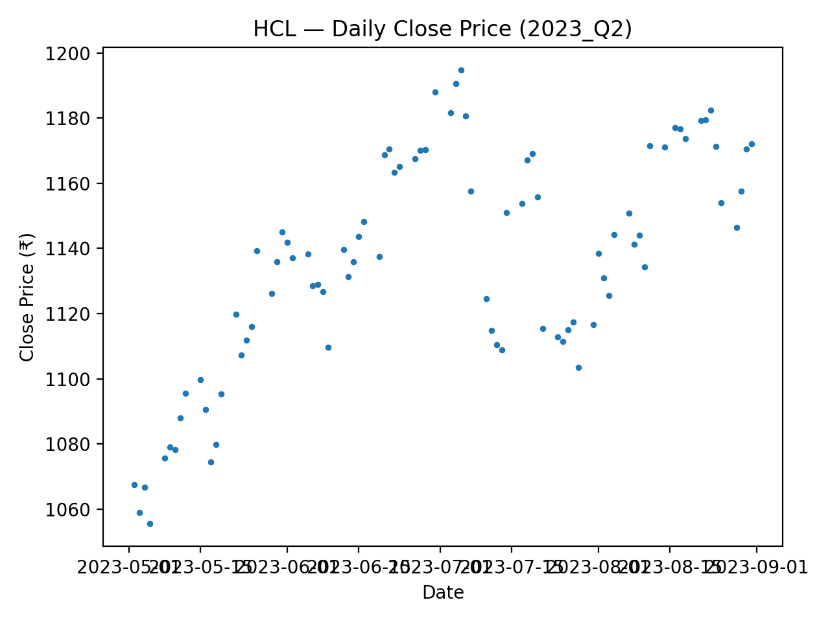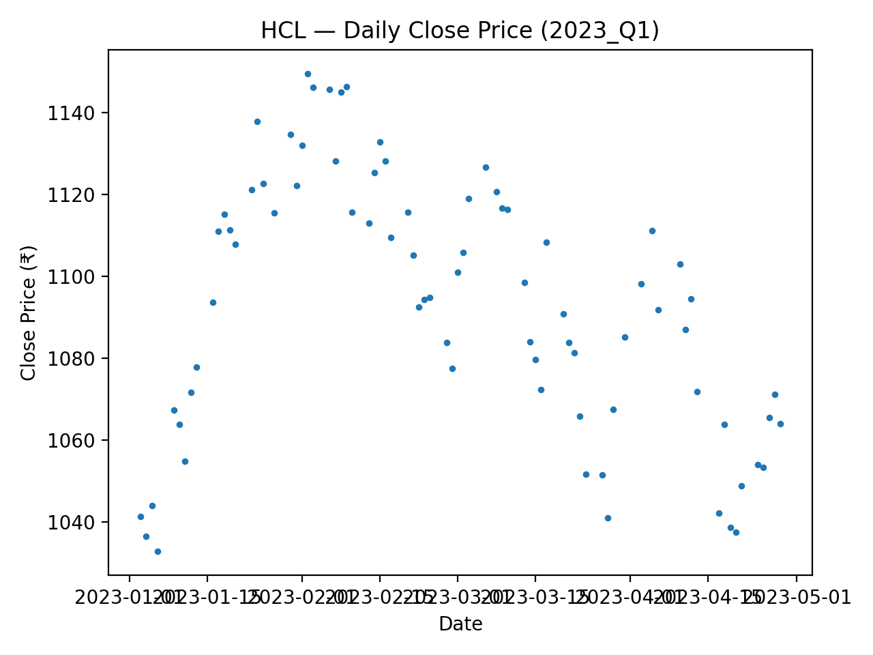
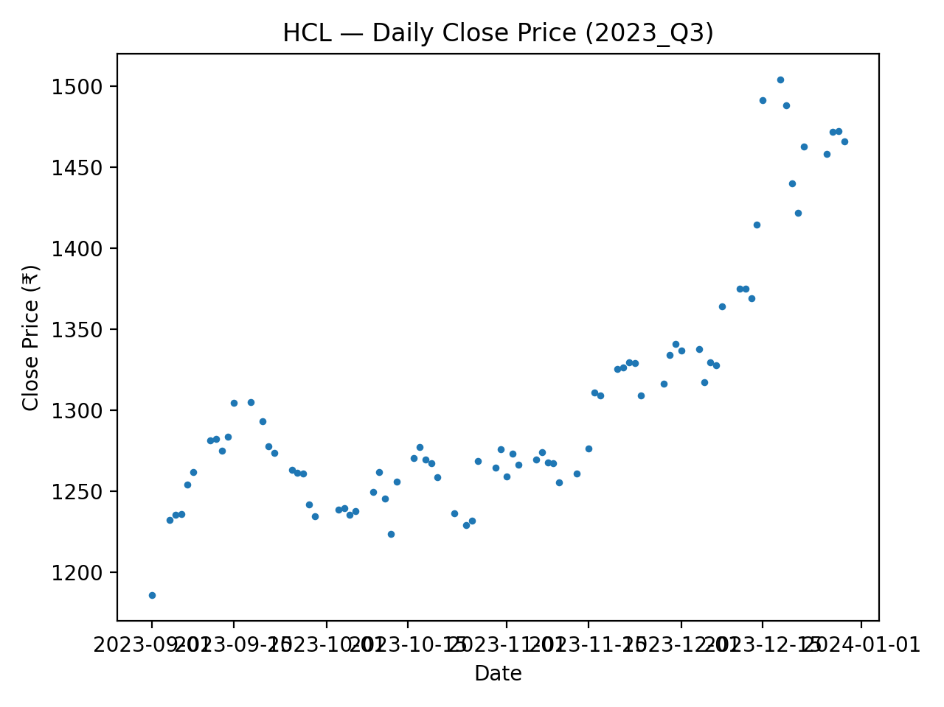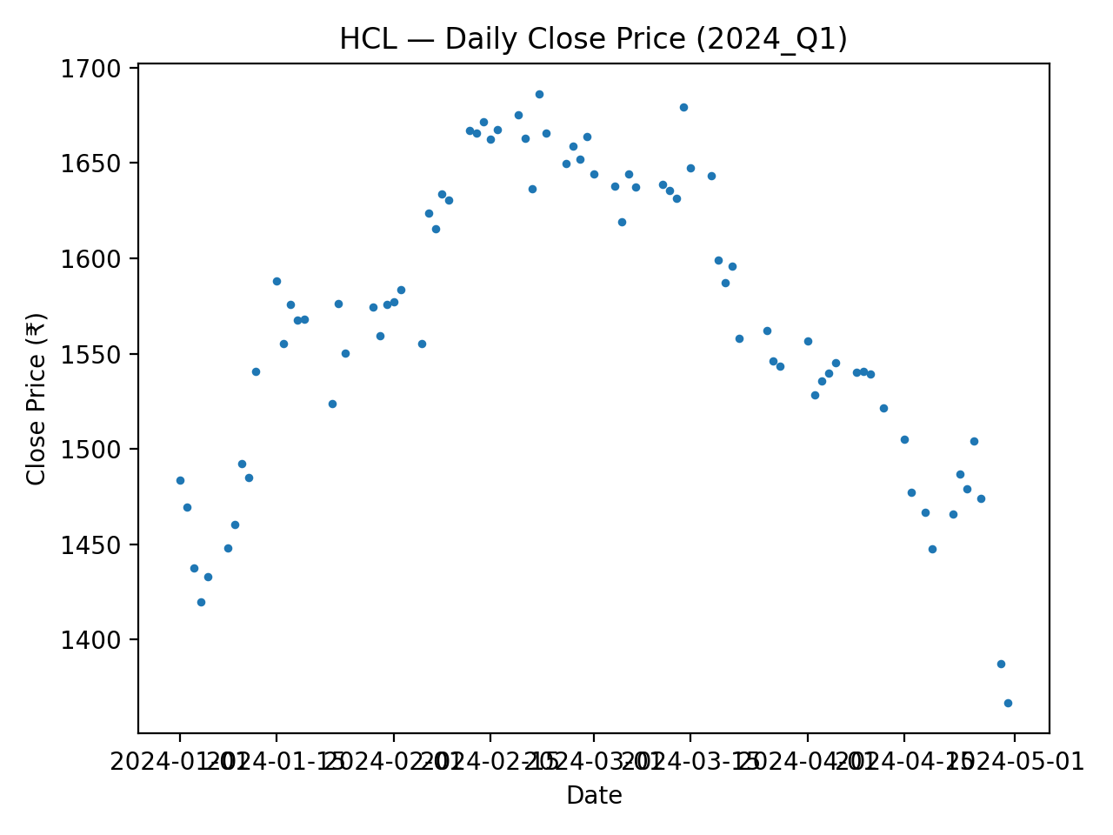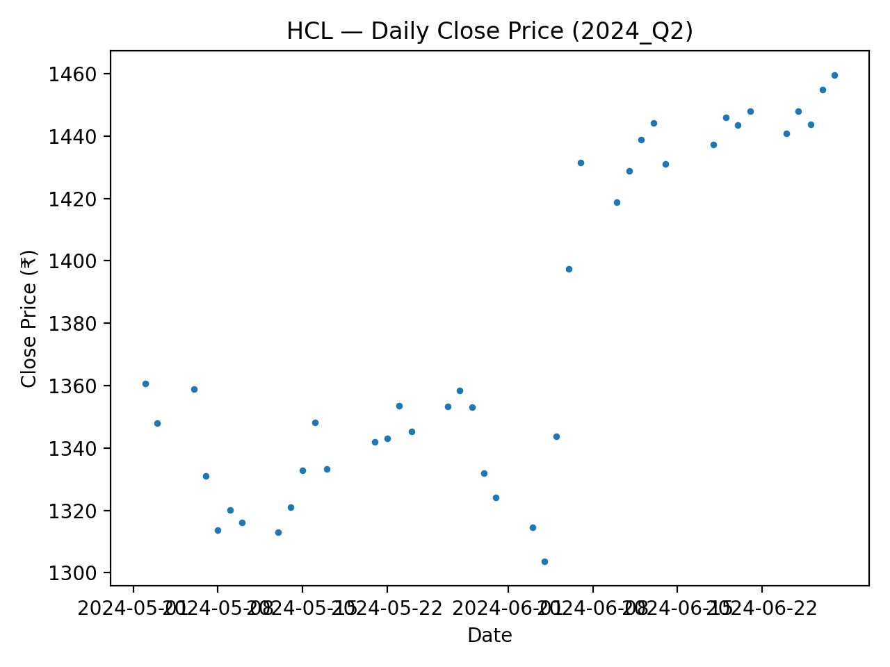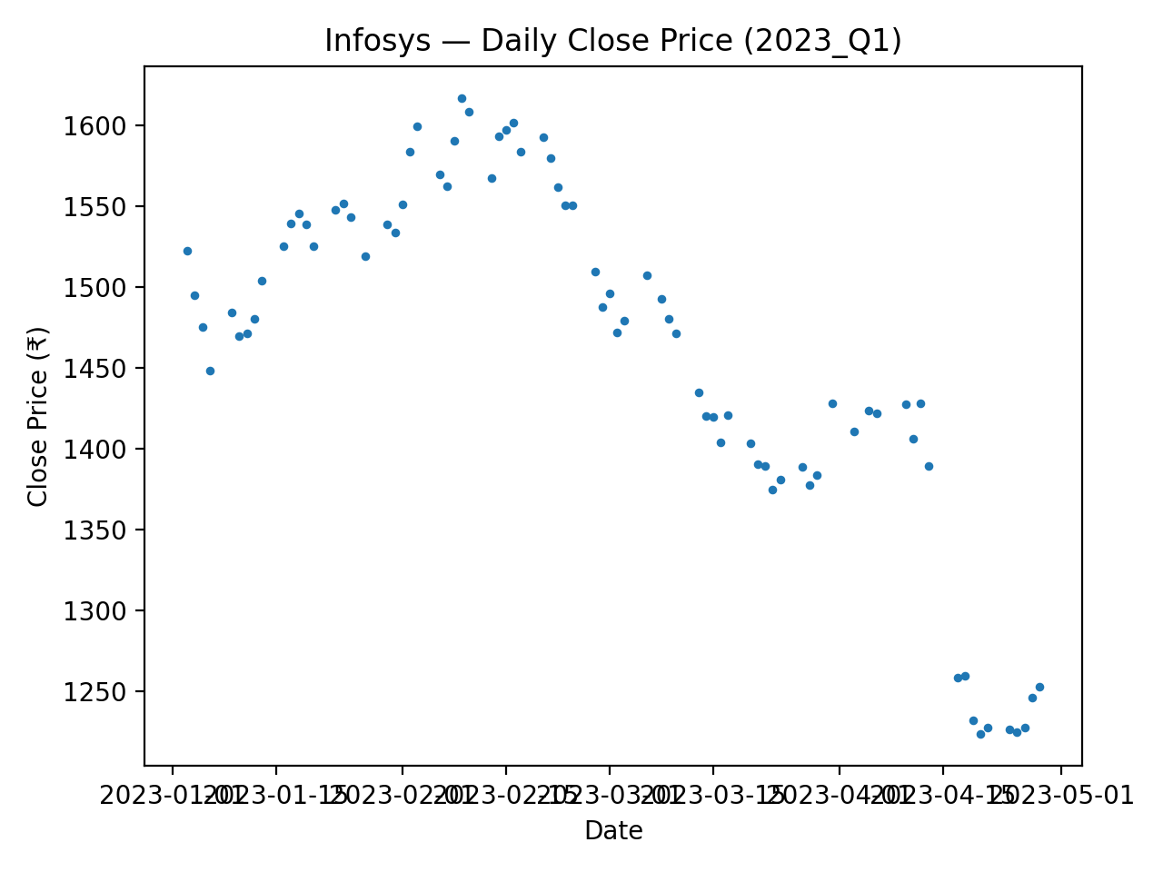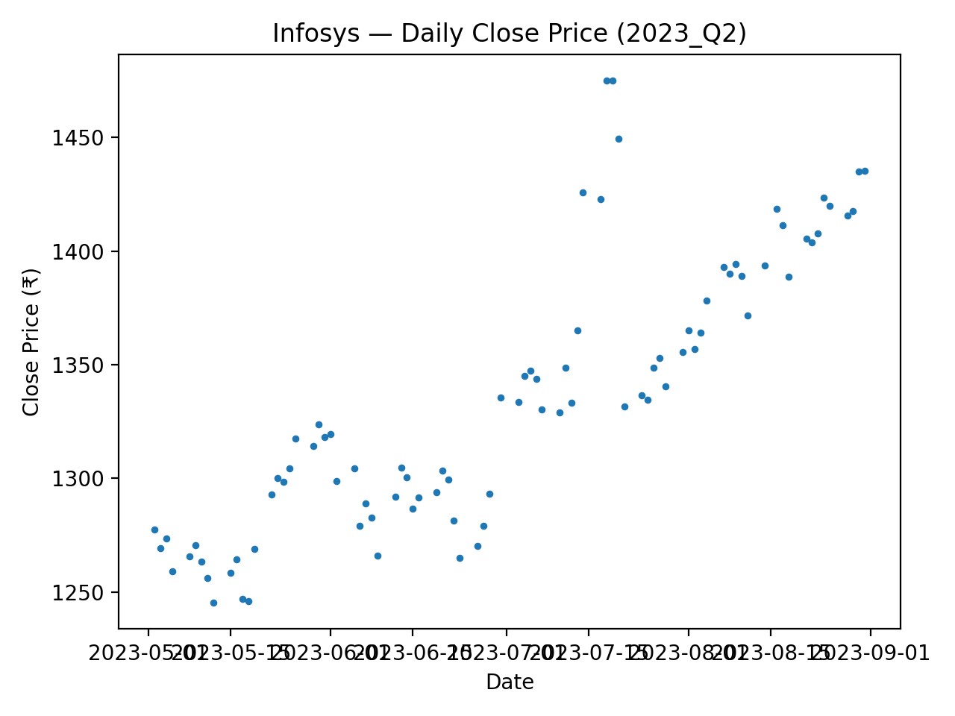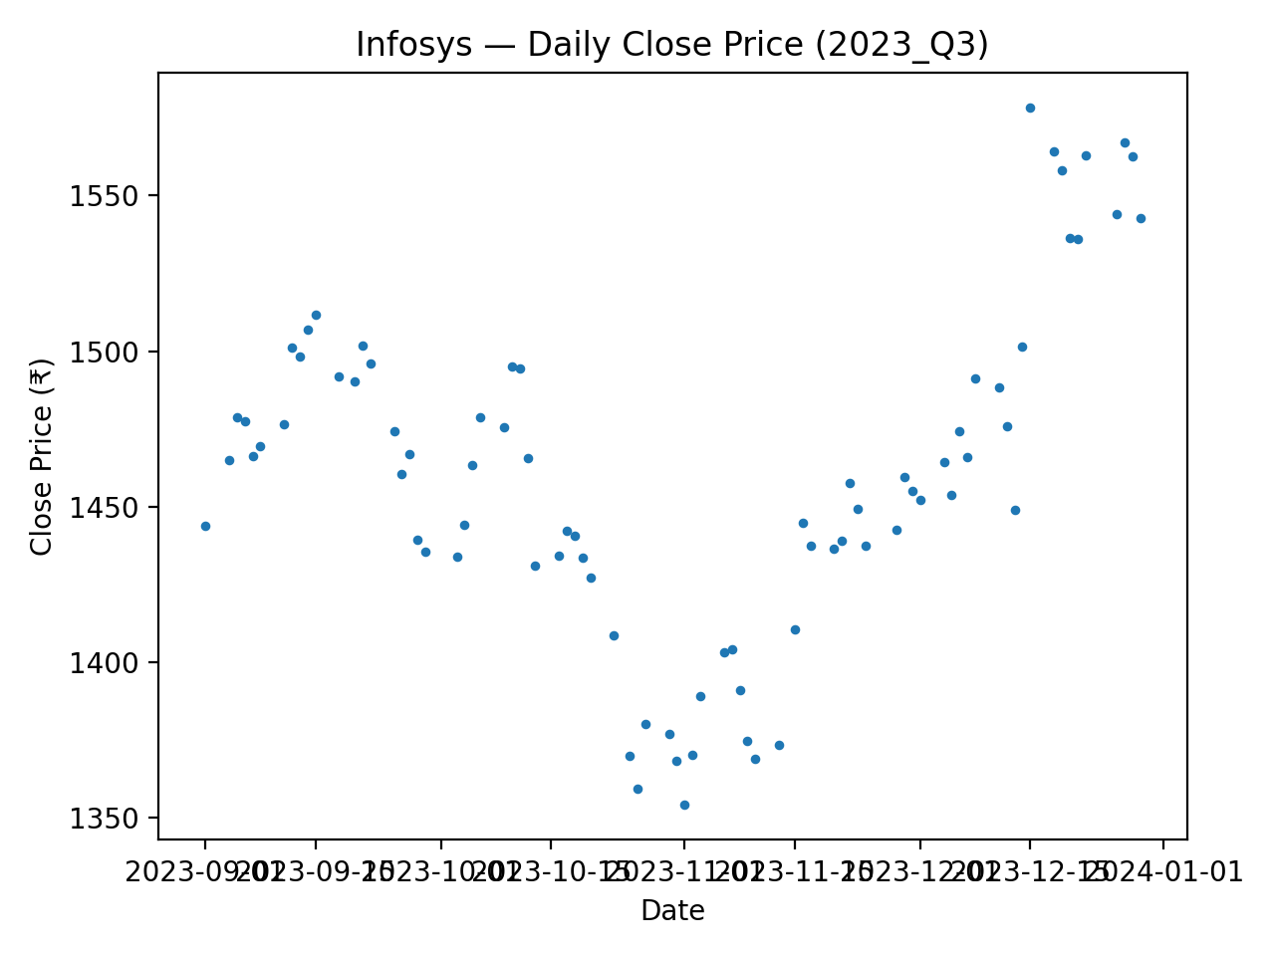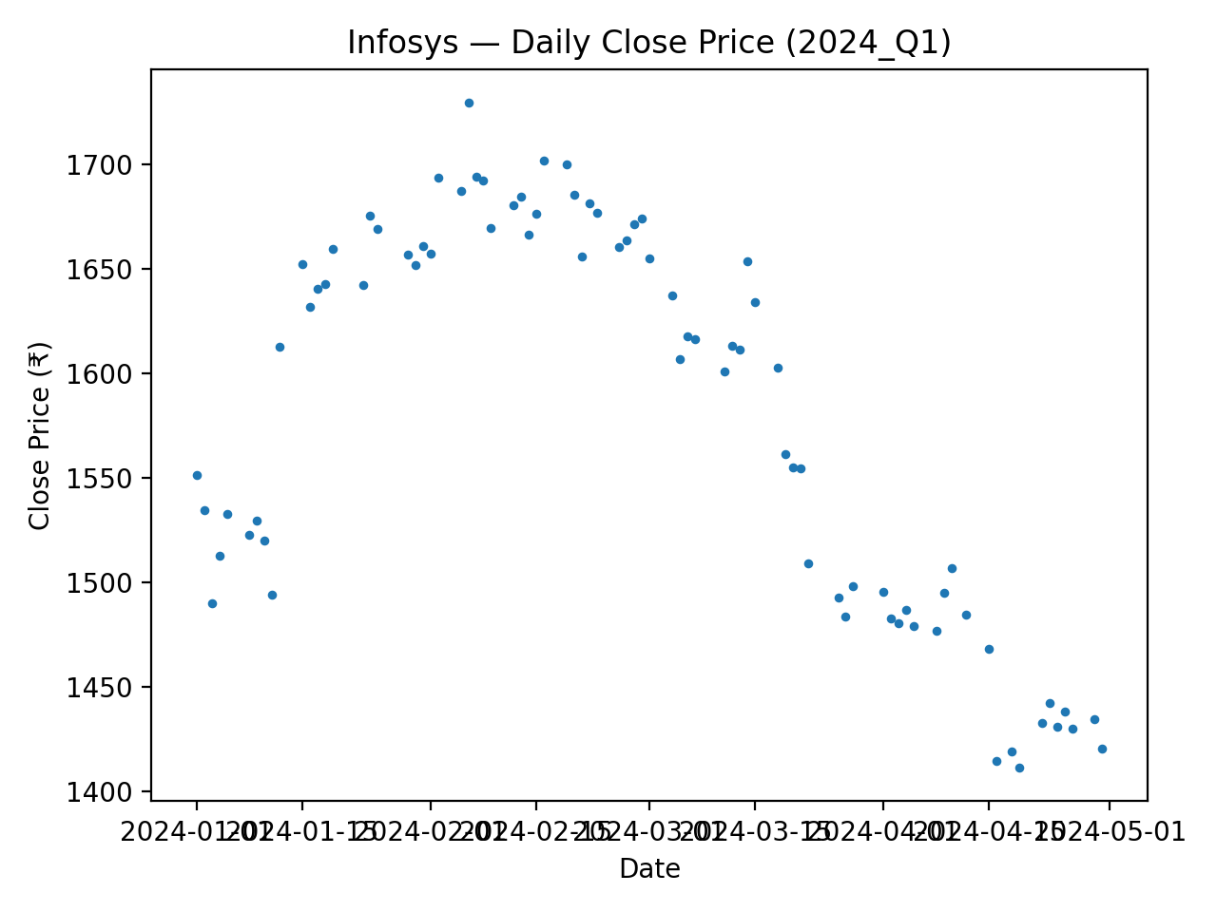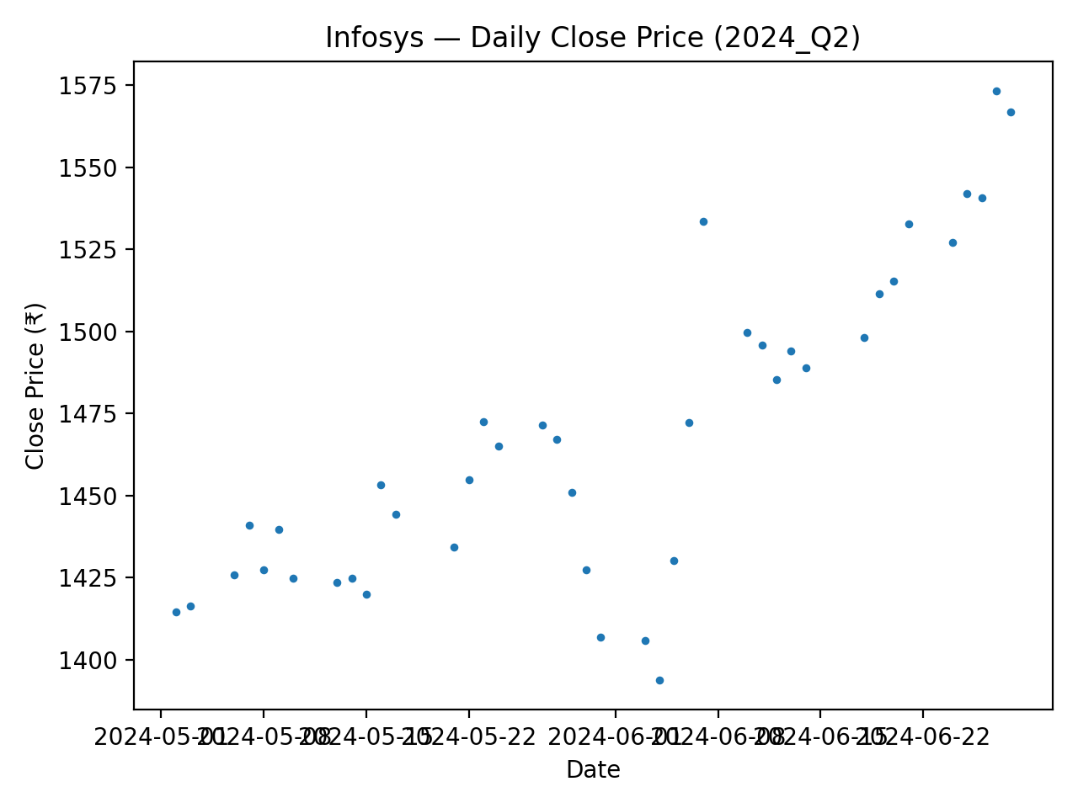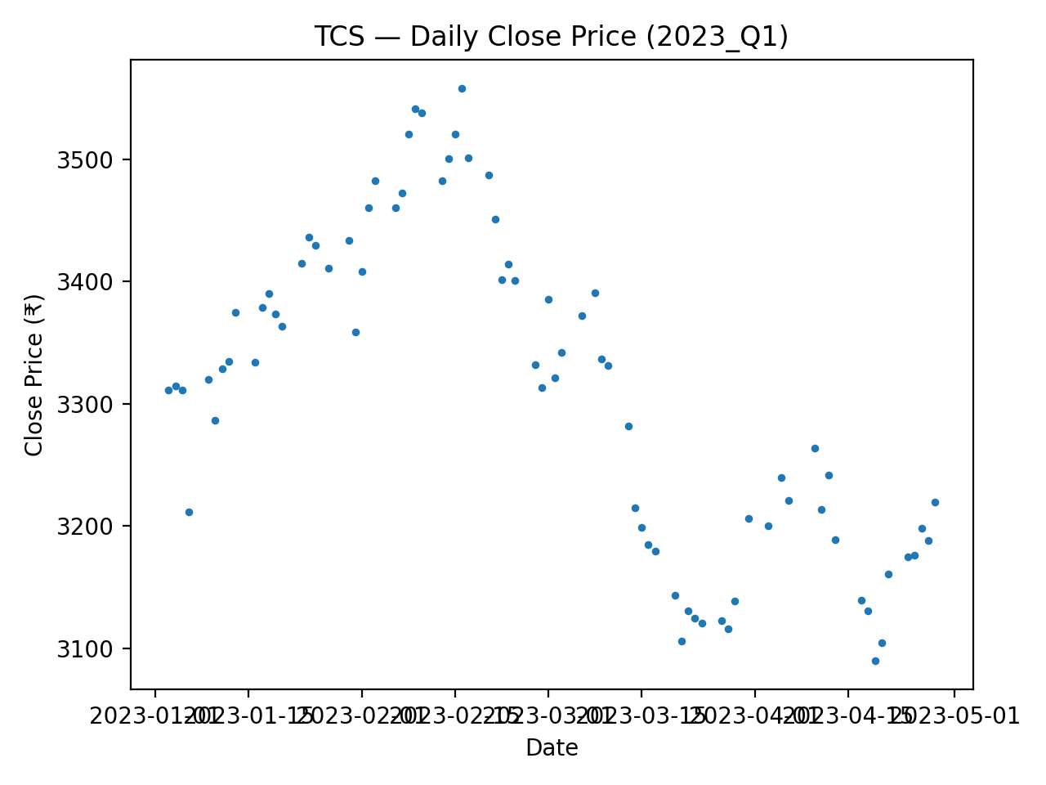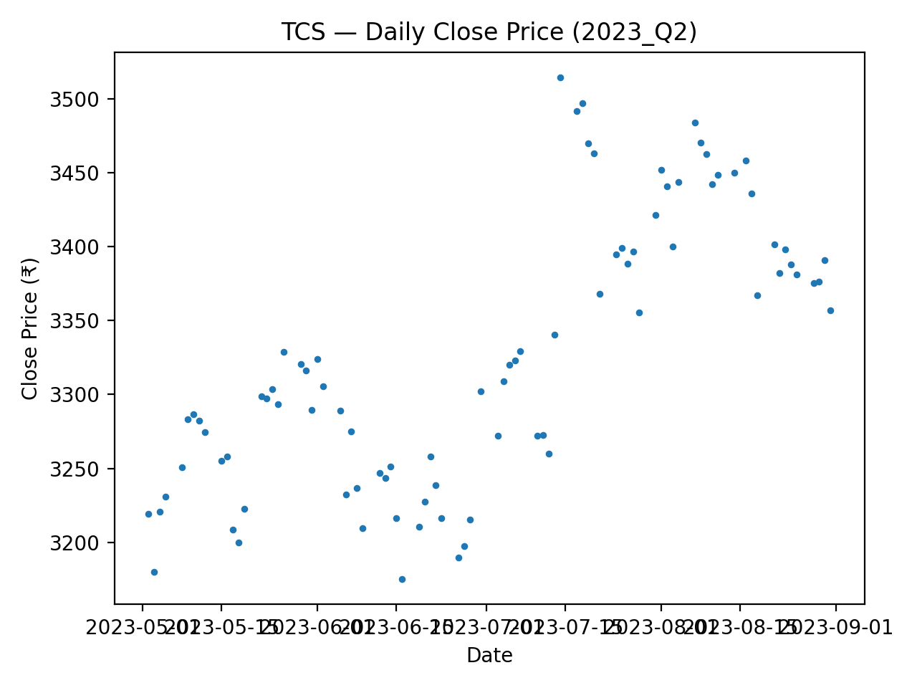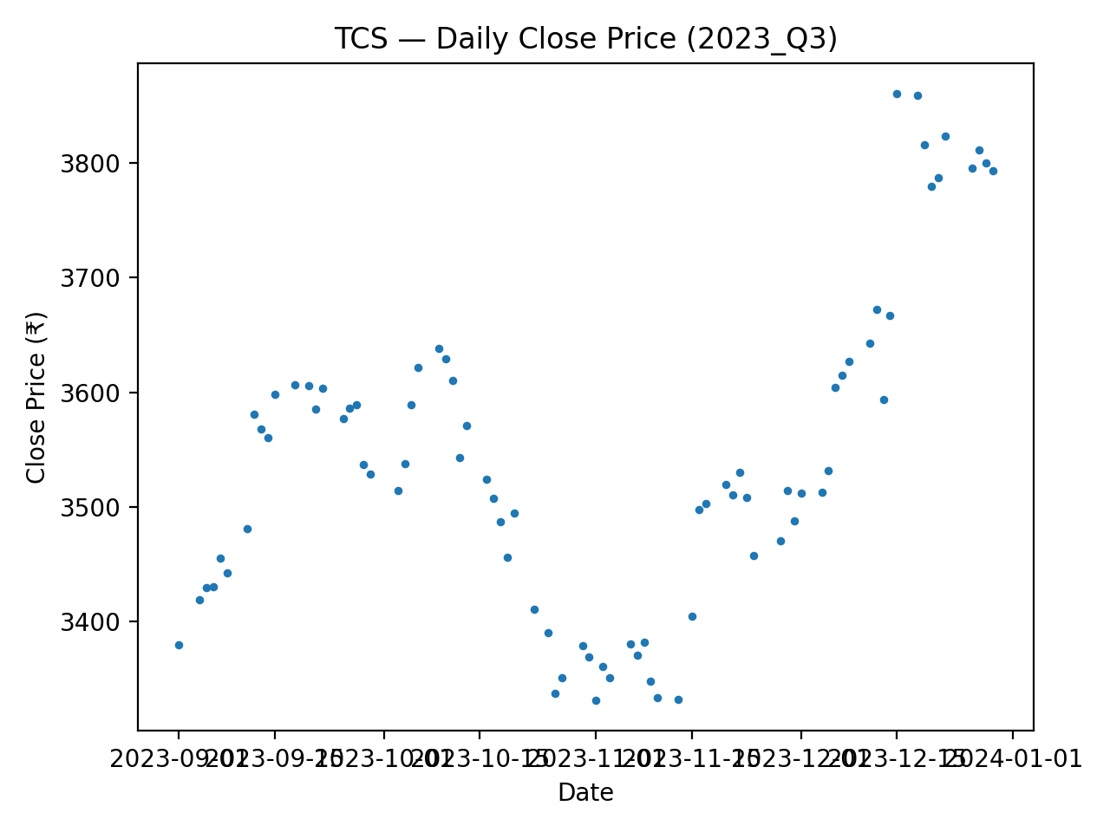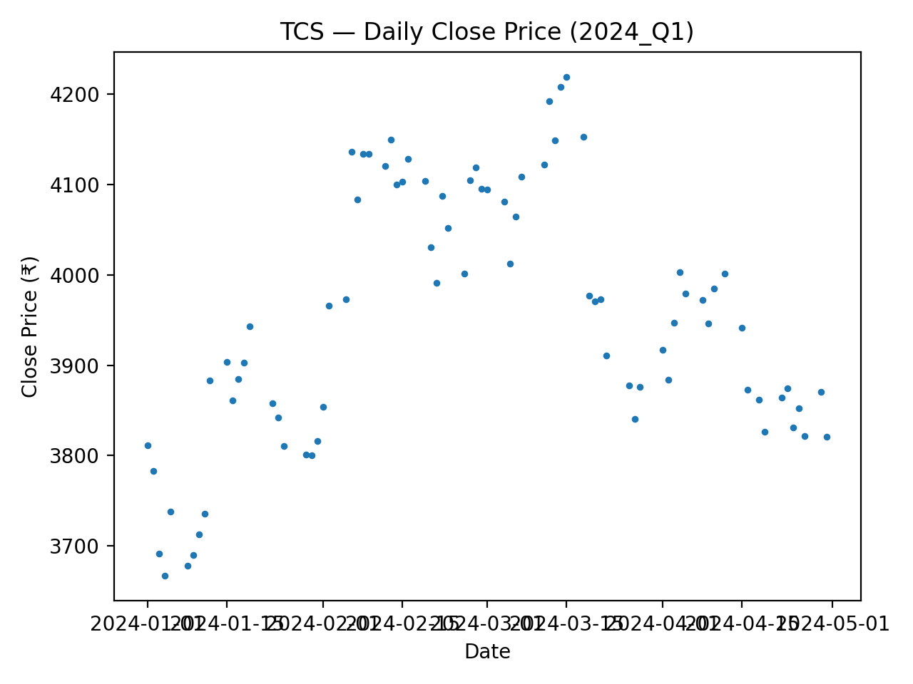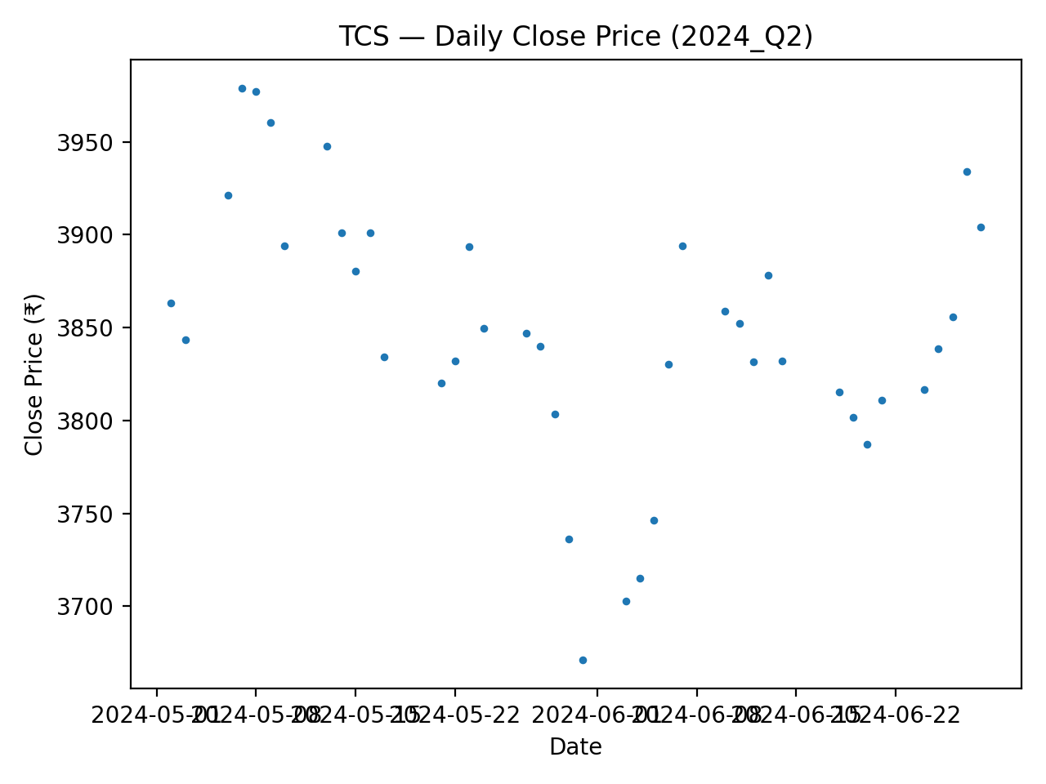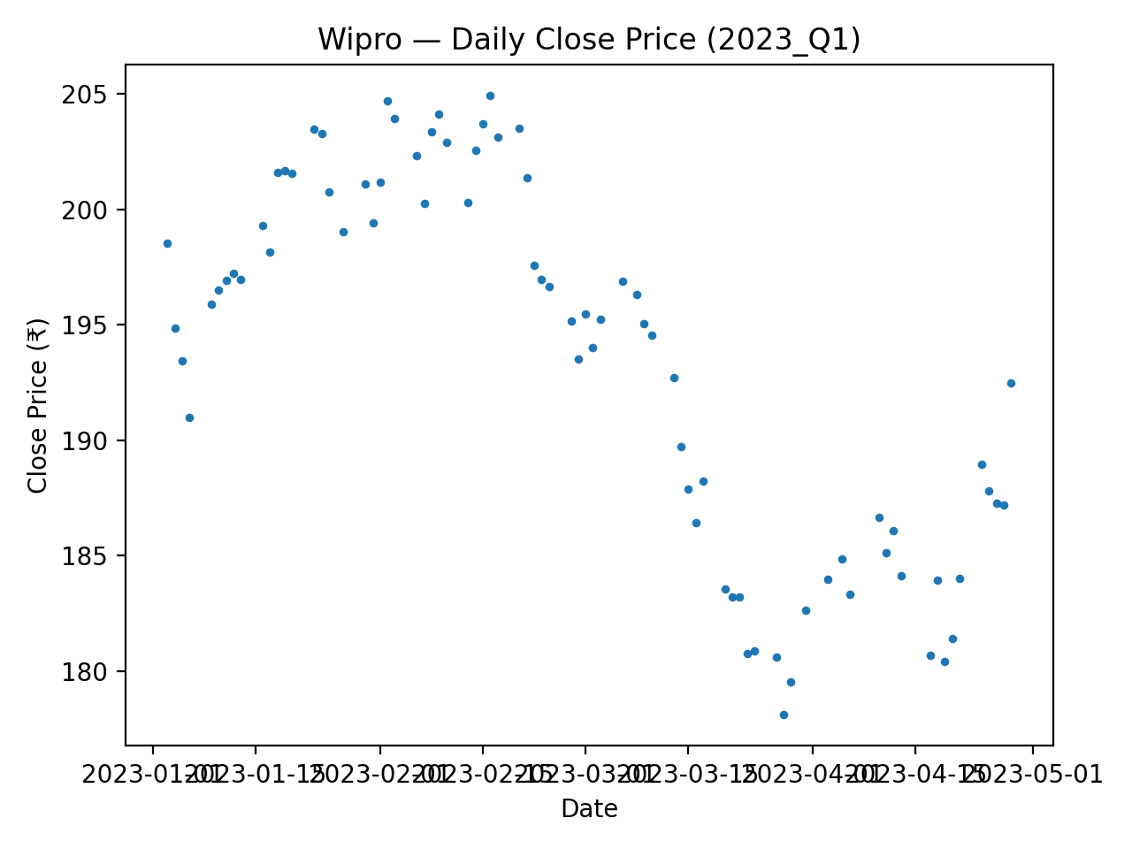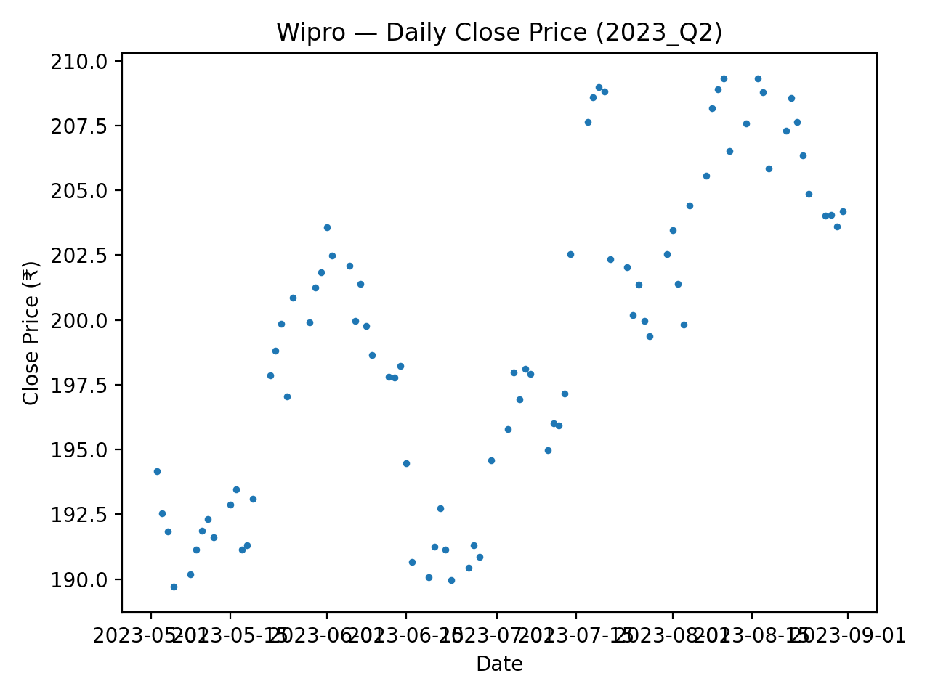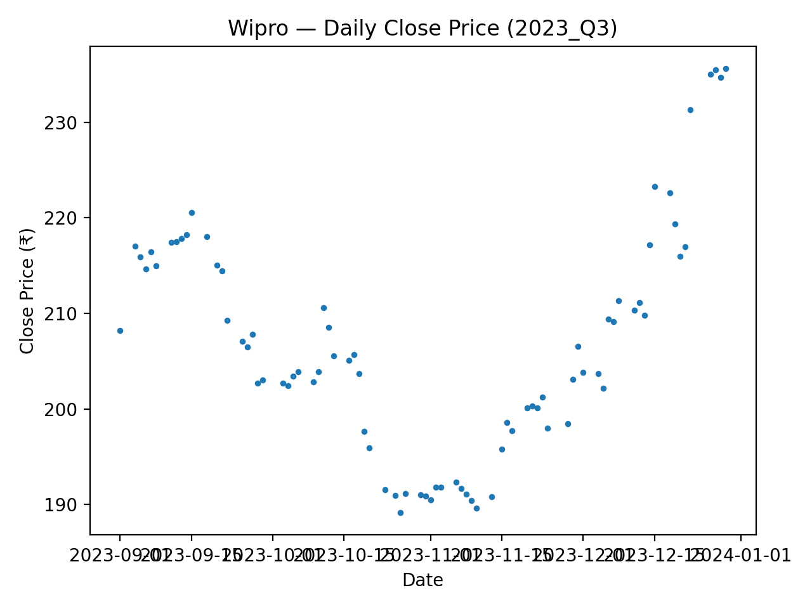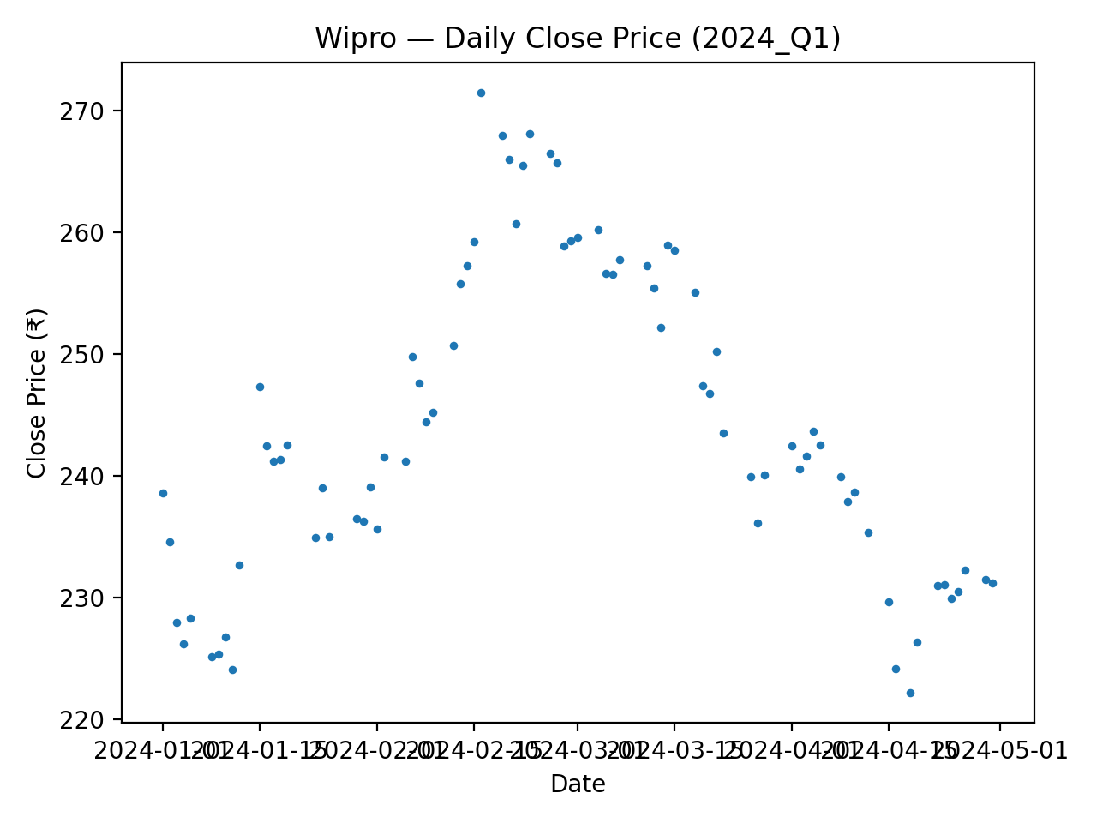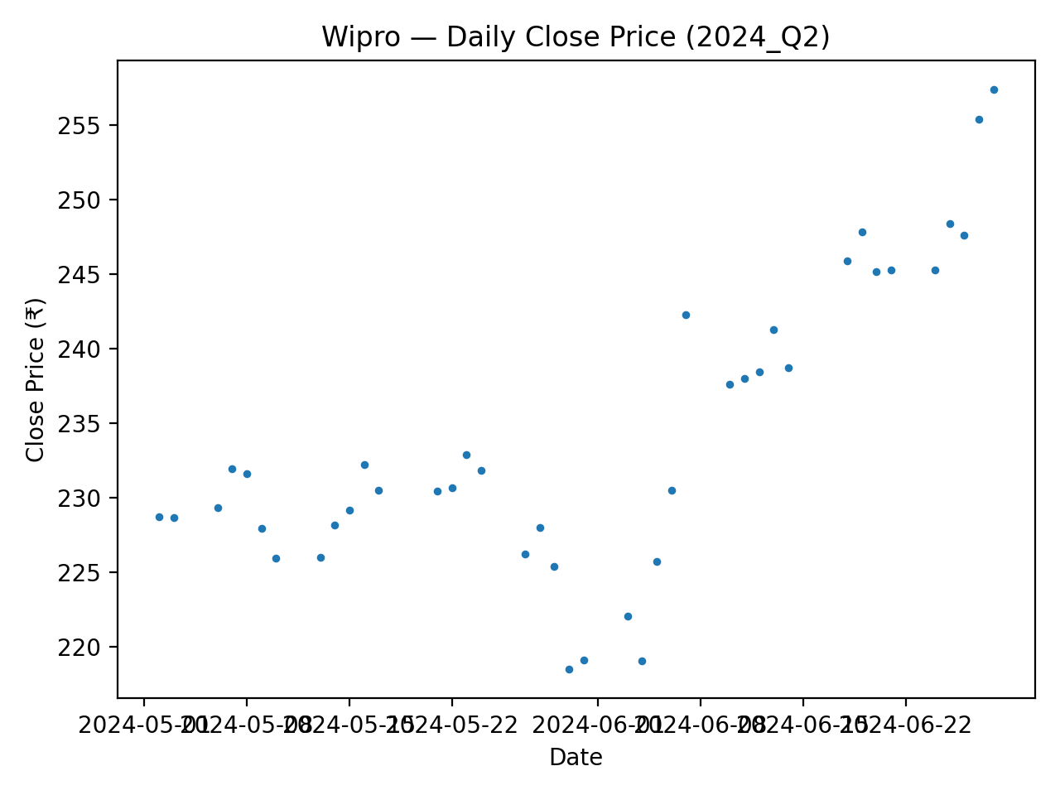

5. Trends Across Quarters and Correlation Analysis
Average daily prices and standard deviations were plotted across quarters to study temporal behavior. Prices generally increased into early 2024, followed by mild stabilization. Volatility was not constant and showed clustering in specific quarters, suggesting shifts in market uncertainty.
Quarter | HCL | Infosys | TCS | Wipro
2023_Q1 | 1092.717 | 1461.794 | 3310.981 | 193.4179
2023_Q2 | 1135.632 | 1334.624 | 3324.94 | 199.2895
2023_Q3 | 1305.147 | 1459.323 | 3540.126 | 206.7203
2024_Q1 | 1566.856 | 1580.157 | 3952.29 | 243.9878
2024_Q2 | 1376.865 | 1467.796 | 3847.512 | 234.135
Table 5A. Mean by quarter
Quarter | HCL | Infosys | TCS | Wipro
2023_Q1 | 31.62262 | 109.3003 | 130.4506 | 7.98997
2023_Q2 | 34.1781 | 59.30007 | 90.7402 | 6.015281
2023_Q3 | 74.32392 | 53.54004 | 137.8739 | 11.78099
2024_Q1 | 78.04068 | 93.68119 | 140.162 | 12.7997
2024_Q2 | 53.21257 | 47.76882 | 70.33753 | 9.796644
Table 5B. Standard Deviation by quarter
Pearson correlation coefficients were computed for each quarter and for the pooled dataset. Results indicate strong positive correlations among the IT firms, reflecting common sectoral drivers. However, correlation strength varied across quarters, highlighting periods of stronger or weaker comovement.
Quarter | HCL | Infosys | TCS | Wipro
2023_Q1 | 31.62262 | 109.3003 | 130.4506 | 7.98997
2023_Q2 | 34.1781 | 59.30007 | 90.7402 | 6.015281
2023_Q3 | 74.32392 | 53.54004 | 137.8739 | 11.78099
2024_Q1 | 78.04068 | 93.68119 | 140.162 | 12.7997
2024_Q2 | 53.21257 | 47.76882 | 70.33753 | 9.796644
Table 6A. Correlation Matrix
Quarter | Company | N (days) | Mean | SD | Median | Mode | Min | Max | Range
2023_Q1 | HCL | 78 | 1092.717 | 31.62262 | 1094.425 | 1063.85 | 1032.8 | 1149.6 | 116.7999
2023_Q1 | Infosys | 78 | 1461.794 | 109.3003 | 1480.5 | 1223.4 | 1223.4 | 1617 | 393.6
2023_Q1 | TCS | 78 | 3310.981 | 130.4506 | 3325.075 | 3089.6 | 3089.6 | 3558.05 | 468.45
2023_Q1 | Wipro | 78 | 193.4179 | 7.98997 | 195.2 | 183.2 | 178.1 | 204.95 | 26.84999
2023_Q2 | HCL | 86 | 1135.632 | 34.1781 | 1138.4 | 1135.85 | 1055.55 | 1194.8 | 139.25
2023_Q2 | Infosys | 86 | 1334.624 | 59.30007 | 1329.675 | 1245.2 | 1245.2 | 1475.2 | 230
2023_Q2 | TCS | 86 | 3324.94 | 90.7402 | 3307.225 | 3174.9 | 3174.9 | 3514.65 | 339.75
2023_Q2 | Wipro | 86 | 199.2895 | 6.015281 | 199.8 | 191.15 | 189.7 | 209.325 | 19.625
2023_Q3 | HCL | 80 | 1305.147 | 74.32392 | 1275.625 | 1309.15 | 1185.8 | 1504.3 | 318.5
2023_Q3 | Infosys | 80 | 1459.323 | 53.54004 | 1460.125 | 1354.15 | 1354.15 | 1578.4 | 224.25
2023_Q3 | TCS | 80 | 3540.126 | 137.8739 | 3526.325 | 3330.65 | 3330.65 | 3861 | 530.3501
2023_Q3 | Wipro | 80 | 206.7203 | 11.78099 | 205.3125 | 203.725 | 189.125 | 235.65 | 46.52499
2024_Q1 | HCL | 80 | 1566.856 | 78.04068 | 1567.75 | 1366.6 | 1366.6 | 1686.4 | 319.8
2024_Q1 | Infosys | 80 | 1580.157 | 93.68119 | 1612.075 | 1411.25 | 1411.25 | 1729.45 | 318.2
2024_Q1 | TCS | 80 | 3952.29 | 140.162 | 3946.925 | 3666.8 | 3666.8 | 4219.25 | 552.45
2024_Q1 | Wipro | 80 | 243.9878 | 12.7997 | 241.5875 | 242.525 | 222.175 | 271.5 | 49.325
2024_Q2 | HCL | 40 | 1376.865 | 53.21257 | 1353.425 | 1303.55 | 1303.55 | 1459.6 | 156.0499
2024_Q2 | Infosys | 40 | 1467.796 | 47.76882 | 1459.95 | 1393.65 | 1393.65 | 1573.35 | 179.7
2024_Q2 | TCS | 40 | 3847.512 | 70.33753 | 3845.225 | 3670.95 | 3670.95 | 3978.95 | 308
2024_Q2 | Wipro | 40 | 234.135 | 9.796644 | 231.125 | 230.5 | 218.475 | 257.425 | 38.94998
Table 6B. Descriptive Statistics across quarters
Quarter | Company | Q1 | Q2 (Median) | Q3 | IQR | Coeff. of Variation (SD/Mean) | Slope (₹/day)
2023_Q1 | HCL | 1067.462 | 1094.425 | 1116.15 | 48.68756 | 0.028939 | -0.30089
2023_Q1 | Infosys | 1404.612 | 1480.5 | 1547.35 | 142.7375 | 0.074771 | -2.48641
2023_Q1 | TCS | 3198.337 | 3325.075 | 3410.375 | 212.0377 | 0.039399 | -2.52362
2023_Q1 | Wipro | 186.1625 | 195.2 | 200.6562 | 14.49375 | 0.041309 | -0.17715
2023_Q2 | HCL | 1113.4 | 1138.4 | 1167.425 | 54.02496 | 0.030096 | 0.616547
2023_Q2 | Infosys | 1287.338 | 1329.675 | 1386.188 | 98.85001 | 0.044432 | 1.414256
2023_Q2 | TCS | 3250.713 | 3307.225 | 3396.362 | 145.6498 | 0.027291 | 1.848471
2023_Q2 | Wipro | 193.65 | 199.8 | 203.9187 | 10.26874 | 0.030184 | 0.121027
2023_Q3 | HCL | 1258.862 | 1275.625 | 1329.588 | 70.72507 | 0.056947 | 1.685866
2023_Q3 | Infosys | 1434.113 | 1460.125 | 1491.313 | 57.20001 | 0.036688 | 0.334854
2023_Q3 | TCS | 3438.9 | 3526.325 | 3606.075 | 167.1751 | 0.038946 | 1.672533
2023_Q3 | Wipro | 198.3188 | 205.3125 | 215.2688 | 16.95 | 0.05699 | 0.042704
2024_Q1 | HCL | 1517.388 | 1567.75 | 1637.725 | 120.3375 | 0.049807 | -0.28399
2024_Q1 | Infosys | 1493.812 | 1612.075 | 1661.575 | 167.7625 | 0.059286 | -1.57966
2024_Q1 | TCS | 3853.662 | 3946.925 | 4088.913 | 235.2502 | 0.035463 | 0.832347
2024_Q1 | Wipro | 234.8625 | 241.5875 | 255.9938 | 21.13126 | 0.05246 | -0.01172
2024_Q2 | HCL | 1332.638 | 1353.425 | 1437.587 | 104.95 | 0.038648 | 2.559038
2024_Q2 | Infosys | 1426.95 | 1459.95 | 1498.587 | 71.63742 | 0.032545 | 2.248106
2024_Q2 | TCS | 3816.375 | 3845.225 | 3893.912 | 77.53735 | 0.018281 | -1.4317
2024_Q2 | Wipro | 228.0062 | 231.125 | 241.5438 | 13.53751 | 0.041842 | 0.406715
Table 6C. Quartile Data across Quarters and Slope Analysis
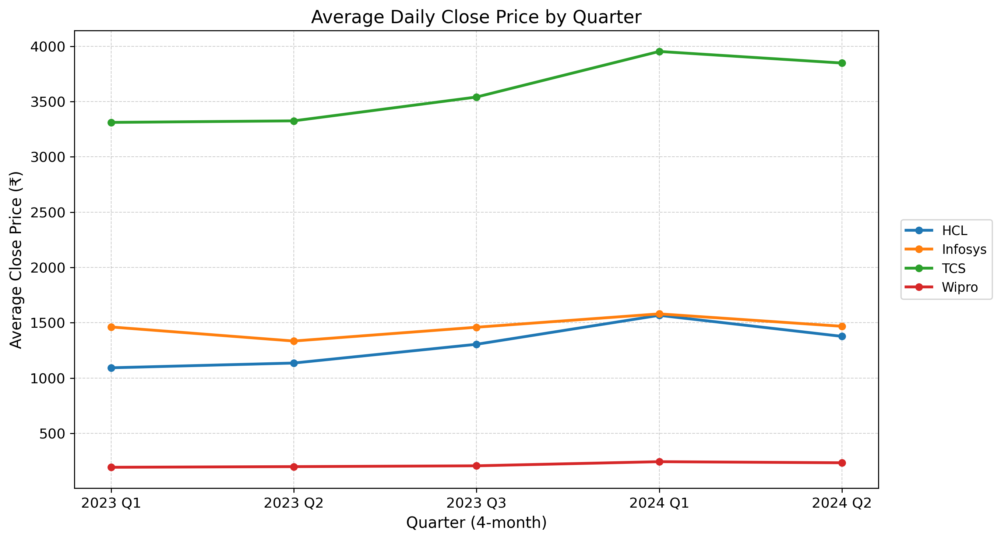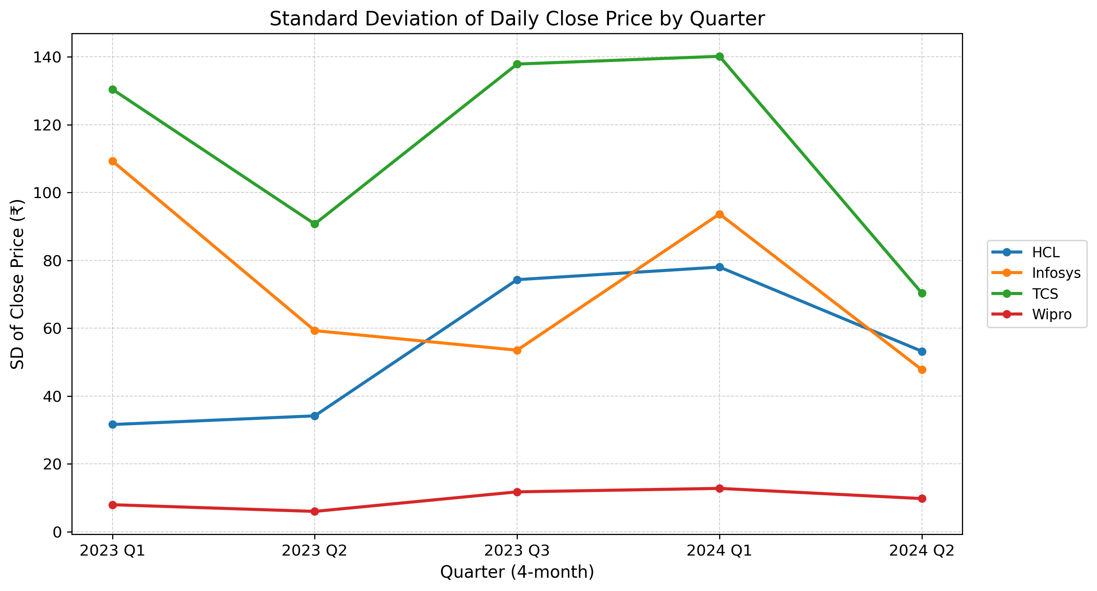

7. Conclusion
This analysis shows that while all four companies are influenced by shared IT sector dynamics, they differ in price levels, volatility, and short-term trends. TCS and Infosys display strong comovement, whereas Wipro shows relatively more idiosyncratic behavior. Quarterly analysis highlights the importance of temporal segmentation in understanding market behavior.

