LP Formal Report
CAPM Empirical Test with Robust Inference and Stability Checks
Assets: MSFT, GE, FORD | Market Proxy: S&P 500
Sample: 1993-11-02 to 2003-04-03 (N = 2362 daily observations)
Generated: 2026-02-22

Group Members (Name — Roll #): [Add all members]
Course Name & Code: [Add course name and course code]

2. Introduction
The Capital Asset Pricing Model (CAPM) is a foundational benchmark in empirical finance that links an asset’s expected return to its exposure to systematic (non-diversifiable) market risk. In CAPM, the key priced risk is summarized by beta (β), the sensitivity of an asset’s excess return to the market’s excess return. A standard time-series implication is that after controlling for market risk, the intercept (Jensen’s alpha, α) should be zero. A statistically significant non-zero α is often interpreted as abnormal performance relative to CAPM (i.e., CAPM “mispricing” in the alpha-test sense).

This report tests CAPM using daily data for Microsoft (MSFT), General Electric (GE), and Ford (FORD), with the S&P 500 as a market proxy. The sample covers 1993–2003, a period containing multiple market regimes (mid-1990s expansion, late-1990s boom, and early-2000s drawdown), which is useful for evaluating not only average CAPM fit but also whether β appears stable through time.

Daily returns often display heteroskedasticity (volatility clustering), fat tails, and residual autocorrelation. These features can invalidate classical OLS standard errors and p-values even if coefficient point estimates remain similar. Therefore, we combine: (i) regression diagnostics (Breusch–Pagan, Durbin–Watson, Ljung–Box), (ii) HAC/Newey–West robust inference for α and β, and (iii) stability checks using subperiod regressions and rolling 252-day betas. Together, these elements make the CAPM test both statistically valid and economically interpretable.

3. Methodology (Data, Methods, and Analysis)
3.1 Data and Sample
We analyze 2362 aligned daily observations from 1993-11-02 to 2003-04-03. The dataset contains price series for MSFT, GE, FORD, and the S&P 500, along with a Treasury bill yield series as a proxy for the risk-free rate. Observations are sorted chronologically and cleaned so that all regressions use the same dates.

3.2 Log Return Construction
Daily log returns are computed as:
R_t = ln(P_t / P_{t−1}),
where P_t is the closing price at day t. Log returns are commonly used because they are time-additive and provide a good approximation to continuously compounded returns for daily horizons.

3.3 Risk-Free Rate and Excess Returns
The annualized Treasury bill yield (quoted in percent) is converted to an approximate daily risk-free rate as:
Rf_daily = (Tbill / 100) / 252,
where 252 is the typical number of trading days per year. Excess returns are then computed for both each stock and the market index as:
R*_t = R_t − Rf_daily.

3.4 CAPM Regression (Security Characteristic Line)
For each stock i, we estimate the CAPM time-series regression (Security Characteristic Line):
R*_{i,t} = α_i + β_i R*_{m,t} + ε_{i,t},
where R*_{m,t} is the market excess return and ε_{i,t} is the residual.

3.5 Hypothesis Tests
The CAPM alpha restriction implies α_i = 0. We test:
H0: α_i = 0 vs. H1: α_i ≠ 0.
If α_i is statistically significant, the asset exhibits abnormal performance relative to CAPM over the sample.

3.6 Diagnostics and Robust Inference
OLS standard errors assume homoskedastic and uncorrelated residuals. Daily data often violates these assumptions. We therefore apply:
• Breusch–Pagan test for heteroskedasticity,
• Durbin–Watson statistic as a first-order serial correlation screen, and
• Ljung–Box tests for residual autocorrelation at lags 5 and 10.
For inference on α and β, we report HAC/Newey–West robust p-values (maxlags = 10), which remain valid under heteroskedasticity and autocorrelation.

3.7 Stability Checks and the Time-Series Length Question
A long sample can reduce sampling error but may average across regimes if β is time-varying. We assess stability using: (i) subperiod regressions (1993–1997, 1998–2000, 2001–2003) and (ii) rolling-window 252-day betas.

4. Results and Discussion

4.1 Descriptive Statistics
Table 1 summarizes the distribution of daily excess returns. The S&P 500 market proxy has mean excess return 0.000093 and daily volatility 0.01156. MSFT exhibits the highest volatility among the stocks, consistent with higher uncertainty and greater sensitivity to market conditions during the sample. FORD’s mean excess return is slightly negative over the full period, while GE’s mean is positive. All series have kurtosis above 3, indicating fat tails relative to a normal distribution—typical for daily financial returns and one reason robust inference is appropriate.
Table 1. Descriptive Statistics (Daily Excess Returns)
Series | N | Mean | Std | Min | Max | Skew | Kurtosis
SP500 | 2362 | 0.000093 | 0.01156 | -0.07132 | 0.05568 | -0.09801 | 3.24736
MSFT | 2362 | 0.000811 | 0.02455 | -0.16991 | 0.17858 | -0.10351 | 3.94938
GE | 2362 | 0.000425 | 0.01923 | -0.11309 | 0.11739 | 0.02543 | 3.06651
FORD | 2362 | -0.000187 | 0.02296 | -0.15879 | 0.14485 | 0.11780 | 3.95215

4.2 Security Characteristic Lines (SCL): Visual Fit
Figures 1–3 plot each stock’s excess return against the market excess return with the fitted CAPM line. GE shows the tightest clustering around the fitted line, consistent with a higher R² in the regression results. MSFT and FORD display wider dispersion, suggesting that idiosyncratic factors play a larger role in day-to-day returns.
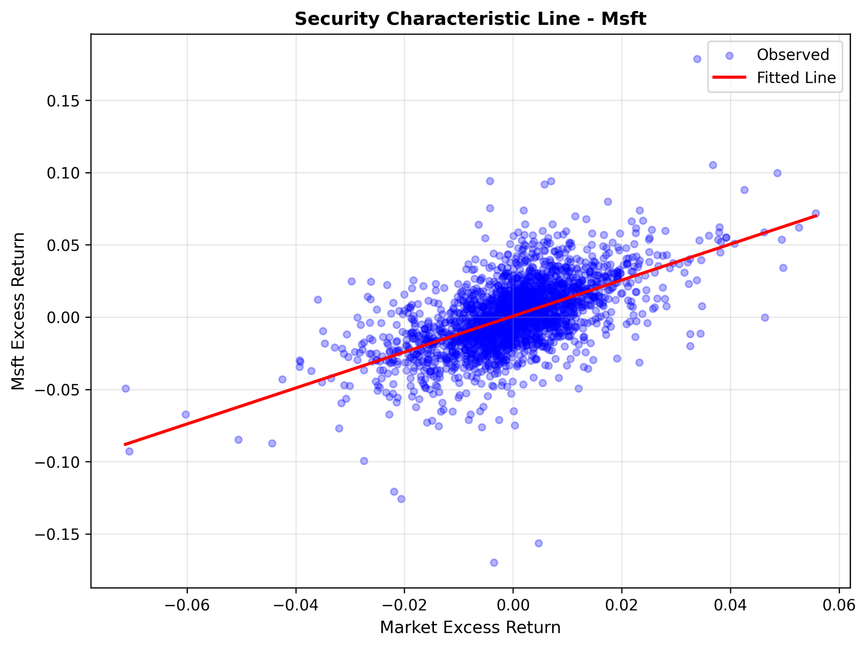
Figure 1. MSFT Security Characteristic Line (Excess Return vs Market Excess Return)

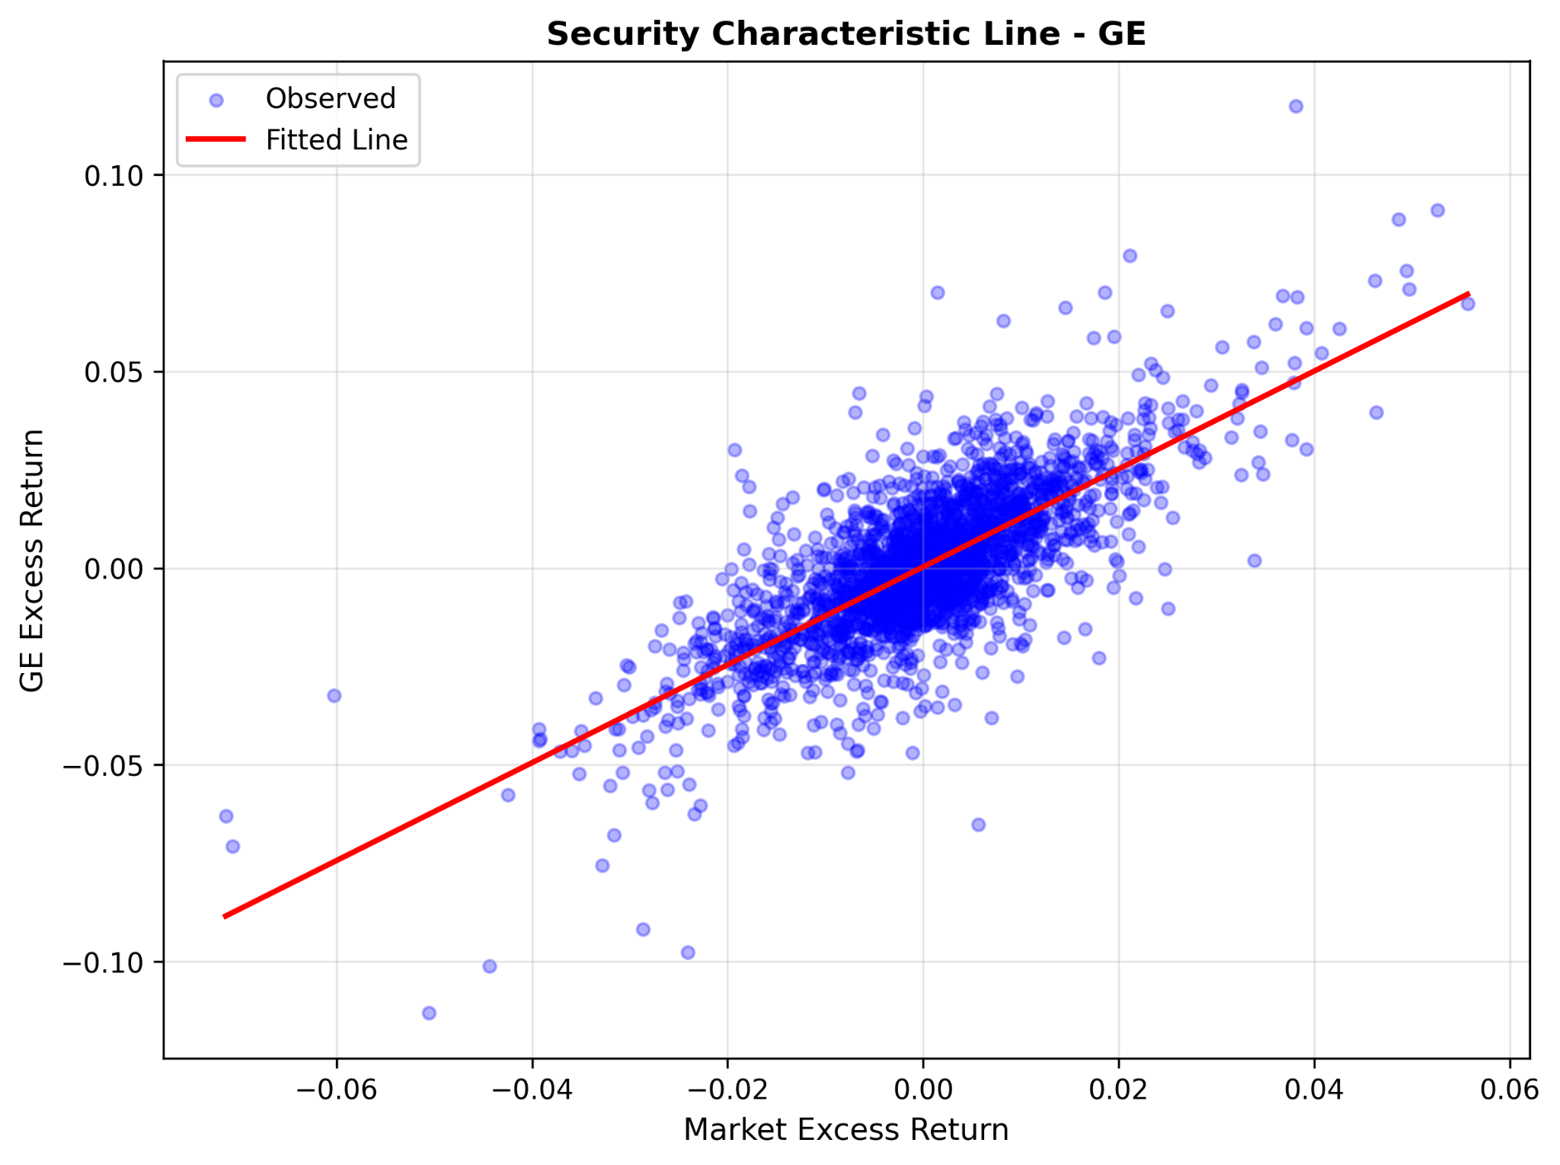
Figure 2. GE Security Characteristic Line (Excess Return vs Market Excess Return)

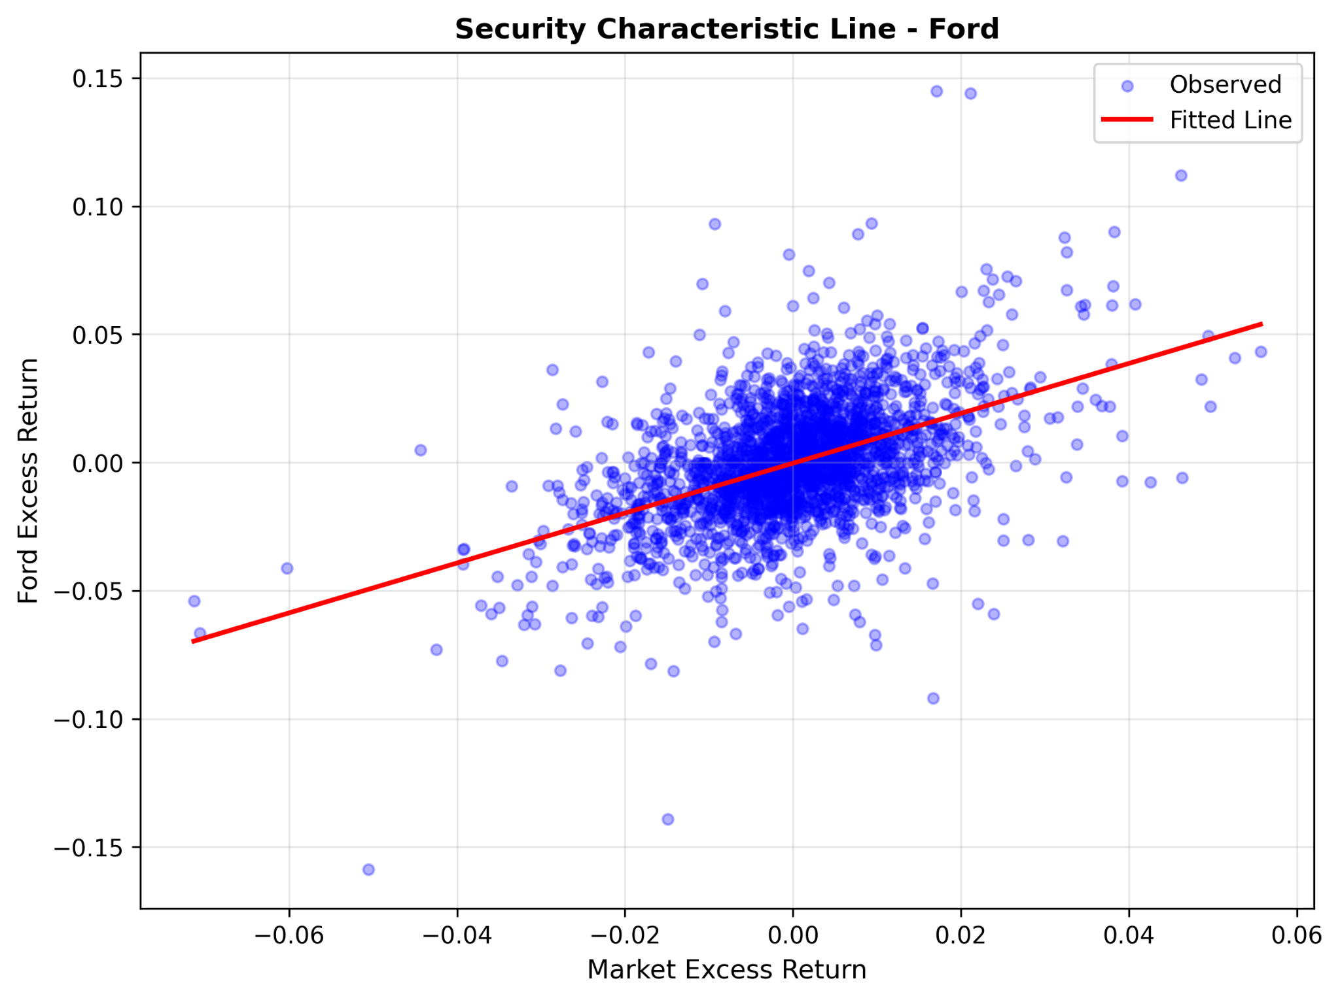
Figure 3. FORD Security Characteristic Line (Excess Return vs Market Excess Return)

4.3 CAPM Regression Results (OLS vs HAC)
Tables 2 and 3 report CAPM regression outputs. Because diagnostics indicate residual autocorrelation (GE and FORD) and heteroskedasticity (FORD), the HAC/Newey–West results are used for primary statistical conclusions about alpha (α) and beta (β).
Table 2. CAPM Regression Results (OLS)
Asset | Alpha | Alpha_pvalue | Beta | Beta_pvalue | R_Squared | Adj_R_Squared | N_Obs
MSFT | 0.000696 | 0.0891 | 1.2445 | <0.0001 | 0.343 | 0.343 | 2362
GE | 0.000310 | 0.2381 | 1.2441 | <0.0001 | 0.559 | 0.559 | 2362
FORD | -0.000277 | 0.5015 | 0.9732 | <0.0001 | 0.240 | 0.240 | 2362

Table 3. CAPM Regression Results (HAC / Newey–West)
Asset | Alpha | Alpha_pvalue | Beta | Beta_pvalue | R_Squared | Adj_R_Squared | N_Obs
MSFT | 0.000696 | 0.0741 | 1.2445 | <0.0001 | 0.343 | 0.343 | 2362
GE | 0.000310 | 0.1713 | 1.2441 | <0.0001 | 0.559 | 0.559 | 2362
FORD | -0.000277 | 0.4367 | 0.9732 | <0.0001 | 0.240 | 0.240 | 2362

4.3.1 Interpretability: What α and β mean here
• Beta (β) is the market sensitivity of excess returns. β > 1 implies above-market exposure (more cyclical/aggressive); β ≈ 1 implies market-like exposure; β < 1 implies below-market exposure.
• Alpha (α) is abnormal return relative to CAPM after controlling for β. A statistically significant α suggests the asset’s average excess return is not fully explained by market risk.
MSFT: β = 1.244 (p <0.0001) indicates above-market sensitivity. α = 0.000696 with p = 0.0741 is not significant at 5%. R² = 0.343 implies the market explains about 34.3% of daily MSFT excess return variation.
GE: β = 1.244 (p <0.0001) and the highest R² (0.559) suggest the strongest market linkage among the three. α = 0.000310 with p = 0.1713 is not significant at 5%.
FORD: β = 0.973 (p <0.0001) is close to market-like exposure on average. α = -0.000277 with p = 0.4367 is not significant at 5%.

4.4 Diagnostics and Assumption Checks
Table 4 reports diagnostic tests applied to regression residuals.
MSFT: Breusch–Pagan p = 0.7234 indicates no strong evidence of heteroskedasticity; Ljung–Box p-values at lags 5 and 10 are 0.3197 and 0.3988, suggesting weak autocorrelation.
GE: Ljung–Box p-values (0.0069, 0.0361) indicate residual autocorrelation, motivating HAC inference.
FORD: Breusch–Pagan p = 0.0247 indicates heteroskedasticity; Ljung–Box p-values are extremely small, indicating strong residual autocorrelation. These violations imply that standard OLS p-values can be overly optimistic, so HAC/Newey–West inference is appropriate.
Table 4. Residual Diagnostics (Breusch–Pagan, Durbin–Watson, Ljung–Box)
Asset | BP_pvalue | DW_stat | LB_pvalue_lag5 | LB_pvalue_lag10 | N_obs
MSFT | 0.7234 | 2.021 | 0.3197 | 0.3988 | 2362
GE | 0.4224 | 2.050 | 0.0069 | 0.0361 | 2362
FORD | 0.0247 | 2.260 | <0.0001 | <0.0001 | 2362

4.5 Stability, Sample Length, and Rolling Betas
Table 5 reports CAPM estimates across three subperiods. Figures 4–6 show rolling 252-day betas. Together, these results address the practical question of whether a decade-long sample produces a stable estimate of β.

A key tradeoff exists: longer samples reduce sampling error but may mask changes in systematic risk exposure across regimes. Rolling betas provide a continuous view of time variation.
Table 5. Subperiod CAPM Results (1993–1997, 1998–2000, 2001–2003)
Asset | Period | Alpha | Alpha_pvalue | Beta | Beta_pvalue | R2 | N_obs
MSFT | 1993-01-01 to 1997-12-31 | 0.000932 | 0.0745 | 1.2902 | <0.0001 | 0.264 | 1047
MSFT | 1998-01-01 to 2000-12-31 | -0.000088 | 0.9157 | 1.3409 | <0.0001 | 0.362 | 755
MSFT | 2001-01-01 to 2003-12-31 | 0.001149 | 0.1939 | 1.1302 | <0.0001 | 0.401 | 560
GE | 1993-01-01 to 1997-12-31 | 0.000340 | 0.2407 | 1.2321 | <0.0001 | 0.515 | 1047
GE | 1998-01-01 to 2000-12-31 | 0.000514 | 0.3262 | 1.0968 | <0.0001 | 0.488 | 755
GE | 2001-01-01 to 2003-12-31 | 0.000153 | 0.8147 | 1.3914 | <0.0001 | 0.651 | 560
FORD | 1993-01-01 to 1997-12-31 | -0.000093 | 0.8377 | 0.9474 | <0.0001 | 0.204 | 1047
FORD | 1998-01-01 to 2000-12-31 | 0.000101 | 0.9001 | 0.8951 | <0.0001 | 0.212 | 755
FORD | 2001-01-01 to 2003-12-31 | -0.001015 | 0.3408 | 1.0576 | <0.0001 | 0.288 | 560

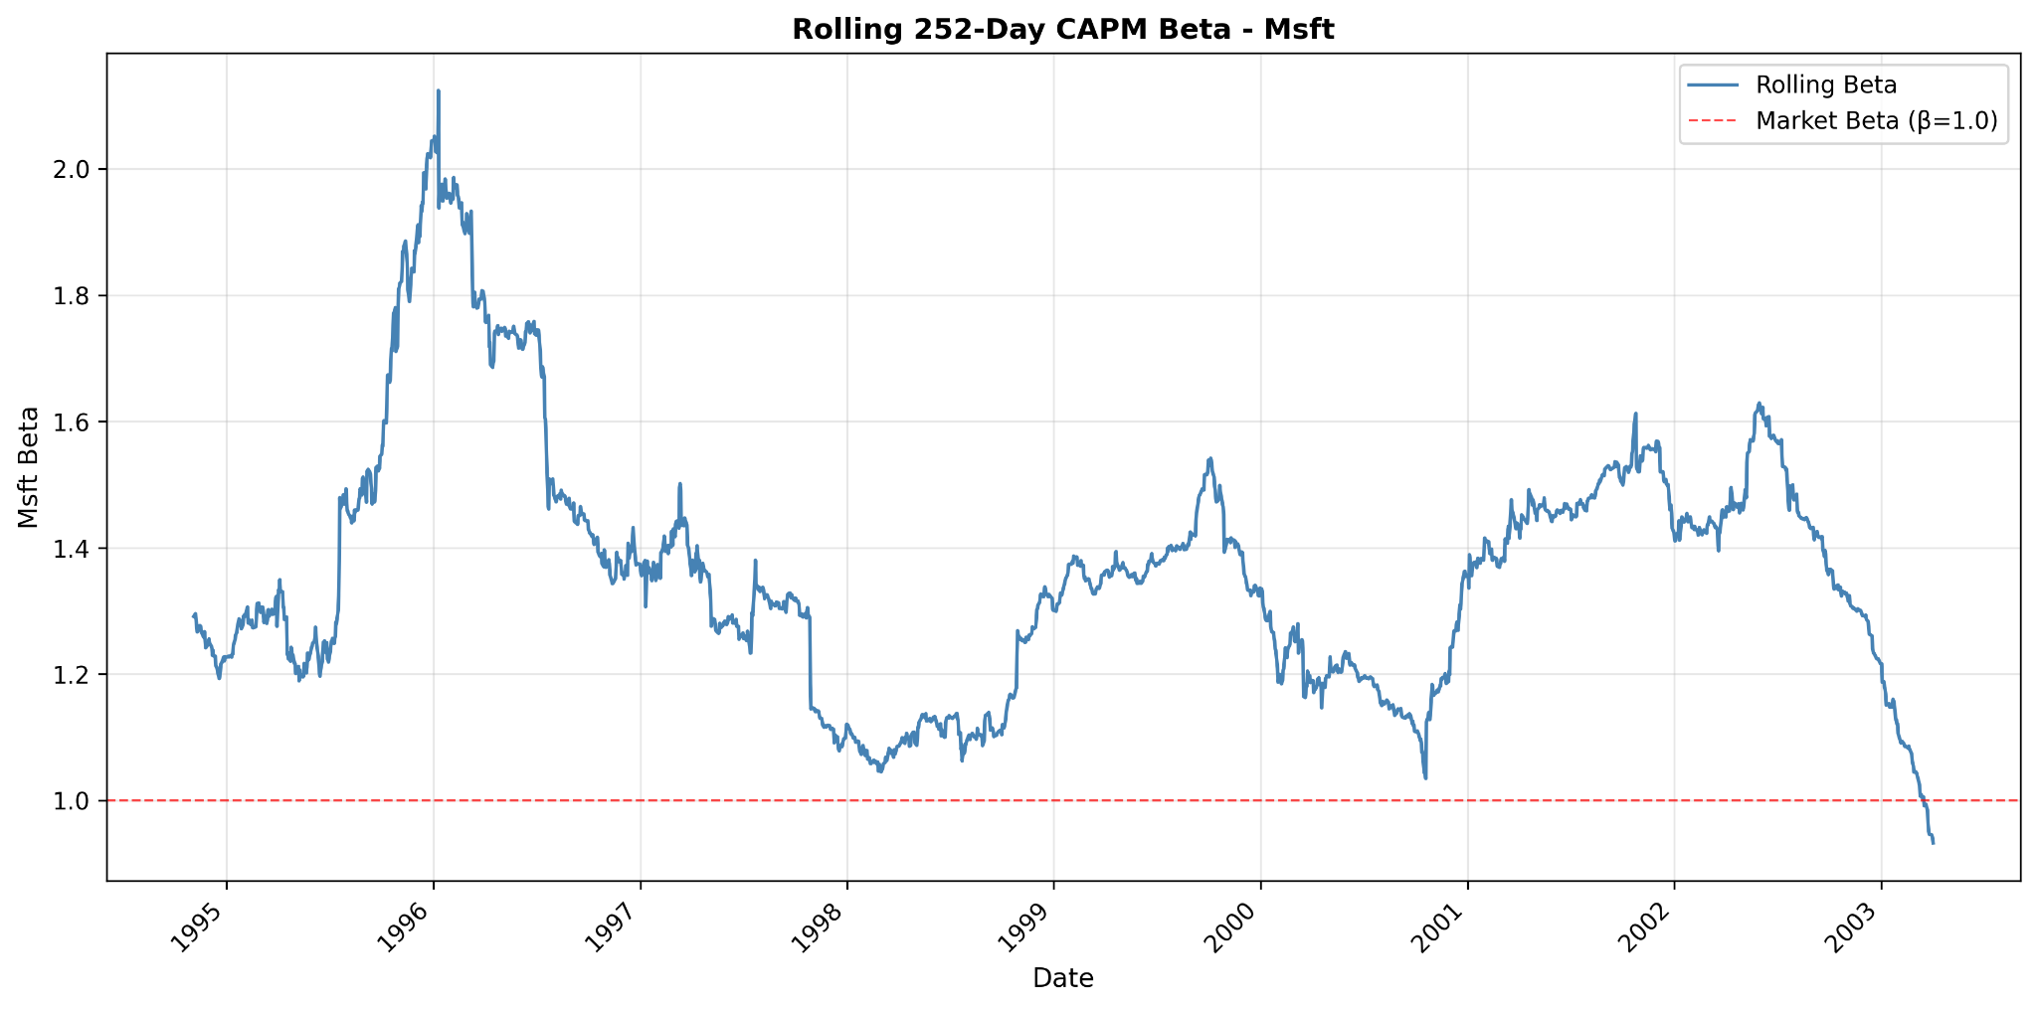
Figure 4. Rolling 252-day CAPM Beta — MSFT

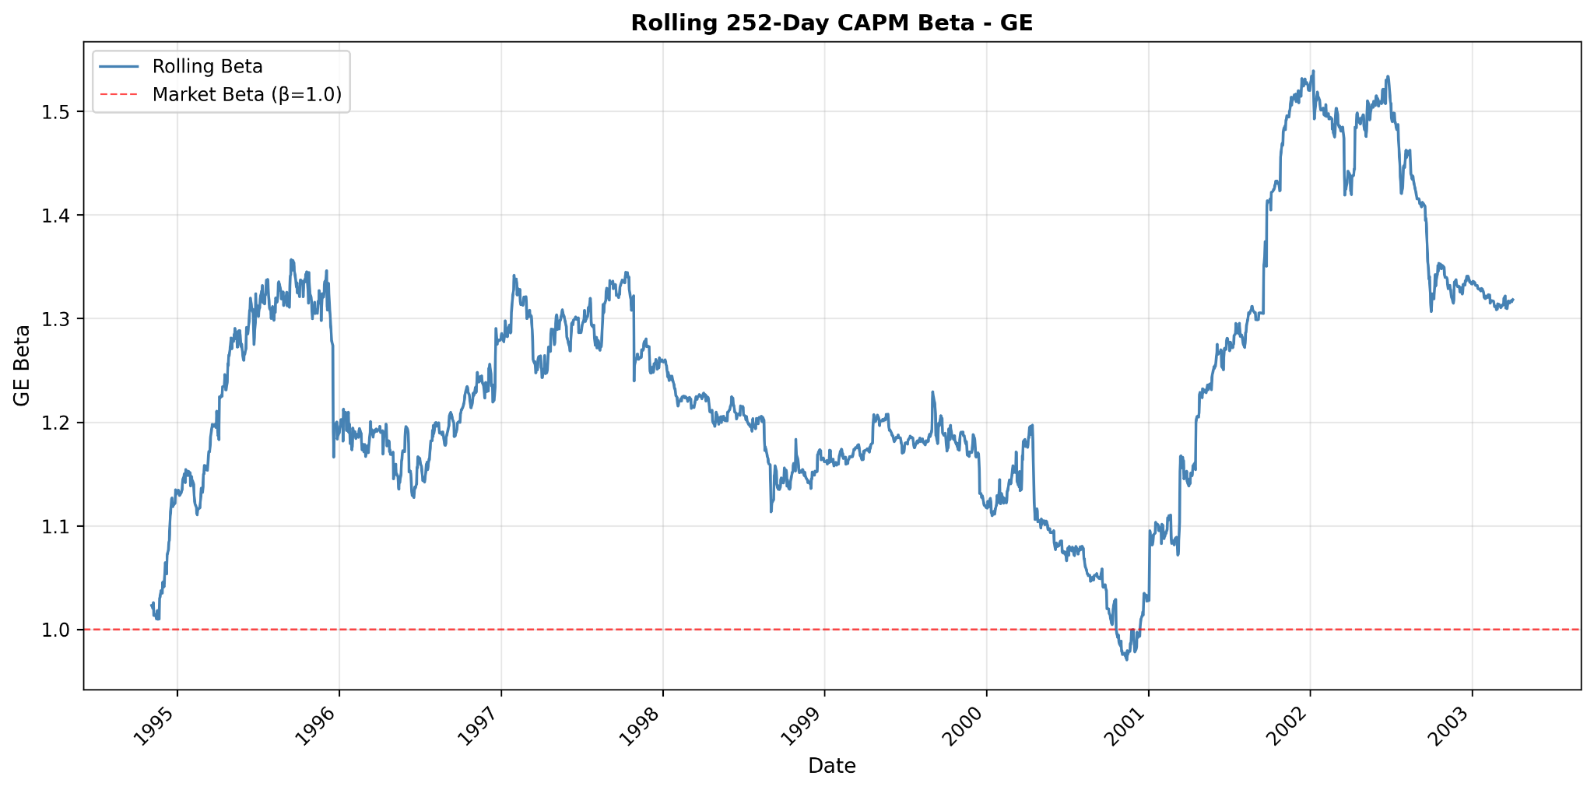
Figure 5. Rolling 252-day CAPM Beta — GE

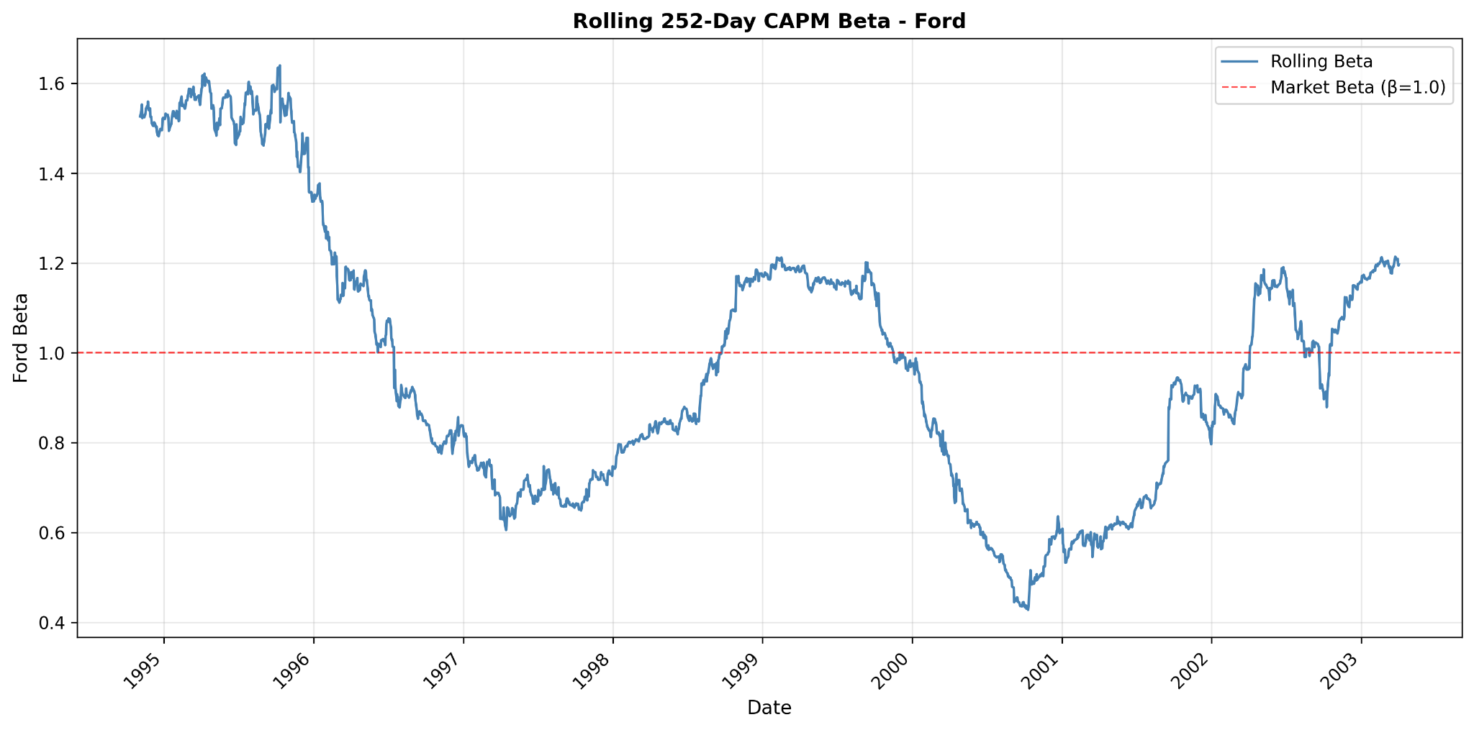
Figure 6. Rolling 252-day CAPM Beta — FORD

Subperiod beta ranges summarize stability:
• MSFT: 1.130 to 1.341 (range 0.211)
• GE: 1.097 to 1.391 (range 0.295)
• FORD: 0.895 to 1.058 (range 0.163)

These results suggest that assuming a constant β over a decade can be restrictive, particularly when the sample spans distinct market regimes.

5. Recommendations (Based on Results)
1) Use HAC/Newey–West inference for daily CAPM tests. Diagnostics indicate autocorrelation (GE) and both autocorrelation and heteroskedasticity (FORD), making robust standard errors the appropriate default.

2) Prefer rolling or regime-consistent beta estimates when the sample spans multiple regimes. Rolling betas show meaningful time variation, and subperiod betas can differ materially. For practical risk measurement, shorter windows (e.g., 1–3 years) or rolling estimates are often preferable.

3) Interpret CAPM fit alongside residual behavior. Even when α is not significant, lower R² implies substantial idiosyncratic variation in daily returns, especially for MSFT and FORD. If explanatory power is the objective, multi-factor models are a natural extension.

6. Conclusion and Limitations
Using 2362 daily observations from 1993-11-02 to 2003-04-03, estimated CAPM betas are positive and statistically significant for MSFT, GE, and FORD, indicating meaningful exposure to systematic market risk. Under HAC/Newey–West inference, none of the three assets has a statistically significant alpha at the 5% level, providing no strong evidence of persistent abnormal performance relative to CAPM over the full sample.

Limitations include CAPM’s single-factor structure, fat-tailed and heteroskedastic daily returns, approximate risk-free conversion, and possible parameter instability across regimes. Rolling and subperiod results indicate that β may vary through time, which matters for applications that rely on a single constant beta estimate.

Appendix A. Consolidated Summary
Table A1 consolidates HAC regression outputs, diagnostics, and descriptive statistics for quick cross-asset comparison.
Table A1. CAPM Master Summary
Asset | Alpha_HAC | Alpha_p_HAC | Beta_HAC | Beta_p_HAC | R2 | Adj_R2 | N | BP_pvalue | DW_stat | LB_p_lag5 | LB_p_lag10 | Mean_asset | Std_asset | Mean_mkt | Std_mkt | Beta_subperiod_min | Beta_subperiod_max | Beta_subperiod_range
MSFT | 0.000696 | 0.07408 | 1.24449 | 0 | 0.343363 | 0.343085 | 2362 | 0.723441 | 2.02141 | 0.319725 | 0.39878 | 0.000811 | 0.024546 | 9.3e-05 | 0.011557 | 1.13021 | 1.34089 | 0.210674
GE | 0.00031 | 0.171345 | 1.24413 | 0 | 0.559118 | 0.558931 | 2362 | 0.422447 | 2.04956 | 0.006854 | 0.036097 | 0.000425 | 0.01923 | 9.3e-05 | 0.011557 | 1.09679 | 1.39136 | 0.294577
FORD | -0.000277 | 0.436673 | 0.973173 | 0 | 0.239997 | 0.239675 | 2362 | 0.024739 | 2.26006 | 0 | 0 | -0.000187 | 0.022959 | 9.3e-05 | 0.011557 | 0.895065 | 1.05757 | 0.162507

Appendix B. Residual Diagnostics Figures
Appendix B provides residual diagnostic plots supporting Table 4 and illustrating departures from classical OLS assumptions (volatility clustering, autocorrelation, and non-normality).

Appendix B.MSFT
For MSFT, the residual time-series plot visualizes volatility clustering; the residuals-vs-fitted plot highlights potential heteroskedasticity; the ACF plot illustrates residual dependence; and the Q–Q plot shows deviations from normality in the tails.
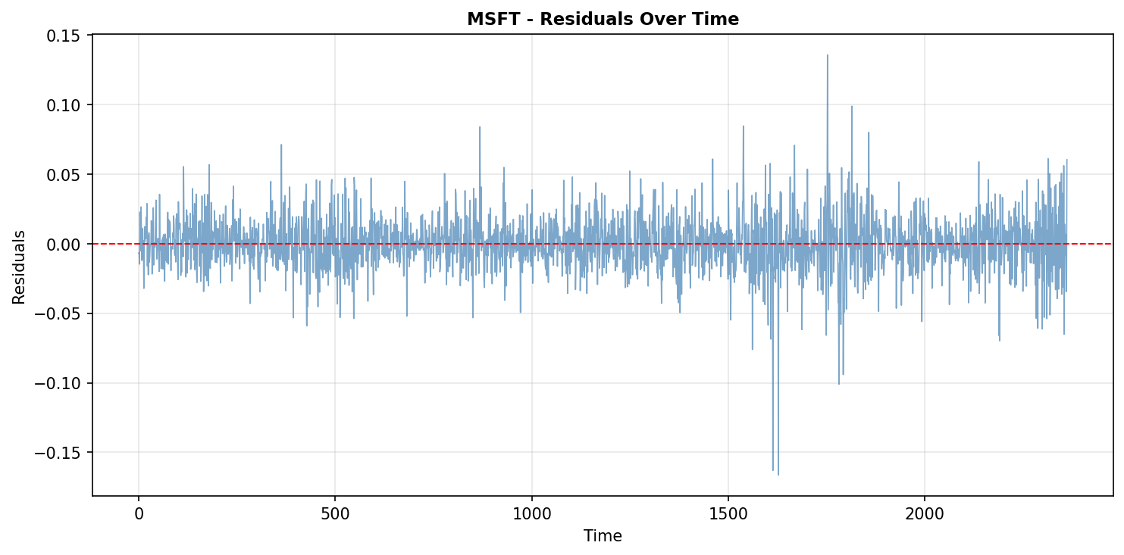
Figure 7. MSFT — MSFT residuals timeseries

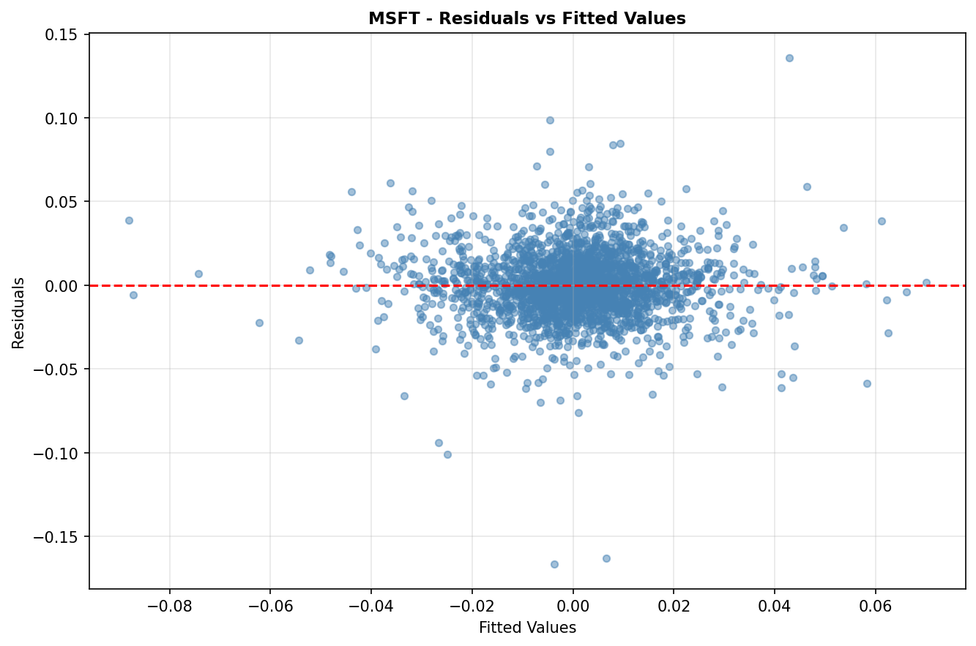
Figure 8. MSFT — MSFT residuals vs fitted

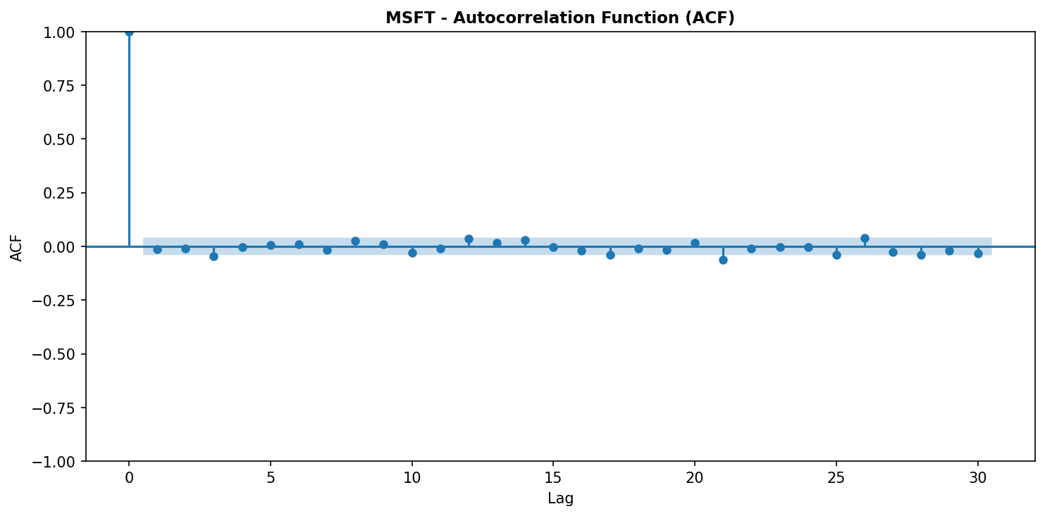
Figure 9. MSFT — MSFT residuals acf

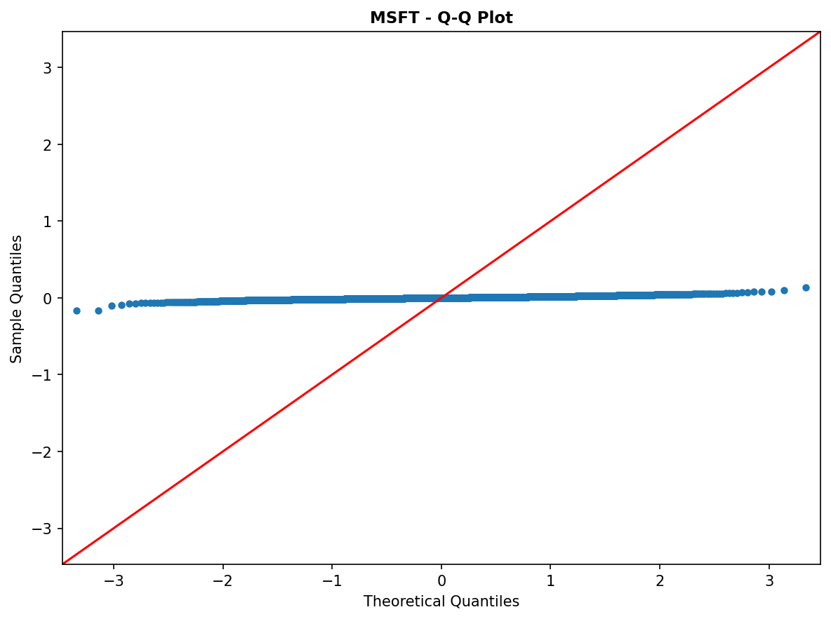
Figure 10. MSFT — MSFT qqplot

Appendix B.GE
For GE, the residual time-series plot visualizes volatility clustering; the residuals-vs-fitted plot highlights potential heteroskedasticity; the ACF plot illustrates residual dependence; and the Q–Q plot shows deviations from normality in the tails.
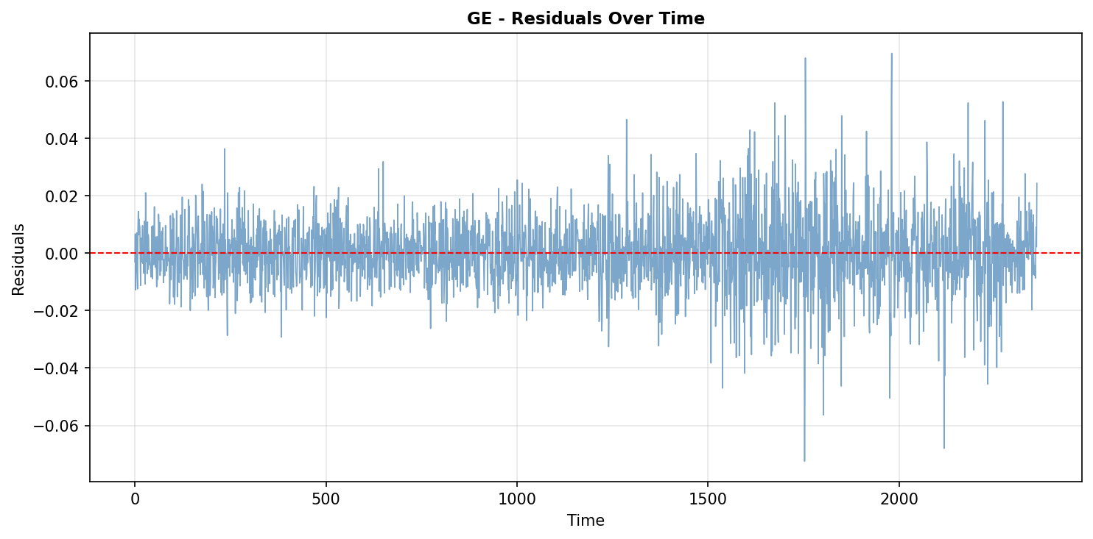
Figure 11. GE — GE residuals timeseries

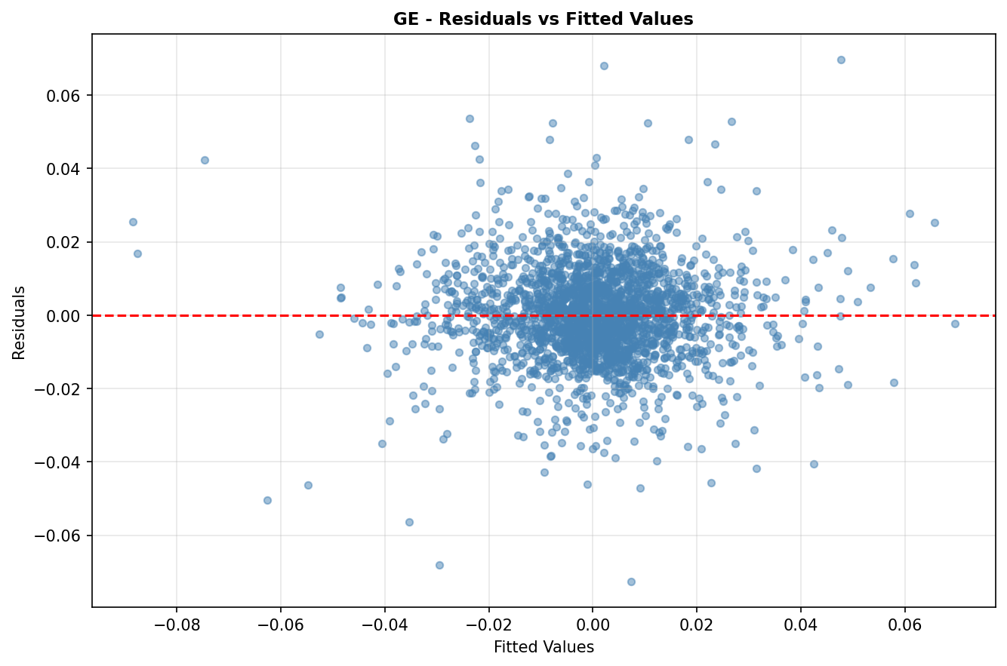
Figure 12. GE — GE residuals vs fitted

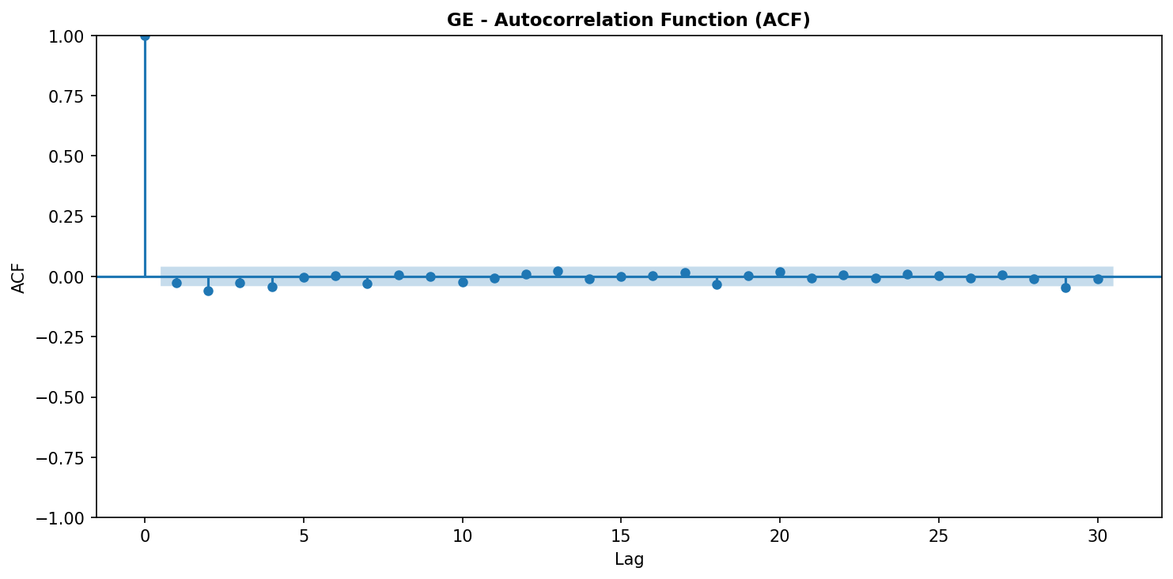
Figure 13. GE — GE residuals acf

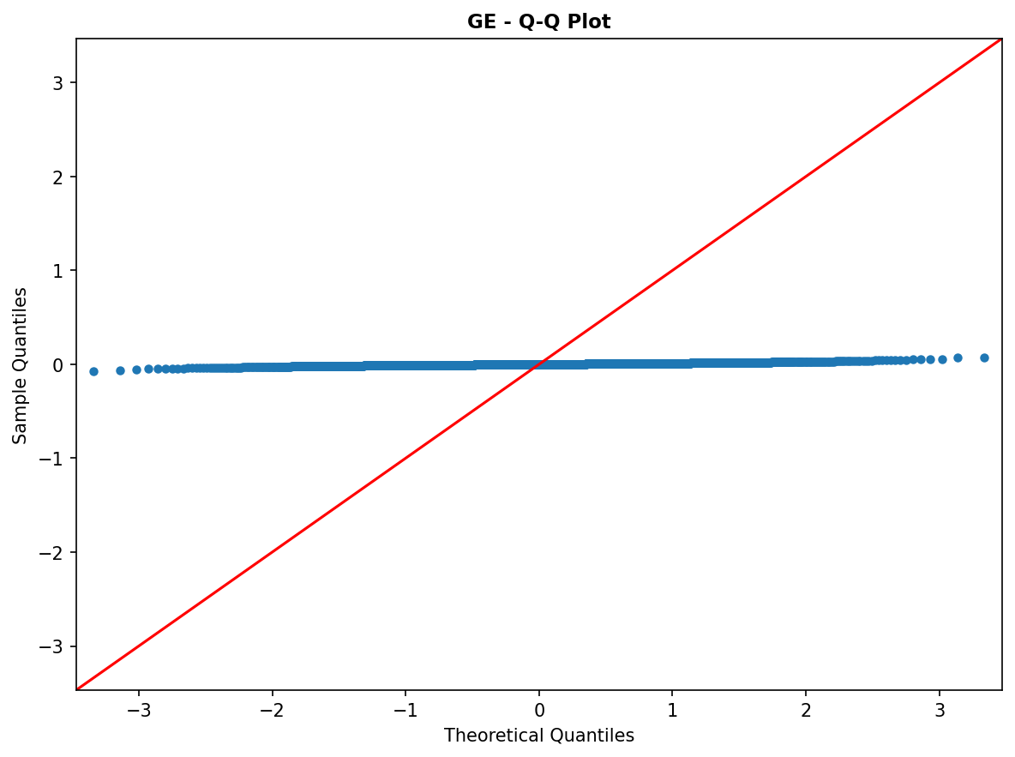
Figure 14. GE — GE qqplot

Appendix B.FORD
For FORD, the residual time-series plot visualizes volatility clustering; the residuals-vs-fitted plot highlights potential heteroskedasticity; the ACF plot illustrates residual dependence; and the Q–Q plot shows deviations from normality in the tails.
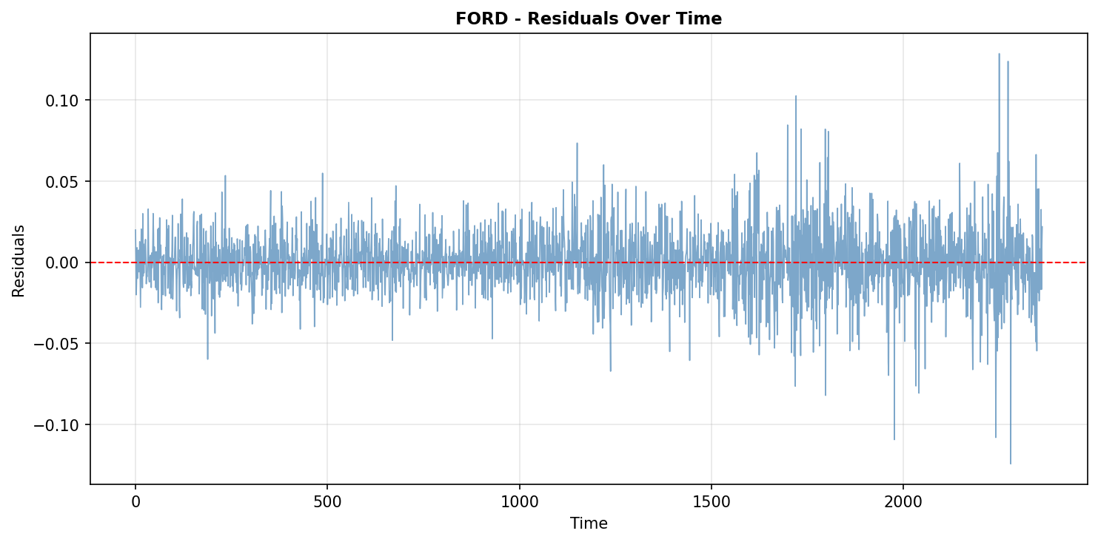
Figure 15. FORD — FORD residuals timeseries

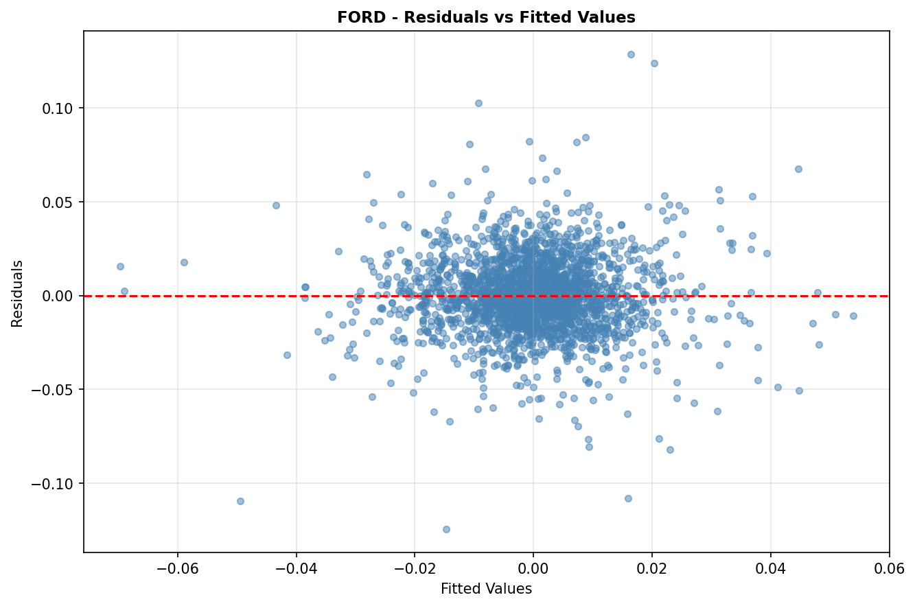
Figure 16. FORD — FORD residuals vs fitted

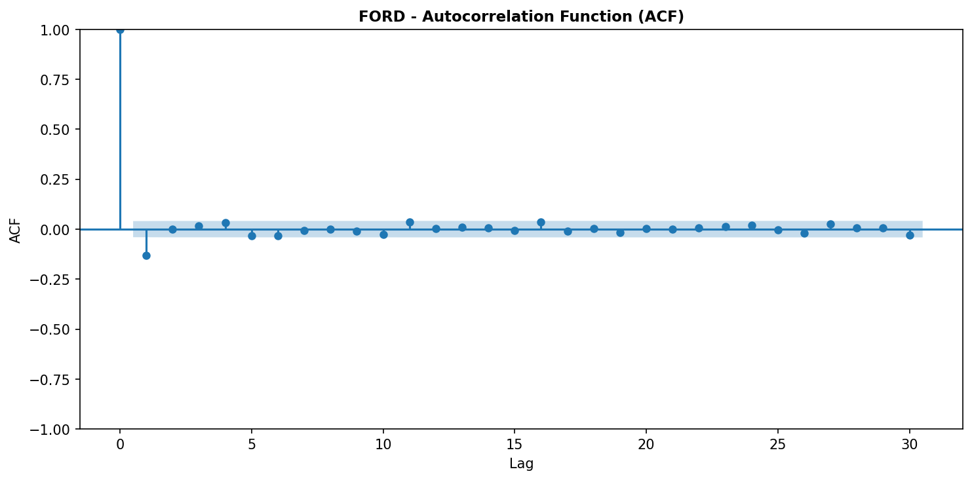
Figure 17. FORD — FORD residuals acf

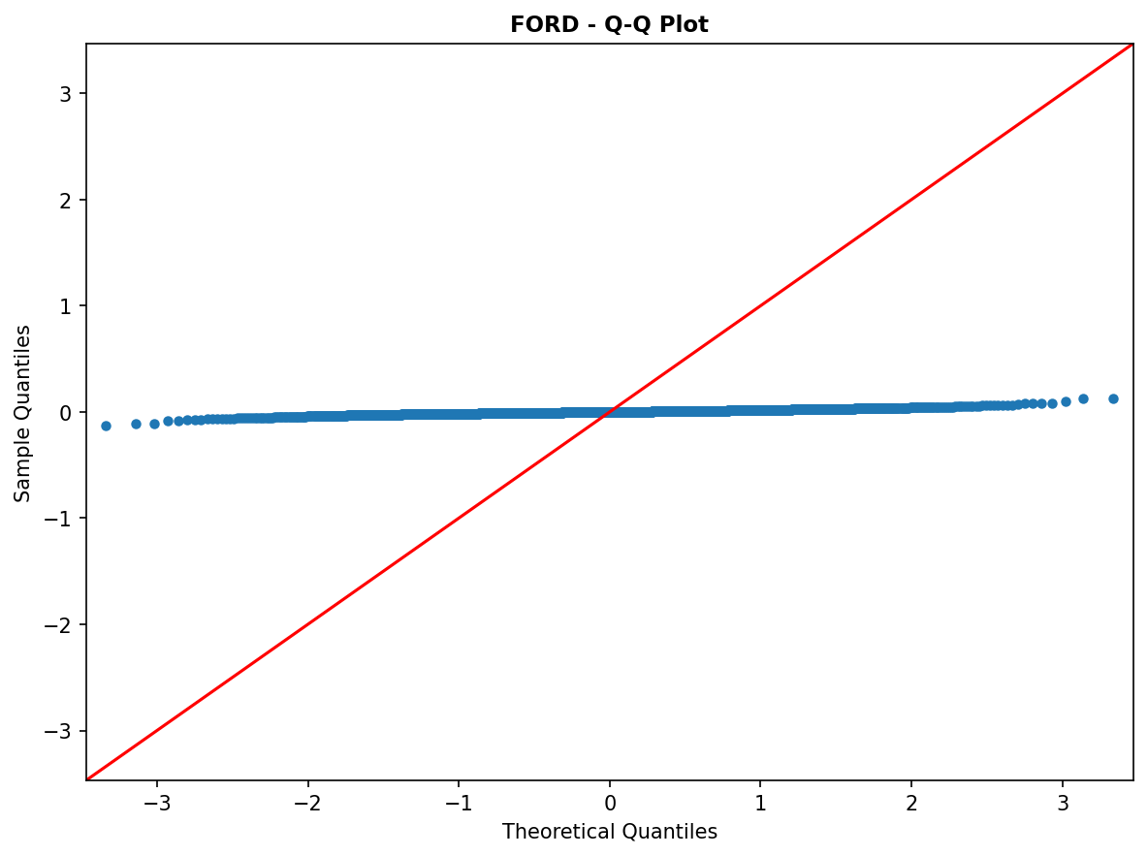
Figure 18. FORD — FORD qqplot

7. References
Sharpe, W. F. (1964). Capital Asset Prices: A Theory of Market Equilibrium under Conditions of Risk. Journal of Finance, 19(3), 425–442.
Lintner, J. (1965). The Valuation of Risk Assets and the Selection of Risky Investments in Stock Portfolios and Capital Budgets. Review of Economics and Statistics, 47(1), 13–37.
Mossin, J. (1966). Equilibrium in a Capital Asset Market. Econometrica, 34(4), 768–783.
Jensen, M. C. (1968). The Performance of Mutual Funds in the Period 1945–1964. Journal of Finance, 23(2), 389–416.
Fama, E. F., & French, K. R. (2004). The Capital Asset Pricing Model: Theory and Evidence. Journal of Economic Perspectives, 18(3), 25–46.
Newey, W. K., & West, K. D. (1987). A Simple, Positive Semi-definite, Heteroskedasticity and Autocorrelation Consistent Covariance Matrix. Econometrica, 55(3), 703–708.
Breusch, T. S., & Pagan, A. R. (1979). A Simple Test for Heteroscedasticity and Random Coefficient Variation. Econometrica, 47(5), 1287–1294.
Durbin, J., & Watson, G. S. (1950). Testing for Serial Correlation in Least Squares Regression I. Biometrika, 37(3/4), 409–428.
Durbin, J., & Watson, G. S. (1951). Testing for Serial Correlation in Least Squares Regression II. Biometrika, 38(1/2), 159–178.
Ljung, G. M., & Box, G. E. P. (1978). On a Measure of Lack of Fit in Time Series Models. Biometrika, 65(2), 297–303.

