Adaptive Pairs Trading (APT)
A Methodology and Out-of-Sample Validation Study
Statistical-arbitrage pairs trading on the NSE cash-equity universe,
with an adaptive-equilibrium extension and a crypto out-of-sample retest

Authors: Om Chitlangia · Manan Raina Kumar
Supervisors: Dr. Barik · Dr. Malu
Institution / Department: [TODO — fill before submission]
Date: June 2026

Audience: academic committee. Reproducibility: every table is rendered from a persisted CSV and every figure from a persisted PNG; no experiment is re-run for this document. All performance numbers are reported gross AND net of transaction cost.

Structured Abstract
Background — Classical statistical-arbitrage pairs trading exploits temporary dislocations between cointegrated assets. Two structural headwinds motivate this study: (i) the documented decay of the equity-pairs edge as the strategy has become crowded, and (ii) the cash-market constraints of the Indian (NSE) venue — no native shorting in the cash segment, discrete-lot frictions, and a split/bonus-only (dividend-unadjusted) price history.
Objective — To build a fully reproducible pairs-trading pipeline on the NSE universe; to test whether an adaptive-equilibrium signal (a per-session causal Kalman level filter) improves on a frozen cointegration relationship; and to subject the strongest result to a multiple-testing-aware validation gate (Deflated Sharpe Ratio and the Probability of Backtest Overfitting) before retesting the mechanism out-of-sample on a breadth universe (crypto perpetual pairs).
Methods — Engle–Granger cointegration with Benjamini–Hochberg FDR control for pair selection (Johansen used as an order-independent comparator); a frozen-OLS hedge ratio with a β-aware (1+β) transaction-cost convention; Ornstein–Uhlenbeck fitting with Bertram (2010) cost-aware optimal thresholds; a μ-only local-level Kalman equilibrium filter (West–Harrison discount form) with a train-only absorption guard; and a leakage-free walk-forward backtest. Validation uses the Deflated Sharpe Ratio (Bailey & López de Prado, 2014) and PBO via CSCV (Bailey et al., 2017).
Results — On the daily NSE universe the baseline is net-profitable (net Sharpe 1.08 over ~7 out-of-sample years). At intraday frequency the tradeable universe collapses to two pair-folds; on that matched universe the adaptive Kalman arm roughly doubles the net Sharpe of the frozen engine (2.15 vs 0.95–1.00) and is the only engine to clear the N=46 Deflated-Sharpe luck bar (DSR 0.808) — but its p-value is 0.192 (not significant) and the result rests on n=2. The β-tracking escalation fails by weak identification (β collapses at intraday frequency). On the breadth crypto universe the ordering replicates (Kalman > frozen on gross and net; Kalman uniquely positive gross), yet net is deeply negative for every engine and the net Deflated Sharpe is 0.002 — the edge does not survive realistic intraday transaction cost.
Conclusion — We document a real, repeatable, universe-general mean-reversion mechanism that does NOT clear realistic intraday transaction costs. The strongest in-sample NSE result is statistically indistinguishable from luck after Deflated-Sharpe correction (n=2), and on the breadth/crypto universe the strategy is net-negative. We present this as a rigorous negative result and a methodological contribution: the obstacle is execution cost and turnover, not signal, so the productive next step is structural (lower-frequency re-anchoring, a cheaper venue, maker execution) rather than parametric.
Keywords: pairs trading; cointegration; Engle–Granger; Johansen; Ornstein–Uhlenbeck; Bertram thresholds; Kalman filter; adaptive equilibrium; Deflated Sharpe Ratio; PBO; walk-forward; NSE; crypto.

Contents

1. Executive Summary — the Honest Verdict
The headline finding is a disciplined negative. Across four years of staged development — NSE data engineering, a daily walk-forward baseline, an intraday Ornstein–Uhlenbeck/Bertram engine, an adaptive Kalman-equilibrium extension, and a crypto out-of-sample retest — we find a real, repeatable, universe-general mean-reversion mechanism that does not clear realistic intraday transaction costs.
The adaptive equilibrium filter genuinely extracts more signal than a frozen cointegration relationship: it beats the frozen engine on gross and net Sharpe on the matched NSE universe, and the same ordering replicates on a completely different (crypto) universe, where the adaptive engine is uniquely positive on gross return. That cross-universe replication is the positive methodological result. But two facts gate any deployment claim: (i) the strongest NSE result rests on only n=2 intraday pair-folds and, after Deflated-Sharpe correction for the number of trials, is statistically indistinguishable from luck (DSR p = 0.192); and (ii) on the breadth crypto universe — where the statistics are trustworthy — the net edge is decisively negative (net DSR 0.002). Gross is alive, net is dead: the obstacle is execution cost and turnover, not the signal.
Table 1. Headline result ladder (all net figures are after the β-aware (1+β) cost). Sources: reports/backtest_portfolio_metrics.csv, reports/phase3_ou/figures/matched_universe/matched_metrics.csv, reports/phase4/verification/1b_eight_cell_table.csv, reports/phase4/dsr_pbo/2b_dsr.csv, reports/phase4/crypto_adaptive/dsr_pbo_kalman.csv.
stage | universe | gross tot | net tot | gross Sh | net Sh | DSR | reading
NSE daily baseline (Phase 2A) | 492→341 univ. | 297.35% | 215.67% | 1.28 | 1.08 | — | net-profitable; broad universe
NSE intraday frozen-OU best (Ph 3) | 2 pair-folds | 54.87% | 46.20% | 1.08 | 0.95 | 0.23 | matched universe; n=2
NSE intraday Kalman best (Ph 4) | 2 pair-folds | 161.35% | 139.94% | 2.32 | 2.15 | 0.81 | clears luck bar; p=0.192
Crypto Kalman best, Regime A (A10) | 14 pairs×540d | +8.96% | −63.20% | +0.11 | −1.31 | 0.002 | gross alive, net dead

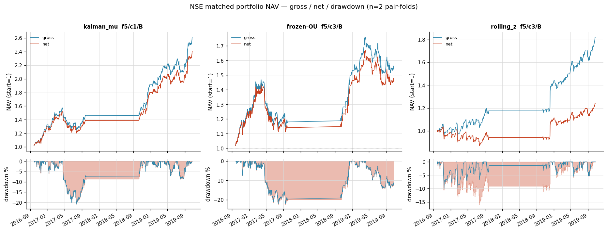
Figure 1. NSE adaptive equity (matched universe). Portfolio NAV with gross and net lines and an underwater (drawdown) panel, for the Kalman best cell alongside the frozen-OU and rolling-z companions. The adaptive arm compounds to roughly 2.4× net over the two concatenated out-of-sample folds. Source: final_nse_plots.py.

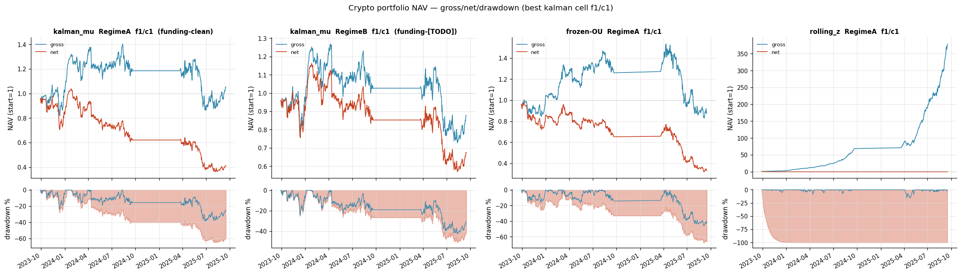
Figure 2. Crypto adaptive equity (breadth universe, 14 pairs × 540 sessions). Gross stays near flat-to-positive for the Kalman arm while net craters under intraday taker + spread cost; Regime B is funding-unpriced [TODO]. This is the cost wall that blocks deployment. Source: final_crypto_plots.py.

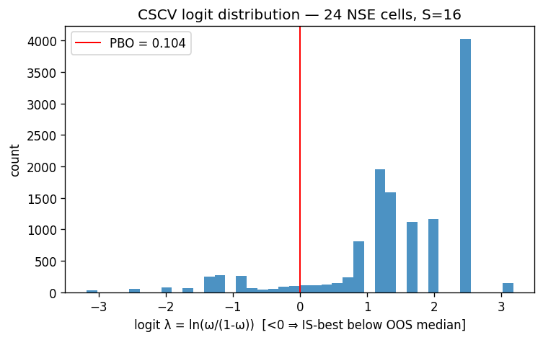
Figure 3. The validation gate (NSE matched universe). CSCV logit distribution behind the Probability of Backtest Overfitting (PBO = 0.104). Only the adaptive Kalman arm clears the N=46 Deflated-Sharpe luck bar; its p-value (0.192) still falls short of significance. Source: s2_dsr_pbo.py.

2. Introduction and Objective

2.1 Statistical-arbitrage pairs trading
Pairs trading is the canonical market-neutral statistical-arbitrage strategy: two assets whose prices share a long-run equilibrium are traded as a single mean-reverting spread — short the rich leg, long the cheap leg — and the position is unwound when the spread reverts. The edge depends on (a) the existence of a stable cointegrating relationship, (b) a spread that mean-reverts fast enough to be capital-efficient yet slowly enough to be tradeable net of cost, and (c) execution cheap enough that round-trip frictions do not consume the captured dislocation.

2.2 Cash-market constraints and the decay context
- Decay of equity pairs: the equity-pairs edge has decayed as the strategy crowded — naive rolling-z mean reversion is largely arbitraged away on liquid names, which raises the bar for any claimed edge and motivates an explicit overfitting-aware validation gate.
- NSE cash constraints: the NSE cash segment does not permit native short selling for multi-day carry, lot-size discretisation adds friction, and the available daily history is split/bonus-only (dividends are NOT back-adjusted), so total-return effects are absent from the price series.
- Crypto → futures rationale: a venue with 24/7 trading, native two-sided leverage via perpetual futures, and genuine intraday co-movement is the natural place to retest the mechanism with breadth — and is a stepping stone toward a regulated futures (e.g. CME) deployment where the cash-market constraints do not bind.

2.3 Objective and thesis
The thesis under test: does an adaptive equilibrium — letting the spread's mean-reversion level track slowly rather than freezing it at the in-sample estimate — produce a transaction-cost-robust improvement over a frozen cointegration relationship? The study answers this in three movements: establish a disciplined NSE pipeline and baseline (Phases 1–2); develop and stress the adaptive engine at intraday frequency (Phases 3–4); and retest the mechanism out-of-sample with breadth on crypto, gating every claim through a Deflated-Sharpe / PBO filter.

3. Data

3.1 NSE daily universe and the seven-rule cleaning cascade
The raw source is a read-only archive of per-symbol NSE daily OHLCV CSVs (/Data6/db): 492 symbols and ~1.6 million rows. The history is split/bonus-only — a dividend-flavor probe (Table 2) shows split adjustments present but dividends unadjusted on all five dividend-paying probe names. Cleaning is a deterministic, idempotent seven-rule cascade; each rule is a pure function with logged row counts.
Table 1. The seven-rule cleaning cascade (src/apt/data, config/default.yaml cleaning/liquidity/universe blocks). Rule 6 (min-history) and Rule 7 (contiguity) gate the symbol count.
rule | name | operation
1 | Trading-calendar filter | drop weekend/holiday/off-calendar bars
2 | Residual-split patch | back-adjust pre-ex-date OHLC for residual splits (e.g. FEDERALBNK, VINATIORGA)
3 | Phantom-seam trim | drop history before the last unexplained >65% day-over-day jump (phantom_jump_threshold = 0.65)
4 | Structural-event windowing | keep only history after structural events (mergers/demergers; e.g. ADANIENT, IDEA)
5 | Liquidity floor | drop bars with 60-day rolling-median ADV < ₹10M (close×volume)
6 | Minimum-history filter | drop symbols with < 756 cleaned rows (~3 trading years)
7 | Contiguity filter | keep only the longest contiguous segment (gaps > 10 calendar days split a symbol)

Symbol funnel: 492 raw symbols → 342 survive the cascade (Rule 6/7 gating) → 341 trading universe after one share-class duplicate is dropped at backtest time. [Inter-doc note: the clean log records 342 post-cascade; the backtest loads 341 — the difference is a single share-class de-duplication, not a data loss.]
Table 2. Dividend-flavor diagnostic (reports/dividend_flavor_diagnosis.csv). The low coefficient of variation against raw close vs the larger CV against a total-return adjusted close indicates split-only adjustment — dividends are not back-adjusted in the source.
symbol | n overlap | cv vs close | cv vs adj_close | verdict | confidence
ITC | 4538 | 0.003 | 0.115 | split_only | high
COALINDIA | 2617 | 0.000 | 0.203 | split_only | high
HINDPETRO | 4520 | 0.000 | 0.196 | split_only | high
NTPC | 4096 | 0.041 | 0.097 | split_only | medium
POWERGRID | 3373 | 0.000 | 0.089 | split_only | high

Corporate actions are repaired conservatively: after a diagnostic pass over yfinance split/dividend coverage (reports/corporate_actions_audit.csv, corporate_actions_coverage.csv), the pipeline drops ratio-snap ADJUST in favour of routing every flagged action to TRIM (resample to the post-event spine) — a deliberate choice to avoid introducing synthetic back-adjustment error (reports/ca_repair_classification.csv).

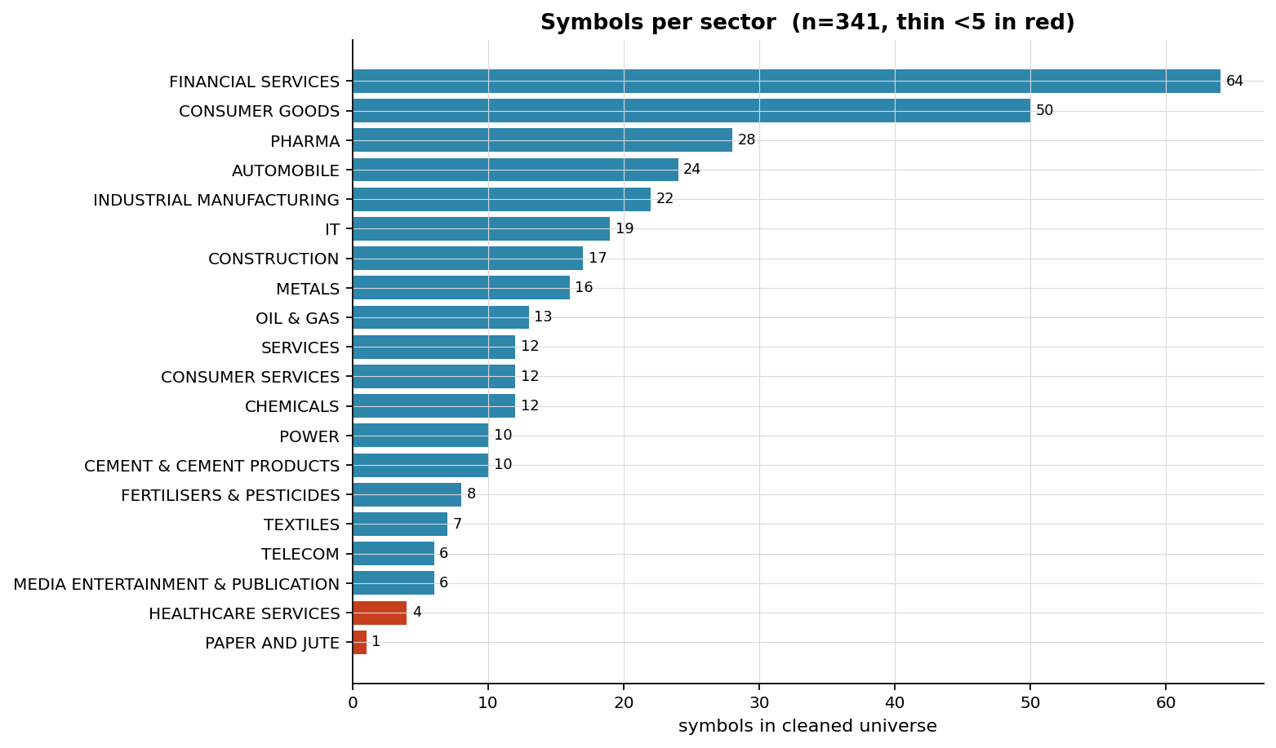
Figure 4. Cleaned NSE universe by sector (scripts/06 universe EDA). The surviving universe is concentrated in financials and materials — the sectors that later dominate the cointegrated-pair pool (banks, cement, oil & gas).

3.2 Crypto universe
The out-of-sample venue is Binance 1-minute klines (12-column headerless; epoch timestamps in UTC, with a mixed ms/µs convention after Binance's 2025 switch that the loader normalises by magnitude). 30 USDT pairs span 2017-08 → 2026-04. A liquidity gate (median daily quote-volume ≥ $10M, labelled default) keeps 22/30 symbols; at $50M only 7 survive, too thin for breadth. The NSE seven-rule cascade does not transfer (no corporate actions; 24/7 sessions) — only minimal cleaning applies (dedup open_time, drop non-positive OHLC and zero-volume bars). A funding-rate series is absent from the archive, so funding cost is carried as a [TODO] and every multi-day-carry (Regime B) number is marked funding-unpriced.

4. Methodology
Each technique is given a model specification, the reason it was chosen, how it is fit TRAIN-only, how it is validated, and a pointer to the result. A single discipline runs through all of it: nothing is fit, tuned, or selected on test data; every hyperparameter is chosen on a training window and frozen before the out-of-sample slice is touched.

4.1 Pair selection — Engle–Granger + BH-FDR (Johansen comparator)
Candidate pairs are first correlation-screened, then tested for cointegration by the Engle–Granger two-step: regress log-prices to obtain a static hedge ratio β and residual, then ADF-test the residual for stationarity. Because hundreds of pairs are tested per fold, raw ADF p-values are corrected for multiple comparisons by the Benjamini–Hochberg false-discovery-rate procedure (α = 0.05) — this is the single most important guard against selecting spuriously-cointegrated pairs.
log Y_t = α + β · log X_t + r_t ; ADF(r_t) → p ; BH-FDR over {p_i} (Engle–Granger + BH)
Johansen's trace test is implemented as an order-independent comparator (it does not privilege one leg as the dependent variable). On a common 234-pair candidate set it selects 41 pairs vs Engle–Granger+FDR's 13 — but Section 6 shows that gap is almost entirely the absence of a multiple-testing correction on the Johansen path, not a structurally different selection. The two universes are therefore reported separately and never merged into a matched performance table.

4.2 Spread, hedge ratio, and the (1+β) cost convention
The traded spread is s_t = log Y_t − β·log X_t − α with β frozen from the training OLS fit (direction chosen so β > 0). A one-unit spread position is long 1 notional unit of Y and short β notional units of X, so the round-trip transaction cost in cost-log space is proportional to the engaged notional (1+β), not to a flat 2 legs:
cost_per_pair_round_trip = (1 + β) · cost_per_leg (β-aware billing)
This corrects a legacy equal-notional 2× convention. The bias ratio is (1+β)/2: high-β pairs were under-charged, low-β pairs over-charged. Re-billing the entire pipeline under (1+β) moved the headline frozen-OU best cell by only −0.33 percentage points of annual return (decomposed exactly as billing −0.398 pp + threshold-refit +0.071 pp = −0.326 pp; Section 5.4), and moved the daily Phase-2A net Sharpe by +0.006 — negligible — but it removed a spurious rolling-z-beats-OU inversion at the lowest cost and is the single billing convention used everywhere thereafter.

4.3 OU process and Bertram cost-aware thresholds
At intraday frequency the spread is modelled as an Ornstein–Uhlenbeck process and fit by its exact AR(1) discretisation on the training window:
dX_t = κ(μ − X_t) dt + σ dW_t ⇔ X_{t+1} = c + φ·X_t + ε_t
κ = −ln(φ)/Δt , μ = c/(1−φ) , σ_eq² = σ²/(2κ) , half-life = ln(2)/κ
Entry/exit thresholds are not hand-set: they solve Bertram's (2010) closed-form optimum, which maximises expected return per unit time net of round-trip cost c, trading at ±a* in equilibrium-σ units and exiting at the mean. The transcription was Monte-Carlo validated against a first-passage simulation (analytic crossing probability 1.140×10⁻³ vs simulated 1.132×10⁻³). The threshold is re-solved per cost level, so a* widens monotonically with cost (e.g. 0.41 → 0.54 σ-units from 1 → 8 bps on the KOTAK fold) — the engine self-amortises cost by trading less, which is the structural reason it is far more cost-resilient than a fixed-band rolling-z rule.
A half-life band filter separates two trade regimes: Regime A (intraday square-off) admits half-lives in [30, 120] minutes; Regime B (multi-day carry) admits [120, 1875] minutes (1875 min = 5 sessions). A time-of-day volatility normalisation removes the intraday U-shape before z-scoring. Critically, 0 of 18 valid OU fits fall in the Regime-A band at any frequency — the NSE pairs mean-revert on a multi-session timescale, which makes intraday square-off structurally infeasible (Section 6.3).

4.4 Adaptive equilibrium — the μ-only Kalman filter
The central methodological contribution replaces the frozen equilibrium μ with a per-session causal local-level (random-walk-plus-noise) filter, so the spread's reversion target tracks slowly rather than being pinned at the in-sample estimate:
state: μ_t = μ_{t−1} + w_t observation: y_t = μ_t + e_t
constant gain (West–Harrison discount): K = 1 − 2^(−1/H) H = half-life in sessions
H is the discount horizon in sessions; H = ∞ gives K = 0 and recovers the frozen engine exactly (the frozen-control equivalence, unit-tested bit-for-bit). The filter updates μ at session close and applies it from the next session open — strictly causal, no intra-session look-ahead. H is selected TRAIN-only from {∞, 20, 10, 5} by the Bertram net-return criterion on training residuals, subject to an absorption guard: the residual half-life under the candidate H must stay within [0.5×, 1.5×] of the frozen-μ half-life, otherwise the configuration is inadmissible. This guard is what prevents the filter from over-tracking and absorbing genuine signal into μ.

4.5 β-escalation and its identification failure
The natural escalation is to also let the hedge ratio track. The joint (β, c) filter uses a returns-regression observation for β and a level observation for c = α + μ:
β̂_s = cov_s(Δx, Δy) / var_s(Δx) , ℓ̂_s = mean_s(y − β_s·x) per-session, diagonal gains
This is collapse-prone by construction: when the legs' intraday increments stop co-moving, cov(Δx,Δy) → 0 and β̂ → 0, evaporating the hedge. A β-stability guard requires β_s ∈ [0.25, 4]×β₀ over the training window. Section 6.6 shows every finite tracking horizon collapses β out of that band on all three diagnostic pair-folds — so train selection freezes β (H_β = ∞), at which point the joint filter is identically the μ-only filter. The escalation fails, and the failure — weak intraday identification of the hedge ratio — is itself a finding.

4.6 Cost model and backtest protocol
- Cost: an NSE CostBreakdown (STT 2.5 + brokerage 0.5 + exchange/regulatory 1.5 = 4.5 bps fixed per leg) plus a quoted-spread sweep {1,3,5,8} bps, all billed (1+β). Crypto cost = taker fee (5 bps/side default) + spread sweep, also (1+β); funding is [TODO] (no series).
- Walk-forward: annual walk-forward with [prior][train][test] windows rolled forward; every fit (cointegration, OU, OU-residual, Kalman H, Bertram a*) is performed on the training window of that fold only and frozen before the test slice. Regime A (intraday square-off) vs Regime B (multi-day carry); bar-frequency sweep {1,5,15} minutes.
- Reporting standard: every performance number is reported gross AND net; every equity curve carries a drawdown panel; exits are tagged with a fixed five-category vocabulary (mean_revert / z_stop / time_stop / eod_squareoff / fold_close).

4.7 Validation framework — Deflated Sharpe and PBO
Because the development searched a grid of engines × frequencies × costs × regimes, the in-sample-best Sharpe is upward-biased by selection. Two complementary deflators are applied. The Deflated Sharpe Ratio (Bailey & López de Prado, 2014) computes the probability that the observed Sharpe exceeds the expected maximum Sharpe achievable by N independent random trials, accounting for the return series' skew, kurtosis and length; the expected-maximum benchmark SR₀ grows with the honest trial count N (reconstructed from the search grids). The Probability of Backtest Overfitting (Bailey et al., 2017) uses Combinatorially-Symmetric Cross-Validation: split the return matrix into S blocks, and over all C(S, S/2) symmetric in-/out-of-sample partitions measure how often the in-sample-best configuration underperforms the out-of-sample median. The Bertram threshold transcription itself was validated by an independent Monte-Carlo first-passage check (Section 4.3).

5. Results by Stage

5.1 Phase 2A — daily walk-forward baseline
On the daily NSE universe the strategy is net-profitable. Across an 8-fold annual walk-forward (~7 out-of-sample years, 1764 daily observations) the portfolio returns 297.35% gross / 215.67% net, with a net Sharpe of 1.08 (gross 1.28) and a net maximum drawdown of -17.39%. This is the broad-universe anchor against which the narrow intraday results must be read.
Table 3. Phase 2A daily walk-forward portfolio, gross vs net under the (1+β) billing (reports/backtest_portfolio_metrics.csv).
metric | gross | net
Total return | 297.35% | 215.67%
Annualised return | 21.79% | 17.85%
Annualised vol | 15.39% | 15.16%
Sharpe | 1.28 | 1.08
Max drawdown | -15.66% | -17.39%
Observations / years | 1764 / 7 | 1764 / 7

Table 4. Phase 2A per-pair contributors (top 8 of 25 pairs by net return; reports/backtest_per_pair_metrics.csv). PFC/SBIN and the oil-complex pairs carry the book — foreshadowing the concentration finding.
pair | trades | gross tot% | net tot% | gross Sh | net Sh | net maxDD%
SBIN/AXISBANK | 4 | 27.07 | 24.85 | 2.35 | 2.26 | -5.04
HINDPETRO/IOC | 5 | 38.41 | 34.57 | 1.76 | 1.66 | -12.40
OIL/ONGC | 5 | 25.32 | 22.51 | 1.77 | 1.65 | -4.45
PFC/SBIN | 14 | 185.08 | 163.09 | 1.72 | 1.62 | -18.96
ONGC/OIL | 14 | 88.41 | 76.44 | 1.51 | 1.38 | -8.08
BANKBARODA/ICICIBANK | 5 | 29.46 | 25.85 | 1.25 | 1.15 | -13.34
AMBUJACEM/ACC | 6 | 13.33 | 10.11 | 1.34 | 1.06 | -7.43
TATASTEEL/JINDALSTEL | 7 | 19.59 | 16.20 | 0.93 | 0.78 | -15.10

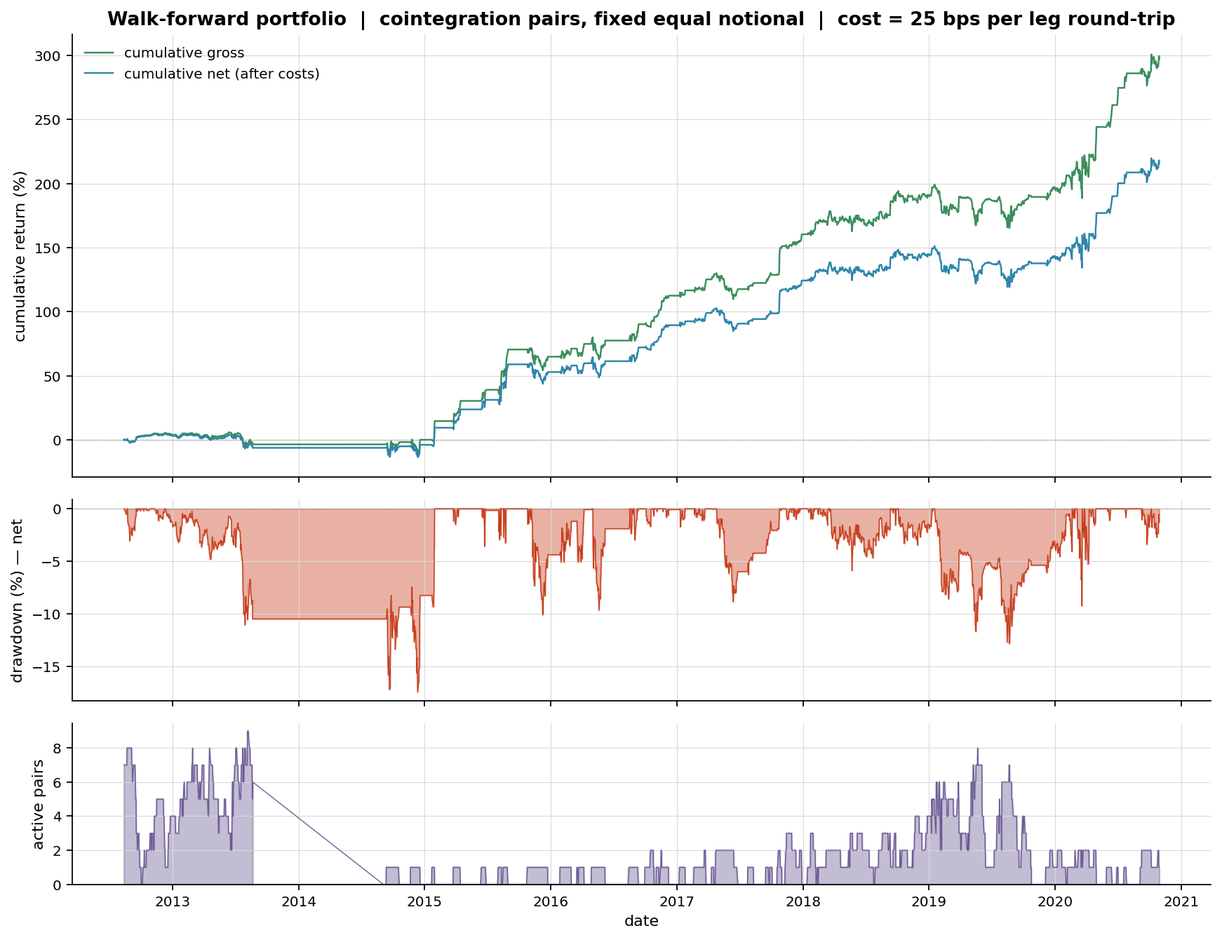
Figure 5. Phase 2A portfolio equity curve, daily walk-forward (scripts/10 backtest).

5.2 Phase 2B — risk-managed ablation (rolled back)
A sizing/risk ablation ladder (R0 baseline → R4 with cluster caps and a relationship-kill switch) tested whether the baseline's drawdown is a sizing problem. It is not. Volatility-matching R0 and the heavily risk-controlled R3 to a common target produces near-identical Sharpe (0.941 vs 0.930) — a tie. The drawdown is driven by the cointegrated pairs being concentrated in a few clusters (banks, oil) that dislocate together, not by position sizing. The experiment was reverted; the finding — concentration is a universe problem, not a sizing problem — is preserved on its branch.
Table 5. Risk-managed ladder R0–R4 (reports/risk_managed_ladder.csv). R3/R4 cut drawdown only by cutting the book to ~half the trades; net return falls with it.
rung | kill | trades | net tot% | net Sh | maxDD% | turnover/yr
R0 | none | 198 | 214.02 | 1.08 | -17.45 | 56.6
R1 | none | 198 | -88.80 | -0.10 | -99.99 | 56.6
R2 | none | 198 | 14.34 | 0.25 | -14.61 | 56.6
R3 | none | 94 | 9.95 | 0.92 | -4.24 | 26.9
R4 | relationship | 82 | 8.69 | 0.89 | -2.38 | 23.4
Table 6. Volatility-matched comparison (reports/risk_managed_vol_matched.csv): the Sharpe tie (0.941 vs 0.930) that motivated rollback.
rung | raw vol% | target vol% | vt return% | vt Sharpe | vt maxDD%
R0 | 15.18 | 11.98 | 11.93 | 0.941 | -18.57
R3 | 1.47 | 4.38 | 4.16 | 0.930 | -12.19

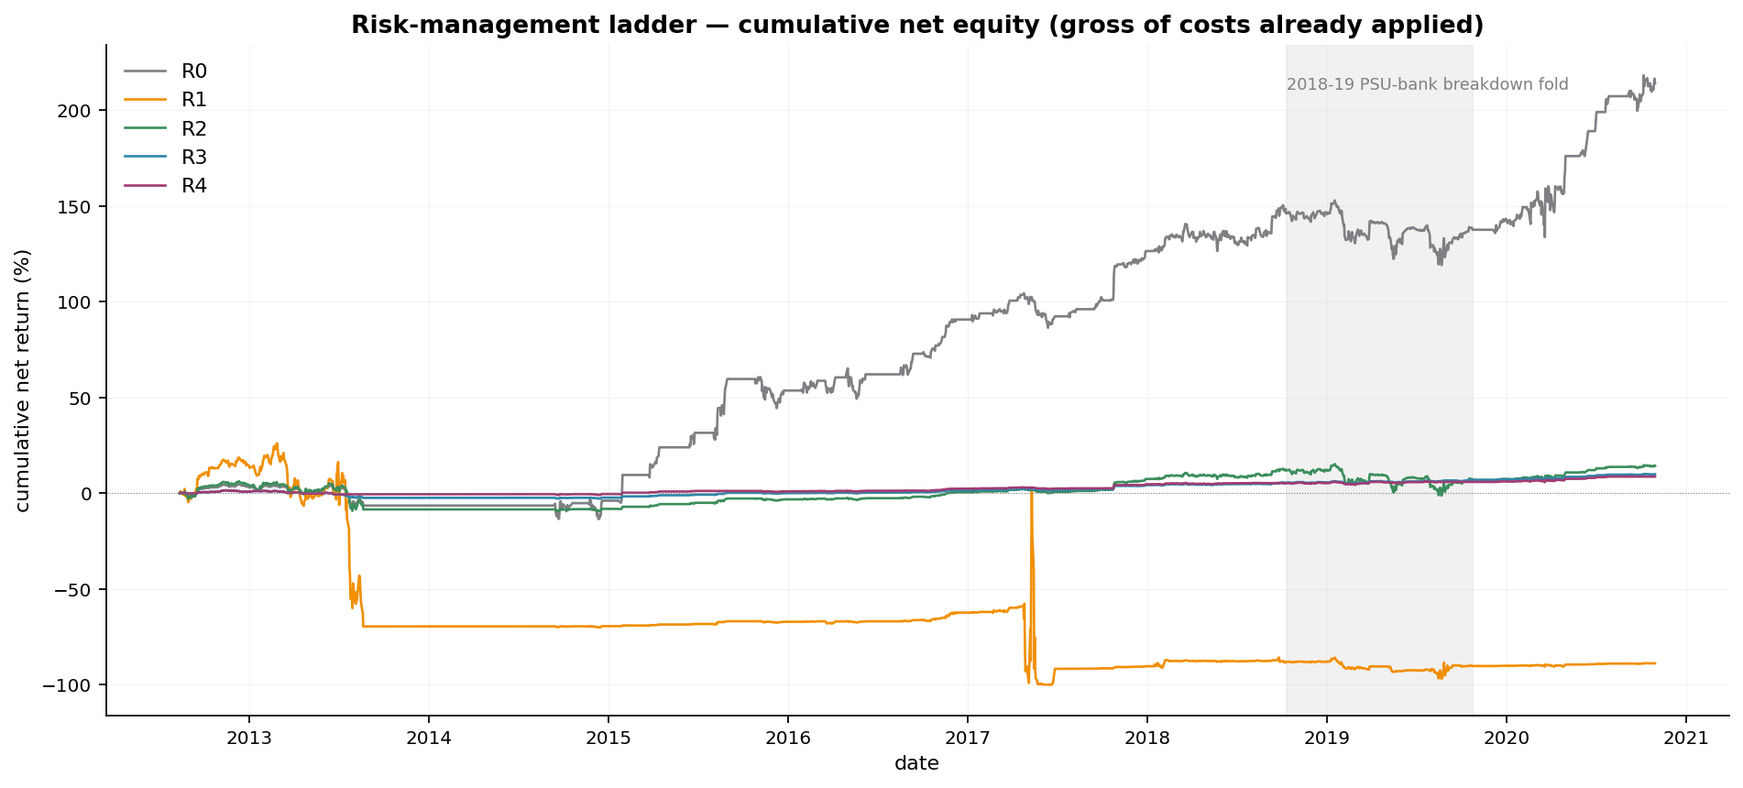
Figure 6. Phase 2B ablation ladder equity (reverted experiment). The risk-controlled rungs compress both drawdown and return; the risk-adjusted ratio does not improve.

5.3 Phase 3 — intraday port and Regime-A infeasibility
Porting to intraday bars exposes two facts. First, naive intraday rolling-z is net-negative under any cost — at 1 bps the two-regime precursor runs net Sharpe −1.46 (Regime A) and −0.34 (Regime B), both underwater. Second, and structurally: every OU half-life lands in the multi-session band, so the intraday-square-off Regime A admits zero pairs. Daily-cointegrated NSE pairs simply do not mean-revert within a session; forcing an end-of-day flat closes trades before reversion completes. The 1-minute frequency additionally inflates half-life estimates via bid-ask bounce (a microstructure artefact), so 1-minute 'passes' are not cited as intraday-reversion evidence.

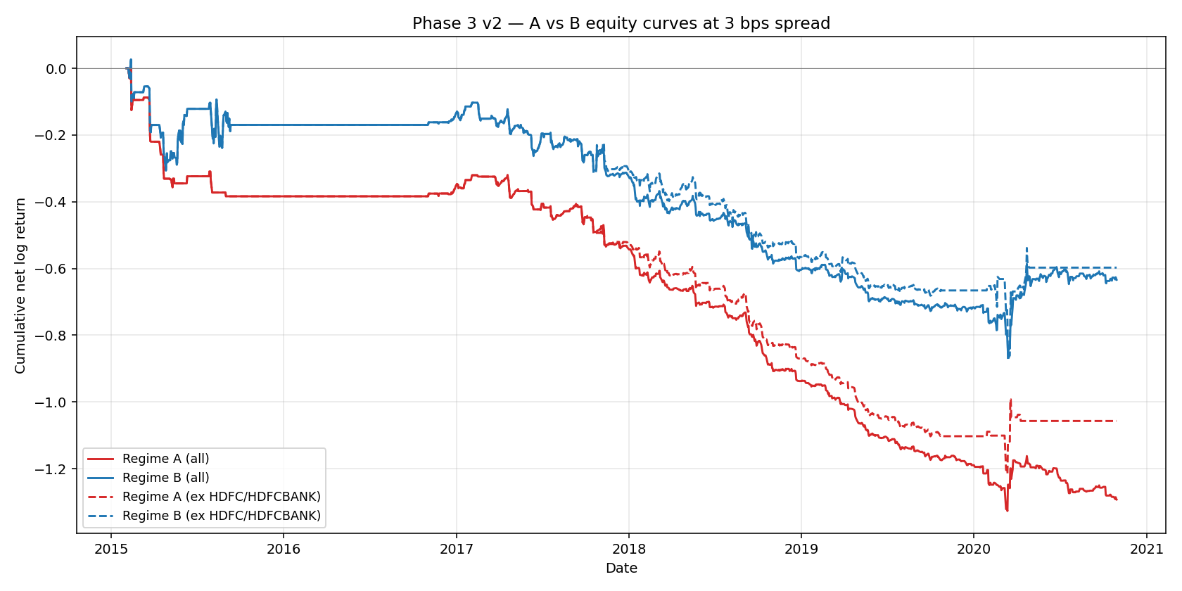
Figure 7. Phase 3 intraday Regime A vs Regime B equity at 3 bps (scripts/14). Regime A (intraday square-off) is structurally starved of admissible pairs.

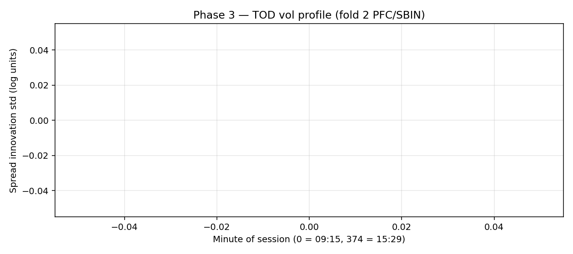
Figure 8. Time-of-day volatility profile used for intraday normalisation — the U-shape removed before z-scoring.

5.4 Phase 3 — OU/Bertram engine and the matched universe
Applying the half-life band filter and Bertram thresholds reduces the intraday universe to two Regime-B survivors: INDUSINDBK/HDFCBANK (fold 4) and KOTAKBANK/HDFCBANK (fold 6). This is the matched universe on which all subsequent engine comparisons run. On it, the frozen-OU best cell (5-min, Regime B, 3 bps) is net-profitable and materially more cost-resilient than rolling-z.
Table 7. Matched-universe cost ladder, 5-min Regime B (reports/phase3_ou/figures/matched_universe/matched_metrics.csv). OU's net Sharpe decays gently with cost (0.98 → 0.93) while rolling-z collapses (0.95 → −0.11) and flips sign at 8 bps — the cost-amortisation property.
engine | cost | trades | gross tot% | net tot% | gross Sh | net Sh
ou | 1 | 36 | 54.98 | 48.27 | 1.083 | 0.981
ou | 3 | 34 | 54.87 | 46.20 | 1.083 | 0.949
ou | 5 | 32 | 53.34 | 43.17 | 1.065 | 0.905
ou | 8 | 30 | 57.17 | 44.28 | 1.135 | 0.935
rolling_z | 1 | 225 | 82.16 | 37.67 | 1.759 | 0.945
rolling_z | 3 | 225 | 82.16 | 24.34 | 1.759 | 0.643
rolling_z | 5 | 225 | 82.16 | 12.30 | 1.759 | 0.341
rolling_z | 8 | 225 | 82.16 | -3.60 | 1.759 | -0.107

Canonical frozen-OU best cell: net annualised 20.915%, net Sharpe 0.949, net total 46.20%, max drawdown −22.54%, 34 trades (reports/phase3_ou/metrics_ou.csv). The (1+β) re-billing decomposes the change from the legacy convention exactly: A {old a*, old bill} = 21.241 → B {old a*, new bill} = 20.844 (billing −0.398) → C {new a*, new bill} = 20.915 (refit +0.071), total −0.326 pp.

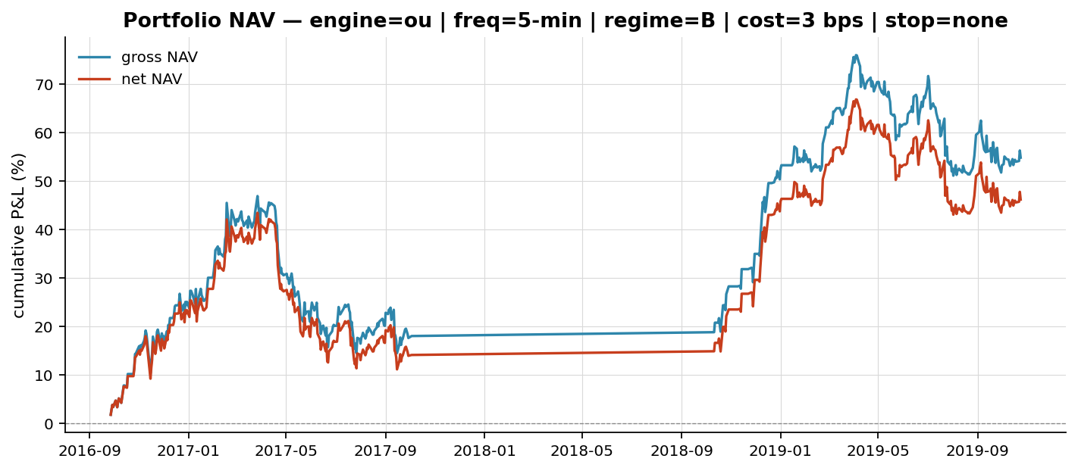
Figure 9. OU best-cell portfolio NAV, gross vs net (reports/phase3_ou/figures/ou_best_cell).

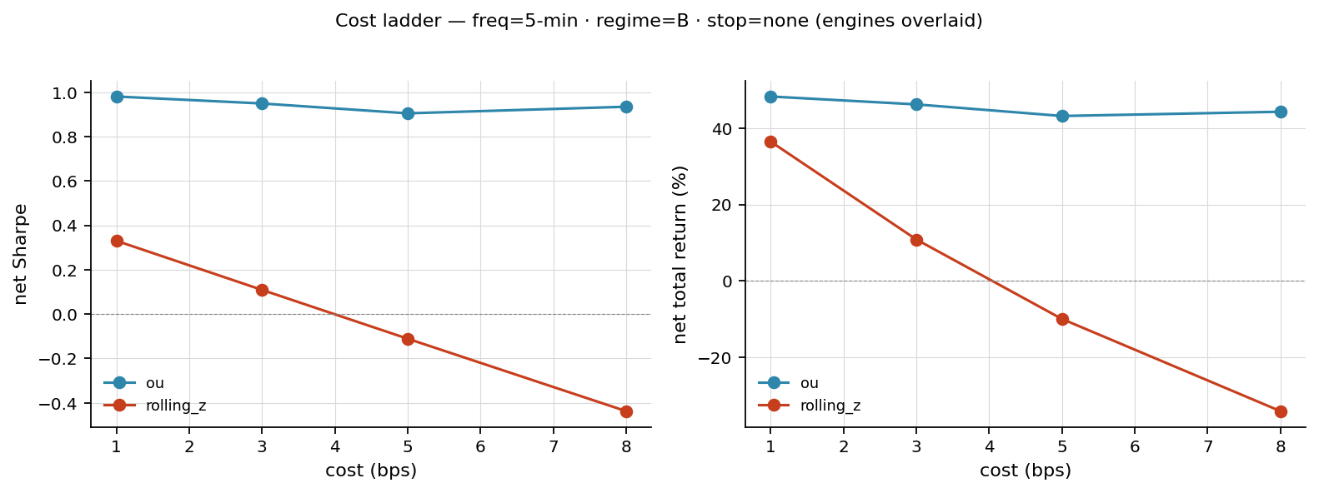
Figure 10. Cost ladder, 5-min Regime B: OU vs rolling-z net Sharpe and net total return vs cost. OU's flat slope is the engine-attributable cost resilience.

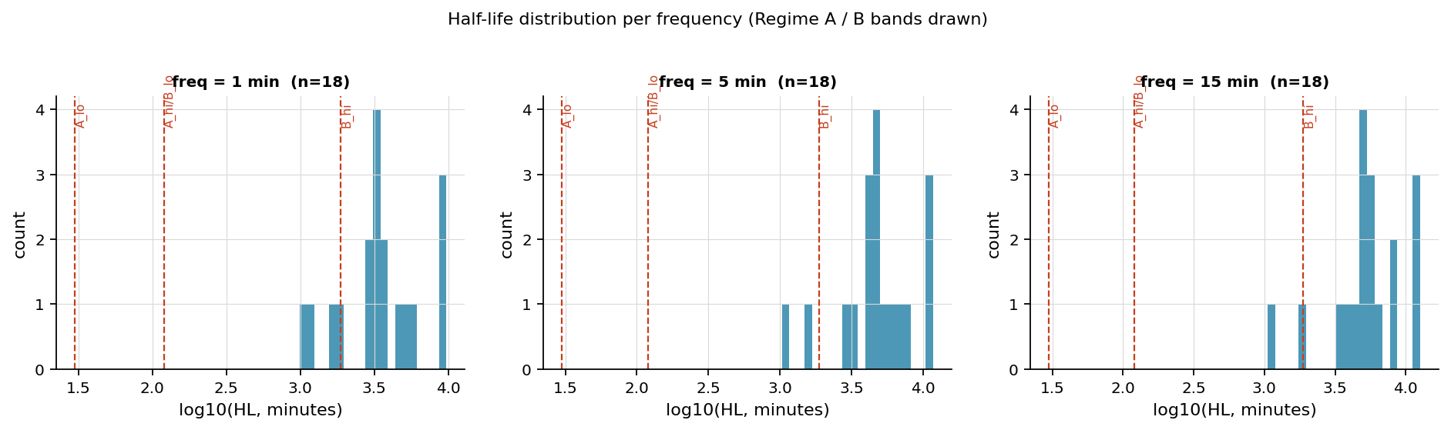
Figure 11. OU half-life distribution with Regime-A/B band boundaries. No fit lands in the Regime-A [30,120]-min band — the structural reason intraday square-off is infeasible.

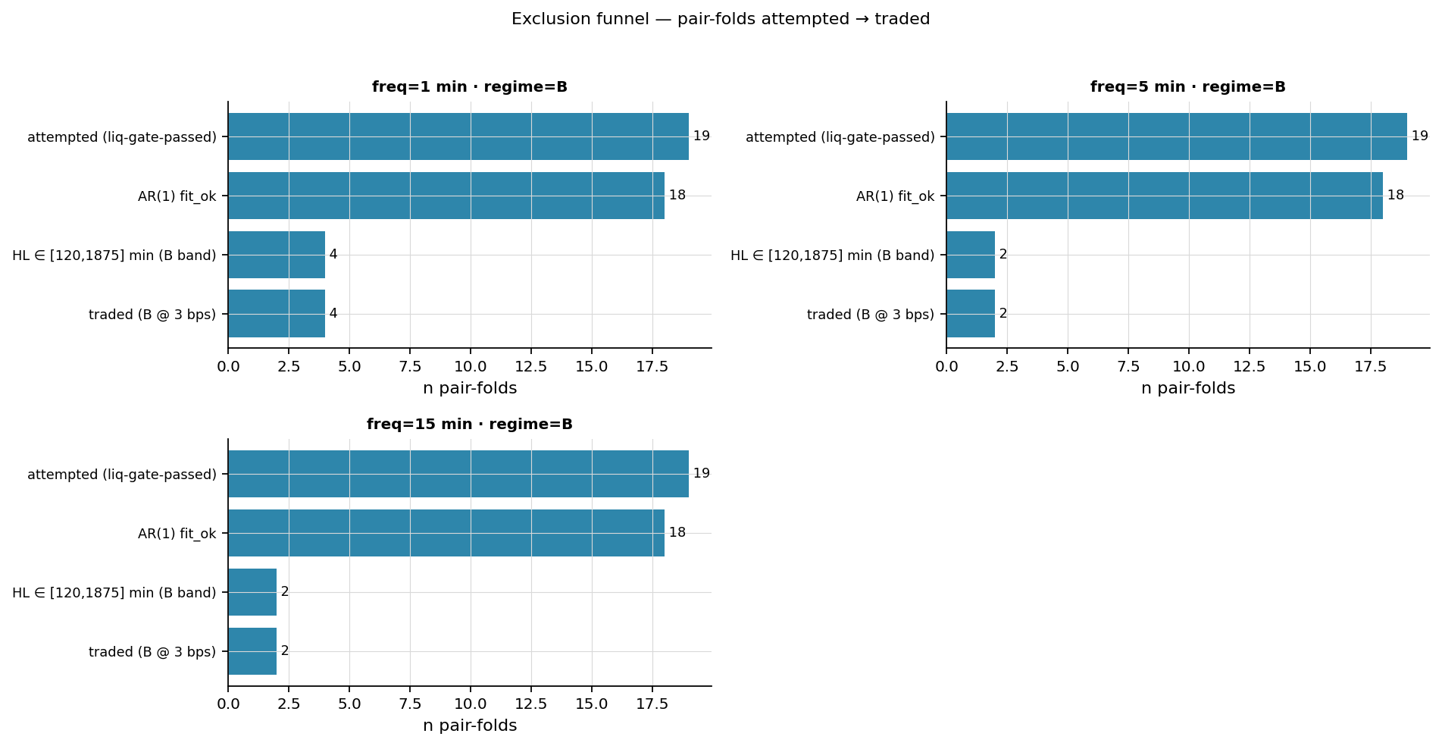
Figure 12. Exclusion funnel: 19 pair-folds → 18 valid AR(1) → 2 traded Regime-B survivors at 5-min. The narrowness of the matched universe (n=2) is the central fragility.

5.5 Phase 4 — adaptive Kalman equilibrium (the 8-cell verification)
On the same matched universe the μ-only Kalman arm roughly doubles the frozen-OU net Sharpe across the cell grid. The verification reproduces the headline (net Sharpe ≈ 2.1 at the best cell) but also corrects the mechanism narrative.
Table 8. Kalman vs frozen-OU vs rolling-z, all eight matched cells (reports/phase4/verification/1b_eight_cell_table.csv). Kalman net Sharpe ≈ 2× the frozen engine at every cell.
freq | cost | k tr | k net% | k net Sh | k netAnn% | k maxDD% | ou net Sh | rz net Sh
5 | 1 | 69 | 139.94 | 2.145 | 54.90 | -21.02 | 0.981 | 0.945
5 | 3 | 60 | 119.16 | 1.959 | 48.04 | -21.08 | 0.949 | 0.643
5 | 5 | 53 | 103.13 | 1.781 | 42.53 | -20.68 | 0.905 | 0.341
5 | 8 | 51 | 115.20 | 1.937 | 46.70 | -20.37 | 0.935 | -0.107
15 | 1 | 66 | 141.29 | 2.145 | 55.34 | -21.48 | 1.003 | 0.613
15 | 3 | 57 | 126.21 | 2.013 | 50.40 | -21.65 | 0.830 | 0.473
15 | 5 | 52 | 113.96 | 1.901 | 46.27 | -20.71 | 0.684 | 0.331
15 | 8 | 41 | 80.13 | 1.524 | 34.21 | -20.56 | 0.745 | 0.113

What the verification corrects: the adaptive edge is downside-tail compression, not larger winners — the Kalman 5th-percentile trade is −168 bps vs the frozen engine's −605 bps, while its median trade is actually lower. The edge is NOT sourced from rescuing the frozen engine's stuck trades (the overlap with frozen losing time-stop/fold-close windows is +0.23% of gross). And the win rate is mechanism-inflated: 78.6% of trades see the tracking anchor μ move toward the entry spread during the hold. Two of four pre-registered reviewer predictions are NOT MET (the per-trade capture is smaller than predicted and the overlap story is wrong), even though the net-Sharpe improvement is real.

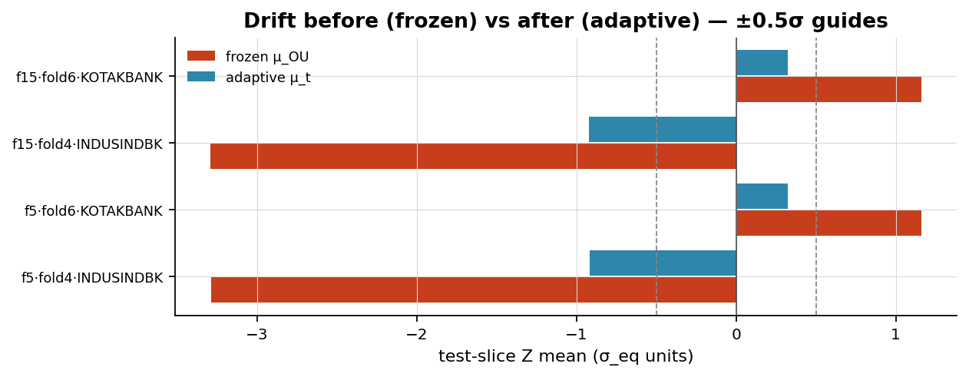
Figure 13. Equilibrium drift before/after adaptive tracking (reports/phase3_kalman/figures). The filter pulls the standardised test-slice drift toward zero.

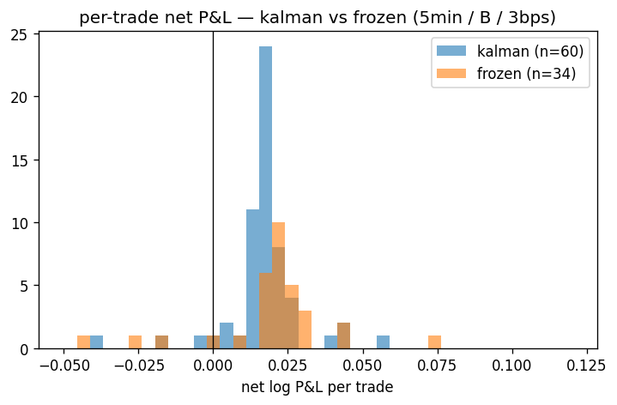
Figure 14. Per-trade net P&L: Kalman vs frozen-OU. The Kalman distribution is left-tail compressed (tighter p5), not right-shifted — downside control, not bigger wins.

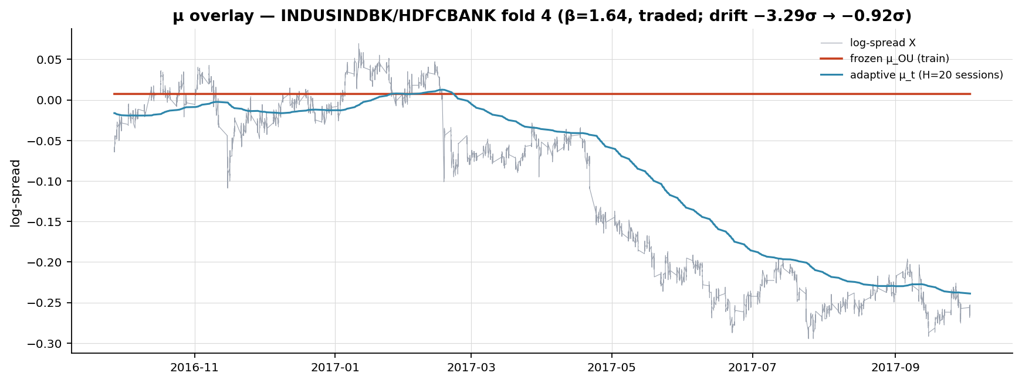
Figure 15. μ-tracking overlay, INDUSINDBK/HDFCBANK fold 4: spread with frozen μ and tracking μ_t and trade marks. The anchor moves materially across sessions.

5.6 Phase 4 — β-escalation (weak identification)
Allowing β to track as well fails. At every finite tracking horizon, on every diagnostic pair-fold, β collapses toward zero (fold 4: 1.643 → 0.089 at H_β=10; the KOTAK fold even flips β negative). Intraday increment co-movement is too weak to identify the hedge ratio, so the returns-regression observation drags β to the floor. Train selection consequently picks H_β = ∞ — it refuses to track β — at which point the joint filter is identically the μ-only filter (verified bit-for-bit). The canonical −7σ fold-6 case is not admissibly neutralised by a tracking-β filter on this data. The gate fails, and the failure is the finding: the path forward is to estimate β at a lower frequency or on a universe that genuinely co-moves intraday.
Table 9. β-collapse diagnostic, 5-min, finite horizons (reports/phase4/beta_escalation/beta_collapse.csv). Every finite H_β drives β below the stability band on every pair-fold.
pair | H_β | β₀ | β min | min ratio | →0? | stable?
INDUSINDBK/HDFCBANK | inf | 1.643 | 1.643 | 1.000 | no | yes
INDUSINDBK/HDFCBANK | 40.0 | 1.643 | 0.197 | 0.120 | yes | no
INDUSINDBK/HDFCBANK | 20.0 | 1.643 | 0.139 | 0.085 | yes | no
INDUSINDBK/HDFCBANK | 10.0 | 1.643 | 0.089 | 0.054 | yes | no
KOTAKBANK/HDFCBANK | inf | 0.872 | 0.872 | 1.000 | no | yes
KOTAKBANK/HDFCBANK | 40.0 | 0.872 | 0.134 | 0.154 | yes | no
KOTAKBANK/HDFCBANK | 20.0 | 0.872 | 0.039 | 0.044 | yes | no
KOTAKBANK/HDFCBANK | 10.0 | 0.872 | -0.158 | -0.181 | yes | no
INDUSINDBK/HDFCBANK | inf | 1.138 | 1.138 | 1.000 | no | yes
INDUSINDBK/HDFCBANK | 40.0 | 1.138 | 0.209 | 0.184 | yes | no
INDUSINDBK/HDFCBANK | 20.0 | 1.138 | 0.189 | 0.166 | yes | no
INDUSINDBK/HDFCBANK | 10.0 | 1.138 | 0.146 | 0.128 | yes | no

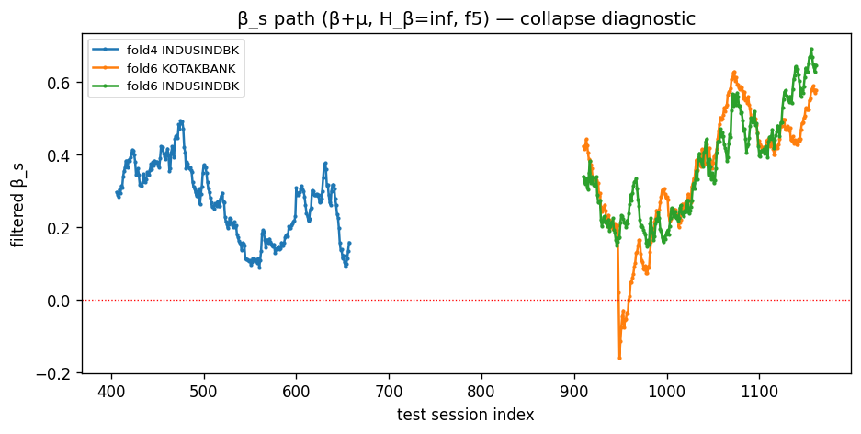
Figure 16. β tracking paths (5-min). Every finite horizon collapses the hedge ratio toward zero — weak intraday identification.

5.7 Phase 4 — rolling cointegration-stability gate
A rolling-ADF gate on the frozen-(α,β) residual blacklists a pair after three consecutive non-stationary windows. At the default it fires on 19/19 NSE pair-folds — including both traded survivors — and the sensitivity sweep shows this is robust, not a threshold accident (15/19 still gate even at the lenient p>0.50 / 120-day setting). Two forces are entangled and cannot be separated on n=2: genuinely marginal cointegration, and low ADF power on short windows. The gate is correct and tested but uncalibratable on this universe — it is marked [TODO]-pending-breadth.
Table 10. Gate sensitivity (reports/phase4/coint_stability/threshold_sensitivity.csv).
window | ADF p> | consec | gated | frac gated
60 | 0.05 | 3 | 19 | 1.000
60 | 0.10 | 3 | 19 | 1.000
60 | 0.25 | 3 | 19 | 1.000
60 | 0.50 | 3 | 19 | 1.000
120 | 0.05 | 3 | 19 | 1.000
120 | 0.10 | 3 | 19 | 1.000
120 | 0.25 | 3 | 18 | 0.947
120 | 0.50 | 3 | 15 | 0.789

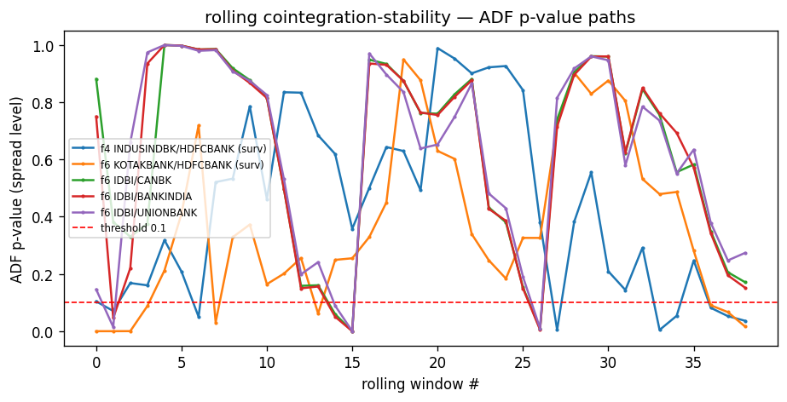
Figure 17. Rolling-ADF p-value paths with the blacklist threshold. The NSE spreads drift non-stationary on rolling windows.

5.8 Phase 4 — Johansen comparison
On 234 common candidates, Johansen-95% selects 41 pairs vs Engle–Granger+FDR's 13 (28 new, 0 lost; Jaccard 0.32). But the honest attribution is multiple-testing, not the estimator: a fresh Engle–Granger pass reproduces the persisted FDR selection at 99.1% agreement, and Johansen's 41 sits right next to EG-raw-p<0.05's 50 — the expansion is the absence of an FDR correction on the Johansen path. The 28 new pairs are unvalidated candidates and are explicitly not merged into any performance table.

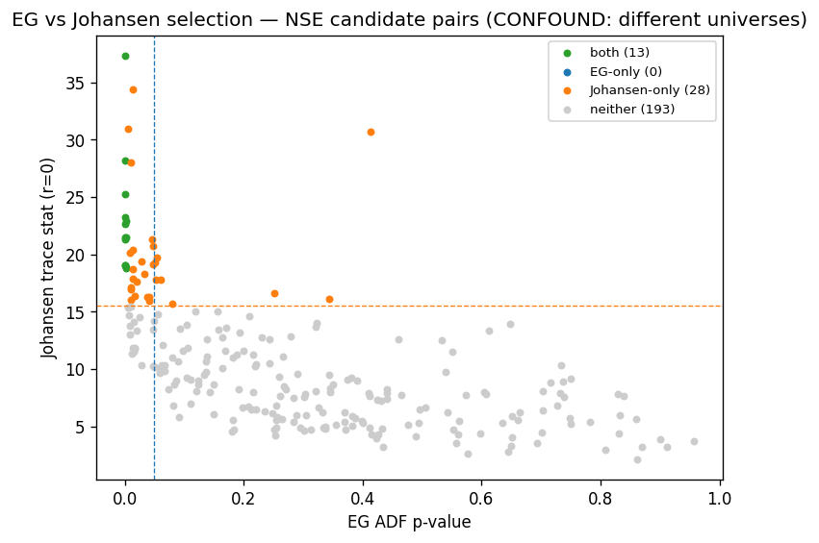
Figure 18. Engle–Granger p-value vs Johansen trace statistic, coloured by selection (reports/phase4/johansen). The gap is the FDR correction, not order-independence.

5.9 Phase 4 — the DSR / PBO validation gate (NSE)
This is the primary result. Over an honest N=46 trials, only the adaptive Kalman arm clears the expected-maximum luck bar; the frozen-OU and rolling-z best cells fall below it.
Table 11. Deflated Sharpe Ratio, NSE matched universe, N=46 (reports/phase4/dsr_pbo/2b_dsr.csv). Only Kalman clears the bar; its p-value (0.192) is still not significant. PBO over the 24-cell matrix = 0.104 (reports/phase4/dsr_pbo/2c_pbo.csv).
engine | cell | ann net Sh | per-period SR | SR₀ bar | DSR | p-value
kalman | f5/c1 | 2.145 | 0.135 | 0.096 | 0.808 | 0.192
ou | f15/c1 | 1.003 | 0.063 | 0.096 | 0.234 | 0.766
rz | f5/c1 | 0.945 | 0.063 | 0.096 | 0.230 | 0.770
Table 12. DSR sensitivity to the assumed trial count N (reports/phase4/dsr_pbo/2b_dsr_sensitivity_to_N.csv). Kalman DSR stays above 0.5 across N but never reaches p<0.05.
N trials | SR₀ bar | Kalman DSR | p-value
1 | 0.000 | 0.999 | 0.001
30 | 0.089 | 0.848 | 0.152
46 | 0.096 | 0.808 | 0.192
100 | 0.108 | 0.725 | 0.275
200 | 0.118 | 0.647 | 0.353

Mandatory caveat: with n=2 pair-folds the per-period series is the concatenation of two disjoint folds (≈2017 and ≈2019); it violates the iid assumption behind DSR and mixes two regimes inside every CSCV block. The NSE DSR/PBO numbers are INDICATIVE, not definitive. What would make them trustworthy is universe breadth — which the crypto retest supplies.

5.10 Phase 4 / A10 — crypto out-of-sample retest (the decisive experiment)
The same three engines were wired through the crypto intraday pipeline with EG-FDR per-fold selection, (1+β) billing, train-only H selection, and a {1,5,15}-minute × {1,3,5,8}-bps sweep over both regimes — 5 folds, 17 EG-FDR pair-folds, 14 traded pairs over 540 sessions. Two findings emerge in order of importance.
- The ordering replicates: on both gross and net Sharpe, Kalman > frozen-OU at every frequency, and Kalman is the only engine with positive gross. The adaptive mechanism extracts more signal than the frozen mean on a completely different universe — exactly the NSE ordering.
- But net is negative for all engines: crypto intraday taker + spread cost (≈2,800 round-trips, (1+β)-billed) destroys the edge — Kalman is the least bad (−63%) but still deeply unprofitable; rolling-z's +37,803% gross at 1-min is a pure overtrading artefact (94,403 trades) that evaporates to −100% net. Gross > 0 but net ≪ 0 means this is a cost/turnover problem, not a signal problem.
Table 13. Crypto A10 headline, Regime A (funding-clean), cost 3 bps (reports/phase4/crypto_adaptive/metrics.csv). Kalman is uniquely positive on gross; every engine is deeply negative on net.
engine | freq | trades | gross tot% | net tot% | gross Sh | net Sh | maxDD%
kalman_mu | 1 | 2862 | 8.96 | -63.20 | 0.112 | -1.308 | -67.39
kalman_mu | 5 | 2820 | 4.92 | -64.13 | 0.062 | -1.334 | -67.25
kalman_mu | 15 | 2778 | 6.62 | -63.03 | 0.085 | -1.320 | -66.28
frozen_ou | 1 | 2982 | -9.35 | -71.16 | -0.133 | -1.680 | -71.37
frozen_ou | 5 | 2969 | -15.80 | -73.01 | -0.234 | -1.786 | -73.28
frozen_ou | 15 | 2953 | -15.81 | -72.90 | -0.235 | -1.788 | -73.02
rolling_z | 1 | 94403 | 37,802.90 | -100.00 | 9.426 | -51.406 | -100.00
rolling_z | 5 | 20256 | 98.63 | -99.92 | 1.096 | -11.512 | -99.92
rolling_z | 15 | 7237 | 78.66 | -88.67 | 1.064 | -3.988 | -88.61

Table 14. Crypto Kalman DSR/PBO, N=28 honest trials (reports/phase4/crypto_adaptive/dsr_pbo_kalman.csv). Net DSR = 0.002 — the edge does not survive. (Gross Kalman DSR = 0.546, p 0.454 — marginal, not significant.) Breadth (14 pairs × 540 d) makes these trustworthy.
regime | funding | cell | ann net Sh | per-period SR | SR₀ bar | net DSR | p-value | PBO
A | clean | f1/c1 | -1.155 | -0.073 | 0.049 | 0.002 | 0.998 | 0.395
B | UNPRICED_TODO | f1/c1 | -0.503 | -0.032 | 0.049 | 0.030 | 0.970 | 0.392

Frequency does not rescue net: median holding is ≈1,430 minutes (~1 day) at all frequencies and the best-frequency vote is split across pairs. The absorption guard admitted 29/51 cells at the selected H=10, so the intraday crypto residual is tradeable (the guard binds sensibly) — the problem is purely cost. An earlier daily rolling-z crypto port (Section appendix) was negative on gross already — a signal problem for that weaker engine — and is superseded by A10 as the real test.

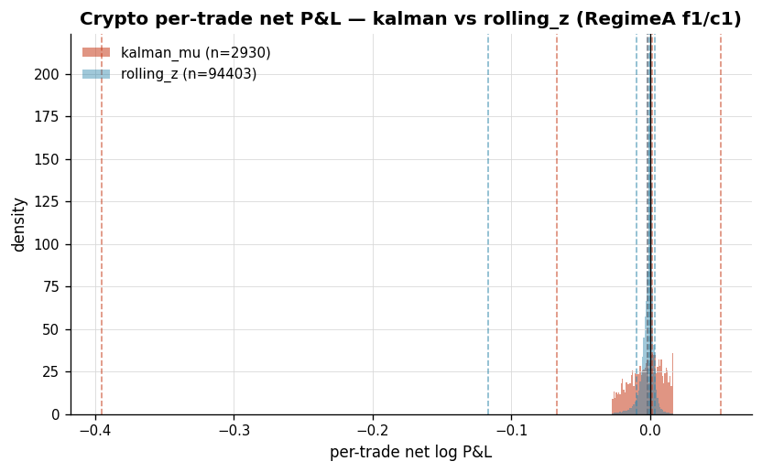
Figure 19. Crypto per-trade net P&L, Kalman vs rolling-z (Regime A). The typical Kalman trade is profitable (median +14.3 bps) but the mean is −14.4 bps — the left tail plus per-trade cost sink the aggregate. Source: final_crypto_plots.py.

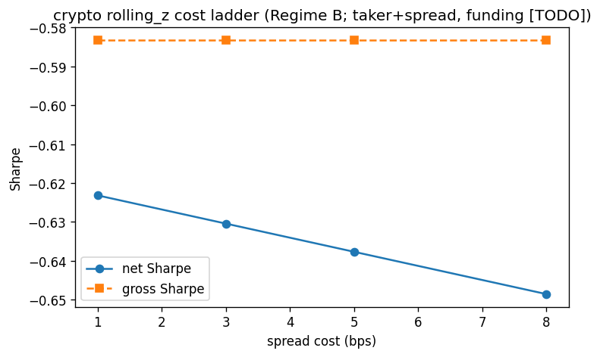
Figure 20. Crypto cost ladder (daily rolling-z port, Section appendix): decisively negative, gross already below zero. Source: s6_crypto.py.

6. Discussion — Methodological Lessons
Concentration is a universe problem, not a sizing problem. Phase 2B's vol-matched tie (Sharpe 0.941 vs 0.930) shows risk controls cannot neutralise drawdown that comes from cointegrated pairs clustering in a few sectors that dislocate together. The remedy is breadth and de-correlation in selection, not leverage targeting.
Cost-aware thresholds reduce but do not eliminate over-trading. Bertram's optimal a* widens with cost and flattens the NSE cost ladder relative to a fixed-band rolling-z — but on crypto, where turnover is intrinsically high, even cost-aware widening leaves net deeply negative. Cost amortisation is necessary, not sufficient.
In-sample selection inflates Sharpe, and deflation is the arbiter. The same matched-universe Kalman Sharpe of ~2.1 reads very differently once N=46 trials are priced in: DSR 0.808 but p=0.192. The Deflated Sharpe Ratio, not the raw Sharpe, is what separates an indicative result from a deployable one.
The n=2 fragility dominates every NSE conclusion. Two intraday pair-folds cannot support an iid validation framework: the CSCV blocks straddle a fold join and the DSR series is regime-mixed. No amount of careful in-sample work overcomes the absence of cross-sectional width — which is precisely why the crypto retest exists.
Dynamic hedge ratios are weakly identified at high frequency. β collapses on every finite tracking horizon because intraday increment co-movement is too weak to identify it. The frozen β is not a simplification of convenience — it is what the data will support; tracking β requires lower-frequency estimation or a genuinely co-moving universe.
The cost wall is the binding constraint. Across both universes the adaptive engine wins on gross and on the engine ordering, yet loses on net. The mechanism is real and universe-general; the obstacle is execution cost at the turnover the signal demands. This reframes the research question from 'find a better signal' to 'execute the same signal more cheaply'.

7. Conclusion
We have built and validated, end-to-end, an adaptive pairs-trading methodology, and the honest verdict is a rigorous negative: a real, repeatable, universe-general mean-reversion mechanism that does not clear realistic intraday transaction costs.
The adaptive-equilibrium filter is genuine — it beats a frozen cointegration relationship on gross and net Sharpe on the matched NSE universe, and the same ordering replicates on an independent crypto universe where it is uniquely positive on gross. That cross-universe replication is the contribution: the mechanism is not an NSE-specific artefact. But the strongest in-sample NSE result is statistically indistinguishable from luck after Deflated-Sharpe correction (DSR p=0.192, n=2), and on the breadth crypto universe — where the statistics are trustworthy — the net edge is decisively negative (net DSR 0.002).
What would change the verdict is structural, not parametric. Because gross is alive and net is dead, the lever is turnover and execution cost, not the signal: lower-frequency re-anchoring with fewer round-trips, a cheaper venue or maker/rebate execution, and a turnover-aware variant of the same adaptive engine. Re-parameterising the signal will not help; re-engineering the cost will. We present this as a methodological result — a disciplined demonstration of where a plausible edge actually dies, and why deflation and breadth, not a larger in-sample Sharpe, are the instruments that reveal it.

8. Limitations and Threats to Validity
Sample size (n=2 intraday). The matched NSE intraday universe is two pair-folds. Every NSE intraday conclusion — including the headline Kalman Sharpe and its DSR — is a two-fold-concatenation statistic and is labelled indicative throughout.
Non-iid, regime-mixed return series. DSR assumes iid returns; the concatenated folds are serially dependent and span different volatility regimes, and CSCV blocks straddle the fold join. The deflation is therefore an approximation that flatters neither direction cleanly.
Dividend-unadjusted prices. The NSE history is split/bonus-only; total-return effects are absent, which can bias spread levels for high-yield names.
Crypto funding cost unpriced [TODO]. No funding series was available, so every Regime-B (multi-day carry) crypto number is funding-unpriced. Funding would worsen, not rescue, an already-negative net — but the exact magnitude is unquantified.
Labelled-default cost parameters. The crypto taker fee (5 bps/side) and the liquidity gate ($10M median quote-vol) are reasonable but venue-dependent defaults, not measured from a specific exchange's schedule.
Single risk-management placeholder. Crypto risk management is a single hard z-stop (3.5σ), not a tuned framework; the −73% drawdowns are not risk-optimised.
Selection-grid trial count. The honest N (46 NSE, 28 crypto) is reconstructed from the search grids rather than pre-registered; implicit selections (half-life bands, best-of-cell reporting) compound N further, so the true deflator is if anything stronger than reported.
Coint-stability gate uncalibrated. The rolling-ADF blacklist fires 19/19 on NSE and cannot be calibrated without a broad-universe base rate; its binary verdict is deferred.

9. Future Work
The deferred units, ordered by how much each could move the headline:
- Low-cost / turnover-aware execution: the binding constraint. Maker/rebate execution, lower-frequency re-anchoring (daily-or-coarser μ updates with far fewer round-trips), and a turnover penalty inside the Bertram objective — the only lever that can flip the crypto net sign.
- Lower-frequency β estimation: the path the data demands — estimate the hedge ratio where the legs actually co-move (daily) and trade the residual intraday, or move to a venue with genuine intraday co-movement.
- Regime/HMM, meta-labelling, RL sizing: regime/HMM gating of when to trade, meta-labelling of trade quality, and RL-based position sizing — the deferred modelling units, to be added only after the cost wall is addressed (sizing cannot rescue a net-negative edge).
- Breadth-aware selection: PCA / DBSCAN clustering for de-correlated pair selection — directly attacks the concentration finding from Phase 2B.
- CME / futures port: a regulated-futures deployment (e.g. CME) where the NSE cash-market short and lot constraints do not bind and execution is cheaper — the eventual venue rationale behind the crypto retest.

10. Appendices

A. ASSUMPTIONS register and open [TODO]s
Table A1. Labelled defaults and open [TODO]s carried through the study (docs/phase4_report.md §0).
# | assumption / [TODO] | value used | what would change it
A1 | DSR/PBO NSE sample length | n=2 pair-folds, ~504 sessions | broaden universe (crypto) for cross-sectional width
A2 | Honest trial count N | 46 (NSE), 28 (crypto) | maintain a pre-registered trial ledger
A7 | Crypto taker fee | 5 bps/side (labelled default) | confirm vs venue schedule (gross already negative)
A8 | Crypto funding series | ABSENT → funding = 0 [TODO] | pull a funding series; prices Regime-B carry
A9 | Crypto risk management | single z-stop 3.5σ, not tuned | dedicated risk framework
A_LIQ | Crypto liquidity gate | median quote-vol ≥ $10M | keeps 22/30; $50M leaves 7 (too thin)
A6 | Coint-stability threshold | 60d / p>0.10 / 3 consecutive | needs broad-universe base rate to calibrate

Inter-document inconsistencies flagged during assembly:
- 341 vs 342 symbols: the clean log records 342 symbols post-cascade; the backtest loads 341. Difference = one share-class duplicate dropped at backtest. Resolved to 341 trading universe.
- 20.886 vs 20.915: untraceable in all working-tree files and git history; equals none of the A/B/C decomposition legs. The canonical frozen-OU best net annual is 20.915% (reports/phase3_ou/metrics_ou.csv); 20.886 is not carried forward.
- 7 vs 8 folds: Phase-2A reports 8 fold indices spanning ~7 out-of-sample years (1764 daily obs ≈ 7×252). Both are correct; the report states 8 folds / ~7 OOS years.
- Partial v2 re-billing: the (1+β) re-billing was applied to the Phase-3 v2 cells at 3 bps; the 1/5/8 bps v2 cells remain on the legacy convention in their persisted CSVs (documented [TODO scope]). The OU/Kalman/crypto headline cells are all on the corrected billing.

B. Figure catalogue
Every figure embedded in this report, with its source PNG and the driver that produces it. All PNGs ship a companion same-basename CSV (the data behind the figure); PNGs are gitignored and regenerated by their driver.
fig | source PNG | driver
1 | plots/phase4/final/nse/portfolio_equity.png | final_nse_plots.py
2 | plots/phase4/final/crypto/portfolio_equity.png | final_crypto_plots.py
3 | plots/phase4/dsr_pbo/pbo_logit_distribution.png | s2_dsr_pbo.py
4 | plots/phase1/universe/01_symbols_per_sector.png | scripts/06 universe EDA
5 | plots/phase2/backtest/equity_curve.png | scripts/10 backtest
6 | plots/phase2/risk_managed/ladder_equity.png | scripts/12 risk-managed
7 | plots/phase3/equity_A_vs_B_3bps.png | scripts/14 two-regime
8 | plots/phase3/tod_vol_profile.png | scripts/14 two-regime
9 | reports/phase3_ou/figures/ou_best_cell/b_ou_best_portfolio_nav.png | scripts/15 OU
10 | reports/phase3_ou/figures/grid_rollups/d_cost_ladder_f5_B.png | scripts/15 OU
11 | reports/phase3_ou/figures/grid_rollups/f_half_life_distribution.png | scripts/15 OU
12 | reports/phase3_ou/figures/grid_rollups/k_exclusion_funnel.png | scripts/15 OU
13 | reports/phase3_kalman/figures/drift_before_after.png | scripts/17 Kalman
14 | plots/phase4/verification/per_trade_pnl_dist.png | s1_unit_k_verification.py
15 | reports/phase3_kalman/figures/mu_overlay_fold4.png | scripts/17 Kalman
16 | plots/phase4/beta_escalation/beta_paths_f5.png | s3_beta_escalation.py
17 | plots/phase4/coint_stability/adf_pvalue_paths.png | s4_coint_stability.py
18 | plots/phase4/johansen/eg_vs_johansen.png | s5_johansen.py
19 | plots/phase4/final/crypto/trade_return_distribution.png | final_crypto_plots.py
20 | plots/phase4/crypto/crypto_cost_ladder.png | s6_crypto.py

C. Table provenance
Table C1. Every performance table in this report traces to a committed CSV.
table | content | source CSV
1 | the seven cleaning rules | src/apt/data, config/default.yaml
2 | dividend-flavor diagnostic | reports/dividend_flavor_diagnosis.csv
3–4 | Phase 2A portfolio + per-pair | reports/backtest_portfolio_metrics.csv, backtest_per_pair_metrics.csv
5–6 | Phase 2B ladder + vol-match | reports/risk_managed_ladder.csv, risk_managed_vol_matched.csv
7 | OU matched-universe cost ladder | reports/phase3_ou/figures/matched_universe/matched_metrics.csv
8 | Kalman 8-cell verification | reports/phase4/verification/1b_eight_cell_table.csv
9 | β-collapse diagnostic | reports/phase4/beta_escalation/beta_collapse.csv
10 | coint-stability sensitivity | reports/phase4/coint_stability/threshold_sensitivity.csv
11–12 | NSE DSR + sensitivity | reports/phase4/dsr_pbo/2b_dsr.csv, 2b_dsr_sensitivity_to_N.csv
13 | crypto A10 headline | reports/phase4/crypto_adaptive/metrics.csv
14 | crypto Kalman DSR/PBO | reports/phase4/crypto_adaptive/dsr_pbo_kalman.csv

D. Reproducibility — stack, branches, configuration
Python 3.11 (uv-managed). Core stack: polars, pandas, numpy, scipy, statsmodels, matplotlib, python-docx; pytest for the test suite. Linting via ruff. The full pipeline is the numbered scripts 01–10 plus the phase-3/4 drivers; every script is idempotent.
Branches (development lineage):
experiment/risk-managed-2b feature/cost-beta-notional feature/crypto-adaptive feature/final-report feature/kalman-equilibrium feature/ou-optimal-thresholds feature/phase4-omnibus feature/reporting-standard main phase/3-intraday origin/experiment/risk-managed-2b origin/feature/cost-beta-notional origin/feature/crypto-adaptive origin/feature/kalman-equilibrium origin/feature/ou-optimal-thresholds origin/feature/phase4-omnibus origin/feature/reporting-standard origin/main origin/phase/3-intraday origin/phase1/minute-ingestions
Commit provenance (most recent 40 across all branches):
b314869 feat(phase4-final): Part 3 — crypto consolidated plots + report (A10 verdict)
436182a feat(phase4-final): Part 2 (A10) — adaptive engines on crypto + DSR/PBO
5940c18 feat(phase4-final): Part 1 — NSE consolidated plots (gross/net/drawdown)
85cc4a2 docs(phase4): Section 7 — finalize report (figure inventory, punch list, verdicts)
33635f8 feat(phase4): Section 6 crypto port — scaffold + first results
7eb210f feat(phase4): Section 5 Johansen pair selection (NSE) + confound
bbe3da6 feat(phase4): Section 4 rolling cointegration-stability gate (NSE)
30c42d7 feat(phase4): Section 3 beta-escalation — joint beta+mu filter, beta-collapse finding
64fb9a0 feat(phase4): Section 2 DSR/PBO gate — apt.stats.dsr + apt.stats.pbo + tests
239ec65 feat(phase4): Section 1 Unit-K verification — reconciliation, 8-cell table, P&L decomposition
19c9f47 docs(kalman): Unit K run report + figures script
ac4fd8f feat(kalman): per-session local-level μ filter + orchestrator + tests
d9d0a6a docs(kalman): errata 0a/0b + Q1-Q8 decision log
63c8562 docs(kalman): discovery + design note for adaptive equilibrium (Unit K)
65b15f6 Merge feature/cost-beta-notional — β-aware (1+β) cost billing is now the single convention
2597444 docs(cost-beta): Part A close-out — billing-vs-refit decomposition + §5.2 correction
41eddac docs+phase2a(cost-beta): Unit C report + Phase 2A trade schema + re-runs
48a8b8b feat(cost): (1+β) per-leg billing — single central function + propagate
93441c8 Merge main (post reporting-standard merge) into feature/cost-beta-notional
19eaa6b Merge feature/reporting-standard — reporting standard + Unit V figures
ba4fb3b docs(phase3+reporting): verification round — matched-universe ladder, drift caption fix, MLflow status
acff45b docs(phase3): retroactive figures appendix + driver script (Unit V)
01752f0 chore: ruff-format compliance on two test files
ad03cda feat(reporting): standard figures + report skeleton module
ff30abe docs(cost-beta): discovery + design note for β-proportional notional convention
134f57d Merge feature/ou-optimal-thresholds — Phase 3 OU/Bertram + addendum closure
b89e7a5 docs(phase3): reviewer punch-list — Sharpe reconciliation, universe counts, attribution slice, freq=1 caveat
0043d14 docs(phase3): rolling_z addendum-#5 cells + reviewer punch-list
edbda2e docs(phase3): OU/Bertram run report — full grid + diagnostics
253d2ff feat(phase3): OU orchestrator script + vectorized resample
e07907e feat(intraday): OU signal engine + bar resampler + config plumbing
3693b86 feat(stats): OU fitter + Bertram (2010) threshold solver
bb1df16 docs(ou): lock decisions, add §8 implementation contract
f3e0c0e phase 3 plots: per-pair + overall (Phase-2 style), archive stale v1 plots
8745436 phase 3 re-run: fill-rate liquidity gate + full per-pair reporting
a00f5ab phase 3: intraday two-regime validation
1604a98 docs: methodology report checkpoint 1
4c36516 revert phase 2b risk-managed experiment (finding preserved on branch)
6b91f8b phase 2b vol-matched final curve
1a42e86 phase 2b: risk-managed walk-forward (sizing/risk ablation ladder)

E. Key references
- Engle, R. F., & Granger, C. W. J. (1987). Co-integration and error correction. Econometrica.
- Johansen, S. (1991). Estimation and hypothesis testing of cointegration vectors. Econometrica.
- Benjamini, Y., & Hochberg, Y. (1995). Controlling the false discovery rate. JRSS-B.
- Bertram, W. K. (2010). Analytic solutions for optimal statistical arbitrage trading. Physica A, 389(11), 2234–2243.
- Bailey, D. H., & López de Prado, M. (2014). The Deflated Sharpe Ratio. Journal of Portfolio Management.
- Bailey, D. H., Borwein, J., López de Prado, M., & Zhu, Q. J. (2017). The probability of backtest overfitting. Journal of Computational Finance.
- West, M., & Harrison, J. (1997). Bayesian Forecasting and Dynamic Models (discount factors).

