**Step 1:** Click on google apps option on right corner of homepage and Select Drive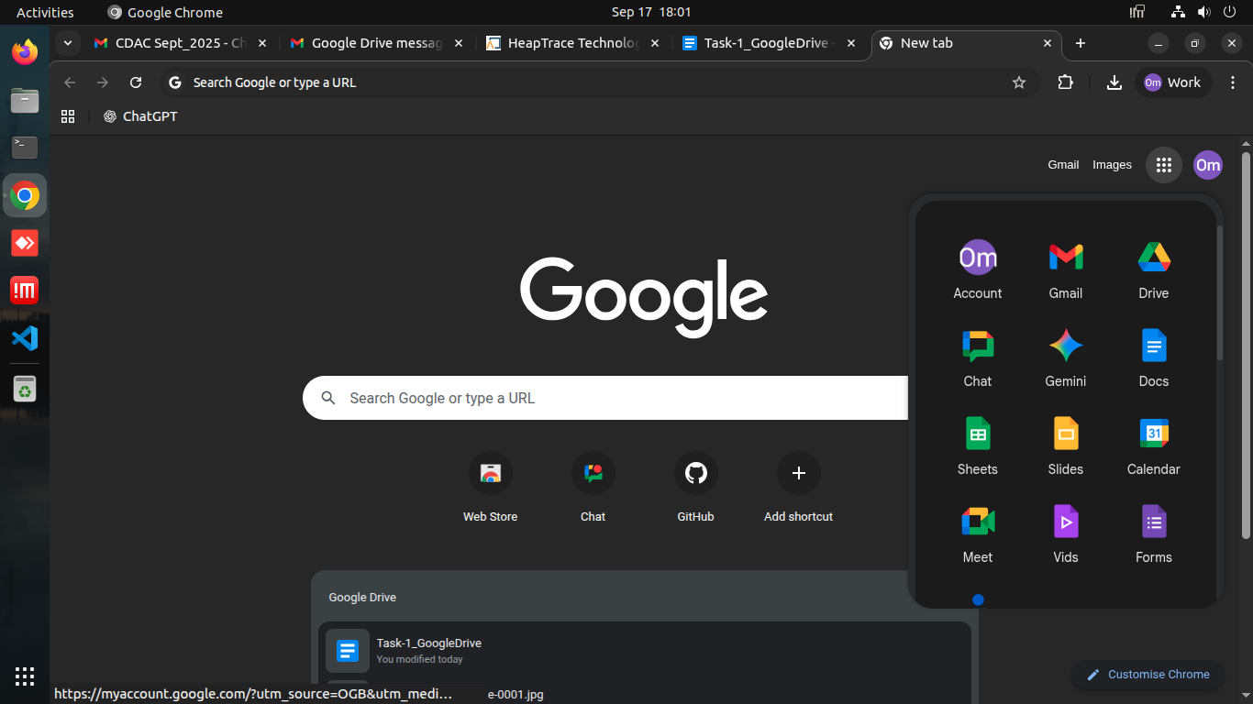

**Step 2:** Right Click on screen and choose “New Folder” option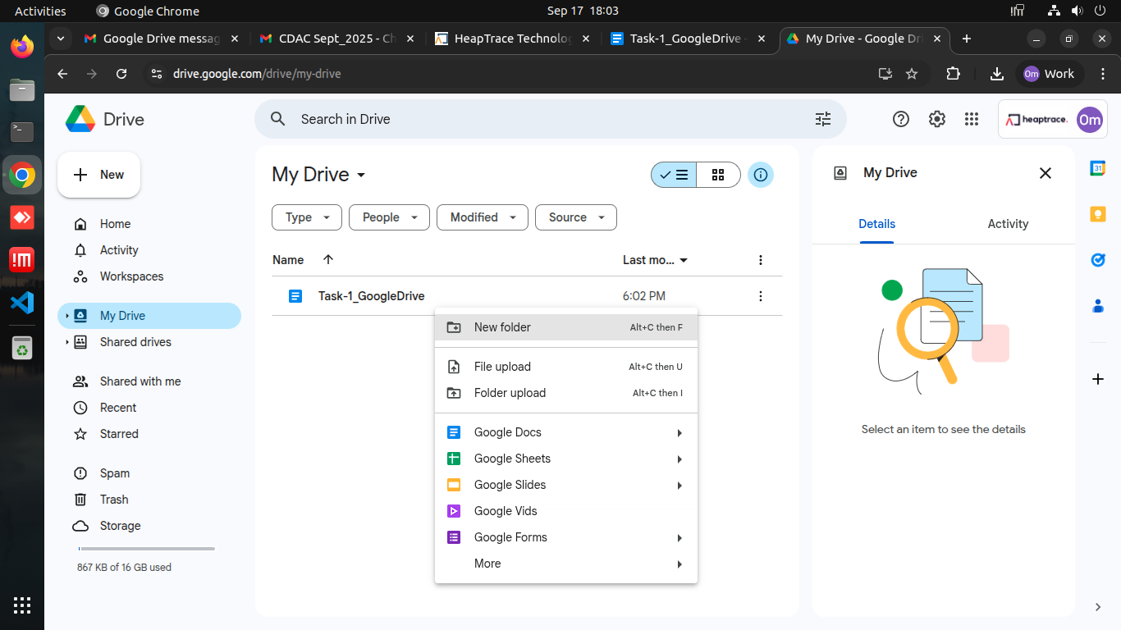

**Step 3:** Set name of folder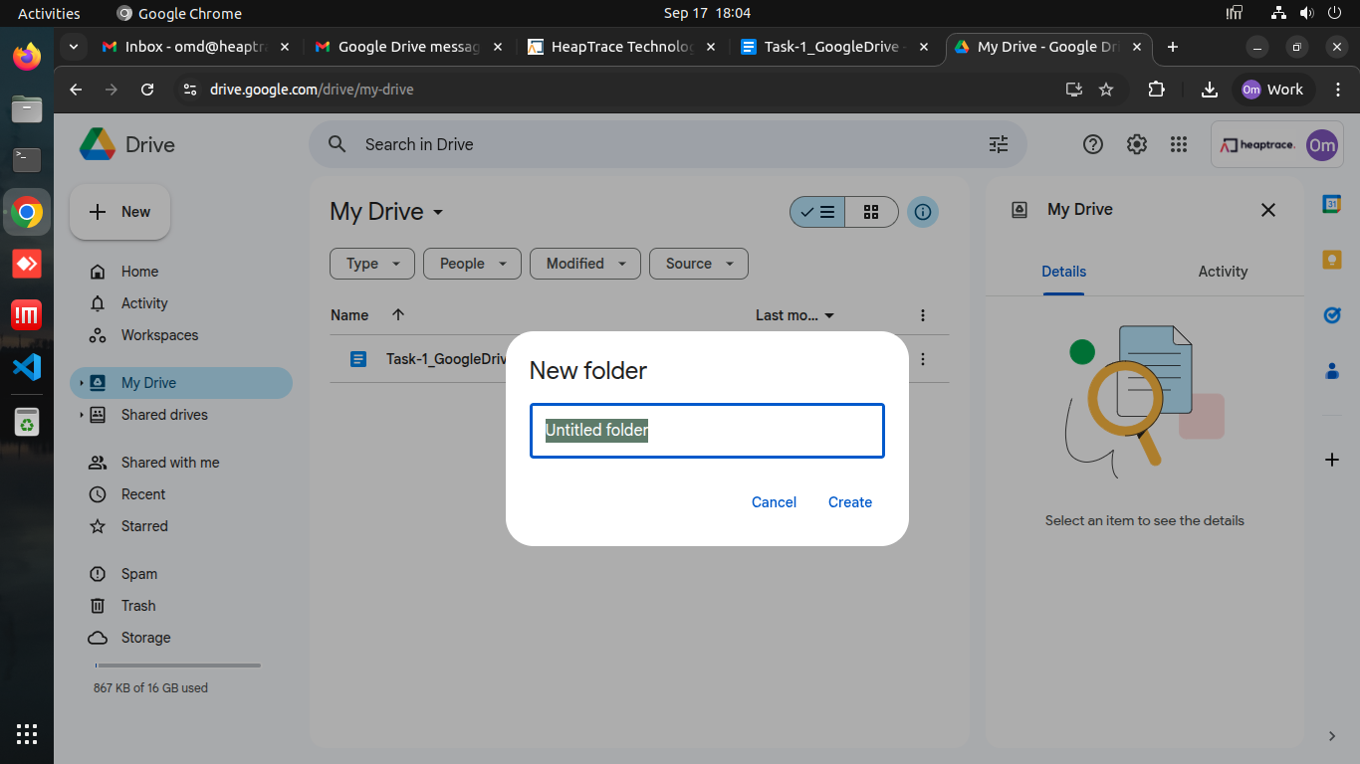

**Step 4:** Click on “Create”

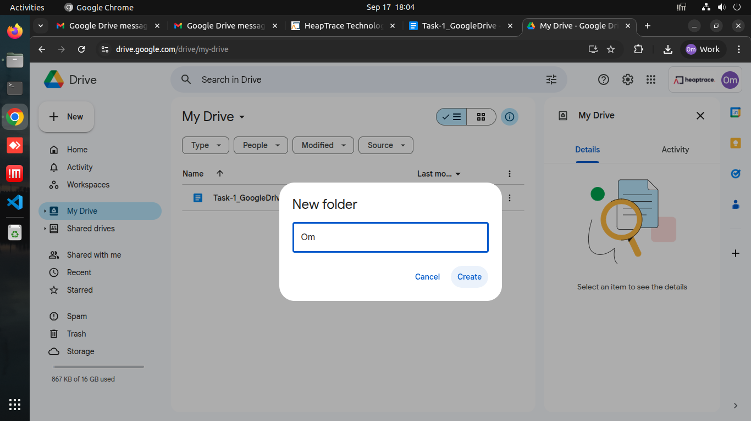

**Step 5:** Successfully Created