**Step 1:** Select Sheets from right corner Google Apps list

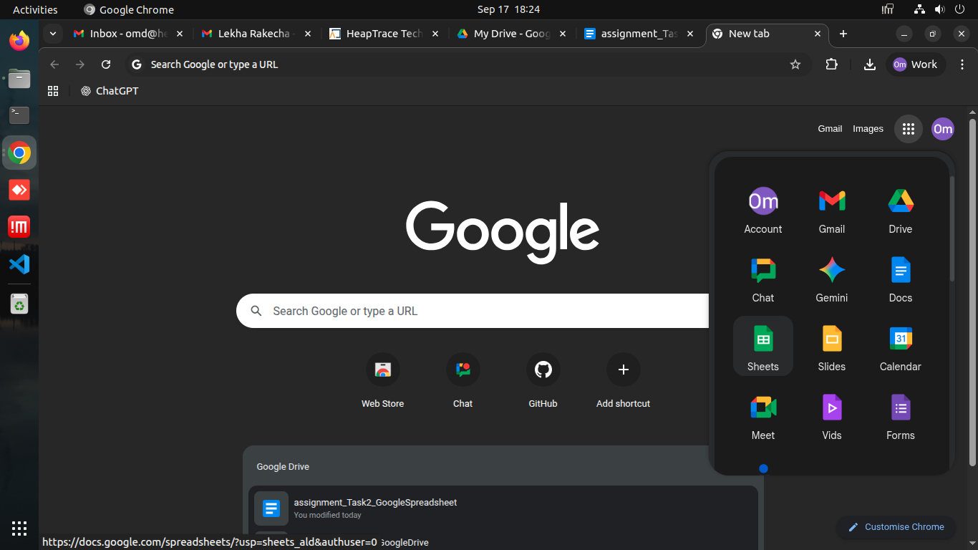

**Step 2:** Choose Blank spreadsheet option

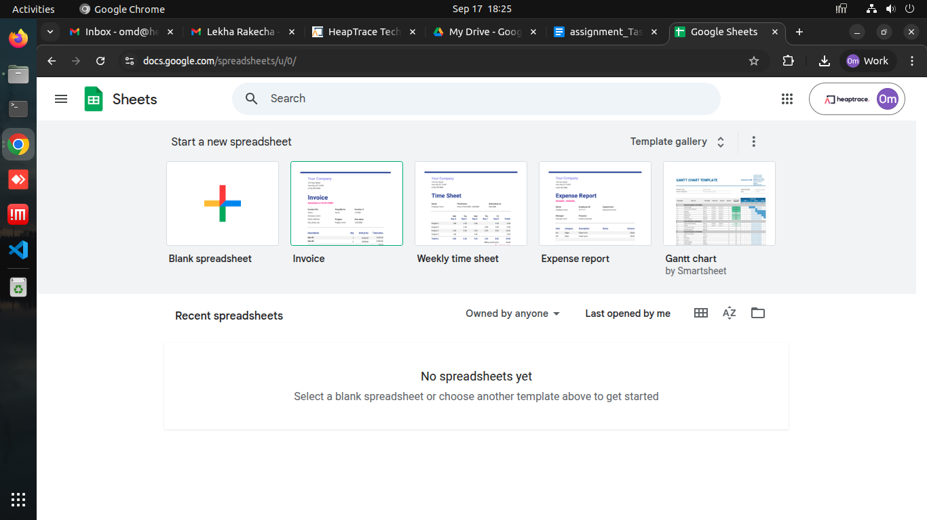

**Step 3:** Enter data

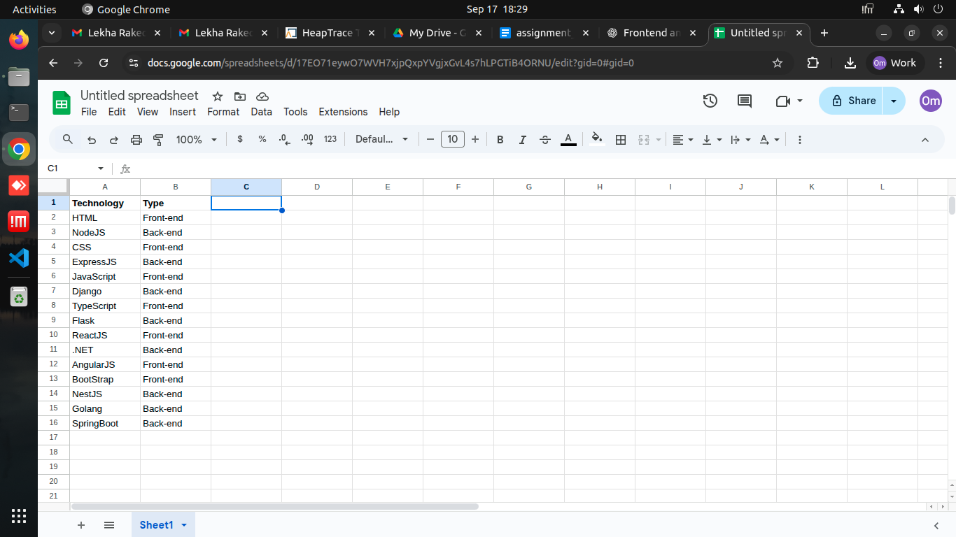

**Step 4:** Click on “Data” > “Create a Filter”

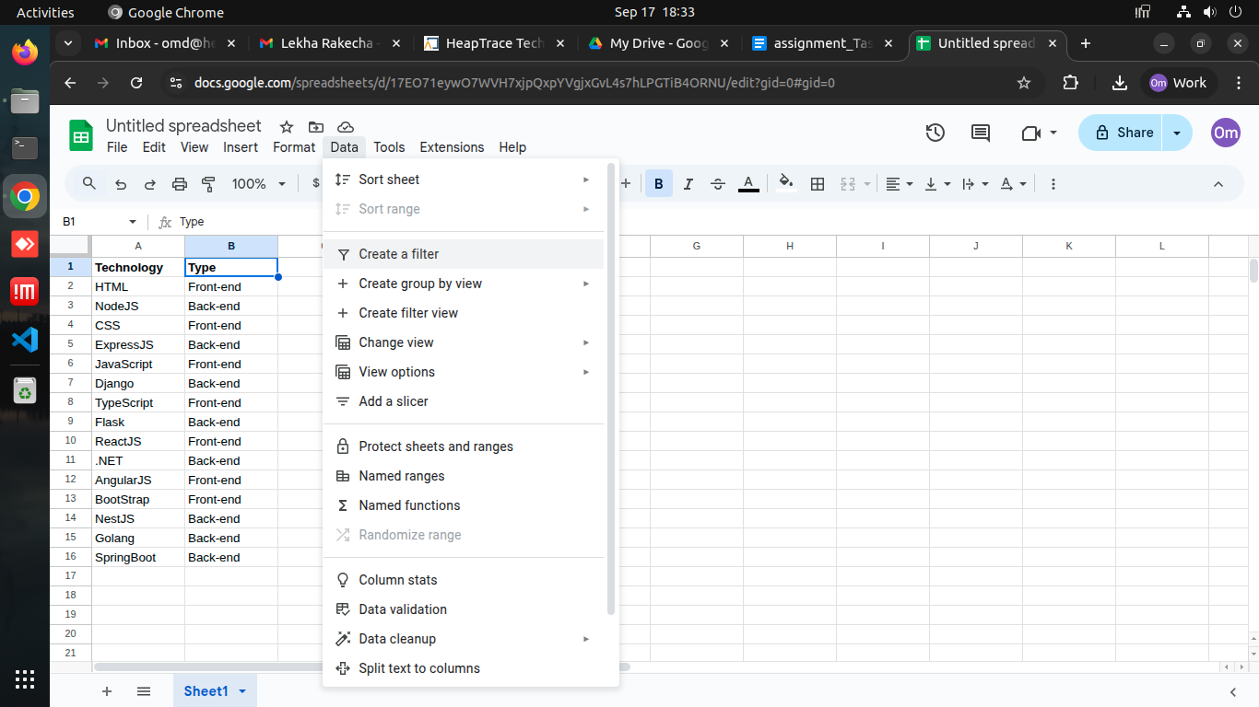

**Step 5 :** Choose conditions to filter and what to show then Click on “OK”

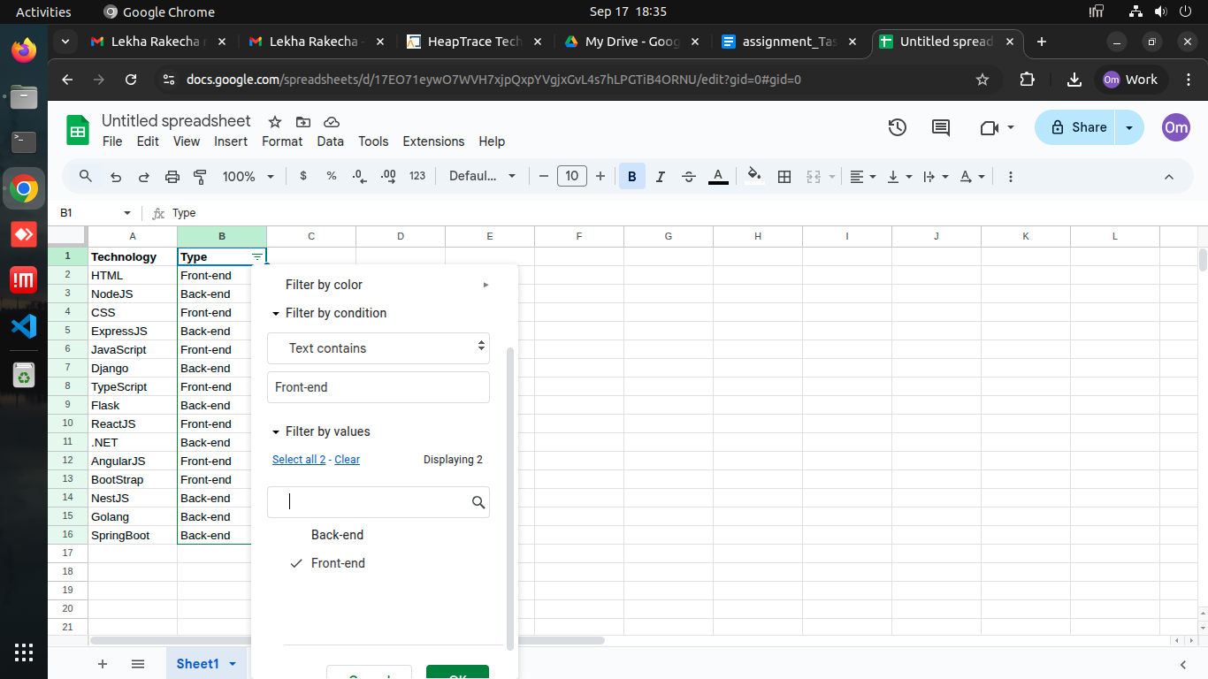

**Step 6 :**  For Back-end

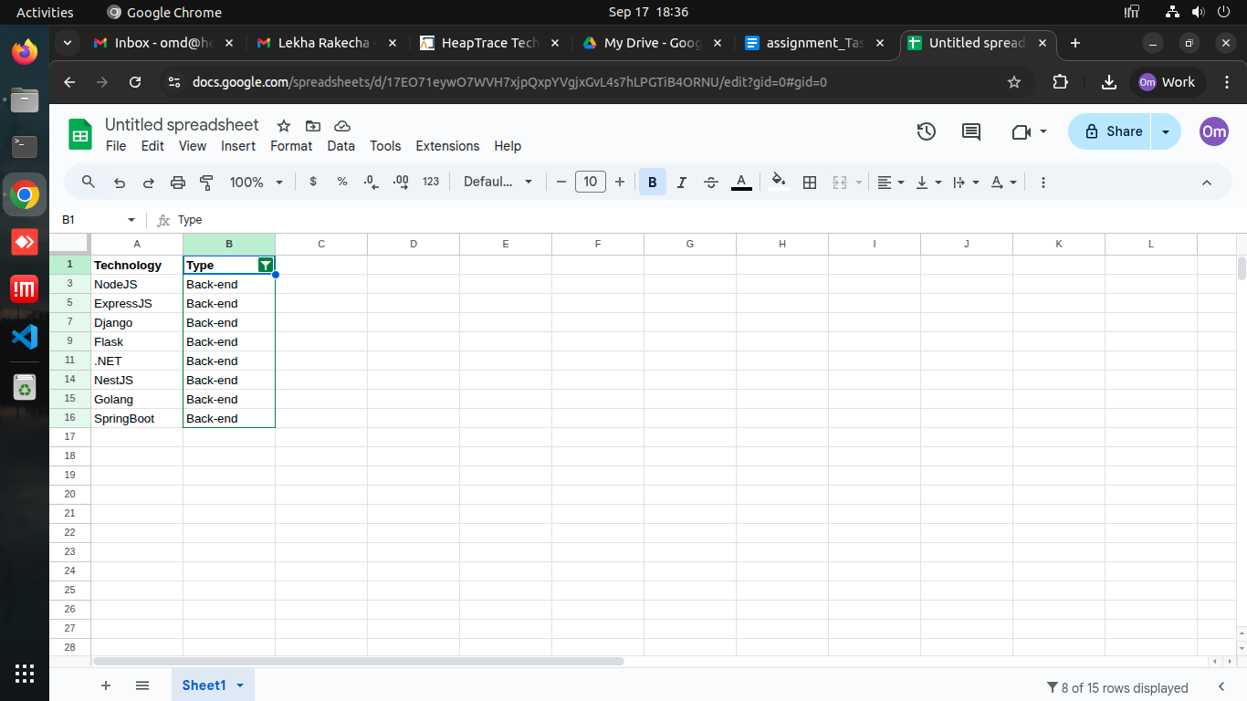

**Step 7 :**  For Front-end

