Altering Database Availability in MySQL
CREATE DATABASE college_db; USE college_db;
CREATE TABLE student (
student_id INT AUTO_INCREMENT PRIMARY KEY, name VARCHAR(100),
course VARCHAR(100)
);

FLUSH TABLES WITH READ LOCK; UNLOCK TABLES;

output:
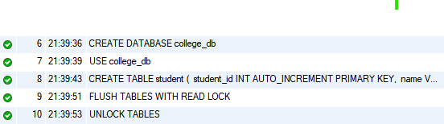

- Shutting Down a Database in MySQL
CREATE DATABASE college_db; USE college_db;
CREATE TABLE students (
student_id INT AUTO_INCREMENT PRIMARY KEY, name VARCHAR(100),
course VARCHAR(50), admission_date DATE
);

INSERT INTO students (name, course, admission_date)

VALUES
('Ravi Kumar', 'MCA', '2025-01-12'),
('Priya Sharma', 'MBA', '2025-02-22');
SELECT * FROM students;

FLUSH TABLES WITH READ LOCK; UNLOCK TABLES;

CREATE USER IF NOT EXISTS
'student_user'@'localhost' IDENTIFIED BY'password123';

REVOKE ALL PRIVILEGES ON college_db.* FROM
'student_user'@'localhost'; FLUSH PRIVILEGES;
GRANT ALL PRIVILEGES ON college_db.* TO 'student_user'@'localhost';

FLUSH PRIVILEGES; SHUTDOWN;
Output:
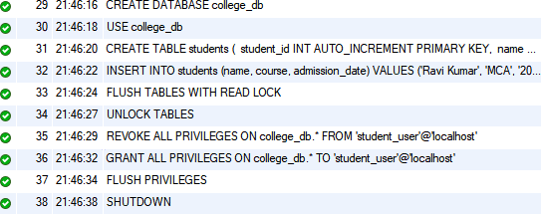

- Quiescing a Database
CREATE DATABASE college_db; USE college_db;
CREATE TABLE students ( student_id INT AUTO_INCREMENT PRIMARY KEY, name VARCHAR(100), course VARCHAR(50),
admission_date DATE );
INSERT INTO students (name, course, admission_date) VALUES
('Ravi Kumar', 'MCA', '2025-01-12'), ('Priya
Sharma', 'MBA', '2025-02-22');
SELECT * FROM students;

USE college_db;

FLUSH TABLES WITH READ LOCK;

SET GLOBAL read_only = ON;

SHOW VARIABLES LIKE 'read_only'; SELECT * FROM students;

SET GLOBAL read_only = OFF; UNLOCK TABLES;

INSERT INTO students (name, course, admission_date) VALUES ('Amit Verma', 'BCA', '2025-03-01');
SELECT * FROM students;

FLUSH PRIVILEGES;
Output:

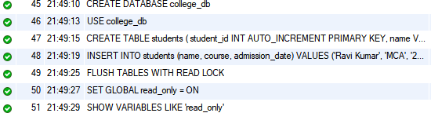
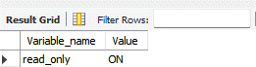

Suspending and Resuming a Database
CREATE DATABASE college_db; USE college_db;
CREATE TABLE students ( student_id INT AUTO_INCREMENT PRIMARY KEY, name VARCHAR(100), course VARCHAR(100),
admission_date DATE );

INSERT INTO students (name, course, admission_date) VALUES
('John Doe', 'MCA', '2025-01-10'), ('Jane
Smith', 'Mca Computer application', '2025-02-15');
-- View data in the table SELECT * FROM students; USE college_db;

FLUSH TABLES WITH READ LOCK;
SELECT * FROM students;

UNLOCK TABLES;

INSERT INTO students (name, course, admission_date) VALUES ('Robert Miller', 'BBA', '2025-03-05');

SELECT * FROM students;
Output:
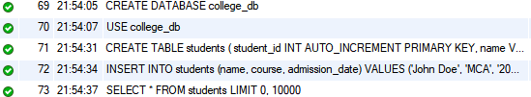
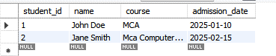

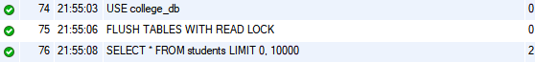

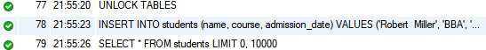

Configuring Database Resident Connection Pooling (DRCP)
CREATE DATABASE IF NOT EXISTS college_dba;

USE college_db;

CREATE USER IF NOT EXISTS 'app_user'@'%' IDENTIFIED
BY 'app_pass';

GRANT ALL PRIVILEGES ON college_db.* TO 'app_user'@'%';
FLUSH PRIVILEGES;

SELECT PLUGIN_NAME, PLUGIN_STATUS

FROM information_schema.PLUGINS WHERE PLUGIN_NAME LIKE 'thread%';
INSTALL PLUGIN thread_pool SONAME 'thread_pool.so'; SHOW VARIABLES LIKE 'thread_pool%';
SET GLOBAL thread_pool_size = 16;

SET GLOBAL thread_pool_stall_limit = 60; SHOW PROCESSLIST;
SELECT NOW() AS current_time;

SHOW | STATUS | LIKE | 'Threads_connected';
SHOW | STATUS | LIKE | 'Connections';
SHOW | STATUS | LIKE | 'Threads_running';

FLUSH HOSTS;

FLUSH STATUS;

output:
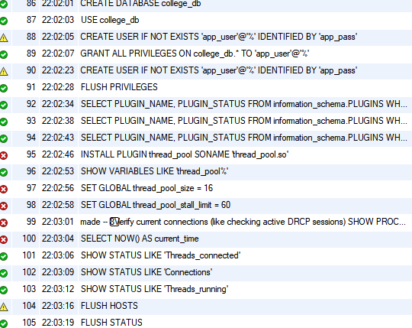

Monitoring Database Operations
CREATE DATABASE college_db; USE college_db;
CREATE TABLE students (
student_id INT AUTO_INCREMENT PRIMARY KEY, name VARCHAR(100),
course VARCHAR(100),

admission_date DATE
);
INSERT INTO students (name, course, admission_date) VALUES
('John Doe', 'MCA', '2025-01-10'),
('Jane Smith', 'MCA Computer Application', '2025-02- 15');
SELECT * FROM students; SHOW PROCESSLIST;
SHOW STATUS;
SHOW GLOBAL STATUS LIKE 'Queries%'; SHOW ENGINE INNODB STATUS;
SHOW OPEN TABLES WHERE In_use > 0;
SHOW VARIABLES LIKE 'max_connections';
SHOW VARIABLES LIKE 'innodb_buffer_pool_size'; SHOW TABLE STATUS;
SHOW VARIABLES LIKE 'slow_query_log%'; SHOW GLOBAL STATUS LIKE 'Handler_read%'; SHOW GLOBAL STATUS LIKE 'Handler_write%'; SELECT COUNT(*) FROM students;
FLUSH TABLES WITH READ LOCK;
SHOW OPEN TABLES WHERE In_use > 0; UNLOCK TABLES;
DROP DATABASE college_db;

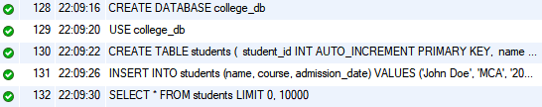
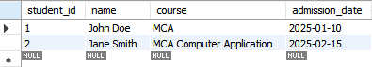
Output:

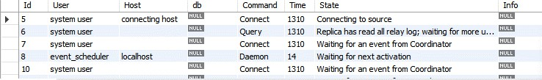
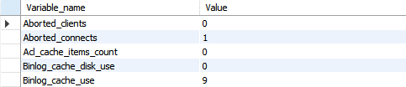
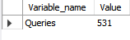

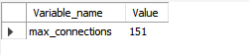
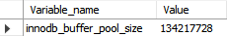

- Creating Control Files, Backing Up Control Files, and Dropping Control Files
CREATE DATABASE college_db CHARACTER SET utf8mb4 COLLATE utf8mb4_unicode_ci;
USE college_db;
CREATE TABLE students (
student_id INT AUTO_INCREMENT PRIMARY KEY, name VARCHAR(100),
course VARCHAR(100), admission_date DATE
);
INSERT INTO students (name, course, admission_date) VALUES
('John Doe', 'MCA', '2025-01-10'),
('Jane Smith', 'Computer Applications', '2025-02- 15');
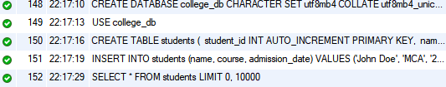
SELECT * FROM students; DROP DATABASE college_db; Output:

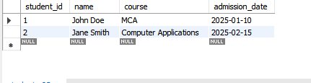

Managing Tablespaces

CREATE DATABASE IF NOT EXISTS college_db;
USE college_db;
CREATE TABLESPACE college_ts
ADD DATAFILE 'college_ts.ibd' ENGINE = InnoDB;
CREATE TABLE students (
student_id INT AUTO_INCREMENT PRIMARY KEY, name VARCHAR(100),
course VARCHAR(100), admission_date DATE
) ENGINE = InnoDB
TABLESPACE = college_ts;
INSERT INTO students (name, course, admission_date) VALUES
('John Doe', 'MCA', '2025-01-10'),
('Jane Smith', 'MCA Computer Application', '2025-02-15');

SELECT * FROM students;

SELECT * FROM information_schema.INNODB_TABLESPACES; SELECT NAME, SPACE, SPACE_TYPE
FROM information_schema.INNODB_TABLES WHERE NAME LIKE 'college_db/%';
DROP TABLE IF EXISTS students; DROP TABLESPACE college_ts; DROP DATABASE college_db;

Output:
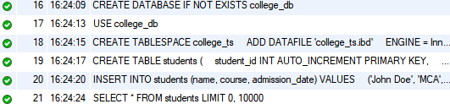
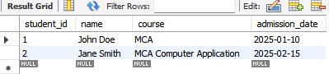




Managing Data Files and Temp Files

CREATE DATABASE college_db CHARACTER SET utf8mb4
COLLATE utf8mb4_unicode_ci; USE college_db;
CREATE TABLESPACE college_ts
ADD DATAFILE 'college_ts.ibd' ENGINE = InnoDB;
CREATE TABLE students (
student_id INT AUTO_INCREMENT PRIMARY KEY, name VARCHAR(100),
course VARCHAR(100), admission_date DATE
) ENGINE = InnoDB
TABLESPACE = college_ts;
INSERT INTO students (name, course, admission_date) VALUES
('John Doe', 'MCA', '2025-01-10'),
('Jane Smith', 'MBA', '2025-02-15'),
('Arun Kumar', 'BCA', '2025-03-05');

SELECT * FROM students;
SELECT NAME AS table_name, SPACE, SPACE_TYPE
FROM information_schema.INNODB_TABLES

WHERE NAME LIKE 'college_db/%';
SHOW VARIABLES LIKE 'innodb_temp_data_file_path'; CREATE TEMPORARY TABLE temp_students AS
SELECT * FROM students WHERE course = 'MCA'; SELECT * FROM temp_students;
DROP TEMPORARY TABLE IF EXISTS temp_students; DROP TABLE IF EXISTS students;
DROP TABLESPACE college_ts; DROP DATABASE college_db;

Output:
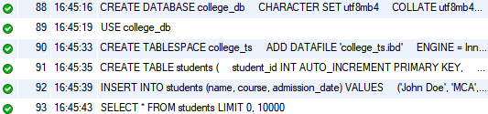
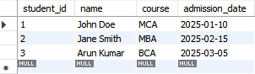



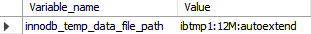

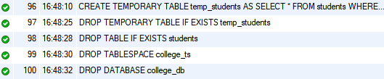

Managing Undo
CREATE DATABASE college_db CHARACTER SET utf8mb4
COLLATE utf8mb4_unicode_ci; USE college_db;
CREATE TABLESPACE college_ts ADD DATAFILE 'college_ts.ibd' ENGINE = InnoDB;
CREATE TABLE students (
student_id INT AUTO_INCREMENT PRIMARY KEY, name VARCHAR(100),
course VARCHAR(100), admission_date DATE
) ENGINE = InnoDB
TABLESPACE = college_ts;
INSERT INTO students (name, course, admission_date) VALUES
('John Doe', 'MCA', '2025-01-10'),
('Jane Smith', 'Computer Applications', '2025-02-15');
SELECT SPACE, NAME, SPACE_TYPE, STATE
FROM information_schema.INNODB_TABLESPACES; ALTER TABLE students ENGINE = InnoDB;
DROP TABLE IF EXISTS students; DROP TABLESPACE college_ts;

DROP DATABASE IF EXISTS college_db;

Output:
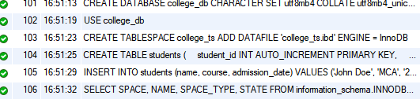
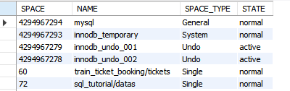


Managing Tables

CREATE DATABASE IF NOT EXISTS college_db;
USE college_db;
CREATE TABLE students (
student_id INT AUTO_INCREMENT PRIMARY KEY, name VARCHAR(100),
course VARCHAR(100), admission_date DATE

);
INSERT INTO students (name, course, admission_date) VALUES
('John Doe', 'MCA', '2025-01-10'),
('Jane Smith', 'MCA Computer Application', '2025-02- 15');
SELECT * FROM students;
RENAME TABLE students TO student_details; ALTER TABLE student_details
ADD email VARCHAR(150);
ALTER TABLE student_details MODIFY course VARCHAR(150);
ALTER TABLE student_details DROP COLUMN email;
CREATE TABLE departments (
dept_id INT AUTO_INCREMENT PRIMARY KEY,
dept_name VARCHAR(100)
);
ALTER TABLE student_details ADD dept_id INT,
ADD CONSTRAINT fk_dept
FOREIGN KEY (dept_id) REFERENCES
departments(dept_id); DESCRIBE student_details;
LOCK TABLES student_details READ;

UNLOCK TABLES;

DROP | TABLE IF | EXISTS student_details;
DROP | TABLE IF | EXISTS departments;
DROP | DATABASE | IF EXISTS college_db;

Output:
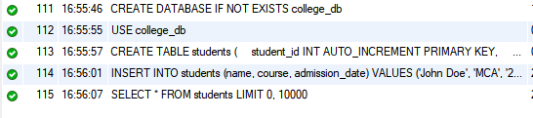
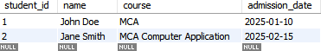

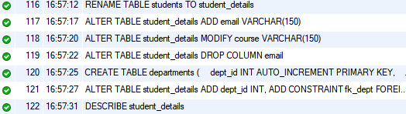
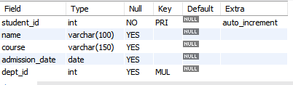


Managing Distributed Database

CREATE DATABASE IF NOT EXISTS
college_main;
USE college_main;
CREATE TABLE students_local (
student_id INT AUTO_INCREMENT PRIMARY KEY,
name VARCHAR(100),
course VARCHAR(100), admission_date DATE
);
INSERT INTO students_local (name, course, admission_date)

VALUES
('John Doe', 'MCA', '2025-01-10'),
('Jane Smith', 'BCA', '2025-02-15');
SELECT * FROM students_local; CREATE DATABASE IF NOT EXISTS
college_remote;
USE college_remote;
CREATE TABLE students_remote ( student_id INT PRIMARY KEY,

name VARCHAR(100),
course VARCHAR(100), admission_date DATE
);
CREATE TABLE students_distributed ( student_id INT NOT NULL,
name VARCHAR(100),
course VARCHAR(100), admission_date DATE

) ENGINE=FEDERATED
CONNECTION='mysql://remote_user:remote_pa ss@192.168.1.20:3306/college_remote/stude nts_remote';

SHOW ENGINES;
INSERT INTO students_distributed SELECT * FROM students_local; SELECT * FROM students_remote; SELECT TABLE_NAME, ENGINE
FROM information_schema.TABLES WHERE ENGINE = 'FEDERATED';

UPDATE students_distributed SET course = 'MCA - Advanced' WHERE name = 'John Doe';
DELETE FROM students_distributed WHERE name = 'Jane Smith';

DROP TABLE IF EXISTS
students_distributed;
DROP TABLE IF EXISTS students_local; DROP DATABASE IF EXISTS college_main;
-- Run separately on remote server:

-- DROP DATABASE IF EXISTS
college_remote;
Output:
