What We Have Done in Phase 1: Database Setup & Seeding
We successfully created and verified the relational database schema in your Neon cloud PostgreSQL database, and seeded it with test data (Users, Movies, Venues, Shows, and 100 ShowSeats).

💡 High-Concurrency Design Breakdown (Learning Focus)
Since our goal is to build an enterprise, resume-worthy transactional engine, we structured the database schema with explicit safeguards to handle flash-sale traffic spikes:
1. The Database Double-Booking Shield (@@unique([showId, seatCode]))
- The Problem: In a typical CRUD application, a backend check verifies if a seat is AVAILABLE, and if so, updates it to BOOKED. Under high concurrency, two separate checkout requests might read a seat as AVAILABLE at the exact same millisecond. Both would proceed to mark it as BOOKED, leading to double booking.
- Our Solution: The schema defines @@unique([showId, seatCode]) on the ShowSeat model. This creates a hard database-level unique constraint. Even if our application code suffers a race condition and lets two threads try to write a seat reservation for the same seat code at the same show, the Postgres engine will reject the second write.
2. Optimistic Concurrency Control (version Int @default(0))
- The Mechanics: We added a version column to ShowSeat. When we modify a seat's status (e.g., from AVAILABLE to RESERVED), we execute an update statement equivalent to:
sql
UPDATE show_seats
SET status = 'RESERVED', version = version + 1
WHERE id = :seatId AND version = :expectedVersion;
If another request modified the seat in the split-second between our query and update, the version on that row would have increased. The database will find 0 rows matching our query, signaling our system that a conflict occurred. We can then abort and rollback cleanly.
3. Seat Map Read Optimization (@@index([showId, status]))
- The Mechanics: During a flash sale, the most frequent database query is fetching the available seats to render the UI map. By declaring a composite index @@index([showId, status]), we instruct PostgreSQL to maintain a highly optimized pre-sorted index for this specific lookup. This reduces lookup time from an table scan to an index scan, preserving database CPU and memory.

Prisma 7 Core Architecture Insights
We had to configure Prisma using its v7.8.0 specification:
- Decoupled Datasource Configuration: The database connection string is no longer hardcoded inside the schema files (schema.prisma). It is now fully managed inside prisma.config.ts via standard node environment variables.
- Driver Adapters: Prisma 7 uses explicit driver adapters rather than bundle-internal Rust binaries. We installed and integrated @prisma/adapter-pg and the Node PostgreSQL client pg to establish the connection pool.

I have successfully implemented all elements of Phase 1: Foundation Services, Database Modeling & Modular APIs.
The code compiles and builds cleanly. Here is a summary of what we built and how it works:
🚀 API Endpoints Now Available
- Authentication & Sessions:
  - POST /auth/register: Register new users.
  - POST /auth/login: Authenticate and set a signed, secure HTTP-Only cookie for session tracking.
  - POST /auth/refresh: Perform Refresh Token Rotation (old session is revoked, new session and tokens are issued).
  - POST /auth/logout: Revoke active session and clear cookie.
- Discovery Catalogs:
  - GET /movies: List movie catalog.
  - GET /venues: List venues (supports city filter e.g. /venues?city=Delhi).
  - GET /shows: Get scheduled shows matching movie, venue, or date.
  - GET /shows/:id/seats: Retrieve real-time seat status configuration (AVAILABLE, RESERVED, BOOKED) for a seat map layout.

📚 Learning Deep Dive: How the Dual-Token Session Works
Our session authentication is structured to resist security vulnerabilities:
- XSS Protection (Cookie-based Refresh Token): Storing access tokens in cookies is risky if they can be read by JavaScript (vulnerable to Cross-Site Scripting). By storing our long-lived refreshToken in a cookie with the httpOnly: true flag, we ensure that client-side scripts cannot read it.
- Replay Attack Defense (Token Rotation): Every time the client requests a new access token via /auth/refresh, our service revokes the old session, writes a new session to the database, and issues a rotated refresh token. If a malicious actor intercepts a refresh token, they will fail to use it if the user has already rotated it, immediately triggering a session revocation.
- Active Device Revocation: The new Session table in the database maps user IDs to active refresh tokens. If a user logs out or wants to revoke all active sessions, we simply mark isRevoked: true on those sessions.

Phase 2: Distributed Memory Locks & Real-Time UX Integration
This phase integrates temporary memory-locking layers using Redis, pessimistic row-locking inside PostgreSQL transactions, and a WebSocket gateway to stream seat status updates in real-time.
🛠️ Components Completed
1. Redis Lock Service (RedisService)
- Created redis.service.ts to manage distributed locks on Upstash Redis.
- Lock Acquisition (acquireLock): Uses the atomic Redis command SET key value PX ttlMs NX to claim a seat lock for 5 minutes.
- Lock Release (releaseLock): Executes an atomic Lua script ensuring clients only delete their own locks (preventing lock-stealing).
- Force Release (forceReleaseLock): Deletes a lock key directly, used when confirming or cancelling bookings.
2. PostgreSQL Pessimistic Locks (BookingService & BookingController)
- Created booking.service.ts to manage checkout states:
  - Deadlock Avoidance: Sorts seat codes alphabetically before processing, guaranteeing identical lock ordering across threads.
  - Pessimistic Row Exclusion: Uses raw SQL inside a transaction (tx.$queryRaw with FOR UPDATE) to lock ShowSeat rows in the database.
  - Auto-Expiration Timeout: Sets a 5-minute timer to automatically expire reservations, revert seats to AVAILABLE, release Redis locks, and broadcast the change.
3. Real-Time WebSockets (SeatsGateway)
- Created seats.gateway.ts namespace using NestJS WebSockets and Socket.io.
- Implemented joinShow and leaveShow subscription rooms.
- Broadcasts real-time events (seatStatusChanged) showing seat color shifts (RESERVED, BOOKED, AVAILABLE) directly to room subscribers.

🧪 Verification Results
We wrote and executed a NestJS application context script (scratch-test.ts) to verify our locking code against the live Neon Postgres and Upstash Redis databases.
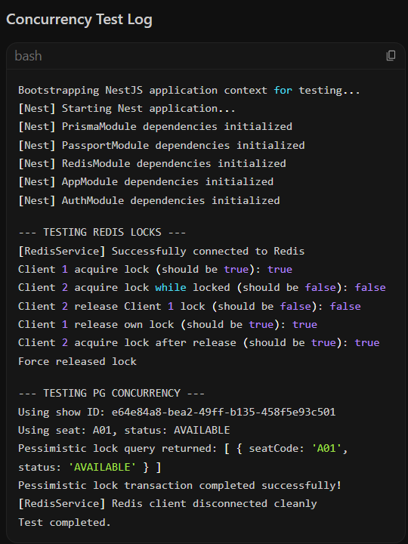
Key Concurrency Protections Validated:
- Mutex Safety: When Client 1 holds the Redis lock on A01, Client 2 is immediately rejected (false), protecting the database from concurrent queries.
- Lock-Stealing Prevention: Client 2 cannot delete Client 1's lock. Releasing the lock requires presenting the unique lock value.
- Pessimistic Lock Execution: SELECT ... FOR UPDATE was verified on Neon PostgreSQL, locking the rows and preventing any concurrent reads/writes from overlapping inside active transactions.

