A Mini Project Synopsis
On
IntelliLoan, AI Powered Loan Approval and Credit Risk Assessment System
Submitted to Walchand College of Engineering, Sangli for the partial fulfilment of Bachelor of Technology Multidisciplinary Minor in
Artificial Intelligence and Machine Learning
Submitted By
Mr. Om Chougule, PRN 23410007
Mr. Maanas Tekade, PRN 23410031
Ms. Avanti Pandhare, PRN 23410032
Mr. Rohan Mane, PRN 23410028
Guided By
Mr. Sahil Nadaf

Multidisciplinary Minor in Artificial Intelligence and Machine Learning
Walchand College of Engineering, Sangli
Academic Year 2026 to 27

Abstract
Loan approval and credit risk assessment are critical yet resource intensive tasks for financial institutions, traditionally relying on manual review of applicant details, income, credit history and supporting documents. This synopsis presents IntelliLoan, an AI powered decision support system that integrates machine learning based credit risk prediction with automated document verification and affordability analysis to assist preliminary loan assessment. The system is trained on a Loan Approval and Credit Risk Prediction dataset comprising 1000 applicant records with 20 input attributes, using Logistic Regression, Decision Tree, Random Forest and XGBoost classifiers to estimate approval probability and risk category. Optical Character Recognition, referred to as OCR, is used to extract the declared name and income from uploaded documents and cross verify them against the submitted application, while EMI and debt to income calculations recommend an affordable loan amount or tenure. All outputs, prediction, risk score, verification status and affordability analysis, are consolidated into a unified dashboard to support the final decision made by an authorized loan officer. The proposed system aims to make the loan screening process faster, more consistent and more transparent, while retaining human oversight over the final lending decision.
Keywords. Loan Approval, Credit Risk Assessment, Machine Learning, XGBoost, Optical Character Recognition OCR, EMI and Affordability Analysis, Decision Support System

1. Introduction
Financial institutions receive a large volume of loan applications that must be evaluated for creditworthiness, income adequacy and document authenticity before a lending decision can be made. Conventional credit scoring approaches use applicant financial and credit history variables to estimate borrower risk, and this evaluation is largely carried out manually by loan officers. As application volumes grow, manual screening becomes slow, difficult to scale and prone to inconsistent judgement across cases. Moreover, a single approval prediction model neither verifies the information declared by the applicant nor tests whether the requested loan amount is actually affordable for the applicant. IntelliLoan is proposed as an integrated decision support pipeline that combines machine learning based credit risk prediction, OCR based document verification and EMI and affordability analysis within a single system, while the final lending decision continues to rest with the authorized loan officer.
1.1 Motivation
- Manual loan assessment requires reviewing applicant details, credit history, income and supporting documents, which is time consuming.
- High application volumes make manual screening slow and can produce inconsistent judgement across similar cases.
- A single approval prediction model does not verify declared applicant information or test whether the requested loan is affordable.
- An integrated pipeline combining prediction, verification and affordability analysis can support faster, more consistent decision making while keeping the final decision with the loan officer.
1.2 Objective
- Analyse historical loan applications and identify factors associated with loan approval or rejection.
- Preprocess numerical and categorical applicant and loan features and perform exploratory data analysis, EDA.
- Train and compare Logistic Regression, Decision Tree, Random Forest and XGBoost models for loan approval classification.
- Predict approval probability and convert the model output into a preliminary risk category.
- Extract declared name and income from uploaded documents using OCR and cross check them against the submitted application data.
- Calculate EMI and debt to income, and EMI to income ratios, and recommend an affordable loan amount or tenure.
- Provide a unified dashboard presenting prediction, risk, verification and affordability results.
1.3 Problem Statement
Traditional loan processing relies on manual examination of applicant information and supporting documents. This process can be slow, difficult to scale to high application volumes, and inconsistent across cases, and it does not independently verify declared information or assess loan affordability. The proposed system, IntelliLoan, automates this analytical workflow, covering prediction, document verification, risk scoring and affordability analysis, while retaining human oversight over the final loan decision.

2. Related Work and Literature Survey
Traditional credit scoring approaches use applicant financial and credit history variables, such as income, employment history and existing debt, to estimate borrower risk. Machine learning classifiers, including Logistic Regression, Decision Trees and Random Forest, are widely used for credit and loan classification because of their interpretability and reasonable predictive performance. Boosting methods such as XGBoost extend this further by modelling nonlinear interactions among financial and demographic features, and have shown strong performance on structured, tabular prediction tasks. Separately, OCR based document processing, built on engines such as Tesseract, can automate the extraction of information from scanned financial documents and reduce manual data entry effort. Open source libraries such as Scikit learn provide the classification, preprocessing and evaluation tools commonly used to build and benchmark such models. Existing literature also emphasizes careful feature engineering and model evaluation, since class imbalance and the differing costs of false approvals and false rejections directly affect the practical usefulness of a credit model. However, many existing student and academic prototypes stop at loan status prediction alone. IntelliLoan extends this line of work by combining ML based prediction with OCR based document verification, credit risk scoring and EMI and affordability analysis within a single decision support dashboard.

3. Proposed Methodology, Algorithm, Approach
IntelliLoan follows an end to end pipeline in which applicant data and uploaded documents are processed through preprocessing, feature engineering, ML based prediction, OCR based validation, credit risk assessment and affordability analysis before a final dashboard recommendation is generated, as shown in Figure 3.1. The applicant first submits personal, financial and loan related details along with supporting documents, Step 1. The data is cleaned and explored through preprocessing and exploratory data analysis, EDA, Step 2, followed by feature engineering to derive ratios such as debt to income, DTI, and EMI to income, Step 3. Logistic Regression, Decision Tree, Random Forest and XGBoost models are then trained and compared on the processed dataset, Step 4, and the best performing model is used to generate an approval probability prediction, Step 5. In parallel, uploaded documents are processed using OCR to extract declared name and income, which are cross checked against the application data for verification, Step 6. The verified information feeds into a credit risk assessment, Step 7, and EMI and affordability calculations determine whether the requested amount is affordable or whether an alternative amount or tenure should be recommended, Step 8. These outputs are combined into a loan recommendation, Step 9, and finally consolidated into a unified dashboard, Step 10, that presents the applicant profile, model result and supporting analytical indicators to the loan officer. Model performance is evaluated using Accuracy, Precision, Recall and F1 score.
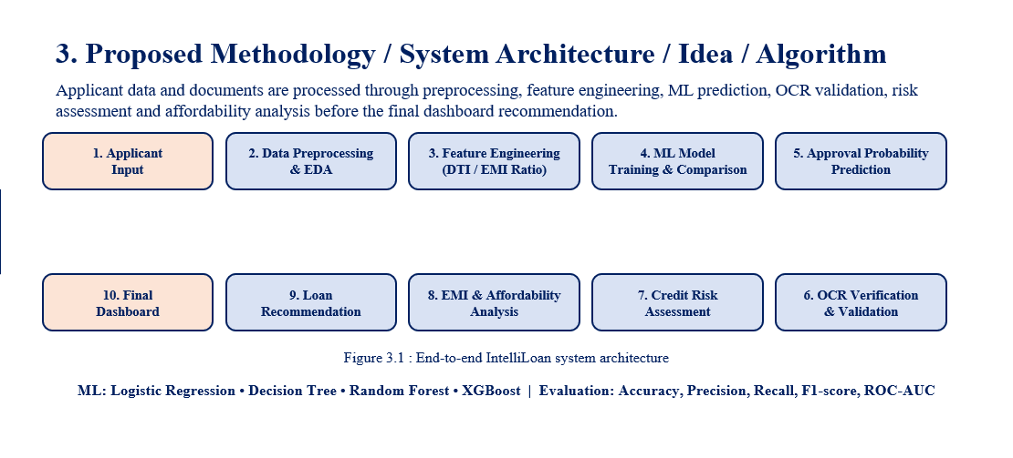
Figure 3.1. End to end IntelliLoan system architecture

4. Datasets Used
The recommended dataset for IntelliLoan is a publicly available Loan Approval and Credit Risk Prediction dataset, consisting of 1000 applicant records described by 20 input attributes and a binary loan status target. The key fields include age, gender, education, annual income, employment experience, home ownership status, loan amount, loan intent, interest rate, loan to income ratio, credit history length, credit score and a previous loan default indicator. This dataset was selected because its variables map directly to the applicant profile required by IntelliLoan and support binary classification, exploratory data analysis and the feature engineering steps, such as DTI and EMI to income ratio, used in the proposed methodology.

5. Conclusion
IntelliLoan is expected to generate an approval probability along with a preliminary decision or risk category, a document verification status, verified or mismatch, based on OCR extracted fields, and EMI and affordability figures with a recommended loan amount or tenure, all presented through a consolidated dashboard. For an illustrative applicant, the system is expected to produce an approval probability of 87.4%, a risk score of 24 out of 100, categorized as LOW, a verified document status, and a recommended loan amount of ₹6 to 7 lakh against a requested amount of ₹8,00,000 with an estimated EMI of ₹16,606. The system, however, has certain limitations. Dataset performance does not guarantee real world banking performance, OCR accuracy depends on document quality and layout, and the prototype is intended to provide decision support rather than autonomous loan approval or rejection, and the final decision remains with the authorized loan officer. As future scope, the system can be extended with SHAP based explainable AI for individual predictions, real time fraud and anomaly detection with bank and API integration, multilingual OCR for regional language documents, and a mobile applicant interface with broader historical credit integration.

6. Software and Hardware Requirements
Hardware
- Laptop or desktop with 8 GB RAM or more.
- Modern multi core processor. GPU is optional.
- Scanner or mobile camera input for capturing document images.
Software
- Python, Pandas, NumPy, Scikit learn, XGBoost, Joblib.
- OpenCV and EasyOCR for document preprocessing and OCR.
- Matplotlib, Seaborn and Plotly for EDA and visualization.
- Streamlit for the dashboard, and SQLite or MySQL for application data storage.

References
- Lessmann, S., Baesens, B., Seow, H.V., and Thomas, L.C., 2015. Benchmarking state of the art classification algorithms for credit scoring, an update of research.
- Breiman, L., 2001. Random Forests. Machine Learning
- Chen, T., and Guestrin, C., 2016. XGBoost, a scalable tree boosting system.
- Smith, R., 2007. An overview of the Tesseract OCR engine.
- Pedregosa, F. et al., 2011. Scikit learn, machine learning in Python.
- Lo, T., 2024. Loan Approval Classification Data. Kaggle. A synthetic dataset of 1000 applicant records with 20 attributes and a binary loan status target, used for supervised loan outcome prediction.

Dr., Mr., Mrs. | Mr. S.S Nadaf | Ms A.B. Patil
Guide | MDM Project Coordinator | MDM Coordinator

