WEEK-5 PROJECT PLAN

A Task Board (Kanban Style)

Requirements Breakdown:
Task Management
- View tasks
- Create task
- Edit task
- Delete task

Kanban Board
- Filters
- To Do
- In Progress
- Done
- Drag & Drop functionality

Comments
- View comments
- Add comment

API Handling
- Loading
- Errors
- API failures
Deployment
- Build
- Deploy
Modules:
- The modules in this project:
- Authentication module:
  - When user logged in, it can access the dashboard of task list.
- Task management module:
  - It contain the task board with task status and task details
  - Also contain the edit, delete, add task operations
  - It task management dashborad, task are dragged and dropped to change their status
- Comment module
  - see the comments of each task
  - add and edit comment
- Profile Page
  - edit name, detail, profile photo
Day-1: (1day)
- Understand and read the documentation, requirements
- Understand each feature of this project
- Make a proper valid folder structure for the developement
- Make a list of each component that will use in the project
- Make a list of states which are require for handling different information in different component
- Access and checks the api
- Set up and download json server
- Create a git repo for it with readme file

Day-2: (1 day)
- Start the developement
- build the layout of the kanban board
  - make a three columns for to do, in progress, done
- make task card ui with the details of task
- fetch the get api for rendering task on the pages
- manage error and loading state

Day-3 (approx 1-2 days)
- Start implement CRUD operation for task
- make a form for add task
- make a form for edit task
- make delete task
- works on the drag n drop functionality
- fetch api for add, edit, delete

Day-4 (approx 1-2 days)
- Start work on the comments for the task
- fetch the comments from an api
- addd comments functionality
- manage loading/ error state
- manage the api failure condition and slow api response – for both manage that what user see on the browser in these situation

Day-5 (1 day)
- Test all the functionality working properly or not (add,edit,delete task/comment, drage and drop)
- make a perfect readme file containing all the information related to the project
- Live Project
- Review from the mentor

State management:

State | Why | In which file
Tasks | For managing current tasks | TaskBoard
Loading | Initial task loading | TaskBoard
Error | When task API give error | TaskBoard
Selected task | Currently opened task | Board/Details
Saving | Save request (task) | TaskForm
Deleting | Delete request (task) | TaskCard
Comments | Selected task comments | Comments
Comment add | Manage new comment | CommentForm
Comment loading | Comment request | Comments
Comment error | Comment API error | Comments

Flowchart:

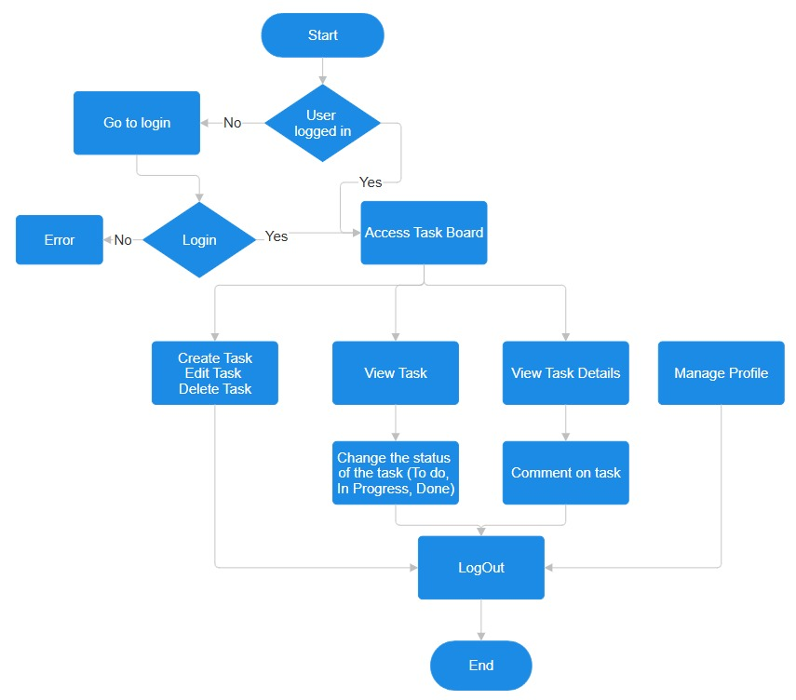
Total pages:
- /login - Login Page: Login form design. Email, password, validation, login button, loading state, login error.
- /board - Task Board: To Do / In Progress / Done columns, view tasks, create task, edit task, delete task, drag & drop, status update.
- /board/tasks/[id] - Task Details: Full task information, description, status, task actions, comments list, add comment, comment loading/error states
- /profile - Profile Page: User information, edit profile, account details, logout

Drag and drop functionality:
- There are 3 different method for building this functionality.
- HTML Native API:
  - You have to write whole code by using browser’s buit-in tools.it is super light.
  - No automatic animations.
  - Somethimes glitchy and unreliable for the phones.
- @hello-pangea/dnd:
  - it require the downloading the packages.
  - Cards drags and drops smoothly.
  - Only works for straight vertical lines.

- @dnd-kit:
  - It is modern, lightweight and uses react hooks.
  - You have to code animations by your self.
  - Designed from scratch for flawless mobile and tablet touch gestures.
  - Perfect for irregular shapes, multi-directional grids, and dashboards.

@hello-pangea/dnd:
- <DragDropContext> - Wraps the part of your application you want to have drag and drop enabled for.
- <Droppable /> - An area that can be dropped into. Contains <Draggable />s.
- <Draggable /> - What can be dragged around.

.
└── task-board/
├── public/
│ ├── images/
│ └── icons/
├── src/
│ ├── app/
│ │ ├── (auth)/
│ │ │ ├── login/
│ │ │ │ └── page.tsx
│ │ │ └── register/
│ │ │ └── page.tsx
│ │ ├── (dashboard)/
│ │ │ └── board/
│ │ │ ├── page.tsx
│ │ │ └── tasks/
│ │ │ └── [id]/
│ │ │ └── page.tsx
│ │ ├── layout.tsx
│ │ └── globals.css
│ ├── api/
│ │ ├── tasks.ts
│ │ └── comments.ts
│ ├── features/
│ │ ├── auth/
│ │ │ ├── components/
│ │ │ │ ├── LoginForm.tsx
│ │ │ │ └── RegisterForm.tsx
│ │ │ ├── hooks/
│ │ │ │ └── useAuth.ts
│ │ │ ├── types/
│ │ │ │ └── auth.types.ts
│ │ │ └── utils/
│ │ │ └── auth.utils.ts
│ │ ├── tasks/
│ │ │ ├── components/
│ │ │ │ ├── TaskBoard.tsx
│ │ │ │ ├── TaskColumn.tsx
│ │ │ │ ├── TaskCard.tsx
│ │ │ │ ├── TaskForm.tsx
│ │ │ │ ├── TaskDetails.tsx
│ │ │ │ └── TaskActions.tsx
│ │ │ ├── hooks/
│ │ │ │ └── useTasks.ts
│ │ │ ├── types/
│ │ │ │ └── taskTypes.ts
│ │ │ └── utils/
│ │ │ └── task.Utils.ts
│ │ └── comments/
│ │ ├── components/
│ │ │ ├── CommentList.tsx
│ │ │ ├── CommentItem.tsx
│ │ │ └── CommentForm.tsx
│ │ ├── hooks/
│ │ │ └── useComments.ts
│ │ ├── types/
│ │ │ └── commentTypes.ts
│ │ └── utils/
│ │ └── commentUtils.ts
│ ├── components/
│ │ ├── ui/
│ │ │ ├── Button.tsx
│ │ │ ├── Input.tsx
│ │ │ └── ErrorMessage.tsx
│ │ ├── LoadingState.tsx
│ │ └── EmptyState.tsx
├── db.json

List of components:

Authentication Module:
- LoginForm: Handles email/password input and login submission

Task Management Module
- TaskBoard: Main Kanban board containing all task columns
- TaskColumn: Displays tasks belonging to one status: To Do, In Progress, or Done
- TaskCard: Displays individual task information
- TaskForm: Used for creating and editing tasks
- TaskDetails: Displays complete information about a selected task
- TaskActions: Handles task actions such as Edit and Delete

Comment Module
- CommentList: Displays all comments of a task
- CommentItem: Displays one individual comment
- CommentForm: Allows the user to add a new comment

Shared UI Components
- Button: Reusable button for different actions
- Input: Reusable text/email/password input
- Spinner: Displays loading animation
- ErrorMessage: Displays API or validation errors (shadcn)
- SideBar: Side Bar contain info for pages
- Header: Header for every page

State:

Authentication States
State | Component | Purpose
email | LoginForm | Stores the email entered by the user
password | LoginForm | Stores the password entered by the user
isLoggingIn | LoginForm | Shows whether login request is running
loginError | LoginForm | Stores login error message
name | RegisterForm | Stores user's name
confirmPassword | RegisterForm | Confirms the password
registerError | RegisterForm | Stores registration error
currentUser | useAuth | Stores currently authenticated user
isAuthenticated | useAuth | Indicates whether the user is logged in

Task States
State | Component | Purpose
tasks | useTasks | Stores tasks fetched from the API
isLoading | useTasks | Shows task loading state
error | useTasks | Stores task API error
selectedTask | TaskDetails | Identifies the task being viewed
taskTitle | TaskForm | Stores task title while typing
taskDescription | TaskForm | Stores task description while typing
taskStatus | TaskForm | Stores selected task status
isCreating | TaskForm | Shows create request status
isEditing | TaskForm | Shows edit request status
isDeleting | TaskActions | Shows delete request status
taskError | Task components | Displays task operation errors
draggedTask | TaskBoard | Identifies the task currently being dragged
isDragging | TaskBoard | Tracks drag operation

Comment States
State | Component | Purpose
comments | useComments | Stores comments fetched from API
commentText | CommentForm | Stores comment currently being typed
isLoadingComments | useComments | Shows comment loading state
isAddingComment | CommentForm | Shows comment submission state
commentError | Comment components | Stores/display comment API error

For a Kanban Taskboard, the clear winner is dnd kit [1].
While it has a slightly higher initial learning curve than @hello-pangea/dnd, it is perfectly optimized for modern React, fully compatible with Next.js Client Components, and effortlessly handles multi-column movement (dragging a card between different status columns) [1].
Direct Comparison for Kanban Boards
Feature | dnd kit (Recommended) | @hello-pangea/dnd | Pragmatic Drag and Drop
Kanban Suitability | Excellent. Designed for multi-column sortable lists [1]. | Good, but restricted to rigid, straight-line layouts. | Excellent, but overkill unless handling thousands of cards.
Next.js / SSR Support | Great. Runs cleanly inside a "use client" container [1]. | Tricky. Often suffers from hydration mismatches unless delayed [1]. | Great. Light DOM footprint means it handles SSR boundaries easily [1].
Grid / Flexbox Layouts | Fully Supported. Items can wrap or change sizes seamlessly [1]. | No. Items must have fixed dimensions and uniform sizes. | Fully Supported. Headless nature handles any styling layout [1].
Performance | High. Uses hardware-accelerated CSS transforms [1]. | Medium. Re-renders heavily during drags. | Maximal. Built by Atlassian specifically for speed [1].
Sensory / Touch Control | Excellent. Built-in support for pointers, touch, and keys [1]. | Excellent. Very smooth default physics out of the box [1]. | Custom. You must code or attach your own visual styles [1].
Why dnd kit is the Best Fit for a Kanban Board
- Native Multi-Column Dragging: Kanban boards require cards to shift within a column and move between different columns. dnd kit provides a pre-built @dnd-kit/sortable preset that naturally detects container intersections, shifting cards smoothly as you hover over a new column [1].
- No Hydration Mismatches: @hello-pangea/dnd (the old react-beautiful-dnd) frequently throws errors in Next.js because it tries to calculate DOM dimensions on the server before the browser renders [1]. dnd kit is modern and avoids this issue when wrapped cleanly in a client wrapper [1].
- Layout Freedom: Kanban boards often feature varying card heights (e.g., a card with a long description vs. one with just a title). dnd kit measures layouts dynamically [1], whereas @hello-pangea/dnd breaks or glitches if cards are not completely uniform.
When to Consider the Alternatives
- Choose Pragmatic Drag and Drop instead if: Your Kanban board is massive (e.g., Jira-level scale with thousands of tasks visible at once) and you need absolute maximum performance [1]. Note that you will have to code all the animations yourself.
- Choose @hello-pangea/dnd instead if: You want a quick hobby project and want beautiful, springy card animations right out of the box without writing any CSS [1].
- Would you like a minimal Next.js boilerplate component structure using dnd kit to help you get your multi-column state hooked up correctly?

