Draft Proposal: Updates to Screening Model

V1.0: April 13, 2005

Andrea, Jean-Marie, Chris, Jason

Scope
This is a logical data model whose aim is to represent the minimal set of information required to support a screening facility and to integrate it with the OME conceptual data model. No assumption is made about the actual mapping of this model into a relational or XML schema.

This model came out from discussion with a TDS developer, Karol Kozak ⎯ TDS is a software being developed at the MPI-CBG (Dresden) to serve a large screening facility, and from our initial attempt to integrate their model in our conceptual framework.

This is not intended to be the OME data model for screening. Further discussion is needed and, most importantly, feedback from other influential screening communities. Our goal is to get the concepts right, and then implement.

Data Model
This data model attempts to capture the information that appears to be essential for providing an initial support to a screening facility. We basically have to be able to represent a screening experiment at two levels:

- Data: Images in a screen.
- Metadata: Physical layout of a screen and description of the screening experiment ⎯ protocol, reporters, compounds.

Here’s a UML representation of the model ⎯ think of it as an enhanced ER model.

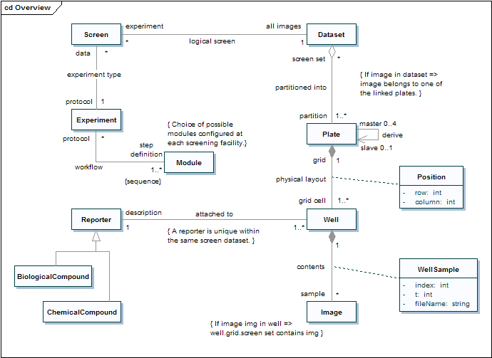

The Screen entity is obviously central to the model. It represents a high-throughput screen and links the image data on which the experiment was carried out to the definition of the experiment type.

In fact, a Screen is always associated with exactly one Dataset, which contains all the images that belong to that screen ⎯ and no others. The same Dataset can be used in multiple screening experiments; all the Screens that operate on the same Dataset form a logical screen ⎯ that is, a set of screens which are thought of as being the same one because they all operate on the same data, but each screen defines a different protocol.

Also, a Screen is always associated with exactly one Experiment, which defines the protocol ⎯ that is, the experiment’s workflow. The same protocol can obviously be reused in multiple screening experiments. The workflow is captured by an association between the Experiment and Module entities; each Experiment is linked to a sequence of Modules, each defining a step in the protocol. Such Modules have to be selected out of a set which is defined and configured at each screening facility. For example, a screening facility could have modules for: manual pipetting, create cell plate, seed cell, transfection, geldoc, etc. Our use of the term Module is consistent with Dresden’s terminology, but this will likely have to be changed. Moreover, the various experimental ontologies we are looking to integrate have this already included. In Dresden, they use this to refer to robot pipetting and esiRNA preparation steps

The Plate entity represents a real world plate, which is composed by a grid of wells ⎯ each containing biological material. For this reason, we have a Well entity joined to the Plate entity by a composition relationship. In order to describe the physical layout of a plate, we need to attach some extra information to each link between a Plate and a Well: the position of the well (row and column) within the plate. This is exactly the purpose of the Position association class.

A common practice is to derive a plate for screening from two or four master plates ⎯ by adding part of the contents of each master well in the wells of the plate to be screened, usually referred to as the slave. A classic example of this is taking 4 96-well master plates and aliquoting their contents into 1 384-well plate. For this reason, a Plate can be linked to up to four other Plates, those from which it was derived, and so we have a recursive association. Note that a master plate may or may be not screened; so in general it’s possible for a plate to be linked to no images. (Although, it will be linked to Wells to describe the physical layout, those Wells will point to no image.)

The contents of a Well are, in our model, represented by image data. So each Well is linked to possibly many 5D images, one for each sample. Each such a link has to carry some extra information to identify the sample index within the well and the time-point at which the image was taken. (This is usually 0 and the image file contains a single time-point. However, we might have to accommodate movies; in which case the image file would contain the same sample at different time-points.) The WellSample association class serves this purpose as well as linking an image to the original file. In practice, the time dimension is small, with just a few timepoints, but it is > 1.

Screen is an abstraction that biologists use to denote a set of plates ⎯ which are real world entities. After a plate has been processed by a microscope, images are generated for each well. So if you have a screen, you also have a set of images. We’ve already said that, in our model, we use a Dataset to link a Screen to all of the images acquired for its plates. The model connects a Screen to its Plates by means of an aggregation between the Dataset and the Plate entities. Said aggregation is constrained to be a partition (in the mathematical sense) of the Dataset by means of the linked Plates: If an image is in a screen Dataset, then it must belong (be linked, indirectly) to exactly one of the Plates linked to that Dataset; moreover, the set of all images that belong to those Plates is the same as the set of all images contained in the Dataset.

Finally, the model makes provisions for describing a Well by means of a Reporter, which comes in two kinds: BiologicalCompound and ChemicalCompound. The same Reporter can be attached to more than one Well, but a Well can only (actually must) be described by one Reporter. Moreover, a Reporter must be unique within the same screen Dataset.

Entities Details
Screen
- Name: string. The name of the screen.
- Description: string. A textual description of the screen.
- ScreenType: string. A human readable identifier for the screen type; e.g. RNAi, etc. Should be picked out of a predefined list.

Dataset
As already defined by the OME schema.

Plate
- Name: string. The name of the plate.
- Description: string. A textual description of the screen; e.g. cell line, etc.
- ExternalID: string. A pointer to an externally defined identifier for this plate. Usually a barcode.
- Status: string. A textual annotation of the current state of the plate with respect to the experiment workflow; e.g. “1. Seed cell: done; 2. Transfection: done; 3. Gel doc: todo.”

Well
- Status: string. A human readable identifier for the screening outcome. It can be one out of a predefined list: “empty” (nothing found), “positive control” (e.g. this is phenotype X), “negative control” (opposite to previous), “original” (start state), “hit” (an expected reaction took place).
- Annotation: string. A textual annotation.

Image
As already defined by the OME schema.

Position, WellSample
As detailed in the above discussion.

Reporter
- Lib: string. A library is a collection of compounds. This field specifies the name of the library that the reporter belong in.
- Annotation: string. A textual annotation.

BiologcalCompound, ChemicalCompound
Not sure how to model all this. It seems as a minimum we should have a pointer to external information (most likely in a DB) provided by the library supplier.

Experiment, Module
Not sure how to model all this. We can define workflows in terms of analysis chains, but defining a protocol that way seem to be an unnatural fit. Also the existing experiment type should be modified.

Notes
Because we store the original file name for each sample, it could be trivial to solve Tony’s problem of looking up an image ID given the original file name. In fact, if we implement the WellSample association class as a ST with image granularity, serving as an association table, then all you would have to do is: SELECT image_id FROM well_sample WHERE file_name = ?

