Incorporating Forecasts into Ordering Decisions

This document provides instructions to produce a tool that can be used to (1) produce demand forecasts, and (2) incorporate those forecasts into an inventory management decision. The first tab (“DRAT Data”) contains the data for the forecasting exercise. The second tab (“Template”) provides a template where we will conduct a Monte Carlo simulation to inform the quantity that should be ordered based on forecasts for each month.

Our forecasting model will be designed to predict sales (Column B) based on the following predictor variables:

* The amount of advertising conducted (Column C)
* Categorical variables to capture variation in sales from month to month (Column D-N)

We will try to predict the last 3 months of sales. As such, we will use the data from rows 2-46 to create our regression model.

Under the Data tab, click on Data Analysis. If you have not yet done so, you may need to install the Analysis Toolpak (go to File🡪Options🡪Add-Ins, click on Manage Excel Add-Ins, and then check the Analysis Toolpak). Click on Regression in the data analysis menu.

For the “Input Y Range,” highlight the cells in B1 to B46. For the “Input X Range,” highlight the cells from C1 to N46. Be sure to check of the “Labels” box to indicate that the first row of our data contains the variables names. For convenience, we will output the data to Q1. Click on the “Output Range” radio button and then indicate cell Q1. Your dialog window should look like the following:

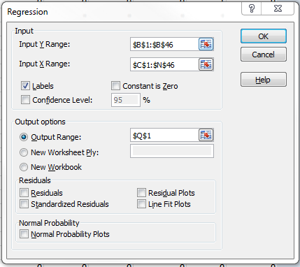

Click OK, then click OK to overwrite the current entry in Q1. You should now see the results of the regression analysis. Next, we will use these coefficients to produce our predictions. In cell O2, enter the equation corresponding to the regression line:

=$R$17+($R$18*C2)+($R$19*D2)+($R$20*E2)+($R$21*F2)+($R$22*G2)+($R$23*H2)+($R$24*I2)+($R$25*J2)+($R$26*K2)+($R$27*L2)+($R$28*M2)+($R$29*N2)

Copy this formula down column O. As a means of visually inspecting the quality of the regression model, you can plot actual sales (column B) against the predicted sales (column O). While not perfect, the regression model does a decent job of capturing the observed variation in the data:

With our regression model, our next step is to incorporate the forecasts and the extent of uncertainty (reflected by the standard error in cell R7) into our ordering exercise. On the template tab, we will follow these steps in our decision making:

1. Simulate a level of demand
2. For a given order quantity and the level of demand, calculate revenue, cost and profit
3. Replicate the simulation procedure 10,000 times
4. Calculate the average profit under a given order quantity, as well as the percentiles

The following instructions detail this for the month of October; you can repeat the same procedure for November and December.

**Simulating order quantity**. We will simulate data from a normal distribution where the mean of the distribution is given by our forecast (cell O47 of the DRAT Data sheet) and the standard deviation is given by the standard error (cell R7). Excel does not have a command that allows for such simulations, so we will trick it by doing the following: (a) simulate a random variable between 0 and 1, and (b) use the norm.inv(*p*,*mean*,*s.d.*) command to identify the value from a normal distribution with *mean* and *s.d.* that corresponds to percentile *p*. In cell B3, enter:

=NORM.INV(RAND(),'DRAT Data'!$O$47, $Y$7)

This provides a simulated level of demand based on our forecast results.

**Revenue calculation**. Our revenue depends on how much is sold and how much is ordered. We generate $15 of revenue for each unit sold (assuming that we have enough inventory to meet demand), and $5 for each unit that is ordered but not sold. One way to write the revenue equation in E3 is:

=(15*MIN(B3,$P$1))+IF($P$1>B3,5*($P$1-B3),0)

The first term provides the revenue for units sold (based on the smaller of demand and quantity ordered), and the second term accounts for revenue when ordered quantity exceeds demand.

**Cost calculation**. Cost depends on the number of units ordered. In H3, the cost for the October units can be written as:

=IF($P$1<101,12*$P$1,IF($P$1<201,1200+10*($P$1-100),1200+1000+8*($P$1-200)))

The cost associated with ordering units 1-100 is always $12. Similarly, the cost of units 101-200 is always $10 per unit. So, if ordering 150 units, the cost is $12 for the first 100, $10 for the next 100, and $8 for the last 50, resulting in a cost of $2600.

Profit:

In K3, October profit can be written as =E3-H3.

**Simulation procedure.** Copy the formulas for demand, revenue, cost and profit down their respective columns. This will produce 10,000 levels of simulated profit.

**Reporting percentiles and averages**. Our expected level of profit for a given order quantity is given by the average across the different levels of simulated profit. In S6, enter the average of the simulated levels of profit: =AVERAGE(K3:K10002). To understand how much uncertainty there is in our forecasts, we next look at the percentiles. The percentile command sorts the data in ascending order, and report the value corresponding to the *p*-th percentile. For example, if X corresponds to the 2.5% level implies that there is a 2.5% chance, based on your analysis, of profit being less than X. In cell P6, enter the following:

=PERCENTILE.EXC($K$3:$K$10002,P$5). This formula can be copied into Q6, R6, T6, U6, and V6.

If you want to know the interval around your forecast that contains 50% of the simulated profit levels, this would be given by the range created by the 25% and 75% levels of profit.