Customer Acquisition Example – Instructions

The workbook contains 3 sheets: Data, LL, and LL-COMPLETE

The Data sheet contains the data for this example.

The LL sheet is a copy of the Data sheet and where we will conduct logistic regression by using Solver to maximize the log-likelihood.

The LL-COMPLETE sheet contains the worked out solution.

1. On the LL sheet, we begin by setting up cells that will hold our coefficient values. Set the values of cells K2-K5 equal to 0.
2. Next, we specify the linear combination of our variables, which will feed into the calculation of the likelihood of the observed outcome. In cell F2, enter the following:

=$K$1+(A2\*$K$2)+(B2\*$K$3)+(C2\*$K$4)+(D2\*$K$5)

Be mindful of the absolute references (indicated by $) that we use for the coefficients.

1. Copy this formula down column F. You can do so by hovering your cursor over the lower right corner of F2 until it turns to a + sign, and then double-clicking.
2. Next, we construct the likelihood in G2 using the linear combination. Enter the formula in G2:

=((EXP(F2)/(1+EXP(F2)))^E2)\*(((1/(1+EXP(F2)))^(1-E2)))

If E2=1, this will take on a value of EXP(F2)/(1+EXP(F2)). If E2=0, it will take on a value of 1/(1+EXP(F2)).

1. Copy the formula in G2 down column G.
2. To construct the log-likelihood, we take the natural logarithm of the likelihood. In cell H2, enter the formula =ln(G2). Copy this formula down column H.
3. To calculate the log-likelihood of the sample, in cell K7, enter the formula =sum(H2:H101).
4. On the Data ribbon, launch Solver. If you do not have Solver installed, go to File→Options→Add-Ins and click the “Go…” button to “Manage: Excel Add-ins”. Check both the Analysis ToolPak and the Solver Add-in.
5. Set the objective to cell K7 with the option to maximize (Max) by changing the values K1-K5. Be sure that the option “Make Unconstrained Variables Non-Negative” is NOT checked. The Solver menu should look like this:

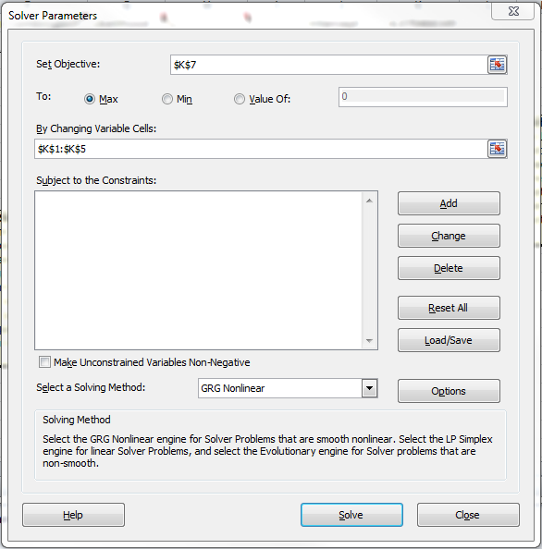

1. Click “Solve”.