Build-a-Game Workshop

Casino games such as craps and roulette are designed to favor the casino. This arises from the way in which the payouts for different outcomes are constructed. In this assignment, we will build a simulation tool in Excel that allows us to investigate this, using roulette as an example.

A roulette wheel consists of the numbers 1 through 36, as well as 0 and 00. Betting on a single number pays out 35 to 1. In addition to returning your original bet, you would win $35 for each $1 that was bet. In addition to betting on a single number, you can bet on combinations of numbers. For example, you can bet on all even numbers or all odd numbers, which pay out 1 to 1. You can be on all red or all black numbers, which also pays out 1 to 1. You can bet on one of the three columns of numbers, which pays out 2 to 1. For these combinations, if the ball were to land on 0 or 00, it would not pay out. For more information on different bets and their payouts, see <https://en.wikipedia.org/wiki/Roulette#Bet_odds_table>.

In this assignment, we will assume we are using the roulette table below:

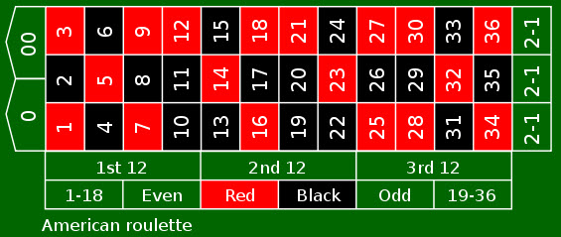

The objective in this assignment is to build a simulation tool that allows for the following:

1. The tool allows users to bet on single numbers (including 0 and 00) or any of the spaces marked in the table above (the columns marked “2-1”, “1st 12”, “2nd 12”, “3rd 12”, “1-18”, “Even”, “Red”, “Black”, “Odd” and “19-36”.). For those who would like more of a challenge, consider designing a tool that also allows for row, split, street, corner, topline, basket and six line bets as described in the Bet Odds Table. The tool should allow for multiple bets to be placed at the same time.
2. The tool simulates 1000 spins of the roulette wheel and the payouts associated with each spin, based on the bet(s).
3. The tool reports the total amount of the bet(s), the expected earnings, and the minimum and maximum of the expected earnings from the 1000 spins.

The Excel file containing the tool should be uploaded to the course website.