Employment Yield Worksheet

Download the Employment Yield worksheet from the course site. The file contains a single sheet. In cell B1 is the number of offers that are extended. Cell B2 contains the probability that an offer will be accepted. In cells A5 through A25 are different potential outcomes for the number of offers that are accepted. We will populate cells B5 through B25 with the probability that a specific number of offers will be accepted. To do this, we will use the binomial distribution, which takes the form:

=binom.dist(n,N,p,option)

where n is the number of successes, N is the total number of trials of the binomial distribution, and p is the probability corresponding to a single trial being a success. The option term allows you to calculate the probability mass function (option=FALSE) or the cumulative distribution function (option=TRUE).

If 10 offers are made, then the number of offers that can be accepted ranges from 0 to 10. More generally, if N offers are made, no more than N offers can be accepted. To account for this, we will construct an IF statement in Excel of the following form:

* If N offers are made and n<=N, calculate the probability of n offers being accepted
* If N offers are made and n>N, the probability of n offers being accepted is 0

This can be written as an Excel formula as:

=IF(criteria,value_if_true,value_if_false)

where the criteria is whether or not n<=N is true, value_if_true is given by the binomial distribution, and value_if_false is 0.

In cell B5, enter the formula:

=if(A5<=$B$1,binom.dist(A5,$B$1,$B$2,false),0)

Copy this formula down the remaining cells in column B. This will provide the probability that a given number of offers are accepted, based on the probability of an offer being accepted and the number of offers made.

We can make the spreadsheet more interactive by adding a spinner to change the number of offers made. If you do not see the Developer ribbon, go to File-> Options->Customize Ribbon and check the box next to the Developer in the Main Tabs box. Go back to the spreadsheet and select the Developer ribbon. Click on Insert and select the spin button, which appears as an upward facing triangle above a downward facing triangle.

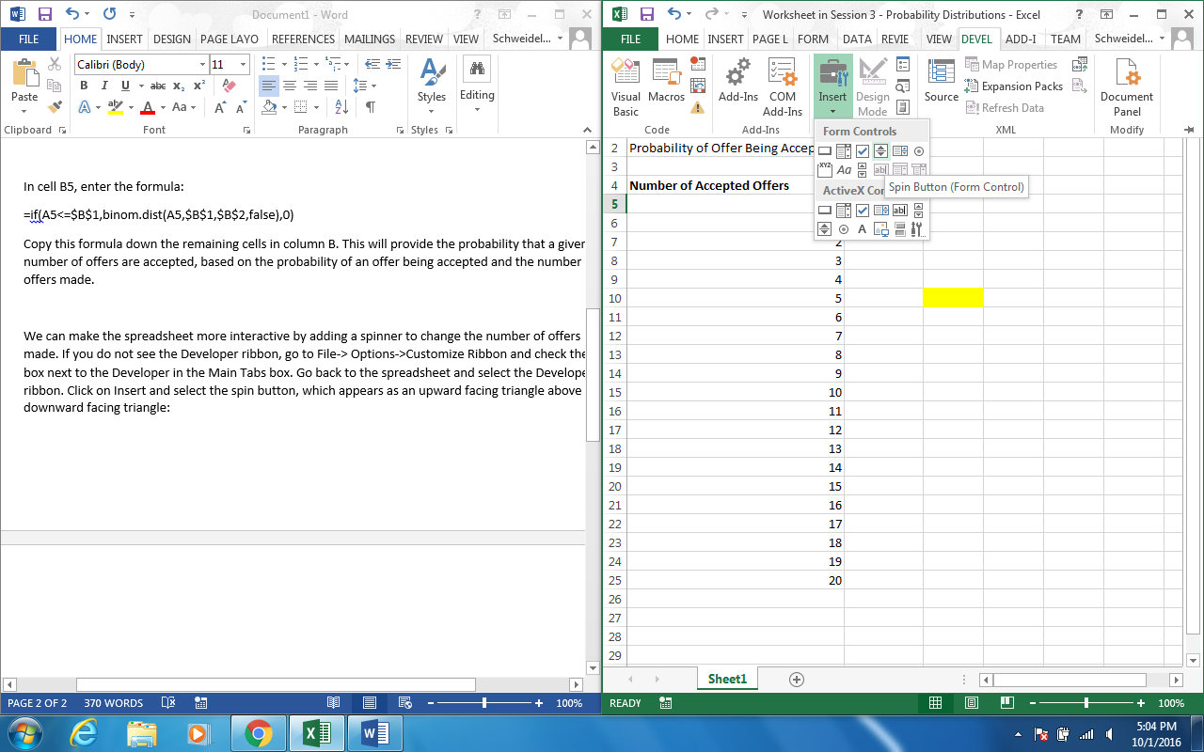

Click and drag to draw the spinner button to the right of cells B1 and B2. Once drawn, right click on the button and select Format Control. Set the current value to 7, the minimum value to 0, the maximum value to 20, and incremental change to 1. Set the Cell Link to cell B1. Once set up, you should be able to adjust the number of offers made by clicking up and down on the spinner button.

To calculate the probability of between 5-7 offers being made, we can sum the corresponding probabilities. In cell C10, enter:

=sum(B10:B12)

To visualize how the probabilities change as a function of the number of offers made or the probability of an individual offer being accepted, highlight B5 to B25, click on the Insert ribbon and select the bar graph.