Lab 2: Zero Downtime Deployments (blue-green deployments)

Description: During this lab we will push an application, then update it with a new version and manage the application routes for seamless upgrading without any downtime.

1. Change to the PaaSTutorial directory.
2. Push the US map version of the PCFDemo application

*cf push map-userX –p pcfdemo-us.war –i 2*

Open a web browser and visit http://map-userX.cfdemo5.fe.gopivotal.com

* Notice the IP address displayed at the top, this is the IP address of the container serving your instance.
* Also notice the RabbitMQ service is not bound to the application. We’ll complete this in the next lab.

1. Now let’s say you made an update to that app, changing the US map to actually be the European Union map (EU). So, let’s push the new version of our application to a different route and test it.

*cf push map-userX-eu –p pcfdemo-eu.war –i 2*

Visit <http://map-userX-eu.cfdemo5.fe.gopivotal.com> to check it’s working

1. At this point we have two different app versions – one with US Map and the other with EU map – running and using different routes.

However, as we verified this new EU version is working fine, we’d like to add it to the original application route, splitting the traffic between the old and new versions.

On the Pivotal CF Web Console, select the space you’ve pushed the application to, and detail the app.

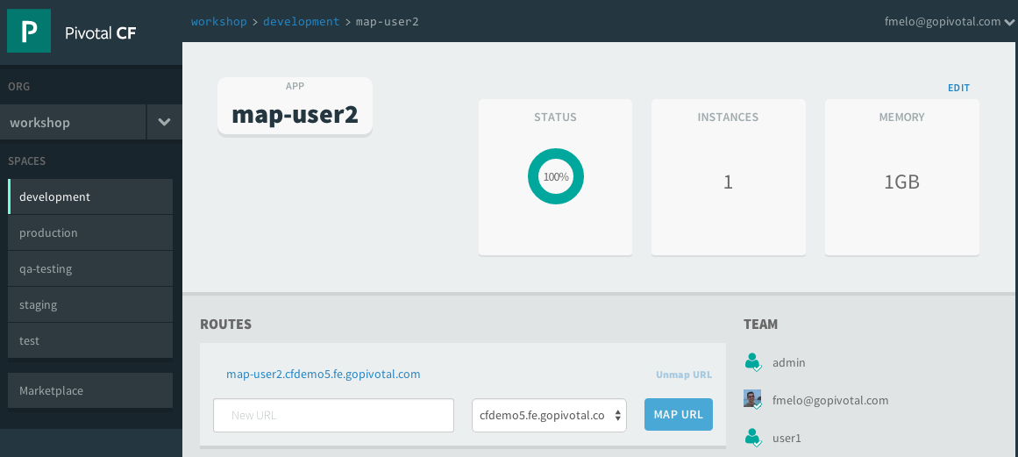

Click on “Routes” and add the original application route to it: map-userX.cfdemo5.fe.gopivotal.com. Click “Map URL

As this route is already being used by the 1st application version (the US map), the Cloud Foundry router will split the requests between the two applications.

Alternatively, the same can be done from the command-line:

*cf map-route map-userX-eu cfdemo5.fe.gopivotal.com -n map-userX*

After doing this, our original route map-userX.cfdemo5.fe.gopivotal.com will be load-balancing between 4 instances: 2 of the US Map and 2 of the EU map (50% each). We can change this proportion providing more instances of each application version if needed:

*cf scale map-userX-eu -i 4*

Now we would have 4 out of 6 requests going to the EU version and only 2 to the US map version. You can play with this hitting refresh on your browser (however browser can cache requests sometimes)

1. As we’re done testing the new version, remove the old application version from the original route, completing our rolling upgrade.

On the Web Console, detail the original US map application, and on the route, click “Unmap URL”.

Alternatively, you can do the same using the command line:

*cf unmap-route map-userX cfdemo5.fe.gopivotal.com -n map-userX*

1. Now the route http://map-userX.cfdemo5.fe.gopivotal.com will only handle requests for the EU version of the app. The original version can then be deleted

Just click “Delete App” when detailing the application through the Web Console.

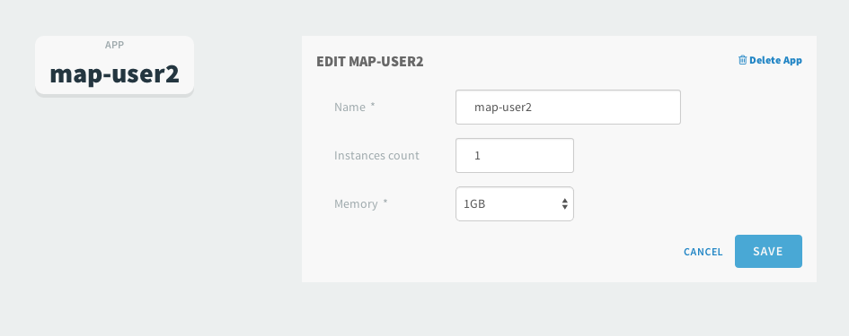

You can also use the command line:

*cf delete map-userX*

**OR** you can just assign a new route for it and keep the app:

*cf map-route map-userX cfdemo5.fe.gopivotal.com -n map-userX-old*