JADE BUSINESS SOLUTIONS
JBSIntelliQE
Platform Architecture & Data Model
A Leadership Overview

AI-Powered QA Automation Platform
Prepared June 2026 · Confidential

Contents

1. Executive Summary
JBSIntelliQE is Jade Business Solutions’ AI-powered quality-assurance platform. It uses a team of Claude AI agents to automatically read software requirements, design test cases, write automated test scripts, run them, and even repair tests when they break — work that traditionally requires a team of manual QA engineers.
The platform is multi-tenant: a single deployment serves many customer organizations, with each customer’s data fully isolated from every other. This document explains, in plain terms, the building blocks of the platform and the database that underpins it, and includes a one-page visual map (Entity-Relationship diagram) of how the data fits together.
3  Runtime services  (API, Worker, Web app) | 22  Database tables  in 7 groups | 6  Specialised AI agents  in the pipeline

2. What the Platform Does
In everyday language, the platform turns a written requirement into working, self-maintaining automated tests:
- Understands the application — an AI agent explores the live web app to learn how each page works.
- Plans the testing — it designs a comprehensive set of test cases covering the feature.
- Writes the automation — it generates ready-to-run Playwright test scripts.
- Runs and reports — it executes the tests and produces reports and email notifications.
- Heals itself — when a test fails because the app changed, an agent diagnoses and fixes it.
- Keeps an audit trail — every action is logged for compliance and traceability.

3. How the System Is Built
The platform is organised into three cooperating services that share one database:
Service | What it does | Technology
Web App (Frontend) | What users see and click — the chat wizard, dashboards, reports, and configuration screens. | React + Vite
API (Backend) | The brain of the system — handles logins, business rules, data, and coordinates the AI pipeline. | Node.js + Express
Worker(s) | Background engine(s) that run the heavy AI work by calling the Claude API, so the app stays responsive. | Node.js + Claude SDK

Information flows in one direction and back: the Web App talks to the API, which stores everything in PostgreSQL and hands AI jobs to the Worker. Progress streams back to the user’s screen live as each stage completes.

3.1 Component Inventory
The API is itself made of clearly separated parts. Leadership-level summary:
Building block | Responsibility
AI Agents | The six specialists: Requirements, Planner, Generator, Script-writer, Execution, and Healer — each a Claude agent with its own job.
Orchestrator | The conductor — decides which agent runs next, enforces budget caps and quality gates, prevents runaway loops.
Worker queue | A to-do list of AI jobs; workers pick up tasks, do them, and report back.
API Routes (22) | The doors into the system — chat, test cases, reports, integrations (Jira, Git, Confluence, SharePoint), user management, and more.
Services | Reusable helpers — test execution, email, reporting, integrations, real-time progress streaming.
Security layer | Login checks, role permissions, credential encryption, and the audit log.

4. The Data Model at a Glance
The diagram on the next page is a visual map of the database. Each box is a table; the colour shows which group it belongs to; the connecting lines show how records relate (one record links to many). It is intended to be read top-to-bottom, left-to-right.

Entity-Relationship Diagram
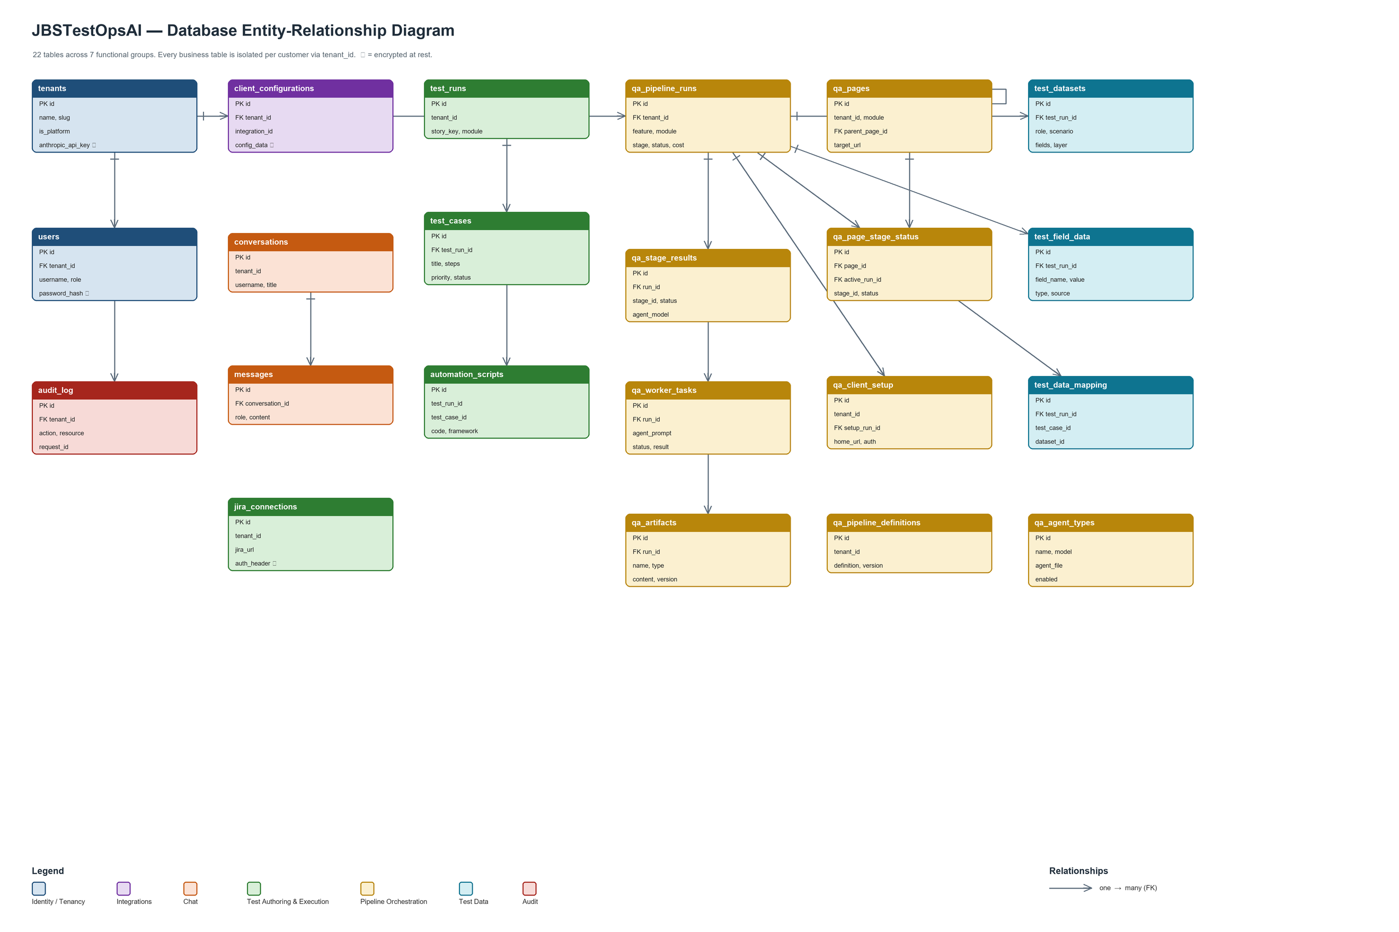

5. Database Tables by Group
The 22 tables are organised into seven groups by purpose. This grouping is what makes the schema easy to reason about and to reuse for new customers.
Grp | Group | Tables | What it stores
A | Identity & Tenancy | 2 | Customer organizations (tenants) and their users / roles.
B | Integrations | 1 | Per-customer connections to Jira, Git, Confluence, SharePoint, etc.
C | Chat & Conversations | 2 | The conversational wizard history between users and the assistant.
D | Test Authoring & Execution | 4 | Test runs, individual test cases, generated automation scripts, Jira links.
E | Pipeline Orchestration | 9 | The AI engine: runs, stage results, artifacts, the worker queue, page map, agent catalog.
F | Test Data | 3 | Reusable datasets and field values that drive data-aware tests.
G | Audit | 1 | An immutable log of who did what, for compliance.

The hub-and-spoke design: the tenants table sits at the centre of the business data (everything is owned by a customer), and qa_pipeline_runs is the hub of the AI engine (stages, artifacts, tasks and test data all trace back to a run). This is visible in the diagram as the two tables with the most connecting lines.

6. Security, Compliance & Multi-Tenancy
- Tenant isolation — every business record carries a tenant_id, so one customer can never see another’s data.
- Encryption at rest — sensitive fields (API keys, passwords, integration credentials, Jira tokens) are encrypted in the database, shown with a lock icon in the diagram.
- Role-based access — users are admins, QA engineers, or data analysts, each with appropriate permissions.
- Full audit trail — the audit_log records every action with a per-request identifier, supporting HIPAA-style compliance reviews.

7. Reusing the Schema for a New Customer
Because the schema is cleanly defined and self-contained, standing it up for a new customer is straightforward. A ready-to-run, customer-neutral database skeleton has been prepared — it creates all 22 tables and their indexes, with no JBS-specific data or credentials.
Deliverable | Purpose
customer-skeleton.sql | One-shot script to create the entire schema in a customer’s own PostgreSQL database. Idempotent and safe to re-run.
DATABASE_SCHEMA.md | Plain-language documentation of every table and column, with sensitivity classification — for security and compliance reviewers.
backend/src/db.ts | The live source of truth in code; the SQL files are kept in lock-step with it.

To onboard a customer: (1) run the skeleton against an empty database; (2) insert the customer’s own organization and first admin user; (3) set a unique encryption key. No code changes are required.

Source files: backend/db/seed/customer-skeleton.sql · docs/DATABASE_SCHEMA.md · backend/src/db.ts

