IntelliQE
API AUTOMATION
End-to-End User Guide & Functional Documentation

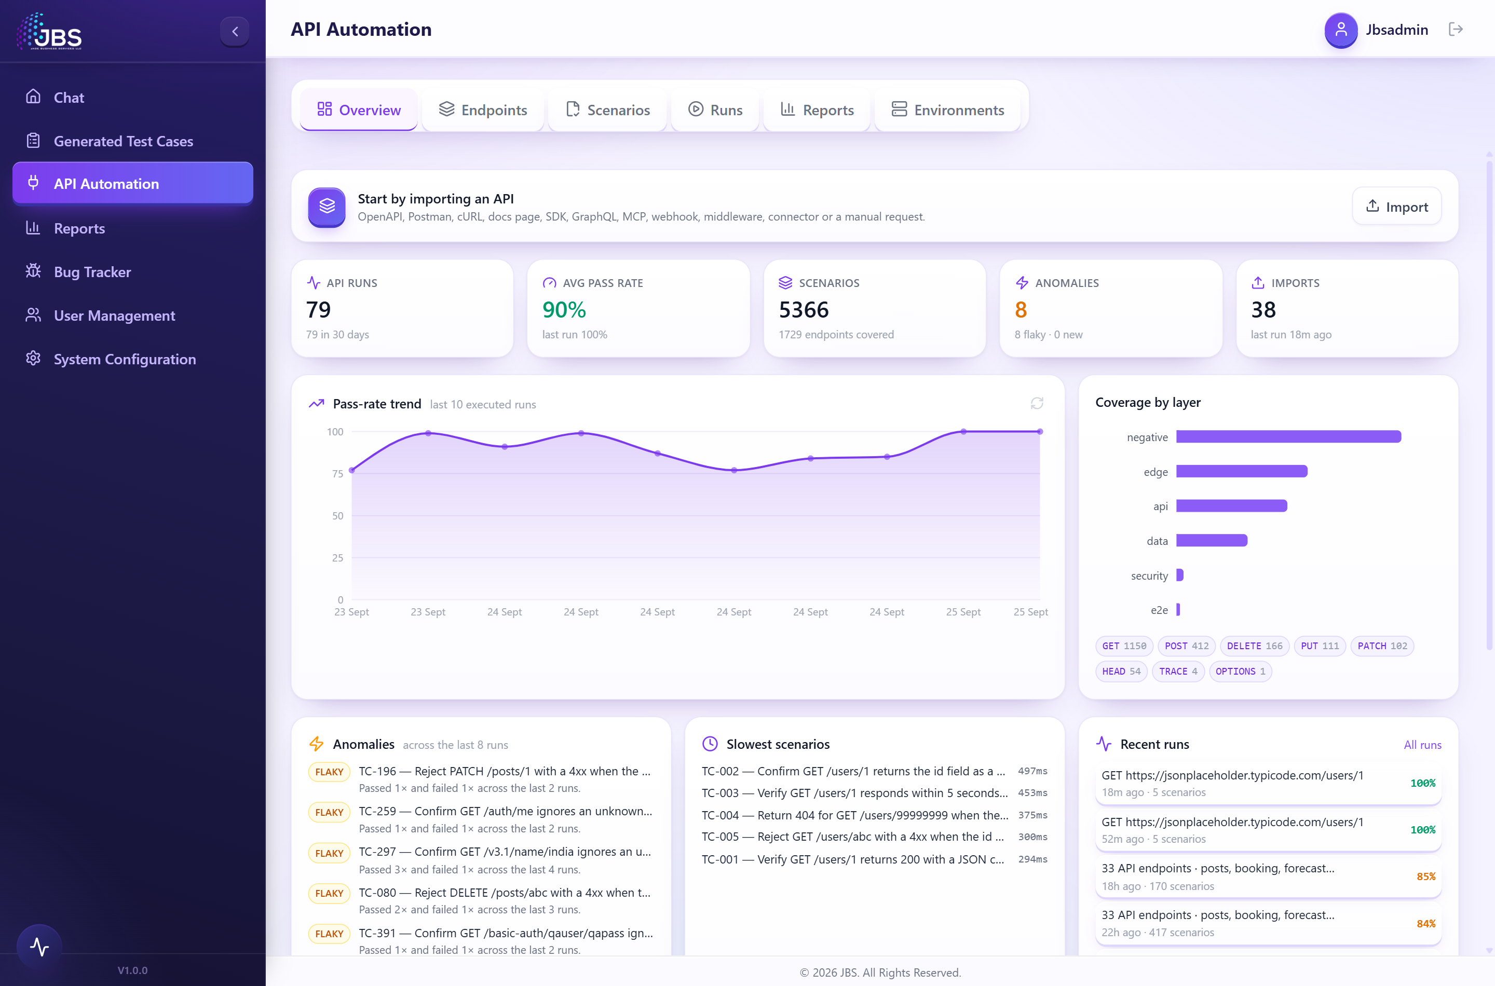
Figure 1. The API Automation dashboard — a live view of every API test run.
AI-powered API test generation, execution, self-healing and reporting
Version 1.0 · September 2026

Contents

Tip: if the contents look empty, click anywhere in the list and press F9 (or right-click → Update Field) to refresh page numbers.

1. Introduction
IntelliQE API Automation is an AI-powered workspace that turns any API into a complete, executed and self-healing test suite — without writing test code by hand. You bring in an API; the platform understands it, designs the test scenarios a professional QA team would write, runs them against your live endpoints, automatically repairs tests that broke for the wrong reasons, and publishes a clear pass/fail report with trends over time.

1.1 What problem it solves
Traditional API testing is slow and brittle: engineers hand-write requests and assertions, maintain them as the API changes, and spend hours diagnosing failures. IntelliQE compresses that cycle. It reads your API the way a senior tester would, proposes the right coverage, and keeps the suite healthy as the API evolves.

1.2 Who it is for
- QA engineers & SDETs — generate broad, high-quality coverage in minutes and review it before anything runs.
- Developers — validate contracts, catch regressions and security issues early, and pull tests straight into your Git repository and CI pipeline.
- QA leads & managers — track pass-rate trends, anomalies and sign-offs across every run from one dashboard.

1.3 Key capabilities at a glance
- Import any API — twelve intake methods, from an OpenAPI file to a live URL, a cURL command, a GraphQL schema or plain-English documentation.
- Automatic understanding — the platform profiles the API (resources, authentication, data relationships, risks) and recommends a test strategy.
- AI scenario design — positive, negative, security, schema, boundary and end-to-end flow tests — each one presented for your review before it runs.
- Execution & self-healing — runs against your live endpoints and automatically repairs tests that failed because the test was wrong, not the API.
- Clear reporting — pass rate, failures, what healing changed, plus a full HTML/Allure report and export to your repo and CI.
- A full quality toolkit — contract checks, security scans, load tests, governance linting, coverage, regression baselines, data-driven testing, scheduling, alerts and sign-off.

2. How the platform works
Every piece of the product serves one straight-line workflow. Understanding these seven stages makes the rest of this guide easy to follow.
Stage | What happens
1. Import | You bring an API in by any of twelve methods. Everything lands in one place — the catalogue.
2. Understand | The platform automatically profiles the API: its resources, operations, authentication, data dependencies and risks.
3. Scenarios | AI designs the test scenarios your chosen strategy calls for. This is the one deliberate stop — the review gate.
4. Automate | Each approved scenario is turned into a runnable, executable test.
5. Execute | The suite runs against your live endpoints and records pass/fail with timings.
6. Heal | Failures are diagnosed; tests that broke for the wrong reason are repaired and re-run automatically.
7. Report | A clear result is published — pass rate, failures, healing notes and a full report — with export options.

The review gate — you are always in control
Nothing is automated, executed or reported until you approve it. After the AI designs scenarios, the workflow pauses so you can review every one and deselect anything you do not want. Once you run the suite, Automate → Execute → Heal → Report proceed straight through.

3. Getting started

3.1 Signing in and opening API Automation
- Open IntelliQE in your browser and sign in with your username and password.
- In the left-hand sidebar, click API Automation.
- You arrive on the Overview dashboard (shown below).

3.2 The workspace layout
API Automation is organised as a single page with a row of tabs that follow the workflow left to right:
- Overview — the dashboard: KPIs, pass-rate trend, anomalies and recent runs.
- Endpoints — the catalogue of everything you have imported, and where you launch test generation and the quality tools.
- Scenarios — the AI-designed test scenarios, presented for your review.
- Runs — live and historical runs, with per-scenario results.
- Reports — the outcome of a run: pass rate, failures, healing and export.
- Environments — named targets (dev, staging, production) with their base URLs and credentials.
Two more controls are always at hand: Import (a button that opens the intake window over any tab) and the Activity log (a slide-out panel that narrates each run stage in real time).
Figure 2. The API Automation workspace, showing the tab bar and the Overview dashboard.

4. The end-to-end walkthrough
This section follows a complete journey — from importing an API to a finished, self-healed report — the way you would actually use the product. The screenshots use a sample public API (JSONPlaceholder) so every step shows real results.

4.1 Step 1 — Import your API
Click Import to open the intake window. IntelliQE offers twelve ways to bring an API in — all of them end the same way: the endpoints land in your catalogue, already profiled and ready to test.
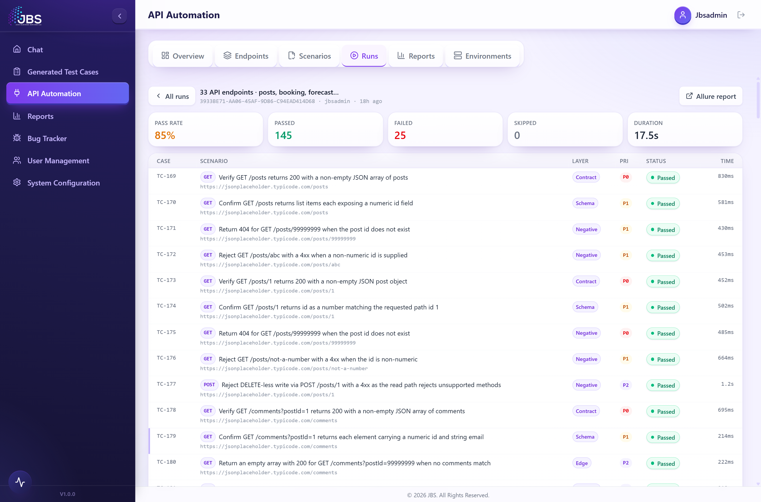
Figure 3. The Import window: a bulk drop-zone at the top and the twelve import methods below.
The twelve import methods:
Method | What you provide
OpenAPI / Swagger | A spec file (JSON/YAML) or its URL — every path and method is built automatically.
Postman Collection | A Postman, Bruno or HAR export; saved responses become the expected contract.
API URL / Endpoint | One live URL; it is probed for its real response and the origin is searched for a spec.
cURL | Paste one command or a whole script; method, headers, auth and body are parsed exactly.
API Documentation URL | A reference page; any linked spec is used, otherwise the page is read by AI.
Custom Connector | A portable JSON/YAML manifest (base URL, auth, endpoints).
SDK | Client-library source code; every HTTP call it makes becomes an endpoint (AI-assisted).
Webhook | Your consumer endpoint and its event payloads; deliveries are signed.
GraphQL | The endpoint (or schema); one operation per Query and Mutation field.
MCP Server | A Model Context Protocol server URL; one test per exposed tool.
Middleware | Server route/controller source (Express, Spring, FastAPI, ASP.NET…); every route becomes an endpoint (AI-assisted).
Manual HTTP Request | Build a single request by hand in a guided editor.

Each method opens the small form it needs. For example, the Custom Connector method takes a manifest describing the base URL and a list of endpoints:
Figure 4. A method form (Custom Connector). Every method presents only the fields it needs.
When the import finishes, a result panel confirms how many endpoints were added, how the source was parsed, any warnings, and a plain-English summary of what the API looks like. Click Review catalogue to continue.

4.2 Step 2 — Review the endpoint catalogue
The Endpoints tab is the catalogue of everything you have imported. Endpoints are grouped by host and resource so a large API stays readable. Each row shows the HTTP method, the path and title, the authentication it uses, the expected status code, and where it came from.
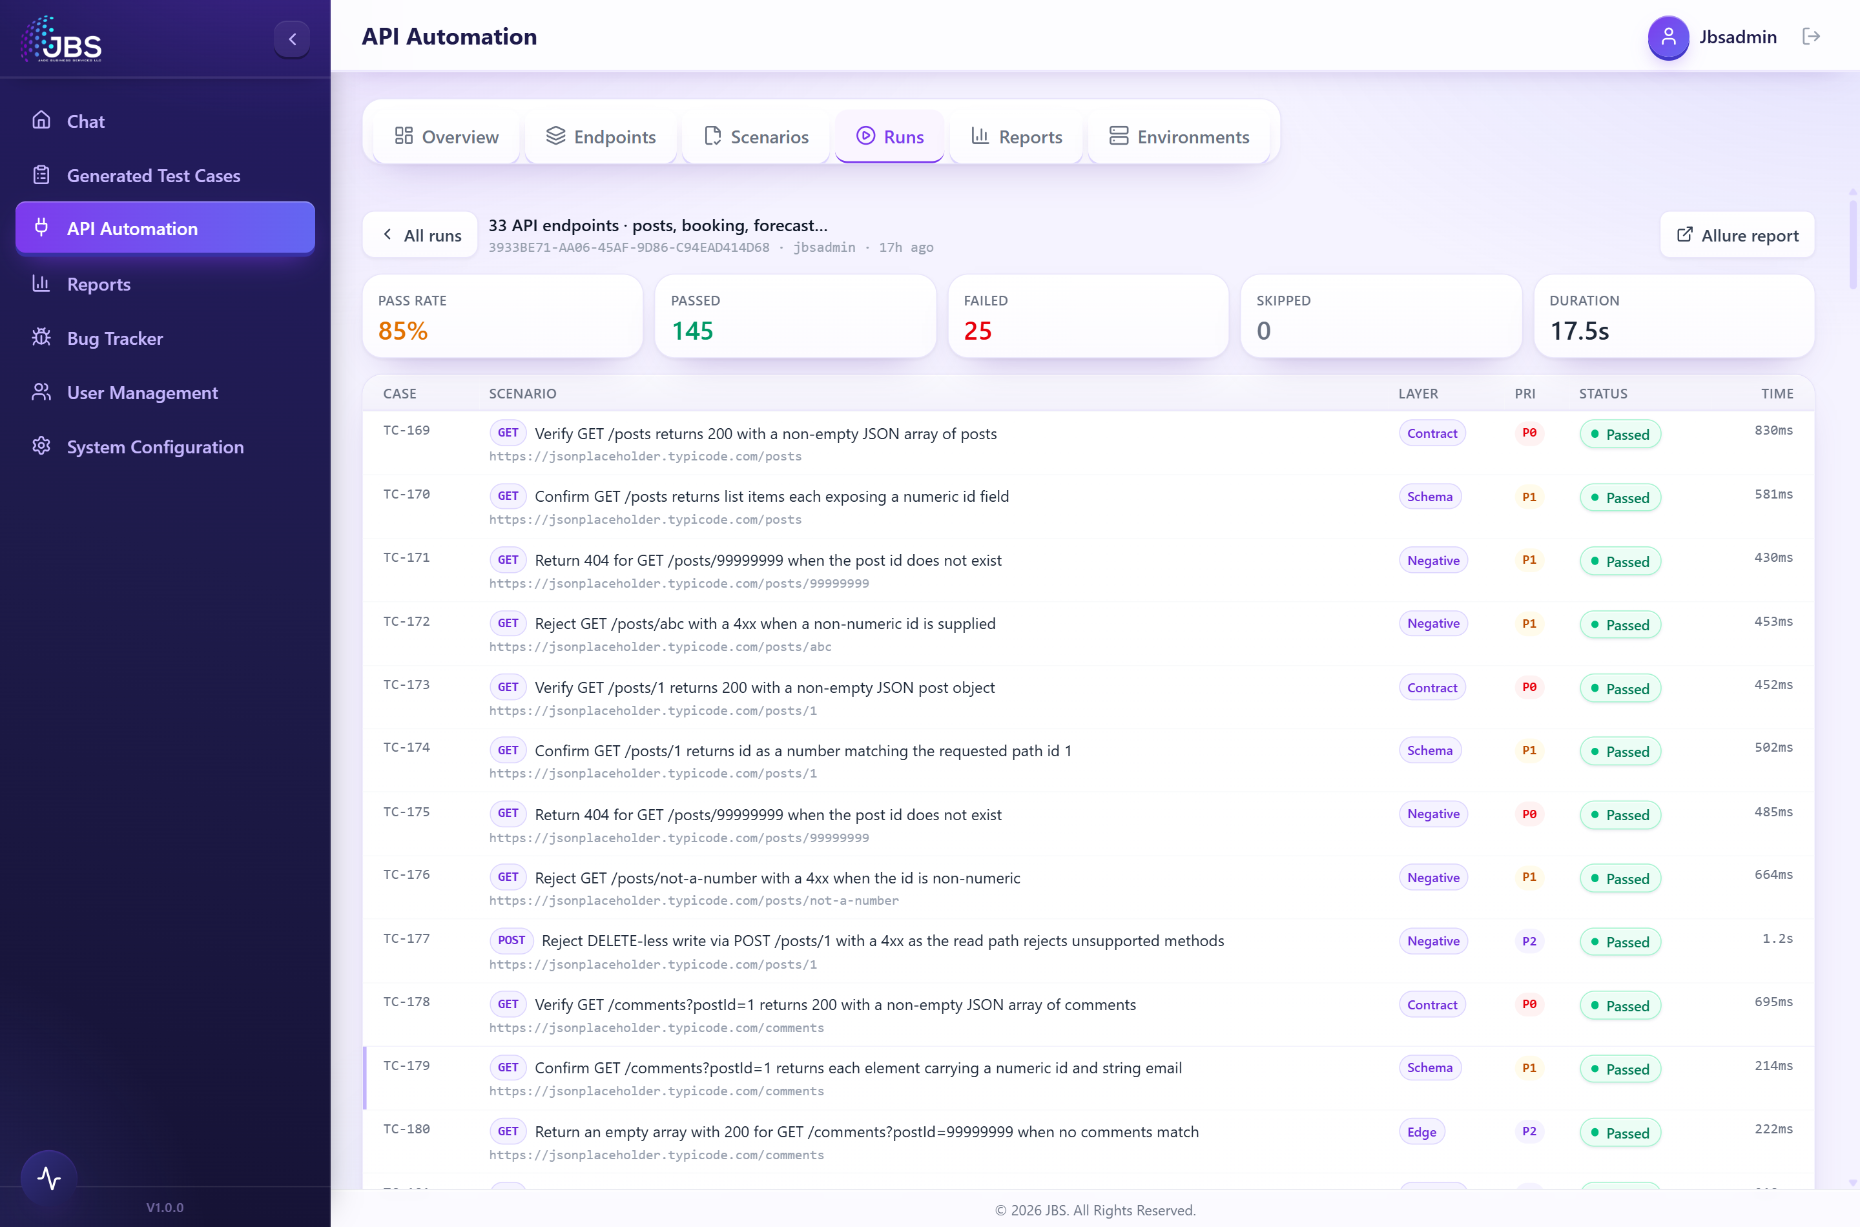
Figure 5. The endpoint catalogue: endpoints grouped by resource, with selection checkboxes and the quality tools.
- Select what to test — tick the endpoints you want. A counter shows how many are selected; everything new is selected by default.
- Filter & focus — search by path, name or tag, filter by method, or focus on a single resource.
- Edit any endpoint — open the editor to adjust the request, headers, authentication, body and expected response. Credentials are encrypted and only ever sent from the server at run time.
- Tools & Export — the Tools menu runs quality checks on your selection (Section 7); Export downloads a portable OpenAPI spec, connector manifest, mock server or Pact contract.
Automatic understanding runs behind the scenes
As soon as endpoints arrive, the platform profiles the whole API — detecting resources and their create/read/update/delete operations, authentication schemes, pagination, data dependencies, end-to-end flows and risks — and recommends a test strategy. This intelligence steers scenario generation even though it works quietly in the background.

4.3 Step 3 — Generate the test scenarios
With your endpoints selected, click Testcase generation (it shows the number selected). The AI designs the coverage your strategy calls for — usually about one model call per endpoint — and the workspace moves to the Scenarios tab. Large catalogues take a few minutes; progress appears in the Activity log.

What a "scenario" is
A scenario is one designed test case: a title and description, a category (positive, negative, security, schema, boundary, flow, performance), a priority, human-readable steps and expected result, and the exact HTTP request it will send (method, URL, headers, body and expected status).

Strategy — coverage depth and test layers
Two dials shape what the AI generates. Coverage depth chooses how far to go — Essential (the highest-value checks), Standard (a balanced regression suite) or Exhaustive (every layer and variation). Test layers choose which kinds of tests to include:
Test layer | What it verifies
Smoke | One happy-path request per endpoint — proves reachability and the expected status.
Contract | Status code, content-type and response-time guards on every endpoint.
Schema | Field-level type and value checks where an example response exists.
Negative | Unknown IDs, malformed input, missing required fields, wrong method, bad JSON.
Auth | Missing and malformed credentials on protected endpoints return 401/403.
Security | Injection-shaped input is rejected cleanly and never echoed back.
Performance | A response-time ceiling on each endpoint’s happy path; trends show on the dashboard.
Flows | Multi-step lifecycles that chain create → read → update → delete on real IDs.

4.4 Step 4 — Review the scenarios (the gate)
Every designed scenario lands on the Scenarios tab for review. This is the one deliberate stop in the workflow: the generator designs the coverage, and you decide what actually runs. Deselecting a scenario drops it from automation, execution and the report alike.
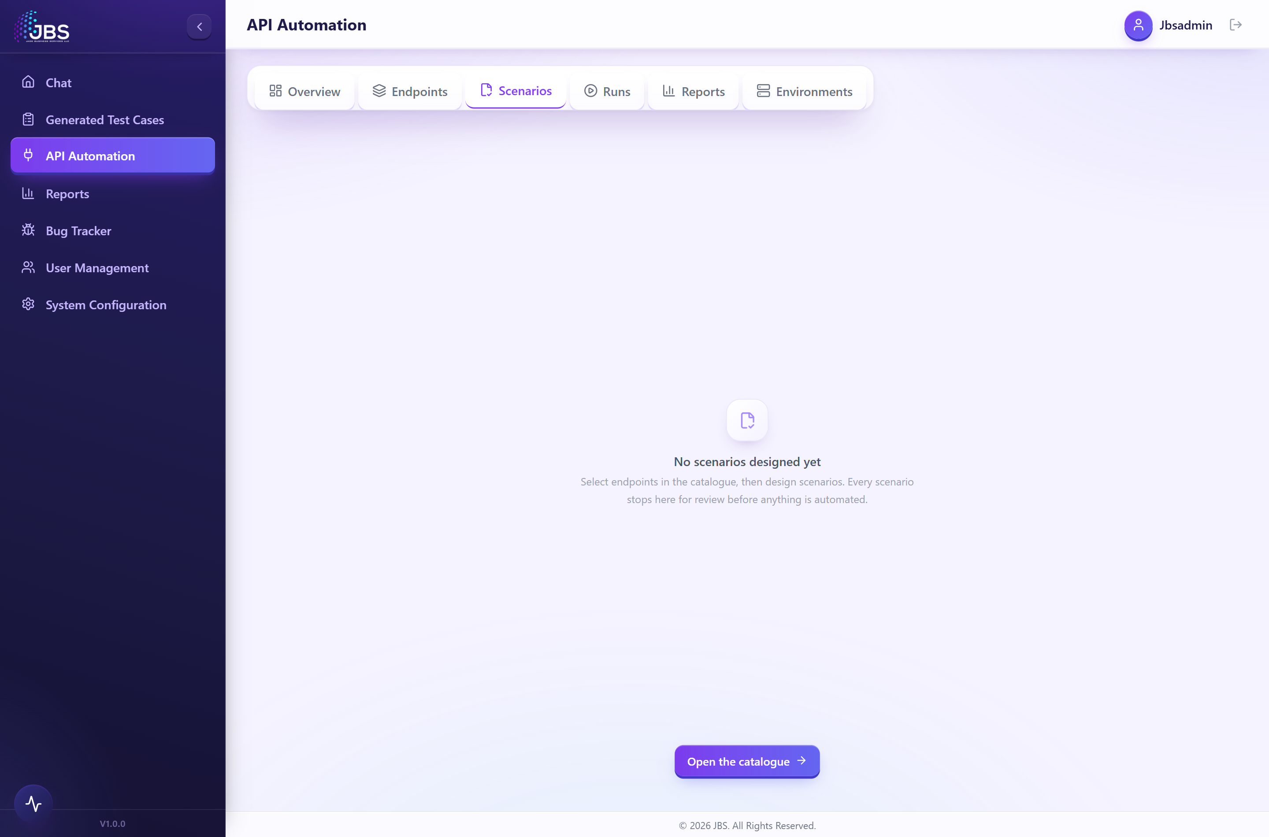
Figure 6. The Scenarios tab — the review gate. Each scenario can be expanded to inspect its request and assertions.
- Filter by text or by category, and use the header checkbox to select or clear all.
- Expand any row to see the exact request (method, URL, headers, body) and its steps split into actions and assertions.
- When you are satisfied, click Run to launch the suite.

4.5 Step 5 — Run the suite: Automate, Execute, Heal
Once you run the selected scenarios, three stages proceed automatically, shown on a live stage rail:
- Automate — each approved scenario is rendered into a runnable, executable test and saved to the Reports database.
- Execute — the suite runs against your live endpoints; each scenario turns green (passed) or red (failed) in real time.
- Heal — if anything failed, the self-healing engine takes over (described below). If nothing failed, healing is skipped.

Self-healing, explained
When tests fail, IntelliQE diagnoses each failure against what the live endpoint actually returned, then repairs the tests that broke for the wrong reason and re-runs them — automatically, in a bounded loop:
- It tells a test defect from an API defect. Because it knows each endpoint’s documented contract, it can distinguish "the test asserted the wrong thing" from "the API is genuinely broken." Only the former is healed; genuine defects are reported honestly, never masked.
- It is bounded and converges. Healing runs a limited number of passes within a time budget and stops early when everything is green, or when a pass makes no progress (the same failures remain).
- It re-executes for real. After each repair the suite is run again, so the final result reflects real pass/fail — not an optimistic guess.
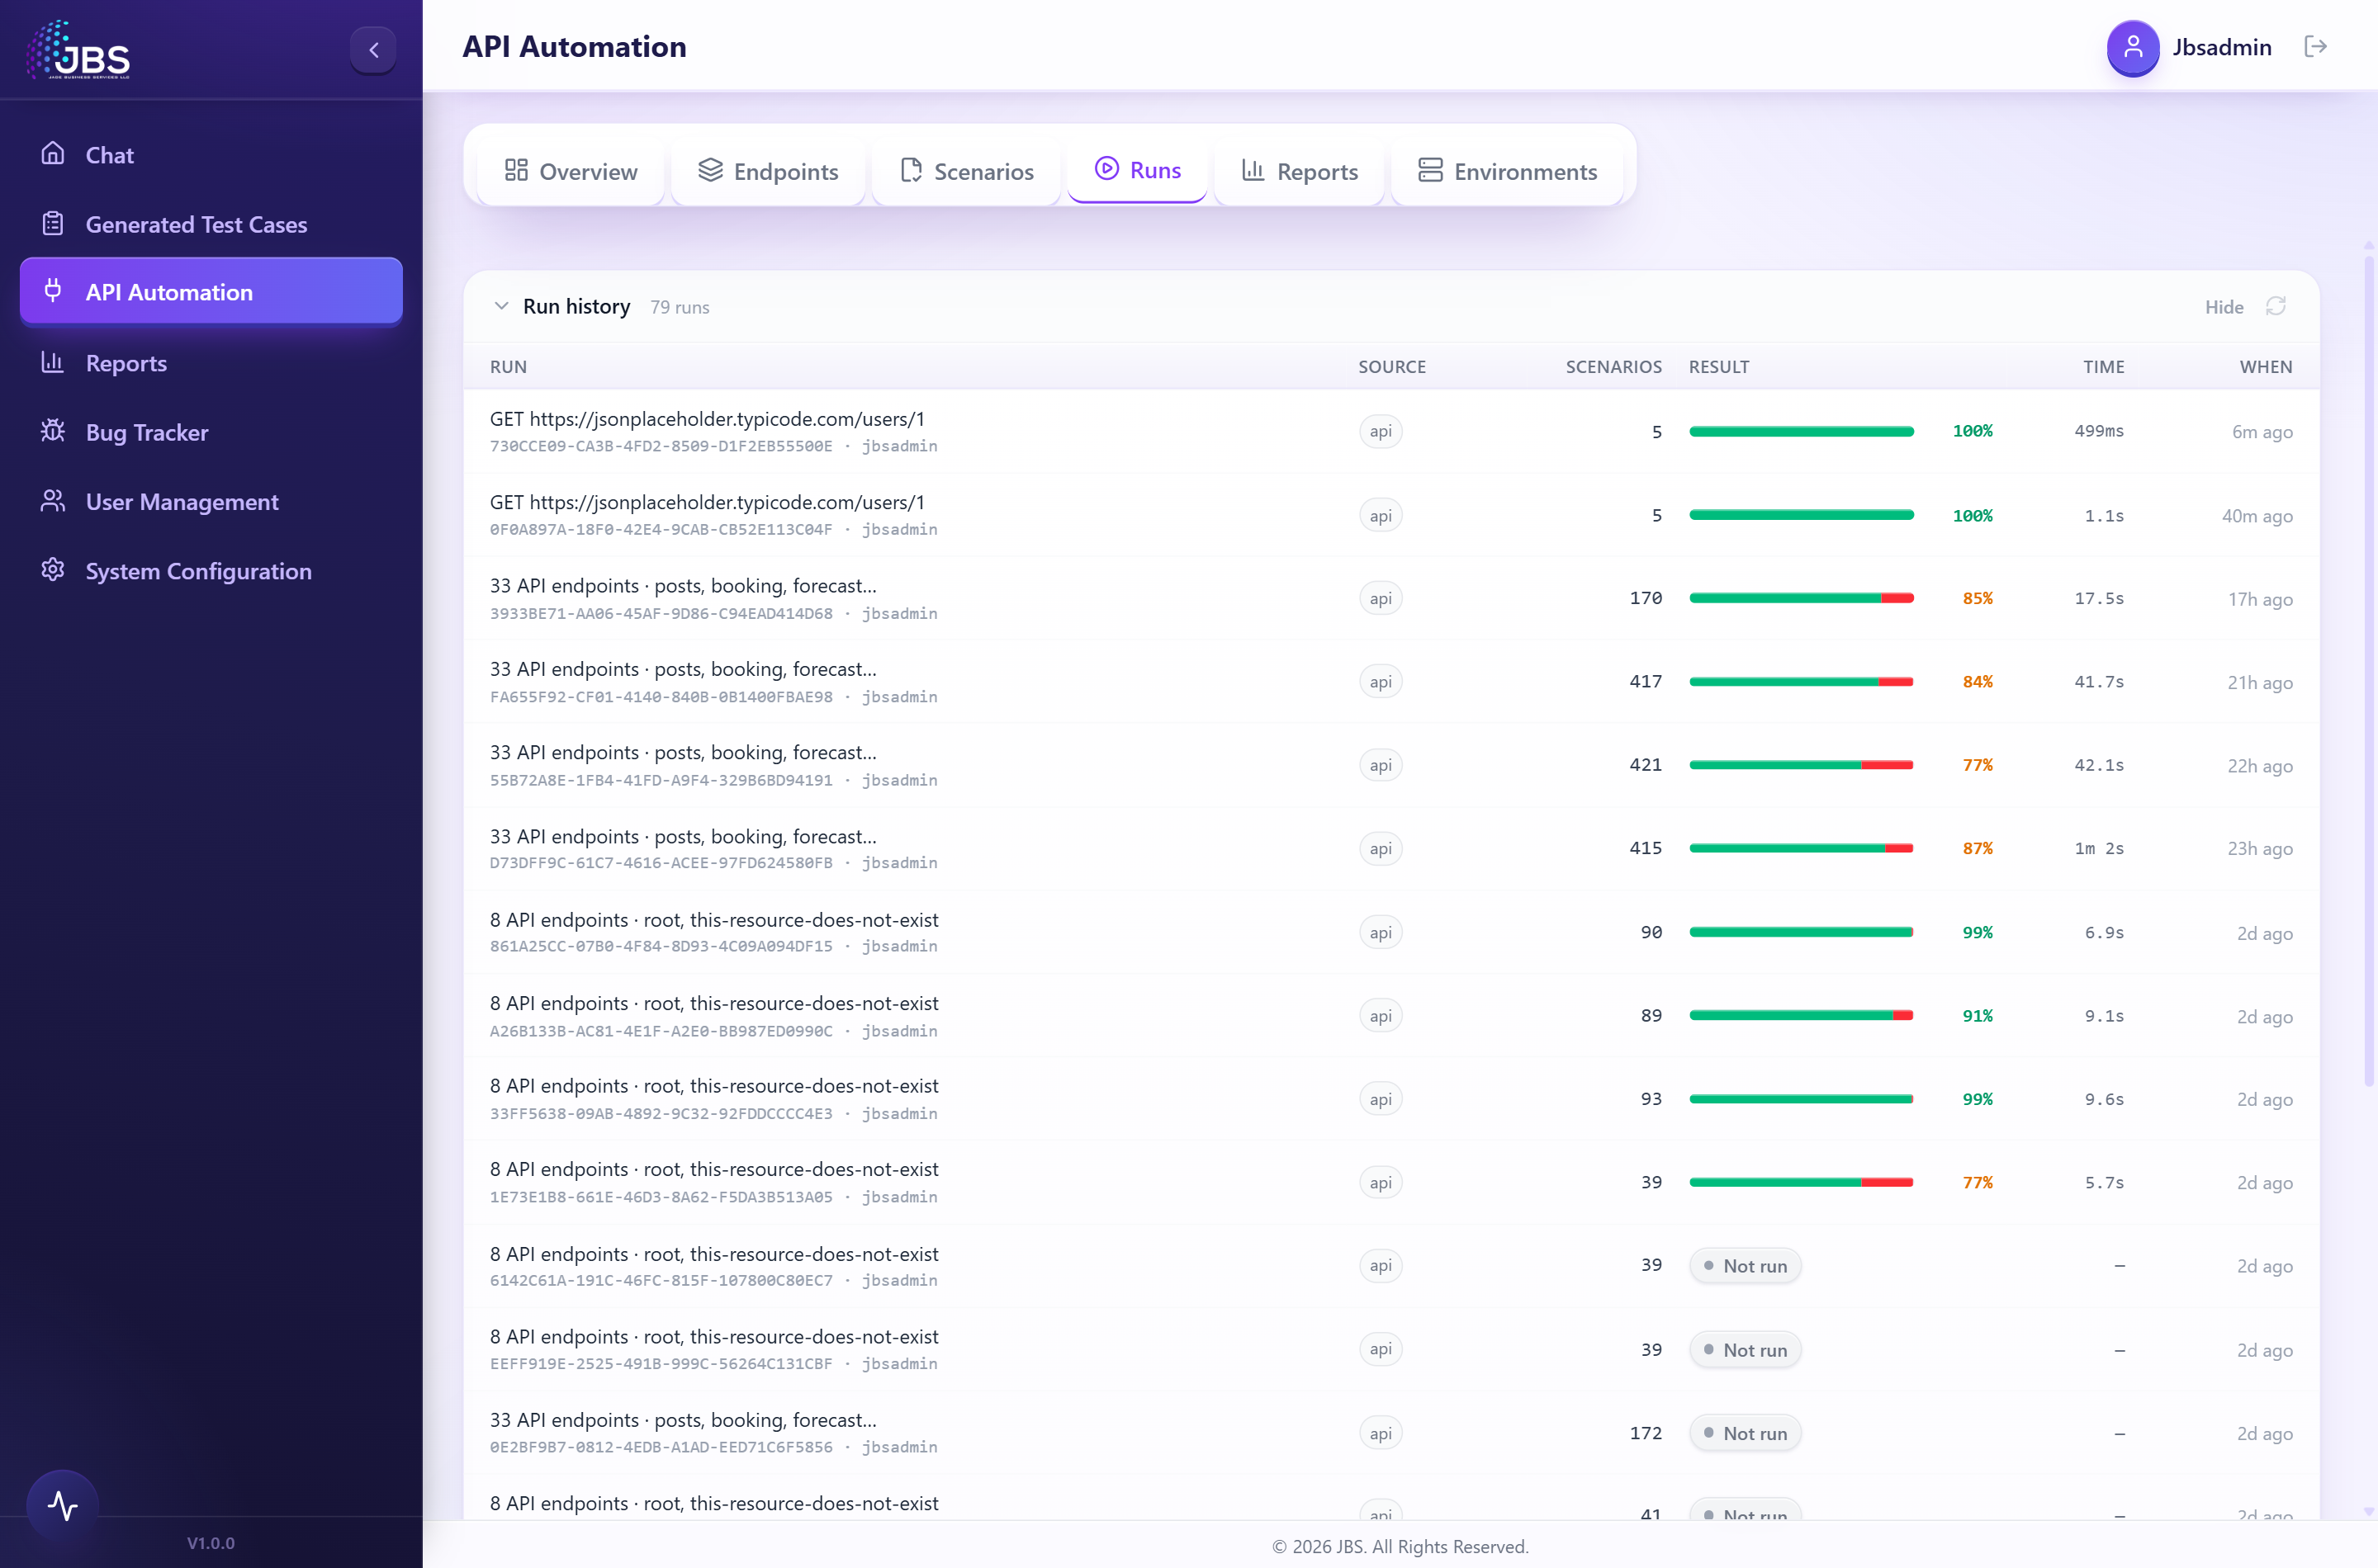
Figure 7. The Runs tab: live run status at the top and the full history of past runs below.

4.6 Step 6 — The report and results
When the run finishes, the Reports tab presents the outcome: a headline verdict and pass-rate percentage, counter tiles for Passed, Failed, Not run, Healed and Duration, and a proportional pass/fail bar. Opening any past run from the Runs tab shows the same detail for that run.
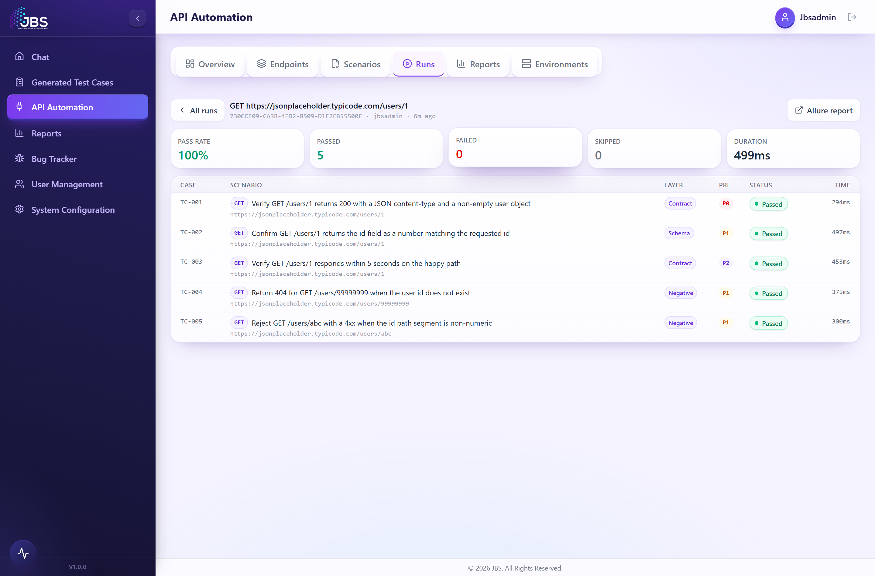
Figure 8. A completed run: pass rate, counts and duration, with the full report one click away.
Below the summary, every failed or not-run scenario is listed under "Needs attention" with the first lines of its error, and every healed scenario is listed under "Self-healing" with a note on exactly what healing did (or deliberately did not do).
Figure 9. Per-scenario results for a run: method, scenario, layer, priority, status and time.
From the report you can:
- Explain a failure — click Explain on any failed scenario for an AI root-cause analysis and a ready-to-paste reproduction (Section 7).
- Export the scenarios — download the test cases as CSV or JSON.
- Push to your repository — commit the generated tests to a connected GitHub, GitLab or Bitbucket repo, as a pull request or a direct commit.
- Sign off — a teammate can approve, reject or request changes on the run, with an audit trail (Section 7).
Honest counting
A scenario the runner never reached is reported as "not run" — it is never quietly folded into passed or failed. The numbers you see are the numbers that happened.

5. The dashboard (Overview)
The Overview tab aggregates every API run your team has made into a single at-a-glance picture.
- KPI cards — total API runs, average pass rate (colour-coded), scenarios and endpoints covered, anomalies and imports.
- Pass-rate trend — how the last several executed runs have trended.
- Coverage by layer — how many scenarios exist per test layer, plus a breakdown by HTTP method.
- Anomalies — flaky scenarios, new failures and slow outliers surfaced automatically.
- Recent runs & imports — jump straight into any recent run or see what was imported when.
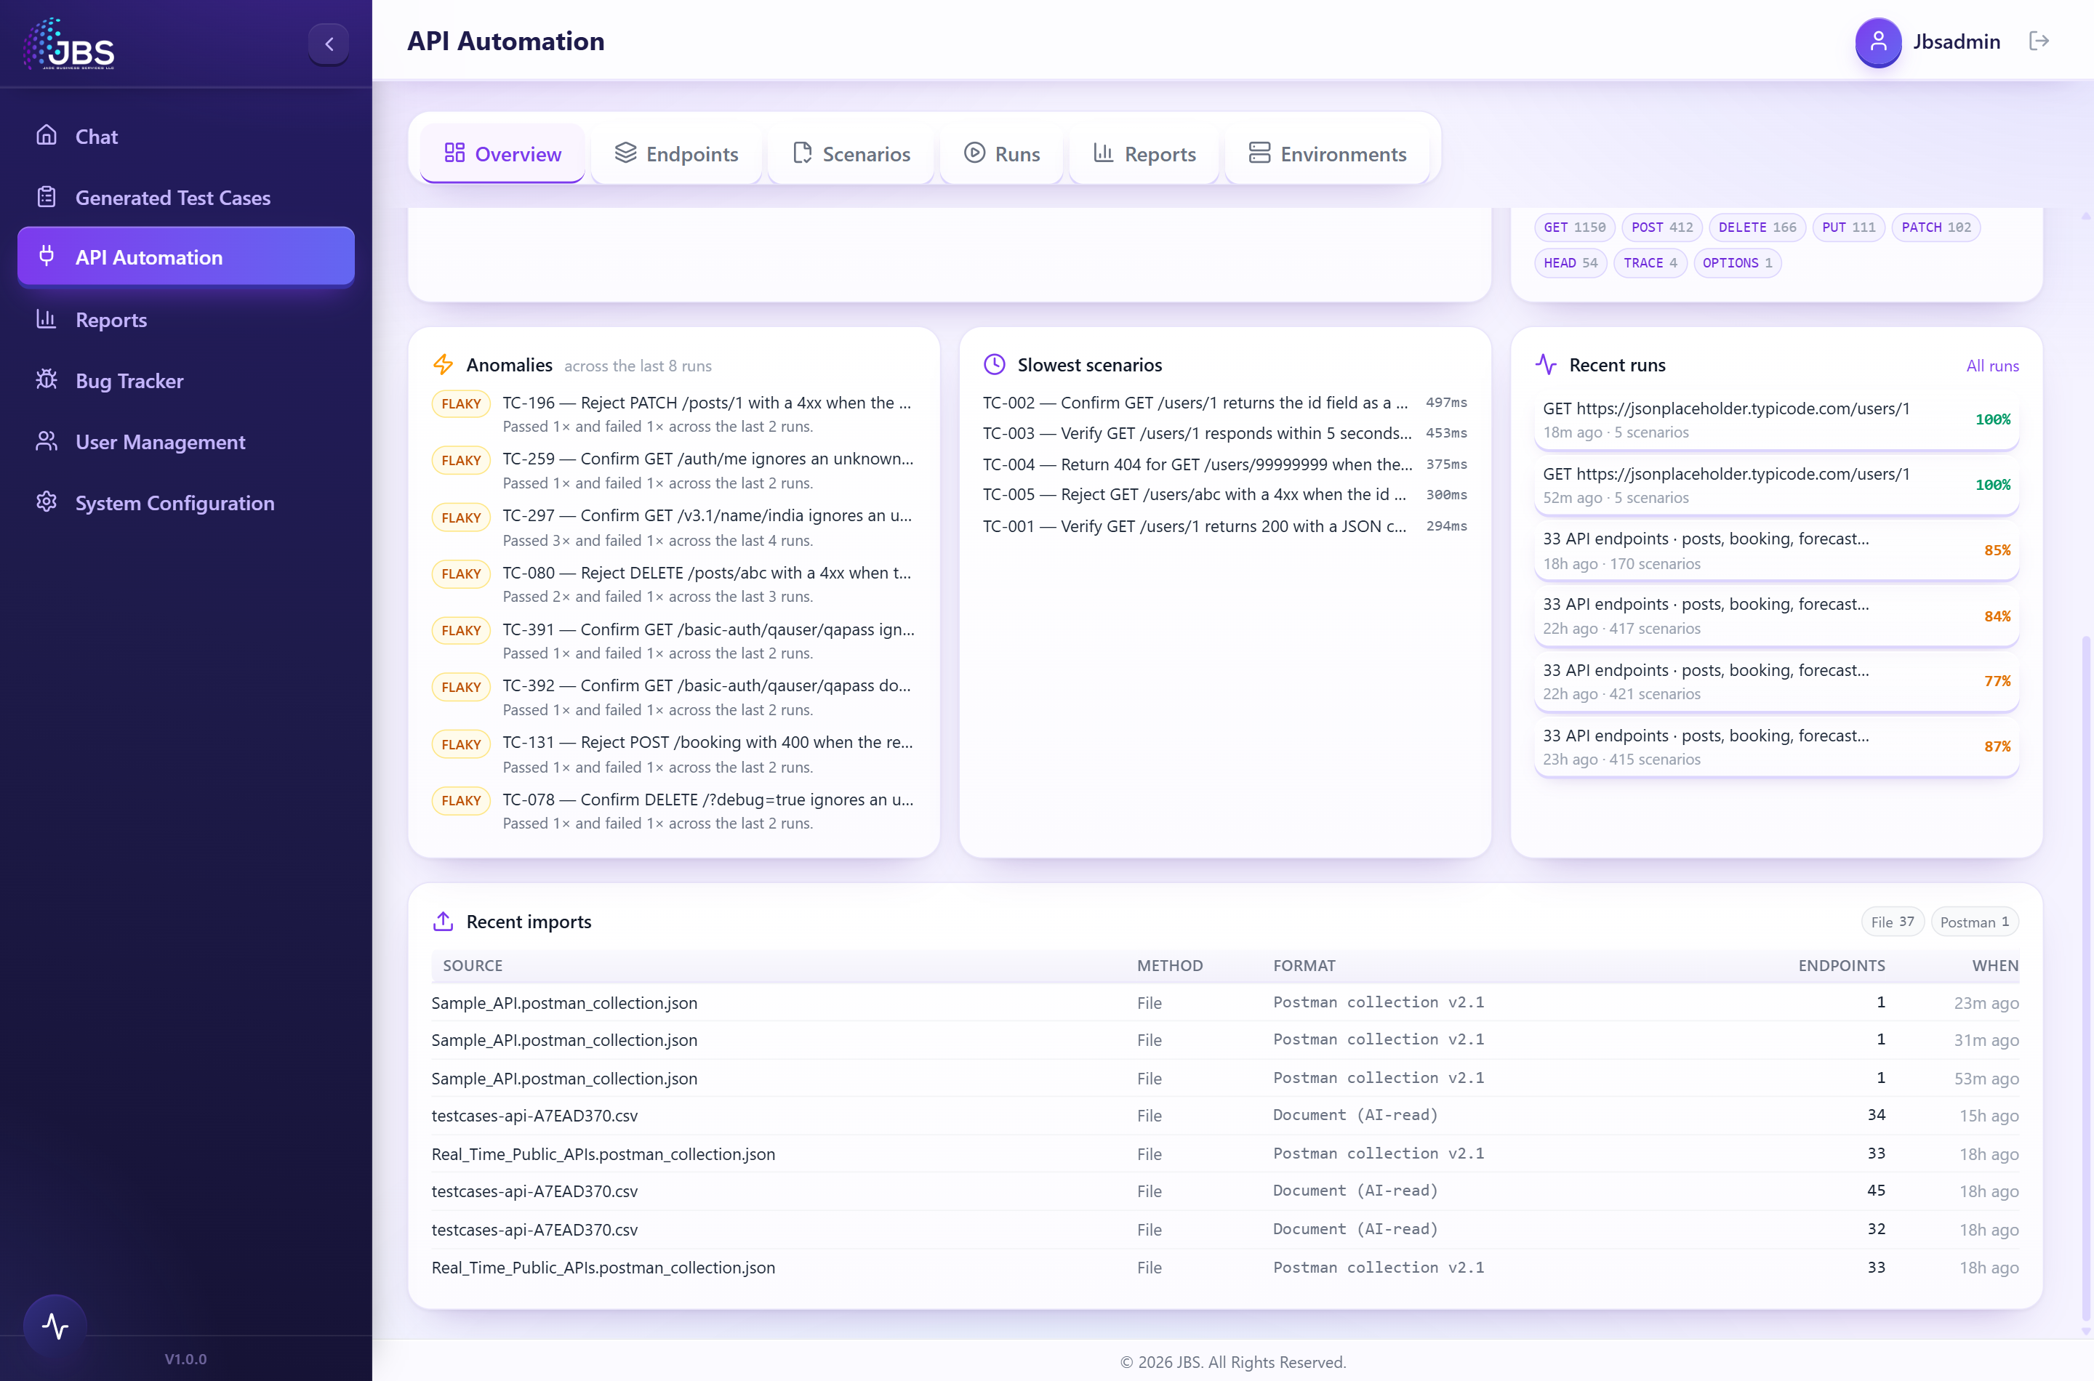
Figure 10. The lower dashboard: anomalies, slowest scenarios, recent runs and recent imports.

6. Environments
An environment is a named target — dev, staging or production — defined by a base URL and a set of variables. Endpoints can use {{placeholders}} that the chosen environment fills in at run time, so the same suite runs against any target without editing a single test.
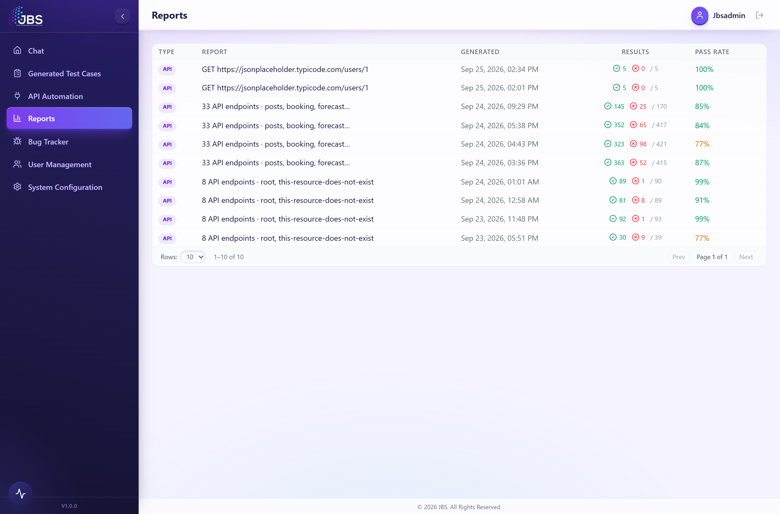
Figure 11. The Environments tab: one card per target, with a default marked.
- Base URL — e.g. https://staging-api.acme.com/v1.
- Variables — key/value pairs; any variable can be marked secret, in which case it is encrypted at rest and shown masked.
- Convenient auth — conventional names resolve automatically: token becomes a Bearer token, apiKey becomes an API-key header, and basicAuth (user:password) becomes Basic auth.
- Default — mark one environment as the default for new runs.
Figure 12. Creating an environment: base URL plus secret and non-secret variables.

7. The quality toolkit
Beyond the core generate-run-heal pipeline, API Automation includes a full set of opt-in quality tools. Most open from the Tools menu on the Endpoints tab and run on the endpoints you have selected; two more live on the Reports tab. Each tool is self-contained and never changes your test cases.
Figure 13. The Tools menu on the Endpoints tab — the quality toolkit.

7.1 Author in plain English
What it is for. Lets anyone describe what they want tested in ordinary language and turns it into a focused test strategy — without bypassing the normal generator.
How to use it. Open it from the Tools menu, type what the tests should cover (example prompts are provided), and click Generate brief. Review the returned brief, then Apply to strategy.
What you get. A structured brief — a requirements summary, a recommended coverage depth, the test layers to include, the endpoints to focus on and an outline of scenario titles. Applying it feeds the normal generator, which does the rest.
Figure 14. Author in plain English.

7.2 Contract validation
What it is for. Confirms each live endpoint still honours its contract — the right status code, JSON content type and response shape — so a silently changed API is caught before you test against it.
How to use it. Open it from the Tools menu; it probes your selected endpoints once and checks them automatically. A Re-run button re-checks.
What you get. A pass/fail summary per endpoint: status OK, content-type OK and schema OK or "schema drift". A new field is tolerated; a missing or re-typed field is flagged.
Figure 15. Contract validation.

7.3 Contract drift
What it is for. Keeps the catalogue’s recorded expectations current. It compares the live response to what the endpoint was imported to expect and lets you adopt the live shape with one click.
How to use it. Open it from the Tools menu; it scans automatically. On a drifted endpoint, click Adopt live to write today’s response shape back into the catalogue.
What you get. A per-endpoint verdict (drifted / in sync / unreachable). Adopting updates the catalogue so future generated tests assert against current reality. (It compares structure, not illustrative values.)
Figure 16. Contract drift.

7.4 Security scan
What it is for. A quick, non-destructive security pass in the spirit of the OWASP API risks — no external scanner required — flagging common weaknesses per endpoint.
How to use it. Open it from the Tools menu; it runs automatically. It never sends attack payloads to write operations (POST/PUT/PATCH/DELETE) — those are inspected safely only.
What you get. Findings by severity (high/medium/low/info): missing security headers, permissive CORS, information leakage, transport/HSTS issues, possible broken authentication and injection exposure.
Figure 17. Security scan.

7.5 Load test
What it is for. A lightweight performance check on a single endpoint — latency, throughput and status mix — without needing a separate load-testing tool.
How to use it. Choose an endpoint, set the number of requests and the concurrency, and run. For a write endpoint you must explicitly opt in, so you only load-test writes against a safe environment.
What you get. Throughput (requests/second), completed/failed/non-2xx counts, a latency distribution (min, p50, p90, p95, p99, max, average) and the status-code mix.
Figure 18. Load test.

7.6 Governance lint
What it is for. An API-design linter that checks your catalogue against good-practice rules — instantly, in your browser — so design smells are caught before tests are built.
How to use it. Open it from the Tools menu; it lints the catalogue immediately, with no inputs.
What you get. A list of findings by severity, such as endpoints served over plain HTTP, write endpoints without authentication, verbs in paths, missing versioning or inconsistent casing.
Figure 19. Governance lint.

7.7 Test coverage
What it is for. Answers "which endpoints are actually tested, and how?" by mapping your designed scenarios back onto the catalogue.
How to use it. Open it from the Tools menu after scenarios have been designed; it is instant and read-only.
What you get. An overall coverage percentage, the mix of scenario categories, an explicit list of untested endpoints, and the scenario count per covered endpoint.
Figure 20. Test coverage.

7.8 Regression baselines
What it is for. Catches silent response regressions by snapshotting today’s responses and comparing future responses against them.
How to use it. Click Capture baseline to snapshot the live responses; later, click Compare now to diff live responses against the snapshot.
What you get. A per-endpoint verdict — unchanged, drifted, unreachable or no baseline — with the exact fields that were added, removed, re-typed or changed. Volatile fields (IDs, timestamps, tokens) are compared by type, so a fresh ID never counts as a regression.
Figure 21. Regression baselines.

7.9 Data-driven testing
What it is for. Runs one endpoint against a whole table of inputs — boundary and negative data sets — without hand-writing a test per row.
How to use it. Choose an endpoint and paste a dataset as JSON rows or CSV. Placeholders in the endpoint are filled from each row; add an expectedStatus column to assert per row. Then run.
What you get. Pass/fail counts, average latency and a per-row results table.
Figure 22. Data-driven testing.

7.10 Async & streaming
What it is for. Tests streaming endpoints that a normal request/response cannot express — WebSocket and Server-Sent Events (SSE).
How to use it. Enter the endpoint URL (it auto-detects WS vs SSE), optionally a message to send and an expected substring, choose how long to listen, and connect.
What you get. Whether it connected, how many frames/events arrived, the time to first byte, the duration and whether your expected content was seen.
Figure 23. Async & streaming.

7.11 Schedules & webhooks
What it is for. Runs the suite unattended on a recurring schedule (for example, a nightly smoke run) and notifies your team when a run finishes.
How to use it. On the Schedules tab, name a schedule, pick an interval and optionally enable self-healing, then create it. On the Webhooks tab, add a Slack, Microsoft Teams or generic JSON webhook.
What you get. Recurring runs that use the same headless pipeline as the workspace, with last-status recorded; and automatic notifications (with a pass/fail summary) sent to your channels. Existing schedules can be run now, paused or deleted.
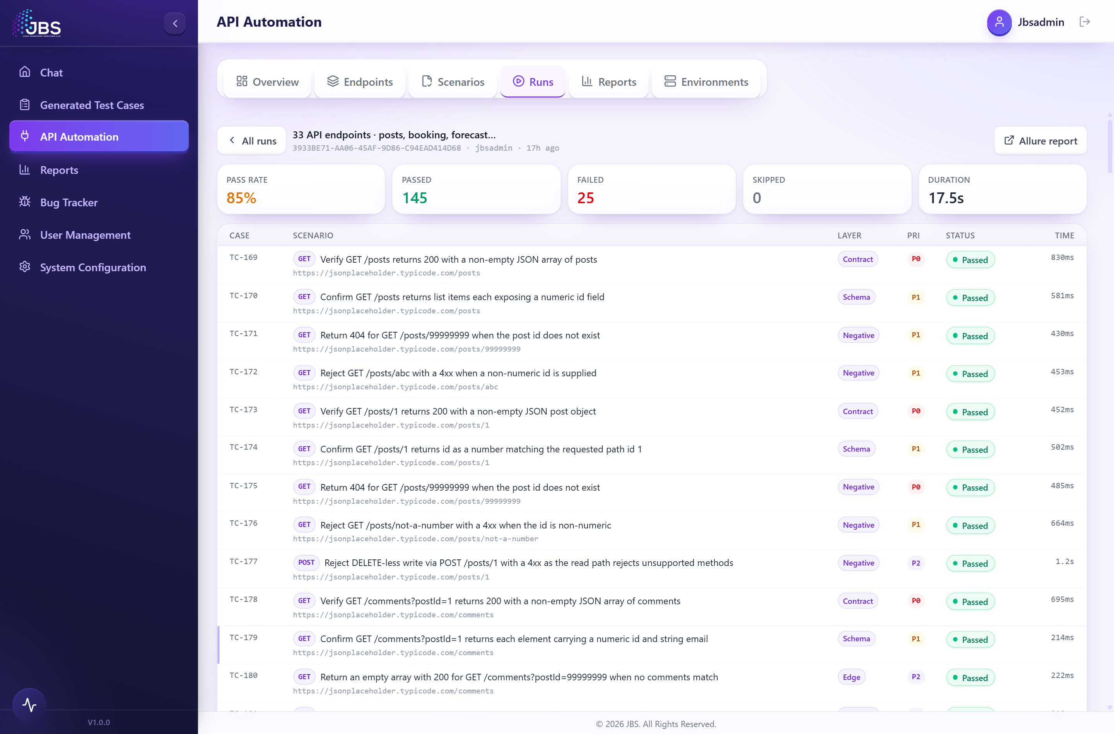
Figure 24. Schedules & webhooks — the Schedules tab.
Figure 25. Schedules & webhooks — the Webhooks tab (Slack / Teams / generic).

7.12 Root-cause analysis (Explain)
What it is for. Explains, in plain English, why a single test failed — so no one has to read a raw stack trace. It diagnoses; it does not change anything.
How to use it. On the Reports tab, in the "Needs attention" list, click Explain on any failed scenario.
What you get. A failure category, a concise root cause and suggested fix with a confidence rating, plus a ready-to-paste reproduction command you can drop into the Bug Tracker.

7.13 Run sign-off
What it is for. Lightweight collaboration on a run — a teammate can approve, reject, request changes or comment, with an audit trail.
How to use it. It appears at the bottom of the Reports tab for a saved run. Pick a decision, add an optional note and record it.
What you get. The run’s current status reflects the latest decision, and a threaded history shows who decided what and when.

7.14 Contract validation vs. baselines vs. drift
These three tools sound similar but answer different questions:
Tool | Question it answers | Acts on
Contract validation | Is the live endpoint healthy right now (status, content-type, schema)? | Nothing — a pass/fail health check.
Regression baselines | Has the response changed since I last snapshotted it? | A stored snapshot in the database.
Contract drift | Does the live response still match what the catalogue expects? | The catalogue — you can adopt the live shape.

8. Developer access & integrations
Everything you can do in the workspace is also available programmatically. These screens live under System Configuration.

8.1 Developer & API access
For administrators, this page provides a RESTful API and a command-line tool (intelliqe-api) so runs can be triggered from anywhere — including CI/CD. It shows your API token (masked, with copy warnings), the full list of REST endpoints with sample requests, a copy-ready example to start a run, the CLI usage, and the custom-connector manifest schema.
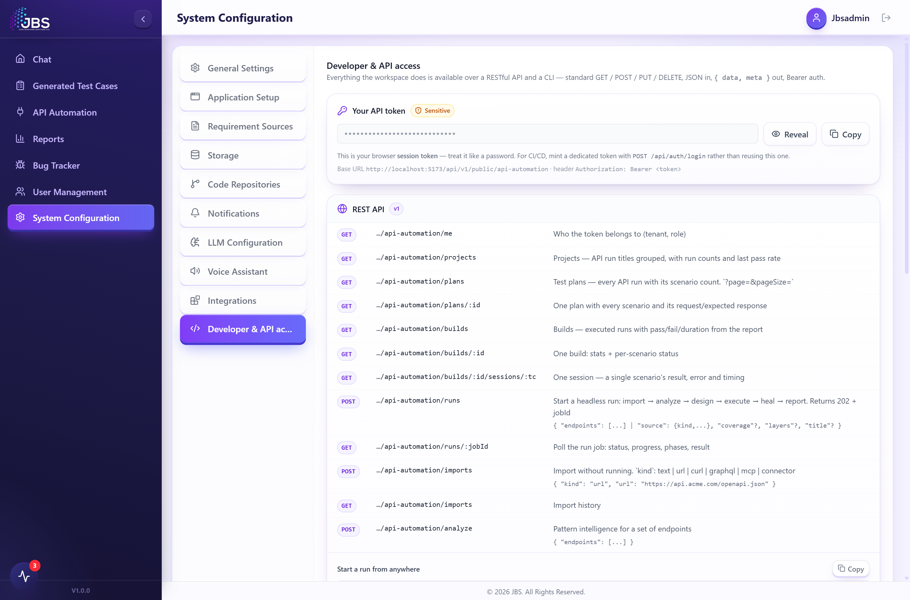
Figure 26. Developer & API access: your token and the REST API reference.
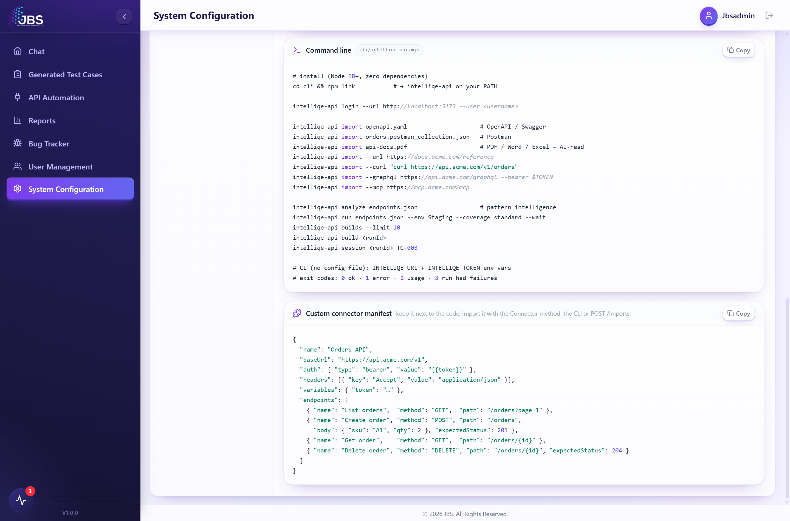
Figure 27. Developer & API access: the command-line tool and connector manifest.

8.2 Integrations
The Integrations directory lists the testing tools across test management, API testing, automation, performance, device clouds and CI/CD that the platform is designed to work alongside. (Your existing sources — such as JIRA, Azure DevOps, Confluence and SharePoint — are configured on the Code Repositories and Requirement Sources tabs.)
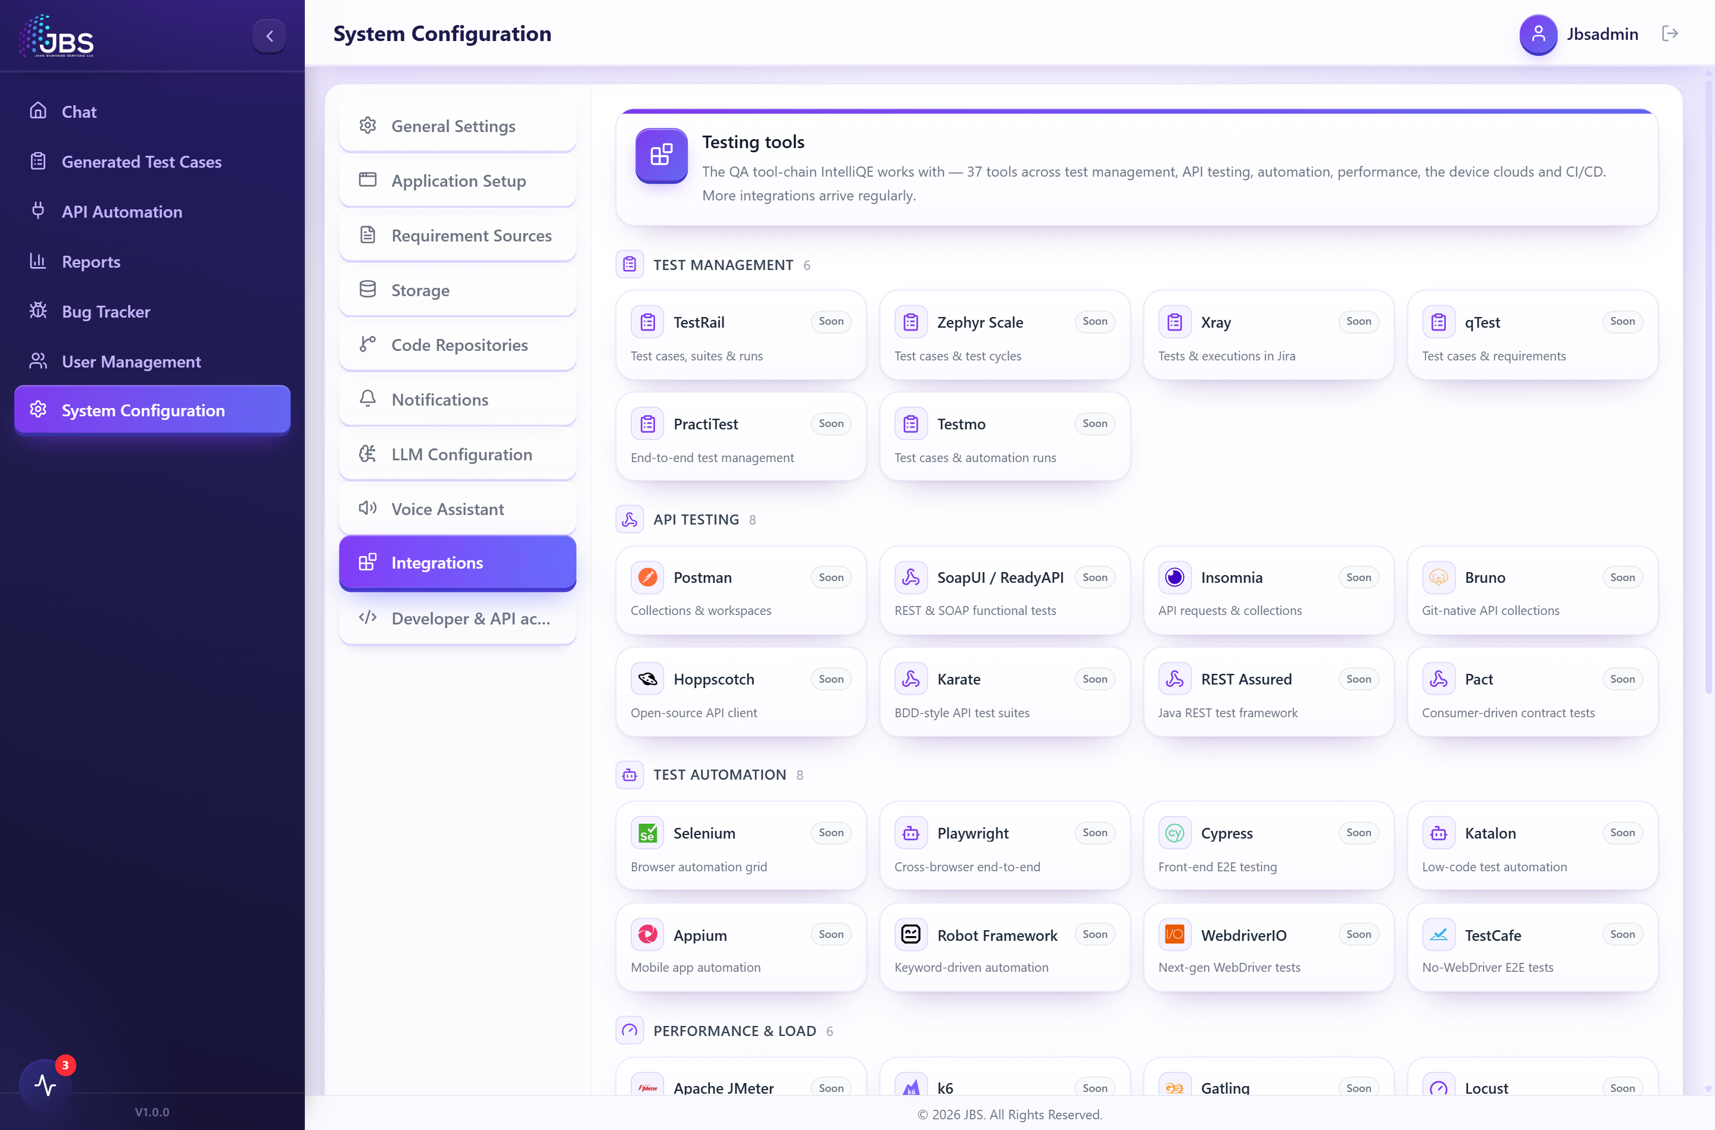
Figure 28. The Integrations directory.

9. Exporting, repository push & CI/CD
- Export scenarios — download your generated test cases as CSV or JSON from the report.
- Push to repository — commit the generated tests and supporting files to a connected GitHub, GitLab or Bitbucket repository — as a pull request or a direct commit — from the report or the run stage rail.
- Portable artifacts — from the Endpoints tab, export an OpenAPI 3 spec, a connector manifest (which re-imports into IntelliQE), a runnable zero-dependency mock server, or a Pact consumer contract.
- Run from CI — trigger the full import → generate → execute → heal → report pipeline over the REST API or the intelliqe-api command-line tool, so API tests run on every build.
Figure 29. The Export menu: portable artifacts generated from your catalogue.

10. Glossary
Term | Meaning
Catalogue | The collection of imported endpoints in your workspace.
Endpoint | A single API operation — a method and URL, with its headers, auth, body and expected response.
Profile | The platform’s automatic understanding of an imported API (resources, auth, dependencies, risks).
Strategy | Your choices of coverage depth and test layers that steer scenario generation.
Scenario | One designed test case, with its request, steps and expected result.
Layer | A kind of test — smoke, contract, schema, negative, auth, security, performance or flow.
Automate / Execute / Heal | Turning scenarios into runnable tests, running them live, and auto-repairing wrong tests.
Environment | A named target (base URL + variables) the suite can run against.
Run | One pass of the pipeline that produces an executed, reported suite.

11. Appendix — the sample API used in this guide
To make every screen show real results, this guide uses JSONPlaceholder (https://jsonplaceholder.typicode.com), a free public REST API, imported as a connector with the following endpoints:
- GET /posts, POST /posts, GET /posts/1, PUT /posts/1, PATCH /posts/1, DELETE /posts/1
- GET /posts/1/comments, GET /comments
- GET /users, GET /users/1, GET /users/1/albums, GET /todos

IntelliQE API Automation — End-to-End User Guide
© 2026 Jade Business Solutions. All rights reserved.

