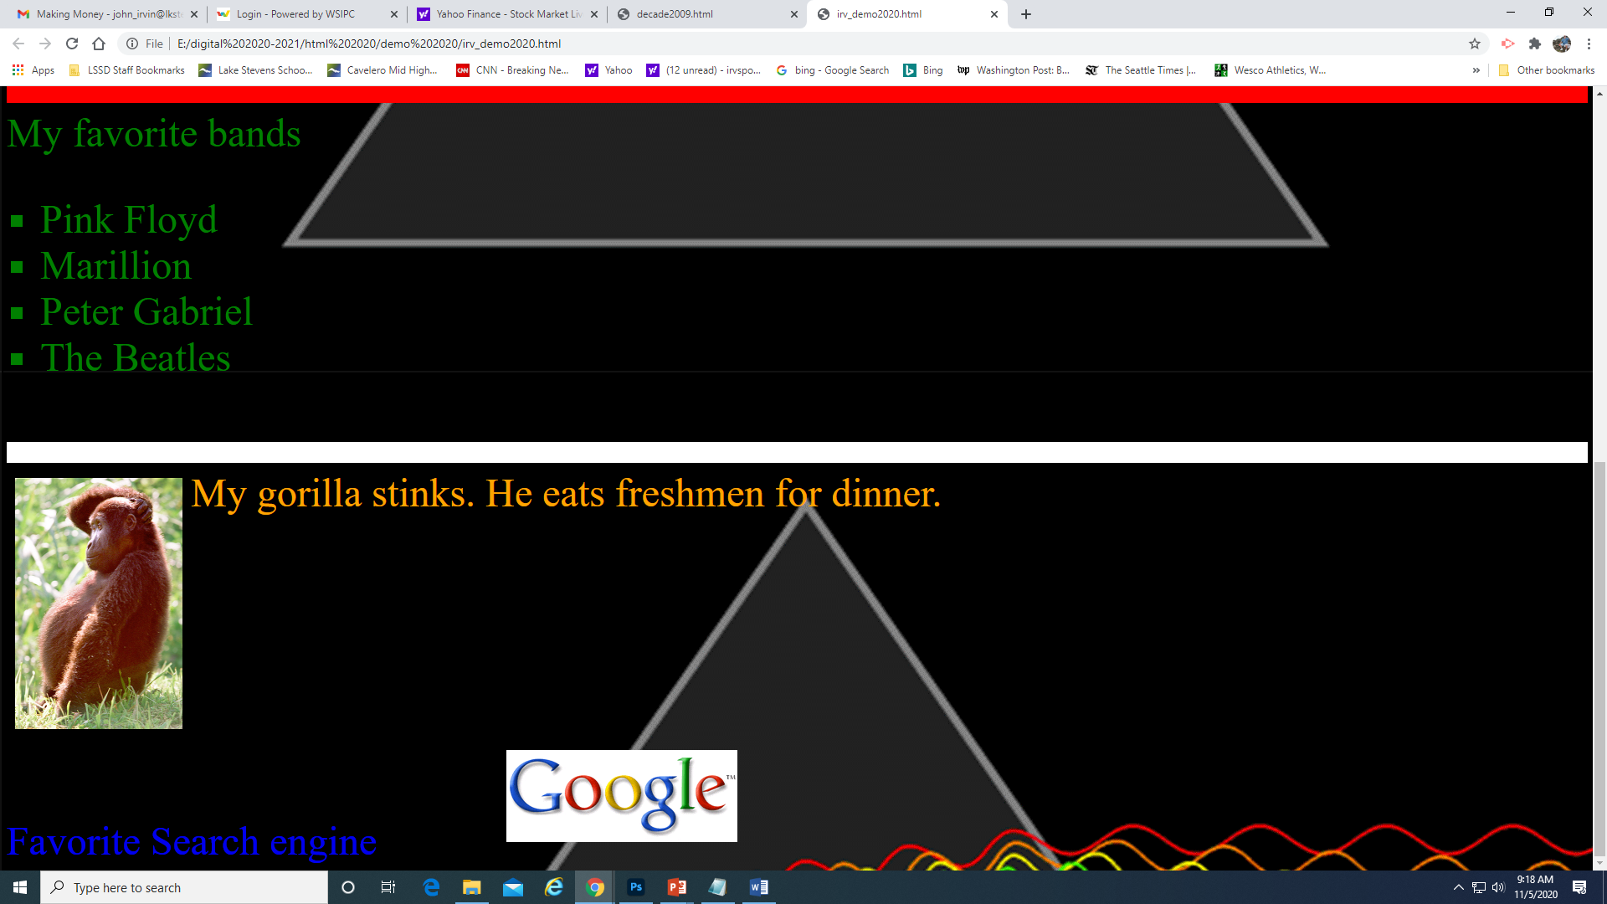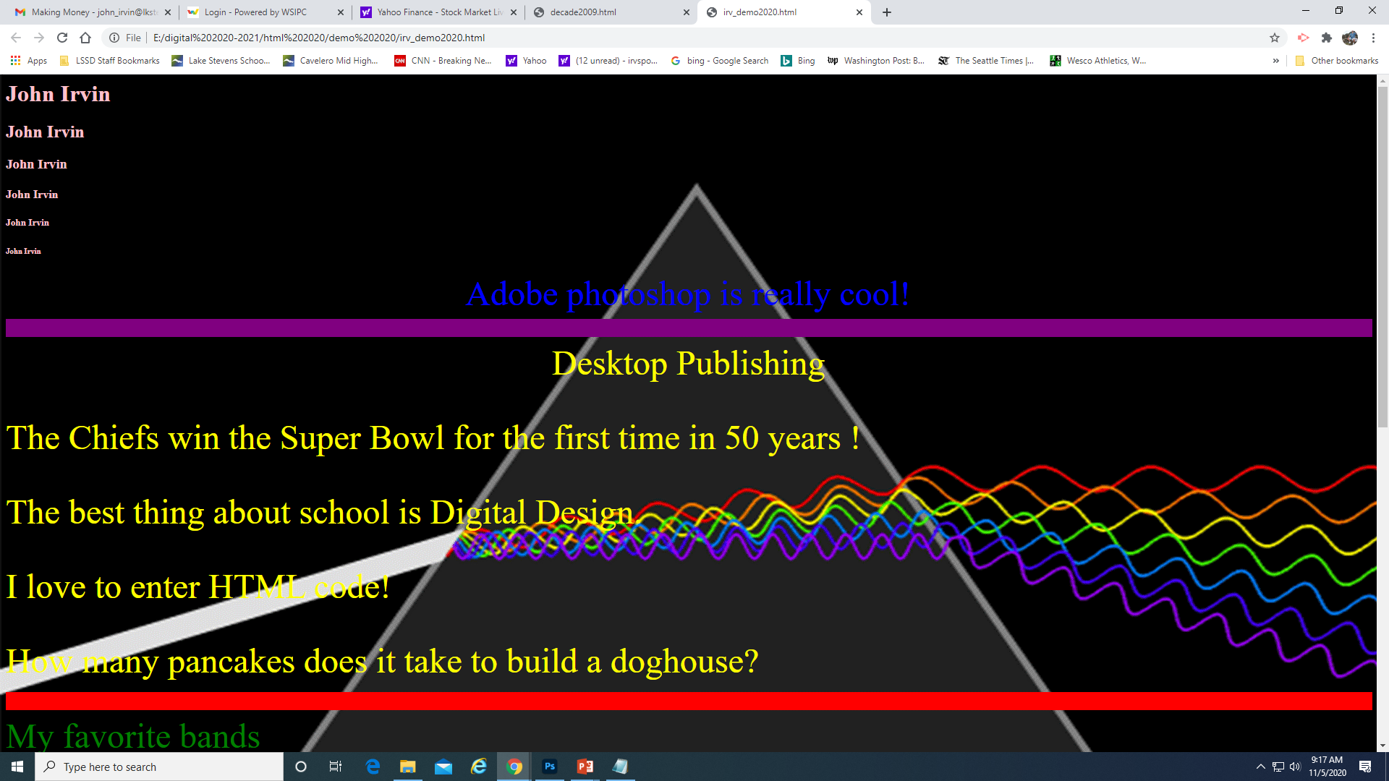

This is what your final page should look like

Don’t forget to copy the entire html demo 2020 folder from class shares and paste it into your student folder in the server, next to portal

Your text can say anything you want it to, within reason

All of your code is entered in notepad

When you finish a section, file / save as / html_demo_last name.html

To see your results, you have to go to your student folder, open it, and then right click / open with / google chrome

Open two windows so you can start and stop the video; it has all the code you will need to enter on it