Supporting document for an Elsevier manuscript · Applied Energy
Experiment Dossier: Software–Hardware Validation of the Digital Twin of a Communication-Node Power Supply
Archive contents · test-bench description · experimental protocol · visualised results and tables · manuscript integration kit
Package: dt_power_hil (dtpower 1.0.0) · 51 runs · configuration SHA-256 8e3860c064c016fb… · generated 29 September 2026
[Authors and affiliations — to be completed from the manuscript]
EVIDENCE CLASSIFICATION. Software-in-the-loop (SIL) simulation with emulated hardware (virtual testbed). The battery, DC bus, load branches, INA226/INA228 measurement channels, MQTT link and ESP32 controller are reproduced by models parameterised with datasheet characteristics of the real components listed in Part B. No physical measurement was performed. The results must be reported as a pre-hardware (virtual-testbed) validation, never as HIL, CHIL, PHIL or field results. Part B describes the physical bench that the same software and protocols are prepared for.

How to use this document
Table 1. Structure of the dossier and its intended use in the manuscript
Part | Content | Use in the Elsevier manuscript
A. Archive contents | Directory inventory, file catalogue, data dictionary, run registry, reproduction and integrity | Data availability statement; supplementary material description
B. Test bench | Architecture, wiring, components with characteristics, measurement points, measurement chain, controller, timing, protection, calibration, emulation parameters | New subsection “Experimental testbed” in Methods (text and Tables B-x can be pasted)
C. Protocol | Hypotheses, scenarios, policies, metric definitions, statistical design | Methods: “Experimental protocol and metrics”
D. Results | Acceptance summary, metrology, scenario dynamics, twin accuracy, timing, faults, policy comparison, 14-day reproduction, sizing | Results: “Validation on the virtual testbed”; figures and tables with captions
E. Integration kit | Ready-to-paste section text, figure/table mapping, abstract/highlight/conclusion insertions, data statement, reviewer response, allowed claims | Direct insertion and revision letter
Appendix | Full per-run metrics (51 runs), calibration levels | Supplementary tables

Part A. Archive contents

A.1. Package overview
The archive `dt_power_hil_EN.zip` unpacks into a single directory `dt_power_hil/` (338 files, 20.6 MB uncompressed). It is self-contained: one command regenerates every result, figure, protocol, report and the web page from the configuration files. Fig. 1 shows the data flow from inputs to deliverables.
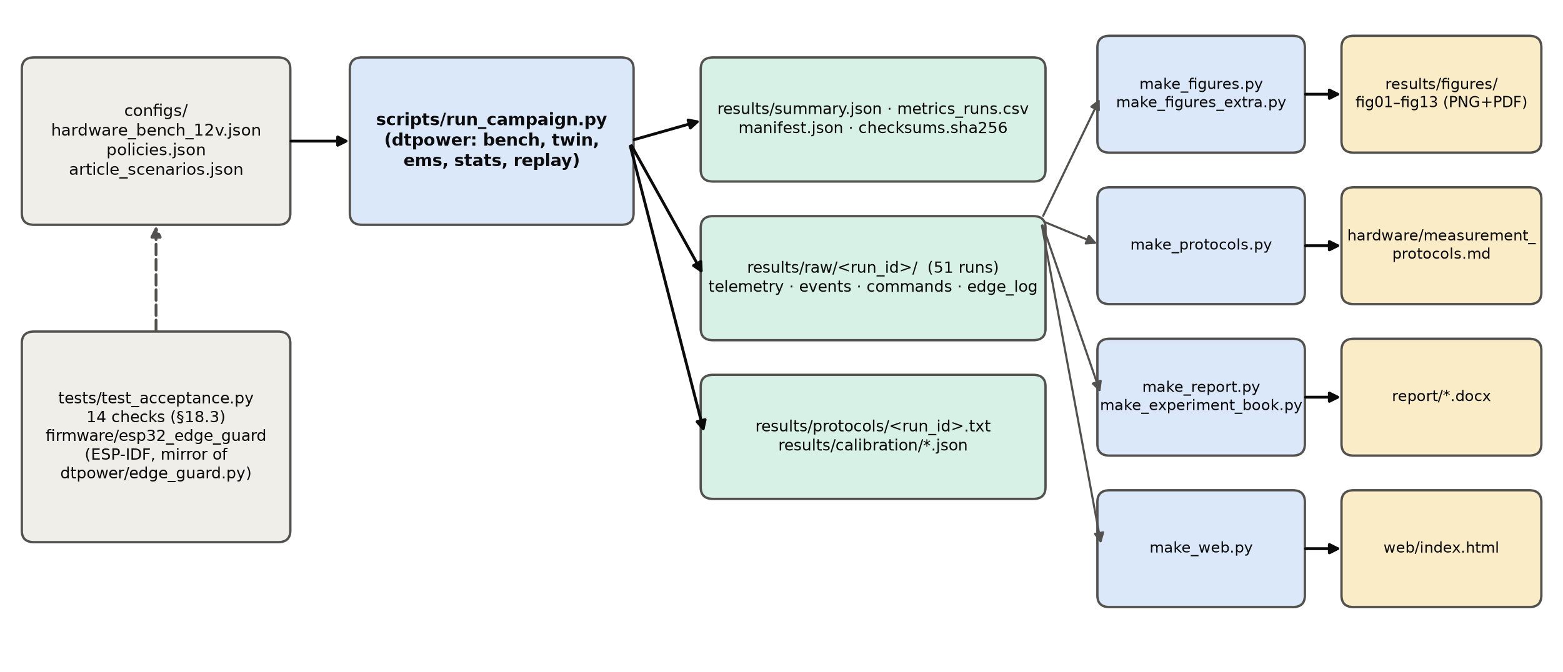
Fig. 1. Data pipeline of the package: configuration → campaign runner (dtpower) → result package (summary, raw logs, protocols, calibration) → generators of figures, measurement protocols, reports and the web dashboard. Tests and firmware mirror the controller logic.

A.2. Directory inventory
Table 2. Directory inventory of the archive (Ukrainian-language files excluded)
Directory | Content | Files | Size | Origin
dtpower/ | Python package: digital twin, virtual testbed, EMS, statistics | 18 | 78.1 KB | hand-written source
scripts/ | Campaign runner and generators of figures, protocols, reports, web | 7 | 159.4 KB | hand-written source
tests/ | Software acceptance tests (protocol §18.3) | 1 | 4.8 KB | hand-written source
configs/ | Hardware passport, policy thresholds, manuscript scenarios S1–S3 | 3 | 6.9 KB | hand-written input
firmware/ | ESP32-S3 edge_guard firmware (ESP-IDF, C) | 4 | 11.0 KB | hand-written source, not compiled
hardware/ | Bill of materials, wiring, measurement protocols P-1…P-7 | 2 | 16.9 KB | BOM hand-written; protocols generated
results/ | Complete result package of the emulated campaign | 293 | 16.9 MB | generated by run_campaign.py
results/raw/ | Per-run raw logs (telemetry, events, commands, edge log) | 204 | 10.5 MB | generated
results/protocols/ | Per-run protocols in the §21.3 format | 51 | 58.9 KB | generated
results/calibration/ | E00 calibration, E09 capacity, channel characteristics, uncertainty budget | 4 | 27.1 KB | generated
results/figures/ | Figures fig01–fig13 as PNG (300 dpi) and vector PDF | 26 | 2.5 MB | generated
results/configs/ | Frozen copy of the configurations used by the campaign | 3 | 6.9 KB | generated
report/ | Elsevier-style report and this dossier (DOCX) | 2 | 3.3 MB | generated
web/ | Self-contained results dashboard (index.html) and its template | 2 | 180.4 KB | generated / template

A.3. File catalogue
Table 3. File catalogue (excluding per-run files, which follow the pattern in Table A-3)
Path | Description
README.md | Package description, reproduction commands, migration steps to the physical bench
configs/hardware_bench_12v.json | Hardware passport: battery, BMS limits, generation source, branches, INA226/INA228/DS18B20 characteristics, shunts, channels M0–M5/REF, calibration standard, timing budget, network model, protection
configs/policies.json | Frozen thresholds of policies C0, C1, C2, C_oracle; stop threshold SOC_ref = 0.20; ε_P = 0.5 W
configs/article_scenarios.json | Manuscript parameters of S1–S3 (Tables 2–3), 14-day PSH array, values reported in the manuscript
dtpower/__init__.py | Package version and evidence-class string
dtpower/config.py | Configuration loading, SHA-256 hashing, run-configuration validation (§21.4 rejection rules)
dtpower/profiles.py | Normalised PV shape, lighting mask, hourly profiles, zero-order-hold upsampling, step profiles
dtpower/sizing.py | Analytical sizing (B.4–B.7), sensitivity table and grid
dtpower/energy_sim.py | Energy-level SOC simulator of the manuscript with pre-step limits, unserved and curtailed energy bookkeeping
dtpower/battery.py | LiFePO₄ equivalent-circuit plant (OCV table, R0, R1C1, η_Q, BMS cut-offs) with hidden unit parameters
dtpower/sensors.py | Measurement-chain emulation: shunt tolerance/TCR, IC offset, gain error, noise, LSB quantisation, saturation; DS18B20
dtpower/calibration.py | E00 procedure (zero, 5 levels, fit/verify split), uncertainty budget, protocol-row derivation
dtpower/capacity.py | E09 working-interval capacity and coulombic-efficiency test
dtpower/transport.py | MQTT-like channel: log-normal latency, loss, QoS-1 duplicates, blackouts
dtpower/edge_guard.py | Python mirror of the ESP32 firmware: state machine, command contract, watchdog, local protection
dtpower/twin.py | Telemetry validator; SOC prior/posterior (coulomb counting + EKF); bus balance; open-loop prediction
dtpower/forecast.py | Causal generation and demand forecasters (no access to the scenario profile)
dtpower/ems.py | Policies C0 (schedule), C1 (SOC hysteresis), C2 (forecast rule) and C_oracle
dtpower/bench.py | Virtual-testbed orchestrator (plant, sensors, edge, transport, twin, EMS, REF logger, service probe) and bench builder
dtpower/scenarios.py | Scenario matrix E01–E08
dtpower/replay.py | E11: SIL replication of S1–S3, reconciliation grid, lockstep controller replay
dtpower/stats.py | BCa bootstrap, exact sign-flip test, Holm correction, Friedman test
scripts/run_campaign.py | Runs E00–E11 in parallel, writes raw logs, protocols, metrics, summary, manifest, checksums
scripts/make_figures.py | Figures fig01–fig09
scripts/make_figures_extra.py | Figures fig10–fig13 (wiring, scenario dynamics, uncertainty budget, pipeline)
scripts/make_protocols.py | Generates hardware/measurement_protocols.md
scripts/make_report.py | Generates the Elsevier-style report
scripts/make_experiment_book.py | Generates this dossier
scripts/make_web.py | Builds web/index.html with embedded data
tests/test_acceptance.py | 14 acceptance checks: 10 W·1 h = 10 Wh, sign convention, no energy creation, curtailment, night PV = 0, manuscript sizing, stale/duplicate/boot-id commands, no-future forecaster, validator, config rules, statistics, end-to-end run
firmware/esp32_edge_guard/main/edge_guard.c | ESP-IDF firmware: INA226 over I²C, 10 Hz sampling, 1 Hz telemetry, state machine, command contract, watchdog, relay GPIO
firmware/esp32_edge_guard/CMakeLists.txt, main/CMakeLists.txt, main/Kconfig.projbuild | ESP-IDF build files; broker URI option
hardware/BOM_and_wiring.md | 24-item bill of materials, functional diagram, meter selection check, installation rules
hardware/measurement_protocols.md | Protocols P-1…P-7 with EMU values and blank PHYS columns
results/summary.json | All metrics, statistics, calibration, E06/E07/E10/E11 outputs, acceptance table
results/metrics_runs.csv | One row per run: 40 metric columns (see Table A-4)
results/series_selected.json | 10-s time series of selected runs used by figures and the web page
results/manifest.json | Versions, seeds, run list, wall time, evidence class
results/checksums.sha256 | SHA-256 of every file in results/
report/DT_HIL_Experiment_Report_Elsevier_EN.docx | Elsevier-style experiment report
report/DT_HIL_Experiment_Dossier_Testbed_EN.docx | This dossier
web/index.html | Self-contained interactive dashboard (opens offline in a browser)

A.4. Data dictionary
Table 4. Per-run raw files in results/raw/<run_id>/
File | Rows | Columns and meaning
telemetry_10s.csv | every 10 s + every relay switch | t (s, model time); soc_true (hidden plant SOC, emulation only); soc_ref (independent REF SOC); soc_prior / soc_post (twin before/after update); v_batt (V); i_batt (A, + = discharge); i_ref (A, REF channel); p_gen_avail (W, scenario); p_gen (W, accepted by the bus); p_crit_term, p_aux_term (W at load terminals); aux_sched (0/1 schedule); aux_cmd (0/1 ESP32 output); relay (0/1 physical state); pred_min (C2 forecast min SOC); valid (cumulative valid samples); residual_w (bus balance r_P, W); service_ok (0/1 HTTP probe)
events.csv | per event | run_id, event_id, t_model_s, event_type (RUN_START, TELEMETRY_STALE, TELEMETRY_RESTORED, INVALID_SAMPLE, STOP_LIMIT_SOC_REF, RUN_END), value
commands.csv | per command | run_id, command_id, action (SET_AUX_ON/OFF), reason, sent_s, ack_s, effect_s, effect_kind (edge / state_confirmed), accepted, reject_reason, retry_of
edge_log.csv | per controller event | t_s, kind (AUX_ON, AUX_OFF, ACK, REJECT, STATE), detail
results/protocols/<run_id>.txt | 1 per run | Run protocol fields of §21.3 (RUN_ID … ANALYST_REVIEW)

Table 5. Columns of results/metrics_runs.csv
Column | Meaning
run_id | unique run identifier <date>_<scenario>_<policy>_R<repeat>_EMU
scenario_id | E01…E08
policy | C0, C1, C2, C_oracle
repeat | block index (E05: 0–9)
mode | sil_hw_emulated
duration_h | run duration
stop_reason | completed / stopped_limit
right_censored | true if the limit was not reached
coverage_pct | valid telemetry share
unknown_duration_s | time without telemetry beyond 2 s
soc_ref_start | initial SOC_ref
min_soc_ref | minimum SOC_ref
mae_soc_pp | MAE posterior vs SOC_ref, pp
rmse_soc_pp | RMSE, pp
max_soc_err_pp | max |error|, pp
ref_vs_true_mae_pp | REF vs hidden truth (emulation only)
energy_error_pct | twin vs REF discharge energy, %
critical_unserved_wh | critical unserved energy
aux_served_wh | lighting energy delivered
aux_unserved_wh | lighting unserved (incl. EMS curtailment)
lolh_critical_h | loss-of-load hours, critical
lpsp_critical | LPSP_E critical
lpsp_total | LPSP_E total
service_checks | HTTP probes
service_failures | failed probes
availability_pct | observed availability
commands | commands sent
commands_accepted | accepted by ESP32
commands_effect_confirmed | accepted with confirmed effect
switch_count | relay transitions
residual_w_mean | mean bus residual r_P
residual_w_sd | SD of r_P
e_gen_wh | generation accepted
e_curtailed_wh | generation curtailed
e_ref_dis_wh | discharge energy by REF
rtt_median_ms | command RTT median
rtt_p95_ms | RTT p95
rtt_max_ms | RTT max
effect_median_ms | decision → current edge median
effect_max_ms | decision → current edge max

Table 6. Top-level keys of results/summary.json
Key | Content
evidence_class, dtpower_version, config_sha256 | identification
bench | seed and hidden truth of the emulated unit
calibration, capacity, channels, uncertainty | E00, E09, P-1 rows, P-3 budget
runs | per-run metrics (as metrics_runs.csv, plus transport statistics)
e05 | per-policy summaries, primary/secondary paired contrasts, Friedman, common-interval analysis
e06, e07, e10 | fault-handling results
e11 | SIL S1–S3, 1-min check, reconciliation grid, controller replay
sizing, sensitivity, sensitivity_grid | analytical sizing
timing | RTT and decision-to-effect statistics
acceptance | protocol §17 criteria with verdicts

A.5. Run registry
Table 7. Registry of the 51 runs by scenario
Scenario | Runs | Policies | Seeds | Duration, h | Stop reasons
E01 | 1 | C0 | 20260929…20260929 | 1.00–1.00 | completed×1
E02 | 1 | C0 | 20260936…20260936 | 1.00–1.00 | completed×1
E03 | 3 | C0, C1, C2 | 20260991…20260991 | 2.00–2.00 | completed×3
E04 | 1 | C0 | 20260943…20260943 | 1.50–1.50 | completed×1
E05 | 40 | C0, C1, C2, C_oracle | 20261929…20270929 | 3.54–6.00 | completed×30, stopped_limit×10
E06 | 1 | C1 | 20260950…20260950 | 0.50–0.50 | completed×1
E07 | 1 | C1 | 20260957…20260957 | 0.50–0.50 | completed×1
E08 | 3 | C0, C1, C2 | 20260996…20260996 | 1.00–1.00 | completed×3

A.6. Reproduction and integrity
pip install numpy scipy matplotlib python-docx pytest
cd dt_power_hil
python -m pytest -q tests # 14 acceptance checks
python scripts/run_campaign.py # E00–E11 → results/ (≈ 80 s, 4 cores)
python scripts/make_figures.py && python scripts/make_figures_extra.py
python scripts/make_protocols.py && python scripts/make_report.py
python scripts/make_experiment_book.py && python scripts/make_web.py
sha256sum -c results/checksums.sha256 # integrity check (run inside results/)

Environment of the reference run: Python 3.11.15, NumPy 2.4.6, platform Linux-6.18.44-fc-v37-x86_64-with-glibc2.39. Seeds: bench 1, base 20260929; E05 blocks use seed base + 1000·(block+1), identical for all policies of a block (paired design).

Part B. Test-bench description
This part is written so that it can be inserted into the Methods section of the manuscript as the subsection “Experimental testbed”. It describes the physical 12 V bench on real components; the same description parameterises the emulation used in Part D.

B.1. Purpose and scope
The bench closes the loop between the digital twin and a battery-supplied communication node: real (or emulated) measurements feed the twin, the energy-management system (EMS) decides whether the auxiliary lighting may run, and the decision is executed by a relay and confirmed by a measured change of current. The bench implements the mandatory programme of the protocol: one 12 V class stand, measured generation, battery and load channels, an independent reference, closed-loop control of the auxiliary load, repeatable disturbances, service availability monitoring and immutable logs. Its 12.8 V / 40 Ah battery (≈ 512 Wh) validates the loop and the model of this bench; it is not a physical replica of manuscript scenario S1 (12 V / 200 Ah), and scale transfer requires a separate scaling model.

B.2. Architecture and wiring
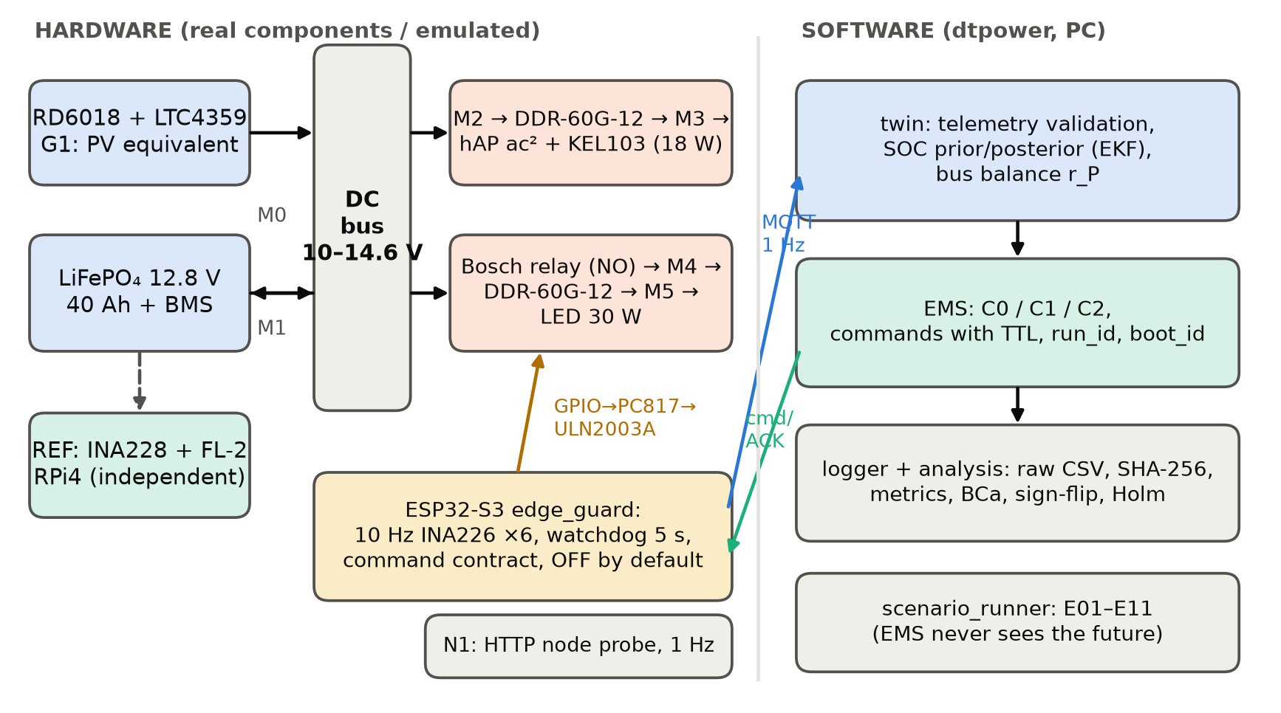
Fig. 2. Functional architecture: hardware part (left) and software part (right). The EMS never receives the future scenario profile.
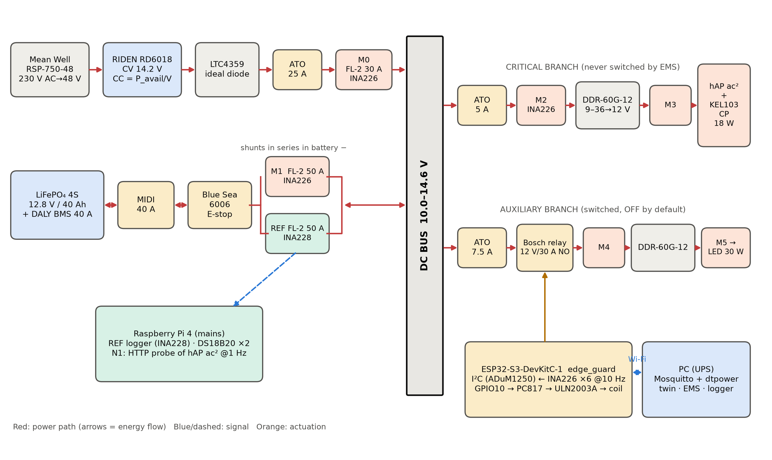
Fig. 3. Wiring of the bench with fuses, shunts, measurement points M0–M5 and REF, the switched auxiliary branch, the never-switched critical branch, the ESP32 edge controller, the PC and the independent Raspberry Pi logger.

B.3. Components and characteristics
Table 8. Bench components and characteristics used in the analysis (nominal datasheet values; verify against the actual units)
Function | Component | Characteristics | Qty
Controller | Espressif ESP32-S3-DevKitC-1 (ESP32-S3-WROOM-1-N8R8) | 2×240 MHz, 3.3 V logic, esp_timer 1 µs; 5 V USB from PC UPS | 1
Battery | LiFePO₄ 4S1P 12.8 V / 40 Ah, DALY 4S 12 V 40 A-class BMS | CV 14.2 V; OVP 14.6 V; UVP 10.0 V; I_ch ≤ 20 A; I_dis ≤ 40 A; T_ch 0–45 °C | 1
Generation G1 | RIDEN RD6018 + Mean Well RSP-750-48 | 0–60 V, 0–18 A, Modbus RTU; 0.01 V / 0.01 A set resolution | 1+1
Reverse-current block | LTC4359 ideal-diode module | minimal forward loss at M0 | 1
Critical DC/DC | Mean Well DDR-60G-12 | in 9–36 V, out 12 V / 5 A, η ≈ 0.90 | 1
Communication node | MikroTik hAP ac² (local HTTP service) | consumption measured by M3 | 1
Load top-up | Korad KEL103 (or Rigol DL3021), CP mode | node + e-load = 18 W at terminals | 1
Auxiliary DC/DC | Mean Well DDR-60G-12 | as above | 1
Auxiliary load | 12 V / 30 W LED floodlight | measured by M5 | 1
Auxiliary switch | Bosch 0 332 019 150 relay (NO) + PC817 + ULN2003A + 1N4007 | operate ≈ 10 ms; open (OFF) when unpowered | 1
Meters M0–M5 | TI INA226 | 16-bit; shunt LSB 2.5 µV (±81.92 mV); bus LSB 1.25 mV (≤ 36 V); offset ≤ ±10 µV; gain ≤ 0.1 % | 6
Reference REF | TI INA228 on Raspberry Pi 4 | 20-bit; shunt LSB 312.5 nV (±163.84 mV); bus LSB 195.3 µV (≤ 85 V); offset ≤ ±1 µV; gain ≤ 0.05 % | 1
Shunts | FL-2 50 A / 75 mV (M1, REF); 30 A / 75 mV (M0); 10 A / 75 mV (M2–M5), class 0.5 | 1.5 / 2.5 / 7.5 mΩ | 7
Temperature | Maxim DS18B20 | ±0.5 °C (−10…+85 °C), 0.0625 °C resolution | 2
I²C isolation | Analog Devices ADuM1250 | breaks USB ↔ bus ground loop | 1
Service probe N1 | Raspberry Pi 4 Model B on mains | HTTP request every 1 s | shared
Protection | MIDI 40 A; ATO 25 / 5 / 7.5 A; Blue Sea Systems 6006 | DC rated fuses and battery disconnect | —
Calibration standard | Fluke 87V + certified 4-terminal shunt | expanded uncertainty from certificate (placeholder 0.05 %) | 1

B.4. Measurement points
Table 9. Measurement points and their role
Point | Location | Quantities | Purpose
M0 | bus after the generation source | V, I, P | power injected into the bus
M1 | battery branch, signed current | V, I, P | twin state estimation, charge/discharge energy
M2 | critical branch input | V, I, P | bus-side critical demand
M3 | critical load terminals | V, I, P | useful critical energy
M4 | auxiliary branch input | V, I, P | lighting power and physical switching confirmation
M5 | auxiliary load terminals | V, I, P | useful lighting energy
REF | independent battery channel | I, V, ∫I dt | reference SOC and check of M1
T1/T2 | battery case / ambient air | temperature | test conditions, charge-temperature limits
N1 | independent network client | request success, RTT | service availability of the node

B.5. Measurement chain and selection check
Table 10. Measurement-channel characteristics derived from datasheets (protocol P-1)
Channel | Meter / shunt | Full scale, A | LSB, mA | Max offset, mA | Uncal. error, % | Max shunt P, W | Calibration levels, A
M0 | INA226 / 2.5 mΩ | 32.8 | 1.000 | ±4.00 | ±0.60 | 0.81 | 3.60; 7.20; 10.80; 14.40; 18.00
M1 | INA226 / 1.5 mΩ | 54.6 | 1.667 | ±6.67 | ±0.60 | 0.60 | −20.00; −5.00; 1.25; 2.50; 10.00
M2 | INA226 / 7.5 mΩ | 10.9 | 0.333 | ±1.33 | ±0.60 | 0.07 | 0.60; 1.20; 1.80; 2.40; 3.00
M3 | INA226 / 7.5 mΩ | 10.9 | 0.333 | ±1.33 | ±0.60 | 0.03 | 0.40; 0.80; 1.20; 1.60; 2.00
M4 | INA226 / 7.5 mΩ | 10.9 | 0.333 | ±1.33 | ±0.60 | 0.12 | 0.80; 1.60; 2.40; 3.20; 4.00
M5 | INA226 / 7.5 mΩ | 10.9 | 0.333 | ±1.33 | ±0.60 | 0.07 | 0.60; 1.20; 1.80; 2.40; 3.00
REF | INA228 / 1.5 mΩ | 109.2 | 0.208 | ±0.67 | ±0.55 | 0.60 | −20.00; −5.00; 1.25; 2.50; 10.00
The INA226 common-mode limit (36 V) suits the 12.8 V bus but not S3 (51.2 V); an uncorrected ±10 µV offset on 1.5 mΩ is ±6.7 mA, i.e. up to 0.4 pp SOC drift per 24 h, so zero calibration is mandatory. Sign convention: positive battery current = discharge.

B.6. Controller, communication and timing budget
Table 11. Timing budget and communication parameters
Item | Value | Remark
Local sampling (INA226 ×6) | 10 Hz | averaging 16, 1.1 ms conversion; energy changes, not switching transients
Aggregated telemetry | 1 s | mean / min / max / n per channel; key (run_id, device_id, boot_id, seq)
Twin update | 1 s | prior before, posterior after each telemetry
EMS decision | 60 s | urgent OFF allowed earlier
Heartbeat / stale threshold | 1 s / 5 s | DEGRADED and aux OFF on expiry
Command TTL / ACK timeout | 2000 ms / 2 s | idempotent SET_AUX_ON / SET_AUX_OFF; TOGGLE forbidden
Clock uncertainty | ±15 ms | SNTP; used conservatively in the expiry check
MQTT topics | dt/node01/{telemetry, state, command, ack, event, health} | no retained commands; QoS 1 for telemetry and commands
Controller states | INIT → READY → RUNNING ⇄ DEGRADED → STOPPED | aux OFF in every state except RUNNING

B.7. Protection and safety
- Battery fuse MIDI 40 A within 150 mm of the “+” terminal; ATO 25 A (generation), 5 A (critical), 7.5 A (auxiliary) in DC-rated holders.
- Blue Sea 6006 disconnect opens the power circuit; PC, ESP32 and Raspberry Pi run from a UPS and keep logging.
- The auxiliary relay is normally open and GPIO10 is pulled down, so the auxiliary branch is OFF at boot, reset or loss of control.
- The critical branch has no controlled switch; it is protected only by its fuse and the BMS.
- BMS and hardware limits have priority over all software thresholds; no deliberate short circuits, BMS bypass, overcharge or deep discharge; boundary tests (E10) by signal injection only.
- Physical runs stop at SOC_ref = 0.20 (not the model SOC_min = 0.15).

B.8. Calibration and independent reference
All channels are calibrated in E00 (60-s zero, five levels, fit on levels 1/3/5, verification on 2/4) against a certified standard. The reference SOC_ref is computed by the Raspberry Pi logger from the REF channel with its own shunt, ADC, clock and coefficients, and with the capacity Q_ref and coulombic efficiency η_Q measured in E09 (CC-CV 20 A / 14.2 V, 2 A tail; 10 A discharge to 11.2 V). In the emulated campaign E09 gave Q_ref = 38.438 Ah, Q_M1 = 38.431 Ah, E_ref = 494.3 Wh and η_Q = 0.9953.

B.9. Software stack
Table 12. Software components of the bench
Layer | Implementation | Status
Controller firmware | ESP-IDF v5.x, C (edge_guard.c): I²C master, esp_timer 10 Hz, ESP-MQTT, cJSON | written; to be compiled and E10-tested on target
Broker | Mosquitto 2.x on the PC, isolated bench VLAN | configuration step
Twin / EMS / logger | Python 3.11.15 package dtpower 1.0.0 | implemented and tested (14 tests)
Analysis | NumPy 2.4.6, SciPy, Matplotlib; BCa, sign-flip, Holm, Friedman | implemented
Reference logger | Raspberry Pi 4, INA228 driver, local CSV | to be implemented with the physical bench
Generation driver | RD6018 Modbus RTU set-points every 1 s | to be implemented with the physical bench

B.10. Emulation of the real components (used for the campaign in Part D)
Table 13. How each real element was emulated and with which parameters
Real element | Emulation model | Parameters (drawn value for bench unit, seed 1)
LiFePO₄ pack + BMS | ECM: OCV(z)+shift, R0, R1C1, η_Q; BMS opens outside 10.0–14.6 V | capacity N(39.0, 0.5) → 39.17 Ah; R0 → 19.6 mΩ; R1 = 10 mΩ, C1 = 20000 F; η_Q = 0.995; OCV shift 6.6 mV
RD6018 + LTC4359 (G1) | power source with CV 14.2 V acceptance and 20 A charge limit; curtailment booked | P_avail from scenario profile
DDR-60G-12 branches | constant efficiency per unit | η_crit = 0.8943, η_aux = 0.8897
Node + e-load | 18 W ± 2 % random ripple | per-second draw
Bosch relay + LED | switch delay 10 ms + 150 ms soft start; 10 Hz edge detection | OFF default
INA226 / INA228 + FL-2 | shunt class and gain/offset errors uniform within datasheet maxima; Gaussian noise; LSB rounding; saturation | see Table B-5; corrected by E00 coefficients
Bus self-consumption | unmetered constant load | 0.35 W
MQTT / Wi-Fi | log-normal one-way latency, loss, QoS-1 duplicates, blackouts | median 12.0 ms, σ_ln 0.6, loss 0.001, dup 0.002
ESP32 edge_guard | Python mirror of edge_guard.c | clock offset uniform ±15 ms
Network service | probe succeeds if the DC/DC input ≥ 9 V and BMS closed; random non-power failures | p_fail = 0.0002

Part C. Experimental protocol
Table 14. Hypotheses and required evidence (protocol §1.1)
Code | Hypothesis | Evidence used
H1 | The model reproduces the energy balance of the bench | SOC error vs independent REF; discharge-energy error; bus residual
H2 | The twin stays current under disturbances | telemetry coverage, age, stale detection, RTT
H3 | Twin decisions change the physical state | chain decision → command → ACK → measured current edge
H4 | Predictive control improves a pre-specified resilience metric | paired E05 blocks; lighting delivered co-reported

Table 15. Scenario matrix (all executed in mode sil_hw_emulated)
Code | Scenario | Duration | Policies
E00/E09 | Calibration of 7 channels; working-interval capacity | — | —
E01 | Stabilisation 25 W; gen 10 W < demand; gen 60 W > demand; lighting off | 60 min | C0
E02 | 18 W base; +30 W LED at 15 min, off at 30, on at 45; gen 25 W | 60 min | C0
E03 | Gen 60 → 10 → 60 W (30/60/30 min); lighting scheduled | 120 min | C0, C1, C2
E04 | Loss of 55 W source for 60 min | 90 min | C0
E05 | SOC₀ 0.45; gen 40 W 1.5 h / 5 W 3 h / 60 W 1.5 h; 18 + 30 W; stop SOC_ref 0.20 | ≤ 6 h | C0, C1, C2, C_oracle × 10
E06 | Uplink loss 30 s; bidirectional loss 30 s; stale and foreign-run commands | 30 min | C1
E07 | Faults in twin telemetry copy: offset, stuck, missing, impossible, sign | 30 min | C1
E08 | SOC₀ 0.33; 20-min deficit; recovery 120 W | 60 min | C0, C1, C2
E10 | 12 protection / contract vectors | — | —
E11 | 14 days S1–S3 (1 h / 1 min); lockstep replay S1 12.8 V / 100 Ah | 336 model h | C0, C1, C2

Table 16. Control policies (thresholds frozen before the campaign)
Policy | Rule | Parameters
C0 | lighting by schedule; shared protections only | —
C1 | SOC hysteresis | off at SOC ≤ 0.3, on at SOC ≥ 0.4, dwell 60 s
C2 | forecast rule: simulate the horizon with lighting; switch off if forecast min SOC < reserve | horizon 6 h, step 5 min, reserve 0.3, return at forecast ≥ 0.35 and SOC ≥ 0.4; causal exponential-smoothing forecast
C_oracle | C2 logic with the true future generation (information bound only) | never mixed with C2

Table 17. Metric definitions (protocol §16)
Metric | Definition
MAE / RMSE SOC | 100·mean|ẑ − z_ref| and 100·√mean(ẑ − z_ref)², percentage points; ẑ = twin posterior, z_ref from REF
Energy error ε_E | 100·|E_twin − E_ref| / E_ref on the discharge energy
Bus residual r_P | P_gen + V·I_batt − P_crit − P_aux (W), measured channels
Unserved energy | ∫max(0, P_dem − P_served) dt per load group with policy-independent demand
LOLH | Σ 1[P_unserved > ε_P]·Δt, ε_P = 0.5 W
LPSP_E | E_unserved / E_demand (energy-based)
Availability | successful / valid scheduled HTTP probes (1 s grid)
RTT | command sent → ACK received (PC clock)
Decision → effect | EMS decision → first 10 Hz M4 sample showing the new state
Time to limit | RUN_START → first SOC_ref ≤ 0.20; right-censored at 6 h

Statistical design: the unit is a paired block (same bench unit, initial state and noise seed for all policies). Paired differences are reported with a 95% BCa bootstrap interval (10,000 resamples) and an exact two-sided sign-flip test (2¹⁰ sign patterns, minimum p = 0.002); Holm correction over the two primary contrasts (C1−C0, C2−C1); Friedman omnibus across C0/C1/C2. Secondary outcomes are exploratory.

Part D. Results

D.1. Acceptance summary
Table 18. Protocol acceptance criteria (§17) on the virtual testbed
Object | Criterion | Observed | Verdict
Telemetry (normal runs) | >= 99 % valid expected packets | min 99.84 % | met
Gaps > 5 s | each has an event and a defined control state | E06: 4 stale/restore events; edge log 9 entries | met
Energy model | <= 5 % on non-zero integral | max 0.18 % | met
SOC | MAE <= 3 pp, max <= 5 pp vs independent REF | MAE max 2.20 pp; |err| max 3.28 pp | met
Command transfer | p95 RTT <= 2 s | p95 43.1 ms (n=111), max 75.9 ms | met
Physical execution | every accepted command has a confirmed effect | 111/111 | met
E06 | stale detected, fallback applied | TELEMETRY_STALE@605s; TELEMETRY_RESTORED@631s; TELEMETRY_STALE@905s; TELEMETRY_RESTORED@931s | met
E07 | each injected fault flagged | 5/5 detected, 0 false flags | met
E10 | all protection/contract vectors pass | 12/12 | met
Critical service | no detected outage in nominal runs | critical unserved max 0.000 Wh; service failures total 129 of 822539 checks | met
Forecast advantage (C2 vs C1) | pre-specified effect with uncertainty | see E05 primary/secondary contrasts | see D.7

Table 19. Key results at a glance
Quantity | Value
Runs / blocks | 51 runs; E05 10 paired blocks × 4 policies
SOC accuracy (nominal runs) | MAE ≤ 2.20 pp; max |error| ≤ 3.28 pp
Energy error | ≤ 0.18 %
Command RTT | median 27.2 ms; p95 43.1 ms; max 75.9 ms (n = 111)
Decision → current edge | median 200 ms; max 300 ms (n = 85)
Confirmed executions | 111/111
Fault detection | 5/5, false flags 0
E05: C1 − C0 time to limit | +2.40 h (Holm p = 0.0039)
E05: C2 − C1 lighting | −32.9 Wh (H4 not supported)
E11: critical unserved, S1 100 Ah | C0 424 → C2 154 Wh

D.2. Metrology
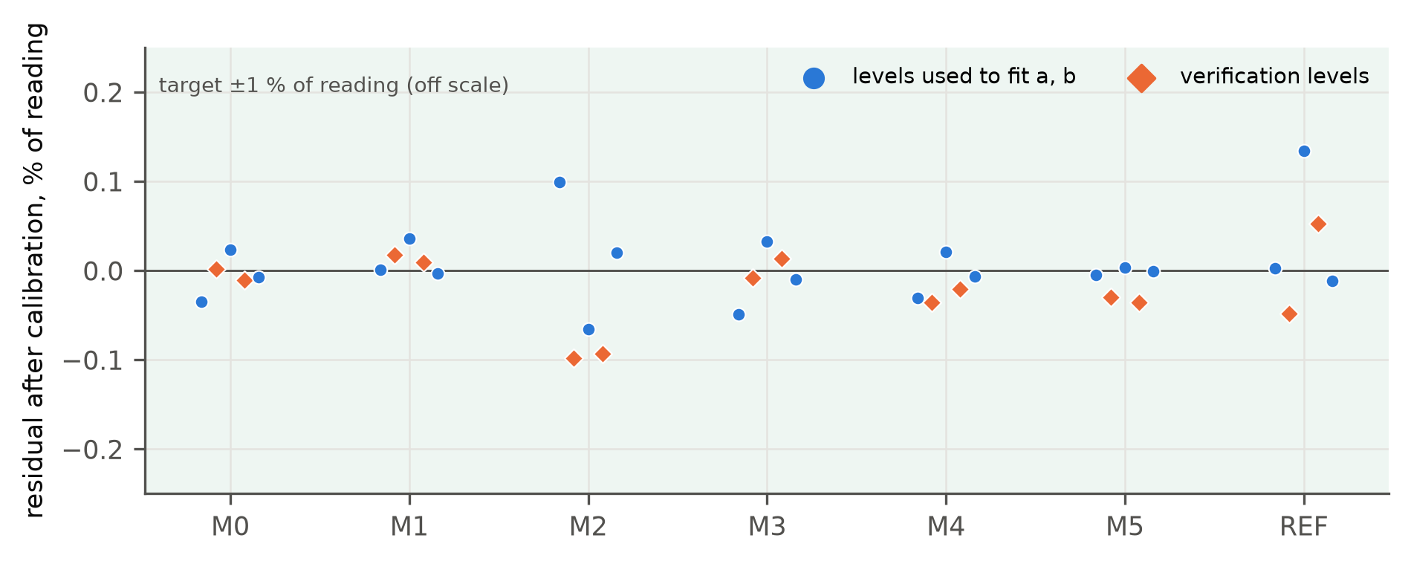
Fig. 4. Residuals after E00 calibration: circles — fit levels, diamonds — verification levels. The ±1 % target is off scale.
Table 20. E00 calibration results (EMU)
Channel | Raw zero, mA | a | b, mA | Max verification residual, % | Pass
M0 | −1.50 | 0.99597 | −0.56 | 0.010 | yes
M1 | −6.29 | 0.99894 | 6.29 | 0.017 | yes
M2 | −0.53 | 0.99708 | −0.24 | 0.098 | yes
M3 | −0.62 | 1.00223 | 0.66 | 0.014 | yes
M4 | 1.22 | 0.99480 | −1.21 | 0.036 | yes
M5 | 1.26 | 1.00334 | −1.67 | 0.036 | yes
REF | 0.15 | 0.99675 | 1.93 | 0.053 | yes

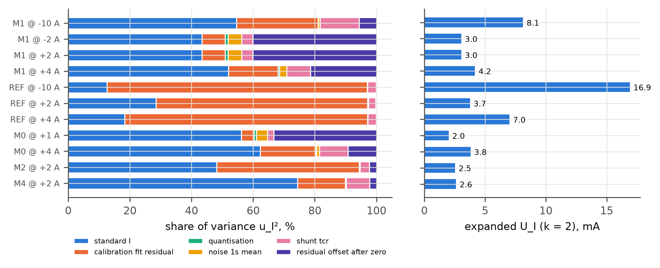
Fig. 5. Uncertainty budget of calibrated 1-s current values: variance shares of the components (left) and expanded uncertainty U_I (k = 2) (right).
Table 21. Expanded uncertainty (k = 2) at operating points
Channel @ I | U_I, mA | U_I, % of reading | U_V, % | U_P, %
M1 @ −10 A | 8.12 | 0.081 | 0.053 | 0.097
M1 @ −2 A | 3.04 | 0.152 | 0.053 | 0.161
M1 @ 2 A | 3.04 | 0.152 | 0.053 | 0.161
M1 @ 4 A | 4.16 | 0.104 | 0.053 | 0.117
REF @ −10 A | 16.90 | 0.169 | 0.051 | 0.177
REF @ 2 A | 3.75 | 0.187 | 0.051 | 0.194
REF @ 4 A | 7.00 | 0.175 | 0.051 | 0.182
M0 @ 1 A | 2.00 | 0.200 | 0.053 | 0.207
M0 @ 4 A | 3.80 | 0.095 | 0.053 | 0.109
M2 @ 2 A | 2.52 | 0.168 | 0.053 | 0.176
M4 @ 2 A | 2.61 | 0.104 | 0.053 | 0.117

D.3. Scenario dynamics
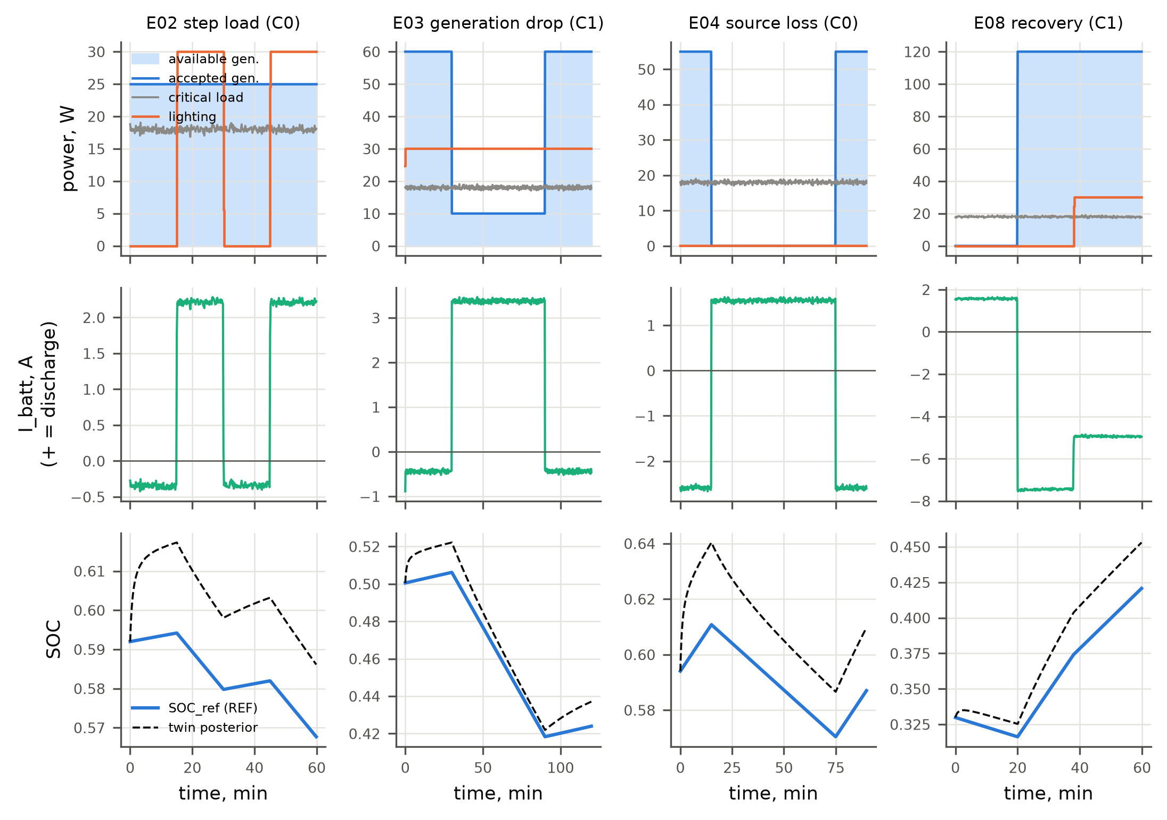
Fig. 6. Dynamics of E02 (step load), E03 (generation drop, C1), E04 (source loss) and E08 (recovery, C1): bus powers (top), battery current (middle, + = discharge) and SOC_ref vs twin posterior (bottom).
Table 22. Per-scenario outcomes (single runs; E03/E08 per policy)
Run | Duration, h | Stop | Coverage, % | Min SOC_ref | Lighting served, Wh | Switches | Commands (confirmed) | Availability, %
E01 C0 | 1.00 | completed | 99.86 | 0.593 | 0.0 | 0 | 1 (1) | 100.000
E02 C0 | 1.00 | completed | 99.89 | 0.568 | 15.0 | 3 | 4 (4) | 99.917
E04 C0 | 1.50 | completed | 99.89 | 0.570 | 0.0 | 0 | 1 (1) | 99.981
E06 C1 | 0.50 | completed | 96.44 | 0.574 | 14.1 | 5 | 5 (3) | 100.000
E07 C1 | 0.50 | completed | 63.94 | 0.555 | 15.0 | 1 | 1 (1) | 99.944
E03 C0 | 2.00 | completed | 99.92 | 0.418 | 60.0 | 1 | 1 (1) | 99.986
E03 C1 | 2.00 | completed | 99.92 | 0.418 | 60.0 | 1 | 1 (1) | 99.986
E03 C2 | 2.00 | completed | 99.94 | 0.472 | 27.5 | 3 | 4 (4) | 100.000
E08 C0 | 1.00 | completed | 99.86 | 0.294 | 30.0 | 1 | 1 (1) | 99.972
E08 C1 | 1.00 | completed | 99.89 | 0.316 | 11.0 | 1 | 2 (2) | 99.972
E08 C2 | 1.00 | completed | 99.89 | 0.316 | 11.0 | 1 | 2 (2) | 99.972

D.4. Twin accuracy (H1)
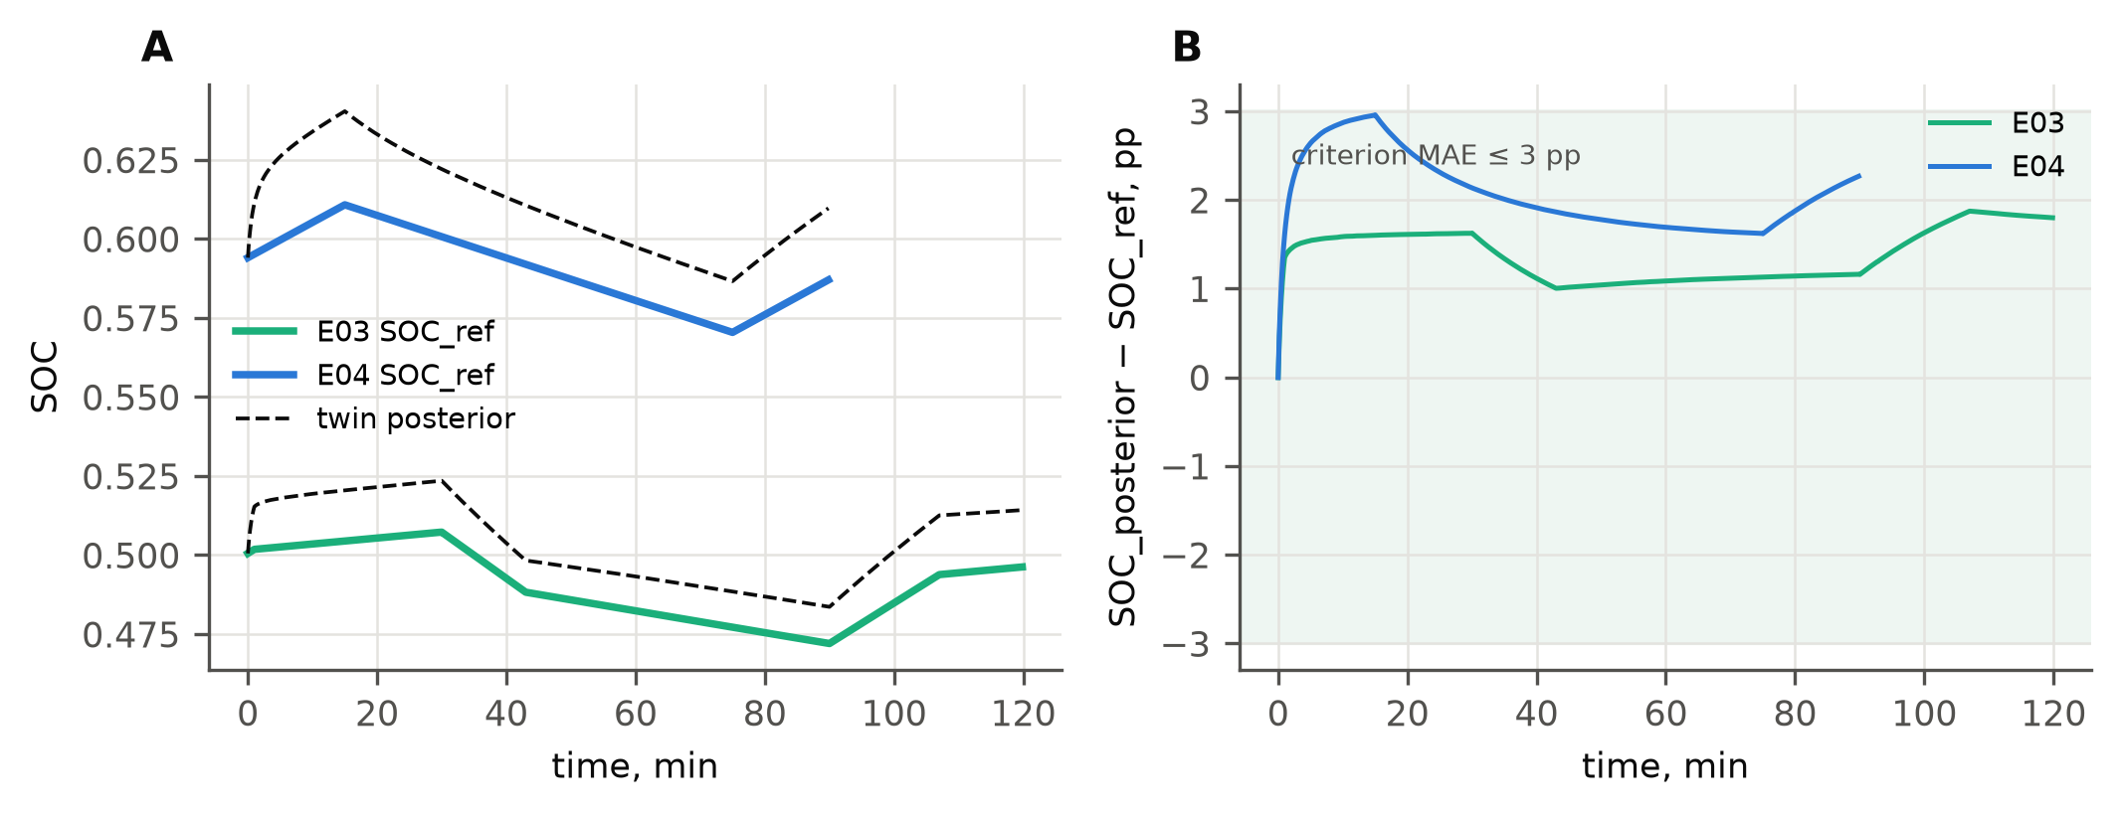
Fig. 7. SOC tracking (A) and error (B) for E03-C2 and E04-C0; shaded band = ±3 pp criterion.
Table 23. State and energy accuracy
Run | MAE, pp | RMSE, pp | Max, pp | Energy error, % | REF − truth, pp | r_P mean ± SD, W
E01 C0 | 1.70 | 1.72 | 2.29 | — | 0.18 | 0.35 ± 0.01
E02 C0 | 2.00 | 2.01 | 2.31 | 0.16 | 0.82 | 0.34 ± 0.08
E04 C0 | 2.07 | 2.11 | 2.96 | 0.14 | 0.61 | 0.34 ± 0.01
E03 C0 | 0.95 | 1.05 | 1.60 | 0.07 | 0.06 | 0.35 ± 0.03
E03 C1 | 0.95 | 1.05 | 1.60 | 0.07 | 0.06 | 0.35 ± 0.03
E03 C2 | 1.38 | 1.41 | 1.87 | 0.16 | 0.03 | 0.35 ± 0.05
E08 C0 | 1.05 | 1.38 | 2.55 | 0.06 | 0.04 | 0.36 ± 0.04
E08 C1 | 2.05 | 2.30 | 3.23 | 0.14 | 0.06 | 0.36 ± 0.05
E08 C2 | 2.05 | 2.30 | 3.23 | 0.14 | 0.06 | 0.36 ± 0.05
E05 C0 (n=10, mean) | 0.86 | — | 1.84 | 0.10 | — | —
E05 C1 (n=10, mean) | 1.12 | — | 3.28 | 0.12 | — | —
E05 C2 (n=10, mean) | 1.63 | — | 2.91 | 0.18 | — | —
E05 C_oracle (n=10, mean) | 1.46 | — | 2.75 | 0.10 | — | —

D.5. Synchronisation and execution (H2, H3)
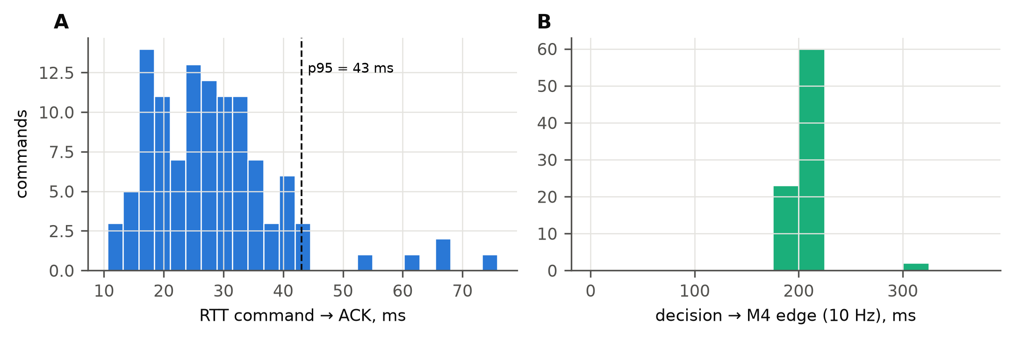
Fig. 8. Command → ACK RTT (A) and decision → M4 current edge (B).

D.6. Faults and protection logic
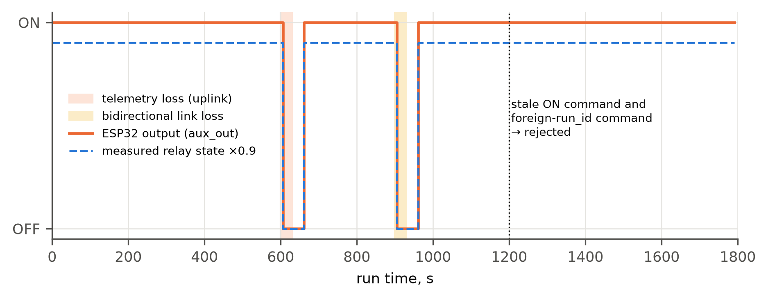
Fig. 9. E06: ESP32 output and measured relay state during uplink loss (600–630 s) and bidirectional loss (900–930 s); stale and foreign-run commands rejected at 1200 s.
Table 24. E06 event log
Time, s | Event / controller entry
605.0 | TELEMETRY_STALE
631.0 | TELEMETRY_RESTORED
905.0 | TELEMETRY_STALE
931.0 | TELEMETRY_RESTORED
0.0 | AUX_ON cmd:20260929_E06_C1_R00_EMU-c00000
605.0 | AUX_OFF cmd:20260929_E06_C1_R00_EMU-c00001
660.0 | AUX_ON cmd:20260929_E06_C1_R00_EMU-c00002
904.5 | STATE RUNNING->DEGRADED (heartbeat stale)
904.5 | AUX_OFF state_DEGRADED
931.0 | STATE DEGRADED->RUNNING (reconciled)
960.0 | AUX_ON cmd:20260929_E06_C1_R00_EMU-c00004
1200.0 | REJECT 20260929_E06_C1_R00_EMU-stale:expired
1200.0 | REJECT 20260929_E06_C1_R00_EMU-oldrun:run_id

Table 25. E07 fault detection
Fault | Parameter | Duration, s | Detected | Latency, s | Flag | Flagged share
current offset | 0.39 | 180 | yes | 4.01 | balance_residual | 98 %
stuck value | — | 180 | yes | 8.01 | stuck_value | 96 %
missing field | p_gen_bus_w | 60 | yes | 0.00 | missing:p_gen_bus_w | 100 %
impossible value | 99.0 | 60 | yes | 0.02 | impossible_voltage | 100 %
sign flip | — | 180 | yes | 4.00 | balance_residual | 98 %

Table 26. E10 protection and contract vectors
Vector | Expected | Observed | State after | Result
ON accepted in RUNNING with permissions | yes | yes | RUNNING | PASS
Low pack voltage (12.2 V < 12.4 V) forces OFF | yes | yes | RUNNING | PASS
ON rejected while local protection active | no | no | RUNNING | PASS
BMS open forces OFF | yes | yes | RUNNING | PASS
Expired command rejected (TTL, clock bound) | no | no | RUNNING | PASS
Wrong run_id rejected | no | no | RUNNING | PASS
Wrong boot_id rejected | no | no | RUNNING | PASS
TOGGLE not accepted (non-idempotent) | no | no | RUNNING | PASS
Duplicate QoS-1 delivery does not re-switch | yes | yes | RUNNING | PASS
Heartbeat loss > 5 s -> DEGRADED, aux OFF | yes | yes | DEGRADED | PASS
ON rejected in DEGRADED | no | no | DEGRADED | PASS
Synthetic-mode command rejected in physical mode | no | no | RUNNING | PASS

D.7. Policy comparison in the deficit test (E05, H4)
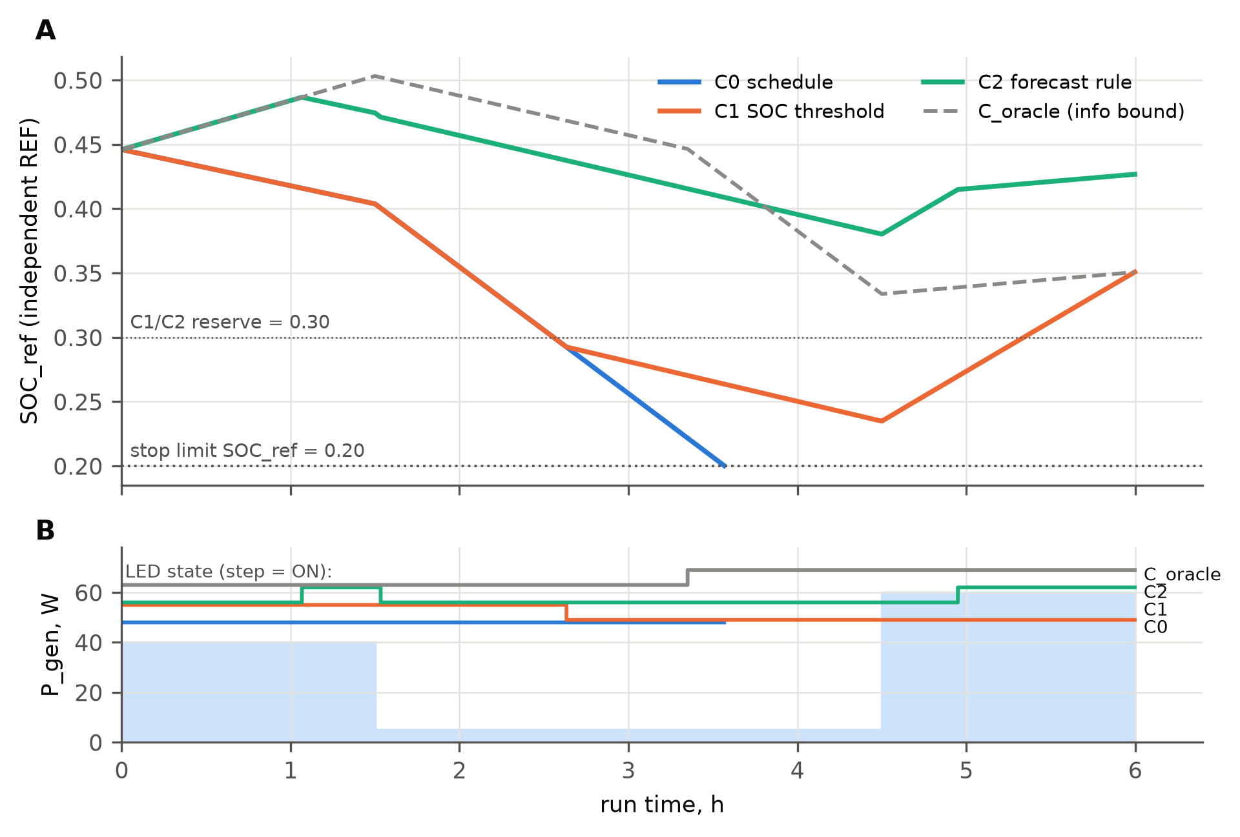
Fig. 10. E05 block R00: SOC_ref of the four policies (A); available generation and lighting state (B).
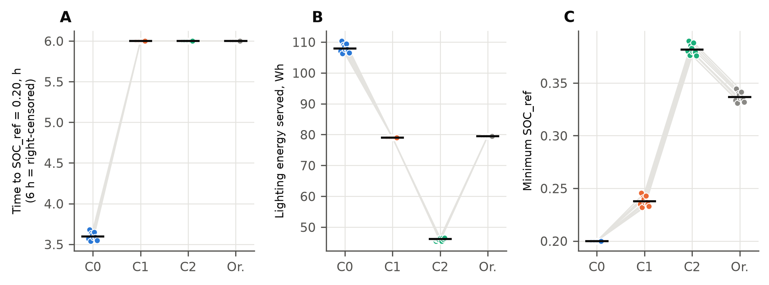
Fig. 11. E05 paired results over 10 blocks: time to limit (A), lighting delivered (B), minimum SOC_ref (C).
Table 27. E05 per-policy summary (mean ± SD over 10 blocks)
Policy | Time to limit, h | Censored | Lighting, Wh | Min SOC_ref | Switches | SOC MAE, pp
C0 | 3.60 ± 0.05 | 0/10 | 107.9 ± 1.4 | 0.200 ± 0.000 | 1.0 | 0.86
C1 | 6.00 ± 0.00 | 10/10 | 79.0 ± 0.0 | 0.238 ± 0.004 | 2.0 | 1.12
C2 | 6.00 ± 0.00 | 10/10 | 46.1 ± 0.4 | 0.382 ± 0.005 | 3.0 | 1.63
C_oracle | 6.00 ± 0.00 | 10/10 | 79.5 ± 0.0 | 0.337 ± 0.004 | 1.0 | 1.46

Table 28. E05 paired contrasts (improvement orientation: later policy − earlier policy)
Contrast | Mean | 95% BCa CI | p sign-flip | p Holm
Time to limit C1 − C0, h (primary) | 2.402 | 2.373; 2.426 | 0.0020 | 0.0039
Time to limit C2 − C1, h (primary) | 0.000 | 0.000; 0.000 | 1.0000 | 1.0000
aux served wh: C1-C0 | −28.948 | −29.791; −28.220 | 0.0020 | expl.
aux served wh: C2-C1 | −32.901 | −33.152; −32.701 | 0.0020 | expl.
aux served wh: C oracle-C2 | 33.400 | 33.200; 33.650 | 0.0020 | expl.
min soc ref: C1-C0 | 0.038 | 0.035; 0.041 | 0.0020 | expl.
min soc ref: C2-C1 | 0.144 | 0.144; 0.145 | 0.0020 | expl.
min soc ref: C oracle-C2 | −0.045 | −0.046; −0.045 | 0.0020 | expl.
switch count: C1-C0 | 1.000 | 1.000; 1.000 | 0.0020 | expl.
switch count: C2-C1 | 1.000 | 1.000; 1.000 | 0.0020 | expl.
switch count: C oracle-C2 | −2.000 | −2.000; −2.000 | 0.0020 | expl.
mae soc pp: C1-C0 | 0.254 | 0.177; 0.275 | 0.0020 | expl.
mae soc pp: C2-C1 | 0.510 | 0.476; 0.518 | 0.0020 | expl.
mae soc pp: C oracle-C2 | −0.168 | −0.180; −0.128 | 0.0020 | expl.
critical unserved wh: C1-C0 | 0.000 | 0.000; 0.000 | 1.0000 | expl.
critical unserved wh: C2-C1 | 0.000 | 0.000; 0.000 | 1.0000 | expl.
critical unserved wh: C oracle-C2 | 0.000 | 0.000; 0.000 | 1.0000 | expl.
aux served common interval wh: C1-C0 | −28.977 | −29.836; −28.244 | 0.0020 | expl.
aux served common interval wh: C2-C1 | −64.338 | −64.588; −64.137 | 0.0020 | expl.
Friedman across C0/C1/C2: lighting χ² = 20.0, p = 4.5e-05. Intervals reflect measurement-noise variability on one bench unit only.

D.8. Fourteen-day scenario and reproduction of the manuscript (E11)
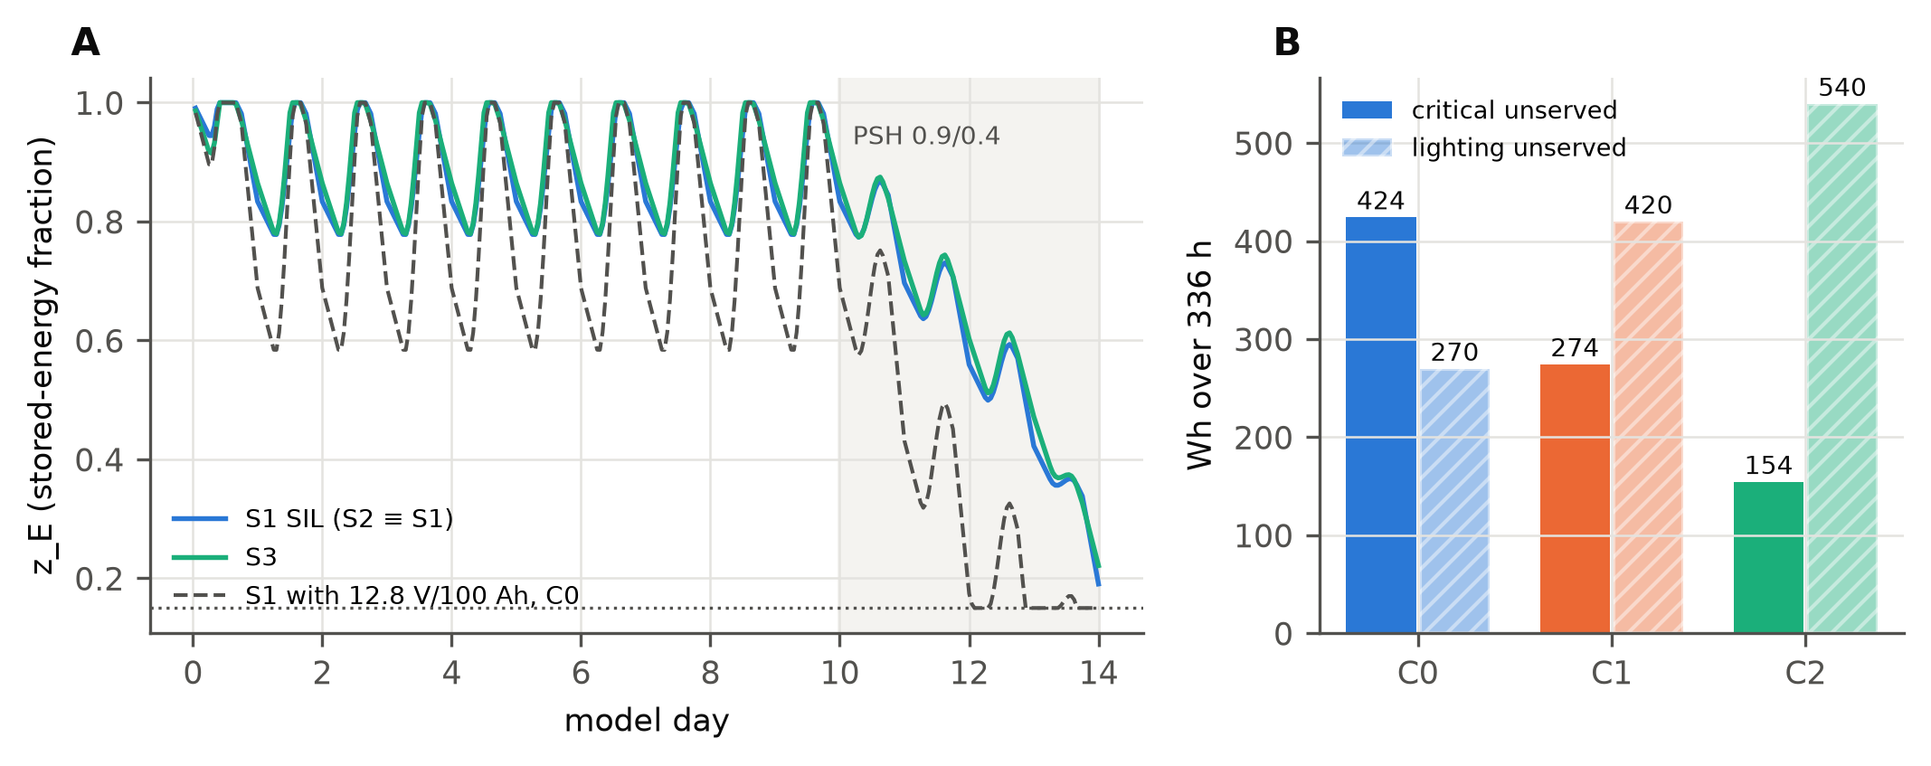
Fig. 12. E11: stored-energy fraction for S1 and S3 (A); critical and lighting unserved energy for S1 with 12.8 V / 100 Ah under C0–C2 (B).
Table 29. E11 SIL reproduction
Scenario | MinSOC manuscript | SIL 1 h | SIL 1 min | Nameplate V | LOLH, h | LPSP_E | Curtailed, Wh
S1 | 0.219 | 0.190 | 0.190 | 0.241 | 0 | 0.0000 | 1180
S2 | 0.219 | 0.190 | 0.190 | 0.241 | 0 | 0.0000 | 1180
S3 | 0.247 | 0.221 | 0.221 | 0.270 | 0 | 0.0000 | 9083

Table 30. E11 lockstep controller replay, S1 with 12.8 V / 100 Ah
Policy | Critical unserved, Wh | Lighting unserved, Wh | Total bus unserved, Wh | LOLH, h | Commands accepted | Switches
C0 | 424 | 270 | 772 | 26 | 27/27 | 27
C1 | 274 | 420 | 772 | 26 | 24/24 | 24
C2 | 154 | 540 | 772 | 22 | 22/22 | 22

Table 31. MinSOC sensitivity to undocumented manuscript parameters
Day order | Battery efficiency | k_T | S1 | S3
late (protocol 10.2) | eta_ch=eta_dis=0.95 | 0.95 | 0.190 | 0.221
late (protocol 10.2) | eta_ch=eta_dis=0.95 | 1.00 | 0.231 | 0.260
late (protocol 10.2) | eta_rt only on charge (0.9025,1) | 0.95 | 0.231 | 0.260
late (protocol 10.2) | eta_rt only on charge (0.9025,1) | 1.00 | 0.269 | 0.297
late (protocol 10.2) | no battery loss (1,1) | 0.95 | 0.261 | 0.292
late (protocol 10.2) | no battery loss (1,1) | 1.00 | 0.298 | 0.327
middle | eta_ch=eta_dis=0.95 | 0.95 | 0.150 | 0.150
middle | eta_ch=eta_dis=0.95 | 1.00 | 0.178 | 0.179
middle | eta_rt only on charge (0.9025,1) | 0.95 | 0.178 | 0.179
middle | eta_rt only on charge (0.9025,1) | 1.00 | 0.219 | 0.220
middle | no battery loss (1,1) | 0.95 | 0.208 | 0.211
middle | no battery loss (1,1) | 1.00 | 0.248 | 0.250
early | eta_ch=eta_dis=0.95 | 0.95 | 0.267 | 0.261
early | eta_ch=eta_dis=0.95 | 1.00 | 0.304 | 0.298
early | eta_rt only on charge (0.9025,1) | 0.95 | 0.304 | 0.298
early | eta_rt only on charge (0.9025,1) | 1.00 | 0.339 | 0.333
early | no battery loss (1,1) | 0.95 | 0.324 | 0.320
early | no battery loss (1,1) | 1.00 | 0.358 | 0.354

D.9. Analytical sizing and sensitivity
Table 32. Sizing (B.4–B.7) — exact agreement with the manuscript
Scenario | E_load, Wh/d | E_src, Wh/d | E_batt, Wh | C, Ah | P_PV, Wp | I²R vs 12 V | Mean bus I, A
S1 | 612 | 680.0 | 1772.9 | 147.7 | 604.4 | 1.0000 | 2.36
S2 | 612 | 680.0 | 1772.9 | 73.9 | 604.4 | 0.2500 | 1.18
S3 | 2820 | 3065.2 | 7991.4 | 166.5 | 2724.6 | 0.0625 | 2.66

Table 33. Sensitivity (S1): required Wp and Ah (reproduces Table 4 of the manuscript)
η_dc | PSH 1.2, Wp | PSH 1.8, Wp | PSH 2.5, Wp | C, Ah
0.85 | 960 | 640 | 461 | 156.4
0.90 | 907 | 604 | 435 | 147.7
0.95 | 859 | 573 | 412 | 140.0

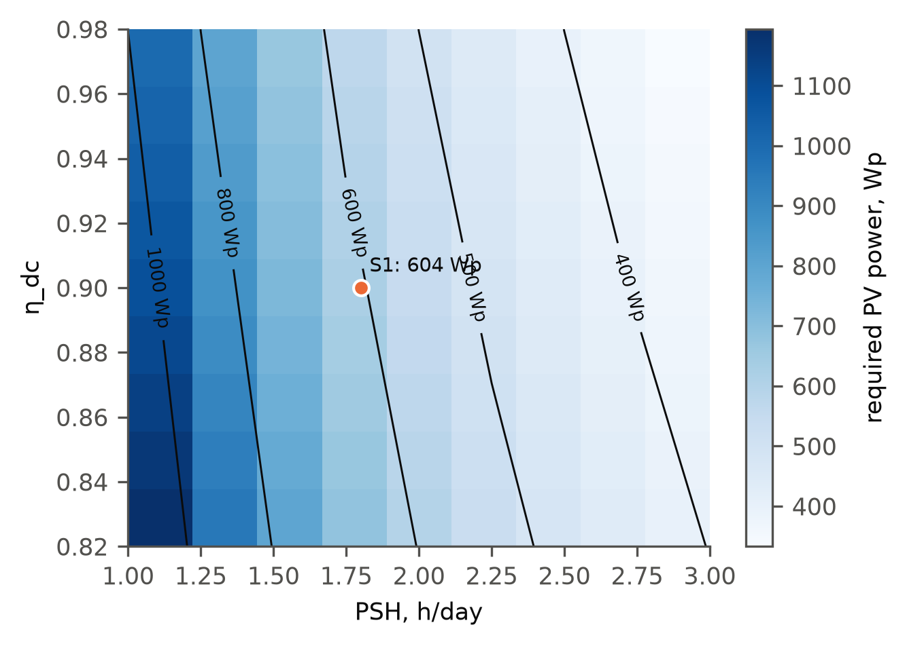
Fig. 13. Required PV power for S1 versus PSH and η_dc.

Part E. Manuscript integration kit

E.1. Proposed new subsection (ready to paste)
Suggested title: “Validation of the digital twin on a virtual testbed with emulated hardware” (keep “hardware-in-the-loop” out of the title until physical runs exist).
Testbed. The digital twin was validated on a virtual testbed that reproduces a 12 V communication-node power supply built from commercially available components: a 12.8 V / 40 Ah LiFePO₄ pack with BMS, a programmable DC supply (RIDEN RD6018) acting as PV equivalent, Mean Well DDR-60G-12 converters feeding an 18 W critical load (router and electronic load) and a relay-switched 30 W lighting branch, INA226 monitors on FL-2 shunts at six measurement points and an independent INA228 reference channel, and an ESP32-S3 edge controller connected over MQTT (Fig. X, Table X). Each component was emulated with its datasheet characteristics (ranges, LSBs, offset and gain errors, noise, delays), while the twin and the energy-management system run unchanged software.
Protocol. Channels were calibrated against a reference standard (E00) and the working-interval capacity was measured by the reference channel (E09). Scenarios covered steady state, step disturbances, source loss, a controlled energy deficit, link loss, faulty sensors, recovery, protection logic and the 14-day stress profile of the original study. Three policies — schedule (C0), SOC threshold (C1) and a forecast-based rule (C2) — were compared in 10 paired blocks with an information-bound oracle.
Results. The twin tracked SOC with a mean absolute error of at most 2.20 pp against the independent reference and reproduced the discharge energy within 0.18 %. Command round-trip time was 43 ms at the 95th percentile, and every accepted command produced a measured current change (median 200 ms after the decision). Link loss and all five injected data faults were detected and handled without interrupting the critical load. Threshold control extended operation to the working limit by 2.40 h (95% CI 2.37–2.43), whereas the forecast rule with a persistence forecast did not improve the primary outcome and delivered 32.9 Wh less lighting; the oracle bound indicates that the benefit of predictive control is limited by the generation forecast.
Limitations. These results were obtained with emulated hardware and establish software and protocol readiness, not physical performance. A physical campaign on the specified bench, using the same software and measurement protocols, is required before hardware-in-the-loop or field claims can be made.

E.2. Figure and table mapping
Table 34. Mapping of dossier figures to the manuscript
Dossier figure | File | Suggested manuscript placement | Short caption
Architecture | fig01_architecture.pdf | Methods, new subsection — Fig. 13 | Architecture of the validation testbed
Wiring | fig10_bench_wiring.pdf | Methods — Fig. 14 or Supplementary | Wiring and measurement points of the 12 V bench
Calibration | fig09_calibration.pdf | Supplementary | Calibration residuals of the measurement channels
Uncertainty | fig12_uncertainty_budget.pdf | Supplementary | Uncertainty budget of current measurements
Scenario dynamics | fig11_scenarios.pdf | Results — Fig. 15 | Response of the twin to load, generation and source disturbances
Twin accuracy | fig04_twin_accuracy.pdf | Results — Fig. 16 | SOC tracking against the independent reference
Timing | fig08_timing.pdf | Results or Supplementary | Command and actuation latency
Link loss | fig05_e06_link_loss.pdf | Supplementary | Behaviour under communication loss
Policy comparison | fig02_e05_timeseries.pdf + fig03_e05_paired.pdf | Results — Fig. 17 (two panels) | Comparison of control policies under deficit
14-day | fig06_e11_14day.pdf | Results — Fig. 18 | 14-day stress profile and load-priority redistribution
Pipeline | fig13_data_pipeline.pdf | Data availability / Supplementary | Reproducible data pipeline

E.3. Insertions for other manuscript sections
Table 35. Proposed text insertions
Section | Insertion
Highlights | “A virtual testbed with emulated real components validates the twin: SOC error ≤ 2.20 pp, actuation confirmed for every command.”
Abstract (append) | “The twin was further validated on a virtual testbed emulating a 12 V bench of real components, showing accurate state tracking, reliable closed-loop actuation and robust fault handling; threshold-based load control extended autonomy, while forecast-based control was limited by forecast quality.”
Methods | Insert Part B text (B.1–B.8) as subsection “Experimental testbed” and Part C as “Validation protocol and metrics”.
Results | Insert E.1 “Results” paragraph with Tables D.1/D.7 and Figs. 15–18.
Discussion | State that predictive control requires a forecast better than persistence and that bench conclusions do not scale automatically to S1–S3.
Conclusions | Add: software and protocols are ready for physical validation; physical HIL campaign is the next step.
Data availability | “Code, configurations, raw logs of all 51 runs, protocols and figures are available in the dt_power_hil package (repository and DOI to be added). No physical measurements are included.”

E.4. Response to the reviewer (draft)
“We thank the reviewer for requesting hardware-based validation. We have specified a 12 V testbed on commercially available components and implemented the complete software chain (digital twin, energy management, ESP32 edge controller logic, logging and analysis). Before spending battery life on physical runs, we validated this chain on a virtual testbed in which each component is emulated with its datasheet characteristics. The revised manuscript reports these results explicitly as a virtual-testbed validation (new Section X, Figs. X–Y). Physical hardware-in-the-loop measurements will be reported once the campaign described in the measurement protocols has been completed.”

E.5. Claims that are and are not supported
Table 36. Claim register
Supported by this dossier | Not supported — do not claim
Software chain works end-to-end with realistic instrument errors | Hardware-in-the-loop, CHIL, PHIL or field validation
SOC error ≤ 3 pp against an independent reference in emulation | Physical SOC accuracy of the bench
Every accepted command had a measured effect (emulated) | Real Wi-Fi/MQTT latency of the bench
Threshold control extends autonomy on the 40 Ah bench model | Superiority of predictive (C2/MPC/RL) control
Analytical sizing of S1–S3 reproduced exactly | Exact reproduction of MinSOC 0.219 / 0.247
Protocols and tolerances are derived from component datasheets | Battery degradation, seasonal reliability or 48 V field performance

Appendix. Full per-run metrics
Table 37. All 51 runs (EMU)
run_id | h | Stop | Cov. % | MAE | Max | E err % | Light Wh | Min SOC_ref | RTT p95 ms
E01_C0_R00 | 1.00 | done | 99.86 | 1.70 | 2.29 | — | 0.0 | 0.593 | 41.7
E02_C0_R00 | 1.00 | done | 99.89 | 2.00 | 2.31 | 0.16 | 15.0 | 0.568 | 41.3
E04_C0_R00 | 1.50 | done | 99.89 | 2.07 | 2.96 | 0.14 | 0.0 | 0.570 | 35.1
E06_C1_R00 | 0.50 | done | 96.44 | 1.09 | 1.19 | 0.86 | 14.1 | 0.574 | 28.8
E07_C1_R00 | 0.50 | done | 63.94 | 0.29 | 0.57 | 36.10 | 15.0 | 0.555 | 43.4
E03_C0_R00 | 2.00 | done | 99.92 | 0.95 | 1.60 | 0.07 | 60.0 | 0.418 | 34.6
E03_C1_R00 | 2.00 | done | 99.92 | 0.95 | 1.60 | 0.07 | 60.0 | 0.418 | 34.6
E03_C2_R00 | 2.00 | done | 99.94 | 1.38 | 1.87 | 0.16 | 27.5 | 0.472 | 33.3
E08_C0_R00 | 1.00 | done | 99.86 | 1.05 | 2.55 | 0.06 | 30.0 | 0.294 | 16.0
E08_C1_R00 | 1.00 | done | 99.89 | 2.05 | 3.23 | 0.14 | 11.0 | 0.316 | 27.7
E08_C2_R00 | 1.00 | done | 99.89 | 2.05 | 3.23 | 0.14 | 11.0 | 0.316 | 27.7
E05_C0_R00 | 3.57 | limit | 99.90 | 1.12 | 1.55 | 0.10 | 107.1 | 0.200 | 30.0
E05_C1_R00 | 6.00 | done | 99.88 | 1.39 | 2.99 | 0.12 | 79.0 | 0.235 | 38.2
E05_C2_R00 | 6.00 | done | 99.86 | 1.91 | 2.61 | 0.18 | 45.5 | 0.380 | 62.2
E05_C_oracle_R00 | 6.00 | done | 99.87 | 1.73 | 2.46 | 0.10 | 79.5 | 0.334 | 29.8
E05_C0_R01 | 3.68 | limit | 99.88 | 0.33 | 0.48 | 0.10 | 110.3 | 0.200 | 15.5
E05_C1_R01 | 6.00 | done | 99.88 | 0.41 | 1.91 | 0.12 | 79.0 | 0.246 | 19.6
E05_C2_R01 | 6.00 | done | 99.90 | 0.84 | 1.54 | 0.18 | 46.0 | 0.390 | 30.4
E05_C_oracle_R01 | 6.00 | done | 99.90 | 0.77 | 1.40 | 0.10 | 79.5 | 0.345 | 19.7
E05_C0_R02 | 3.54 | limit | 99.91 | 1.40 | 1.84 | 0.10 | 106.2 | 0.200 | 33.2
E05_C1_R02 | 6.00 | done | 99.91 | 1.68 | 3.28 | 0.12 | 79.0 | 0.232 | 32.9
E05_C2_R02 | 6.00 | done | 99.91 | 2.20 | 2.91 | 0.18 | 46.0 | 0.376 | 38.2
E05_C_oracle_R02 | 6.00 | done | 99.90 | 2.02 | 2.75 | 0.10 | 79.5 | 0.331 | 32.9
E05_C0_R03 | 3.63 | limit | 99.91 | 0.48 | 0.91 | 0.10 | 109.0 | 0.200 | 16.5
E05_C1_R03 | 6.00 | done | 99.91 | 0.76 | 2.35 | 0.12 | 79.0 | 0.241 | 16.3
E05_C2_R03 | 6.00 | done | 99.91 | 1.28 | 1.97 | 0.18 | 46.0 | 0.386 | 50.3
E05_C_oracle_R03 | 6.00 | done | 99.91 | 1.09 | 1.83 | 0.10 | 79.5 | 0.340 | 65.3
E05_C0_R04 | 3.62 | limit | 99.88 | 0.62 | 1.05 | 0.10 | 108.6 | 0.200 | 27.2
E05_C1_R04 | 6.00 | done | 99.88 | 0.89 | 2.49 | 0.12 | 79.0 | 0.240 | 41.4
E05_C2_R04 | 6.00 | done | 99.88 | 1.41 | 2.11 | 0.18 | 46.5 | 0.383 | 42.7
E05_C_oracle_R04 | 6.00 | done | 99.89 | 1.23 | 1.96 | 0.10 | 79.5 | 0.339 | 27.1
E05_C0_R05 | 3.58 | limit | 99.84 | 0.97 | 1.40 | 0.10 | 107.5 | 0.200 | 29.2
E05_C1_R05 | 6.00 | done | 99.87 | 1.24 | 2.84 | 0.12 | 79.0 | 0.236 | 28.6
E05_C2_R05 | 6.00 | done | 99.86 | 1.76 | 2.47 | 0.18 | 46.5 | 0.380 | 69.3
E05_C_oracle_R05 | 6.00 | done | 99.87 | 1.58 | 2.32 | 0.10 | 79.5 | 0.335 | 29.1
E05_C0_R06 | 3.65 | limit | 99.90 | 0.36 | 0.77 | 0.10 | 109.5 | 0.200 | 20.6
E05_C1_R06 | 6.00 | done | 99.89 | 0.62 | 2.20 | 0.12 | 79.0 | 0.243 | 24.6
E05_C2_R06 | 6.00 | done | 99.89 | 1.13 | 1.83 | 0.18 | 45.5 | 0.388 | 59.1
E05_C_oracle_R06 | 6.00 | done | 99.89 | 0.97 | 1.68 | 0.10 | 79.5 | 0.342 | 35.7
E05_C0_R07 | 3.59 | limit | 99.91 | 0.94 | 1.38 | 0.10 | 107.6 | 0.200 | 16.7
E05_C1_R07 | 6.00 | done | 99.90 | 1.22 | 2.81 | 0.12 | 79.0 | 0.237 | 27.7
E05_C2_R07 | 6.00 | done | 99.84 | 1.73 | 2.44 | 0.18 | 46.5 | 0.380 | 20.9
E05_C_oracle_R07 | 6.00 | done | 99.87 | 1.55 | 2.29 | 0.10 | 79.5 | 0.335 | 21.5
E05_C0_R08 | 3.57 | limit | 99.85 | 1.11 | 1.54 | 0.10 | 107.1 | 0.200 | 24.7
E05_C1_R08 | 6.00 | done | 99.88 | 1.38 | 2.98 | 0.12 | 79.0 | 0.235 | 27.0
E05_C2_R08 | 6.00 | done | 99.87 | 1.90 | 2.61 | 0.18 | 46.0 | 0.379 | 24.6
E05_C_oracle_R08 | 6.00 | done | 99.87 | 1.72 | 2.45 | 0.10 | 79.5 | 0.334 | 24.5
E05_C0_R09 | 3.55 | limit | 99.90 | 1.31 | 1.75 | 0.10 | 106.5 | 0.200 | 32.0
E05_C1_R09 | 6.00 | done | 99.88 | 1.59 | 3.19 | 0.12 | 79.0 | 0.233 | 31.0
E05_C2_R09 | 6.00 | done | 99.86 | 2.10 | 2.81 | 0.18 | 46.5 | 0.376 | 40.4
E05_C_oracle_R09 | 6.00 | done | 99.88 | 1.92 | 2.66 | 0.10 | 79.5 | 0.332 | 31.3

Table 38. E00 calibration levels, channel M1
Level, A | Standard, A | DUT raw, A | DUT SD, mA | Calibrated, A | Residual, mA | Residual, % | Role
−20.00 | −19.9988 | −20.0264 | 1.09 | −19.9989 | −0.13 | 0.001 | fit
−5.00 | −4.9989 | −5.0114 | 1.08 | −4.9998 | −0.86 | 0.017 | verify
1.25 | 1.2495 | 1.2450 | 1.08 | 1.2500 | 0.45 | 0.036 | fit
2.50 | 2.4996 | 2.4962 | 1.08 | 2.4998 | 0.24 | 0.010 | verify
10.00 | 9.9998 | 10.0037 | 1.12 | 9.9995 | −0.32 | −0.003 | fit

Table 39. E00 calibration levels, channel REF
Level, A | Standard, A | DUT raw, A | DUT SD, mA | Calibrated, A | Residual, mA | Residual, % | Role
−20.00 | −19.9959 | −20.0636 | 0.28 | −19.9964 | −0.49 | 0.002 | fit
−5.00 | −4.9999 | −5.0158 | 0.27 | −4.9975 | 2.41 | −0.048 | verify
1.25 | 1.2503 | 1.2541 | 0.28 | 1.2520 | 1.68 | 0.135 | fit
2.50 | 2.5006 | 2.5081 | 0.27 | 2.5019 | 1.32 | 0.053 | verify
10.00 | 10.0025 | 10.0320 | 0.28 | 10.0013 | −1.19 | −0.012 | fit

