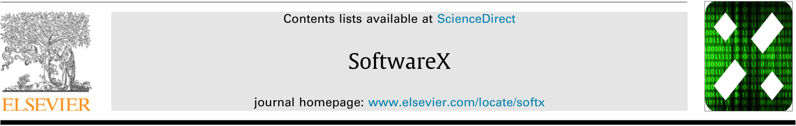
Original software publication

UMSF Incident Lab—Open-source software for rapid, evidence-aware assessment of missile-strike consequences at critical infrastructure facilities and for rescue and recovery logistics
Saltanat Adilzhanovaª, Olga Torstensson^{b,*}, Dmytro Prokopovych-Tkachenko^{c}, Mariia Tykhonenko^{d,e}, Gulzhanat Beketova^{f,a}, Madina Sydybayeva^{g,a}
ª Department of Computer Engineering, Faculty of Information Technology, Almaty Technological University, Almaty, Kazakhstan
^{b} School of Information Technology, Halmstad University, SE-301 18 Halmstad, Sweden
^{c} Department of Cybersecurity and Information Technologies, University of Customs and Finance, Vladimir Vernadsky St. 2/4, Dnipro, 49000, Ukraine
^{d} Independent Researcher, Department of Cybersecurity and Information Technologies, University of Customs and Finance, Dnipro, Ukraine
^{e} Student, Kharkiv National University of Radio Electronics, Kharkiv, Ukraine
^{f} Almaty University of Energy and Communications named after G. Daukeev, Almaty, Kazakhstan
^{g} Satbayev University, Almaty, Kazakhstan
A R T I C L E I N F O  Keywords: missile strike;  consequence assessment;  critical infrastructure;  rescue logistics;  decision support;  data quality;  stream replay;  reproducible research software. |  | A B S T R A C T  This paper presents UMSF Incident Lab, open-source software intended for the rapid assessment of the consequences of a missile strike on a critical infrastructure facility and for planning the logistics of the response: rescue of personnel, recovery of damaged functions and continuity of essential services. Distributed as a self-contained Jupyter notebook, it replays multisensor record streams from worn and stationary sensors under explicit receipt-time cutoffs, validates records against declared schemas, quarantines conflicting duplicates, keeps measurement and receipt times separate, and labels every observation as current, stale, missing or unknown before any group decision or summary is computed. A linked rule-based module, UMSF Incident AI Agent Lab, turns the assessed state into rescue-task assignments, service allocations and repair schedules, reports infeasibility instead of relaxing mandatory constraints, and leaves every proposal awaiting human approval; an auxiliary tool, UMSF Firmware Lab, tests the reference protocol logic natively on a host computer, and a separate archive provides the firmware and local interface of the ESP32 bench prototype. The scenarios are derived from real missile strikes on critical infrastructure facilities in Ukraine in 2026, while all inputs are synthetic or transcribed. On these inputs 217 original tests passed, all 25 reference rows matched earlier synthetic studies, and on identical perturbed streams the full evidence-state rule removed all stale-as-current states, at the cost of more unresolved states during outages; a decision-support run takes well under a second of processing time. Field performance has not been established.
* Corresponding author. E-mail address: olga.torstensson@hh.se (O. Torstensson).

Code metadata
Nr. | Code metadata description | Metadata
C1 | Current code version | v1.2.0 (all three releases; analytical cores umsf_dataset 1.0.0, umsf_agent 1.0.0, firmware 1.0.0)
C2 | Permanent link to code/repository used for this code version | Zenodo archives, each v1.2.0: UMSF Incident Lab (main product), https://doi.org/10.5281/zenodo.23380282; UMSF Incident AI Agent Lab, https://doi.org/10.5281/zenodo.23380523; UMSF Firmware Lab, https://doi.org/10.5281/zenodo.23380409. Bench prototype (firmware and interface, v1.0.0, not part of the verified releases), https://doi.org/10.5281/zenodo.23542153.
C3 | Permanent link to reproducible capsule | None prepared; each release is a self-contained notebook with a hash-checked payload of 66 source and data files
C4 | Legal code license | MIT License
C5 | Code versioning system used | Versioned Zenodo archives with SHA256SUMS inventories
C6 | Software code languages, tools and services used | Python; SQLite; Jupyter notebooks; C/C++ (Firmware Lab); C++ with the Arduino framework for ESP32, HTML and JavaScript (bench prototype)
C7 | Compilation requirements, operating environments and dependencies | Python 3.10 or later. The Incident Lab and Agent Lab analytical cores use only the standard library; optional Incident Lab packages are cryptography (≥ 41), paho-mqtt (≥ 1.6), bleak (≥ 0.21) and pyserial (≥ 3.5). Notebooks: numpy, pandas, matplotlib, seaborn, cryptography, nbformat, nbclient, nbconvert and ipykernel, with the version ranges in requirements.txt. Firmware Lab: GCC (13.3.0 used) and make. Tested for this paper on Linux with CPython 3.13.16, SQLite 3.45.1 and GCC 13.3.0. Bench prototype: PlatformIO with the espressif32 platform for ESP32 DevKit boards; its interface simulator needs only Python 3.8 or later
C8 | If available, link to developer documentation/manual | README.md and docs/ in each release (architecture, dataset format, protocol v1.0, reproducibility, evidence boundaries)
C9 | Support email for questions | olga.torstensson@hh.se

1. Motivation and significance
Incident coordinators at critical infrastructure sites combine readings from worn sensors, stationary nodes and human reports. Incident response is commonly organised around a standard incident management structure [1], and urban search-and-rescue operations are coordinated under international guidelines [2]. Damage to energy and other essential infrastructure makes this a practical problem: interruptions propagate across dependent services, and the information needed for a response arrives incomplete and late [3,4]. In such streams the absence of a deviation is easily confused with the absence of observations [5], a delayed packet can be presented as a current reading [6], and a retransmission can be counted as a new person or event. Optical wearable readings add their own uncertainty [7]. Uncertainty that is not declared in the data or in the decision rule is easily lost, whereas making it explicit is a precondition for interpreting decisions [8]. When these issues are handled implicitly, two analyses of the same incident can disagree without either being wrong in code, and neither can be reproduced.
The intended application is the first hours after a missile strike on a critical infrastructure facility, such as a power plant, a substation or an industrial site that supplies essential services. The response coordinator must establish quickly which zones were hit, whether structural damage, fire or gas prevent entry, which workers are accounted for and which need assistance, and which essential services can still be supplied with the remaining capacity. On that basis the coordinator organises the logistics of consequence management: rescue teams are assigned to tasks, scarce power and resources are allocated among services, and repair work is ordered. Wrong evidence is costly in both directions here: a worker shown as safe on the basis of a stale reading may not be searched for, and a group alarm raised from a few devices can send teams to the wrong zone. The scenarios used in this paper are derived from real missile strikes on critical infrastructure facilities in Ukraine in 2026 [3]: an impact with a blast wave and fire, loss of gateways and stationary nodes, delayed delivery of buffered data, personnel requiring assistance, and capacity insufficient for all services. They reproduce the structure and timing of such incidents but contain no data of real incidents, sites or persons.
Commercial monitoring platforms combine multimodal sensing, dashboards, alerts and gateway buffering [9–11], and general stream processors provide event-time processing, watermarks and late-data handling [12,13] (Table 1). What a researcher studying incident decision rules usually lacks is a small, inspectable tool in which the status and age of every piece of evidence, which matter for situation awareness [14], are explicit from receipt to proposed decision, and in which the same incident can be replayed deterministically under different rules.

Table 1. Relation to existing tool classes (documented functions only).
Criterion | UMSF Incident Lab 1.2.0 | General stream processors (e.g., Apache Flink [12]) | Commercial monitoring platforms [9–11]
Reuse | MIT license; source, tests and data included in the archive | Open source; general-purpose | Proprietary; source code not available
Scenario replay | Deterministic replay at receipt-time cutoffs | Event-time processing with watermarks; replay built by the user | Not documented in the public product information reviewed
Uncertainty handling | Missing, stale, unknown and conflicting records as explicit states | Late data handled by user-defined policies | Not documented in the public product information reviewed
Provenance | Source class, measurement and receipt time, quarantine, rejects and audit logs | Timestamps; provenance model left to the application | Not documented in the public product information reviewed
Decision support | Rule-based proposals with role checks and infeasibility reporting (linked module) | Not in scope | Alerts and dashboards; allocation not documented
Extension | Rosters, horizons, thresholds, services and scenarios are parameters or data files | Programmable | Vendor-dependent

This manuscript presents UMSF Incident Lab, which addresses this need. It lets a researcher (i) replay a synthetic or transcribed multisensor stream at fixed receipt-time cutoffs, (ii) see which observations were current, stale, missing or unknown at each cutoff, (iii) apply a coverage-aware group rule that refuses a group conclusion from too few valid observations, and (iv) compute resource allocations that state explicitly when mandatory services cannot be supported. Together these steps support a rapid assessment of strike consequences and a first plan for rescue and recovery logistics, which a human coordinator approves or rejects. The software grew out of a monitoring research project of the University of Customs and Finance (UMSF). This paper describes the software and its verified behaviour, not a deployed monitoring system; the bench prototype that motivated the record semantics is documented in the Supplementary material for provenance only. Its sensor firmware and local monitoring interface are archived separately [37] and described in Section 4.

2. Software description
The current version (1.2.0) comprises three releases with distinct roles (Table 2). They share record semantics and protocol v1.0 but do not exchange data at run time; they are linked tools, not an integrated platform. Their common rules are described first, under a unified notation; the architecture of each release follows in Section 3. The firmware and interface of the bench prototype are archived separately (v1.0.0) [37]; they are not part of the verified releases and are described with the illustrative examples in Section 4.

Table 2. The three releases (all v1.2.0, MIT license, archived on Zenodo).
Release | Role | Implementation | Main outputs | Checks re-executed for this paper
UMSF Incident Lab [15] | Main product: evidence-aware replay of multisensor streams | Package umsf_dataset 1.0.0 (about 1,900 lines in top-level modules); notebook with 34 analysis cells and 30 figures | Validated SQLite store; CSV/JSONL exports with SHA-256 manifest; quarantine and reject logs; window summaries; offline dashboard | 58/58 unit tests; 25/25 reference rows; 11/11 protocol vectors
UMSF Incident AI Agent Lab [16] | Linked, deterministic rule-based decision support | Package umsf_agent 1.0.0 (about 5,300 lines in top-level modules); notebook with 28 analysis cells and 30 figures | Decision packages (proposals); approval records; hash-chained audit log; report; dashboard | 116/116 unit tests; 44/44 analytical checks
UMSF Firmware Lab [17] | Auxiliary host-side test tool for the reference node firmware | Libraries umsf_proto, umsf_buffer, umsf_features and umsf_gwcore (firmware 1.0.0), built with GCC on a host computer | Native test report; protocol test vectors | 43 native test cases (475 checks); 19/19 vectors verified by a Python verifier and decoded by Incident Lab

2.1. Evidence-state and decision rules
Every record keeps two times, the time of measurement (measured_at) and the time of receipt (received_at), and the state of every source is evaluated at a receipt-time cutoff t using only the records received by t (Fig. 1). At a cutoff t, a personnel device is current (fresh) if its newest received measurement was taken no more than h = 60 s before t, stale if that measurement is older, and missing if no record has been received; a missing device stays in the roster denominator and is never imputed. A late first arrival extends the history but is never made current, and a stationary node whose link is lost becomes unknown instead of receiving a damage state.

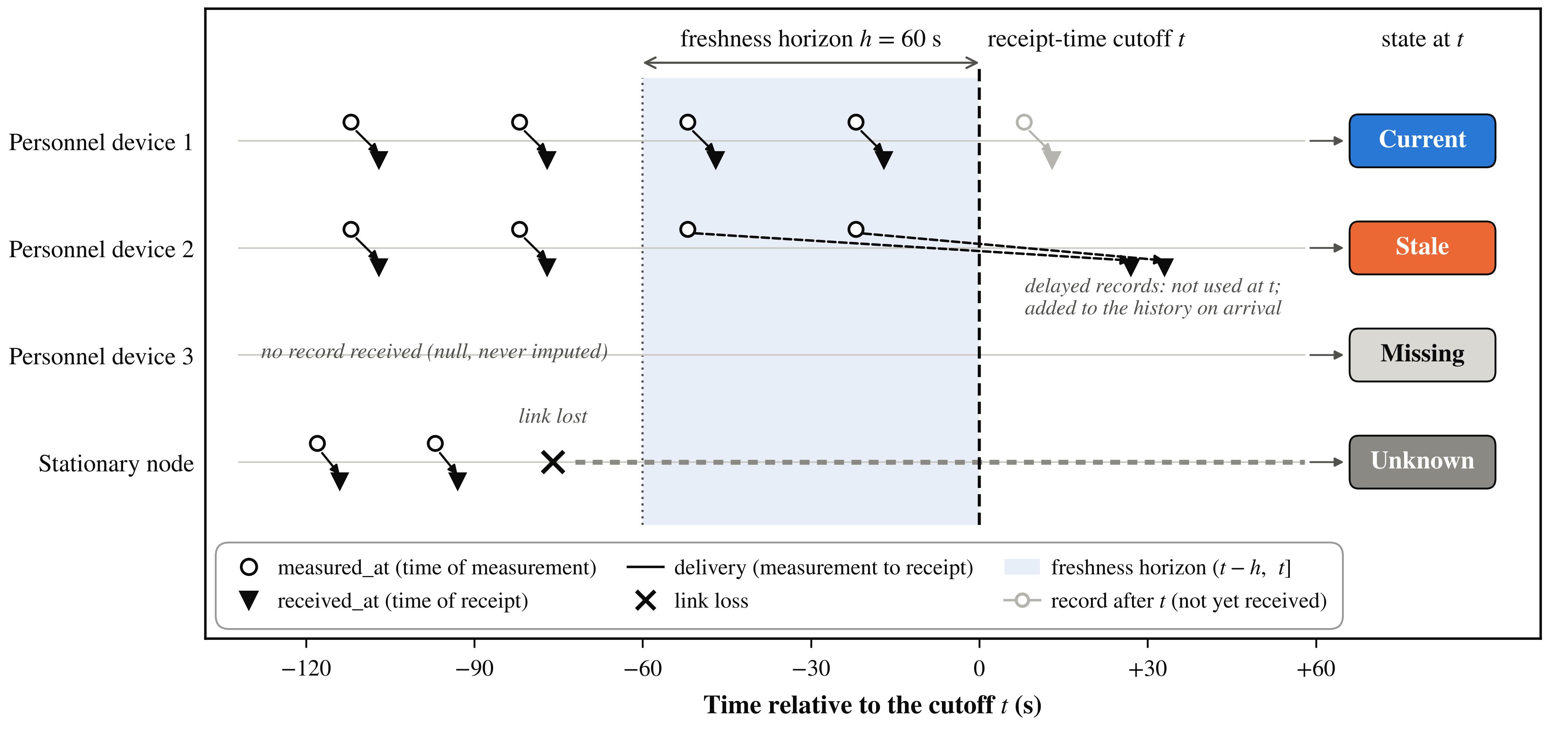
Fig. 1. Schematic of evidence-state classification at a receipt-time cutoff t. Each record is measured (circle) and later received (triangle); only records received by t are used. Device 1 has a measurement within the freshness horizon (t − h, t] and is current; the newer records of device 2 are delayed beyond t, so its newest received measurement is older than h and it is stale; device 3 is rostered but has sent no record and is missing; the stationary node lost its link and is unknown. Delayed records extend the history after they arrive but do not change the state at t.

For zone g with roster size N_{g}, eligible count n_{g} and m_{g} persistent individual flags, the group gate is
$$C_{g}=\frac{n_{g}}{N_{g}}, p_{g}=\frac{m_{g}}{n_{g}}, \left(1\right)$$
$$A_{g}=1\{n_{g}≥n_{min} ∧ C_{g}≥C_{min} ∧ m_{g}≥m_{min} ∧ p_{g}≥θ_{g}\}. \left(2\right)$$
If the roster is absent or N_{g} = 0, no group conclusion is produced. Service continuity selects indivisible services y_{j} ∈ {0, 1} with priority weights ω_{j}, demands η_{sj}, justified capacity lower bounds b_{s}, admissibility γ_{j} and a mandatory set Λ:
maxyj​ωjyj s.t. j​ηsjyj≤bs ∀s, yj≤γj, yj=1 ∀j∈Λ, 3
with prerequisite constraints y_{j} ≤ y_{ℓ}. The reported Q = 100 Σ_{j} ω_{j}y_{j} / Σ_{j} ω_{j} is a weighted service coverage under assumed weights, not a count of people assisted. Rescue assignment solves an exact lexicographic team–task problem, and tasks with unknown eligibility or access are escalated rather than dropped.

3. Software architecture
The analytical cores of the first two releases are Python packages that use only the standard library, and each release runs as a notebook or from the command line (Section 3.3).

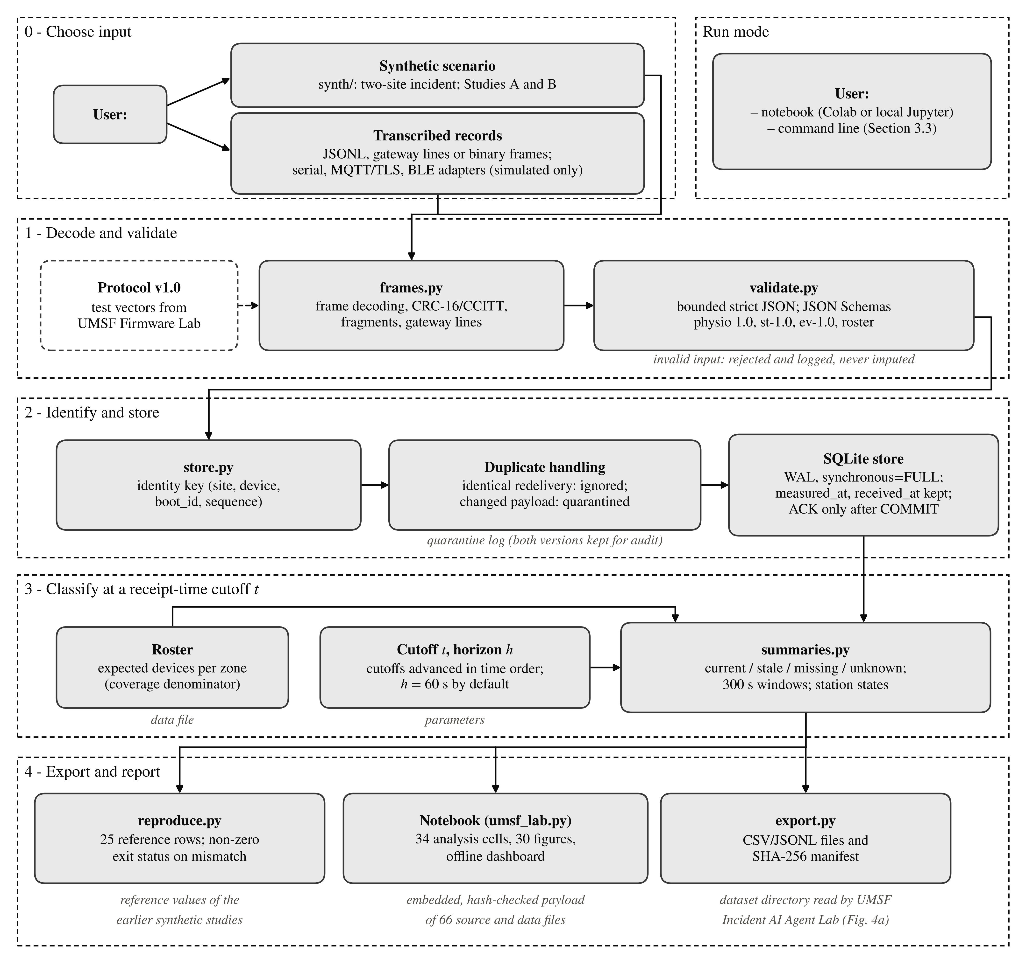
Fig. 2. Architecture of UMSF Incident Lab. Each record passes the numbered stages before it can contribute to summaries; the dataset directory written by export.py is the input of UMSF Incident AI Agent Lab, and the protocol vectors of UMSF Firmware Lab are decoded by frames.py. There is no run-time interface between the releases.

3.1. UMSF Incident Lab
The package umsf_dataset forms the pipeline shown in Fig. 2. The user chooses the input: a scenario generated by the synth/ subpackage, which re-implements two earlier synthetic studies [18,19] and generates the two-site incident scenario used in Section 4, or transcribed records. Adapters for serial, MQTT/TLS and BLE inputs are unit-tested only against simulated interfaces. frames.py decodes binary frames with a CRC-16/CCITT check [20], reassembles fragments and parses gateway text lines; validate.py performs bounded strict JSON parsing [21] (size, depth, duplicate keys, NaN and Infinity) and checks records against JSON Schemas (physio 1.0, station st-1.0, event ev-1.0 and roster). Lines or frames that violate the schema (unknown field, wrong type or range, NaN, malformed JSON) are rejected and logged, never imputed.
Times are ISO-8601 in UTC, missing values are null, never 0 or “normal”, and units appear in field names; a physio record (schema 1.0) carries identity fields, measured_at, received_at, physiological values, quality, battery level and data_origin. The data_origin field labels a record as synthetic or measured, and measured records are rejected unless explicitly allowed; these labels record provenance in the sense of the W3C PROV data model [22]. A roster lists the expected personnel devices per site and zone; these form the coverage denominator (Fig. 3), and stationary nodes are reported separately. Events (ev-1.0) carry a type and a source class: a strike attribution is accepted only from the source class authoritative_external_alert, and a locally derived composite is labelled possible_impact_local (Fig. S1).
A measurement is identified by (site, device, boot_id, sequence). store.py writes accepted records to SQLite in WAL mode with synchronous=FULL [23] and enforces this identity key: an identical redelivery is ignored, whereas a different payload under the same identity quarantines that identity from analytical exports while both versions are kept for audit. An application acknowledgement is issued only after the SQLite COMMIT returns; an MQTT broker acknowledgement [24] never authorizes deletion upstream. summaries.py then classifies every source at each receipt-time cutoff (Section 2.1) and computes roster-based 300 s windows and station states, and export.py writes CSV/JSONL files and a SHA-256 manifest. The notebook embeds the package, its tests and inputs in a hash-checked payload; after three setup cells its 34 analysis cells run individually and produce 30 figures, result tables and an offline dashboard [25].

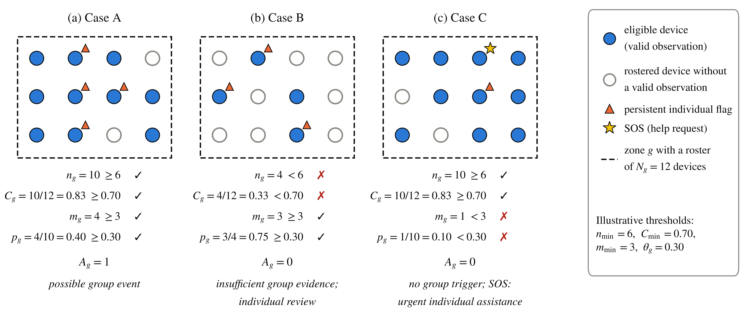
Fig. 3. Graphical representation of the input variables of the coverage-aware group gate, Eqs. (1)–(2), for the constructed cases of Table 4: the zone roster fixes N_{g} = 12, filled markers are eligible devices (n_{g}), triangles are persistent individual flags (m_{g}) and the star is an SOS. Each panel lists the four conditions against the illustrative thresholds and the resulting A_{g}.

3.2. UMSF Incident AI Agent Lab and UMSF Firmware Lab
UMSF Incident AI Agent Lab reads a dataset directory in the format exported by Incident Lab and applies deterministic rules in sequence (Fig. 4a): physio_rules.py computes robust per-person references (median and MAD) [26], capped deviation scores, persistence and the coverage-aware group gate of Eqs. (1)–(2), whose input variables are represented graphically in Fig. 3; incident_state.py assigns a typed zone state (mechanical, hazard, personnel, functional and unknown components) without averaging across evidence types; rescue.py and assignment.py match rescue tasks to teams; continuity.py allocates services exactly over all admissible sets [27]; recovery.py schedules repair activities with a critical-path heuristic [28] that is not guaranteed optimal; policy.py states which role may approve each decision domain; audit.py keeps an unkeyed SHA-256 hash chain [29,30] of approvals and rejections with their reasons. llm.py contains an optional language-model briefing layer, enabled only by an explicit flag, with post-checks and a deterministic fallback; it is not validated and was not used in the notebook or for this paper.
UMSF Firmware Lab compiles the portable C/C++ libraries of the reference node firmware on a host computer and runs native tests and protocol vectors (Fig. 4b). umsf_proto handles frames, CRC, fragmentation and JSON (fragment counts per message type are shown in Fig. S2); umsf_buffer implements a RAM ring with urgent and telemetry priorities; umsf_features computes feature windows, stationary detectors, SOS debounce and link supervision; umsf_gwcore handles gateway identity, the acknowledgement watermark and time mapping. It does not build ESP32 images and does not exercise radio, sensors or power hardware.

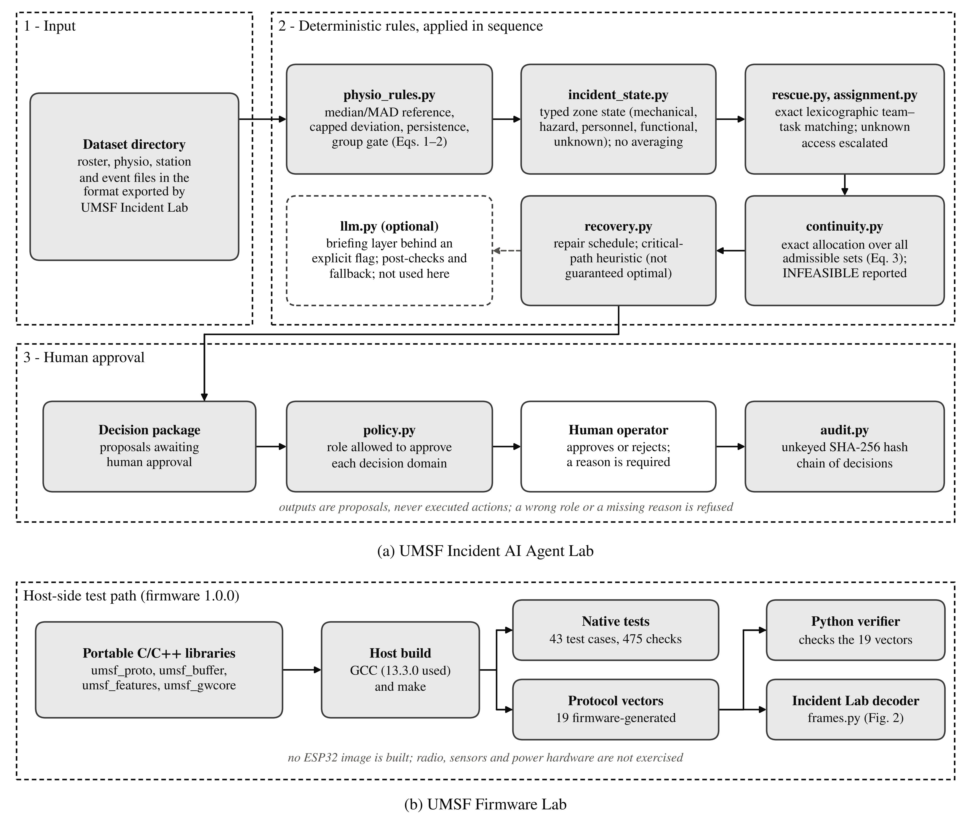
Fig. 4. Companion releases. (a) Rule sequence of UMSF Incident AI Agent Lab and its human-approval loop: rules produce a decision package of proposals, a declared role and a reason are required for every approval or rejection, and decisions are kept in a hash chain. (b) Host-side test path of UMSF Firmware Lab.

3.3. Software functionalities
The main functionalities are the following; Table 3 lists the corresponding edge cases, their expected outcomes and checks.
Missing data versus absence of deviation (summaries.py, physio_rules.py)
Unobserved devices stay in the denominator, and insufficient coverage blocks a group conclusion.
Measurement versus receipt time (store.py, summaries.py)
Both times are stored; states are classified at the receipt-time cutoff.
Duplicates and conflicts (store.py)
Identical redelivery is ignored; a conflicting payload quarantines the identity.
Independent SOS handling (rescue.py)
An SOS bypasses the group gate and persistence.
Explicit infeasibility (continuity.py)
Mandatory services are hard constraints; an infeasible case is reported as INFEASIBLE, with no Q.
Human approval (policy.py, audit.py)
Only the authorised role may approve, and a reason is required.

Table 3. Edge cases with pre-specified expected outcomes and their checks in v1.2.0.
Edge case | Expected outcome | Check in v1.2.0
Rostered device not reporting | Kept in the denominator | test_roster_denominators_not_reporting_devices; Table 4
Roster unavailable | No group conclusion | test_roster_unavailable_no_group_conclusion
Exact duplicate | Counted once | test_duplicates_count_once
Changed payload under the same identity | Identity quarantined; both versions kept for audit | test_dedup_conflict_quarantine
Out-of-order fragments | Reassembled exactly | test_multi_fragment_out_of_order
Late first arrival | Added to history; not current | Replay (Fig. 5a)
Loss of a source | Device stale or missing; stationary node unknown; no damage state | Replay (Fig. 5a)
SOS under insufficient coverage | Urgent task regardless of coverage | Table 4, case C; replay
Unknown access authorization | Escalated, not dropped | test_unknown_access_is_escalated_not_abandoned
Insufficient resources | INFEASIBLE; mandatory services kept | test_infeasible_never_relaxed; Fig. 5c,d
Wrong role or missing reason | Refused; nothing executed | test_wrong_role_or_missing_reason_refused

The notebooks are designed for Google Colab or local Jupyter: the user uploads the notebook and runs all cells. For this paper, local execution was tested; the hosted Colab interface was not. The following commands, run from the release directories, reproduce the tests and checks reported in Section 4 and a decision-support run on a dataset directory; the reproduction exits with a non-zero status on mismatch:
# UMSF Incident Lab (release directory)
PYTHONPATH=src python3 -m unittest discover -s tests
PYTHONPATH=src python3 -m umsf_dataset reproduce
# UMSF Incident AI Agent Lab (package directory)
python -m unittest discover -s tests -t tests
python -m umsf_agent reproduce-paper
umsf-agent run --data <dataset dir> --out <output dir>
# UMSF Firmware Lab (firmware directory)
make -C test/host
Each release ships README.md, CITATION.cff, LICENSE, a changelog, requirements files, docs/, the executed notebook with its HTML report and a SHA256SUMS inventory.

4. Illustrative examples
All examples use synthetic or transcribed inputs, labelled in the data_origin field; release figure numbers refer to [15–17]. The incident and post-impact scenarios follow the pattern of real missile strikes on Ukrainian critical infrastructure facilities in 2026 described in Section 1. The bench prototype at the end of this section is the exception: Figs. 8a and 8b show its interface during a bench run with uncalibrated readings.
Gaps and delays. The incident scenario of UMSF Incident Lab has two sites, twelve personnel devices at 10 s cadence and five stationary nodes, with 2,024 physiological and 7,660 stationary records and 30 events over 30 min. It is replayed at successive receipt-time cutoffs (Fig. 5a). Delayed personnel records appear as stale rather than current; a stationary node whose link is lost changes to unknown for the rest of the scenario instead of receiving a damage state; and records that arrive late extend the history without raising on-time completeness at the original cutoff.
SOS under insufficient group coverage. Three constructed cases with twelve expected workers and illustrative thresholds n_{min} = 6, C_{min} = 0.70, m_{min} = 3 and θ_{g} = 0.30 show how coverage changes the meaning of a group proportion (Table 4; Fig. 3). In case B the affected proportion is high, but only four of twelve workers are observed, so the gate refuses a group conclusion while the individual concerns remain visible. In case C one worker requests help, and the urgent pathway activates without any group threshold. The thresholds illustrate the rule; they are not clinical values.

Table 4. Constructed coverage cases (no participant data).
Case | Expected / valid | Persistent flags | Coverage | Affected proportion | Output
A | 12 / 10 | 4 | 83.3% | 40.0% | Possible group event
B | 12 / 4 | 3 | 33.3% | 75.0% | Insufficient group evidence; individual review
C | 12 / 10 | 1 | 83.3% | 10.0% | Urgent individual assistance; no group trigger

Insufficient resources and decision-support replay. Four indivisible services require 1, 2, 3 and 4 units, with weights 6, 5, 4 and 1; communications and emergency lighting are mandatory, and production requires communications. Exhaustive enumeration of all 16 binary allocations gives: INFEASIBLE for capacity B < 3; Q = 68.75% for 3 ≤ B < 6; Q = 93.75% for 6 ≤ B < 10; and Q = 100% for B ≥ 10 (Fig. 5d). The decision-support module was replayed over 41 one-minute cutoffs in two post-impact scenarios with twelve workers, six zones and six stationary nodes (Fig. 5b,c). The agent kept three urgent tasks explicitly unassigned from minute 7 to minute 28 instead of dropping them, escalated a task whose access authorization was unknown, and reported service continuity as infeasible rather than relaxing a mandatory service when verified backup capacity was absent. On the Incident Lab dataset itself, a run of umsf-agent at the end of the data reports one open assistance request, two unassigned urgent tasks, an optimal continuity allocation with Q = 93.75%, and three blocked recovery activities; it takes about 0.4 s. The Q values in Fig. 5c are those produced by the replay and are not directly comparable with the constructed example above.

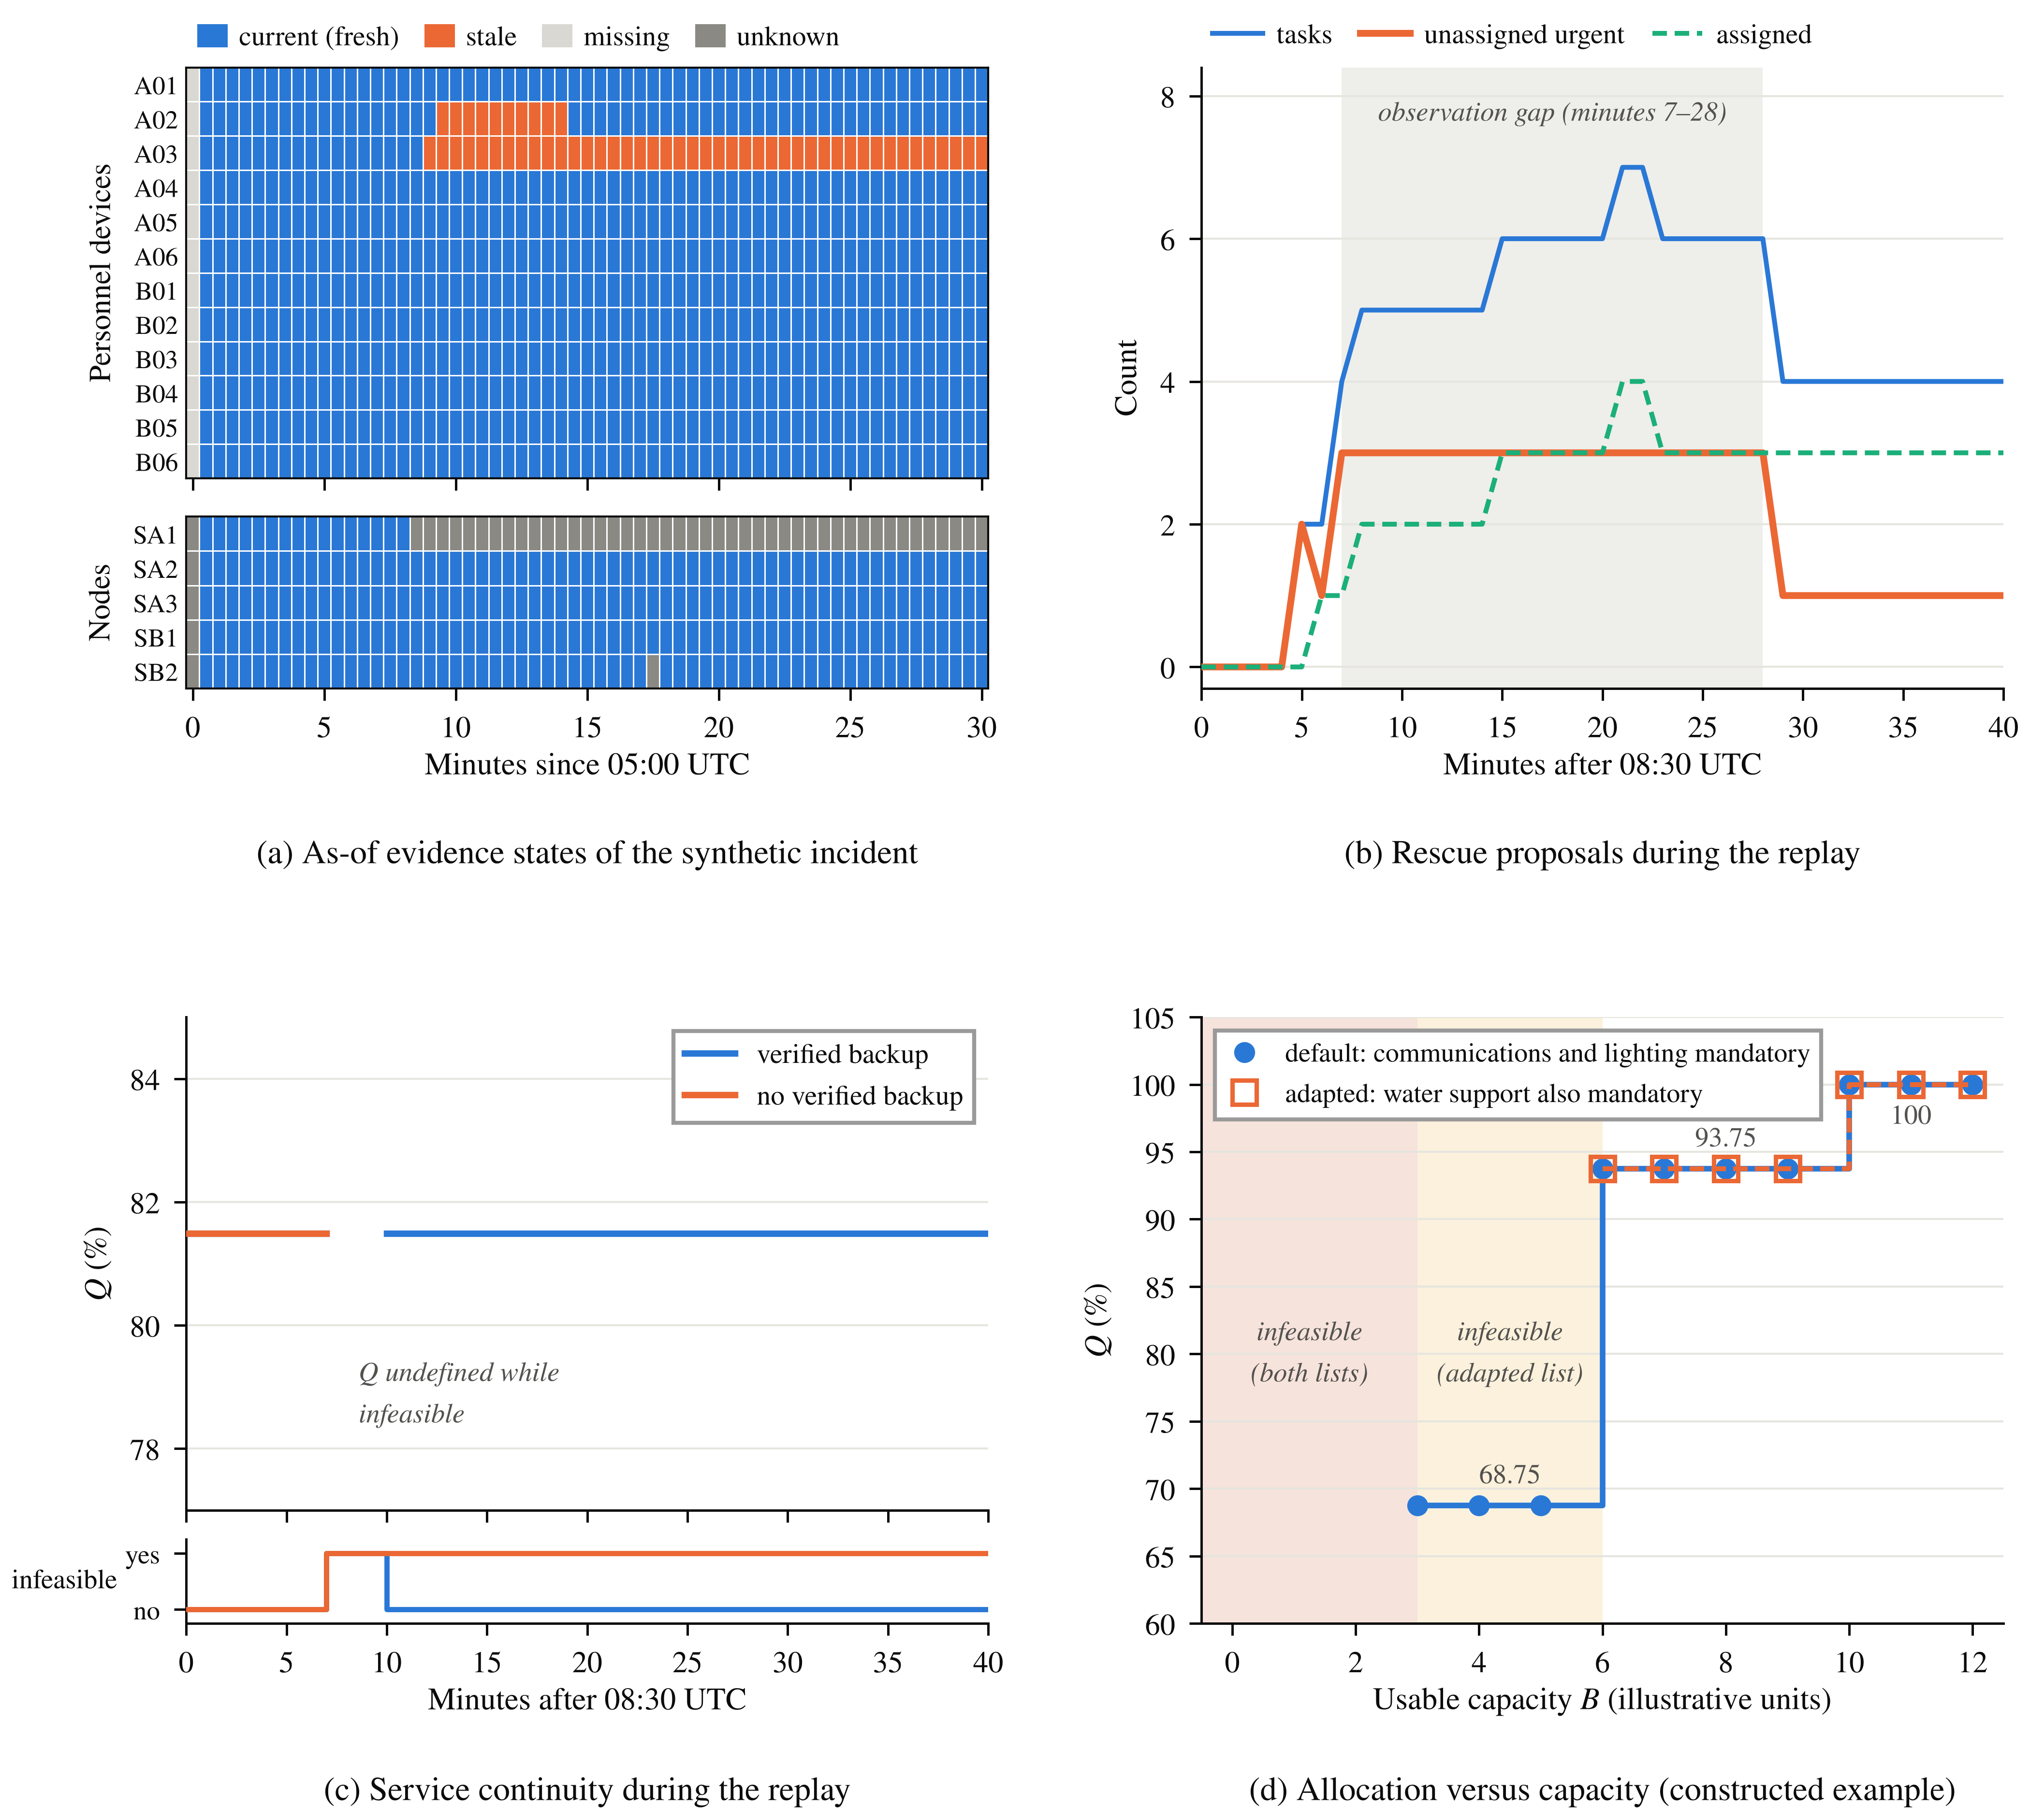
Fig. 5. Illustrative outputs. (a) As-of evidence states of the twelve personnel devices and five stationary nodes in the synthetic 30-min incident at receipt-time cutoffs (redrawn from release figure 19 of UMSF Incident Lab [15]). (b) Rescue tasks, proposed assignments and unassigned urgent tasks over 41 one-minute cutoffs, with the observation gap shaded, and (c) weighted service coverage Q (undefined when infeasible) with and without verified backup capacity, redrawn from the replay data behind release figures 11 and 23 of UMSF Incident AI Agent Lab [16]. (d) Allocation as a function of usable capacity B for the constructed example, for the default service list and for a list in which water support is also mandatory. Synthetic data; outputs are proposals awaiting approval.

Comparison of three configurations on identical streams. To show what the evidence-state rules change, we compared three configurations on identical streams derived from the released incident scenario (Table 5; Fig. S3). C1 shows the last received value of each device as current and computes coverage over the devices that have reported. C2 uses the rostered devices as denominator but still shows the last received value as current. C3 is the full mechanism: the rostered denominator and the release function physio_current_state with its default 60 s freshness horizon. Each of four scenarios (S1–S4, defined with the metrics below Table 5) was run with five seeds at 30 one-minute cutoffs for each site (12 devices; 360 device-cutoffs per run).

Table 5. Configuration comparison, mean over five seeds. Values are for C1 / C2 / C3 out of 360 device-cutoffs per run.
Scenario | Stale value shown as current | Non-reporting rostered device-cutoffs omitted from the denominator | Measuring but not shown as current | Mean coverage error
S1 reference | 27 / 27 / 0 | 0 / 0 / 0 | 0 / 0 / 5 | 0.061 / 0.061 / 0.014
S2 outage, 10 min | 57 / 57 / 0 | 0 / 0 / 0 | 0 / 0 / 35 | 0.061 / 0.061 / 0.097
S3 S2 + 2 devices stop | 81 / 81 / 0 | 0 / 0 / 0 | 0 / 0 / 17 | 0.178 / 0.178 / 0.047
S4 S3 + 1 silent device | 75.6 ± 8.5 / 75.6 ± 8.5 / 0 | 30 / 0 / 0 | 0 / 0 / 16.0 ± 2.0 | 0.249 / 0.166 / 0.044
S1, the reference stream; S2, a 10-min outage of one gateway from minute 8, with backlog delivered at reconnection; S3, S2 with two devices behind that gateway stopping at minute 9; S4, S3 with one further rostered device that never reports. A device counts as measuring at cutoff t if it has a measurement with measured_at in (t − 60 s, t], whether or not that measurement had arrived by t. A shown-as-current device is stale-as-current if its newest arrived measurement is more than 60 s old or none has arrived. Coverage error is the absolute difference between a configuration’s coverage and the true fraction of rostered devices that are measuring, averaged over site-cutoffs.

The full mechanism eliminated stale-as-current states in every scenario, and the roster denominator removed the 30 device-cutoffs in S4 that C1 omits for the silent device. The price is conservatism: during the outage in S2, C3 did not show as current 35 device-cutoffs in which devices were measuring but their data had not yet arrived, so its coverage error was higher than that of C1 and C2 (0.097 against 0.061). In S1, S3 and S4, C3 has the lowest coverage error. These results characterize the rules on synthetic streams; they are not estimates of field accuracy.

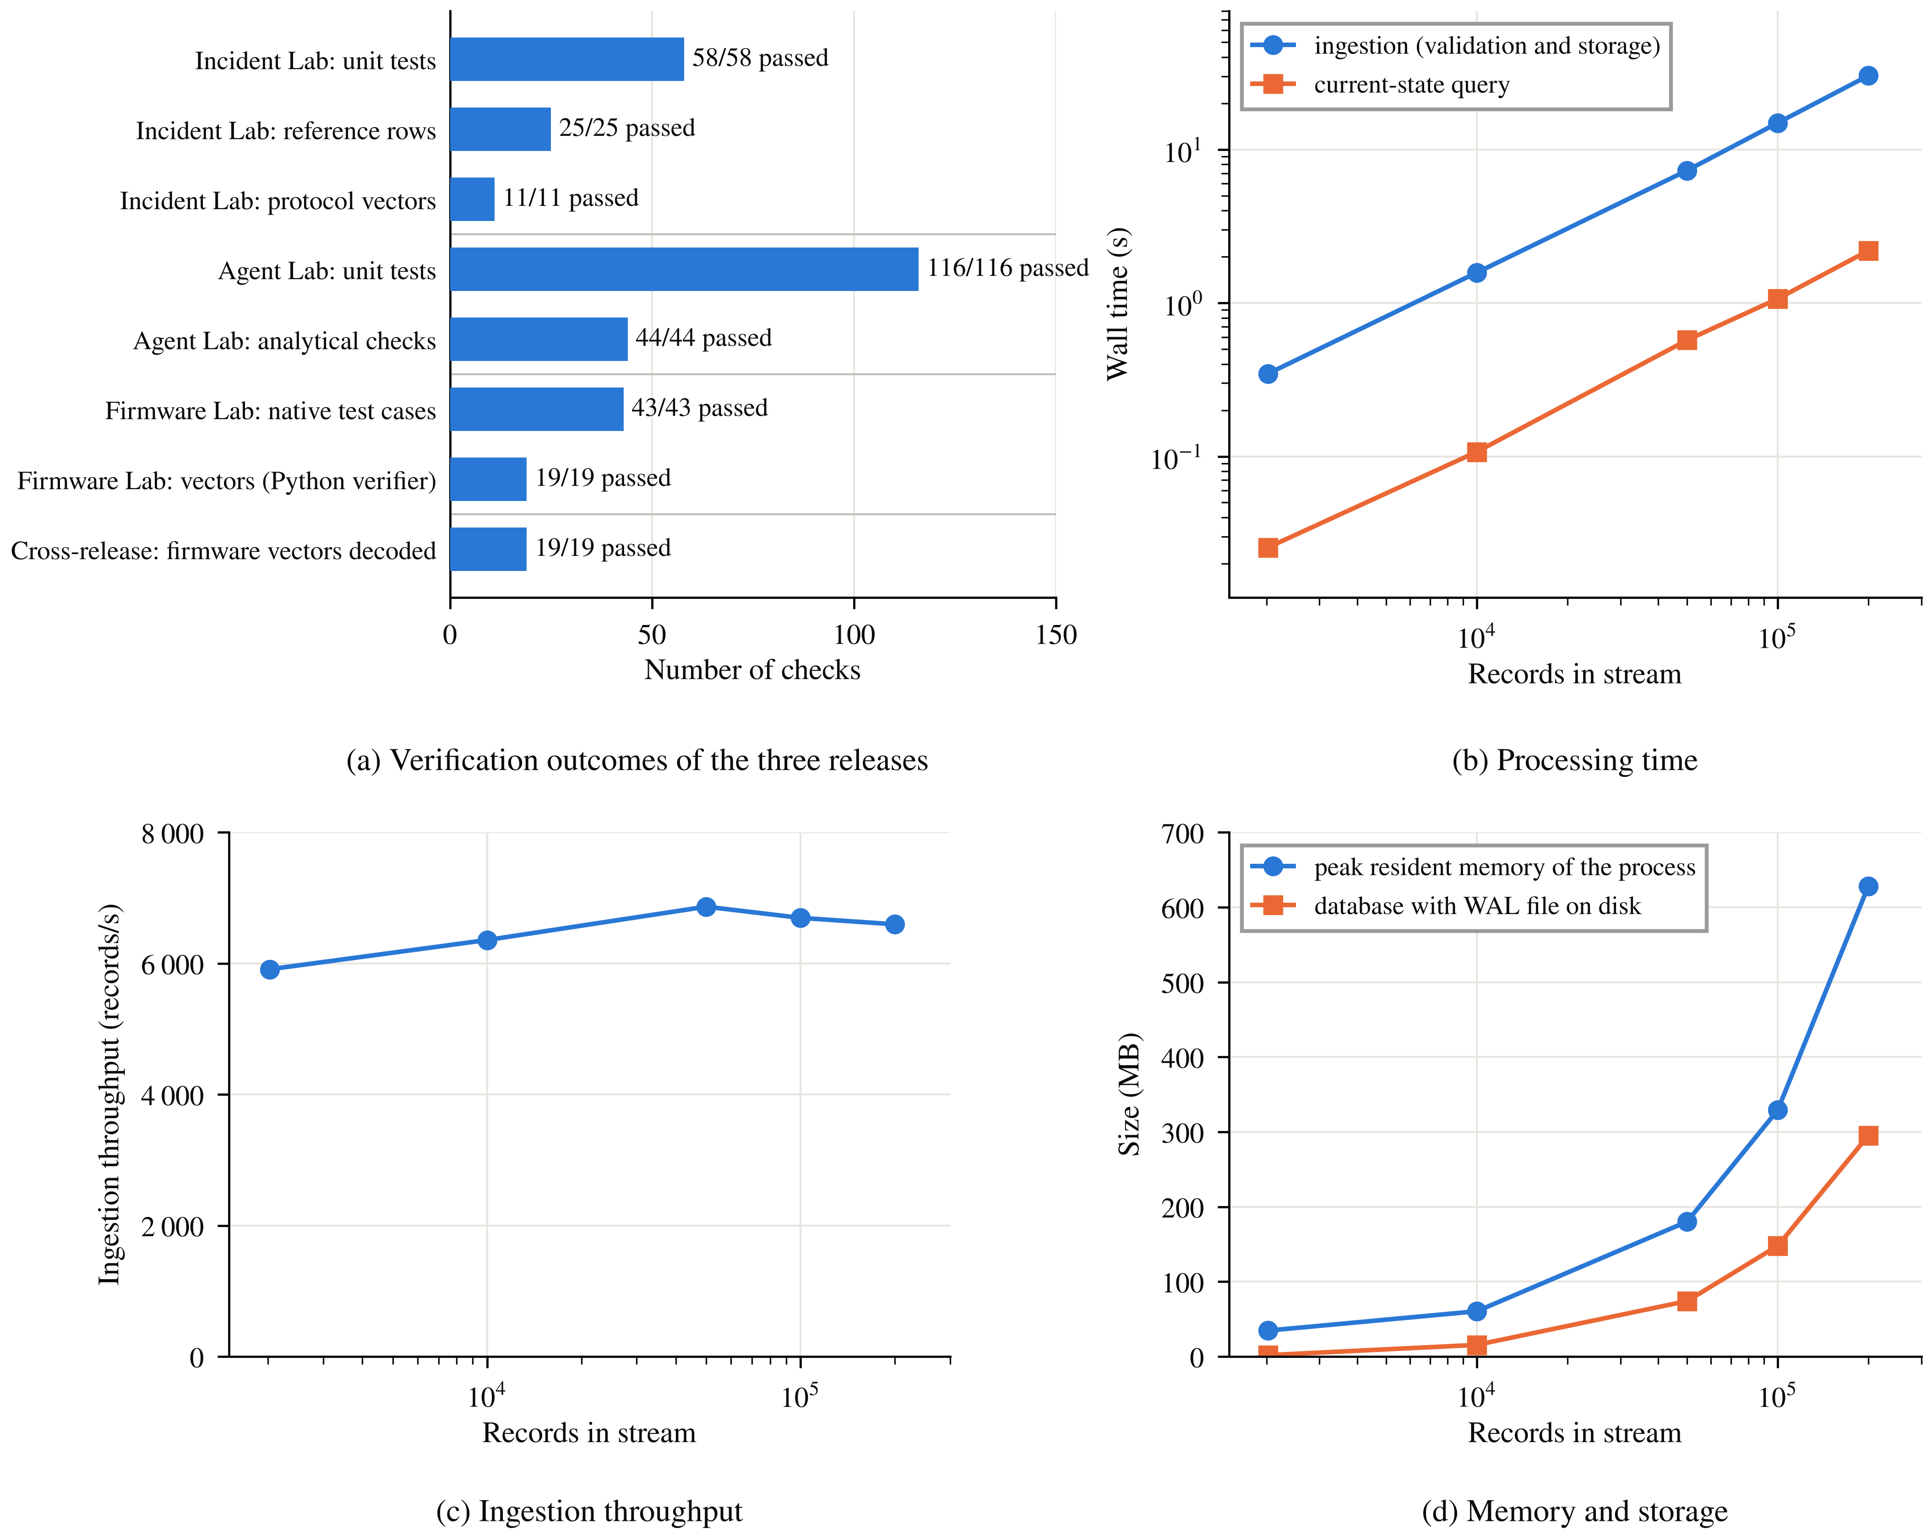
Fig. 6. Outputs of the re-executed releases. (a) Verification outcomes: unit tests, reference rows, protocol vectors, analytical checks and the cross-release decoding of firmware vectors by Incident Lab. (b) Wall time of ingestion and of a current-state query, (c) ingestion throughput and (d) peak memory of the benchmark process and on-disk database size versus stream length for the unchanged umsf_dataset 1.0.0 core. Means of three runs; ± 1 SD is smaller than the markers.

Verification and performance. The outputs of re-executing the three releases are summarized in Fig. 6a. umsf_dataset reproduce compares 25 reference rows with the earlier synthetic studies, including TP = 280, FP = 0, FN = 120 and TN = 4,400 for Study A [18], and the Study B counts of 2,173 input lines, 2,160 unique identities and 2,159 exported non-conflicting records [19]. All 25 rows matched. Because the generators were tuned to these aggregates, this confirms internal consistency, not independent validation. One difference is documented: observed fresh good records in full Study B windows are 33–36 of 36, where the earlier report gives 32–36. All 217 pre-specified tests passed: 58 Incident Lab and 116 Agent Lab unit tests (six of which run only when the neighbouring dataset set, included in the archive, is present) and 43 native firmware test cases with 475 checks. The Incident Lab decoder read all 19 firmware-generated protocol vectors, and umsf-agent processed the Incident Lab dataset directory directly. Ingestion (validation and storage) and a current-state query were timed on streams of 2,024 to 200,000 physiological records, built by replicating the incident stream with distinct identities, with three repetitions per size, on a 2-vCPU Intel Xeon virtual machine at 2.1 GHz with 7 GB RAM, CPython 3.13.16 and SQLite 3.45.1 (Fig. 6b–d). Ingestion was linear at about 5,900–6,900 records per second: 0.34 ± 0.02 s for 2,024 records, 14.9 ± 0.3 s for 100,000 and 30.3 ± 1.2 s for 200,000. A current-state query scans all stored records and took 0.03 s for 2,024 and 2.2 s for 200,000 records. At 200,000 records, the database with its WAL file occupied 295 MB, and the peak resident memory of the benchmark process was 629 MB. An 8-h shift of twelve devices at 10 s cadence (34,560 records) is ingested in about 6 s. These are software processing times on one machine, not transmission latency or incident-response times.
Bench-prototype firmware and interface. The bench prototype that motivated the record semantics is archived as UMSF Bench Prototype v1.0.0 [37] (MIT license). It is not one of the verified releases, and no prototype reading is used as an input in this paper. The bench experiment with the prototype was carried out in the laboratory of the University of Customs and Finance, Dnipro; video recordings of the experiment are available from the corresponding author to anyone interested. The archive contains the firmware of the gateway AG1 and of the wearable nodes W01–W03 (C++, Arduino framework, built with PlatformIO for ESP32 DevKit boards), the gateway’s local monitoring page, an interface simulator, and documentation of the hardware, packet layouts and HTTP interface (Table 6). The nodes broadcast fixed-layout packets over ESP-NOW on Wi-Fi channel 1, once per second and immediately when a status flag changes, so every gateway on the channel receives the same packets (Fig. 7a). The gateway accepts a packet only if both its magic number and its exact length match (40 bytes for a wearable packet, 55 bytes for a fixed-node packet). The receive callback only copies raw bytes into a 16-slot ring, and the packets are processed in the main loop. For each node the gateway counts gaps in the sequence number as lost packets and keeps alarm flags and maxima latched until an operator reset. A node is marked as having lost its link after 5 s without a packet, and its last data remain visible. The rising edge of each flag is entered in a 40-entry event log and written to the serial port as an EVENT line; each wearable packet is also written as a CSV line for logging measurement sessions.

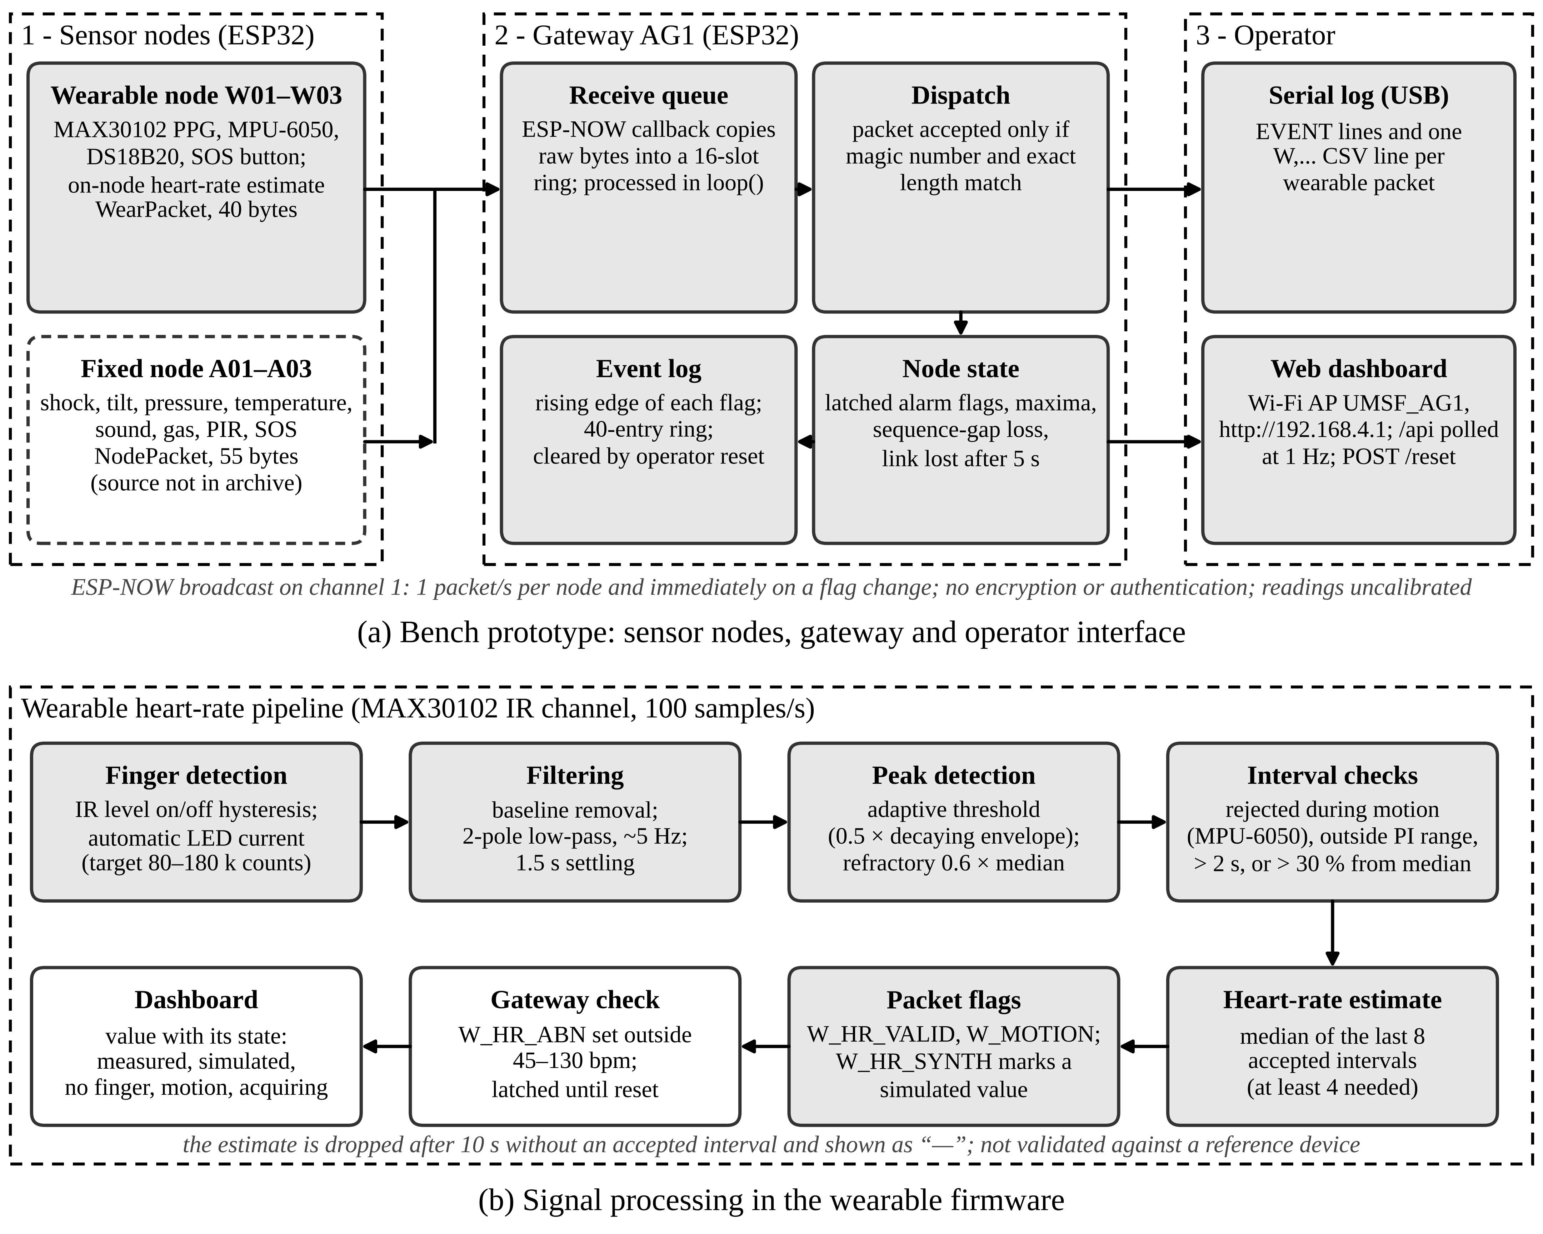
Fig. 7. Bench prototype archived in [37]. (a) Sensor nodes broadcast fixed-layout packets over ESP-NOW; the gateway queues, validates and latches them and serves the operator dashboard and a serial log. The fixed-node firmware is not part of the archive (dashed). (b) Heart-rate processing in the wearable firmware and the way its result is flagged and displayed. Thresholds are bench values, not calibrated.
Table 6. Contents of the bench-prototype archive (UMSF Bench Prototype v1.0.0 [37]).
Component | Files and implementation | Function | Interfaces and main parameters
Gateway AG1 | firmware/gateway/src/main.cpp; C++, 616 lines including the embedded page | ESP-NOW reception, node state, latched alarms, event log, web server | Wi-Fi access point UMSF_AG1, channel 1; GET /, GET /api, POST /reset; link lost after 5 s; serial log at 115,200 baud
Wearable node W01–W03 | firmware/wearable/src/main.cpp; C++, 565 lines | Heart rate, motion and impact, skin temperature, SOS | MAX30102 and MPU-6050 on I²C, DS18B20 on 1-Wire, SOS button; 40-byte packet
Fixed node A01–A03 | firmware/fixed_node/README.md; packet contract only | Shock, tilt, pressure, temperature, sound, gas, motion, SOS | 55-byte packet; firmware source not included
Dashboard | interface/dashboard.html; HTML, CSS and JavaScript extracted verbatim from the gateway | Operator view | Polls /api once per second
Interface simulator | interface/mock_gateway.py; Python standard library, 209 lines | Synthetic /api for inspection without hardware | Scenarios idle, impact, sos and linkloss
Documentation | README.md, docs/HARDWARE.md, docs/PROTOCOL.md, CITATION.cff, SHA256SUMS.txt | Build and wiring instructions, packet layouts with byte offsets, HTTP interface, limitations | —

The wearable firmware estimates heart rate on the node from the infrared channel of a MAX30102 sensor at 100 samples/s (Fig. 7b). After finger detection and automatic adjustment of the LED current, the baseline is removed, the signal is low-pass filtered at about 5 Hz, and peaks are detected with an adaptive threshold and a refractory period. Beat-to-beat intervals are rejected during motion detected by the MPU-6050, outside the perfusion-index range, when longer than 2 s, or when they deviate by more than 30% from the running median. The reported value is the median of the last eight accepted intervals and is withdrawn after 10 s without an accepted interval. An acceleration magnitude above 3 g raises an impact flag and the SOS button raises an SOS flag; both are held for 30 s. A compile-time option sends a simulated heart rate, and every such packet carries a dedicated flag that the dashboard shows as SIMULATED, the same principle as the data_origin field of Incident Lab (Section 3.1).
The gateway runs a Wi-Fi access point and serves a single page at http://192.168.4.1 that polls a JSON endpoint once per second and needs no internet access (Fig. 8). A banner shows the most severe current state. Personnel cards show the heart rate together with its state (measured, simulated, sensor not on finger, motion, acquiring), skin temperature, activity, impact and SOS. Each fixed-node channel is a card with value, unit, categorical status, a one-sentence explanation and a trend of the last 60 polls. Side panels show signs of life (movement, voice or knocking, SOS), a rule-based situation assessment and the event log with a reset control (Fig. 8a,b). A node that stops reporting keeps its last data under an explicit no-link notice instead of being shown as normal (Fig. 8d). These behaviours correspond to rules of Incident Lab: observations stay latched, a lost source is not reported as normal, and an SOS is displayed regardless of other channels. The simulator mock_gateway.py serves the unchanged page with a synthetic JSON endpoint of the same structure in four scenarios (normal operation, impact, SOS and link loss). It uses only the Python standard library, so the interface can be inspected and tested without hardware (Fig. 8c,d). The archive is used as follows:

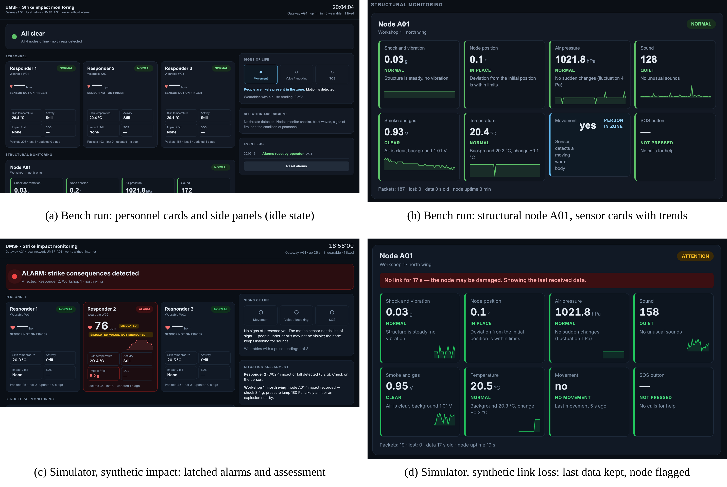
Fig. 8. Local monitoring interface of the bench prototype [37]. (a, b) Screen captures of the gateway dashboard during a bench run: personnel cards with no finger on the PPG sensors, side panels, and the sensor cards of node A01 with their trends. (c, d) The unchanged dashboard served by the interface simulator with synthetic data: (c) latched alarms and the situation assessment after a simulated impact, with the heart rate marked SIMULATED; (d) a node whose link is lost keeps its last data under a no-link notice. Readings are uncalibrated; the cause phrases in the assessment are interface wording, not verified causes (see Known issues and limitations).

# UMSF Bench Prototype (archive directory)
cd firmware/gateway && pio run -t upload
cd firmware/wearable && pio run -t upload # set NODE_ID first
python3 interface/mock_gateway.py --scenario impact
For this paper, the simulator was run in all four scenarios and its pages were rendered in Chromium without script errors, and the packet sizes of 40 and 55 bytes were confirmed by compiling the packed structures on the host.
Known issues. The firmware tests document two behaviours that are reported rather than silently changed: when all slots of the RAM buffer hold urgent records, an incoming telemetry record evicts the oldest urgent record (Fig. S4), and a cumulative acknowledgement releases all sequences at or below its watermark, including unsent ones, so it must be issued only after durable commit and gap accounting. The dashboard of the bench prototype [37] derives cause phrases from fixed thresholds (for example, “ALARM: strike consequences detected” and “Likely a hit or an explosion nearby”, Fig. 8c); these are interface wording, not verified causes, whereas Incident Lab accepts a strike attribution only from an authoritative external source class (Section 3.1).
Limitations. The results of this paper are subject to the following limitations. (i) Data. All quantitative results are obtained on synthetic or transcribed inputs. The scenarios follow the structure and timing of real missile strikes on critical infrastructure facilities in Ukraine in 2026, but they contain no records of real incidents, sites or persons, and the generator parameters were tuned to the aggregates of earlier synthetic studies, so the reproduction confirms internal consistency rather than independent validity. (ii) Validation. The bench experiment was carried out in a laboratory with uncalibrated sensors. No trial at an operating facility, no study with coordinators or rescue teams, and no comparison of the wearable heart-rate estimate with a reference device have been performed, so detection accuracy, false-alarm rates and the benefit for response decisions under real strike conditions are not established. (iii) Timeliness. “Rapid” refers to software processing time: about 0.4 s for a decision-support run and about 6 s to ingest an 8-h shift of twelve devices on one machine. End-to-end latency depends on whether radio links, gateways and power supply survive the strike; evidence that does not arrive is reported as missing or unknown, never inferred.
(iv) Sensing. Stationary nodes observe only their own zones. The motion sensor needs line of sight, so people under debris may not be detected, and the absence of signs of life does not exclude the presence of a person. Physiological readings exist only for personnel who wear a working device in contact with the skin. (v) Decision support. Rules and thresholds are illustrative and must be set by the operator of a facility. Allocations are optimal only with respect to the declared weights, capacities and mandatory services, and repair schedules use a critical-path heuristic that is not guaranteed optimal. All outputs are proposals that a human coordinator must approve: in the taxonomy of levels of automation [32] the module stops at suggesting actions. The software is not a medical device and has not been assessed against medical-device regulation, which depends on intended use [33]. (vi) Security. The CRC detects corruption but provides no authentication; the ESP-NOW packets of the prototype are neither encrypted nor authenticated, and its access-point password is fixed in the source. The role recorded in the approval log is a declared value, not an authenticated identity, and the unkeyed hash chain detects edits to a copied log but cannot prove that a log was not rewritten as a whole. Deployment in operational-technology environments would require security controls for integrity and availability [31] that this software does not provide. (vii) Scale and environment. Performance was measured on one 2-vCPU virtual machine with streams of up to 200,000 records, and the current-state query scans all stored records. Execution was verified locally, not in the hosted Colab interface. The source of the fixed-node firmware is not included in the prototype archive [37].

5. Impact
The software lets a researcher hold an incident constant while changing the rule that interprets it. For operators of critical infrastructure this means that the rules by which strike consequences will be assessed, and rescue and recovery logistics planned, can be prepared and tested before an attack, and that coordinators can be trained on replayed strike scenarios. Typical uses are comparing aggregation or detection rules under identical gaps and delays (Section 4); testing how rules cope with incomplete data; replaying incidents in a controlled time order; studying how capacity, permissions and mandatory services restrict admissible decisions; and teaching stream-data quality in the laboratory. Adaptation changes parameters and data files, not algorithms (Fig. 5d; Fig. S5). Declaring water support mandatory in the service list makes B = 3–5 infeasible (default Q = 68.75%) and leaves Q unchanged for B ≥ 6. Lengthening the freshness horizon changes which devices remain current during a synthetic 10-min gateway outage (minutes 8–18): at minute 9, 7, 8 and 12 of the 12 devices are current for horizons of 20, 60 and 120 s, and after reconnection at minute 19, 10 devices are current for all three. A new scenario is a dataset directory in the documented format, and a new rule can be added beside physio_current_state and compared on the same streams. The bench-prototype archive [37] links the event types of the synthetic scenarios to the firmware that produced them; other groups can rebuild the bench setup, or adapt and test the dashboard with the simulator before connecting hardware.
Deterministic replay, embedded inputs, checksums and stored reference values support the reproducibility expected of research software [34–36]. The next step is a comparative evaluation on independently acquired data with qualified clocks and retained primary logs. No use by other institutions, user numbers or economic effects are claimed.

6. Conclusions
UMSF Incident Lab is intended for the rapid assessment of the consequences of a missile strike on a critical infrastructure facility and for planning the logistics of the response: rescue of personnel, allocation of scarce resources to essential services and the order of recovery work. It provides an open, reproducible way to replay multisensor incident streams in which every observation carries an explicit evidence state, so that missing, delayed or conflicting data are not mistaken for an all-clear, and decisions are restricted by coverage, freshness, authorization and mandatory-service constraints. Its linked decision-support module turns the assessed state into rescue-task assignments, service allocations and repair schedules in less than a second of processing time, always as proposals for a human coordinator. The scenarios are derived from real missile strikes on critical infrastructure facilities in Ukraine in 2026, while all inputs remain synthetic. With the native firmware test tool and the bench-prototype archive, version 1.2.0 offers re-executable behaviour that others can rerun, modify and extend; validation in an operating facility is the next step. The three releases are archived on Zenodo [15–17], and the bench-prototype firmware and interface in a separate archive [37].

CRediT authorship contribution statement
Saltanat Adilzhanova: Conceptualization, Methodology, Software, Writing – original draft. Olga Torstensson: Supervision, Validation, Writing – review & editing. Dmytro Prokopovych-Tkachenko: Methodology, Investigation, Resources, Project administration, Writing – review & editing. Mariia Tykhonenko: Investigation, Data curation, Visualization. Gulzhanat Beketova: Formal analysis, Writing – review & editing. Madina Sydybayeva: Formal analysis, Writing – review & editing.

Declaration of competing interest
The authors declare that they have no known competing financial interests or personal relationships that could have appeared to influence the work reported in this paper.

Acknowledgements
The authors thank Halmstad University for supporting the payment of the article processing charge, and the University of Customs and Finance, Dnipro, Ukraine, for providing the laboratory in which the bench-prototype experiment was carried out. This research did not receive any specific grant from funding agencies in the public, commercial, or not-for-profit sectors.

Data availability
The software, synthetic inputs, executed notebooks and validation reports are archived on Zenodo: UMSF Incident Lab v1.2.0 [15], https://doi.org/10.5281/zenodo.23380282; UMSF Incident AI Agent Lab v1.2.0 [16], https://doi.org/10.5281/zenodo.23380523; and UMSF Firmware Lab v1.2.0 [17], https://doi.org/10.5281/zenodo.23380409. All releases are distributed under the MIT license. The firmware and local monitoring interface of the bench prototype, with an interface simulator that uses synthetic data, are archived as UMSF Bench Prototype v1.0.0 [37], https://doi.org/10.5281/zenodo.23542153 (MIT license). Video recordings of the bench-prototype experiment are available from the corresponding author on request.

Declaration of generative AI and AI-assisted technologies in the writing process
An AI assistant (Claude, Anthropic) was used for language editing, restructuring of the manuscript, drafting and checking of analysis and figure scripts, and re-execution checks. All figures are rendered by plotting scripts from the release data and the values reported in the text; no image was created or altered by a generative image model. Fig. 8 consists of screen captures of the prototype interface and its simulator, cropped but not otherwise altered. It was not used to generate experimental data or measurements. The authors reviewed and edited all content and take full responsibility for it.

Figure provenance
Figs. 1–4 were drawn for this paper. Fig. 5a is redrawn from release figure 19 of UMSF Incident Lab [15]; Figs. 5b and 5c are redrawn from the replay data behind release figures 11 and 23 of UMSF Incident AI Agent Lab [16]; Fig. 5d was recomputed by exhaustive enumeration of the constructed example of Section 4. Fig. 6a summarizes the re-execution results and Figs. 6b–d the benchmark of Section 4, all obtained with the unchanged v1.2.0 code. The provenance of Figs. S1–S7 is given in the Supplementary material. Fig. 7 was drawn for this paper from the archived source code [37]. Figs. 8a and 8b are screen captures of the gateway dashboard during a bench run (uncalibrated readings); Figs. 8c and 8d are screen captures of the unchanged dashboard served by the interface simulator of [37] with synthetic data. The panels were cropped but not otherwise altered.

Appendix A. Supplementary data
Supplementary material related to this article (Section S1 on the bench prototype and Figs. S1–S7) is provided as a separate file. The source code of the bench prototype is archived separately [37].

References
[1] Federal Emergency Management Agency, National Incident Management System, 3rd ed., FEMA, Washington, DC, October 2017, https://training.fema.gov/EMIWeb/IS/IS700b/Handouts/National_Incident_Management%20System_Third%20Edition_October_2017.pdf. Accessed 21 October 2026.
[2] International Search and Rescue Advisory Group (INSARAG), INSARAG Guidelines, 2020 edition, https://insarag.org/methodology/insarag-guidelines/. Accessed 21 October 2026.
[3] World Bank, Government of Ukraine, European Commission and United Nations, Updated Ukraine Recovery and Reconstruction Needs Assessment Released, 23 February 2026. https://www.worldbank.org/en/news/press-release/2026/02/23/updated-ukraine-recovery-and-reconstruction-needs-assessment-released. Accessed 14 October 2026.
[4] International Energy Agency, Ukraine’s Energy Security and the Coming Winter, IEA, Paris, 2024. https://www.iea.org/reports/ukraines-energy-security-and-the-coming-winter. Accessed 14 October 2026.
[5] R.J.A. Little, D.B. Rubin, Statistical Analysis with Missing Data, 3rd ed., Wiley, Hoboken, NJ, 2019, https://doi.org/10.1002/9781119482260.
[6] R.Y. Wang, D.M. Strong, Beyond accuracy: what data quality means to data consumers, J. Manag. Inf. Syst. 12 (4) (1996) 5–33, https://doi.org/10.1080/07421222.1996.11518099.
[7] B. Bent, B.A. Goldstein, W.A. Kibbe, J.P. Dunn, Investigating sources of inaccuracy in wearable optical heart rate sensors, npj Digital Medicine 3 (2020) 18, https://doi.org/10.1038/s41746-020-0226-6.
[8] W.E. Walker, P. Harremoës, J. Rotmans, J.P. van der Sluijs, M.B.A. van Asselt, P. Janssen, M.P. Krayer von Krauss, Defining uncertainty: a conceptual basis for uncertainty management in model-based decision support, Integr. Assess. 4 (1) (2003) 5–17, https://doi.org/10.1076/iaij.4.1.5.16466.
[9] Equivital, Black Ghost, Official product documentation, https://equivital.com/products/black-ghost. Accessed 10 September 2026.
[10] SlateSafety, BAND V2 Connected Safety Wearable Armband, Official product documentation, https://slatesafety.com/products/band-v2/. Accessed 10 September 2026.
[11] U.S. Food and Drug Administration, K242737: Empatica Health Monitoring Platform; EmbracePlus; Empatica Care; Care Portal, 510(k) premarket notification, decision date 6 June 2025, https://www.accessdata.fda.gov/cdrh_docs/pdf24/K242737.pdf. Accessed 21 October 2026.
[12] Apache Software Foundation, Apache Flink documentation: Timely stream processing, https://ci.apache.org/projects/flink/flink-docs-master/docs/concepts/time/. Accessed 21 October 2026.
[13] T. Akidau, R. Bradshaw, C. Chambers, S. Chernyak, R.J. Fernández-Moctezuma, R. Lax, S. McVeety, D. Mills, F. Perry, E. Schmidt, S. Whittle, The Dataflow Model: a practical approach to balancing correctness, latency, and cost in massive-scale, unbounded, out-of-order data processing, Proc. VLDB Endow. 8 (12) (2015) 1792–1803, https://doi.org/10.14778/2824032.2824076.
[14] M.R. Endsley, Toward a theory of situation awareness in dynamic systems, Hum. Factors 37 (1) (1995) 32–64, https://doi.org/10.1518/001872095779049543.
[15] O. Torstensson, D. Prokopovych-Tkachenko, S. Adilzhanova, M. Tykhonenko, G. Beketova, M. Sydybayeva, UMSF Incident Lab: A Self-Contained Reproducible Notebook for Evidence-Aware Multisensor Monitoring in Critical Infrastructure Incident Support, version 1.2.0 [Software], Zenodo, 2026, https://doi.org/10.5281/zenodo.23380282.
[16] O. Torstensson, D. Prokopovych-Tkachenko, S. Adilzhanova, M. Tykhonenko, G. Beketova, M. Sydybayeva, UMSF Incident AI Agent Lab: A Self-Contained Reproducible Notebook for Evidence-Aware Decision Support in Critical Infrastructure Incidents, version 1.2.0 [Software], Zenodo, 2026, https://doi.org/10.5281/zenodo.23380523.
[17] O. Torstensson, D. Prokopovych-Tkachenko, S. Adilzhanova, M. Tykhonenko, G. Beketova, M. Sydybayeva, UMSF Firmware Lab: A Self-Contained Reproducible Notebook for Native Verification of ESP32/BLE Multisensor Monitoring Firmware, version 1.2.0 [Software], Zenodo, 2026, https://doi.org/10.5281/zenodo.23380409.
[18] UMSF project team, Laboratory implementation and synthetic validation (Study A), unpublished technical report, University of Customs and Finance, Dnipro, 2026.
[19] UMSF project team, UMSF Physio offline collector, version 0.1.0 (Study B), unpublished software and technical report, University of Customs and Finance, Dnipro, 2026.
[20] P. Koopman, T. Chakravarty, Cyclic redundancy code (CRC) polynomial selection for embedded networks, in: Proc. Int. Conf. on Dependable Systems and Networks (DSN 2004), IEEE, 2004, pp. 145–154, https://doi.org/10.1109/DSN.2004.1311885.
[21] T. Bray (Ed.), The JavaScript Object Notation (JSON) Data Interchange Format, RFC 8259, Internet Engineering Task Force, December 2017, https://doi.org/10.17487/RFC8259.
[22] L. Moreau, P. Missier (Eds.), PROV-DM: The PROV Data Model, W3C Recommendation, 30 April 2013, https://www.w3.org/TR/2013/REC-prov-dm-20130430/. Accessed 21 October 2026.
[23] SQLite, Write-Ahead Logging, Official documentation, https://www.sqlite.org/wal.html. Accessed 10 September 2026.
[24] OASIS, MQTT Version 5.0, OASIS Standard, 2019, https://docs.oasis-open.org/mqtt/mqtt/v5.0/mqtt-v5.0.html. Accessed 21 October 2026.
[25] T. Kluyver, B. Ragan-Kelley, F. Pérez, et al., Jupyter Notebooks: a publishing format for reproducible computational workflows, in: F. Loizides, B. Schmidt (Eds.), Positioning and Power in Academic Publishing: Players, Agents and Agendas, IOS Press, 2016, pp. 87–90, https://doi.org/10.3233/978-1-61499-649-1-87.
[26] C. Leys, C. Ley, O. Klein, P. Bernard, L. Licata, Detecting outliers: do not use standard deviation around the mean, use absolute deviation around the median, J. Exp. Soc. Psychol. 49 (4) (2013) 764–766, https://doi.org/10.1016/j.jesp.2013.03.013.
[27] H. Kellerer, U. Pferschy, D. Pisinger, Knapsack Problems, Springer, Berlin, 2004, https://doi.org/10.1007/978-3-540-24777-7.
[28] J.E. Kelley Jr., M.R. Walker, Critical-path planning and scheduling, in: Proceedings of the Eastern Joint Computer Conference, 1959, pp. 160–173, https://doi.org/10.1145/1460299.1460318.
[29] B. Schneier, J. Kelsey, Secure audit logs to support computer forensics, ACM Trans. Inf. Syst. Secur. 2 (2) (1999) 159–176, https://doi.org/10.1145/317087.317089.
[30] National Institute of Standards and Technology, Secure Hash Standard (SHS), FIPS PUB 180-4, NIST, Gaithersburg, MD, 2015, https://doi.org/10.6028/NIST.FIPS.180-4.
[31] K. Stouffer, M. Pease, C. Tang, T. Zimmerman, V. Pillitteri, S. Lightman, A. Hahn, S. Saravia, A. Sherule, M. Thompson, Guide to Operational Technology (OT) Security, NIST Special Publication 800-82, Revision 3, NIST, Gaithersburg, MD, 2023, https://doi.org/10.6028/NIST.SP.800-82r3.
[32] R. Parasuraman, T.B. Sheridan, C.D. Wickens, A model for types and levels of human interaction with automation, IEEE Trans. Syst. Man Cybern. A 30 (3) (2000) 286–297, https://doi.org/10.1109/3468.844354.
[33] U.S. Food and Drug Administration, Clinical Decision Support Software: Guidance for Industry and Food and Drug Administration Staff, 28 September 2022 (Federal Register notice 2022-20993), https://www.govinfo.gov/content/pkg/FR-2022-09-28/pdf/2022-20993.pdf. Accessed 21 October 2026.
[34] M.D. Wilkinson, M. Dumontier, I.J. Aalbersberg, et al., The FAIR Guiding Principles for scientific data management and stewardship, Scientific Data 3 (2016) 160018, https://doi.org/10.1038/sdata.2016.18.
[35] M. Barker, N.P. Chue Hong, D.S. Katz, et al., Introducing the FAIR Principles for research software, Scientific Data 9 (2022) 622, https://doi.org/10.1038/s41597-022-01710-x.
[36] G.K. Sandve, A. Nekrutenko, J. Taylor, E. Hovig, Ten simple rules for reproducible computational research, PLoS Comput. Biol. 9 (10) (2013) e1003285, https://doi.org/10.1371/journal.pcbi.1003285.
[37] O. Torstensson, D. Prokopovych-Tkachenko, S. Adilzhanova, M. Tykhonenko, G. Beketova, M. Sydybayeva, UMSF Bench Prototype: ESP32 sensor firmware and local monitoring interface, version 1.0.0 [Software], Zenodo, 2026, https://doi.org/10.5281/zenodo.23542153.

