Supplementary material – additions (Figs. S8 and S9)
UMSF Incident Lab: Evidence-aware assessment of missile-strike consequences at critical infrastructure facilities
To comply with the SoftwareX limit of six figures in the main text, two figures of the previous manuscript version were moved here. Please append them to the existing Supplementary material file after Fig. S7. Reference numbers in square brackets refer to the reference list of the main text. Main text: https://github.com/omega2417/bnt/blob/claude/amazing-mayer-2fbcqe/papers/UMSF_Incident_Lab_SoftwareX_OSP.docx; repository: https://github.com/omega2417/bnt.
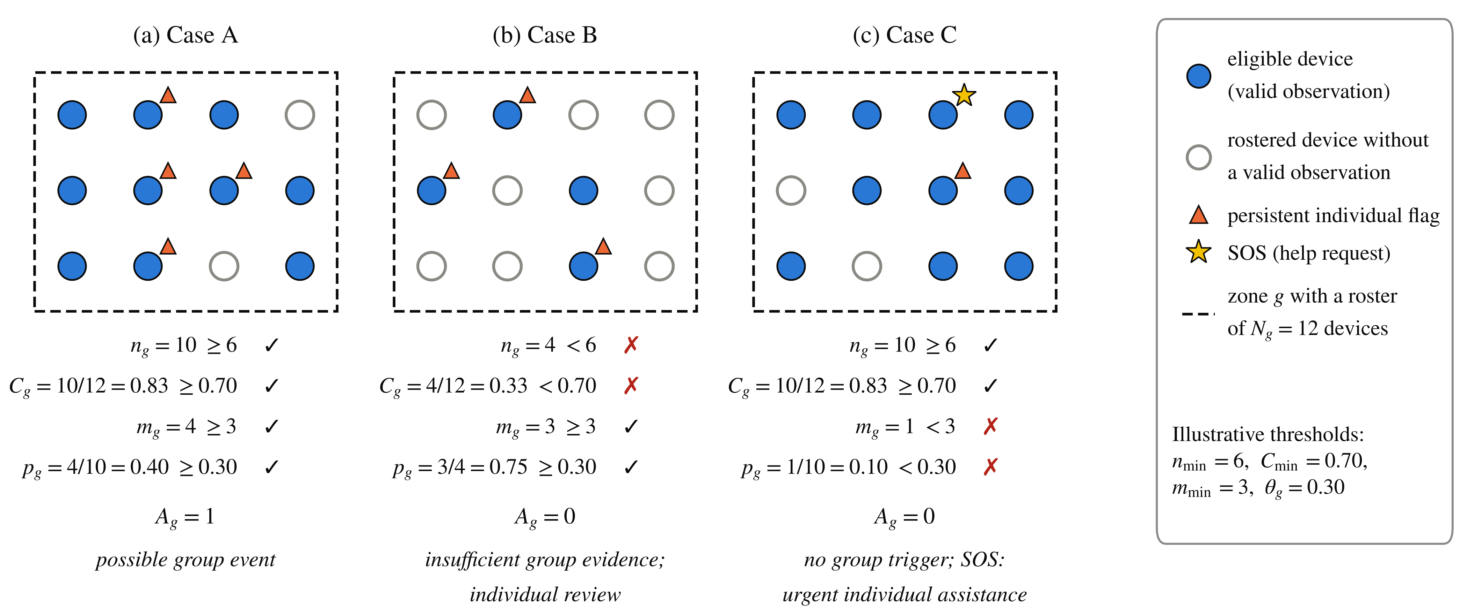
Fig. S8. Graphical representation of the input variables of the coverage-aware group gate, Eqs. (1)–(2) of the main text, for the constructed cases of Table 4: the zone roster fixes N_{g} = 12, filled markers are eligible devices (n_{g}), triangles are persistent individual flags (m_{g}) and the star is an SOS. Each panel lists the four conditions against the illustrative thresholds and the resulting A_{g}. (Fig. 3 of the previous manuscript version.)
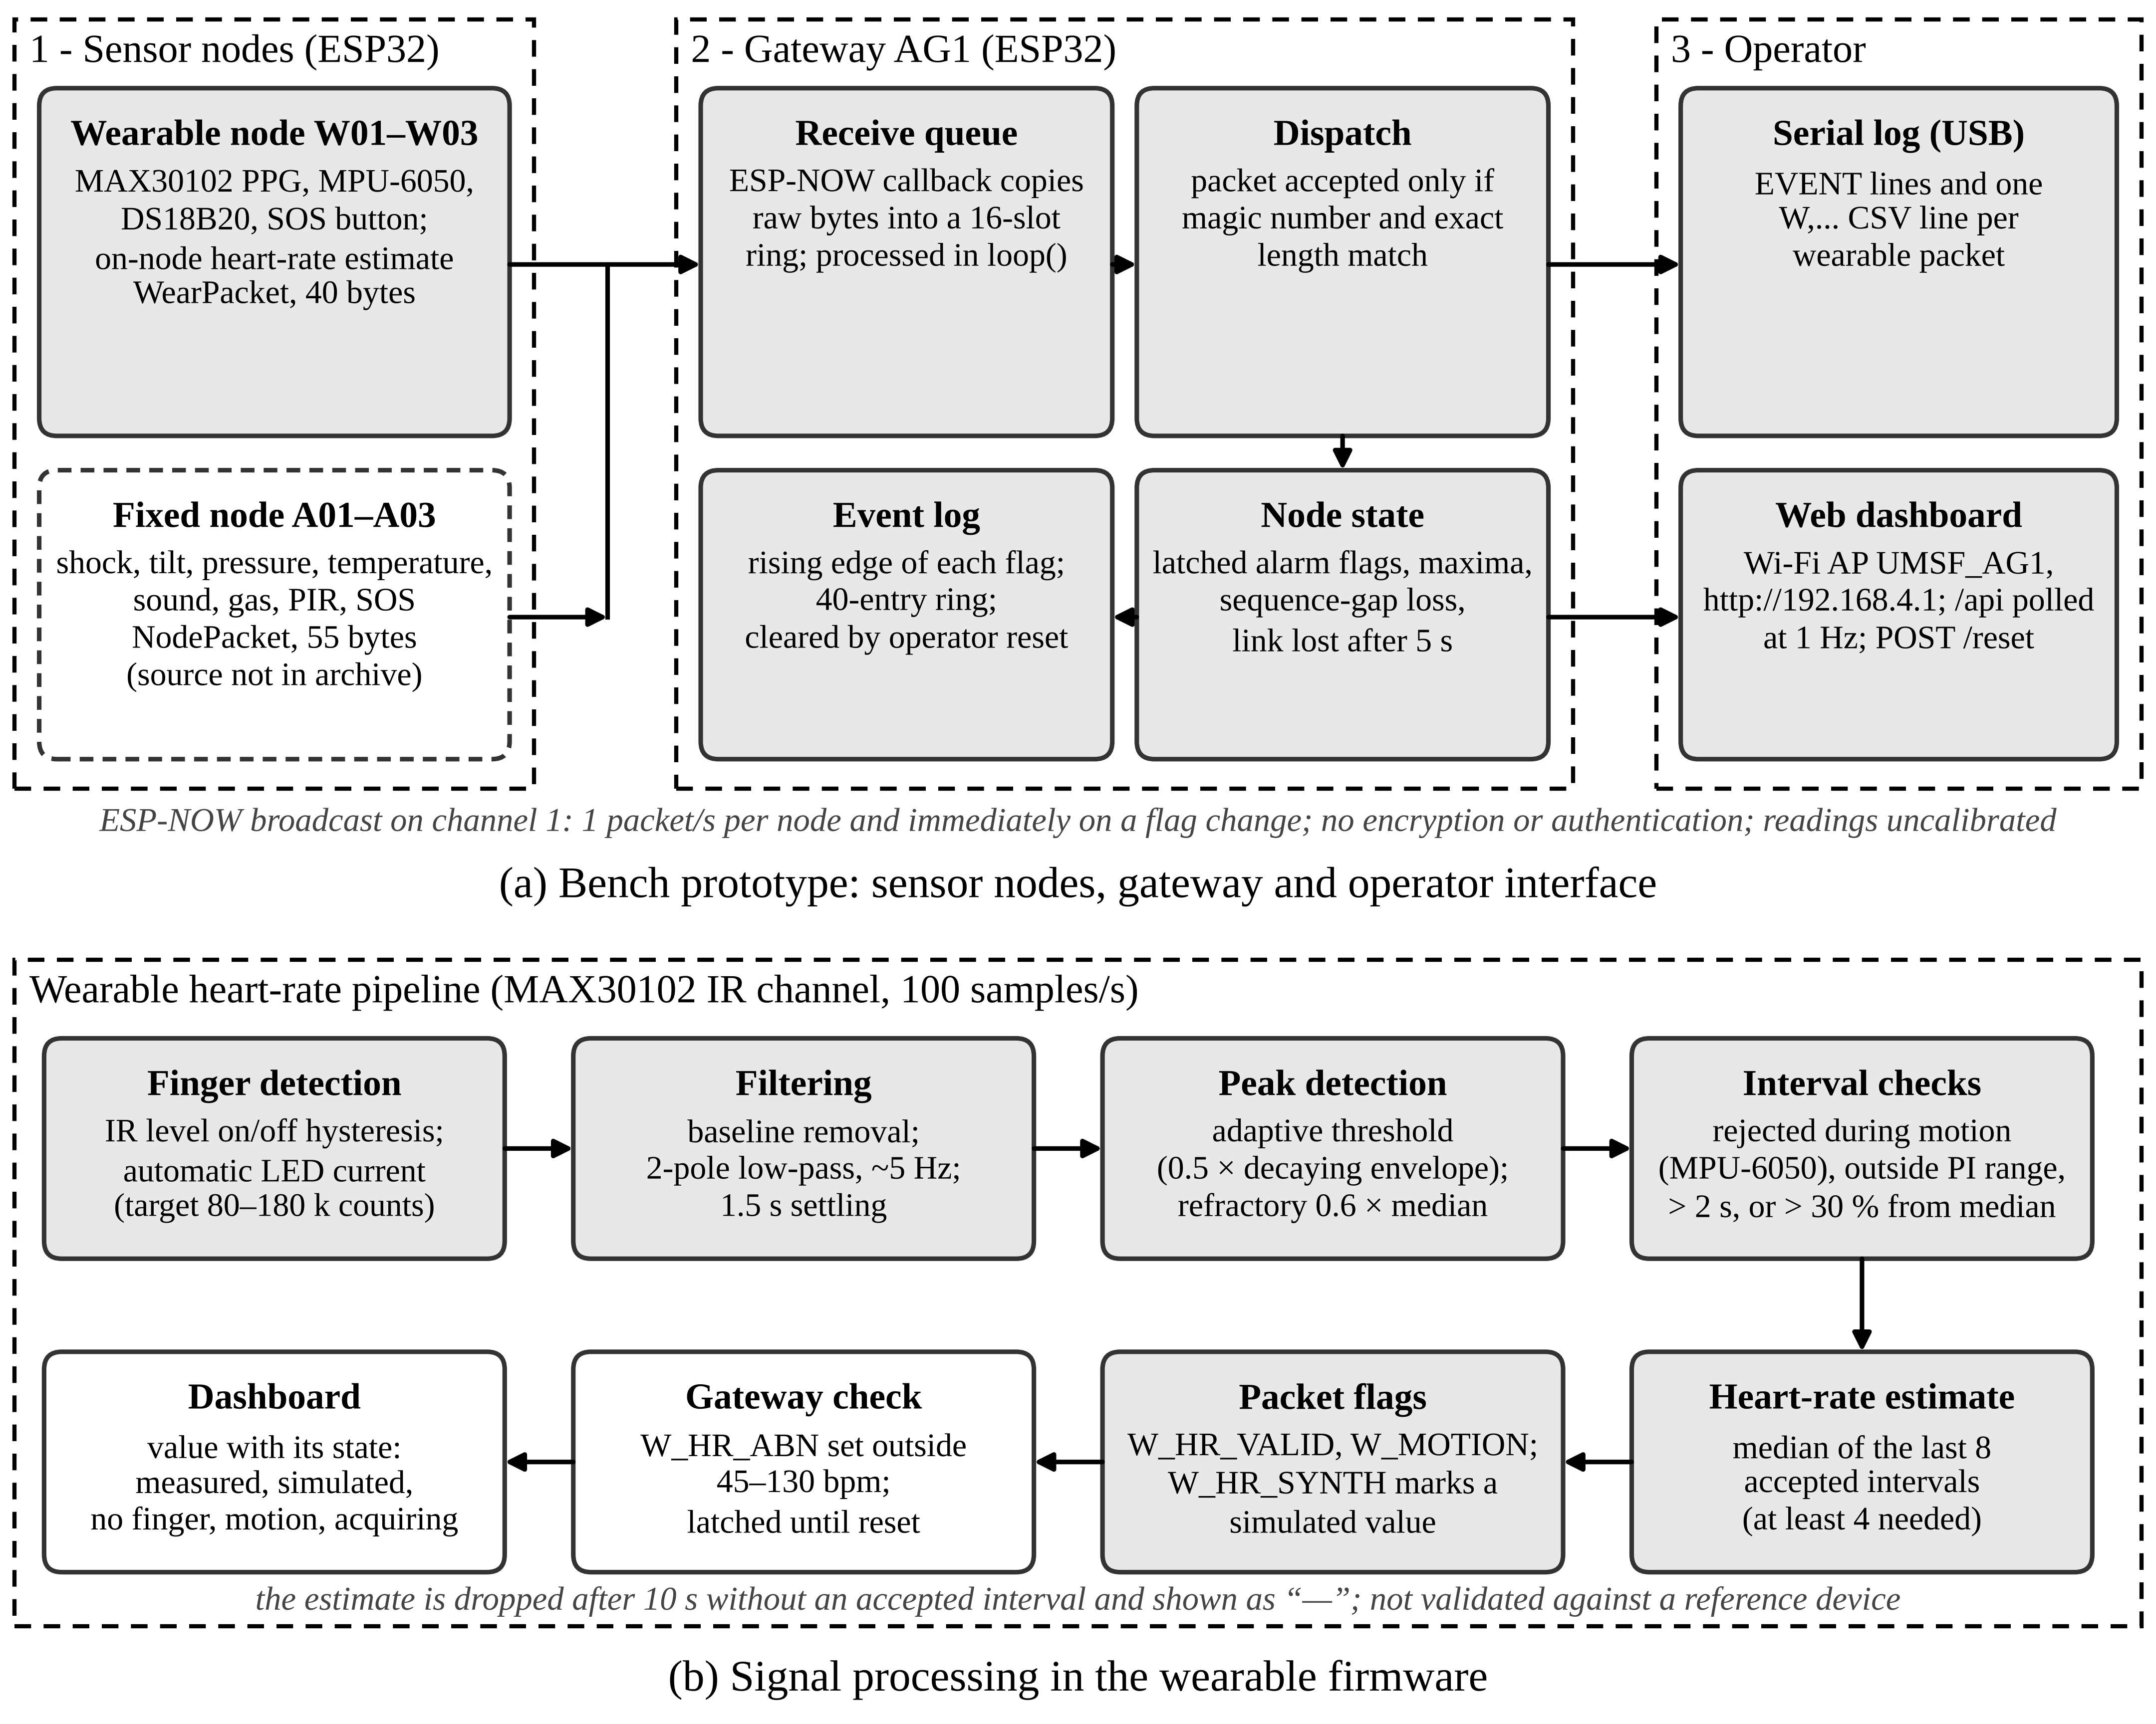
Fig. S9. Bench prototype archived as UMSF Bench Prototype v1.0.0 (main text, ref. [31]). (a) Sensor nodes broadcast fixed-layout packets over ESP-NOW; the gateway queues, validates and latches them and serves the operator dashboard and a serial log. The fixed-node firmware is not part of the archive (dashed). (b) Heart-rate processing in the wearable firmware and the way its result is flagged and displayed. Thresholds are bench values, not calibrated. (Fig. 7 of the previous manuscript version.)
Heart-rate processing in the wearable firmware (moved from the main text; see Fig. S9b). The wearable firmware estimates heart rate on the node from the infrared channel of a MAX30102 sensor at 100 samples/s. After finger detection and automatic adjustment of the LED current, the baseline is removed, the signal is low-pass filtered at about 5 Hz, and peaks are detected with an adaptive threshold and a refractory period. Beat-to-beat intervals are rejected during motion detected by the MPU-6050, outside the perfusion-index range, when longer than 2 s, or when they deviate by more than 30% from the running median. The reported value is the median of the last eight accepted intervals and is withdrawn after 10 s without an accepted interval. An acceleration magnitude above 3 g raises an impact flag and the SOS button raises an SOS flag; both are held for 30 s. The receive callback of the gateway only copies raw bytes into a 16-slot ring, and the packets are processed in the main loop. The rising edge of each flag is entered in a 40-entry event log and written to the serial port as an EVENT line; each wearable packet is also written as a CSV line for logging measurement sessions.
Provenance. Fig. S8 was drawn for the manuscript from the constructed cases of Table 4 of the main text; Fig. S9 was drawn from the archived source code of the bench prototype [31].

