Cognitive optimisation of AI-supported SME decisions through risk-based allocation of managerial attention
Olga Torstensson ^{1,*}, Dmytro Prokopovych-Tkachenko ², Igor Britchenko ^{3,*}, Bakytgul Ilessova ⁴, Nazarii Chubaievskyi ⁵ and Ayaulym Merkibaeva ⁴
1 School of Information Technology, Halmstad University, 301 18 Halmstad, Sweden; olga.torstensson@hh.se (O.T.)
2 Department of Cybersecurity and Information Technologies, University of Customs and Finance, Dnipro, Ukraine; omega2417@gmail.com (D.P.-T.)
3 Higher School of Business (WSB-NLU) in Nowy Sącz, Poland; igor.britchenko@up.krakow.pl (I.B.)
4 Almaty Technological University, Almaty, Kazakhstan; ilesova.b@atu.edu.kz (B.I.); a.merkibaevaa13@gmail.com (A.M.)
5 State University of Trade and Economics, Kyiv, Ukraine; n.chubaievskyy@knute.edu.ua (N.C.)
* Correspondence: olga.torstensson@hh.se (O.T.); igor.britchenko@up.krakow.pl (I.B.)
ORCID: O. Torstensson 0009-0007-2169-6851; D. Prokopovych-Tkachenko 0000-0002-6590-3898; I. Britchenko 0000-0002-9196-8740; B. Ilessova 0000-0001-8357-519X; N. Chubaievskyi 0009-0006-2422-1192; A. Merkibaeva 0009-0006-4951-3415

Abstract
Small and medium-sized enterprises increasingly use artificial intelligence (AI) in transactional workflows, but their capacity to verify recommendations remains limited. This conceptual study asks how firms should allocate managerial attention and decision authority when human review is both costly and fallible. Integrating bounded rationality, the attention-based view and human–automation research, it develops a risk-based attention allocation model for invoice and purchase approval. Recommendation uncertainty, error consequences, reversibility and reviewer availability determine four levels of AI authority. The analysis distinguishes a locally beneficial review from a review that improves the performance of the decision stream: an additional escalation can reduce the quality of all other reviews through workload. The rule is validated against seven alternative allocation rules on 129,878 real card transactions with observed fraud labels and assumed reviewer behaviour. At a review budget of 0.5% of operations, RBAA earned €79.3 per 1,000 operations, against €48.3 for an AI-score alert queue and −€97.2 for amount-based approval limits, used 27 instead of 108 review hours and reduced the total cost of control by 48.7%. The advantage held in 96% of 324 reviewer-behaviour scenarios but required calibrated probabilities and narrowed under a tight budget, and a low mandatory-review threshold cost more than oversight saved. Five hypotheses and a cluster-randomised protocol specify how the organisational claims can be tested in SMEs. The contribution to digital business research is a process-level account, with explicit economic indicators, of how firms can connect AI-enabled execution to scarce oversight capacity and accountable delegation.
Keywords: digital business; managerial attention; human–AI decision-making; AI governance; small and medium-sized enterprises; risk-based delegation; cost of control

1. Introduction
Artificial intelligence (AI) is entering firms faster than the managerial routines needed to supervise it. In 2025, 20.0% of enterprises in the European Union (EU) with ten or more persons employed used at least one AI technology, up from 13.5% in 2024; the share was 17.0% among small enterprises, 30.4% among medium-sized enterprises and 55.0% among large ones (Eurostat, 2026a). For smaller firms, then, the question is shifting from whether to use AI to how its outputs should be supervised by people whose time is already fully committed.
This question is acute in small and medium-sized enterprises (SMEs). AI typically arrives in SMEs embedded in accounting, procurement or banking software that proposes whether to approve an invoice, release a payment or place an order. Unlike large organisations, SMEs rarely possess layered approval hierarchies or dedicated control functions, so the verification burden tends to fall on the owner-manager (Feltham et al., 2005; Kotey & Slade, 2005). Digital adoption in SMEs is also constrained by skills gaps (OECD, 2021). The result is a structural tension: every recommendation can in principle be checked, but the person responsible cannot check all of them carefully.
Digital business research places organisational structures and performance measures alongside digital technologies (Verhoef et al., 2021). In an AI-supported approval process, the corresponding organisational question is how execution rights, exceptions and verification capacity are configured. This paper examines that operational mechanism. It does not equate adopting an AI tool with completing digital transformation, and it does not infer firm-wide performance from a transaction-level calculation.
Research on human interaction with algorithms has produced a rich but fragmented picture. People sometimes avoid algorithms after observing them err (Dietvorst et al., 2015) and sometimes prefer algorithmic to human advice (Logg et al., 2019). Operators of automated systems commit omission and commission errors when they rely on automated aids (Skitka et al., 1999), and such automation bias persists among experts (Mosier et al., 1998; Parasuraman & Manzey, 2010). Explanations can increase acceptance of AI recommendations whether or not they are correct (Bansal et al., 2021), and a recent meta-analysis finds that human–AI combinations, on average, perform worse than the better of the human or the AI alone in decision tasks (Vaccaro et al., 2024). Management scholarship frames these tensions as a paradox between automation and augmentation (Raisch & Krakowski, 2021) and as a choice among organisational decision structures (Shrestha et al., 2019).
Relatively limited attention has been given, however, to the allocation problem that SME managers actually face. First, most studies examine reliance on a single recommendation or treat the level of human oversight as fixed. Yet managers confront a stream of heterogeneous decisions and must decide which of them deserve scrutiny. Oversight is therefore an attention-allocation problem, not a binary property of a human-in-the-loop design. Second, the literature often equates formal approval with control. A manager who clicks 'approve' on every recommendation is formally in the loop but may exercise no substantive judgement (Parasuraman & Riley, 1997). Third, research on AI in entrepreneurship has largely conceptualised AI as a functional input and has paid little attention to the cognitive and behavioural side of entrepreneurial judgement (Retamal-Saavedra et al., 2026). Our claim is not that using AI in SMEs is novel. The unresolved problem is how a bounded, interruptible decision-maker should ration verification effort across AI-supported operations whose stakes differ by orders of magnitude.
The research question is: under what conditions can reallocating scarce managerial attention across AI-supported transactions improve process-level decision performance while preserving mandatory human authority? The comparison is between governance arrangements for the same decision stream, rather than between different predictive algorithms.
This paper addresses that problem. Drawing on bounded rationality (Simon, 1955), the attention-based view of the firm (Ocasio, 1997, 2011) and the human–automation interaction literature (Parasuraman et al., 2000; Lee & See, 2004), we define cognitive optimisation as the allocation of a fixed managerial attention budget across AI-supported operations that reduces expected decision loss and review costs subject to capacity and authority constraints. We then develop a risk-based attention allocation (RBAA) model. In this model, recommendation uncertainty, the expected consequence of error, the reversibility of the action and the manager's current availability jointly determine whether an AI system may only observe, may recommend, may prepare an action or may execute it within pre-authorised limits.
The contribution is a process-level theory of accountable delegation in digital business. First, the model explains how AI-enabled execution can expand a decision stream while managerial verification remains capacity constrained. Second, it separates the local value of reviewing one operation from the effect of that review on the entire queue, making a workload externality explicit. Third, it connects the resulting allocation rule to authority limits and observable verification behaviour, rather than treating human approval as evidence of effective control. Fourth, it quantifies the economic effect of the rule and validates it against established allocation methods, from amount-based approval limits to AI-score triage, cost-sensitive ranking and load-independent deferral, on a real transaction stream. Following conceptual model building (Cornelissen, 2017; Jaakkola, 2020), the paper derives implications, develops falsifiable hypotheses and specifies an empirical test. Sections 2–4 present the theoretical foundations, assumptions and model; Section 5 reports the validation against established methods and the economic effect of oversight; Sections 6–7 discuss implications and conclusions. Appendices A and B provide the derivation and numerical illustrations, and Appendix C contains the full proposed field protocol.

2. Theoretical Framework

2.1. Bounded rationality and managerial attention
Simon (1955) argued that decision-makers do not optimise over all alternatives but search until they find a satisfactory option, because computation and information are costly. Ocasio (1997) extended this insight to the firm. In the attention-based view, organisational behaviour depends on what decision-makers focus their attention on, which in turn depends on the situation and on how the organisation channels and distributes attention. Later work distinguishes attentional perspective, attentional engagement and attentional selection (Ocasio, 2011). Managerial cognitive capabilities, including attention, are a microfoundation of dynamic capabilities (Helfat & Peteraf, 2015). Executive cognition also shapes strategic choices in specific domains (Du et al., 2025).
Two implications motivate the present model. First, attention can become a binding constraint even when information is abundant: AI may increase the number of recommendations without increasing the time available to verify them. This is consistent with information overload, where performance deteriorates when information demands exceed processing capacity (Eppler & Mengis, 2004). Second, broader attention does not necessarily improve performance. Jancenelle (2025) reports an inverted U-shaped association between executives' strategic attention breadth and firm performance. Owner-managers may also rely on overconfidence and representativeness heuristics (Busenitz & Barney, 1997). Heuristics can nevertheless be ecologically rational in suitable environments (Gigerenzer & Gaissmaier, 2011), and intuitive expertise is more dependable where valid cues and timely feedback support learning (Kahneman & Klein, 2009). These findings motivate, but do not by themselves establish, the workload functions assumed below. Invoice and purchase approval may provide delayed or incomplete feedback because some errors remain undiscovered.
Bounded rationality therefore suggests that oversight requirements which exceed available attention may be implemented through abbreviated review. This is a conditional prediction: spare capacity, effective delegation to additional reviewers or better verification tools could prevent that degradation. Entrepreneurial decision research likewise makes the allocation of effort across concurrent demands relevant to decision quality (Shepherd et al., 2015).

2.2. Human–AI decision-making and the limits of oversight
The human factors literature offers the most developed account of how people supervise automated aids. Parasuraman and Riley (1997) distinguish use, misuse (over-reliance), disuse (under-reliance) and abuse of automation. Parasuraman et al. (2000) decompose automation into four stages: information acquisition, information analysis, decision selection and action implementation. Automation can vary in level within each stage. Appropriate reliance requires that trust be calibrated to the system's actual capability (Lee & See, 2004). Trust itself has dispositional, situational and learned layers (Hoff & Bashir, 2015). In organisations, it also depends on the AI's tangibility, transparency, reliability and immediacy (Glikson & Woolley, 2020).
Three findings are central for SME oversight. First, automation bias is robust. Decision-makers both omit actions the aid fails to prompt and commit errors the aid recommends (Skitka et al., 1999). The effect appears in expert populations (Mosier et al., 1998) and across clinical decision support (Goddard et al., 2012). It is sensitive to workload and is not eliminated by training alone (Parasuraman & Manzey, 2010). Imperfect automation also produces complacency, particularly after long periods of reliable performance (Wickens et al., 2015). Second, higher degrees of automation involve a trade-off. They improve routine performance and reduce workload, but impair situation awareness and performance when the automation fails (Onnasch et al., 2014; see also Endsley, 1995; Kaber & Endsley, 2004). Bainbridge (1983) called this an irony of automation: the more reliable the system, the less prepared its human supervisor is to catch its rare failures. Third, interface interventions have mixed effects. Displaying confidence scores can help people calibrate trust (Zhang et al., 2020). Explanations can raise acceptance indiscriminately (Bansal et al., 2021) or reduce over-reliance when they lower the cost of verification (Vasconcelos et al., 2023). Cognitive forcing functions reduce over-reliance but are disliked by users (Buçinca et al., 2021). People are also poor judges of both their own and the algorithm's accuracy (Green & Chen, 2019).
Management research has moved from asking whether to automate to asking how to combine human and algorithmic agency. Shrestha et al. (2019) describe full delegation, sequential hybrid and aggregated decision structures. Murray et al. (2021) theorise forms of conjoined agency between humans and technologies. Kellogg et al. (2020) show how algorithms restructure control over work. Lebovitz et al. (2022) find that professionals who interrogated opaque AI outputs integrated them more productively than those who did not. Anthony et al. (2023) urge a system view of 'collaboration' with AI. Algorithm aversion and appreciation are now understood as context-dependent (Burton et al., 2020). Cristofaro et al. (2024) propose a de-biasing framework for managers of medium enterprises, and Kohnke et al. (2024) show that management factors shape digital adoption through employees' psychological processes.
Experimental evidence suggests that delegation quality depends on who allocates cases and what they know about comparative competence. Fügener et al. (2022) find benefits from AI-initiated delegation in their experimental setting, while Steyvers et al. (2022) connect complementarity to confidence information. Selective prediction formalises abstention when its expected cost is preferable to classification error (Chow, 1970). Learning-to-defer formulations can optimise machine decisions and deferral jointly against an expert model (Madras et al., 2018; Mozannar & Sontag, 2020). The present model builds on this logic but makes reviewer quality depend on the workload generated by the routing policy itself. This is a specific extension of the formulations used here, not a claim that all deferral research assumes fixed human accuracy. Conformal prediction can support uncertainty assessment under its coverage assumptions (Angelopoulos & Bates, 2023); it does not supply a calibrated probability of error for every individual case or guarantee validity under arbitrary distribution shift.
Despite this growing body of work, three gaps remain. Few studies model oversight as the allocation of a finite attention budget over a stream of operations with heterogeneous stakes. Uncertainty and consequence are rarely combined with reversibility and managerial availability, which are central in SME operations. Finally, field evidence on substantive, as opposed to formal, human control remains scarce. Laboratory tasks typically present one recommendation at a time to an attentive participant, which is precisely the condition SME managers do not enjoy. In the language of the job demands–resources model, AI recommendations add job demands unless they are accompanied by resources that make review proportionate (Bakker & Demerouti, 2007).

3. Conceptual method and model assumptions

3.1. Conceptual research approach
The study uses conceptual model building (Cornelissen, 2017; Jaakkola, 2020), rather than a systematic review or an empirical test of organisational effects. The unit of theorising is a stream of auditable operations sharing a bounded reviewer. Bounded rationality motivates the capacity constraint; the attention-based view motivates selective allocation; and human–automation research motivates beneficial corrections, harmful overrides and workload-dependent review quality. The analytical procedure defines expected loss, derives the net value of review, identifies sufficient conditions for a process-level optimum and translates the mechanism into hypotheses that can be rejected. Equations (1)–(3) and Appendix A make the formal assumptions explicit. The literature is selected for its role in the argument; no exhaustive-search or systematic-review claim is made.
Three kinds of material accompany the conceptual argument. Table A1 contains hypothetical transactions used to check routing and arithmetic. Table 7 and Figure A2 contain planning calculations, with assumed effect sizes and loss distributions. Section 5 validates the allocation rule against established methods on public card transactions, whose outcomes and amounts are observed but whose reviewer behaviour is imposed; Appendix B documents the archived version of that back-test and its reconciliation with the re-run. Three openly archived software packages reproduce these calculations (Section 3.3); neither they nor Section 5 constitute an SME field study or evidence that H1–H5 hold. Appendix C specifies the proposed experiment. SOC research supplies an analogy for escalation architecture only; no SOC effect size or threshold is transferred.

3.2. Assumptions and evidential scope
The base model assumes that an operation has a verifiable reference decision; that the probability of an erroneous AI recommendation can be estimated on data relevant to deployment; and that the consequence of error, review costs and delay costs can be expressed on a common monetary scale. Reviewer detection and harmful-override probabilities remain in [0, 1] over the feasible workload range. The model describes one review stage and does not represent strategic supplier responses, learning over time or correlated fraud campaigns. Availability affects feasible capacity and the cost of review; workload affects the quality of that review. These channels must be estimated separately to avoid counting the same burden twice. Where these assumptions are not credible, the model supports observation, deferral or human decision-making rather than autonomous execution.
A probability score, a monetary loss estimate and a normative authority limit answer different questions. The score estimates uncertainty; the loss estimate values consequences; the limit determines what the organisation permits. A profitable calculation cannot by itself establish permission to act. This distinction is retained throughout the model, numerical illustrations and proposed trial.

3.3. Software and reproducibility
Every calculation in the article can be reproduced from three software packages archived on Zenodo under the MIT licence. Each package records its configuration, software environment and SHA-256 checksums of its outputs, and contains built-in checks that compare the computed values with those printed in the article.
rbaa-sim, version 1.1.0 (Prokopovych-Tkachenko, 2026a; https://doi.org/10.5281/zenodo.SIM_DOI), is a self-contained Jupyter and Google Colab notebook without empirical data. It implements Equations (1)–(3) and the routing rule of Table 2, reproduces Table A1 and Table 7, checks the derivatives of Appendix A numerically, computes the optima e* and the marginal-only stopping rates within valid probability bounds (Figure A1) and estimates simulation-based power (Figure A2). It also runs the analysis plan of Appendix C.9 on synthetic trial data, with a design-weighted outcome audit, randomised threshold-policy contrasts for H4 and a firm-level moderation model for H5.
rbaa-validation, version 1.1.0 (Prokopovych-Tkachenko, 2026b; https://doi.org/10.5281/zenodo.VAL_DOI), contains the archived counterfactual back-test on public card transactions and the Eurostat adoption context reported in Appendix B (Figures B1–B3). rbaa-benchmark, version 1.0.0 (Prokopovych-Tkachenko, 2026c; https://doi.org/10.5281/zenodo.BEN_DOI), is supplied as Supplementary Material S1 and reproduces the comparative validation of Section 5, including Tables 3 and 4, Figures 2 and 3 and the robustness analyses. The transaction data are not redistributed: both data-based packages download the original public release and verify it by checksum before any calculation.

4. Risk-based attention allocation model and analytical implications
The completed contribution consists of a construct definition, a routing model and conditional analytical implications. The five hypotheses express predictions for future organisational research. Numerical illustrations demonstrate how the rules behave under specified inputs and do not establish treatment effects in SMEs.

4.1. Defining cognitive optimisation
Cognitive optimisation is defined here as the allocation of a bounded managerial attention budget to reduce expected decision loss and review costs, subject to authority and safety constraints. Decision quality, workload, uncertainty-assessment accuracy, escalation diagnostics and managerial time provide complementary measures (Table 1). They are not assumed to form a single validated psychometric scale. An allocation may be more efficient at a given quality level, or produce better quality within a given attention budget; claiming improvement requires stating which constraint and comparison apply.
Table 1. Operationalisation of variables
Construct / role | Variable | Operational definition | Level | Source / instrument | Timing
Decision quality (primary outcome) | Severity-weighted decision-error rate | Inverse-inclusion-weighted sum of audited error × preregistered severity weight, divided by total operations and multiplied by 100; an index, not euro loss | Operation → firm-period | Blind probability-based outcome audit; escalation-triggered audits analysed separately | Weeks 3–28
Decision quality | Decision error (binary) | 1 if audit finds the final decision wrong (wrong approval or rejection, amount, supplier or account); 0 otherwise | Operation | Audit protocol; double-coded subsample with Cohen's κ | Weeks 3–28
Cognitive load | Raw NASA-TLX (RTLX) | Mean of six 0–100 subscales (mental, physical and temporal demand, performance, effort, frustration) | Manager-day; sampled review episodes | Hart (2006); Hart & Staveland (1988) | End of each working day; random episodes
Probabilistic judgement accuracy | Brier score of managers' judgements | Mean (f − o)² on common calibration probes; f is the probability that the AI recommendation is correct; calibration and resolution reported separately | Reviewed operation | In-workflow slider completed before the decision; Brier (1950) | Every reviewed operation (T1, T2); calibration probes at equal rates in T1 and T2
Escalation diagnostic | Apparently redundant escalation rate | Correct AI recommendation confirmed without recorded new information; ex post diagnostic, not proof that the review lacked ex ante value | Operation → firm-period | System log + audit | T2, weeks 13–28
Missed escalations | Missed-escalation rate | Share of non-escalated operations with an audited error above the materiality threshold | Operation → firm-period | Audit | T2, weeks 13–28
Managerial time | Minutes per operation | Total active managerial review, audit and corrective-work minutes divided by all genuine operations, including operations receiving no review | Manager-week | System telemetry | Weeks 3–28
Substantive control (mechanism) | Unverified-error escape rate | Among erroneous AI recommendations, share becoming erroneous final actions without logged verification; human approvals and autonomous errors also reported separately | Operation | System log + audit | T1, T2
Substantive control (mechanism) | Seeded-error detection rate | Share of blocked synthetic test operations rejected or queried; excluded from the primary outcome on genuine operations | Firm-period | Synthetic operations inserted by the partner, blocked from payment | Equal rate in all arms, weeks 3–28
Substantive control (mechanism) | Override quality | Counts and rates of beneficial, harmful and neutral overrides; beneficial/harmful ratio only if the denominator is non-zero | Manager-period | Audit | T1, T2
Attention allocation (mechanism) | Attention concentration | Share of review time spent on operations in the top decile of expected loss EL_{i} | Manager-week | System log; EL_{i} from shadow-mode AI in T0 | Weeks 3–28
Treatment | Arm | T0 business as usual; T1 AI recommendation with uniform review; T2 AI with risk-based escalation | Firm | Stratified randomisation 1:1:1 | Week 11, before onboarding
Treatment | Escalation-threshold block | Low, medium or high threshold, in randomised order | Firm-block (T2) | Randomisation of block order | Weeks 17–28
Routing inputs | p_{i}, C_{i}, R_{i}, A_{t} | As defined in Equations (1)–(2) | Operation / manager-time | AI module (recalibrated); contract data; action type; queue and calendar | Continuous
Moderator | Digital competence | Primary moderator: preregistered task-based verification score, mean-centred; DigCompSat self-report secondary | Manager | Clifford et al. (2020); Vuorikari et al. (2022) | Baseline; before allocation
Control | Case-complexity index | Number of invoice lines, new supplier, foreign currency, deviation from purchase order, three-way-match outcome | Operation | Enterprise resource planning (ERP) data | Continuous
Control | Baseline firm error rate | Audited error rate during shadow-mode baseline | Firm | Audit | Weeks 3–10
Control | Calendar and firm characteristics | Calendar-week fixed effects; firm-specific peak indicators; size class; sector | Firm / week | Partner data | Continuous
Manipulation check | AI calibration | Reliability plots, Brier score and error rates by strata, with calibration error summaries | Firm-period | Audit | Continuous
Note. Measures refer to the proposed field study. Primary between-arm estimates use the probability-based outcome audit sample with known inclusion probabilities. Additional escalation-triggered audits support diagnostics and are not pooled into the primary outcome without design weights. Auditors are blind to arm where feasible. Source: authors' proposed research design.
Decision quality is operationalised as the severity-weighted error rate per 100 operations, using an independently adjudicated error indicator and preregistered exposure-band weights multiplied by the irreversibility factor. This is a severity index, not realised monetary loss. Monetary net performance is analysed separately with exposure denominated in euros. Cognitive load is measured with the raw NASA Task Load Index (Hart, 2006; Hart & Staveland, 1988), in relation to cognitive load theory (Sweller, 1988). The Brier score measures the overall accuracy of probabilistic judgements, with calibration and resolution reported separately (Brier, 1950; Murphy, 1973). An escalation that confirms a correct recommendation may still provide assurance; therefore, the original unnecessary-escalation indicator is treated as an ex post diagnostic of apparently redundant review, not proof that escalation was unnecessary ex ante. Managerial time includes review, subsequent checking and corrective work.
The definition makes the trade-off explicit. A faster process that increases material errors is not automatically preferable, and a more accurate process may be infeasible if it exceeds available capacity. The formal model uses expected monetary net benefit within a defined decision stream; the proposed empirical study keeps safety, workload and decision-quality outcomes visible rather than concealing them in an arbitrary composite score.

4.2. Risk-based allocation of managerial attention
For each operation i at time t, four determinants inform routing: recommendation uncertainty pᵢ, the estimated probability that the proposed AI action is wrong; consequence Cᵢ, the monetary exposure conditional on an erroneous decision; reversibility Rᵢ, ranging from 0 for irreversible actions to 1 for actions that can be undone at negligible cost; and managerial availability Aₜ, the capacity currently available for review. Cᵢ is not already probability weighted: doing so would count uncertainty twice in expected loss. Contractual and monetary exposures must use an explicit conversion rather than adding currency amounts to an unscaled score.
The expected loss of letting the AI act without review is
${EL}_{i} = p_{i} × C_{i} × φ(R_{i})$ (1)
where φ(R_{i}) ≥ 1 is an irreversibility multiplier that equals 1 for fully reversible actions and increases as reversibility falls; a simple specification is φ(R_{i}) = 1 + λ(1 − R_{i}), where λ ≥ 0 is the additional weight that the owner attaches to an irreversible error. The value of human review is
${VR}_{i} = q(L_{t}, DC) × {EL}_{i} − h(L_{t}) × (1 − p_{i}) × C_{i} − c(A_{t}) − d_{i}$ (2)
Here q is the conditional probability that review corrects an AI error, h is the conditional probability that review changes a correct recommendation into an error, c(Aₜ) is the monetary attention cost and dᵢ is delay cost. The two branches are mutually exclusive. Detection q is assumed to decrease with load Lₜ and increase with relevant digital competence DC; h is assumed not to decrease with load. These are model assumptions motivated by human–automation research, not estimates of SME behaviour (Goddard et al., 2012; Parasuraman & Manzey, 2010; Green & Chen, 2019). Equation (2) adapts information value and rejection-option reasoning (Howard, 1966; Chow, 1970). A positive VRᵢ makes review locally worthwhile at the stated load; it does not by itself make review optimal for the entire queue. The base harmful-override term assumes that a wrongful rejection or amendment is recoverable. If that error is also irreversible, its loss must receive the corresponding multiplier. These two error pathways should be distinguished in an implementation.
The model distinguishes four levels of AI authority, adapted from the stage model of Parasuraman et al. (2000) and summarised in Table 2. At the observation level, the AI monitors and flags but issues no recommendation; this level applies when the operation falls outside the model's validated scope and its uncertainty estimate is itself unreliable. At the recommendation level, the AI proposes an action with an uncertainty estimate and the manager decides; for the highest-stakes operations, the manager records an independent judgement before seeing the recommendation, a form of cognitive forcing (Buçinca et al., 2021). At the action-preparation level, the AI prepares the transaction and the manager must explicitly authorise it. At the permitted-execution level, the AI executes within a pre-authorised envelope, and a random sample of executed operations is audited after the fact.
Table 2. Levels of AI authority and routing rules in the risk-based attention allocation (RBAA) model
Level | AI role | Human role | Routing condition | Safeguard | Illustrative operation
1 Observation | Monitors, classifies and flags; gives no advice | Decides and acts unaided | Outside validated scope, inadequate calibration evidence or unreliable uncertainty assessment | Logged for recalibration; no AI output shown | New supplier category invoiced in a foreign currency
2 Recommendation | Proposes a decision with an uncertainty estimate | Decides; records a probability judgement; for hard-floor cases records an independent judgement before seeing the recommendation | High expected review benefit or complex high-stakes judgement; scope and hard-floor gates first | Cognitive forcing for hard-floor cases; at least one verification action required | Large advance payment to a new supplier
3 Action preparation | Prepares the transaction (payment draft, purchase order) | Explicitly authorises or rejects | Moderate review benefit; mandatory-review case; or execution-ineligible case awaiting capacity | Authorisation counts as substantive only with a logged verification action | Above-materiality invoice from a known supplier matching the purchase order
4 Permitted execution | Executes within a pre-authorised envelope | Audits a random sample after the fact; may reverse | All scope, uncertainty, consequence and reversibility gates satisfied; no mandatory review; discretionary review not selected after capacity assessment | Hard floor: never for C_{i} ≥ materiality threshold or R_{i} = 0; random ex post audit | Reversible recurring order or authorised scheduled transaction within the envelope
Note. Mandatory-review and scope gates take precedence over the value-of-review calculation. Low availability leads to queuing or deputy review when autonomous execution is inadmissible. A positive local review value is assessed against capacity and the workload externality before discretionary review is scheduled. Levels adapt Parasuraman et al. (2000). Source: authors' model.
The routing rule applies gates in a fixed order. Operations outside the validated scope receive no actionable AI recommendation. In-scope operations then face a hard floor: those at or above the materiality threshold, or with an irreversible action, require a human decision. Only the remaining operations are eligible for discretionary review or execution within the authorised envelope. If mandatory work exceeds capacity, the system must queue, stop or invoke an authorised deputy; a negative VRᵢ never overrides the hard floor. A logged verification action and a pilot-calibrated minimum review time constitute a process indicator of substantive review, not direct evidence that the manager understood the case. Audit accuracy, seeded-error detection and override quality provide converging behavioural evidence. The concern about automation bias also appears in Article 14(4)(b) of the EU AI Act; here it is a governance reference for design, not an assertion that every invoice-processing system is legally high-risk.
Figure 1 summarises the proposed mechanism. Operation-level determinants inform a routing decision subject to scope, authority and capacity constraints. The hypothesised pathways are concentration of attention on consequential operations and fewer unverified erroneous decisions. Digital competence may moderate the quality of verification. These arrows are theoretical relationships, not estimated causal effects.
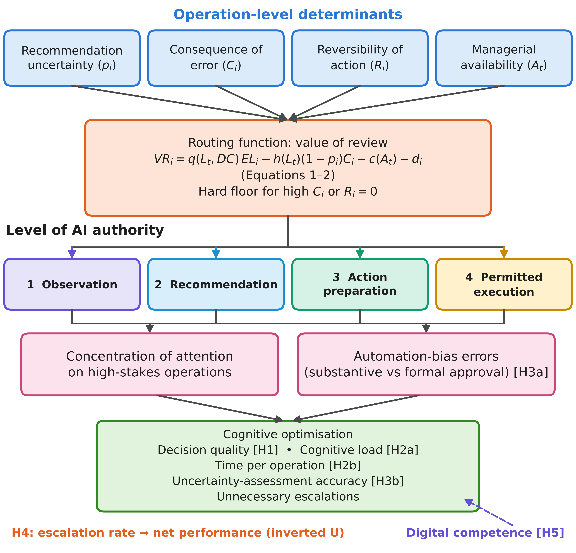
Figure 1. Proposed RBAA mechanism linking routing to managerial oversight. The value-of-review calculation is subject to the precedence of scope, mandatory-review and capacity gates described in the text. Arrows depict hypothesised relationships. Source: authors' conceptual model.

4.3. Conditional analytical propositions
Proposition 1. With fixed reviewer quality and costs, the local value of review rises with the probability of an erroneous recommendation. Holding the other inputs constant and assuming a positive denominator, review is locally worthwhile when pᵢ exceeds the ratio of harmful-override exposure plus review and delay costs to the sum of potential correction and harmful-override exposure. Increased review cost raises this threshold. The proposition concerns marginal economics; scope and mandatory-review gates still take precedence.
Proposition 2. When an added review reduces the expected quality of other scheduled reviews, its process-level marginal benefit is lower than its isolated value. Under the fixed-ordering and strict-concavity conditions in Appendix A, the load-aware stopping rate is no greater than the marginal-only stopping rate. The result identifies the mechanism behind H4 without asserting that an interior optimum exists in every application.
Proposition 3. A mandatory-review constraint can force review beyond the unconstrained economic optimum. This is a deliberate governance trade-off. If the required volume exceeds available reviewer capacity, queuing, a deputy or suspension is required. Raising autonomous authority because the queue is long is outside the permitted policy.

4.4. Testable hypotheses
The hypotheses compare three ways of organising AI-supported approval: business as usual without AI recommendations, AI recommendations with uniform human review, and AI with risk-based escalation according to the RBAA model.
Under uniform review, every recommendation demands the manager's attention. Because the attention budget is fixed, the average attention per operation falls as volume rises. The few operations with high expected loss therefore receive no more scrutiny than routine ones. Bounded rationality predicts satisficing under these conditions (Simon, 1955), and the automation literature predicts rising commission errors as workload increases (Parasuraman & Manzey, 2010; Skitka et al., 1999). Risk-based escalation concentrates attention where VR_{i} is high and lets routine, reversible, low-uncertainty operations proceed under ex post audit. AI-initiated deferral has outperformed human-initiated delegation in experimental work (Fügener et al., 2022). Relative to business as usual, the AI also screens operations that an unaided manager might approve by habit. Accordingly, we propose:
Hypothesis 1: Risk-based escalation reduces the severity-weighted decision-error rate relative to uniform review of AI recommendations (H1a) and is at least non-inferior to business-as-usual approval (H1b).
Uniform review imposes a demand for every operation. Risk-based escalation removes most routine verification from the manager's queue and replaces it with sampled audit. Higher degrees of automation reduce workload for routine operations (Onnasch et al., 2014). In job demands–resources terms, escalation converts an undifferentiated demand into a prioritised one (Bakker & Demerouti, 2007).
Hypothesis 2: Risk-based escalation reduces managers' perceived cognitive load (H2a) and managerial time per operation (H2b) relative to both uniform review and business-as-usual approval.
The most consequential failure of human oversight is approving an erroneous recommendation without substantive review. Under uniform review, the share of erroneous recommendations is low, and long runs of correct recommendations encourage complacency (Wickens et al., 2015). Under risk-based escalation, the manager sees fewer operations, each flagged as uncertain or consequential. That flag is a cue to engage. Escalated cases also come with an uncertainty estimate, which can help managers calibrate their own judgement (Zhang et al., 2020).
Hypothesis 3: Relative to uniform review, risk-based escalation reduces the proportion of erroneous AI recommendations that become unverified erroneous final actions (H3a) and improves managers' probabilistic judgement accuracy on common calibration probes (H3b). Calibration and resolution are evaluated separately.
The model predicts a cost curve for discretionary review only under conditions that make some review worthwhile and additional review eventually harmful. A low threshold can overload the manager; a high threshold can leave costly errors uncorrected. Information-overload and automation research motivate this possibility (Eppler & Mengis, 2004; Jancenelle, 2025; Onnasch et al., 2014), but they do not prove its shape for SMEs. If review remains valuable at the maximum feasible rate, or is never worthwhile, the optimum lies at a boundary rather than inside the range.
Hypothesis 4: Within the feasible range of discretionary escalation in T2, net decision performance has an interior maximum when the ordering, endpoint and curvature conditions in Appendix A hold. A boundary optimum, a flat relationship or a monotonic relationship remains possible when those conditions do not hold. The comparative part of this prediction does not depend on the curvature conditions and can be rejected directly: under a fixed ordering, a load-aware stopping rule reviews no more operations than a rule that evaluates each review in isolation and, when review quality declines with load, achieves at least the same net performance. Section 5 tests this part on real transactions.
To formalise this conditional prediction, let e be the reviewed share of a fixed stream and s its rank under an ordering that is fixed across the feasible load range. Equation (3) describes net benefit relative to unreviewed execution, before mandatory-review constraints are imposed:
$NP(e) = \int_{0}^{e}{v_{(s)}(L(e))} ds − κe$ (3)
The expected review benefit at rank s is v₍ₛ₎(L) = q(L)EL₍ₛ₎ − h(L)(1 − p₍ₛ₎)C₍ₛ₎. The constant κ is the monetary review cost per operation; delay is absent or included in κ. L(e) increases with the reviewed share. The derivative contains both the value of the marginal review and the effect of the added load on all reviews already scheduled. Appendix A gives sufficient conditions for an interior optimum and shows that ignoring this second term can over-escalate. The result is conditional on a load-invariant ordering of review benefits: ranking by expected loss alone need not preserve that ordering when harmful-override losses differ. If priorities change with load, the problem requires joint selection and capacity allocation rather than applying the scalar derivative mechanically.
Finally, managers differ in how well they use the attention that routing frees. Digital competence includes the ability to evaluate data, interpret digital content critically and solve problems with digital tools (Vuorikari et al., 2022). Managers with higher digital competence should be better able to interrogate an uncertainty estimate and verify a flagged operation, as the AI-interrogation practices observed by Lebovitz et al. (2022) suggest. A rival expectation is that digitally competent managers trust AI more and therefore scrutinise it less (Logg et al., 2019). We state the theoretically favoured direction but test both. This proposed interaction requires digital competence to improve the verification of flagged operations specifically; general familiarity with AI alone may not be sufficient.
Hypothesis 5: Managerial digital competence strengthens the reduction in severity-weighted decision errors produced by risk-based escalation relative to uniform review.

5. Validation against established methods and economic effect

5.1. Design of the comparison
Table A1 checks the routing gates on hypothetical operations, and Figure A1 illustrates the load externality under assumed functions (Appendix A). To assess whether the allocation rule adds value over methods that firms and software vendors already use, the counterfactual back-test of Appendix B was re-run from the source data and extended into a comparative validation with the rbaa-benchmark package (Prokopovych-Tkachenko, 2026c). The decision stream is the out-of-time test period of the public ULB/Worldline card-transaction data (Machine Learning Group, Université Libre de Bruxelles, n.d.): 129,878 transactions over 19.2 hours, of which 143 are labelled fraudulent, with a total fraud value of €21,159.67. A histogram gradient-boosting classifier with isotonic calibration (three-fold cross-validation) was fitted on the first 60% of elapsed time, and the test period was used only for evaluation. The classifier reached a ROC AUC of 0.948, an average precision of 0.683 and a Brier score of 0.00053. Its mean predicted fraud probability (0.00159) exceeded the observed rate (0.00110), so calibration out of time is imperfect.
Transaction amounts and fraud labels are observed; reviewer behaviour and costs are assumed, as in Appendix B. Reviewer load is the reviewed share relative to a capacity of 2% of the stream, L = e/0.02, with q(L) = 0.90 − 0.50L and h(L) = 0.005 + 0.010L clipped to [0, 1]. A review costs κ = €5 and takes ten minutes, and a harmful override of a legitimate transaction is charged its full amount (ω = 1), a deliberately conservative choice. The realised net benefit of a policy is the fraud value corrected by review, minus losses from harmful overrides, minus review costs. It is reported per 1,000 operations relative to unreviewed execution.
Seven alternative rules were compared with RBAA (Table 3). Three represent current practice in SMEs: random audit (spot checks); amount-based approval limits, which review the largest operations first; and a classifier threshold, which holds every operation with p ≥ 0.5 for review. Two represent data-driven prioritisation: an AI-score alert queue, which ranks operations by fraud probability as in alert triage for card fraud (Dal Pozzolo et al., 2014), and cost-sensitive expected-loss ranking by p_{i}C_{i} (Elkan, 2001; Bahnsen et al., 2015). Two represent the deferral literature: fixed-accuracy deferral, which reviews every operation whose value of review is positive at the reviewer’s unloaded accuracy, as in learning-to-defer formulations with a load-independent expert (Madras et al., 2018; Mozannar & Sontag, 2020); and an isolated value-of-review rule, which evaluates each additional review at the current load but ignores its effect on the reviews already scheduled. RBAA ranks operations by their unloaded value of review and stops at the escalation share that maximises predicted net performance, Equation (3), using predicted probabilities only.
Each rule was evaluated in three regimes. Under a tight budget of 129 reviews (0.1% of operations), the budget binds for every rule. Under a generous budget of 649 reviews (0.5%), rules without a stopping rule use the whole budget, whereas RBAA and the two deferral rules decide their own volume. In a matched-volume comparison, ranking rules review exactly as many operations as RBAA chose, which separates the contribution of ranking from that of stopping. Uncertainty is quantified by a paired bootstrap over 10-minute blocks of the test period (116 blocks, 1,000 replications) in which the whole policy, including ranking, budget share and stopping, is re-applied in each resample (Efron & Tibshirani, 1993). The interval reflects variation in the transaction stream; uncertainty in the classifier and in the assumed reviewer behaviour is examined separately in Section 5.3.

5.2. Comparative results
Table 3 and Figure 2 report the results. With a generous budget, RBAA earned €79.3 per 1,000 operations, the highest of all rules, and stopped at 162 reviews (27 review hours). The AI-score queue earned €48.3 and cost-sensitive ranking €14.6, because both continue reviewing after additional reviews no longer pay: with 649 reviews, load lowers detection and harmful overrides on large legitimate transactions accumulate. Relative to the AI-score queue, RBAA added €31.0 per 1,000 operations (bootstrap mean 30.9, 95% CI 26.4–35.4) while using 81 fewer review hours. Amount-based approval limits and random audit destroyed value (−€97.2 and −€28.1 per 1,000 operations), because they spend attention on operations whose error probability is low. The classifier threshold returned the most per review hour (€499) but left fraud value unrecovered; its shortfall of €19.1 per 1,000 operations relative to RBAA was not statistically reliable (bootstrap mean 18.3, CI −3.2 to 43.8).
Table 3. Validation of RBAA against established allocation rules on 129,878 real card transactions (net benefit in € per 1,000 operations)
Allocation rule | Reviews | Review hours | Net benefit, tight budget | Net benefit, generous budget | RBAA advantage [95% CI] | Net € per review hour
Random audit (spot checks) | 649 | 108.2 | −5.5 | −28.1 | 106.4 [70.1, 148.9] | −34
Amount-based approval limits | 649 | 108.2 | −30.4 | −97.2 | 177.1 [129.4, 223.2] | −117
Classifier threshold (p ≥ 0.5) | 94 | 15.7 | 60.2 | 60.2 | 18.3 [−3.2, 43.8] | 499
AI-score alert queue | 649 | 108.2 | 61.8 | 48.3 | 30.9 [26.4, 35.4] | 58
Cost-sensitive expected-loss ranking | 649 | 108.2 | 75.9 | 14.6 | 64.3 [56.6, 71.4] | 17
Fixed-accuracy deferral (learning-to-defer logic) | 244 | 40.7 | 77.9 | 74.1 | 5.0 [2.4, 7.6] | 237
Isolated value-of-review rule | 210 | 35.0 | 77.9 | 76.1 | 3.3 [1.1, 6.0] | 282
RBAA (load-aware stopping) | 162 | 27.0 | 77.9 | 79.3 | — | 381
Note. Reviews, review hours and net € per review hour refer to the generous budget of 649 reviews (0.5% of operations); the tight budget is 129 reviews (0.1%). RBAA advantage is the bootstrap mean of the paired difference RBAA − rule under the generous budget, with 95% percentile interval (10-minute blocks, 1,000 replications); positive values favour RBAA. Amounts and fraud labels observed; reviewer behaviour assumed (Section 5.1). Source: authors’ calculations with rbaa-benchmark (Prokopovych-Tkachenko, 2026c).
Comparing the regimes separates the sources of the gain. With matched volume, ranking by value of review added €9.8 per 1,000 operations over AI-score ranking (bootstrap mean 7.6, CI −5.5 to 29.3) and €1.8 over expected-loss ranking (bootstrap mean 2.2, CI 0.3–4.7); the larger part of the generous-budget gain over the AI-score queue, about €21 of €31, came from knowing when to stop. Load-awareness itself added €3.2 per 1,000 operations relative to the isolated rule (bootstrap mean 3.3, CI 1.1–6.0) and €5.2 relative to fixed-accuracy deferral (bootstrap mean 5.0, CI 2.4–7.6), with 48 and 82 fewer reviews respectively. This is the empirical counterpart of Proposition 2 and of the comparative part of H4: a rule that ignores the workload externality over-escalates and earns less. Under the tight budget, by contrast, the three value-of-review rules coincide, because the budget binds before any stopping rule applies. RBAA then exceeded the AI-score queue by €16.0 per 1,000 operations, but the interval included zero (bootstrap mean 14.1, CI −4.7 to 39.6), and its margin over expected-loss ranking was small (€1.9; bootstrap mean 1.6, CI 0.0–4.8).
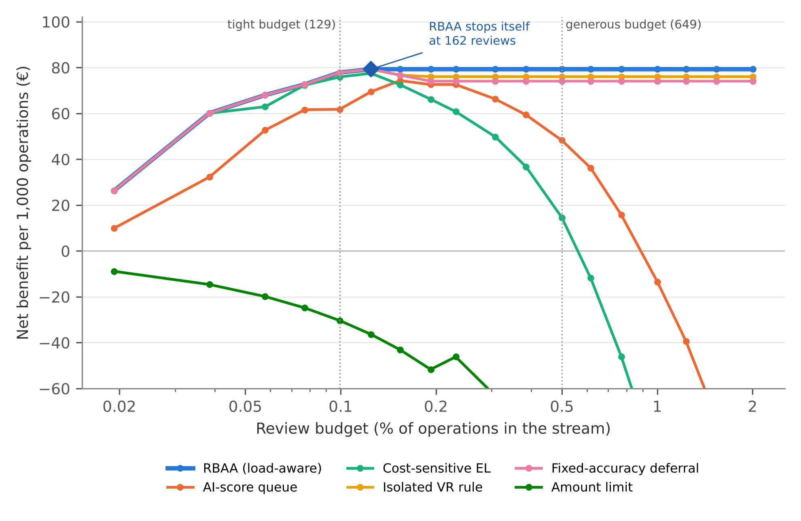
Figure 2. Net benefit per 1,000 operations by review budget and allocation rule on 129,878 real card transactions (out-of-time test period). Rules without a stopping rule use the whole budget; RBAA (diamond) stops at 162 reviews when the budget allows. Reviewer behaviour assumed: q(L) = 0.90 − 0.50L, h(L) = 0.005 + 0.010L, L = e/0.02, κ = €5, ω = 1. Random audit and the classifier threshold are omitted for legibility (Table 3). Source: authors’ calculations with rbaa-benchmark (Prokopovych-Tkachenko, 2026c).

5.3. Robustness and boundary conditions
The ordering of rules was robust to the assumed reviewer behaviour. Across 324 scenarios that varied unloaded detection (q₀ = 0.7 or 0.9), the load slopes of detection (0.25–1.0) and of harmful overrides (0.005–0.02), reviewer capacity (1–5% of the stream), review cost (€2.5–10) and the loss from a harmful override (ω = 0.25 or 1), RBAA was best or tied for best in 95.7% of scenarios under the generous budget and in 93.8% with matched volume, and under the generous budget it never fell below the AI-score queue or cost-sensitive ranking. Its median gain over the best alternative was €2.6 per 1,000 operations and its largest shortfall €2.5. Under the tight budget, RBAA was best or tied in 79.9% of scenarios and the median difference from the best alternative was zero. Replacing the classifier by four further random seeds or by a calibrated logistic regression left RBAA with the highest net benefit under the generous budget in all six cases (€57.6–79.3 per 1,000 operations), whereas under the tight budget the AI-score queue performed better in two of the six.
Calibration is the main boundary condition. When predicted probabilities were distorted on the logit scale (slope 0.75–1.5, intercept shift −1 to +1), RBAA remained above the AI-score queue in all twelve settings (€55.3–81.1 against €48.3 per 1,000 operations). When probabilities were flattened (slope 0.5), RBAA fell below the AI-score queue unless they were also deflated: it earned €10.8 per 1,000 operations without a shift and, when probabilities were also inflated (shift +1), reviewed the whole budget and lost €18.3, whereas the AI-score queue, which uses only the ordering of scores, was unaffected. Because RBAA prices review in money, it is only as good as the probability estimates it prices; calibration monitoring and the manipulation check in Appendix C are therefore preconditions for deployment, not refinements.

5.4. Economic effect of oversight
Because every term of the model is monetary, the allocation can be evaluated with the instruments of management accounting. For a period t, the total cost of control of a policy is the expected loss that remains after review plus the cost of review and governance:
${TCC}_{t} = ∑_{i}(1 − x_{i}q_{i}){EL}_{i} + ∑_{i}x_{i}h_{i}(1 − p_{i})C_{i} + ∑_{i}x_{i}(c_{i} + d_{i}) + G_{t} = ∑_{i}{EL}_{i} − ∑_{i}x_{i}{VR}_{i} + G_{t}$ (4)
where x_{i} indicates that operation i is reviewed, q_{i} and h_{i} are evaluated at the load that the policy itself generates and G_{t} is the cost of the independent audit sample. In cost-of-quality terms the first two terms are failure costs, the third is an appraisal cost and G_{t} combines appraisal and prevention costs; in agency terms the first two are the residual loss of delegation and the third its monitoring cost (Jensen & Meckling, 1976). Because ΣEL_{i} does not depend on routing, minimising the total cost of control is equivalent to maximising the summed value of review, and the net economic effect of oversight relative to unreviewed execution is
${NEE}_{t} = ∑_{i}{EL}_{i} − {TCC}_{t} = ∑_{i}x_{i}{VR}_{i} − G_{t}$ (5)
Review time is priced at the capacity cost rate of the reviewer, as in time-driven activity-based costing (Kaplan & Anderson, 2004); here €5 for ten minutes, or €30 per hour. Table 4 translates the comparison into these indicators. Unreviewed execution leaves the full fraud value, €162.9 per 1,000 operations, as residual loss. RBAA reduced the total cost of control to €83.6 per 1,000 operations, a reduction of 48.7%, whereas the AI-score queue reduced it by 29.6% and cost-sensitive ranking by 8.9%; amount-based limits raised it by 59.7%. Each review hour under RBAA returned €381 net, against €58 under the AI-score queue, and each euro spent on review returned €12.7. Replacing an AI-score queue by RBAA lowered the total cost of control by 19.0% of the value at risk, about €31 per 1,000 operations here, and released 81 review hours per 129,878 operations that the owner can redeploy.
Table 4. Economic indicators of the oversight function at a review budget of 0.5% of operations
Indicator | RBAA | AI-score queue | Cost-sensitive ranking | Amount-based limits
Reviews (review hours) | 162 (27.0) | 649 (108.2) | 649 (108.2) | 649 (108.2)
Fraud value corrected, % of value at risk | 57.4 | 52.6 | 52.5 | 13.3
Harmful-override loss, € per 1,000 operations | 8.01 | 12.48 | 45.89 | 93.89
Review cost, € per 1,000 operations | 6.24 | 24.98 | 24.98 | 24.98
Total cost of control (TCC), € per 1,000 operations | 83.62 | 114.66 | 148.35 | 260.13
Reduction in TCC relative to unreviewed execution, % | 48.7 | 29.6 | 8.9 | −59.7
Net economic effect per review hour, € | 381 | 58 | 17 | −117
Net return per € of review cost | 12.7 | 1.9 | 0.6 | −3.9
Note. Unreviewed execution: TCC = €162.92 per 1,000 operations (all fraud value lost), reduction 0%. TCC excludes the governance cost G_{t}, which is common to all policies. Reviewer behaviour and costs assumed as in Section 5.1. Source: authors’ calculations with rbaa-benchmark (Prokopovych-Tkachenko, 2026c).
The budget constraint gives managerial attention an explicit price. At the tight budget, twenty additional reviews (200 review minutes) raised RBAA’s net benefit by €1.66 per review minute, so one more ten-minute review was worth about €16.6 net of its cost. Under the generous budget the shadow price was zero, because RBAA stopped before the budget bound. An owner should therefore add review capacity, for example a deputy or an external bookkeeping service, only while the shadow price of attention exceeds the cost of that capacity per minute, and release time to other work when it stays at zero.
Mandatory review is a governance choice with a measurable price (Figure 3a). A hard floor at €1,000 made 1,414 reviews mandatory and turned the net benefit of oversight into a loss of €24,676 on the test stream (−€190 per 1,000 operations), a price of €34,974 relative to RBAA without a floor, or €24.7 per mandatory review. Almost all of this price arises from harmful overrides on large legitimate transactions rather than from workload: routing the mandatory reviews to a deputy reduced it only to €31,095. At the materiality threshold used in Table A1, €5,000, only 26 reviews were mandatory, the price fell to €938 (9.1% of the net benefit), and RBAA with the floor still earned €72.1 per 1,000 operations, more than the AI-score queue, cost-sensitive ranking or the classifier threshold without any floor. With a lighter harmful-override loss (ω = 0.25), the price of a €1,000 floor fell to €15,146. The hard floor therefore remains a constraint that cost minimisation may not relax, but the choice of its threshold is an economic decision: the owner can read from this curve how much assurance each threshold buys and at what price.
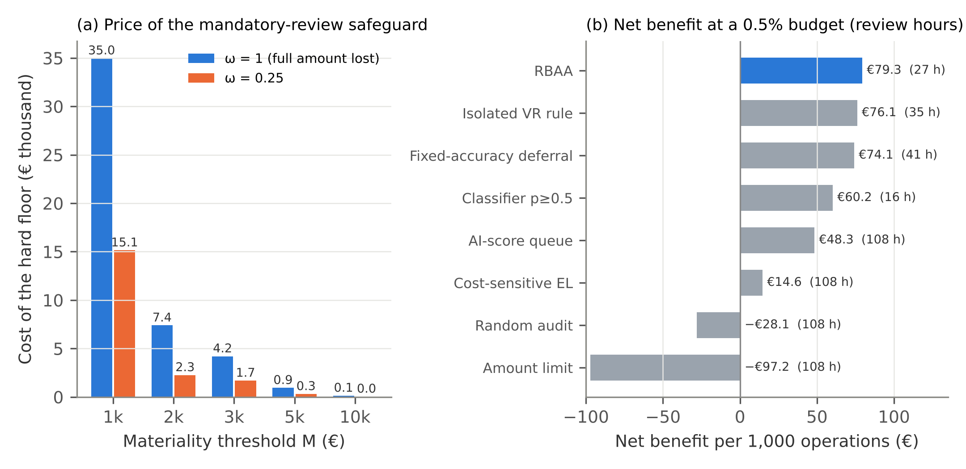
Figure 3. Economic effect of oversight on 129,878 real card transactions. (a) Price of a mandatory-review hard floor: loss of net benefit relative to RBAA without a floor, by materiality threshold M and harmful-override loss fraction ω, with mandatory reviews handled by the same reviewer. (b) Net benefit per 1,000 operations and review hours used at a budget of 649 reviews (0.5% of operations). Reviewer behaviour assumed as in Figure 2. Source: authors’ calculations with rbaa-benchmark (Prokopovych-Tkachenko, 2026c).
Adopting RBAA is an investment: calibration, a shadow-mode period, elicitation of routing parameters, training and audit design are incurred before benefits accrue. With implementation cost I₀, gain ΔNEE_{t} in period t relative to the policy replaced, planning horizon T_{h} and discount rate r, the owner can appraise the change as
$NPV = −I_{0} + \sum_{t = 1}^{T_{h}}{\frac{Δ{NEE}_{t}}{{(1 + r)}^{t}}}$ (6)
In the validation, ΔNEE relative to an AI-score queue equalled 19.0% of the fraud value at risk. For a firm whose AI-supported approval stream carries an expected loss from undetected errors of V per year, the change would therefore pay back within a year when I₀ < 0.19V, provided that its reviewer behaviour and loss structure resemble the assumed ones. Field data are required to estimate ΔNEE for SME invoice approval; Equation (6) identifies the quantities an SME must track to make that judgement.

5.5. Remaining empirical agenda
The validation rests on observed transactions but assumed reviewer behaviour, and card payments are not SME invoices. It shows that the allocation logic outperforms established methods under explicit and widely varied assumptions; it does not show that SME managers behave as assumed.
Appendix C proposes a field test with business-as-usual approval, uniform review of AI recommendations and RBAA. It separates probability-based outcome auditing from operational safety audits, defines a single primary estimand and treats realised escalation as a post-treatment quantity. The protocol, recruitment, ethics review, model calibration and trial registration remain prospective. Version 1.1.0 of rbaa-sim implements this protocol on synthetic data, including the design-weighted primary estimator and the threshold-policy contrasts; the code will be locked before preregistration.

6. Discussion

6.1. Theoretical contribution and boundary conditions
The paper starts from a simple observation. In SMEs, AI multiplies recommendations but not the managerial attention needed to check them. We argued that human oversight of AI should therefore be studied as an allocation problem. We defined cognitive optimisation through five measurable indicators and proposed the RBAA model, which specifies when an AI system may observe, recommend, prepare or execute.
The model develops the attention-based view for AI-supported operational decision streams (Ocasio, 1997, 2011). It complements decision-structure accounts (Shrestha et al., 2019) by allowing authority to vary across operations while preserving common capacity and accountability constraints. In the automation–augmentation debate (Raisch & Krakowski, 2021), it offers a conditional mechanism for combining execution and human verification rather than claiming to resolve that debate. The distinction between formal approval and substantive review is made observable through several imperfect indicators, including audit accuracy and override quality. The central analytical addition is the workload externality: under the stated assumptions, reviewing one more case degrades review elsewhere in the queue. This shifts the relevant unit of optimisation from the isolated transaction to the decision stream. The inverted-U implication is sufficient-condition reasoning, not an asserted universal law of oversight.
The account is compatible with experimental findings on AI-initiated delegation (Fügener et al., 2022) and with evidence that human–AI combinations need not outperform their better component (Vaccaro et al., 2024). It provides a candidate explanation: adding review can contribute little locally and impose costs elsewhere. Whether this mechanism explains observed performance requires measuring review quality under different workloads, rather than inferring it from an escalation count or a statistically fitted curve alone.
The validation adds a comparative result to this account. Against seven alternative rules on a real transaction stream, the advantage of RBAA came mainly from two features that established methods lack: a stopping rule that prices each further review against its cost, and a stopping rule that also prices the review’s effect on the rest of the queue. Score-based triage and cost-sensitive ranking order operations sensibly but continue to review after review has ceased to pay, and deferral rules with load-independent human accuracy stop too late. The economic gain therefore comes from a better allocation of a scarce human resource rather than from a better prediction, which is what the attention-based view would lead one to expect.
For digital business, the proposed governance mechanism connects the growth of AI-enabled transaction processing to changes in decision rights, exception handling and control costs. Digital transformation research emphasises organisational structures, capabilities and performance measures alongside technology (Verhoef et al., 2021). RBAA specifies one operational mechanism through which those organisational choices could affect value capture. Its scope is process redesign, not evidence of a new business model or firm-wide productivity growth. The same mechanism has implications for managerial job design: thresholds and deputy routes redistribute work demands. Delegation research links authority to trust and competence (Leana, 1986; Yukl & Fu, 1999), while research on entrepreneurial cognition and digital adoption motivates testing whether managers can turn released capacity into better decisions (Retamal-Saavedra et al., 2026; Kohnke et al., 2024). The same logs that make substantive review observable could also become an instrument of algorithmic surveillance of managers themselves; sociotechnical accounts of workplace surveillance show that leaders and managers, not only employees, are targets of such monitoring (Kayas et al., 2025). This is why the model keeps oversight logs separate from individual performance appraisal (Section 6.2).
The model also has boundary conditions that the planned test can reveal. If AI uncertainty is poorly calibrated, risk-based escalation should lose its advantage over uniform review. The manipulation check allows this moderating condition to be examined directly. Where managers have spare capacity or AI uncertainty is anti-informative, the hypothesised advantage may diminish or disappear; these boundary conditions require empirical testing. If managers learn over the intervention period that escalated cases are usually benign, the cue value of escalation may erode, reproducing complacency at a higher level (Wickens et al., 2015). Tracking automation-bias errors across the three threshold blocks tests this possibility. Conversely, algorithm aversion may lead some managers to override escalated recommendations indiscriminately (Dietvorst et al., 2015; Burton et al., 2020). Override quality is designed to detect this pattern, which would show up as frequent but harmful overrides. Finally, the model assumes that managerial attention, once freed, is reinvested in the approval process. Managers may instead redirect it to other tasks. That would be a legitimate gain for the firm, but it would weaken the predicted improvement in decision quality. Measuring time use on and off the approval queue separates these explanations.

6.2. Managerial implications
For SME owners, the model suggests a sequence of design decisions to be evaluated before deployment. Define the authorised execution envelope, materiality limits and reversibility conditions; assign a deputy and a stop or queue action when mandatory work exceeds capacity; then calibrate discretionary escalation against observed review quality and available time. Monitor errors and turnaround time jointly, including outcomes for non-escalated operations. Falling verification quality can indicate overload, but lowering the review burden must never relax mandatory safeguards. The validation shows that these safeguards have a measurable price, which falls steeply as the materiality threshold rises (Figure 3a); the threshold should therefore be set by reading the price of assurance from such a curve rather than by convention. The relevant business choice is whether to provide sufficient control capacity, narrow the execution scope or defer deployment.
The indicators of Table 4 can be reported in an SME’s management accounts as a periodic cost-of-control statement: total cost of control per 1,000 operations, net benefit per review hour and the shadow price of attention. A high review cost with a low return per review hour signals over-control, the pattern that Proposition 2 predicts for case-by-case escalation; a rising residual loss under permitted execution signals under-control. Pricing review time at the capacity cost rate of the reviewer also makes visible a cost that SMEs rarely record, because the owner’s time does not appear in the accounts.
For human resource management, the model implies four practices. Escalation rights and deputy routes should be written into job descriptions, so that oversight does not depend solely on the owner's availability. Training should target digital competence, specifically interpreting uncertainty estimates and verifying flagged operations, rather than general tool use. This is consistent with the AI-literacy provision of the EU AI Act, under which providers and deployers must take measures to support the AI literacy of staff who operate AI systems (Regulation (EU) 2024/1689, Art. 4, as amended by Regulation (EU) 2026/1744). Performance appraisal should reward well-founded overrides rather than throughput alone, because a culture that penalises delay encourages formal approval without control. Oversight logs should nevertheless be kept separate from individual performance evaluation, because AI systems that monitor and evaluate the performance of workers are high-risk uses under the AI Act (Regulation (EU) 2024/1689, Annex III, point 4(b)). Finally, workload indicators for managers should include the volume of AI escalations alongside other job demands.
The model also suggests a sequence for introducing AI into approval processes. Firms should begin in observation mode, comparing the AI's recommendations with their own decisions for several weeks before showing them. This builds the calibration evidence that routing requires. It also gives the owner a factual basis for setting thresholds. Firms can then move to recommendation and preparation for most operations. Permitted execution should be introduced last, for a narrow envelope that widens only as audit results justify it. This sequence reverses the common pattern in which automation is switched on first and controls are added after an incident.

6.3. Limitations and future research
Several limitations delimit the contribution. First, the organisational predictions remain untested; future work must report null and adverse findings. Second, calibration and reviewer-quality functions are assumptions that require deployment-relevant data, especially for rare costly errors. Conformal methods do not automatically solve drift. Third, invoice and purchase approval is more structured than strategic judgement, where the reference outcome may itself be contested (Jarrahi, 2018). Fourth, the SOC analogy transfers architecture rather than expertise or effect sizes. Fifth, logging, probes, seeds and questionnaires can alter vigilance, potentially interacting with treatment (McCambridge et al., 2014). Sixth, legal applicability depends on the system's intended purpose and implementation; the human-oversight provisions cited here are design references, and national and EU requirements must be assessed for the actual deployment. Seventh, recruitment through one software partner and exclusion of microenterprises limit external validity. Baseline comparisons with non-participating clients and a reduced-measurement follow-up can assess parts of these limitations.
The analytical result additionally requires a stable ordering of review benefits and sufficient curvature over a feasible workload interval. Hard floors, rank changes, capacity shortages or changing error costs can produce a boundary optimum or invalidate the scalar formulation. The validation in Section 5 uses card payments rather than SME invoices, imposes reviewer behaviour rather than observing it, holds reversibility constant and covers fewer than two days. Its bootstrap reflects variation in the transaction stream but not in classifier training or human behaviour, which were examined through scenario and classifier sensitivity instead. It therefore validates the allocation logic against established methods, not the full four-level governance model in organisations. The synthetic pipeline in rbaa-sim implements the revised estimands of Appendix C but will be locked only before preregistration. Table 7 and Figure A2 remain illustrative planning aids, not evidence of adequate power for the revised primary estimand.

7. Conclusions
AI-supported digital workflows require a decision about where human judgement adds value and where verification capacity is insufficient. This conceptual study develops an RBAA model that connects uncertainty, consequence, reversibility and availability to bounded decision authority. Its main analytical result is conditional: a locally worthwhile review can reduce process-level performance by degrading other reviews, and an interior escalation optimum exists only under explicit assumptions. Mandatory-review constraints remain binding even when they reduce short-run net benefit. On 129,878 real transactions with assumed reviewer behaviour, the rule outperformed amount-based limits, random audit, AI-score triage, cost-sensitive ranking and load-independent deferral, reduced the total cost of control by 48.7% and returned €381 per review hour; its advantage depended on calibrated probabilities and narrowed when the budget was tight. Five hypotheses and a proposed field protocol specify how to test whether SME managers behave as assumed. The contribution is therefore a transparent and economically quantified account of AI delegation and its limits, with separate measures of decision quality, managerial effort and substantive control.
CRediT authorship contribution statement: Olga Torstensson: Conceptualization, Resources, Supervision, Project administration, Writing – review & editing. Dmytro Prokopovych-Tkachenko: Conceptualization, Methodology, Software, Formal analysis, Data curation, Visualization, Project administration, Writing – original draft, Writing – review & editing. Igor Britchenko: Conceptualization, Methodology, Supervision, Writing – original draft, Writing – review & editing. Bakytgul Ilessova: Investigation, Resources, Writing – review & editing. Nazarii Chubaievskyi: Methodology, Formal analysis, Visualization, Writing – original draft, Writing – review & editing. Ayaulym Merkibaeva: Investigation, Resources, Writing – review & editing.
Funding: This research received no specific external grant. Halmstad University provided institutional support for publication-related costs.
Ethics approval: The conceptual analysis reports no research with participants or primary participant records. No ethics approval is claimed for the proposed field study. Required approvals will be obtained before recruitment and data collection, as set out in Appendix C.
Consent to participate: Not applicable to the completed conceptual and secondary-data components. Participating firms and managers will provide informed consent before any proposed field study begins.
Data availability: No primary participant data were collected. The analytical derivation and hypothetical inputs are provided in the manuscript. The code and archived outputs that reproduce all calculations are openly available on Zenodo under the MIT licence: rbaa-sim, version 1.1.0 (https://doi.org/10.5281/zenodo.SIM_DOI), for Tables A1 and 7, Appendix A, Figures A1–A2 and the synthetic analysis pipeline of Appendix C; rbaa-validation, version 1.1.0 (https://doi.org/10.5281/zenodo.VAL_DOI), for Appendix B and Figures B1–B3; and rbaa-benchmark, version 1.0.0 (https://doi.org/10.5281/zenodo.BEN_DOI), for Section 5, Tables 3–4 and Figures 2–3, also supplied as Supplementary Material S1. Versions 1.0.0 of rbaa-sim and rbaa-validation remain available at https://doi.org/10.5281/zenodo.23421069 and https://doi.org/10.5281/zenodo.23421157. The Zenodo records identify Dmytro Prokopovych-Tkachenko as the deposited creator, with the co-authors listed as contributors. The transaction data are the public ULB/Worldline release (284,807 rows, 492 frauds), which retains its own Open Database/Database Contents terms and is not relicensed by the software licence; the packages download it from a public mirror and verify the SHA-256 checksum 76274b691b16a6c49d3f159c883398e03ccd6d1ee12d9d8ee38f4b4b98551a89. Section 5 was computed with Python 3.13 and scikit-learn 1.9.1. Eurostat data are used under the Eurostat re-use policy. No field data or trial registration exists.
Acknowledgements: The authors thank Halmstad University, Sweden, for institutional support, including support for publication-related costs.
Declaration of competing interest: The authors declare that they have no known competing financial interests or personal relationships that could have appeared to influence the work reported in this paper.
Declaration of generative AI and AI-assisted technologies in the writing process: During the preparation of this work the authors used Claude (Anthropic) and ChatGPT (OpenAI) for language editing, bibliographic checks, figure preparation and assistance in writing and running the analysis code reported in Section 5 and the appendices. After using these tools, the authors reviewed and edited the content as needed and take full responsibility for the content of the published article.

Appendix A. Derivation of Hypothesis 4 and worked example of the routing rule
Consider a fixed stream normalised to unit mass, with operations indexed by s ∈ [0, 1] under a fixed ordering. Assume that v₍ₛ₎(L) is non-increasing in s at every feasible load, twice continuously differentiable, and that derivatives can be interchanged with integration. This is stronger than ranking by expected loss alone. Let L(e) = L₀ + ℓe, with ℓ > 0, and restrict the feasible interval so q(L) and h(L) remain probabilities. Assume q′(L) ≤ 0 and h′(L) ≥ 0, so ∂v₍ₛ₎/∂L = q′(L)EL₍ₛ₎ − h′(L)(1 − p₍ₛ₎)C₍ₛ₎ ≤ 0. Differentiation of Equation (3) gives
$NP′(e) = v_{(e)}(L(e)) − κ + ℓ\int_{0}^{e}{\frac{∂v_{(s)}}{∂L}} ds$ (A1)
If v₍₀₎(L₀) > κ, then NP′(0) > 0. If v₍₁₎(L(1)) < κ, then NP′(1) < 0 because the load term is non-positive. Continuity on the compact interval ensures a maximum, and these endpoint signs exclude the endpoints; strict concavity below makes the interior maximiser unique. For a smaller feasible interval, the endpoint tests must be applied at that interval's boundaries. Differentiating again gives
$NP″(e) = \frac{∂v_{(e)}}{∂s} + 2ℓ \frac{∂v_{(e)}}{∂L} + ℓ^{2}\int_{0}^{e}{\frac{∂^{2}v_{(s)}}{∂L^{2}}} ds$ (A2)
The three terms are non-positive if benefits decline with rank, review quality weakens with load, q is linear or concave, and h is linear or convex. Strict concavity requires at least one strictly negative contribution at every interior e; weak inequalities alone do not establish uniqueness. If these conditions hold, a marginal-only rule stopping at eₘ with v₍ₑₘ₎(L(eₘ)) = κ ignores the load term. At that point NP′(eₘ) ≤ 0, and hence e* ≤ eₘ for an interior solution under the same ordering. Strict over-escalation requires a strictly negative load externality. This comparison is not a theorem about a separately re-ranked case-by-case policy. If the hard floor fixes a mandatory prefix e_H and capacity caps review at e_B, the optimum is the projection of e* onto [e_H, e_B] only when that fixed-prefix assumption holds. Otherwise the constrained selection problem must be solved anew. Infeasibility requires more capacity or deferral, not autonomous execution of mandatory cases.
Figure A1 recomputes the analytical illustration from the archived parameter values: q(L) = 0.90 − 0.50L, h(L) = 0.005 + 0.010L, L(e) = 0.2 + ℓe and κ = €5. The expected-loss profile is EL(s) = 400 exp(−6s), and the correct-recommendation exposure (1 − p(s))C(s) is fixed at €600. For ℓ = 2, the admissible curve ends at e = 0.8, where q reaches zero; values beyond this point, where q would be negative, are not plotted. The optima e* are approximately 0.592, 0.393, 0.307 and 0.218 for ℓ = 0, 0.5, 1 and 2, respectively; the corresponding marginal-only rates are 0.592, 0.534, 0.485 and 0.404. The derivative was checked numerically on the admissible interval, and all four optima and marginal-only rates are reproduced by rbaa-sim (Prokopovych-Tkachenko, 2026a). Figure A2 retains the archived simulation-based power illustration, whose assumed losses and analysis implementation must be reconsidered for the final field protocol. Neither figure is empirical evidence for H4.
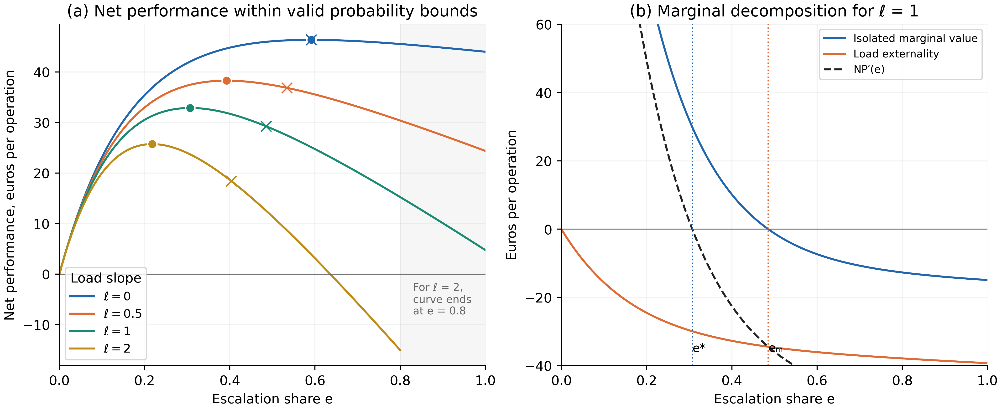
Figure A1. Recomputed analytical illustration with valid probability bounds. (a) Net performance for four load slopes; circles mark e* and crosses the marginal-only stopping rate. The ℓ = 2 curve stops at e = 0.8. (b) Decomposition of marginal performance at ℓ = 1. Values are hypothetical, not observed. Source: authors’ calculation from the functions and parameters stated in Appendix A with rbaa-sim (Prokopovych-Tkachenko, 2026a).
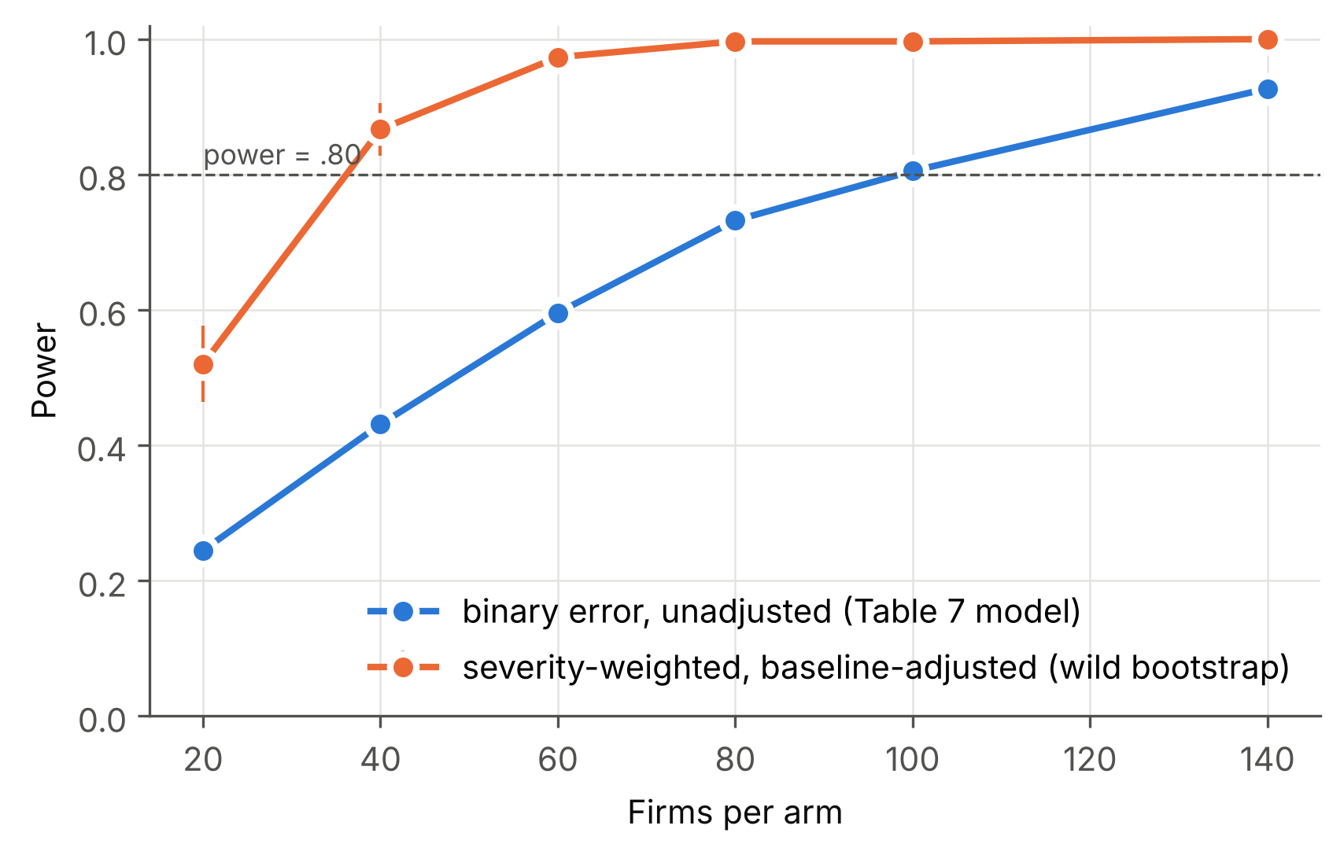
Figure A2. Simulated power for the comparison of T2 with T1 by number of firms per arm: binary decision error without baseline adjustment (the model behind Table 7) and severity-weighted errors analysed with baseline adjustment and a wild-bootstrap test (error rate under T1 = 8%, relative reduction 30%, m = 150, ICC = .05; 300 replications per point; bars show 95% Monte Carlo intervals). The result depends on the assumed loss distribution and will be recomputed from pilot data. Source: authors' calculations with the companion code (Prokopovych-Tkachenko, 2026a).
Table A1 illustrates the routing rule of Table 2 with hypothetical values. The examples show three features of the model: operations with similar expected loss can receive different levels of authority because of the hard floor; low availability delays rather than delegates operations whose uncertainty is above the execution threshold; and operations outside the validated scope are routed to observation regardless of their value.
Table A1. Worked example of the RBAA routing rule (hypothetical values)
Operation | p_{i} | C_{i} (€) | R_{i} | EL_{i} (€) | VR_{i} (€) | Level of AI authority and reason
Recurring utility invoice matching the contract | .02 | 400 | .9 | 8.80 | −2.76 | 4 Permitted execution: VR_{i} ≤ 0 and within the execution envelope; ex post audit
Small invoice deviating from the purchase order | .08 | 600 | .9 | 52.80 | 26.44 | 3 Action preparation: VR_{i} > 0 but below the Level 2 threshold
Same invoice while the manager is unavailable (c = €40) | .08 | 600 | .9 | 52.80 | −8.56 | 3 Action preparation, queued: p_{i} above the execution threshold, so low availability delays rather than delegates
Cross-border transfer to a known supplier | .01 | 900 | 0 | 18.00 | −1.31 | 3 Action preparation: hard floor (R_{i} = 0) overrides VR_{i} ≤ 0
Above-materiality invoice matching the purchase order | .03 | 8,000 | .6 | 336.00 | 152.60 | 3 Action preparation: hard floor (C_{i} ≥ €5,000) with low p_{i}
Large advance payment to a new supplier | .15 | 20,000 | 0 | 6,000.00 | 4,025.00 | 2 Recommendation with cognitive forcing: VR_{i} ≥ €1,000 and hard floor
New supplier category invoiced in a foreign currency | — | 2,500 | .6 | — | — | 1 Observation: outside the validated scope; uninformative conformal prediction set
Note. EL_{i} and VR_{i} are computed from Equations (1)–(2) with φ(R_{i}) = 1 + (1 − R_{i}), q = .70, h = .01, c = €5 (about 10 minutes of managerial time at €30 per hour; €40 when the manager is unavailable) and d_{i} = 0. Materiality threshold €5,000; execution envelope C_{i} < €1,000, R_{i} ≥ .8 and p_{i} < .05; Level 2 threshold VR_{i} ≥ €1,000. All values are hypothetical and chosen for illustration only. Source: authors' calculations; reproducible with the companion code (Prokopovych-Tkachenko, 2026a).

Appendix B. Illustrations from the companion back-test on real open data
Appendix B separates adoption context from the archived transaction illustration. Figure B1 has been redrawn from the values printed in Eurostat's 2026 statistical report (Eurostat, 2026b, Figure 1, p. 14); rbaa-validation reproduces it from these values. In 2025, AI adoption was 17.0% for small, 30.4% for medium and 55.0% for large enterprises, and 20.0% overall among covered enterprises with at least ten persons employed. These percentages describe technology adoption, not verification practices, queue size or the effectiveness of RBAA. They do not establish that the oversight problem grows fastest in any size class.
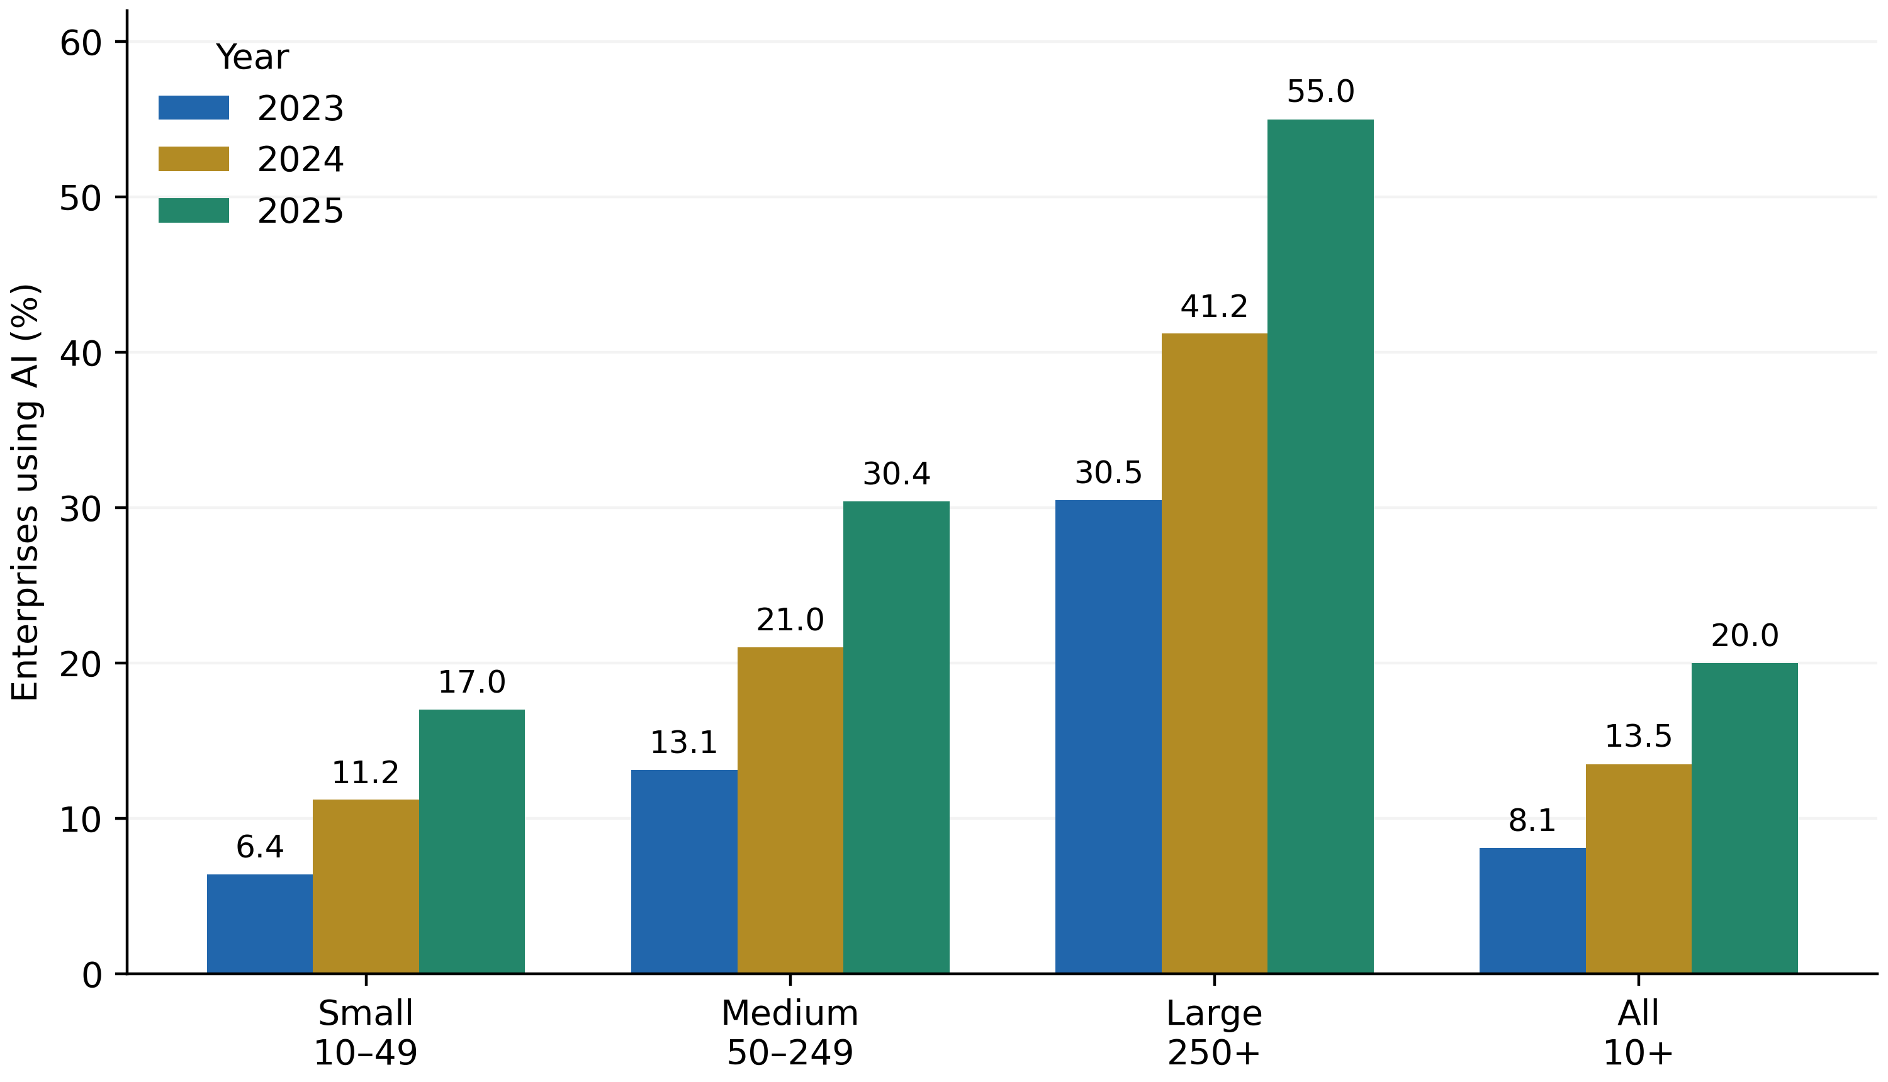
Figure B1. EU enterprise use of AI by size class, 2023–2025. Redrawn from the labelled values in Eurostat (2026b), Figure 1, p. 14, under CC BY 4.0. Adoption context only; no inference about RBAA use or effectiveness.
The archived back-test (rbaa-validation version 1.0.0, reproduced unchanged by version 1.1.0; Prokopovych-Tkachenko, 2026b) uses 284,807 card transactions, including 492 labelled frauds, from European cardholders over two days in September 2013. The archive's DATA_SOURCES.md identifies Worldline and the ULB Machine Learning Group, a TensorFlow mirror, the dataset checksum and Open Database terms. The split is at 60% of elapsed transaction time, not 60% of rows, leaving 129,878 test transactions with 143 labelled frauds. A histogram gradient-boosting classifier with isotonic calibration and three-fold cross-validation is fitted within the earlier period; test labels are used for evaluation, not for the predicted stopping rule. The inputs are transaction amount and transformed features, not SME invoices or observations of managerial review. Reversibility is held constant and the irreversibility multiplier is one. The archived mean predicted fraud probability is 0.00172 versus an observed rate of 0.00110, so applying calibration does not imply perfect out-of-time calibration.
With L = e/0.02, the default reviewer model clips q(L) = 0.90 − 0.50L and h(L) = 0.005 + 0.010L to [0, 1]. Review costs €5 and takes ten minutes by assumption. For each ranked prefix, expected fraud loss avoided is q times the labelled fraudulent amount; expected harmful-override loss is h times legitimate amount; review cost is then deducted. The load-aware stopping point is selected using predicted probabilities, not realised labels. Rankings are fixed using the zero-load review score, so this calculation is an optimum along that ordering, not proof of globally optimal case selection at every load.
At the shared budget of 129 reviews (21.5 hours), archived net benefits are €10,351.82 for simplified RBAA, €8,878.00 for AI-score ranking, −€694.68 for random checks and −€3,942.76 for amount-based ranking. The RBAA advantage over AI-score ranking is €1,473.82, with a 95% percentile interval of −€417.45 to €3,513.84; the archived one-sided bootstrap tail proportion is 0.0769. Comparisons with random and amount-based ranking have positive intervals, with archived one-sided tail proportions of 0.001. These tail proportions describe the archive's resampling procedure and are not randomised-trial p-values. The load-aware and marginal-only rules yield €10,351.82 and €9,572.97, respectively, under the imposed review functions.
A material qualification is that these same-budget headline results omit the hard floor required by the SME governance model. The archived constrained variant always reviews amounts of at least €1,000; its predicted stopping rule reviews 1,474 operations (245.67 hours) and yields −€24,419.09. The €34,770.91 difference from the unconstrained result is the modelled cost of imposing this particular safeguard under the selected review assumptions. It is not an estimate of the real price of regulatory compliance. The archive therefore illustrates both favourable and adverse outcomes rather than establishing policy dominance.
The 1,000-replicate bootstrap resamples hourly blocks of the short test window while holding the fitted classifier, ranking, review functions and selected budget fixed. It does not propagate uncertainty from retraining, calibration, reviewer behaviour or selecting the budget. With fewer than two days of data and rare fraud, its intervals have limited external interpretation. Amounts and fraud labels are observed, but avoided losses, harmful overrides, review hours and monetary benefit are counterfactual model outputs. The dataset's source licence is distinct from the companion code's MIT licence. The provenance file and recorded checksum should be retained whenever the analysis is reproduced.
Re-running the back-test from the source data for Section 5 reproduced the archived results closely. At the shared budget of 129 reviews, the re-run gave €10,111.82 for RBAA (archive €10,351.82), €8,028.48 for the AI-score queue (€8,878.00), −€715.96 for random checks (−€694.68) and an identical −€3,942.76 for amount-based ranking, which does not depend on the classifier. The constrained variant with a €1,000 floor reviewed the same 1,474 operations and gave −€24,675.58 (archive −€24,419.09). The differences arise from refitting the classifier (scikit-learn 1.9.1, time stamp excluded from the features) and do not change the ordering of policies. Section 5 reports the re-run values throughout; rbaa-benchmark (Prokopovych-Tkachenko, 2026c) reproduces them.
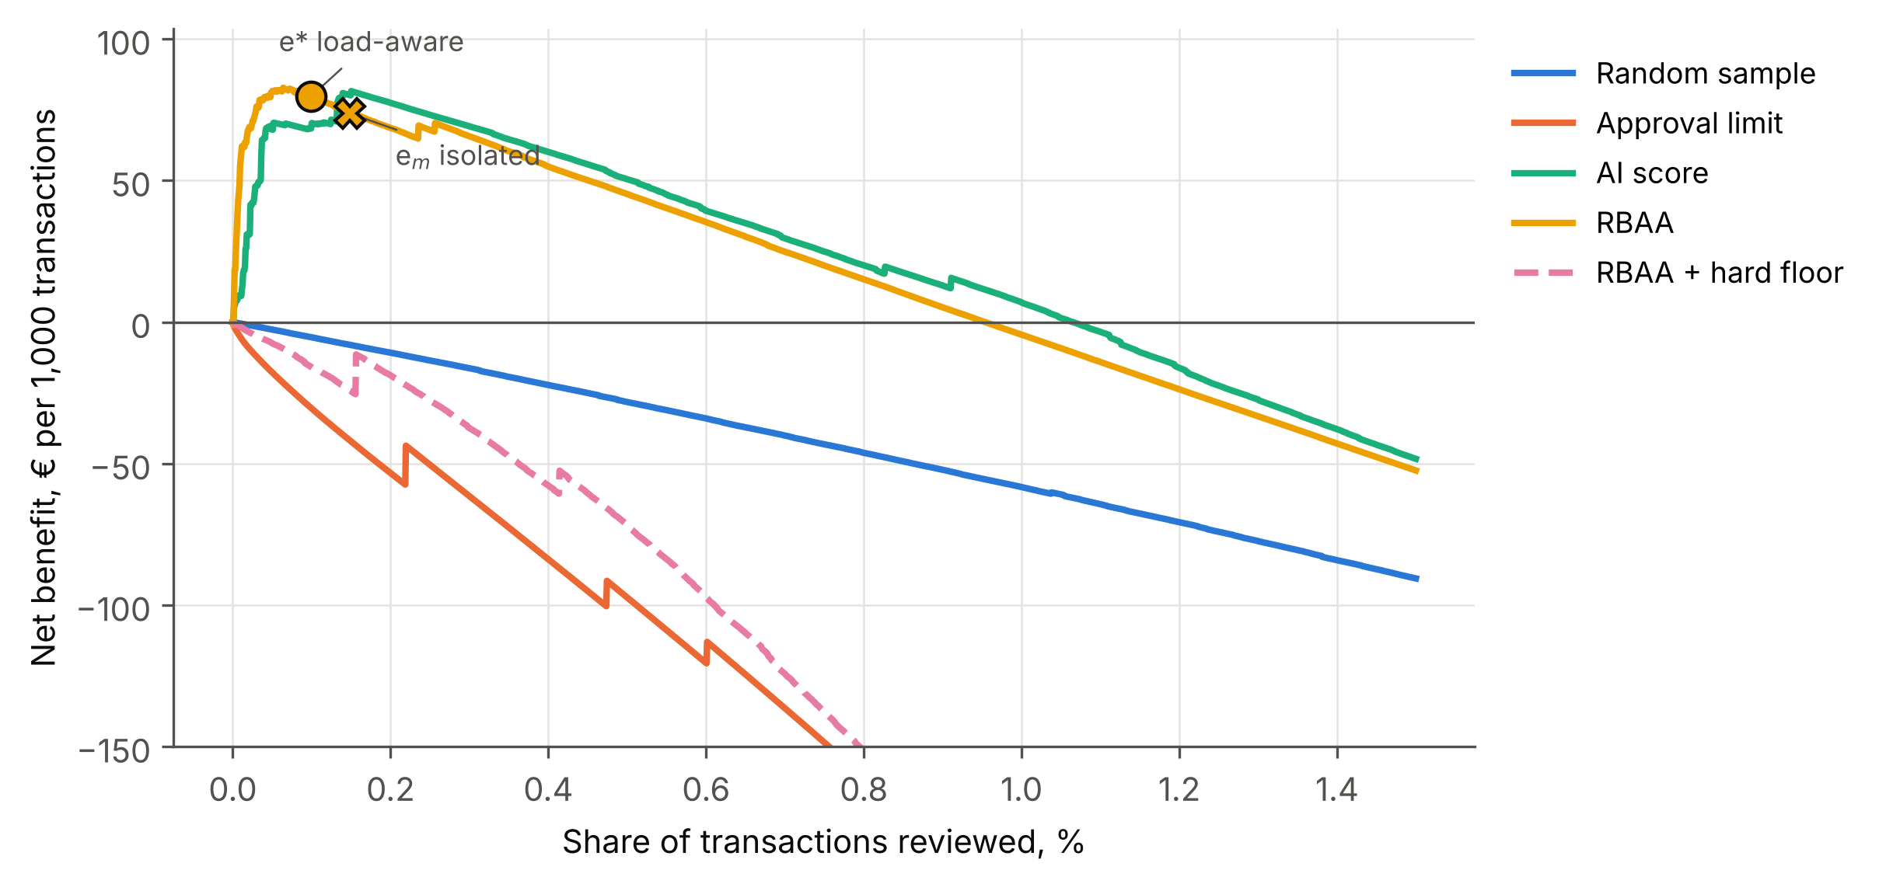
Figure B2. Archived counterfactual net benefit per 1,000 transactions against review share in the 129,878-transaction test period. The main RBAA line omits the mandatory materiality floor; the dashed line adds a €1,000 floor. Reviewer functions are assumed, with L = e/0.02 and probabilities clipped to [0, 1]. The plotted range contains only a small fraction of the full stream. Source: Prokopovych-Tkachenko (2026b).
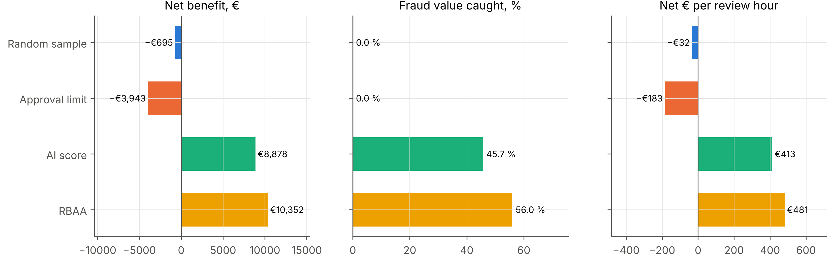
Figure B3. Archived same-budget comparison for 129 reviews, approximately 0.10% of 129,878 transactions, requiring 21.5 assumed review hours. Fraud value caught and net benefit are modelled expectations using observed labels and imposed reviewer probabilities; they are not observed human performance. The RBAA result omits the hard floor. Source: Prokopovych-Tkachenko (2026b).

Appendix C. Proposed field validation and analysis protocol

C.1. Research design and methodological source
A three-arm cluster-randomised field experiment is proposed for SME invoice and purchase approval (Harrison & List, 2004). It has not been conducted, approved or preregistered. The primary comparison is risk-based escalation versus uniform review of the same AI recommendations; business-as-usual approval provides a secondary benchmark. A baseline period and randomised threshold blocks support future evaluation of the theoretical mechanism. All numerical design values below are planning assumptions.
The design adapts the tiered alert-escalation logic of AI-enabled security operations centres (SOCs) (Kokulu et al., 2019; Vielberth et al., 2020), in which first-tier analysts triage machine-generated alerts and escalate unresolved cases to more experienced responders, while automation increasingly pre-filters alerts (Tilbury & Flowerday, 2024). SOCs face a structurally similar problem. A high volume of machine-generated alerts, most of them benign, must be triaged by analysts with limited time. Qualitative evidence documents analyst fatigue and distrust caused by false positives (Alahmadi et al., 2022). Table 5 separates what is transferred from the source domain from what is not. We transfer the design logic: tiered escalation, separation of detection from response authority, logging of analyst actions and audit of non-escalated items. We do not transfer empirical results, thresholds, effect sizes or performance figures. SOC analysts are trained specialists working in shifts, whereas SME owner-managers are generalists for whom approval is one task among many. Any SOC findings therefore serve only as motivation and do not constitute evidence for the hypotheses.
Table 5. Methodological transfer from AI-enabled security operations centres (SOCs) to SME approval
Design element | Source domain: AI-enabled SOC | Target domain: SME invoice and purchase approval | Status in this study
Volume and base rate | High volume of machine-generated alerts, most of them benign (Alahmadi et al., 2022) | High volume of routine invoices and purchase requests; errors rare but sometimes costly | Logic transferred; base rates measured in the baseline period, not assumed
Tiered escalation | Triage passes alerts from first-line analysts to senior responders (Kokulu et al., 2019; Vielberth et al., 2020) | Four levels of AI authority; deputy route under low availability | Logic transferred and adapted
Separation of detection and response authority | Detection tools flag; analysts accept automation more readily in detection than in response, and full automation is reserved for well-defined, low-severity processes (Tilbury & Flowerday, 2024) | Distinction between recommendation, action preparation and permitted execution | Logic transferred
Logging of human actions | Case-management records of analyst actions | Audit non-escalated operations using probability sampling; additional safety audits kept separate | Logic transferred
Audit of non-escalated items | Retrospective review of suppressed or auto-closed alerts; alert tuning and suppression can hide genuine incidents (Kokulu et al., 2019) | Blind probability-based outcome audit with common sampling rules across arms; inclusion weights recorded | Logic transferred
Human actors | Trained specialists working in shifts | Generalist owner-managers for whom approval is one task among many | Not transferred: expertise and availability differ
Empirical results, thresholds and effect sizes | Reported in SOC studies (e.g., Alahmadi et al., 2022; Tilbury & Flowerday, 2024) | — | Not transferred; motivation only, not evidence for the hypotheses
Regulatory context | Security and incident-reporting rules | Accounting, tax and AI-governance rules | Not transferred
Note. Source domain entries summarise the cited SOC literature; no SOC results are used as evidence. Source: authors' analysis.

C.2. Setting, units of analysis and participants
The study requires an accounting or procurement software partner with an AI module for invoice and purchase-request processing. Eligible firms employ 10–249 persons, corresponding to the enterprise-size bands used in the cited Eurostat statistics; this operational criterion does not establish every legal condition for SME status. Microenterprises are outside the proposed sample. Firms should process at least 150 operations per month, subject to pilot confirmation, and have an identifiable approval manager. The country setting depends on partner access. No cross-country comparison or harmonised legal coverage is assumed unless separately designed.
The design has three levels. The firm is the unit of randomisation. The operation (an invoice or purchase request) is the unit of analysis for decision quality, automation-bias errors, escalations and time. The manager-day is the unit for cognitive load. Operations are nested in managers and managers in firms. This nesting determines both the sample-size calculation and the analysis.

C.3. Experimental conditions
Firms are randomised in equal proportions to three arms, stratified by sector, size class, baseline monthly volume and baseline error rate. In T0 (business as usual), managers approve operations as before. The AI runs in shadow mode: its recommendations and uncertainty estimates are logged but not displayed. In T1 (AI recommendation, uniform review), the AI's recommendation and uncertainty estimate are shown for every operation, and every operation requires the manager's approval. In T2 (AI with risk-based escalation), operations are routed according to the RBAA model (Table 2). Permitted execution is limited to the pre-authorised envelope, the hard floor applies, and a random sample of non-escalated operations is audited.
Within T2, each firm completes a four-week run-in at a default threshold and then three four-week blocks with low, medium and high thresholds in randomised order. Thresholds vary only discretionary escalation; all scope and hard-floor safeguards remain active. The assignments identify comparisons between feasible threshold policies. They do not, by themselves, identify a causal quadratic effect of the realised escalation rate, which also reflects case mix and the identity of cases reviewed. All arms receive equivalent software onboarding; T1 and T2 receive the same uncertainty display and explanation. Threshold spacing is fixed from pilot information before randomisation.

C.4. Operationalising the routing inputs
The routing inputs will be estimated from workflow information. pᵢ denotes the probability that the recommendation is wrong, calibrated using labelled shadow-mode data with training and calibration partitions separated in time or by a prespecified cross-fitting scheme. Sparse firm-level errors require pooled or partially pooled calibration rather than unstable firm-specific fits. Out-of-scope features, insufficient calibration data or drift trigger observation and human handling. A conformal prediction set may supply an additional deferral signal only under justified exchangeability or other valid coverage conditions; it is not a guarantee under arbitrary distribution shift (Angelopoulos & Bates, 2023). Cᵢ combines invoice exposure and documented contractual consequences in euros. Rᵢ follows action type and enforceable cancellation terms. Aₜ is derived from queue information and calendar blocks voluntarily marked unavailable. Model versions and input definitions are logged.
The routing parameters are set before randomisation. These are the irreversibility multiplier, the materiality threshold for the hard floor, the execution envelope and the three escalation thresholds used in T2. Each owner sets them with the research team in a structured elicitation that uses the firm's own baseline operations as examples. The parameters are then recorded in a time-stamped addendum to the preregistration, filed before randomisation. This procedure keeps the routing rule transparent to the people who are accountable for it. It also prevents the research team from adjusting thresholds in response to emerging results. The elicitation itself yields data on how owner-managers trade off consequence against reversibility, which can be analysed descriptively.

C.5. Measures
The primary outcome is the severity-weighted decision-error rate per 100 operations. Before intervention, an audit sample of m operations per firm will be selected by probability sampling across periods and prespecified complexity strata. Conditional inclusion probabilities are recorded, with the same sampling rules in all arms; low-volume firms may require a census. A fixed m need not imply an identical sampling fraction across firms. Additional audits of escalated operations support safety and process diagnostics but are excluded from the primary outcome estimator. Each firm-level outcome is estimated from its probability sample using inverse-inclusion weights and the known total operation count. Auditors receive de-identified evidence without routing or arm labels where feasible. A double-coded sample, disagreement adjudication and Cohen's kappa assess reliability (Cohen, 1960). This separation addresses selective observation of outcomes (Lakkaraju et al., 2017; Kleinberg et al., 2018).
The principal H3a measure is an unverified-error escape rate: among AI recommendations adjudicated as erroneous, the proportion that leads to an erroneous final action without logged verification. In T2 this includes execution at Level 4, but such machine-only errors are distinguished from behavioural automation bias in a human reviewer. Human approvals without verification are reported separately. Seeded operations provide an additional test of detection: synthetic invoices with known defects are disclosed in the consent process, individually unmarked, and blocked from payment at system level. Their insertion rate and case mix are common across arms and they traverse the assigned routing process. Seeds are excluded from the primary outcome on genuine operations, because their prevalence and severity are experimentally controlled.
The raw NASA-TLX is collected at the end of each working day and after randomly sampled review episodes, with subscales oriented consistently so higher scores indicate greater workload (Hart, 2006). T1 and T2 managers provide pre-decision probability judgements on reviewed operations and on common calibration probes. Probe burden and timing are identical by design, and probe events are marked in the logs. Digital competence is assessed before randomisation with DigCompSat and a short piloted task test aligned with DigComp 2.2 (Clifford et al., 2020; Vuorikari et al., 2022). The task-based score is the prespecified primary moderator; self-report is secondary. AI calibration is monitored using reliability plots, Brier scores and error rates by relevant strata, as well as calibration error summaries that can otherwise conceal rare-event miscalibration.

C.6. Duration, seasonality and case complexity
The protocol (Table 6, Figure 4) runs for 28 weeks per cohort. It consists of two weeks of set-up and consent, eight weeks of baseline in shadow mode for all firms, two weeks of onboarding and sixteen weeks of intervention. The baseline period provides firm-level pre-treatment error rates and AI calibration estimates. These estimates are used for stratification and covariate adjustment.
Approval workloads are seasonal, with peaks around month- and quarter-ends and tax deadlines. Three features address seasonality. All arms run concurrently, so calendar shocks affect them equally. Firms are recruited in two cohorts starting three months apart, so the intervention period covers different calendar positions. Calendar-week fixed effects and firm-specific peak indicators enter all models. Case complexity is captured by an operation-level index. It combines the number of invoice lines, whether the supplier is new, currency, deviation from the purchase order and the outcome of three-way matching between purchase order, receipt and invoice. The index serves as a stratification variable for audit sampling and as a covariate.

C.7. Sample size justification
Because firms are randomised, power depends on the number of firms, the within-firm correlation and the variation in severity weights. The illustrative approximation for binary errors is K = n[1 + (m − 1)ρ]/m, where n is the required number of individually randomised operations per arm, m the audited operations per firm and ρ the intracluster correlation. Table 7 uses pooled-variance normal planning calculations at two-sided α = .05 and 80% power; all entries are hypothetical. Its range is 17–249 firms per arm. These counts do not establish power for the severity-weighted primary outcome. That calculation requires simulation of pilot-informed losses, baseline adjustment, audit sampling, attrition and the planned cluster-level estimator. A pilot with three to five firms can establish feasibility but cannot estimate the ICC precisely; planning should cover a plausible range and conservative upper values. Fixed audit counts limit variability in sampled cluster sizes (Eldridge et al., 2006), while inclusion weights account for different sampling fractions. The T2-only threshold analysis and moderation analysis require separate power assessments and may remain exploratory if feasible recruitment is insufficient. No gain from baseline adjustment is assumed without simulation.
Table 6. Study protocol
Phase | Weeks (per cohort) | Activities | Data collected | Safeguards and checks
0 Pilot | Before cohort 1 | Feasibility pilot in three to five firms; test audit, logs, seeds and questionnaires; explore planning distributions | Review times, feasibility, provisional error rates and a broad ICC sensitivity range | Pilot firms excluded; a small pilot cannot estimate ICC precisely
1 Set-up and consent | 1–2 | Recruitment through the partner; eligibility check; informed consent; digital-competence measurement; elicitation of routing parameters with each owner | Firm and manager characteristics; digital competence; routing parameters | Preregistration filed before recruitment; routing-parameter addendum filed before randomisation
2 Baseline (shadow mode) | 3–10 | All firms continue business as usual; AI recommendations logged but not shown; audit and seeded operations begin | Baseline error rate; AI calibration; time per operation; RTLX | Stratification variables computed; auditors blind
3 Allocation and onboarding | 11–12 | Stratified randomisation 1:1:1 (sector, size class, volume, baseline error rate); identical onboarding within T1 and T2 | Onboarding completion | Allocation concealed from auditors
4 Intervention | 13–28 | T0: business as usual. T1: AI recommendation with uniform review. T2: risk-based escalation, run-in (weeks 13–16) and three threshold blocks (17–20, 21–24, 25–28) in random order | All outcome, mechanism and manipulation-check measures (Table 1) | Common probability-sampling rules; recorded inclusion probabilities; separate safety audits; adherence monitoring
5 Close-out | After week 28 | Debriefing; optional follow-up with reduced measurement; data lock; analysis as preregistered | Optional exit interviews under separate consent | Report of deviations from protocol
Note. A second cohort starts three months after the first so that the intervention period covers different calendar positions. Source: authors' research design.
Table 7. Illustrative sample-size sensitivity for the comparison of T2 with T1 (planning values, not estimates)
Assumed error rate under T1 | Assumed relative reduction under T2 | Audited operations per firm (m) | Firms per arm, ICC = .02 | Firms per arm, ICC = .05 | Firms per arm, ICC = .10
6% | 30% | 150 | 63 | 133 | 249
6% | 30% | 300 | 55 | 125 | 242
6% | 40% | 150 | 34 | 71 | 132
6% | 40% | 300 | 29 | 67 | 129
10% | 30% | 150 | 36 | 77 | 144
10% | 30% | 300 | 32 | 73 | 140
10% | 40% | 150 | 20 | 41 | 77
10% | 40% | 300 | 17 | 39 | 75
Note. Hypothetical planning inputs; no empirical effects are estimated. The original pooled-variance approximation, design effect and upward rounding are retained and were checked against the archived table. These calculations concern binary errors, not the severity-weighted primary outcome. Final planning requires pilot-informed simulation and allowance for attrition. Source: Prokopovych-Tkachenko (2026a).
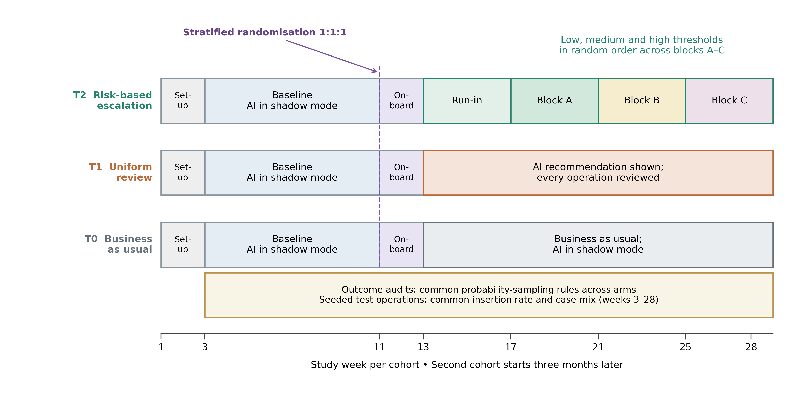
Figure 4. Proposed three-arm cluster-randomised design for one cohort. The audit band denotes probability-based outcome auditing with common rules across arms, not an identical sampling fraction in firms of different volume. No trial has been conducted. Source: authors' research design.

C.8. Ethics, data protection and preregistration
Before recruitment, the investigators will obtain the approvals required by the participating institutions and applicable national arrangements, register the protocol and analysis plan, and agree responsibilities for data processing. Consent will disclose logging, questionnaires, calibration probes and seeded operations; seeds will be blocked from payment. The initial registration precedes recruitment, and a time-stamped parameter addendum precedes randomisation. Operational records will be minimised and pseudonymised at source; identifiable supplier records will remain in the partner environment. Pseudonymisation is a safeguard, not proof of compliance with Regulation (EU) 2016/679. Access, retention, lawful processing grounds, withdrawal limits and incident handling will be specified with the partner. Research logs will not be supplied for individual employment appraisal. Overrides, safety incidents, audit discrepancies and deviations from assigned routing will be reported. The preregistration approach follows Nosek et al. (2018); no completed registration or ethics approval is claimed here.

C.9. Planned analysis

C.9.1. Estimands and primary models
The primary estimand is the average-firm intention-to-treat effect of T2 versus T1 on severity-weighted errors per 100 operations during intervention. For each firm, sampled error severity is inverse-probability weighted to estimate its total and divided by its known operation count. A baseline-adjusted firm-level regression with treatment and randomisation strata estimates the arm difference, giving equal weight to each firm. An operation-weighted estimand is secondary and explicitly labelled. Binary decision errors are analysed separately with firm and manager random intercepts where identifiable (Bates et al., 2015); a manager effect is omitted when each firm has only one manager. Cognitive load is analysed at manager-day level. Time outcomes include zero-review operations, so the main efficiency outcome is total logged managerial time per operation at firm-period level; a gamma model is reserved for positive review durations, not zero-inflated operation-level time.

C.9.2. Effect sizes and confidence intervals
Effects are reported with confidence intervals. The primary measure is the adjusted difference in severity-index points per 100 operations with a two-sided 95% interval. Firm-level randomisation inference follows the actual stratified assignment; suitable cluster-robust or wild-bootstrap analyses provide sensitivity checks (Athey & Imbens, 2017; Cameron et al., 2008; MacKinnon & Webb, 2017). Binary error analyses report marginal risk differences and risk ratios, workload analyses mean differences and Hedges' g, and efficiency analyses time differences and percentage changes. H1b uses a substantively justified non-inferiority margin fixed before randomisation. At one-sided α = .05, the upper bound of the two-sided 90% interval for T2 minus T0 must lie below that margin. This is not an equivalence test (Lakens, 2017). Both intention-to-treat and adherence-sensitive analyses are reported; non-significance of a superiority test is never interpreted as non-inferiority.

C.9.3. Automation errors and quality of human overrides
Three quantities are kept separate: unverified erroneous final actions, seeded-error detection, and the quality of human overrides. Overrides are classified as beneficial, harmful or neutral by audit; rates and counts are primary descriptive summaries, and the beneficial-to-harmful ratio is reported only when its denominator is non-zero. H3b is evaluated on common probability-judgement probes to avoid comparing the harder selected cases in T2 with the full reviewed stream in T1. The Brier score measures overall probabilistic accuracy; its reliability and resolution components distinguish calibration from discrimination (Murphy, 1973). Analyses on all reviewed cases are secondary and acknowledge residual case-mix differences. Attention concentration is the fraction of review time directed to operations in the top decile of baseline-defined expected loss. It is exploratory; any mediation analysis states the sequential-ignorability assumptions and includes sensitivity analysis (Imai et al., 2010). Verification logs remain proxies for cognitive engagement.

C.9.4. Curvilinearity and moderation
For H4, the primary experimental analysis compares net performance under the randomly assigned low, medium and high discretionary-threshold policies within T2, using firm, period, sequence and calendar controls. It reports each policy's escalation rate and uncertainty. An interior pattern is suggested when a middle policy outperforms both extremes, but three policy levels do not establish a continuous inverted U. A quadratic regression on realised escalation and its square is secondary and associational; it reports curvature, endpoint slopes and whether the turning point lies inside the observed support (Haans et al., 2016; Lind & Mehlum, 2010). Threshold assignment is not assumed to be a valid instrument: it changes the composition and timing of reviewed cases as well as their number, threatening exclusion. A causal dose–response claim would require a separate justified design. All assigned weeks enter the main policy contrast; excluding the first week of each block is a carryover sensitivity check, since learning may persist longer. H5 uses the preregistered task-based competence score in a baseline-adjusted firm-level treatment interaction, aggregating multiple managers with weights fixed from baseline workload. Simple effects at ±1 SD and a Johnson–Neyman region are reported where supported (Bauer & Curran, 2005).

C.9.5. Robustness, missing data and multiplicity
The primary analysis retains every randomised firm according to assignment; low audit coverage is reported rather than used to remove firms from the intention-to-treat population. Missing audited outcomes require a prespecified missingness model, inverse-response weighting or imputation where justified, and adverse-case sensitivity bounds. Questionnaire imputation preserves the clustered design, with complete-case results as a sensitivity analysis. Adherence-adjusted and per-protocol estimates are exploratory because treatment receipt and review intensity have multiple components; a complier effect is not claimed without a defensible treatment definition and identification assumptions. Other checks vary severity weights and materiality thresholds, distinguish invoices from purchase requests, and assess cohort and calendar sensitivity. The single primary H1a contrast uses α = .05. H1b and the remaining confirmatory secondary contrasts belong to a prespecified multiplicity family with Holm adjustment, with compatible adjusted intervals where relevant. H4 shape fitting and mechanism analyses are explicitly exploratory. Table 8 aligns outcomes and decision rules.
Table 8. Hypotheses, outcomes and planned analyses
Test | Outcome | Contrast | Estimator | Effect size reported | Decision rule
H1a | Primary: severity-weighted errors per 100 operations; binary error secondary | T2 vs T1 | Equal-weight firm-level baseline-adjusted analysis of design-weighted outcome; binary mixed model secondary | Difference in severity-index points with 95% CI; secondary binary risk difference and risk ratio | Primary two-sided 95% CI entirely below zero for T2 minus T1
H1b | Severity-weighted error rate | T2 vs T0 | Non-inferiority of firm-level outcome; margin fixed before randomisation | Difference in severity-weighted error rate with two-sided 90% CI | Upper CI bound below margin, with secondary-family multiplicity adjustment
H2a | RTLX | T2 vs T1; T2 vs T0 | Linear mixed model, manager-day level | Hedges' g with 95% CI | Holm-adjusted p < .05 in predicted direction
H2b | Minutes per operation | T2 vs T1; T2 vs T0 | Firm-period time per all operations; positive review duration model secondary | Percentage difference with 95% CI | Holm-adjusted p < .05 in predicted direction
H3a | Unverified-error escape rate; seeded detection secondary | T2 vs T1 | Generalised linear mixed model (logit) | Risk difference and risk ratio with 95% CI | Holm-adjusted inference in predicted direction; autonomous and human errors distinguished
H3b | Brier score on common probes; calibration and resolution components | T2 vs T1 | Linear mixed model on operation-level squared error for calibration probes common to both arms | Mean difference with 95% CI; calibration and resolution components | Holm-adjusted inference for improved overall accuracy; calibration assessed separately
H4 | Net decision performance | Threshold blocks within T2 | Randomised threshold-policy contrasts; quadratic realised-rate model exploratory, without presumed IV identification | Policy differences with intervals; exploratory slopes and turning point where supported | Middle-policy advantage is suggestive; continuous causal inverted U is not established by three policies
H5 | Severity-weighted error rate | Arm × task score (T2 vs T1) | Firm-level primary-outcome model with treatment × baseline task-score interaction | Simple effects at ±1 SD; Johnson–Neyman region | Holm-adjusted interaction inference; treat as exploratory if underpowered
Other | Attention concentration; override quality; redundant and missed escalations | All contrasts | Descriptive analysis; mediation models with sensitivity analysis | Estimates with 95% CI | Labelled exploratory; no confirmatory claims
Note. CI = confidence interval; RTLX = raw NASA Task Load Index; SD = standard deviation. All analyses are intention-to-treat unless stated otherwise. Source: authors' analysis plan.

C.10. Quasi-experimental fallback
If the planned randomisation is infeasible, the study will be redesigned and registered before implementation. A randomly ordered rollout remains a randomised design and should be analysed accordingly. If adoption timing is instead non-random, a multiple-period difference-in-differences analysis may be considered (Callaway & Sant'Anna, 2021), conditional on plausible parallel trends, no anticipation, no material interference and suitable not-yet-treated comparisons. Baseline auditing and common outcome measurement are retained. Such a fallback changes the estimand and strength of inference; it is not treated as an equivalent substitute for the original experiment.

References
Alahmadi, B. A., Axon, L., & Martinovic, I. (2022). 99% false positives: A qualitative study of SOC analysts' perspectives on security alarms. In Proceedings of the 31st USENIX Security Symposium (pp. 2783–2800). USENIX Association. https://www.usenix.org/conference/usenixsecurity22/presentation/alahmadi
Angelopoulos, A. N., & Bates, S. (2023). Conformal prediction: A gentle introduction. Foundations and Trends in Machine Learning, 16(4), 494–591. https://doi.org/10.1561/2200000101
Anthony, C., Bechky, B. A., & Fayard, A.-L. (2023). "Collaborating" with AI: Taking a system view to explore the future of work. Organization Science, 34(5), 1672–1694. https://doi.org/10.1287/orsc.2022.1651
Athey, S., & Imbens, G. W. (2017). The econometrics of randomized experiments. In A. V. Banerjee & E. Duflo (Eds.), Handbook of economic field experiments (Vol. 1, pp. 73–140). North-Holland. https://doi.org/10.1016/bs.hefe.2016.10.003
Bahnsen, A. C., Aouada, D., & Ottersten, B. (2015). Example-dependent cost-sensitive decision trees. Expert Systems with Applications, 42(19), 6609–6619. https://doi.org/10.1016/j.eswa.2015.04.042
Bainbridge, L. (1983). Ironies of automation. Automatica, 19(6), 775–779. https://doi.org/10.1016/0005-1098(83)90046-8
Bakker, A. B., & Demerouti, E. (2007). The job demands–resources model: State of the art. Journal of Managerial Psychology, 22(3), 309–328. https://doi.org/10.1108/02683940710733115
Bansal, G., Wu, T., Zhou, J., Fok, R., Nushi, B., Kamar, E., Ribeiro, M. T., & Weld, D. (2021). Does the whole exceed its parts? The effect of AI explanations on complementary team performance. In Proceedings of the 2021 CHI Conference on Human Factors in Computing Systems (pp. 1–16). ACM. https://doi.org/10.1145/3411764.3445717
Bates, D., Mächler, M., Bolker, B., & Walker, S. (2015). Fitting linear mixed-effects models using lme4. Journal of Statistical Software, 67(1), 1–48. https://doi.org/10.18637/jss.v067.i01
Bauer, D. J., & Curran, P. J. (2005). Probing interactions in fixed and multilevel regression: Inferential and graphical techniques. Multivariate Behavioral Research, 40(3), 373–400. https://doi.org/10.1207/s15327906mbr4003_5
Brier, G. W. (1950). Verification of forecasts expressed in terms of probability. Monthly Weather Review, 78(1), 1–3. https://doi.org/10.1175/1520-0493(1950)078<0001:VOFEIT>2.0.CO;2
Buçinca, Z., Malaya, M. B., & Gajos, K. Z. (2021). To trust or to think: Cognitive forcing functions can reduce overreliance on AI in AI-assisted decision-making. Proceedings of the ACM on Human-Computer Interaction, 5(CSCW1), 1–21. https://doi.org/10.1145/3449287
Burton, J. W., Stein, M.-K., & Jensen, T. B. (2020). A systematic review of algorithm aversion in augmented decision making. Journal of Behavioral Decision Making, 33(2), 220–239. https://doi.org/10.1002/bdm.2155
Busenitz, L. W., & Barney, J. B. (1997). Differences between entrepreneurs and managers in large organizations: Biases and heuristics in strategic decision-making. Journal of Business Venturing, 12(1), 9–30. https://doi.org/10.1016/S0883-9026(96)00003-1
Callaway, B., & Sant'Anna, P. H. C. (2021). Difference-in-differences with multiple time periods. Journal of Econometrics, 225(2), 200–230. https://doi.org/10.1016/j.jeconom.2020.12.001
Cameron, A. C., Gelbach, J. B., & Miller, D. L. (2008). Bootstrap-based improvements for inference with clustered errors. The Review of Economics and Statistics, 90(3), 414–427. https://doi.org/10.1162/rest.90.3.414
Chow, C. (1970). On optimum recognition error and reject tradeoff. IEEE Transactions on Information Theory, 16(1), 41–46. https://doi.org/10.1109/TIT.1970.1054406
Clifford, I., Kluzer, S., Troia, S., Jakobsone, M., Zandbergs, U., Vuorikari, R., Punie, Y., Castaño Muñoz, J., Centeno Mediavilla, I. C., O'Keeffe, W., & Cabrera Giraldez, M. (2020). DigCompSat: A self-reflection tool for the European Digital Competence Framework for Citizens (JRC123226). Publications Office of the European Union. https://doi.org/10.2760/77437
Cohen, J. (1960). A coefficient of agreement for nominal scales. Educational and Psychological Measurement, 20(1), 37–46. https://doi.org/10.1177/001316446002000104
Cornelissen, J. (2017). Editor's comments: Developing propositions, a process model, or a typology? Addressing the challenges of writing theory without a boilerplate. Academy of Management Review, 42(1), 1–9. https://doi.org/10.5465/amr.2016.0196
Cristofaro, M., Giardino, P. L., Camilli, R., & Hristov, I. (2024). Unlocking the sustainability of medium enterprises: A framework for reducing cognitive biases in sustainable performance management. Journal of Management & Organization, 30(3), 490–520. https://doi.org/10.1017/jmo.2023.55
Dal Pozzolo, A., Caelen, O., Le Borgne, Y.-A., Waterschoot, S., & Bontempi, G. (2014). Learned lessons in credit card fraud detection from a practitioner perspective. Expert Systems with Applications, 41(10), 4915–4928. https://doi.org/10.1016/j.eswa.2014.02.026
Dietvorst, B. J., Simmons, J. P., & Massey, C. (2015). Algorithm aversion: People erroneously avoid algorithms after seeing them err. Journal of Experimental Psychology: General, 144(1), 114–126. https://doi.org/10.1037/xge0000033
Du, F., Li, J., & Zhang, J. Z. (2025). Executive cognition and servitization of manufacturing firms: Empirical evidence from listed companies in China. Journal of Management & Organization, 31(6), 2793–2820. https://doi.org/10.1017/jmo.2025.10031
Efron, B., & Tibshirani, R. J. (1993). An introduction to the bootstrap. Chapman & Hall/CRC. https://doi.org/10.1201/9780429246593
Eldridge, S. M., Ashby, D., & Kerry, S. (2006). Sample size for cluster randomized trials: Effect of coefficient of variation of cluster size and analysis method. International Journal of Epidemiology, 35(5), 1292–1300. https://doi.org/10.1093/ije/dyl129
Elkan, C. (2001). The foundations of cost-sensitive learning. In Proceedings of the Seventeenth International Joint Conference on Artificial Intelligence (pp. 973–978). Morgan Kaufmann.
Endsley, M. R. (1995). Toward a theory of situation awareness in dynamic systems. Human Factors, 37(1), 32–64. https://doi.org/10.1518/001872095779049543
Eppler, M. J., & Mengis, J. (2004). The concept of information overload: A review of literature from organization science, accounting, marketing, MIS, and related disciplines. The Information Society, 20(5), 325–344. https://doi.org/10.1080/01972240490507974
Eurostat. (2026a). Artificial intelligence by size class of enterprise (isoc_eb_ai; indicator E_AI_TANY) [Data set]. Retrieved October 12, 2026, from https://ec.europa.eu/eurostat/databrowser/view/isoc_eb_ai/default/table
Eurostat. (2026b). The use of artificial intelligence technologies in the European Union: Key results—2026 edition. Publications Office of the European Union. https://doi.org/10.2785/9221093
Feltham, T. S., Feltham, G., & Barnett, J. J. (2005). The dependence of family businesses on a single decision-maker. Journal of Small Business Management, 43(1), 1–15. https://doi.org/10.1111/j.1540-627X.2004.00122.x
Fügener, A., Grahl, J., Gupta, A., & Ketter, W. (2022). Cognitive challenges in human–artificial intelligence collaboration: Investigating the path toward productive delegation. Information Systems Research, 33(2), 678–696. https://doi.org/10.1287/isre.2021.1079
Gigerenzer, G., & Gaissmaier, W. (2011). Heuristic decision making. Annual Review of Psychology, 62, 451–482. https://doi.org/10.1146/annurev-psych-120709-145346
Glikson, E., & Woolley, A. W. (2020). Human trust in artificial intelligence: Review of empirical research. Academy of Management Annals, 14(2), 627–660. https://doi.org/10.5465/annals.2018.0057
Goddard, K., Roudsari, A., & Wyatt, J. C. (2012). Automation bias: A systematic review of frequency, effect mediators, and mitigators. Journal of the American Medical Informatics Association, 19(1), 121–127. https://doi.org/10.1136/amiajnl-2011-000089
Green, B., & Chen, Y. (2019). The principles and limits of algorithm-in-the-loop decision making. Proceedings of the ACM on Human-Computer Interaction, 3(CSCW), 1–24. https://doi.org/10.1145/3359152
Haans, R. F. J., Pieters, C., & He, Z.-L. (2016). Thinking about U: Theorizing and testing U- and inverted U-shaped relationships in strategy research. Strategic Management Journal, 37(7), 1177–1195. https://doi.org/10.1002/smj.2399
Harrison, G. W., & List, J. A. (2004). Field experiments. Journal of Economic Literature, 42(4), 1009–1055. https://doi.org/10.1257/0022051043004577
Hart, S. G. (2006). NASA-Task Load Index (NASA-TLX); 20 years later. Proceedings of the Human Factors and Ergonomics Society Annual Meeting, 50(9), 904–908. https://doi.org/10.1177/154193120605000909
Hart, S. G., & Staveland, L. E. (1988). Development of NASA-TLX (Task Load Index): Results of empirical and theoretical research. In P. A. Hancock & N. Meshkati (Eds.), Human mental workload (pp. 139–183). North-Holland. https://doi.org/10.1016/S0166-4115(08)62386-9
Helfat, C. E., & Peteraf, M. A. (2015). Managerial cognitive capabilities and the microfoundations of dynamic capabilities. Strategic Management Journal, 36(6), 831–850. https://doi.org/10.1002/smj.2247
Hoff, K. A., & Bashir, M. (2015). Trust in automation: Integrating empirical evidence on factors that influence trust. Human Factors, 57(3), 407–434. https://doi.org/10.1177/0018720814547570
Howard, R. A. (1966). Information value theory. IEEE Transactions on Systems Science and Cybernetics, 2(1), 22–26. https://doi.org/10.1109/TSSC.1966.300074
Imai, K., Keele, L., & Tingley, D. (2010). A general approach to causal mediation analysis. Psychological Methods, 15(4), 309–334. https://doi.org/10.1037/a0020761
Jaakkola, E. (2020). Designing conceptual articles: Four approaches. AMS Review, 10(1–2), 18–26. https://doi.org/10.1007/s13162-020-00161-0
Jancenelle, V. E. (2025). Exploring the relationship between strategic attention breadth and performance: The role of corporate social responsibility. Journal of Management & Organization, 31(1), 330–345. https://doi.org/10.1017/jmo.2024.34
Jarrahi, M. H. (2018). Artificial intelligence and the future of work: Human-AI symbiosis in organizational decision making. Business Horizons, 61(4), 577–586. https://doi.org/10.1016/j.bushor.2018.03.007
Jensen, M. C., & Meckling, W. H. (1976). Theory of the firm: Managerial behavior, agency costs and ownership structure. Journal of Financial Economics, 3(4), 305–360. https://doi.org/10.1016/0304-405X(76)90026-X
Kaber, D. B., & Endsley, M. R. (2004). The effects of level of automation and adaptive automation on human performance, situation awareness and workload in a dynamic control task. Theoretical Issues in Ergonomics Science, 5(2), 113–153. https://doi.org/10.1080/1463922021000054335
Kahneman, D., & Klein, G. (2009). Conditions for intuitive expertise: A failure to disagree. American Psychologist, 64(6), 515–526. https://doi.org/10.1037/a0016755
Kaplan, R. S., & Anderson, S. R. (2004). Time-driven activity-based costing. Harvard Business Review, 82(11), 131–138.
Kayas, O. G., Ong, C. E., & Belal, H. M. (2025). From humans to algorithms: A sociotechnical framework of workplace surveillance. Digital Business, 5(2), 100120. https://doi.org/10.1016/j.digbus.2025.100120
Kellogg, K. C., Valentine, M. A., & Christin, A. (2020). Algorithms at work: The new contested terrain of control. Academy of Management Annals, 14(1), 366–410. https://doi.org/10.5465/annals.2018.0174
Kleinberg, J., Lakkaraju, H., Leskovec, J., Ludwig, J., & Mullainathan, S. (2018). Human decisions and machine predictions. The Quarterly Journal of Economics, 133(1), 237–293. https://doi.org/10.1093/qje/qjx032
Kohnke, O., Nieland, T., Straatmann, T., & Mueller, K. (2024). How do management factors influence digital adoption in the case of a large-scale digital transformation project: A process perspective. Journal of Management & Organization, 30(5), 1564–1584. https://doi.org/10.1017/jmo.2023.59
Kokulu, F. B., Soneji, A., Bao, T., Shoshitaishvili, Y., Zhao, Z., Doupé, A., & Ahn, G.-J. (2019). Matched and mismatched SOCs: A qualitative study on security operations center issues. In Proceedings of the 2019 ACM SIGSAC Conference on Computer and Communications Security (pp. 1955–1970). ACM. https://doi.org/10.1145/3319535.3354239
Kotey, B., & Slade, P. (2005). Formal human resource management practices in small growing firms. Journal of Small Business Management, 43(1), 16–40. https://doi.org/10.1111/j.1540-627X.2004.00123.x
Lakens, D. (2017). Equivalence tests: A practical primer for t tests, correlations, and meta-analyses. Social Psychological and Personality Science, 8(4), 355–362. https://doi.org/10.1177/1948550617697177
Lakkaraju, H., Kleinberg, J., Leskovec, J., Ludwig, J., & Mullainathan, S. (2017). The selective labels problem: Evaluating algorithmic predictions in the presence of unobservables. In Proceedings of the 23rd ACM SIGKDD International Conference on Knowledge Discovery and Data Mining (pp. 275–284). ACM. https://doi.org/10.1145/3097983.3098066
Leana, C. R. (1986). Predictors and consequences of delegation. Academy of Management Journal, 29(4), 754–774. https://doi.org/10.2307/255943
Lebovitz, S., Lifshitz-Assaf, H., & Levina, N. (2022). To engage or not to engage with AI for critical judgments: How professionals deal with opacity when using AI for medical diagnosis. Organization Science, 33(1), 126–148. https://doi.org/10.1287/orsc.2021.1549
Lee, J. D., & See, K. A. (2004). Trust in automation: Designing for appropriate reliance. Human Factors, 46(1), 50–80. https://doi.org/10.1518/hfes.46.1.50_30392
Lind, J. T., & Mehlum, H. (2010). With or without U? The appropriate test for a U-shaped relationship. Oxford Bulletin of Economics and Statistics, 72(1), 109–118. https://doi.org/10.1111/j.1468-0084.2009.00569.x
Logg, J. M., Minson, J. A., & Moore, D. A. (2019). Algorithm appreciation: People prefer algorithmic to human judgment. Organizational Behavior and Human Decision Processes, 151, 90–103. https://doi.org/10.1016/j.obhdp.2018.12.005
Machine Learning Group, Université Libre de Bruxelles. (n.d.). Credit card fraud detection [Data set]. Kaggle. https://www.kaggle.com/datasets/mlg-ulb/creditcardfraud
MacKinnon, J. G., & Webb, M. D. (2017). Wild bootstrap inference for wildly different cluster sizes. Journal of Applied Econometrics, 32(2), 233–254. https://doi.org/10.1002/jae.2508
Madras, D., Pitassi, T., & Zemel, R. (2018). Predict responsibly: Improving fairness and accuracy by learning to defer. In Advances in Neural Information Processing Systems 31 (NeurIPS 2018) (pp. 6147–6157). Curran Associates.
McCambridge, J., Witton, J., & Elbourne, D. R. (2014). Systematic review of the Hawthorne effect: New concepts are needed to study research participation effects. Journal of Clinical Epidemiology, 67(3), 267–277. https://doi.org/10.1016/j.jclinepi.2013.08.015
Mosier, K. L., Skitka, L. J., Heers, S., & Burdick, M. (1998). Automation bias: Decision making and performance in high-tech cockpits. The International Journal of Aviation Psychology, 8(1), 47–63. https://doi.org/10.1207/s15327108ijap0801_3
Mozannar, H., & Sontag, D. (2020). Consistent estimators for learning to defer to an expert. In Proceedings of the 37th International Conference on Machine Learning (PMLR 119, pp. 7076–7087). PMLR.
Murphy, A. H. (1973). A new vector partition of the probability score. Journal of Applied Meteorology, 12(4), 595–600. https://doi.org/10.1175/1520-0450(1973)012<0595:ANVPOT>2.0.CO;2
Murray, A., Rhymer, J., & Sirmon, D. G. (2021). Humans and technology: Forms of conjoined agency in organizations. Academy of Management Review, 46(3), 552–571. https://doi.org/10.5465/amr.2019.0186
Nosek, B. A., Ebersole, C. R., DeHaven, A. C., & Mellor, D. T. (2018). The preregistration revolution. Proceedings of the National Academy of Sciences, 115(11), 2600–2606. https://doi.org/10.1073/pnas.1708274114
Ocasio, W. (1997). Towards an attention-based view of the firm. Strategic Management Journal, 18(S1), 187–206. https://doi.org/10.1002/(SICI)1097-0266(199707)18:1+<187::AID-SMJ936>3.0.CO;2-K
Ocasio, W. (2011). Attention to attention. Organization Science, 22(5), 1286–1296. https://doi.org/10.1287/orsc.1100.0602
OECD. (2021). The digital transformation of SMEs. OECD Studies on SMEs and Entrepreneurship. OECD Publishing. https://doi.org/10.1787/bdb9256a-en
Onnasch, L., Wickens, C. D., Li, H., & Manzey, D. (2014). Human performance consequences of stages and levels of automation: An integrated meta-analysis. Human Factors, 56(3), 476–488. https://doi.org/10.1177/0018720813501549
Parasuraman, R., & Manzey, D. H. (2010). Complacency and bias in human use of automation: An attentional integration. Human Factors, 52(3), 381–410. https://doi.org/10.1177/0018720810376055
Parasuraman, R., & Riley, V. (1997). Humans and automation: Use, misuse, disuse, abuse. Human Factors, 39(2), 230–253. https://doi.org/10.1518/001872097778543886
Parasuraman, R., Sheridan, T. B., & Wickens, C. D. (2000). A model for types and levels of human interaction with automation. IEEE Transactions on Systems, Man, and Cybernetics – Part A: Systems and Humans, 30(3), 286–297. https://doi.org/10.1109/3468.844354
Prokopovych-Tkachenko, D. (2026a). rbaa-sim: Reproducible Colab notebook for the risk-based attention allocation model of AI oversight in SMEs (Version 1.1.0) [Computer software]. Zenodo. https://doi.org/10.5281/zenodo.SIM_DOI
Prokopovych-Tkachenko, D. (2026b). rbaa-validation: Back-test of risk-based attention allocation on real open data—Eurostat AI adoption and 284,807 real transactions (Version 1.1.0) [Computer software]. Zenodo. https://doi.org/10.5281/zenodo.VAL_DOI
Prokopovych-Tkachenko, D. (2026c). rbaa-benchmark: Comparative validation of risk-based attention allocation against seven review-allocation rules on 129,878 real card transactions (Version 1.0.0) [Computer software]. Zenodo. https://doi.org/10.5281/zenodo.BEN_DOI
Raisch, S., & Krakowski, S. (2021). Artificial intelligence and management: The automation–augmentation paradox. Academy of Management Review, 46(1), 192–210. https://doi.org/10.5465/amr.2018.0072
Regulation (EU) 2016/679 of the European Parliament and of the Council of 27 April 2016 on the protection of natural persons with regard to the processing of personal data and on the free movement of such data, and repealing Directive 95/46/EC (General Data Protection Regulation). (2016). Official Journal of the European Union, L 119, 1–88. http://data.europa.eu/eli/reg/2016/679/oj
Regulation (EU) 2024/1689 of the European Parliament and of the Council of 13 June 2024 laying down harmonised rules on artificial intelligence (Artificial Intelligence Act). (2024). Official Journal of the European Union, L, 2024/1689. http://data.europa.eu/eli/reg/2024/1689/oj
Regulation (EU) 2026/1744 of the European Parliament and of the Council of 8 July 2026 amending Regulations (EU) 2024/1689, (EU) 2018/1139 and (EU) 2023/1230 as regards the simplification of the implementation of harmonised rules on artificial intelligence (Digital Omnibus on AI). (2026). Official Journal of the European Union, L, 2026/1744. http://data.europa.eu/eli/reg/2026/1744/oj
Retamal-Saavedra, C. D., Andrade-Valbuena, N. A., Contreras Navarro, J. E., Inostroza Caceres, F., & Vidal-Rebolledo, I. (2026). Artificial intelligence in entrepreneurship: Mapping a fragmented field and advancing a cognitive research agenda. Journal of Management & Organization, 32(2), 473–500. https://doi.org/10.1017/jmo.2026.10082
Shepherd, D. A., Williams, T. A., & Patzelt, H. (2015). Thinking about entrepreneurial decision making: Review and research agenda. Journal of Management, 41(1), 11–46. https://doi.org/10.1177/0149206314541153
Shrestha, Y. R., Ben-Menahem, S. M., & von Krogh, G. (2019). Organizational decision-making structures in the age of artificial intelligence. California Management Review, 61(4), 66–83. https://doi.org/10.1177/0008125619862257
Simon, H. A. (1955). A behavioral model of rational choice. The Quarterly Journal of Economics, 69(1), 99–118. https://doi.org/10.2307/1884852
Skitka, L. J., Mosier, K. L., & Burdick, M. (1999). Does automation bias decision-making? International Journal of Human-Computer Studies, 51(5), 991–1006. https://doi.org/10.1006/ijhc.1999.0252
Steyvers, M., Tejeda, H., Kerrigan, G., & Smyth, P. (2022). Bayesian modeling of human–AI complementarity. Proceedings of the National Academy of Sciences, 119(11), e2111547119. https://doi.org/10.1073/pnas.2111547119
Sweller, J. (1988). Cognitive load during problem solving: Effects on learning. Cognitive Science, 12(2), 257–285. https://doi.org/10.1207/s15516709cog1202_4
Tilbury, J., & Flowerday, S. (2024). Humans and automation: Augmenting security operation centers. Journal of Cybersecurity and Privacy, 4(3), 388–409. https://doi.org/10.3390/jcp4030020
Vaccaro, M., Almaatouq, A., & Malone, T. (2024). When combinations of humans and AI are useful: A systematic review and meta-analysis. Nature Human Behaviour, 8(12), 2293–2303. https://doi.org/10.1038/s41562-024-02024-1
Vasconcelos, H., Jörke, M., Grunde-McLaughlin, M., Gerstenberg, T., Bernstein, M. S., & Krishna, R. (2023). Explanations can reduce overreliance on AI systems during decision-making. Proceedings of the ACM on Human-Computer Interaction, 7(CSCW1), 1–38. https://doi.org/10.1145/3579605
Verhoef, P. C., Broekhuizen, T., Bart, Y., Bhattacharya, A., Dong, J. Q., Fabian, N., & Haenlein, M. (2021). Digital transformation: A multidisciplinary reflection and research agenda. Journal of Business Research, 122, 889–901. https://doi.org/10.1016/j.jbusres.2019.09.022
Vielberth, M., Böhm, F., Fichtinger, I., & Pernul, G. (2020). Security operations center: A systematic study and open challenges. IEEE Access, 8, 227756–227779. https://doi.org/10.1109/ACCESS.2020.3045514
Vuorikari, R., Kluzer, S., & Punie, Y. (2022). DigComp 2.2: The digital competence framework for citizens – With new examples of knowledge, skills and attitudes (EUR 31006 EN). Publications Office of the European Union. https://doi.org/10.2760/115376
Wickens, C. D., Clegg, B. A., Vieane, A. Z., & Sebok, A. L. (2015). Complacency and automation bias in the use of imperfect automation. Human Factors, 57(5), 728–739. https://doi.org/10.1177/0018720815581940
Yukl, G., & Fu, P. P. (1999). Determinants of delegation and consultation by managers. Journal of Organizational Behavior, 20(2), 219–232. https://doi.org/10.1002/(SICI)1099-1379(199903)20:2<219::AID-JOB922>3.0.CO;2-8
Zhang, Y., Liao, Q. V., & Bellamy, R. K. E. (2020). Effect of confidence and explanation on accuracy and trust calibration in AI-assisted decision making. In Proceedings of the 2020 Conference on Fairness, Accountability, and Transparency (pp. 295–305). ACM. https://doi.org/10.1145/3351095.3372852

