Article
GoNext: A Transpilation Architecture for Language Extensions with Go Ecosystem Compatibility
Pavlo Forkert ^{1,}*^ and Co-Author Name ¹
¹ Department of Cybersecurity and Information Technologies, University of Customs and Finance, 49000 Dnipro, Ukraine; forkert@example.edu (P.F.); coauthor@example.edu (X.X.)
* Correspondence: forkert@example.edu; ORCID: 0000-0000-0000-0000
Abstract: Building a language on a mature host platform avoids implementing a compiler back end, runtime and tooling from scratch, but the suitability of Go as a target of source-to-source translation has not been examined systematically. This article presents GoNext, an experimental dialect of Go, and a transpiler architecture that adds high-level language extensions while keeping full compatibility with the Go compiler, runtime and ecosystem. Host platforms were compared with twenty criteria in five groups, language transformations were classified as syntactic, structural or representational, and eight extensions were lowered to standard Go and measured. Go source code obtained the highest aggregate score among eight platforms (0.950) and ranked first for 98.4% of randomly sampled weightings. Syntactic extensions were eliminated during translation: a call with named and default arguments took 8.7 ns, against 48.5 ns and one heap allocation for the functional-options idiom. Tagged representations of enums with associated data constructed values 3.3–3.7 times faster than an interface encoding and avoided per-value allocations, whereas storing pointer payloads in integer words caused the collector to reclaim all 10,000 referenced objects in every trial. The approach suits Go dialects and server-side domain-specific languages whose semantics agree with Go's models of types, memory and execution. The transpiler and the reproducibility package are openly available (https://doi.org/10.5281/zenodo.23490820).
Keywords: transpiler; source-to-source compilation; Go programming language; language extensions; algebraic data types; pattern matching; garbage collection; domain-specific languages; compiler architecture
1. Introduction
A new programming language needs much more than a grammar and a type checker. It needs a code generator, a runtime system, a memory manager, a scheduler for concurrent work, a package manager, debuggers, formatters and editor support, together with a body of libraries that makes it useful from the first day. Building this infrastructure from scratch takes years, which is why most practical languages are implemented on top of an existing platform: a virtual machine such as the Java Virtual Machine (JVM) or the Common Language Runtime, a compiler infrastructure such as LLVM [1], a language-implementation framework such as Truffle and Graal [2], or another high-level language that serves as the target of source-to-source translation [3,4]. The choice of host platform determines what the new language inherits for free and what it must still build itself.
Source-to-source translation (transpilation) is the most economical of these strategies when the target is a mature, statically typed language with a stable toolchain. TypeScript, whose type system is erased during translation to JavaScript [5,6], and Scala.js, which compiles Scala to JavaScript while keeping interoperability with existing JavaScript libraries [7], show how far a language can grow without its own runtime. Classic work on extensible languages points in the same direction: library-based syntactic extension [8], languages defined as libraries of a host language [9], language workbenches [10,11] and dedicated program-transformation systems [12–14] all reduce the cost of a language by delegating as much as possible to an existing implementation. Domain-specific languages (DSLs) are the main beneficiaries of this approach [15].
Go is an attractive but rarely studied target for such translation. It compiles ahead of time to native code, has a concurrent garbage collector and lightweight goroutines, ships its parser, type checker and code printer as standard library packages, and comes with a formal compatibility promise for the Go 1 language [16,17]. Its user base has grown more than threefold in five years [18], and large parts of today's cloud and infrastructure software are written in Go, from container orchestration [19] to the services that place and coordinate workloads across the cloud–edge continuum, where declarative placement models [20] and layered reference architectures for deployment [21] are increasingly common. At the same time, Go deliberately offers a small set of language features. It has no sum types or pattern matching [22], although pattern matching on structured data has meanwhile been adopted by other mainstream languages such as Python [23]. It also has no named or default arguments, no extension methods and no short syntax for anonymous functions [24]; since Go 1.18 it supports type parameters [25,26], but methods cannot declare their own type parameters [27]. Each of these gaps is the subject of long discussions in the Go community, and each is filled in practice by idioms such as functional options, sealed interfaces or code generators.
These two observations suggest a concrete research question: can the missing high-level features be added as a dialect of Go that is translated into ordinary Go code, so that every program written in the dialect remains compatible with the Go compiler, runtime and ecosystem? The question has two sides that pull in opposite directions. Some extensions are thin syntactic layers that disappear completely during translation; others require changes in how data are represented, and these changes interact with the garbage collector, the type system and the performance model of the host. Languages built on the Go toolchain, such as XGo (formerly Go+) [28] and Borgo, a statically typed language that compiles to Go [29], demonstrate that the approach is feasible, yet their design decisions are documented mostly in source code and issue trackers. To our knowledge, no systematic account exists of which criteria make Go a suitable host, how language transformations should be classified with respect to their cost, and where the limits of the approach lie.
Opinions on these limits diverge. One position holds that Go is too restrictive to serve as a compilation target for richer languages: without unions, method-level generics or tail calls, every advanced feature must be emulated, and the emulation erodes performance and readability. The opposite position holds that a high-level target is preferable precisely because it is restrictive: generated code stays readable, debuggable and subject to the host's own tooling, which matters more for adoption than the last percent of performance [3]. Studies of translation between languages add a third consideration: automatic translation is reliable only when the semantic gap between source and target is small and explicitly managed [30–32]. The present work addresses this disagreement with an explicit evaluation framework, a classification of transformations and measurements of the generated code.
This article presents GoNext, an experimental dialect of Go and the architecture of its transpiler, developed within the doctoral research of the first author [33]. The aim of the study is to design a transpiler architecture that implements high-level language extensions while keeping full compatibility with the Go ecosystem, and to determine the boundaries within which this approach is applicable. The main contributions are as follows:
- A system of twenty criteria in five groups (execution properties, expressiveness of the host language, interoperability, tooling and implementation effort) for selecting a host platform for language implementation, applied to eight candidate platforms together with a sensitivity analysis of the resulting ranking.
- A classification of language transformations into syntactic, structural and representational classes, which relates the way an extension is implemented to its semantic requirements and to its potential run-time overhead.
- A six-stage transpiler architecture (parsing, internal abstract syntax tree, partial semantic analysis, normalization, lowering to go/ast nodes and emission) that requires no modification of the Go compiler and keeps diagnostics mapped to the source program.
- Lowering schemes for eight GoNext extensions, including enum types with associated data and pattern matching, together with measurements of the generated code and an experimental demonstration that variant representations must keep pointers visible to the garbage collector.
- The GoNext software project (version 1.0.0), covering repository structure, quality gates, release and archiving on Zenodo (https://doi.org/10.5281/zenodo.23490820), and a development roadmap, together with an openly available reproducibility package.
The rest of the article is organized as follows. Section 2 describes the research design, the evaluation criteria, the classification of transformations, the transpiler architecture, the experimental setup and the structure of the software project. Section 3 reports the comparison of host platforms, the classification of GoNext extensions, the lowering schemes and the analysis of the generated code. Section 4 discusses the findings, the domains in which the approach is applicable and the threats to validity. Section 5 concludes the article.
2. Materials and Methods
2.1. Research Design
The study combines four methods, applied in sequence. First, a comparative analysis of language-implementation platforms was performed with an explicit rubric (Section 2.2). Second, a classification of language transformations was developed from the analysis of the extensions planned for GoNext and of related extensible-language systems (Section 2.3). Third, the transpiler was designed as a compiler pipeline whose stages are described in Section 2.4. Fourth, the GoNext dialect served as a feasibility study: for each extension a lowering scheme to standard Go was defined and the generated code was inspected and measured (Sections 2.5 and 2.6). The study is an architectural analysis supported by micro-experiments; it does not claim a full performance evaluation of GoNext on application workloads, which is left for future work (Section 4.3).
2.2. Criteria for Selecting a Host Platform
A host platform is evaluated for a specific target scenario. In this study the scenario is the implementation of statically typed, imperative language extensions and DSLs for server-side and infrastructure software. The criteria are organized in five groups G₁, …, G₅ with four criteria each (Table 1). Each criterion c is scored for platform p on an ordinal scale s_{p,c} ∈ {0, 1, 2}, where 0 means that the property is absent or must be built by the language implementer, 1 that it is partially available, and 2 that it is fully provided by the platform. For the implementation-effort group the scale is oriented so that a higher score always means less work for the implementer.
Table 1. Criteria for evaluating a host platform for language implementation.
Group | Criteria
G₁ Execution properties | E1 ahead-of-time native code; E2 managed memory with a concurrent collector; E3 built-in lightweight concurrency; E4 self-contained deployment and fast start-up
G₂ Expressiveness of the host | X1 parametric polymorphism usable by generated code; X2 first-class closures; X3 interface-based dynamic dispatch; X4 control over data layout and unsafe escape hatches
G₃ Interoperability | I1 direct use of host libraries; I2 host code can call generated code; I3 shared object model without marshalling; I4 integration with the host package system
G₄ Tooling | T1 readable and debuggable target code; T2 standard formatter and static analysis applicable to the output; T3 standard test and benchmark framework; T4 parser and type checker available as libraries
G₅ Implementation effort | C1 no custom back end required; C2 no custom runtime or collector required; C3 small semantic gap for statically typed imperative extensions; C4 stability guarantees of the target

The normalized score of platform p in group g is the mean of its criterion scores divided by the maximum score, and the aggregate score is a weighted sum over groups:
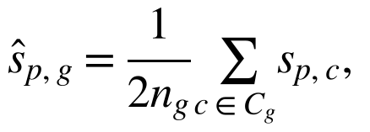 (1)
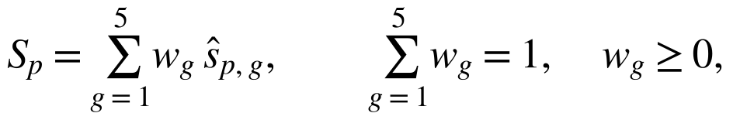 (2)
where C_{g} is the set of criteria in group g, n_{g} = 4 is the number of criteria in it and w_{g} is the weight of the group. Because any fixed choice of weights is debatable, the ranking was also examined under uncertainty: 100,000 weight vectors were drawn from the uniform Dirichlet distribution Dir(1, …, 1) with a fixed random seed, and for each platform we recorded how often it ranked first and among the first two. A leave-one-group-out analysis complemented this test. The criterion scores, the scoring script and the sampling script are part of the reproducibility package (Section 2.7).
2.3. Classification of Language Transformations
Let A_{GN} denote the abstract syntax of GoNext programs and A_{Go} that of Go programs. A language extension e is implemented by a transformation T_{e}: A_{GN} → A_{GN} ∪ A_{Go} that eliminates the constructs of e. We characterize T_{e} by three properties: whether it adds declarations to the program, whether it needs type information that is not syntactically evident, and whether it changes the representation function that maps source types to Go types. These properties define three classes:
class(T_{e}) = syntactic, if Δ_{decl} = ∅ ∧ ρ_{e} = ρ_{Go};
class(T_{e}) = structural, if Δ_{decl} ≠ ∅ ∧ ρ_{e} = ρ_{Go}; (3)
class(T_{e}) = representational, if ρ_{e} ≠ ρ_{Go},
where Δ_{decl} is the set of top-level declarations introduced by the transformation and ρ_{Go} is the identity mapping of Go types. Syntactic transformations rewrite expressions and calls locally; the result contains only constructs that a Go programmer could have written by hand at the same place. Structural transformations introduce new functions or types, change the control-flow structure or need inferred types to produce valid Go, but leave the representation of values unchanged. Representational transformations change how values of a source type are laid out in memory; they therefore interact with allocation, copying, equality and garbage collection, and they carry the highest risk of overhead and of subtle errors. The classification is ordered: a later class subsumes the requirements of the earlier ones.
For representational transformations of variant (sum) types, one invariant is essential in a garbage-collected host. Let V be the set of variants of an enum, let fields(v) be the payload fields of variant v and let P_{R} be the set of slots of representation R that the collector scans as pointers. Then R is admissible only if
(4)
where ptr(τ_{f}) holds when the Go type of f contains pointers. In Go, the collector is precise: it relies on per-type pointer maps and does not treat integers as potential references, and the language documentation states explicitly that a uintptr value does not keep an object alive [34–36]. A layout that overlaps the payloads of different variants in a shared integer buffer therefore violates (4) whenever any variant carries a pointer. Section 3.5 tests this invariant experimentally.
2.4. Transpiler Architecture
The GoNext transpiler is organized as a six-stage pipeline (Figure 1). Its central design rule is that every stage either produces information required by a later stage or removes extension constructs; everything that the Go toolchain can check by itself is delegated to it.
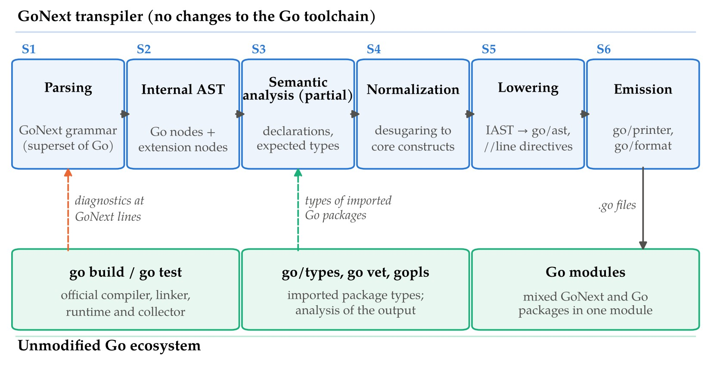
Figure 1. Architecture of the GoNext transpiler. Stages S1–S6 run inside the transpiler; the output consists of ordinary Go source files that are compiled, analyzed and packaged by the unmodified Go toolchain. Dashed arrows show information that flows back: types of imported Go packages are read during semantic analysis, and compiler diagnostics refer to GoNext source lines through //line directives.
S1. Parsing. The GoNext grammar is a superset of the Go grammar. The parser accepts every valid Go file unchanged and adds productions for enum declarations, match expressions, named and default arguments, extension declarations, generic methods and short anonymous functions.
S2. Internal abstract syntax tree (IAST). The IAST reuses the node structure of the Go syntax tree and adds node kinds for the extension constructs. Every node keeps its source position, which is later converted into line directives.
S3. Partial semantic analysis. The transpiler does not reimplement the Go type checker. It resolves names, collects the declarations that extensions depend on (enum variants, extension methods, parameter lists with default values, generic method signatures) and infers types only where lowering needs them: the receiver type of an extension or uniform function call syntax (UFCS) call, the expected function type of a short anonymous function, and the static type of a match scrutinee. Types of imported Go packages are obtained with the standard go/types machinery [37]. Exhaustiveness of match over enum variants is also checked at this stage, because the information is lost after lowering.
S4. Normalization. Extension constructs are rewritten into a small core: UFCS calls and extension method calls become plain calls, argument lists are reordered and completed with default values, short anonymous functions receive explicit parameter and result types, and match is compiled into a decision tree [38] that uses only switch statements, comparisons and variable bindings. Where reordering arguments could change the order of side effects, temporaries are introduced so that Go evaluates the arguments in source order.
S5. Lowering. The normalized IAST is translated into nodes of the standard go/ast package [37]. Representational extensions are lowered here: each enum receives a Go type, constructor functions and tag constants according to the selected representation (Section 3.3.3). A //line directive is emitted for each lowered construct so that compiler errors, panics and stack traces refer to the GoNext source [39].
S6. Emission. The go/ast tree is printed with go/printer and normalized with go/format. The resulting files are ordinary Go sources; they are compiled by go build, tested by go test and analyzed by go vet and the language server gopls [40]. Because the output is a Go package, GoNext and Go files can coexist in one module, and existing Go code can call code written in GoNext without any binding layer. The generation step can be wired into go generate, so that a project using GoNext is built with the standard commands.
The design has two consequences. First, the correctness obligations of the transpiler are limited to preserving the semantics of the extension constructs; type safety of the rest of the program is established by the Go compiler on the generated code. Second, the transpiler depends only on the public, stable surface of the Go toolchain: its grammar, the go/ast API and the line-directive convention.
2.5. Language Extensions of the GoNext Dialect
GoNext adds eight extensions to Go: (i) enum types whose variants carry associated data; (ii) pattern matching with a match construct that can be used as an expression; (iii) named arguments; (iv) default parameter values; (v) extension methods declared outside the package of the receiver type; (vi) generic methods, that is, methods with their own type parameters; (vii) short anonymous functions of the form x => expr; and (viii) uniform function call syntax, which allows f(a, b) to be written as a.f(b). The listings of this article use the concrete syntax of GoNext version 1.0.0; the language reference is part of the software project (Section 2.7). Every extension is designed so that a program that does not use it is a valid Go program with unchanged meaning.
2.6. Experimental Setup for the Analysis of Generated Code
The lowering schemes of Section 3.3 were reproduced as stand-alone Go packages and examined in four micro-experiments. All lowered listings shown in this article are compiled and checked with go vet as part of the reproducibility package, and every experiment includes an equivalence test that verifies that the compared variants compute identical results.
Experiment 1 (enum representations). The enum Shape with four variants (Circle, Rect, Triangle and Text, the last one carrying a string) was lowered in three ways: R1, a sealed interface with one struct type per variant; R2, a flat tagged struct that contains the union of all variant fields; and R3, a compact tagged struct with three shared scalar words, one pointer slot of type unsafe.Pointer and a length word. A workload of 65,536 values with uniformly distributed variants was generated with a fixed seed (42). We measured the time to construct the values into a preallocated slice, the time of an exhaustive match that computes a measure of every value, the number of heap allocations, and the memory per value.
Experiment 2 (named and default arguments). The lowering of a call with one named argument and two omitted defaulted parameters was compared with the two idioms that Go developers use for the same purpose: a configuration struct with zero-value defaults and the functional-options pattern. The callee was marked //go:noinline in all variants so that the comparison concerns the call itself.
Experiment 3 (generic method and short anonymous function; extension method). The lowering of xs.map(x => x * 2) on a 4096-element generic list and of an extension method xs.sum() were compared with hand-written loops.
Experiment 4 (pointer visibility). An enum variant Ref(node *Node) was stored in three ways: in an unsafe.Pointer slot (GC-visible), as a boxed interface value (GC-visible) and in a uintptr word (invisible to the collector). Each trial created 10,000 nodes with finalizers, kept them reachable only through the enum values, forced five garbage-collection cycles and counted how many nodes were finalized while the enum values were still alive. Ten trials were run for each storage mode.
Experiments 1–3 used the standard Go benchmark harness with -benchmem and ten repetitions per benchmark (-count 10); the median and the interquartile range (IQR) are reported, following recommendations for rigorous benchmarking [41,42]. The environment is summarized in Table 2.
Table 2. Experimental environment.
Component | Specification
Processor | Intel Xeon Processor @ 2.10 GHz, 4 virtual CPUs; benchmarks run with GOMAXPROCS = 2
Memory | 15.7 GiB
Operating system | Linux, kernel 6.18 (x86-64), virtualized cloud instance
Go toolchain | go1.24.7 linux/amd64, default compiler flags, default GOGC
Benchmark protocol | go test -p 1 -bench . -benchmem -count 10; median and IQR
Analysis and figures | Python 3, NumPy, Matplotlib; fixed seeds (42 for workloads, 2026 for weight sampling)

2.7. The GoNext Software Project and Reproducibility Package
Beyond the feasibility study, GoNext is developed as an open-source software project whose structure follows the pipeline of Figure 1. The project makes the transpiler usable by other researchers and practitioners, keeps its behavior verifiable as the language evolves, and gives every released version a persistent, citable identifier. Table 3 lists the components of the repository in version 1.0.0.
Table 3. Structure of the GoNext software project (version 1.0.0).
Path | Responsibility
cmd/gonext | Command-line tool: translate, build, test, vet and run wrappers around the Go toolchain; integration with go generate
internal/syntax | Pre-parser for the GoNext productions on top of go/scanner and go/parser; position map to GoNext sources (S1)
internal/iast | Internal abstract syntax tree with positions (S2)
internal/sema | Partial semantic analysis in go/types rounds, exhaustiveness checking, contextual typing of short anonymous functions (S3)
internal/normalize | Named and default arguments, evaluation order, statement form of match (S4)
internal/lower | Lowering to go/ast, enum representations and slot assignment, decision-tree compilation of match (S5)
internal/emit | Printing, formatting and line directives of generated files (S6)
internal/driver | Pipeline over packages; golden, generated-code, diagnostics and differential tests
gnrt | Small run-time helper package in pure Go, without cgo, imported by generated code only when needed
testdata | Golden pairs of GoNext inputs and expected Go outputs; diagnostics tests; programs for differential tests
examples | Example programs, including a package that mixes Go and GoNext files
bench | Micro-experiments of this article and future application-level benchmarks
docs | Language reference, lowering specification, migration guide for Go projects

Each change to the repository passes four quality gates: (1) golden tests that compare generated code with reviewed expectations; (2) a check that every generated file is accepted by gofmt, go vet and the Go type checker without warnings; (3) differential tests that run the same GoNext program under alternative lowering schemes, in the style of the equivalence tests of Section 2.6, and compare the results; and (4) a regression benchmark suite whose results are stored with each release. The generated code depends only on the Go standard library and, where unavoidable, on the gnrt package, so that users of GoNext do not acquire third-party dependencies.
Releases follow semantic versioning. Each released version is archived on Zenodo, which assigns a DOI to each version and a concept DOI to the project as a whole. The repository contains a CITATION.cff file and Zenodo metadata (.zenodo.json) with authors, license (Apache License 2.0) and keywords. Version 1.0.0 of the software and of the reproducibility package used in this article is archived at https://doi.org/10.5281/zenodo.23490820 [43]. The archive contains the complete source code of the transpiler (Table 3), its test suites, the examples and the documentation (language reference, lowering specification and migration guide for Go projects), together with the reproducibility package described below.
The reproducibility package contains the Go packages of the four micro-experiments, the lowered listings, the criterion scores of Section 2.2 (data/platform_scores.csv), the raw benchmark output and a description of the measurement environment (results/raw), the scripts that compute all statistics reported in Section 3 and regenerate Figures 2 and 4, and a README with the exact commands; all results can be regenerated with a single command (bash scripts/reproduce.sh). The development roadmap of the project is summarized in Table 4.
Table 4. Development roadmap of the GoNext software project.
Milestone | Scope | Verifiable outcome
M1 Core release | Stable grammar for the eight extensions; golden test suite; CLI; Zenodo archiving | Version 1.0.0 archived with DOI; all quality gates pass (achieved)
M2 Tooling | Source-mapped diagnostics, editor support through generated sources and gopls | Errors and stack traces reported at GoNext lines
M3 Evaluation | Application-level benchmarks (services, configuration DSLs) against idiomatic Go | Published benchmark data with confidence intervals
M4 Adoption | Language reference, migration guide, incremental use in existing Go modules | Mixed GoNext/Go case studies

2.8. Use of Generative Artificial Intelligence
Generative artificial intelligence (GenAI) was used in the preparation of this study. Claude (Anthropic, Claude Opus 5.5) assisted in drafting and editing the English text, in writing the transpiler, the micro-benchmark programs and the analysis and plotting scripts, and in formatting the manuscript. All benchmark results reported in this article were produced by executing these programs, not generated by the model. The architecture of GoNext, the classification of transformations and the evaluation criteria originate from the doctoral research of the first author. The authors reviewed all code and text and take full responsibility for the content.
3. Results
3.1. Comparative Assessment of Host Platforms
The rubric of Table 1 was applied to eight platforms that are commonly used as targets of language implementation: Go source code, JVM bytecode, .NET Common Intermediate Language (CIL), LLVM intermediate representation (IR), C source code, JavaScript source code, WebAssembly [44] and the bytecode of the BEAM virtual machine. Figure 2a shows the normalized group scores and Figure 2b the aggregate score with equal weights. Go source obtained the highest aggregate score (0.950), followed by .NET CIL and JavaScript source (0.750 each) and JVM bytecode (0.700). Low-level targets scored lowest (LLVM IR 0.325, WebAssembly 0.275), mainly because the implementer must supply a runtime, a garbage collector and most of the tooling.
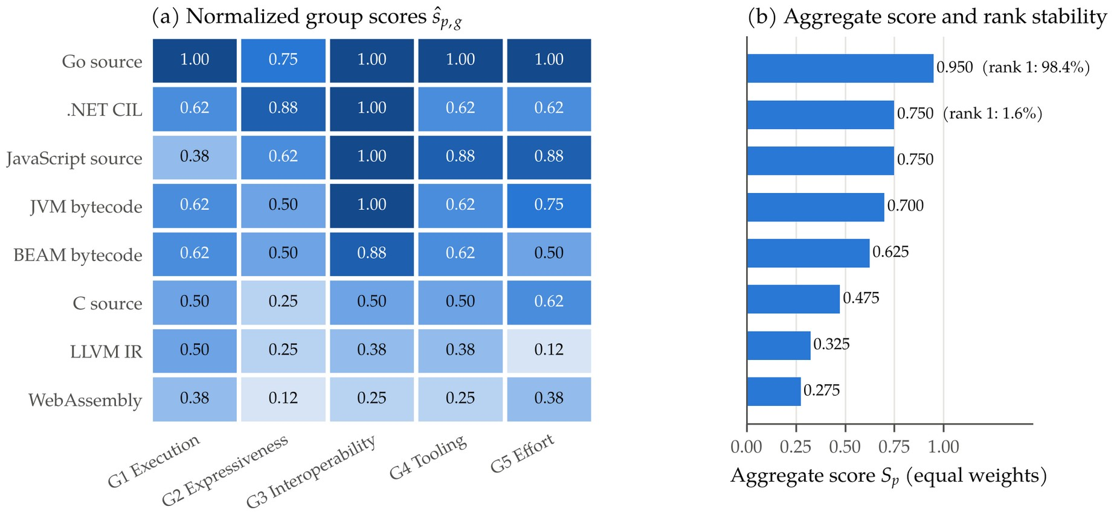
Figure 2. Assessment of host platforms for the target scenario of statically typed server-side extensions: (a) normalized group scores ŝ_{p,g} computed with Equation (1); (b) aggregate score S_{p} with equal weights (Equation (2)) and the frequency with which each platform ranked first among 100,000 random weight vectors drawn from Dir(1, …, 1).
The ranking is stable with respect to the weights. Go source ranked first for 98.4% of the sampled weight vectors and was among the first two in all of them; .NET CIL ranked first in the remaining 1.6%. Removing any single group from the evaluation did not change the first place. The analysis also shows where Go is weakest: in the expressiveness group its score (0.75) is lower than that of .NET CIL (0.88), because Go lacks method-level type parameters and offers only limited control over data layout. These are exactly the properties that the GoNext extensions and their lowering schemes must compensate for, which motivates the classification in the next section.
3.2. Classification of the GoNext Extensions
Applying the definition (3) to the eight extensions of Section 2.5 gives the classification in Table 5 and Figure 3. Four extensions are syntactic, three are structural, and enum types with associated data are representational. Pattern matching is classified by its most demanding part: the control-flow rewriting is structural, while the tests on variants depend on the representation selected for the enum.
Table 5. Classification of GoNext extensions and their lowering targets in standard Go.
Extension | Class | Lowered to | Information required
Named arguments | Syntactic | Positional call; temporaries if evaluation order differs | Callee parameter list
Default parameter values | Syntactic | Default expressions inserted at the call site | Callee parameter list
Extension methods | Syntactic | Top-level function with the receiver as first argument | Receiver type
Uniform function call syntax | Syntactic | Plain call f(a, b) | Receiver type, method sets
Generic methods | Structural | Top-level generic function (lifting) | Type parameters of receiver and method
Short anonymous functions | Structural | Function literal with explicit types | Expected function type
Pattern matching (match) | Structural ¹ | Decision tree of switch statements and bindings | Scrutinee type, variant set
Enums with associated data | Representational | Tagged struct or sealed interface, constructors | Payload types, pointer maps

¹ Tests on enum variants depend on the representational lowering of the enum.
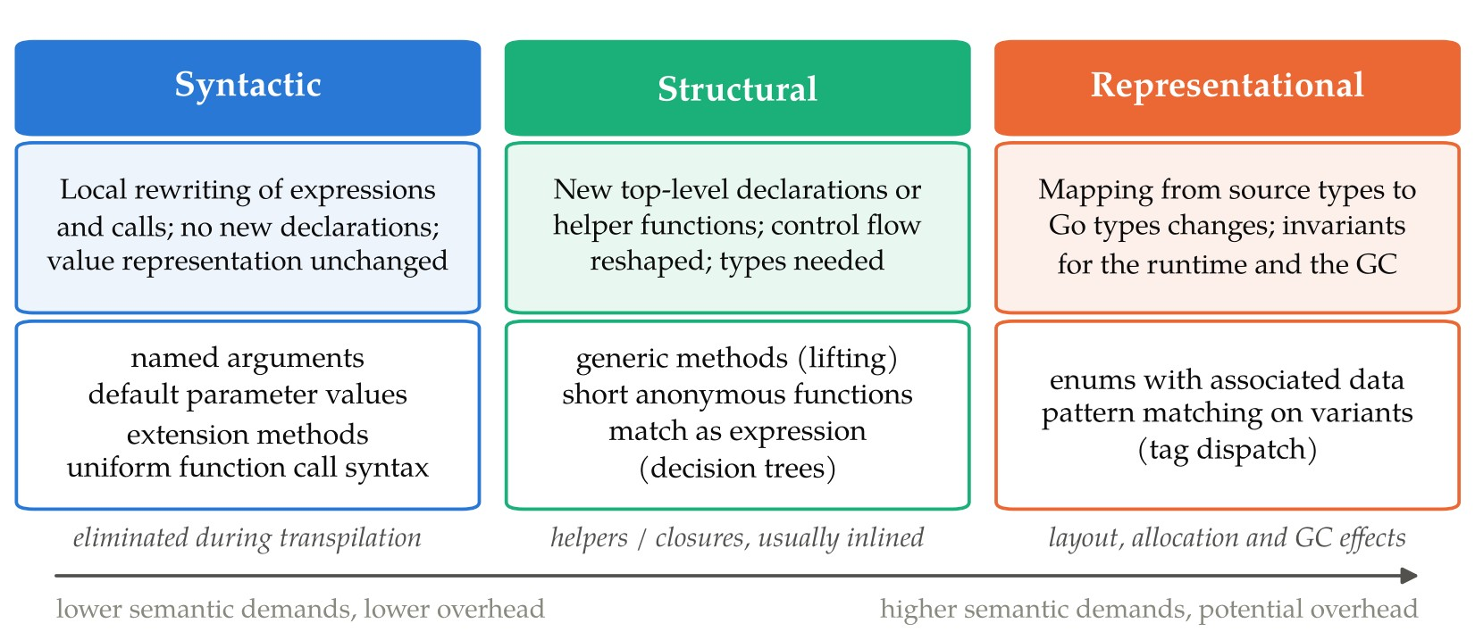
Figure 3. Classes of language transformations in GoNext. The classes are ordered by the semantic information they require and by the run-time cost they can introduce: syntactic transformations disappear during translation, structural ones may introduce helper functions or closures, and representational ones change data layout and interact with allocation and garbage collection.
3.3. Lowering Schemes
3.3.1. Syntactic Extensions
Listing 1 shows GoNext code that uses named arguments, default parameter values, an extension method and UFCS; Listing 2 shows the code produced by the transpiler. All four constructs are reduced to ordinary calls. Default values are evaluated at the call site each time the call is made, so that a default expression may refer to package-level state as in Kotlin or C#. When named arguments are given in an order that differs from the parameter order and at least one argument may have side effects, the arguments are first assigned to temporaries in source order; for side-effect-free arguments the call is emitted directly.
Listing 1. GoNext source with syntactic extensions.
func dial(host string, port int = 443,
timeout time.Duration = 5*time.Second, retries int = 3) Conn

ext func (s []int) sum() int {
t := 0
for _, v := range s { t += v }
return t
}

c1 := dial("example.org", retries: 5) // named + default arguments
c2 := dial(retries: retries(), host: host()) // reordered named arguments
total := xs.sum() // extension method
m := a.max3(b, c) // UFCS form of max3(a, b, c)

Listing 2. Go code generated for Listing 1.
func dial(host string, port int, timeout time.Duration, retries int) Conn
func ext_IntSlice_sum(s []int) int { ... }

c1 := dial("example.org", 443, 5*time.Second, 5)
gnArg1 := retries() // source evaluation order preserved
gnArg2 := host()
c2 := dial(gnArg2, 443, 5*time.Second, gnArg1)
total := ext_IntSlice_sum(xs)
m := max3(a, b, c)

The generated calls are the calls a Go programmer would write by hand, so these extensions have no run-time cost by construction. Experiment 2 quantifies what this means relative to the idioms used in Go today (Figure 4d). The lowered positional call took 8.7 ns per call (median of ten runs), the configuration-struct idiom 10.8 ns, and the functional-options idiom 48.5 ns with one heap allocation of 48 bytes per call. The extension method of Experiment 3 ran in 1264 ns per 4096-element sum, against 1302 ns for the hand-written loop; the difference lies within the interquartile ranges.
3.3.2. Structural Extensions
Go does not allow type parameters on methods [27]. A GoNext generic method is therefore lifted to a top-level generic function whose first parameter is the receiver and whose type parameter list is the concatenation of the receiver's and the method's type parameters (Listings 3 and 4). Call sites written in method syntax are rewritten into calls of the lifted function. Go's own type inference then determines the type arguments, as for any generic call; formal models of Go generics and their translations show that such calls need no special treatment by the compiler [45–48].
Listing 3. GoNext generic method and short anonymous function.
type List[T any] struct { items []T }

func (l List[T]) map[U any](f func(T) U) List[U] {
out := make([]U, len(l.items))
for i, v := range l.items { out[i] = f(v) }
return List[U]{out}
}

ys := xs.map(x => x * 2) // xs has type List[int]

Listing 4. Go code generated for Listing 3.
func List_map[T any, U any](l List[T], f func(T) U) List[U] {
out := make([]U, len(l.items))
for i, v := range l.items {
out[i] = f(v)
}
return List[U]{out}
}

ys := List_map(xs, func(x int) int { return x * 2 })

Short anonymous functions require more than syntactic rewriting, because Go function literals must declare the types of their parameters and results. The transpiler obtains them by contextual (bidirectional) typing [49,50]: the parameter types are taken from the expected function type, here func(T) U with T = int known from the receiver, and the result type is synthesized from the body of the lambda, which fixes U = int. This scheme covers the common cases in which a lambda is passed to a parameter of function type whose input types are determined by other arguments. It does not cover (a) lambdas passed where the expected type is an unconstrained type parameter, so that no function type is available; (b) several lambdas whose parameter types depend on each other's results; and (c) lambdas whose bodies produce untyped constants while the expected result type is still unknown, where Go's default type for the constant may differ from the intended one. In these cases GoNext requires explicit parameter annotations, and the transpiler reports an error at the lambda rather than emitting code that would fail later in the Go compiler.
A match used as an expression is lowered to a statement: the transpiler declares a result variable, compiles the arms into a switch statement and assigns the result in each arm. This avoids wrapping the expression in an immediately invoked closure; such a closure is kept only where moving the evaluation would change the order of effects, for example in the right operand of && or in a loop condition. In Experiment 3, the lowered generic method with a lambda processed 4096 elements in 8.36 µs, while the equivalent hand-written loop took 9.14 µs; both performed one allocation for the result slice. The difference in favor of the lowered code is within the variation that code placement can cause in micro-benchmarks and should not be read as a speed-up; the relevant observation is that the helper function and the closure did not add measurable overhead, because the compiler inlined both.
3.3.3. Representational Extension: Enums with Associated Data
Listing 5 declares an enum with four variants and a function that matches on it. Three representations of the enum in Go were analyzed (Section 2.6). R1 maps each variant to a struct type that implements a sealed interface and lowers match to a type switch; it corresponds to the idiom that Go programmers use manually and to the encoding of algebraic data types by classes in object-oriented languages [51]. R2 maps the enum to one struct that contains a tag and the fields of all variants. R3 overlaps the scalar payloads of different variants in shared machine words and keeps a single slot of type unsafe.Pointer for pointer payloads, as shown in Listing 6.
Listing 5. GoNext enum with associated data and pattern matching.
enum Shape {
Circle(r float64)
Rect(w, h float64)
Triangle(a, b, c float64)
Text(s string)
}

func measure(s Shape) float64 {
return match s {
Circle(r) => math.Pi * r * r
Rect(w, h) => w * h
Triangle(a, b, c) => heron(a, b, c)
Text(s) => float64(len(s))
}
}

Listing 6. Go code generated for Listing 5 with the compact representation R3 (excerpt).
type Shape struct {
tag uint8
w0, w1, w2 uint64 // scalar payload words shared by variants
p unsafe.Pointer // pointer payload: visible to the collector
n int
}

func NewShape_Circle(r float64) Shape {
return Shape{tag: Shape_Circle, w0: math.Float64bits(r)}
}

func measure(s Shape) float64 {
var gnMatch1 float64
switch s.tag {
case Shape_Circle:
r := math.Float64frombits(s.w0)
gnMatch1 = math.Pi * r * r
// ... Rect, Triangle and Text ...
default:
panic("gonext: non-exhaustive match on Shape")
}
return gnMatch1
}

Exhaustiveness is verified by the transpiler during semantic analysis, so the default branch is unreachable in programs accepted by GoNext; it remains in the generated code as a defensive check for values constructed through unsafe means.
3.4. Analysis of the Generated Code
Figure 4 and Table 6 summarize Experiments 1–3. The choice of representation had a large effect on construction and memory and a small effect on matching. With the interface representation R1, every value required one heap allocation (65,536 allocations for 65,536 values), on average 16.0 bytes per value, and construction took 38.0 ns per value. The tagged representations R2 and R3 performed no allocations; construction took 11.6 and 10.4 ns per value, that is, 3.3 and 3.7 times less than R1. An exhaustive match took between 12.8 ns (R2) and 13.4 ns (R1) per value, with R3 at 13.1 ns; the differences between the representations are small and partly within the interquartile ranges, so the cost of converting payload words back to floating-point values in R3 is negligible.
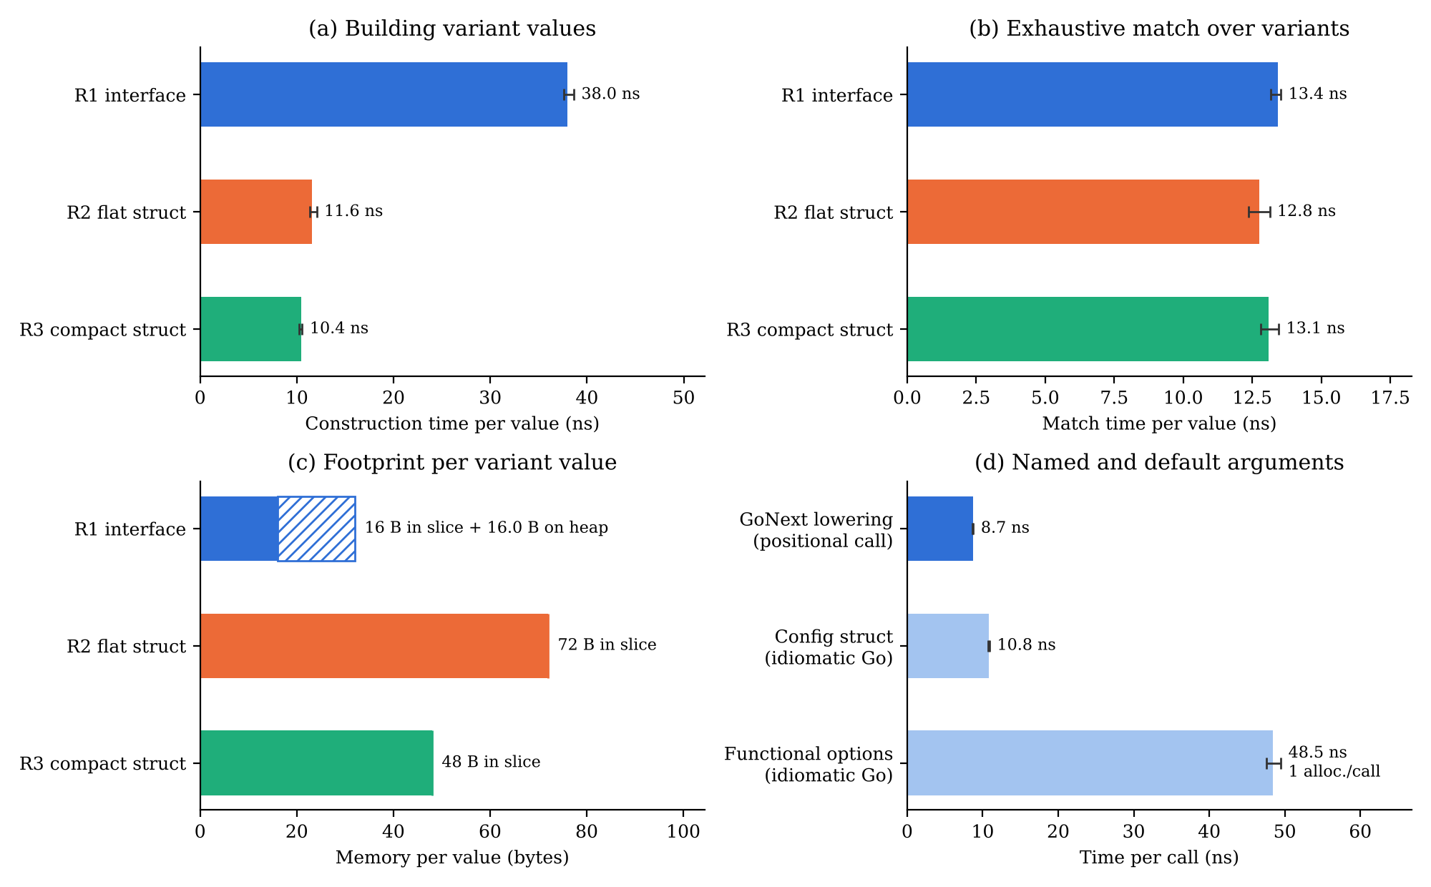
Figure 4. Measurements of generated code (medians of ten runs; error bars show the interquartile range): (a) time to construct one enum value with representations R1–R3; (b) time of an exhaustive match per value; (c) memory per value, split into the slot stored in the slice and the heap allocation of R1 (hatched); (d) call with named and default arguments lowered by GoNext compared with two idiomatic Go emulations.
The memory footprint shows the trade-off between R2 and R3 (Figure 4c). R1 stores a 16-byte interface value per element plus a separately allocated payload of 8 to 24 bytes. R2 needs 72 bytes per value regardless of the variant, because it reserves space for the fields of all variants. R3 needs 48 bytes, a reduction of one third relative to R2, because scalar payloads of different variants share the same three words. The saving grows with the number of variants and is bounded by the size of the largest variant.
Table 6. Generated-code measurements: median [interquartile range] of ten runs.
Benchmark | Time | Allocations | Memory
Enum construction, R1 interface | 38.0 [37.6–38.6] ns/value | 1 per value | 16 B + 16.0 B heap
Enum construction, R2 flat struct | 11.6 [11.3–12.1] ns/value | 0 | 72 B
Enum construction, R3 compact struct | 10.4 [10.3–10.6] ns/value | 0 | 48 B
Exhaustive match, R1 | 13.4 [13.2–13.5] ns/value | 0 | –
Exhaustive match, R2 | 12.8 [12.4–13.1] ns/value | 0 | –
Exhaustive match, R3 | 13.1 [12.8–13.5] ns/value | 0 | –
Named/default call, GoNext lowering | 8.7 [8.6–8.8] ns/call | 0 | 0 B
Named/default call, configuration struct | 10.8 [10.7–10.9] ns/call | 0 | 0 B
Named/default call, functional options | 48.5 [47.5–49.5] ns/call | 1 | 48 B
Generic method + lambda (4096 elements) | 8.36 [8.23–8.74] µs | 1 | 32 KiB
Hand-written loop (4096 elements) | 9.14 [8.61–9.42] µs | 1 | 32 KiB
Extension method sum (4096 elements) | 1.264 [1.183–1.286] µs | 0 | 0 B
Hand-written sum (4096 elements) | 1.302 [1.253–1.319] µs | 0 | 0 B

3.5. Pointer Visibility for the Garbage Collector
Experiment 4 tested the invariant (4) directly. Table 7 shows the result. When the pointer payload of a variant was stored in an unsafe.Pointer slot or as an interface value, none of the 10,000 referenced nodes was finalized in any of the ten trials. When the same payload was stored in a uintptr word, which is what a layout overlapping all payloads in an integer buffer amounts to, the collector reclaimed all 10,000 nodes in every trial (median 10,000, range 10,000–10,000), although the enum values that referred to them were still alive. Any subsequent access through such a value would read freed memory. The defect is silent: the program compiles, go vet (Go 1.24) reports no warning because the integer is never converted back in the test program, and the failure depends on the timing of garbage collection.
Table 7. Objects reclaimed while still referenced by live enum values (10 trials × 10,000 objects).
Storage of the pointer payload | GC-visible | Reclaimed per trial (median) | Range
unsafe.Pointer slot (R3) | Yes | 0 | 0–0
Interface value (R1) | Yes | 0 | 0–0
uintptr word | No | 10,000 | 10,000–10,000

The result explains why compact layouts familiar from C unions cannot be transferred to Go mechanically. A correct compact representation must assign every pointer-carrying payload field to a slot of pointer type, and it must keep pointer slots shared only between payloads whose types are compatible with this treatment; strings and slices, for example, are represented as a pointer word plus integer words. The rule is checked by the lowering stage when it computes the slot assignment of an enum, using the pointer information of the payload types obtained during semantic analysis.
3.6. Comparison with Related Approaches
Table 8 places GoNext among related approaches to language extension and translation. TypeScript and Scala.js show the benefit of a high-level target for adoption, but target JavaScript. Racket and SugarJ provide general mechanisms for extending a host language from within, at the price of tying the extension to that host's macro or library system. Language workbenches and transformation languages provide infrastructure for defining arbitrary languages but leave the choice of target and runtime to the user. XGo and Borgo are the closest systems: both build on the Go toolchain and interoperate with Go code. GoNext differs from them in its goal and method: it extends Go itself rather than defining a separate language, keeps every Go program valid, and is accompanied by an explicit classification of transformations and by measurements of the cost of each class.
Table 8. Comparison of GoNext with related approaches.
Approach | Target | Extension mechanism | Source compatible with target | Cost analysis of transformations
TypeScript [5] | JavaScript | Typed superset, type erasure | Yes (superset) | Not applicable (erasure)
Scala.js [7] | JavaScript | Compiler back end | No | Interoperability semantics
Racket languages [9] | Racket | Macros, languages as libraries | Host-specific | No
SugarJ [8] | Java | Library-based syntax extension | Yes | No
Spoofax, Rascal [10,14] | User-defined | Language workbench | Not applicable | No
XGo (Go+) [28] | Go toolchain | Separate Go-compatible language | Partially | No
Borgo [29] | Go | Separate language compiled to Go | No | No
GoNext (this work) | Go | Dialect of Go, six-stage transpiler | Yes (superset) | Three classes, measured

4. Discussion
4.1. Interpretation of the Results
The results support the working hypothesis that Go can serve as a host platform for high-level language extensions without changes to its compiler, but they also show that the answer depends on the class of the extension. For syntactic extensions the question is settled by construction: the generated code is the code a programmer would write, and Experiment 2 shows that a GoNext call with named and default arguments costs the same as a plain call and less than one fifth of the time of the functional-options idiom that Go programmers use to approximate the feature. The practical benefit of such extensions is therefore not speed but the removal of boilerplate without the hidden allocation of the idiomatic workaround.
Structural extensions occupy the middle ground. Lifting generic methods to top-level functions works because Go's generic functions are a complete substitute at the call site; what is lost is the ability of such methods to satisfy interfaces, which follows from Go's design choice to keep method sets free of type parameters [25,45]. The cost of helper functions and closures depends on inlining by the Go compiler, which in our experiments removed it entirely. The real limit of the structural class lies in type inference: the transpiler must infer types that Go itself does not infer, and it can do so reliably only in the bidirectional form described in Section 3.3.2. This is consistent with the general experience that local, bidirectional inference scales well and global inference does not [49,50].
Representational extensions are where Go's restrictions are felt most directly, and where the generated code must be designed with knowledge of the runtime. The interface representation is the most natural lowering and integrates best with Go tooling, but it allocates on every construction; the tagged representations avoid allocations and reduce construction time by a factor of 3.3 to 3.7, and the compact layout further reduces memory by one third. The pointer-visibility experiment shows that the most compact layouts are unsafe in a precise, concurrent collector. These observations are consistent with empirical findings that uses of the unsafe package in Go projects are a frequent source of subtle errors [52], and they suggest that representation selection should be an explicit, checked decision of the transpiler rather than a fixed scheme.
4.2. Domains of Applicability
The approach is best suited to dialects of Go and to DSLs whose semantics can be aligned with Go's models of types, memory and execution: configuration and policy languages, service-definition languages, data-processing DSLs and languages for describing infrastructure. In these domains the semantic gap to Go is small, and the advantages measured in the platform comparison (native deployment, garbage collection, goroutines, interoperability with existing Go packages, standard tooling) are fully inherited. The approach also supports incremental adoption: because GoNext is a superset of Go and its output is ordinary Go, a team can introduce it into one package of an existing module without affecting the others. Program-analysis tools developed for Go, such as detectors of concurrency bugs [53,54], apply to the generated code without adaptation, which is an advantage that a separate runtime would not offer. It is less suited to languages whose semantics conflict with Go's runtime model, such as languages requiring guaranteed tail calls, first-class continuations, precise control over memory reclamation or a different concurrency model; these would need emulation layers whose overhead falls into the representational class or beyond.
4.3. Limitations and Threats to Validity
Construct validity. The platform assessment uses ordinal scores assigned by the authors for a specific scenario. Different scenarios, such as browser applications or embedded systems, would justify different criteria and scores. The sensitivity analysis protects the ranking against the choice of weights, but not against the scores themselves; for this reason the scores are published as data so that other researchers can revise them.
Internal validity. The micro-experiments measure lowering patterns in isolation. Micro-benchmarks are sensitive to code placement, inlining decisions and processor frequency scaling; we mitigated this with ten repetitions, medians and interquartile ranges and with equivalence tests, but the small differences observed for matching, for the configuration-struct idiom and for the generic-method and extension-method benchmarks should not be interpreted as systematic.
External validity. All measurements were taken on one virtualized x86-64 machine with one Go version. Results on other architectures and with future versions of the Go compiler may differ, in particular for inlining-dependent results. The study does not evaluate GoNext on application workloads, compilation time or memory of complete programs; such a quantitative evaluation requires a separate comparative benchmark study and is part of milestone M3 of the software project.
Scope of the implementation. The listings of Section 3.3 are produced by GoNext version 1.0.0; they are part of the golden tests of the software project (Section 2.7), shown with minor formatting abbreviations. The micro-experiments use stand-alone reproductions of the same lowering schemes, so that the compared variants can be measured in isolation. Version 1.0.0 is a research prototype: for example, a match over an enum must be written in the package that declares the enum, and patterns are not nested; these limitations are documented in the language reference.
4.4. Future Work
Three directions follow from the results. The first is an application-level evaluation that compares GoNext programs with idiomatic Go programs on services and DSL workloads, including compilation time and binary size. The second is automatic selection of enum representations from usage profiles, with the invariant (4) enforced by construction and verified by tests that stress the garbage collector. The third is deeper tool integration, in particular source-level debugging and editor support that present GoNext constructs rather than their lowered form, building on resugaring techniques [55].
5. Conclusions
This article presented GoNext, a dialect of Go, and a transpiler architecture that implements high-level language extensions while preserving compatibility with the Go compiler, runtime and ecosystem. A rubric of twenty criteria in five groups placed Go source code first among eight host platforms for statically typed server-side extensions, with a ranking that held for 98.4% of randomly sampled weightings; its weakest group, expressiveness, is the one that the extensions address. A classification of transformations into syntactic, structural and representational classes explained the cost of each extension: syntactic extensions disappeared during translation, structural extensions relied on helper functions that the compiler inlined, and the representation of enums determined allocation, construction time and memory. The experiments also showed that a compact enum layout must keep pointer payloads visible to the garbage collector; storing them in integer words led to the reclamation of all referenced objects in every trial. The approach is applicable to Go dialects and to DSLs for server-side and infrastructure software whose semantics agree with Go's models of types, memory and execution, and it allows a new language to be introduced into existing Go projects step by step. The GoNext software project (version 1.0.0, https://doi.org/10.5281/zenodo.23490820) and the archived reproducibility package provide the basis for the application-level evaluation that remains to be done.
Author Contributions: Conceptualization, P.F.; methodology, P.F. and X.X.; software, P.F.; validation, P.F. and X.X.; formal analysis, P.F.; investigation, P.F.; resources, X.X.; data curation, P.F.; writing—original draft preparation, P.F.; writing—review and editing, P.F. and X.X.; visualization, P.F.; supervision, X.X.; project administration, X.X.. All authors have read and agreed to the published version of the manuscript.
Funding: This research received no external funding.
Institutional Review Board Statement: Not applicable.
Informed Consent Statement: Not applicable.
Data Availability Statement: The GoNext software (transpiler source code, test suites, examples and documentation) and the reproducibility package of this study (micro-benchmark programs, lowered listings, criterion scores, raw benchmark output and analysis scripts) are openly available in Zenodo at https://doi.org/10.5281/zenodo.23490820 (version 1.0.0) under the Apache License 2.0.
Acknowledgments: During the preparation of this manuscript/study, the authors used Claude (Anthropic, Claude Opus 5.5) for the purposes of drafting and editing the text, writing the transpiler and the benchmark, analysis and plotting scripts, and formatting the manuscript. The authors have reviewed and edited the output and take full responsibility for the content of this publication.
Conflicts of Interest: The authors declare no conflicts of interest.
Abbreviations
The following abbreviations are used in this manuscript:
AST Abstract syntax tree
CIL Common Intermediate Language
DOI Digital Object Identifier
DSL Domain-specific language
GC Garbage collector
GenAI Generative artificial intelligence
IAST Internal abstract syntax tree
IQR Interquartile range
IR Intermediate representation
JVM Java Virtual Machine
UFCS Uniform function call syntax
References
- Lattner, C.; Adve, V. LLVM: A Compilation Framework for Lifelong Program Analysis & Transformation. In Proceedings of the International Symposium on Code Generation and Optimization (CGO 2004), San Jose, CA, USA, 20–24 March 2004; pp. 75–86. https://doi.org/10.1109/CGO.2004.1281665
- Würthinger, T.; Wimmer, C.; Wöß, A.; Stadler, L.; Duboscq, G.; Humer, C.; Richards, G.; Simon, D.; Wolczko, M. One VM to Rule Them All. In Proceedings of the 2013 ACM International Symposium on New Ideas, New Paradigms, and Reflections on Programming & Software (Onward! 2013), Indianapolis, IN, USA, 2013; pp. 187–204. https://doi.org/10.1145/2509578.2509581
- Bastidas Fuertes, A.; Pérez, M.; Meza Hormaza, J. Transpilers: A Systematic Mapping Review of Their Usage in Research and Industry. Appl. Sci. 2023, 13, 3667. https://doi.org/10.3390/app13063667
- Bastidas Fuertes, A.; Pérez, M.; Meza, J. Transpiler-Based Architecture Design Model for Back-End Layers in Software Development. Appl. Sci. 2023, 13, 11371. https://doi.org/10.3390/app132011371
- Bierman, G.; Abadi, M.; Torgersen, M. Understanding TypeScript. In ECOOP 2014—Object-Oriented Programming, Proceedings of the 28th European Conference, Uppsala, Sweden, 28 July–1 August 2014; Jones, R., Ed.; Lecture Notes in Computer Science; Springer: Berlin/Heidelberg, Germany, 2014; Volume 8586, pp. 257–281. https://doi.org/10.1007/978-3-662-44202-9_11
- Gao, Z.; Bird, C.; Barr, E.T. To Type or Not to Type: Quantifying Detectable Bugs in JavaScript. In Proceedings of the 39th International Conference on Software Engineering (ICSE 2017), Buenos Aires, Argentina, 20–28 May 2017; pp. 758–769. https://doi.org/10.1109/ICSE.2017.75
- Doeraene, S.; Schlatter, T.; Stucki, N. Semantics-Driven Interoperability between Scala.js and JavaScript. In Proceedings of the 7th ACM SIGPLAN Symposium on Scala (SCALA 2016), Amsterdam, The Netherlands, 2016; pp. 85–94. https://doi.org/10.1145/2998392.2998404
- Erdweg, S.; Rendel, T.; Kästner, C.; Ostermann, K. SugarJ: Library-Based Syntactic Language Extensibility. In Proceedings of the 2011 ACM International Conference on Object Oriented Programming Systems Languages and Applications (OOPSLA 2011), Portland, OR, USA, 2011; pp. 391–406. https://doi.org/10.1145/2048066.2048099
- Tobin-Hochstadt, S.; St-Amour, V.; Culpepper, R.; Flatt, M.; Felleisen, M. Languages as Libraries. In Proceedings of the 32nd ACM SIGPLAN Conference on Programming Language Design and Implementation (PLDI 2011), San Jose, CA, USA, 2011; pp. 132–141. https://doi.org/10.1145/1993498.1993514
- Kats, L.C.L.; Visser, E. The Spoofax Language Workbench: Rules for Declarative Specification of Languages and IDEs. In Proceedings of the ACM International Conference on Object Oriented Programming Systems Languages and Applications (OOPSLA 2010), Reno/Tahoe, NV, USA, 2010; pp. 444–463. https://doi.org/10.1145/1869459.1869497
- Erdweg, S.; van der Storm, T.; Völter, M.; Tratt, L.; Bosman, R.; Cook, W.R.; Gerritsen, A.; Hulshout, A.; Kelly, S.; Loh, A.; Konat, G.; Molina, P.J.; Palatnik, M.; Pohjonen, R.; Schindler, E.; Schindler, K.; Solmi, R.; Vergu, V.; Visser, E.; van der Vlist, K.; Wachsmuth, G.; van der Woning, J. Evaluating and Comparing Language Workbenches: Existing Results and Benchmarks for the Future. Comput. Lang. Syst. Struct. 2015, 44, 24–47. https://doi.org/10.1016/j.cl.2015.08.007
- Visser, E. Program Transformation with Stratego/XT. In Domain-Specific Program Generation; Lengauer, C., Batory, D., Consel, C., Odersky, M., Eds.; Lecture Notes in Computer Science; Springer: Berlin/Heidelberg, Germany, 2004; Volume 3016, pp. 216–238. https://doi.org/10.1007/978-3-540-25935-0_13
- Cordy, J.R. The TXL Source Transformation Language. Sci. Comput. Program. 2006, 61, 190–210. https://doi.org/10.1016/j.scico.2006.04.002
- Klint, P.; van der Storm, T.; Vinju, J. RASCAL: A Domain Specific Language for Source Code Analysis and Manipulation. In Proceedings of the Ninth IEEE International Working Conference on Source Code Analysis and Manipulation (SCAM 2009), Edmonton, AB, Canada, 20–21 September 2009; pp. 168–177. https://doi.org/10.1109/SCAM.2009.28
- Mernik, M.; Heering, J.; Sloane, A.M. When and How to Develop Domain-Specific Languages. ACM Comput. Surv. 2005, 37, 316–344. https://doi.org/10.1145/1118890.1118892
- Cox, R.; Griesemer, R.; Pike, R.; Taylor, I.L.; Thompson, K. The Go Programming Language and Environment. Commun. ACM 2022, 65, 70–78. https://doi.org/10.1145/3488716
- Go 1 and the Future of Go Programs. Available online: https://go.dev/doc/go1compat (accessed on 20 October 2026).
- Clements, A. Go Turns 15. The Go Blog, 11 November 2024. Available online: https://go.dev/blog/15years (accessed on 20 October 2026).
- Burns, B.; Grant, B.; Oppenheimer, D.; Brewer, E.; Wilkes, J. Borg, Omega, and Kubernetes. Commun. ACM 2016, 59, 50–57. https://doi.org/10.1145/2890784
- Bocci, A.; Forti, S.; Ferrari, G.-L.; Brogi, A. Declarative Secure Placement of FaaS Orchestrations in the Cloud-Edge Continuum. Electronics 2023, 12, 1332. https://doi.org/10.3390/electronics12061332
- Fett, M.; Kraft, M.; Wilking, F.; Goetz, S.; Wartzack, S.; Kirchner, E. Medium-Level Architectures for Digital Twins: Bridging Conceptual Reference Architectures to Practical Implementation in Cloud, Edge and Cloud–Edge Deployments. Electronics 2024, 13, 1373. https://doi.org/10.3390/electronics13071373
- golang/go Issue #19412. Proposal: Spec: Add Sum Types/Discriminated Unions. Available online: https://github.com/golang/go/issues/19412 (accessed on 20 October 2026).
- Kohn, T.; van Rossum, G.; Bucher II, G.B.; Talin; Levkivskyi, I. Dynamic Pattern Matching with Python. In Proceedings of the 16th ACM SIGPLAN International Symposium on Dynamic Languages (DLS 2020), Virtual, USA, 2020; pp. 85–98. https://doi.org/10.1145/3426422.3426983
- golang/go Issue #21498. Proposal: Spec: Short Function Literals. Available online: https://github.com/golang/go/issues/21498 (accessed on 20 October 2026).
- Taylor, I.L.; Griesemer, R. Type Parameters Proposal. Available online: https://go.googlesource.com/proposal/+/refs/heads/master/design/43651-type-parameters.md (accessed on 20 October 2026).
- Go 1.18 Release Notes. Available online: https://go.dev/doc/go1.18 (accessed on 20 October 2026).
- The Go Programming Language Specification. Available online: https://go.dev/ref/spec (accessed on 20 October 2026).
- XGo. Available online: https://github.com/goplus/xgo (accessed on 20 October 2026).
- Borgo Programming Language. Available online: https://github.com/borgo-lang/borgo (accessed on 20 October 2026).
- Emre, M.; Schroeder, R.; Dewey, K.; Hardekopf, B. Translating C to Safer Rust. Proc. ACM Program. Lang. 2021, 5, 1–29. https://doi.org/10.1145/3485498
- Emre, M.; Boyland, P.; Parekh, A.; Schroeder, R.; Dewey, K.; Hardekopf, B. Aliasing Limits on Translating C to Safe Rust. Proc. ACM Program. Lang. 2023, 7, 94. https://doi.org/10.1145/3586046
- Pan, R.; Ibrahimzada, A.R.; Krishna, R.; Sankar, D.; Wassi, L.P.; Merler, M.; Sobolev, B.; Pavuluri, R.; Sinha, S.; Jabbarvand, R. Lost in Translation: A Study of Bugs Introduced by Large Language Models while Translating Code. In Proceedings of the IEEE/ACM 46th International Conference on Software Engineering (ICSE 2024), Lisbon, Portugal, 2024; pp. 1–13. https://doi.org/10.1145/3597503.3639226
- Forkert, P. Title of the Doctoral Dissertation. Doctor of Philosophy Thesis, University, City, Ukraine, 2026.
- Package unsafe—Go Standard Library Documentation. Available online: https://pkg.go.dev/unsafe (accessed on 20 October 2026).
- Hudson, R. Getting to Go: The Journey of Go's Garbage Collector. The Go Blog, 12 July 2018. Available online: https://go.dev/blog/ismmkeynote (accessed on 20 October 2026).
- Jones, R.; Hosking, A.; Moss, E. The Garbage Collection Handbook: The Art of Automatic Memory Management, 2nd ed.; Chapman and Hall/CRC: New York, NY, USA, 2023. https://doi.org/10.1201/9781003276142
- Package ast—Go Standard Library Documentation. Available online: https://pkg.go.dev/go/ast (accessed on 20 October 2026).
- Maranget, L. Compiling Pattern Matching to Good Decision Trees. In Proceedings of the 2008 ACM SIGPLAN Workshop on ML (ML 2008), Victoria, BC, Canada, 2008; pp. 35–46. https://doi.org/10.1145/1411304.1411311
- Command compile: Compiler Directives—Go Documentation. Available online: https://pkg.go.dev/cmd/compile (accessed on 20 October 2026).
- gopls: The Language Server for Go. Available online: https://go.dev/gopls/ (accessed on 20 October 2026).
- Georges, A.; Buytaert, D.; Eeckhout, L. Statistically Rigorous Java Performance Evaluation. In Proceedings of the 22nd Annual ACM SIGPLAN Conference on Object-Oriented Programming Systems, Languages and Applications (OOPSLA 2007), Montreal, QC, Canada, 2007; pp. 57–76. https://doi.org/10.1145/1297027.1297033
- Kalibera, T.; Jones, R. Rigorous Benchmarking in Reasonable Time. In Proceedings of the 2013 International Symposium on Memory Management (ISMM 2013), Seattle, WA, USA, 2013; pp. 63–74. https://doi.org/10.1145/2464157.2464160
- Forkert, P. GoNext: Transpiler and Reproducibility Package, Version 1.0.0; Zenodo: Geneva, Switzerland, 2026. https://doi.org/10.5281/zenodo.23490820
- Haas, A.; Rossberg, A.; Schuff, D.L.; Titzer, B.L.; Holman, M.; Gohman, D.; Wagner, L.; Zakai, A.; Bastien, J.F. Bringing the Web up to Speed with WebAssembly. In Proceedings of the 38th ACM SIGPLAN Conference on Programming Language Design and Implementation (PLDI 2017), Barcelona, Spain, 2017; pp. 185–200. https://doi.org/10.1145/3062341.3062363
- Griesemer, R.; Hu, R.; Kokke, W.; Lange, J.; Taylor, I.L.; Toninho, B.; Wadler, P.; Yoshida, N. Featherweight Go. Proc. ACM Program. Lang. 2020, 4, 149. https://doi.org/10.1145/3428217
- Ellis, S.; Zhu, S.; Yoshida, N.; Song, L. Generic Go to Go: Dictionary-Passing, Monomorphisation, and Hybrid. Proc. ACM Program. Lang. 2022, 6, 168. https://doi.org/10.1145/3563331
- Sulzmann, M.; Wehr, S. A Dictionary-Passing Translation of Featherweight Go. In Programming Languages and Systems (APLAS 2021), Chicago, IL, USA, 2021; Lecture Notes in Computer Science, Volume 13008; Springer: Cham, Switzerland, 2021; pp. 102–120. https://doi.org/10.1007/978-3-030-89051-3_7
- Sulzmann, M.; Wehr, S. A Type-Directed, Dictionary-Passing Translation of Method Overloading and Structural Subtyping in Featherweight Generic Go. J. Funct. Program. 2023, 33, e8. https://doi.org/10.1017/S0956796823000047
- Dunfield, J.; Krishnaswami, N. Bidirectional Typing. ACM Comput. Surv. 2021, 54, 1–38. https://doi.org/10.1145/3450952
- Pierce, B.C.; Turner, D.N. Local Type Inference. ACM Trans. Program. Lang. Syst. 2000, 22, 1–44. https://doi.org/10.1145/345099.345100
- Emir, B.; Odersky, M.; Williams, J. Matching Objects with Patterns. In ECOOP 2007—Object-Oriented Programming, Proceedings of the 21st European Conference, Berlin, Germany, 30 July–3 August 2007; Ernst, E., Ed.; Lecture Notes in Computer Science; Springer: Berlin/Heidelberg, Germany, 2007; Volume 4609, pp. 273–298. https://doi.org/10.1007/978-3-540-73589-2_14
- Costa, D.E.; Mujahid, S.; Abdalkareem, R.; Shihab, E. Breaking Type Safety in Go: An Empirical Study on the Usage of the unsafe Package. IEEE Trans. Softw. Eng. 2022, 48, 2277–2294. https://doi.org/10.1109/TSE.2021.3057720
- Liu, Z.; Zhu, S.; Qin, B.; Chen, H.; Song, L. Automatically Detecting and Fixing Concurrency Bugs in Go Software Systems. In Proceedings of the 26th ACM International Conference on Architectural Support for Programming Languages and Operating Systems (ASPLOS 2021), Virtual, USA, 2021; pp. 616–629. https://doi.org/10.1145/3445814.3446756
- Liu, Z.; Xia, S.; Liang, Y.; Song, L.; Hu, H. Who Goes First? Detecting Go Concurrency Bugs via Message Reordering. In Proceedings of the 27th ACM International Conference on Architectural Support for Programming Languages and Operating Systems (ASPLOS 2022), Lausanne, Switzerland, 2022; pp. 888–902. https://doi.org/10.1145/3503222.3507753
- Pombrio, J.; Krishnamurthi, S. Resugaring: Lifting Evaluation Sequences through Syntactic Sugar. In Proceedings of the 35th ACM SIGPLAN Conference on Programming Language Design and Implementation (PLDI 2014), Edinburgh, UK, 2014; pp. 361–371. https://doi.org/10.1145/2594291.2594319

