Intro to Programming (Python)

Assignment 05

# Overview

In this activity, you will learn to work with Lists and Dictionaries by creating a script and documenting your knowledge. You will also learn how to post work to GitHub, as is common in the industry.

This assignment will include the following tasks:

1. Watch the module videos.
2. Review some web pages.
3. Watch the external videos.
4. Apply your knowledge.
5. Document your knowledge.
6. Post your files to GitHub
7. Post your GitHub link
8. Submit your work.
9. Peer Review (Not Graded)

We are trying to answer the following questions:

* What is the difference between a List and a Dictionary?
* What is the between an Index and a Key?
* How do you read data from a file into a List?
* How do you read data from a file into a Dictionary?
* What is the programming pattern called “Separations of Concerns?”
* How would you use a function to organize your code?
* Why is a script template useful?
* Why is error handling using Try-Except recommend?
* What is GitHub, and why is it used?

# Assignment Steps

The following assignment steps ask you to read about, perform, and write about programming.

***Note:*** *Course assignments help you learn through* ***reading****,* ***watching*** *demonstrations,* ***performing*** *programming in Python, and reflecting on what you learned through* ***writing****. You are strongly encouraged to continue your learning by experimentation.*

## Step 1 - Watch the Module Videos

Please **watch the course videos**, found **on Canvas under modules -> module05**.

## Step 2 - Read a book chapter

Please **read chapter five** in your textbook. You **do not have to perform the exercises or type in the code**, but it is best if you open the script files as you read about them. You can find the downloadable **book files** **on Canvas** for your convenience.

## Step 3 - Web pages

Please review the following web pages. These are shorter than the book and provide online resources you can use later.

Go to this this tutorial page and select the Python option to expand the menu.

<https://www.afterhoursprogramming.com/tutorial/>

In the menu navigate to and read the "List", "Dictionary", and "Reading Files" pages.

## Step 4 - External Videos

Please watch this video. It will explain things a bit differently, which helps with learning!

* Reading from a text file: <https://youtu.be/m0o0CkYsDzI> (external site)

## Step 5 - Apply your knowledge

Now that you have reviewed the websites and videos, **modify** a new script that manages a "ToDo list." This project is like the last one, but different enough to be a challenge.

The "ToDo" file will contain two columns of data, "Task" and "Priority." Load the columns into a Python Dictionary object. Each **dictionary object represents one row of data**, and these rows must be added to a Python ***List* object to create a table of data** (**Like Lab 5-2**).

**I have provided a starting template to I want you to modify and use for your program**. You will note that it is both easier and harder to work with someone else's template and code, and that is part of the assignment.

a. **Create** a new sub-folder called Assignment05 inside the _PythonClass folder.

b. **Create** a new project in PyCharm that uses the _PythonClass\Assignment05 folder as its location

c. **Add** the starter file, "Assigment05_Starter.py," to your project.

d. **Add** code to your script that will perform that assignment’s task. Don't forget to update the changelog in the script's header.

e. **Run** the script in BOTH PyCharm and an OS command/shell window and capture images of it working on your computer.

f. **Verify** that it worked, by locating the text file and opening it in a text editor. The file should be in the same folder as your script if you used the correct, **relative**, file path!

Important: Don't use functions in this assignment, because we will do so in assignment 6 and I want you to compare the differences. And since we are not using functions, you do not have to get a perfect separation of data, presentation, and processing this time, just what you can for now!

## Step 6 - Document your knowledge

After you have created and tested your Python script, **create** a document describing the steps you took in performing this assignment. **Use** screenshots and code samples to explain the process, just as was done in your book, my programming notes, and the web pages you reviewed. **Make sure** the document is in a Microsoft Word document (.doc or .docx) or .pdf file.

**Note**: Make sure you put it in a proper, professional level, formatting! It does not have to be perfect, but if you turn in a simple blob of text, you will not get credit for it! Here is a link that may help you understand what I am looking for: https://youtu.be/9ojhSW9ljjo (External Site)

## Step 7 - Post your Files to GitHub

In this module, you need to **post** your files on a public **GitHub repository** so that others may review it. Please post **both your Word document and your Python file**.

Here are some videos to help you **learn** what GitHub is and how to use it.

* GitHub Tutorial 2020 - Beginner's Training Guide: <https://youtu.be/iv8rSLsi1xo>
* How to use GitHub for Beginners: <https://youtu.be/E8TXME3bzNs>
* Setting up a GitHub Account: <https://youtu.be/Sk1_DU2ky48>

Once, you understand how it works, perform the following to **create** a repository for your code:

a. **Login** to <https://github.com> (*Make a new account if needed!*)

**Important: GitHub requires an email account for your login.** You may use a **new made-up email account** with a made-up name **if you are concerned about security**. If you need more safeguards than that, please talk to your instructor.

b. **Create** a repository called **"*IntroToProg-Python" under your account. Figure 1 shows the steps.***

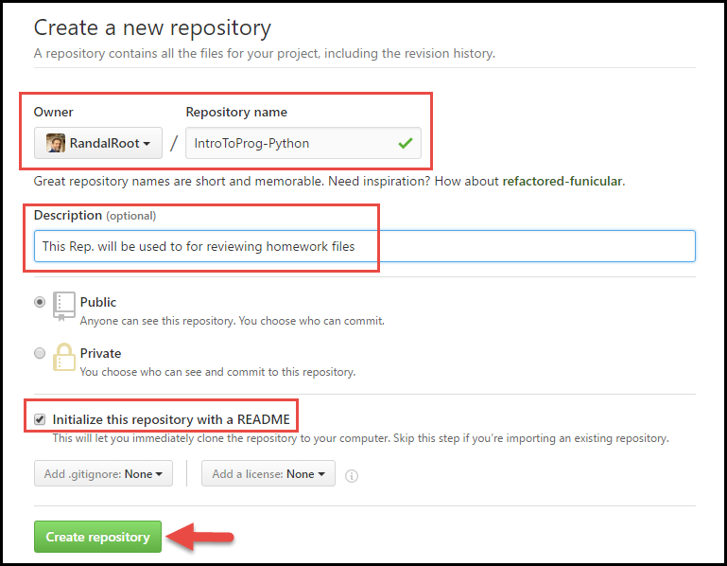

Figure 1. Creating a GitHub repository

c. Upload both of your files to the repository.

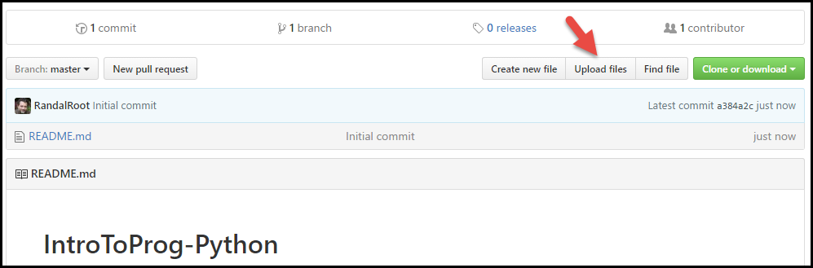

Figure 2. Uploading to a GitHub repository

d. Commit the changes to save your work.

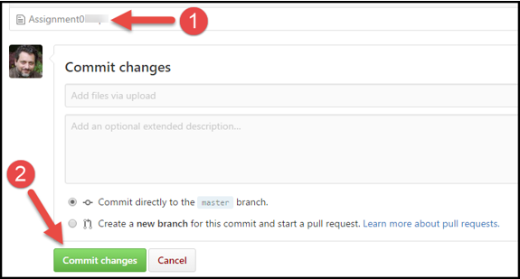

Figure 3. Committing the changes in a GitHub repository

## Step 8 - Post a Link to GitHub

You will share your work using the Canvas discussion board. To do so, you must create a post with a link to your GitHub site. Other students will use this link to perform a peer review.

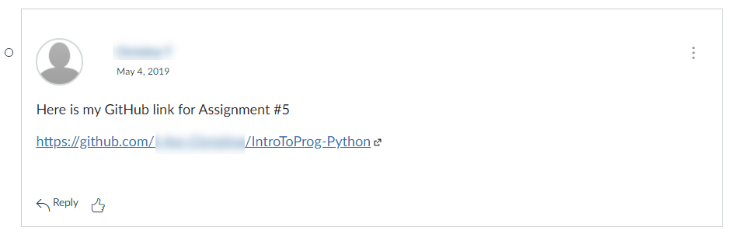

Figure 4. Posting a link to your GitHub repository

***Important:***

1. *Post only on the special discussion board called "Assignment 05 Documents for Review!"*
2. *Please copy and paste the URL for your new GitHub site into your MS Word knowledge document (Figure 2). This make grading a lot easier and is a big help! Thanks!!*

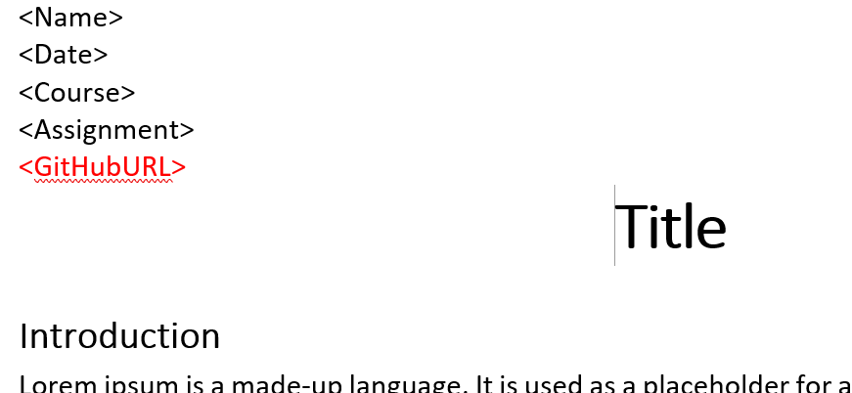

Figure 2. Adding your GitHub URL to your Word document

## Step 9 - Submit your work

Even though you have posted your file on GitHub, you still need to submit them as a Canvas assignment for grading. So, place your document and python script in the Assignment05 folder. Zip this folder into a “.zip” file, then upload the .zip file to the class assignment page.

***Important:***

*1.* ***Upload*** *your work* ***to the Canvas*** *assignment’s as a* ***Zip file****.*

*2.* ***Post*** *a link to your GitHub site* ***on the******assignment textbox****.*

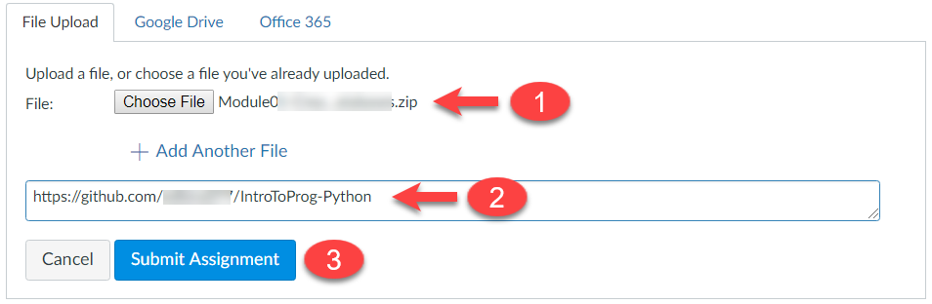

## Step 10 - Perform a Peer Review (Not Graded!)

After you have posted your link to GitHub and submitted your assignment, go to the "Assignment 05 Documents for Review!" discussion board and **select another student's post and review.** Follow the link they posted and review their files on GitHub. **This is an informal review** that **does** **not affect** either your or their **grade**. **Try to pick someone's link that has NOT been reviewed yet, even if you have to wait a few days for one to appear!**

NOTES

* **Post** your comments as a reply to their posting so the review will be nested under the other student's posting.
* **Make sure** to say two things that you liked about their work
* **Make sure** to say one thing that could make the work better

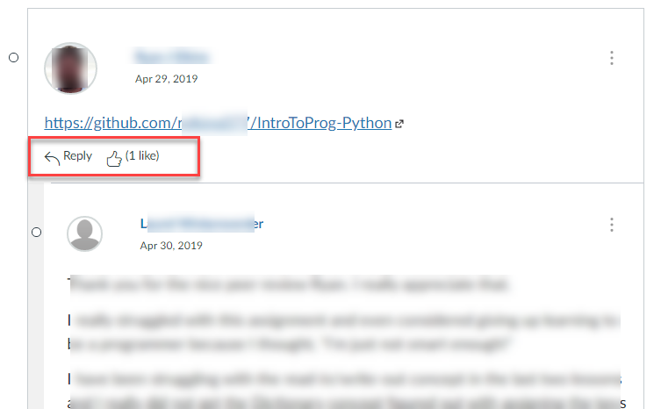

Congratulations! You are done!