

FlightGear Airbus A380 Series
Muraleedharan, [jormapaapa1235], Toryx, Hamilton, Dalvi, Cunningham, Ampere

Please refer to A380/License/README for licensing information

Aircraft Documentation

The Documentation is still in progress... we will update it as soon as possible! Please contact me (omega95, MIA0001, muraleen@my.erau.edu) if you would like to help complete this documentation.

1.0 Aircraft Quick Engine Start-up Procedure

Starting up an Airbus A380 Series aircraft responsibly requires the pilot to follow various pre-flight checklists but to test the aircraft and systems, you can follow this procedure to get the engines started and get going!

Please do not use “quick and dirty” for long-haul or virtual airline tracked flights as it oversees many vital system checks such as pressurization and hydraulics.

NOTE that at the end of this procedure, the fuel system is left at a state where all the fuel is being moved from the wing tanks to the engine feed tanks. This may cause imbalances in the feed tanks over long flights, which require the use of XFR or CROSSFEED tanks to even out the fuel levels.

PROCEDURE STARTS HERE

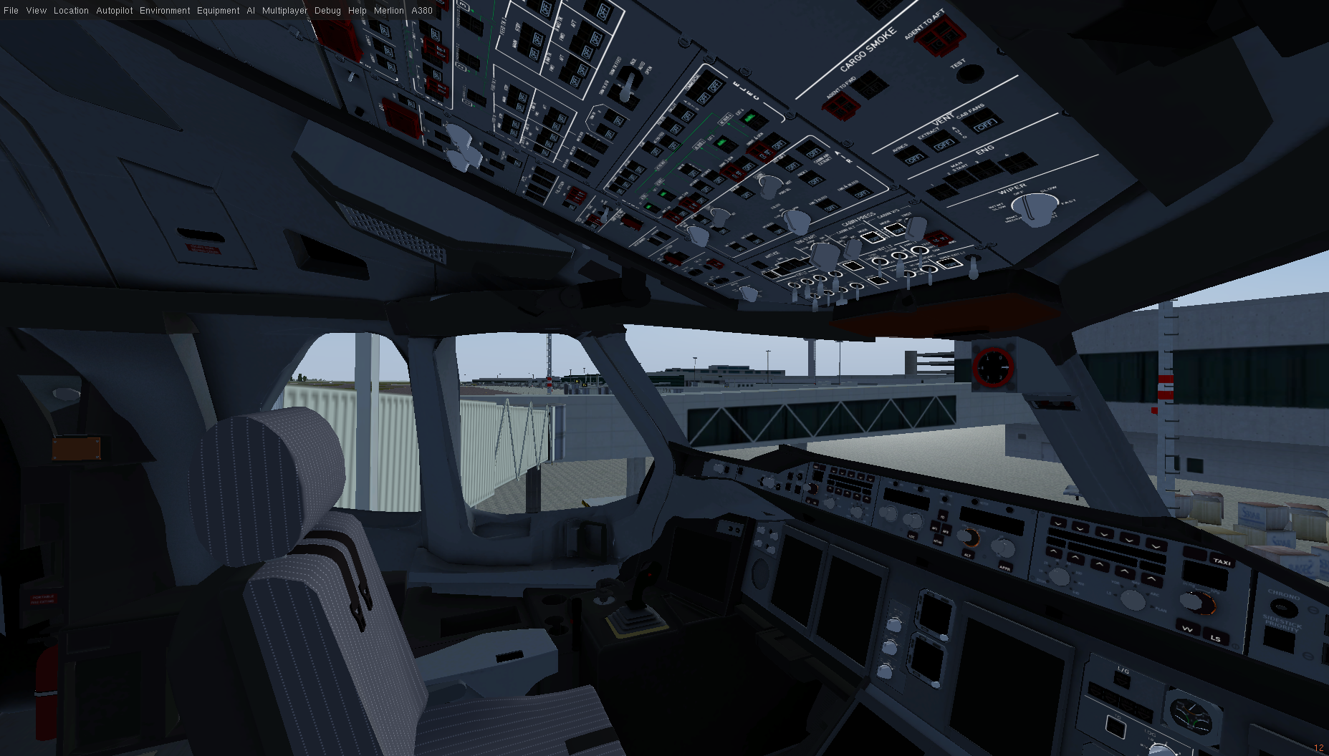
1. Start FlightGear at the airport of your choice, preferably at a gate/ramp. (I chose Singapore Changi Intl. Airport – WSSS, Gate B3) The aircraft should by default be powered down, but NOT in a “cold and dark” phase.

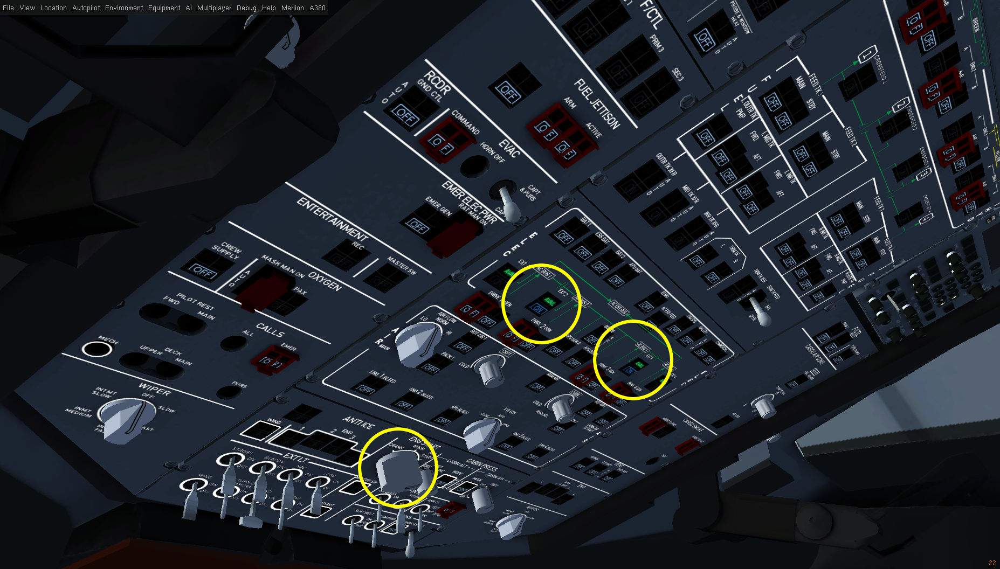
2.a. If the airport provides external power, turn on the external power switches (atleast the ones connected to AC BUSes 2 and 3). And then, turn the ENG START knob to IGN START.

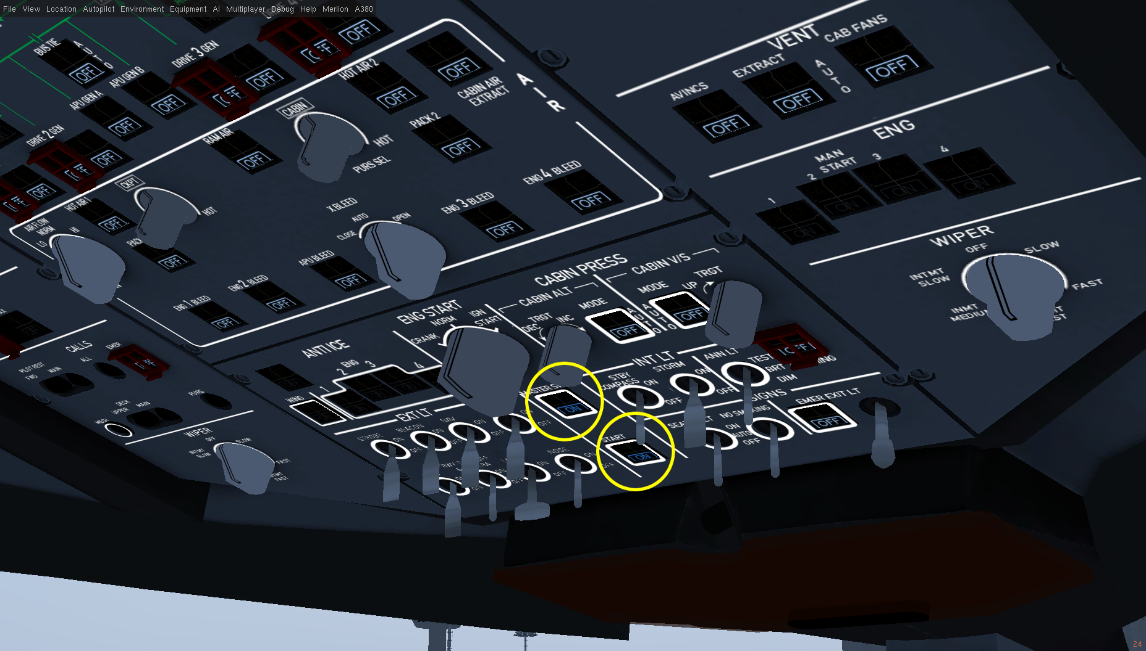
2.b.i. If you do not have external power, you can use the APU to start your aircraft instead. Turn on the APU MASTER SW and APU START switches and wait for the APU to start.

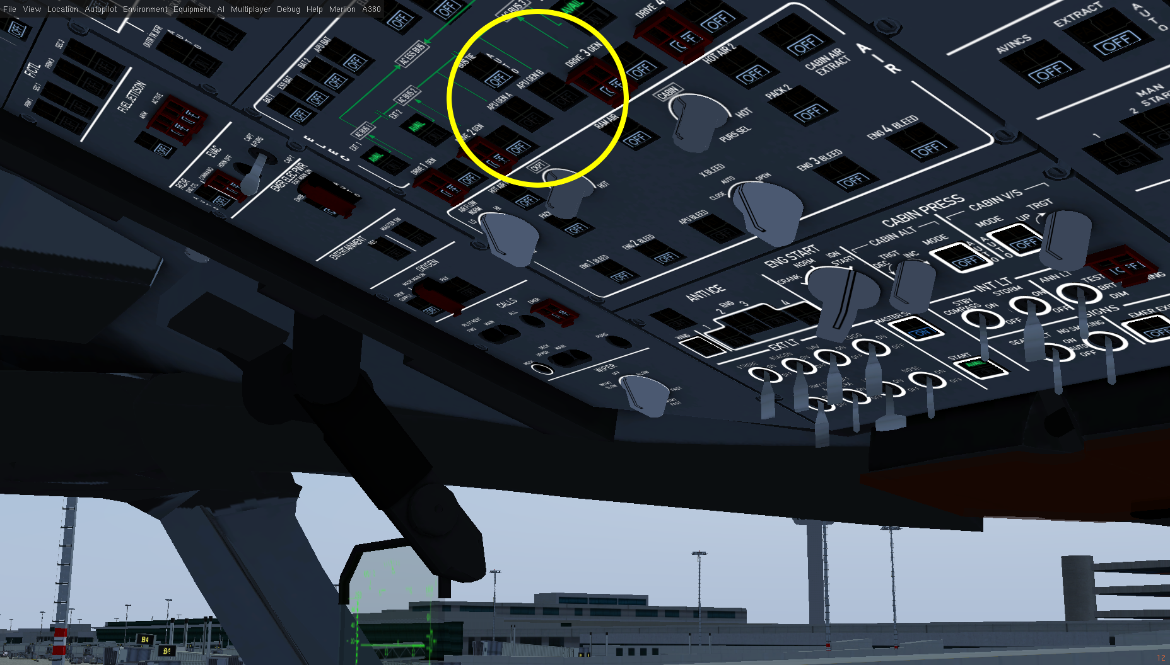
2.b.ii. Turn the APU GEN A and B switches on to get electric power from the APU generators.

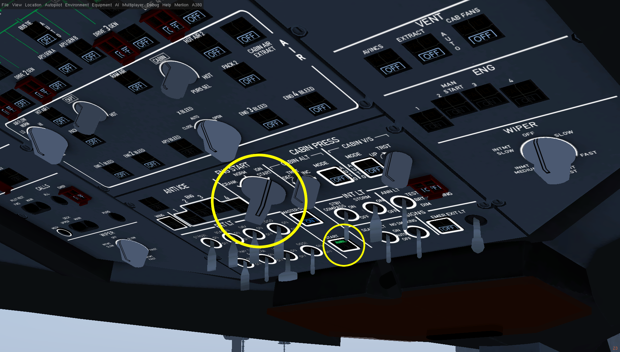
2.b.iii. Once the APU has started (green AVAIL light on START switch), you can turn the APU START switch off and turn the ENG START knob to IGN START. Wait for a few seconds for the engine starter motors to spool up. You can check if the starters are ready in the ECAM displays.

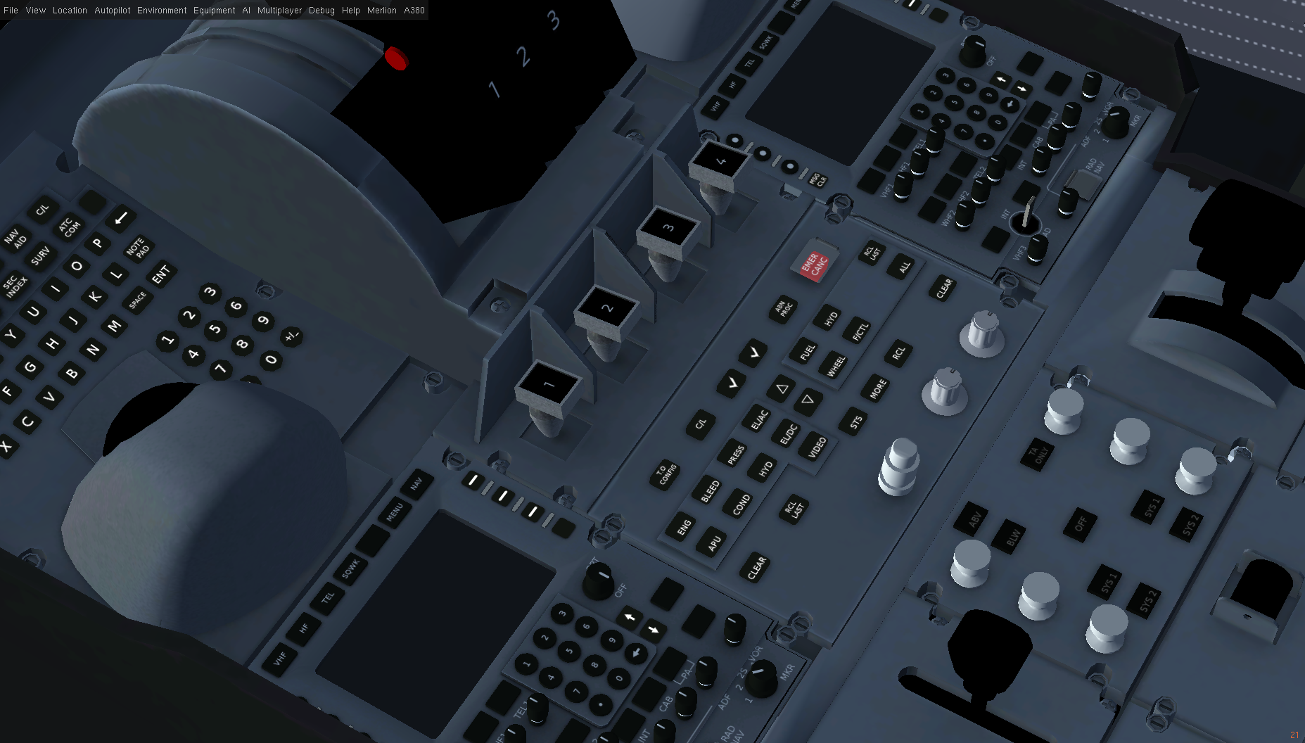
3. Flip the engine master switches on the pedestal forward one by one turning the engines on.

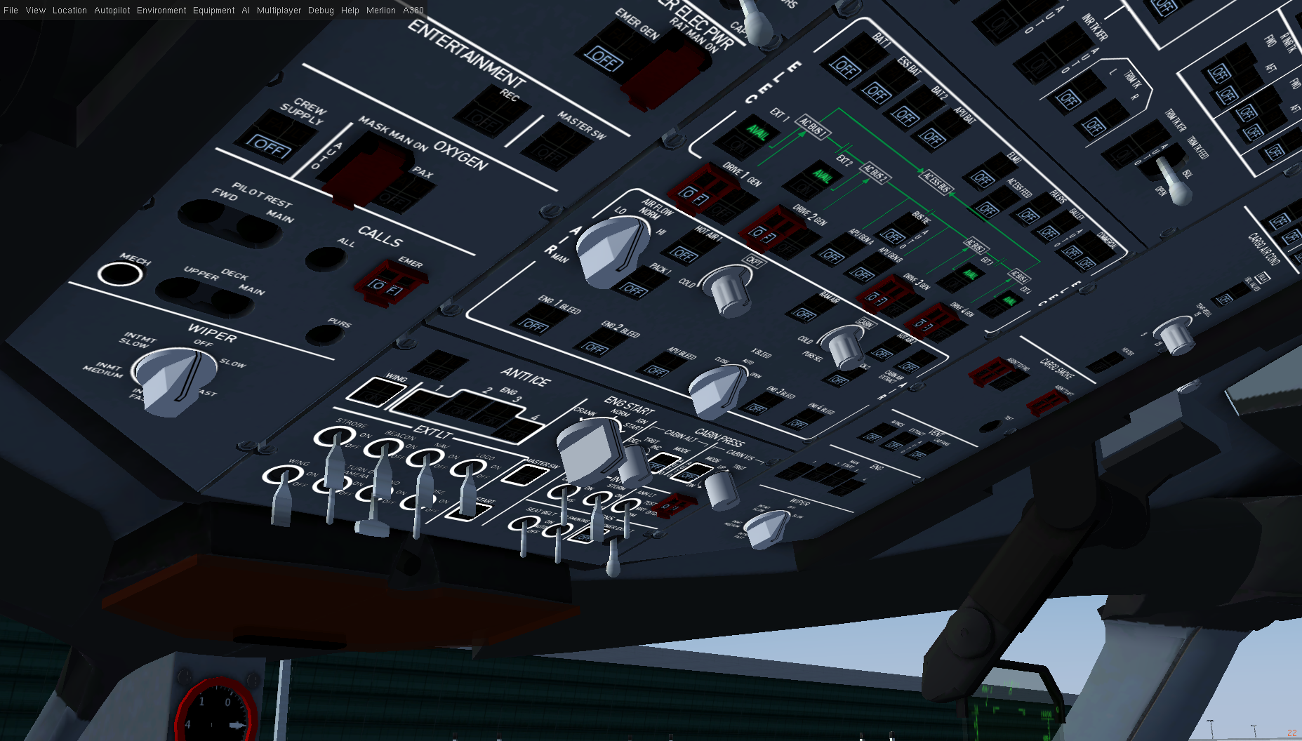
4. Now, the engine generators can provide electric power for the flight systems, so turn the engine DRIVE GEN switches in the overhead panel ON. Now, that you have power, you can turn off the EXT PWR switches and/or APU GEN A and B switches.

From an exterior view. you can watch as the hydraulic control surface actuators get power and come to life!
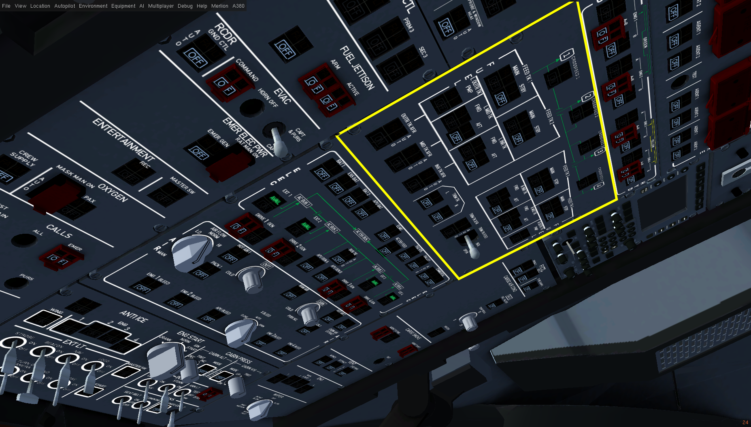
5. By default, this should have your aircraft ready to fly but it's still important to set your fuel system to how you need it. For now, you can just turn on the MAIN feed pumps and FWD TK pumps to get going but you might want to check on your fuel throughout your flight to make sure you're not running out in a tank you need fuel in.

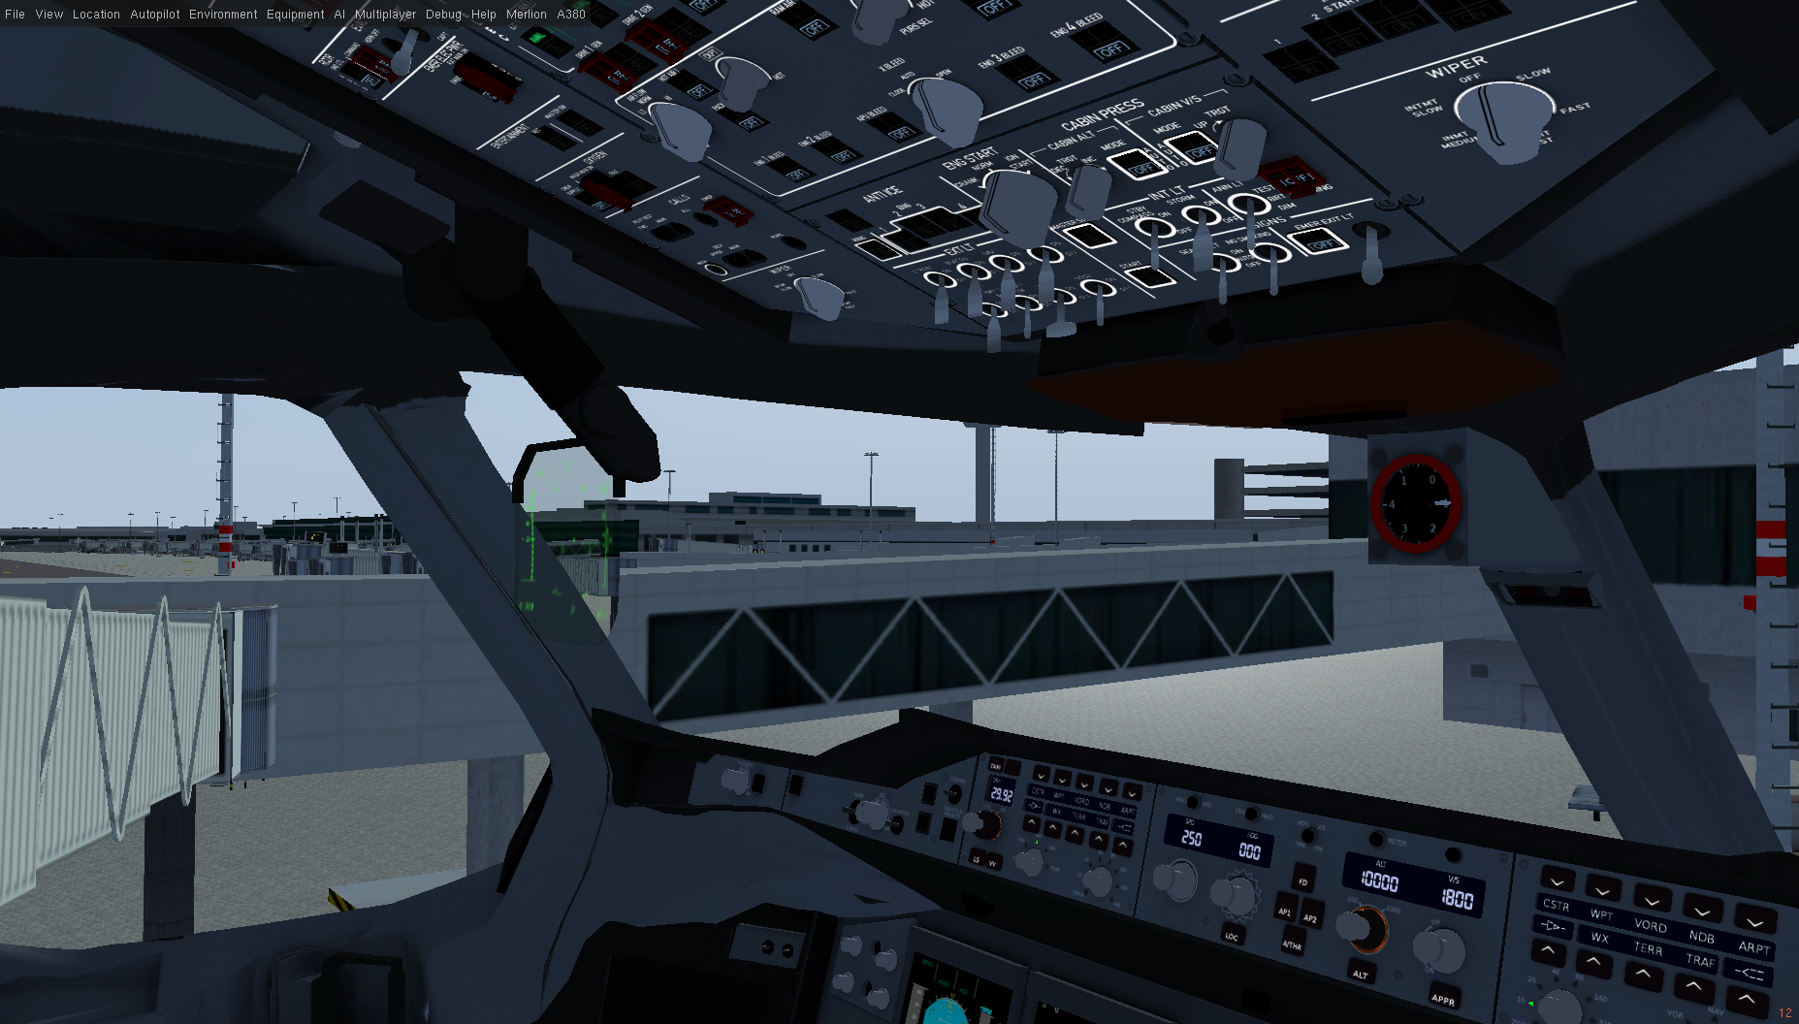
You are all set to go! This will make the A380 flyable, but please follow the checklists the next time to make sure everything goes smoothly.

END OF PROCEDURE

