## A simulation of the Central Limit Theorem

This is a simple simulation to illustrate the Central Limit Theorem for the minimum of a sample. We start with a distribution f(x) and we’ll use the beta(alpha, beta). Let’s set alpha = .25, beta = .25. Let’s see what that looks like

curve(dbeta(x, .25, .25), 0, 1)

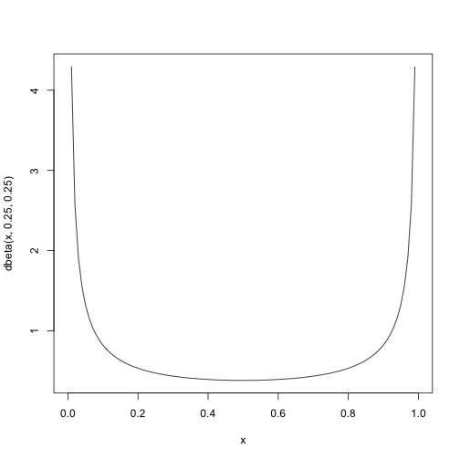

So it is slightly unusual relative to a Normal or an Exponential or Uniform. But, let’s see what happens to the minimum.

We’ll take 1000 samples each of size n where n takes on values 2, 10, 25, 100, 500. So we will do an lapply() over these values of n and for each value of n, we call replicate() to produce the 1000 values. So our code looks like

n = c(2, 10, 25, 100, 500)  
vals = lapply(n, function(n) replicate(1000, min(rbeta(n, .25, .25))))

So that we can conveniently plot this for different values of n using lattice, we will organize the values into a data frame and provide the value of n as a second variable

mins = data.frame(min = vals, n = rep(n, rep(1000, length(n))))

Now we can look at the distributions

densityplot ( ~ min | n, mins)

Alternatively, we might group all the densities on the same panel

densityplot( ~ min, mins, group = n)