n = seq(1000, 100000, by = 5000)

new.times = sapply(n, function(n) system.time(invisible(toJSON(rpois(n, 4)))))

library(rjson)

new.times = sapply(n, function(n) system.time(invisible(toJSON(rpois(n, 4)))))

RCurl is an R package, and Rgraphviz is a Bioconductor package.

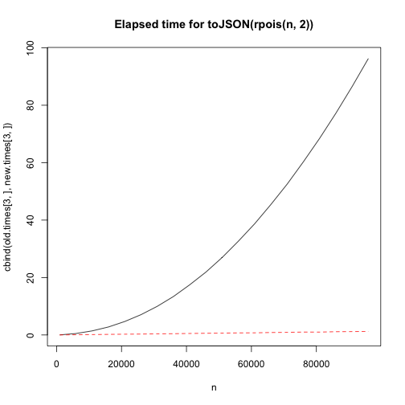

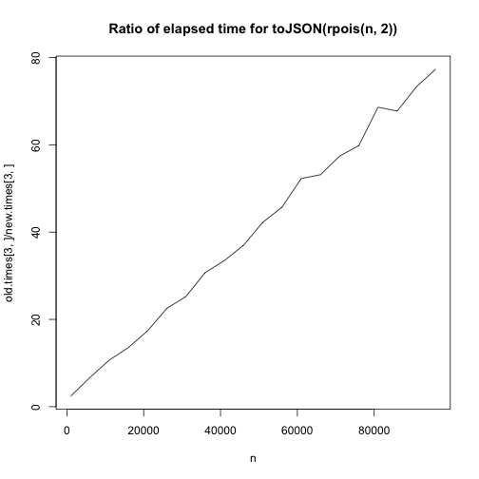

## fromJSON timings

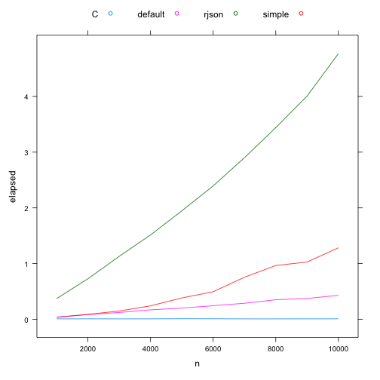

n = seq(1000, by = 1000, 10000)

v = sapply(n, function(n) toJSON(rpois(n, 4)))

a = sapply(v, function(x) system.time(fromJSON(x)), USE.NAMES = FALSE)

b = sapply(v, function(x) system.time(fromJSON(x, RJSONIO:::simpleJSONHandler())), USE.NAMES = FALSE)

f = get("fromJSON", "package:rjson")

c = sapply(v, function(x) system.time(f(x)), USE.NAMES = FALSE)

d = sapply(v, function(x) {

system.time({

buf = rep(as.integer(NA), 100000)

fromJSON(v,getNativeSymbolInfo("R_json_IntegerArrayCallback", PACKAGE = "RJSONIO"),

data = buf)

buf[!is.na(buf)]

})

}, USE.NAMES = FALSE)

matplot(n, cbind(a[3,], b[3,], c[3,], d[3,]), type = "l")

D = data.frame(n = rep(n, 4),

elapsed = c(a[3,], b[3,], c[3,], d[3,]),

type = rep(c("default", "simple", "rjson", "C"), each = ncol(a)))

xyplot(elapsed ~ n, D, group = type, type = "l", auto.key = list(columns = length(levels(D$type))))