Nuno “Omega Leo” Diogo



# Introduction

The following is a concept game for the 9th Pirate Software Game Jam. For this game jam I decided to go for a chess game with a twist based on the theme – Sacrifice is strength – where you can make pieces stronger by sacrificing others of the same or lower level, changing appearance with each level up. The game’s palette only consists of black, white and purple in order to fit in with the Art Restriction – 2 Bit Colors.

I hope to create a final concept that everyone can enjoy, even inexperienced chess players, something they can play for hours, build different strategies on what pieces to sacrifice to power up another piece, and overall have fun and share with the community their experience.

This document is an early concept and will be expanded and modified throughout the development process.

# Revisions

|  |  |  |  |  |
| --- | --- | --- | --- | --- |
| Name | Date | Version | Notes | Link to file |
| Nuno “Omega Leo” Diogo | 15th June 2022 | 1.0 | Initial GDD creation | [Google Drive](https://drive.google.com/file/d/1q4U7lw6mMOHoZztv2xcnAPFzjQ3fzT_Y/view?usp=sharing) |
| Nuno “Omega Leo” Diogo | 26th June 2022 | 1.1 | Added new font |  |

Contents

Introduction 1

Revisions 2

Concept Design 4

Product Design 5

Player Experience and Game POV 5

Visual and Audio Style 5

Audio 5

Concept Art 6

Platform(s), Technology, and Scope 8

Localization 9

Controls 9

Similar Games 10

Shotgun King The Final Checkmate 10

# Concept Design

**Working Title:** Chess War

**Concept Statement:** An exciting twist on chess where you sacrifice your pieces in order to make other pieces stronger, think carefully on which pieces you want to sacrifice.

**Genre(s):** Board Game, Strategy Game

**Unique Selling Points:** In this game your strategy towards a check mate has to take in account the levels of each piece, which pieces you are willing to sacrifice to level up another piece of a higher or equal level to the piece you’re sacrificing. The appearance of the pieces will also change as they level up, as just simple eye candy. There’ll also be animations for when a piece is sacrificed and for when a piece is taken.

**Rules:**

* You can only sacrifice a piece to one of a higher or same level.
  + If the sacrificed piece’s level is lower than the chosen piece the levels of the sacrificed piece will be added to the chosen piece;
  + The King can’t be chosen to claim the sacrificed piece as he has no level.
* If a pawn gets promoted, it’ll transfer it’s added levels onto its promoted piece, for example: if a pawn has 2 added levels and promotes to a queen, it’ll have 8 base levels + 2 added levels, making it level 10 queen.
* Same rules as chess (For reference check: [https://en.wikipedia.org/wiki/Rules_of_chess#Gameplay](https://en.wikipedia.org/wiki/Rules_of_chess%23Gameplay)).

# Product Design

## Player Experience and Game POV

Like a 2D chess game the player will have a top-down view of the board, the player doesn’t need to have experience playing chess as this game has an easy learning curve so the player can get used to making tactics with the sacrifice of pieces. Overall, I want the player to have fun playing against an AI or against a friend, thinking of and sharing strategies.

## Visual and Audio Style

### Audio

**Main Theme:** Metal melody made in Music Maker, that can be played on loop.

**Victory Theme:** When a player achieves victory against the opponent, they’ll hear a sort of triumphant trumpet song as a celebration of their victory.

**Defeat Theme:** When a player is defeated by their opponent, they’ll hear a sad trumpet solo.

**Sound Effects:** The game will have sound effects for button pressing, when a piece is moved and for the different sacrifices and piece taking animations.

**Asset List:**

|  |  |  |
| --- | --- | --- |
| **Asset Name** | **Description** | **Original** |
| chessPieceMove.wav | Sound to play when a chess piece moves or is placed | <https://freesound.org/people/mh2o/sounds/351518/> |
| Your_soul_is_mine.wav | Sound to play when a piece is sacrificed | [Custom made](https://drive.google.com/file/d/15YzDzXB5mF50JHIQtcO6-tJmxAkZ9ZdE/view?usp=sharing) |
| Sacrifice.wav | Main Theme | [Custom made (Made with Magix Music Maker)](https://drive.google.com/file/d/1iEztVse85CTimbvnJnkZSkLKohjV_HSv/view?usp=sharing) |

### Concept Art

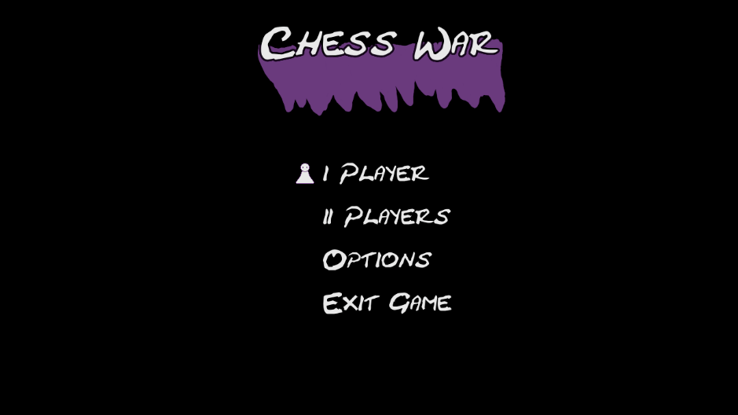

Figure 1- Title Screen Concept

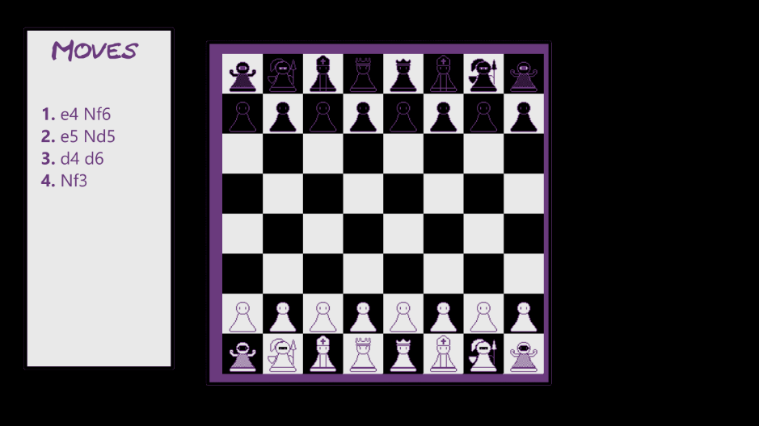

Figure 2-Game Screen Concept

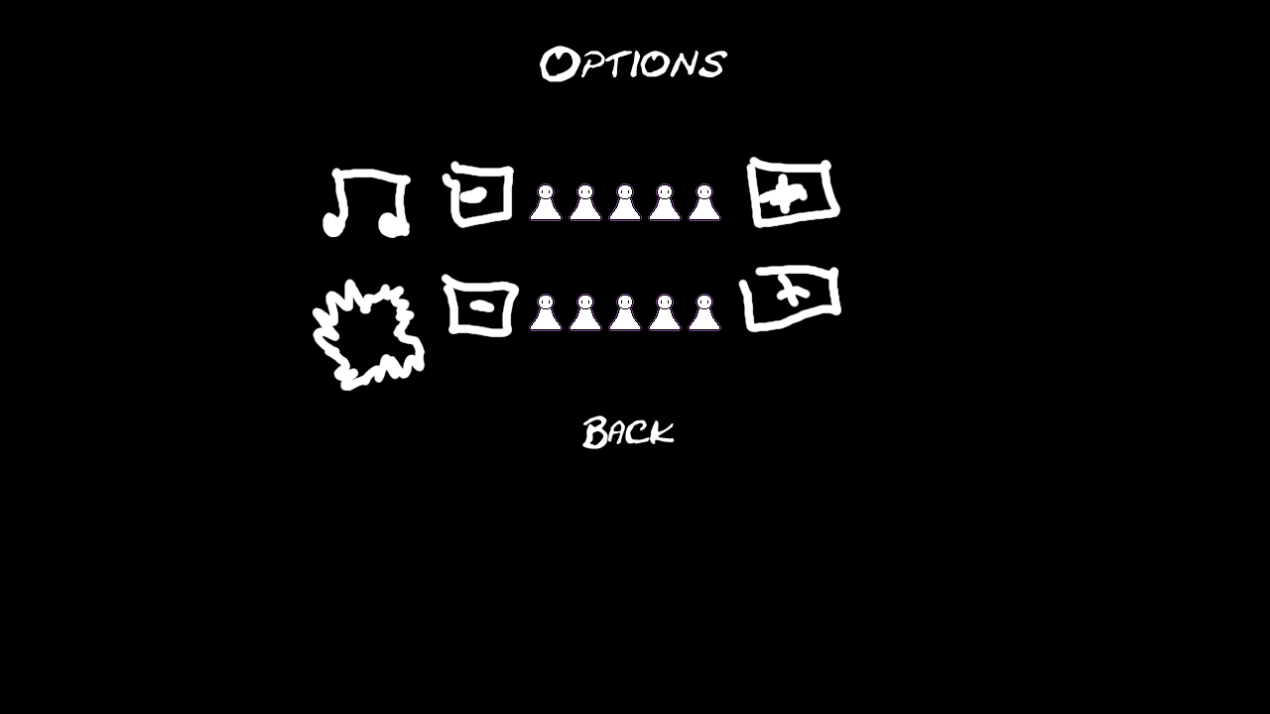

Figure 3- Options Screen

|  |  |  |  |  |
| --- | --- | --- | --- | --- |
| Piece | Level/Condition | White Design | Black Design | Evolved Bonus |
| Pawn | 1 |  |  |  |
|  | 3 |  |  | Move 1 in all directions |
| Rook | 4 |  |  |  |
|  | 6 |  |  | Can move over pieces of same color |
| Knight | 6 |  |  |  |
|  | 9 |  |  | Can move vertically 1 space |
| Bishop | 5 |  |  |  |
|  | 7 |  |  | Can move horizontally 1 space |
| Queen | 8 |  |  |  |
|  | 10 |  |  | Can move twice |
| King | No Level |  |  |  |
|  | If 3 or more pieces have transformed |  |  | When checked switches places with the closest Rook |

Figure 4- Pieces Concept

## Platform(s), Technology, and Scope

For the game jam the platforms will be: WebGL, Windows, Linux (via itch.io).

After the game jam is over, if there’s enough feedback to continue the game and make more improvements, the plan will be to publish to Steam and Google Play Store as F2P with the option of DLC or in-game items to add different appearances to the board, background, pieces and animations.

To make this game I’ll use the Unity game engine since I’m more familiar with it and has a good selection of platforms, for image editing I’ll be using Krita (for titles, concepts, screenshots) and Aseprite (for sprites, etc.), for composing music I’ve chose Magix Music Maker and for audio editing I’ll be using Audacity.

The main scope will be to implement the core mechanics of a normal chess game and then adding the sacrificial piece functionality and the animations. If there’s time left after programming and testing, some new features may be added.

## Localization

For now, the game will be fully in English. In the future if this project continues it’ll be localized to Portuguese (PT-PT) and other languages.

## Controls

For the game jam release, controls will depend just on mouse clicks. If this project continues, keyboard and gamepad integration will be added.

## Similar Games

### Shotgun King The Final Checkmate

**Release date:** 12th May 2022

**Genres:** Turn-based strategy, strategy, action roguelike

**Price:** 5.99€ / 5.99$

