
Dashboard

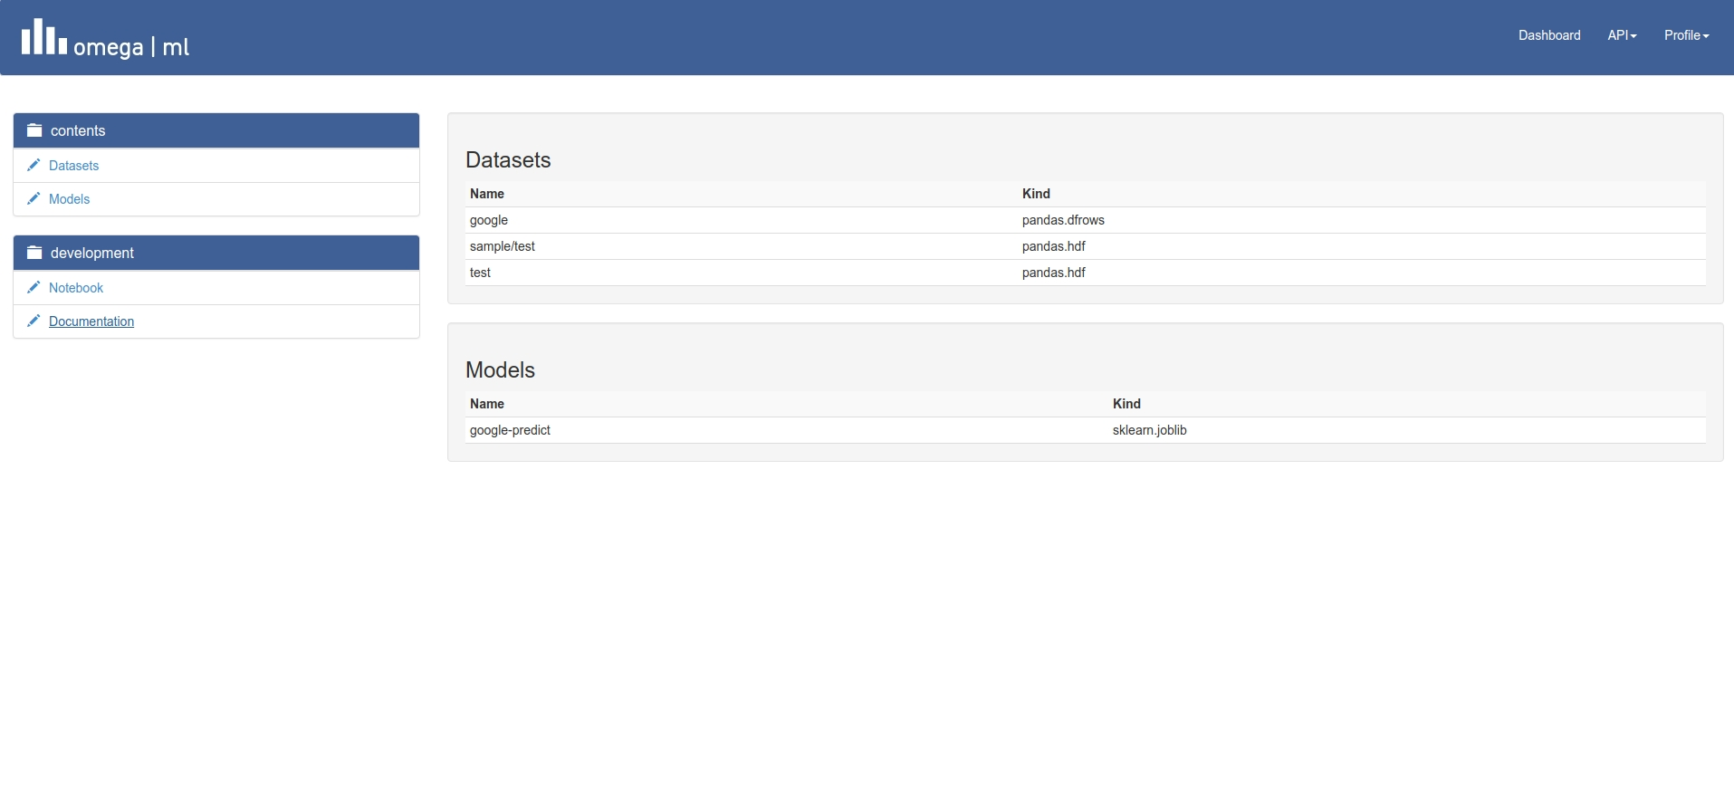
Notebook Online Editor & Report publishing

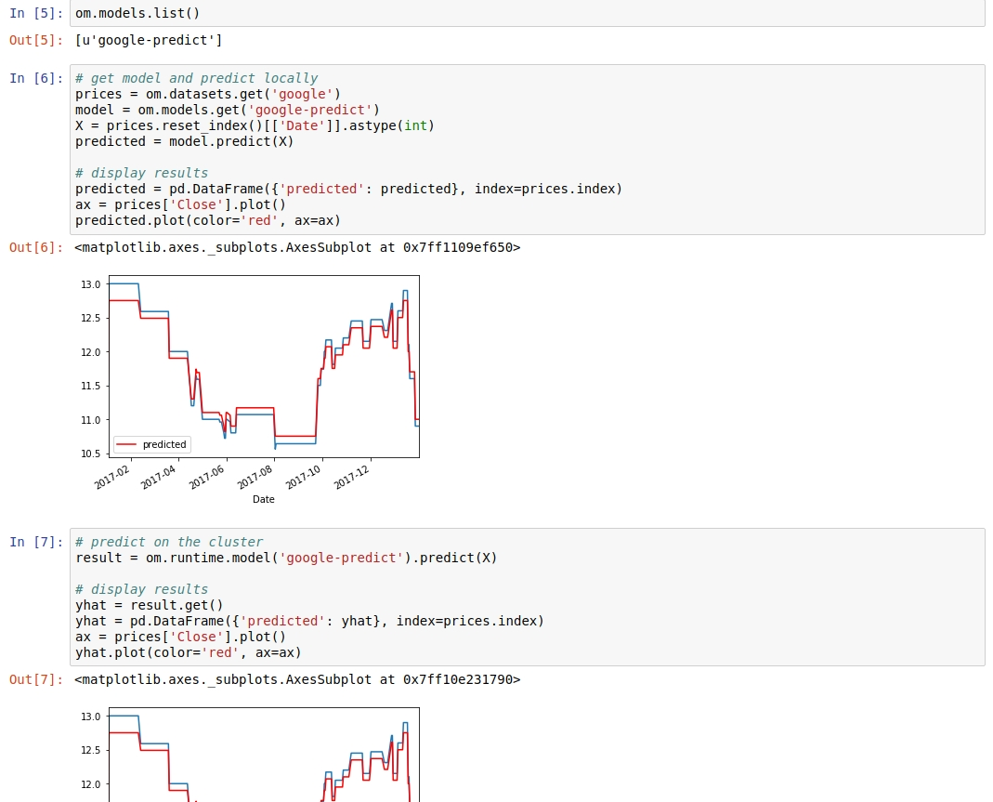

Integrated Online Help

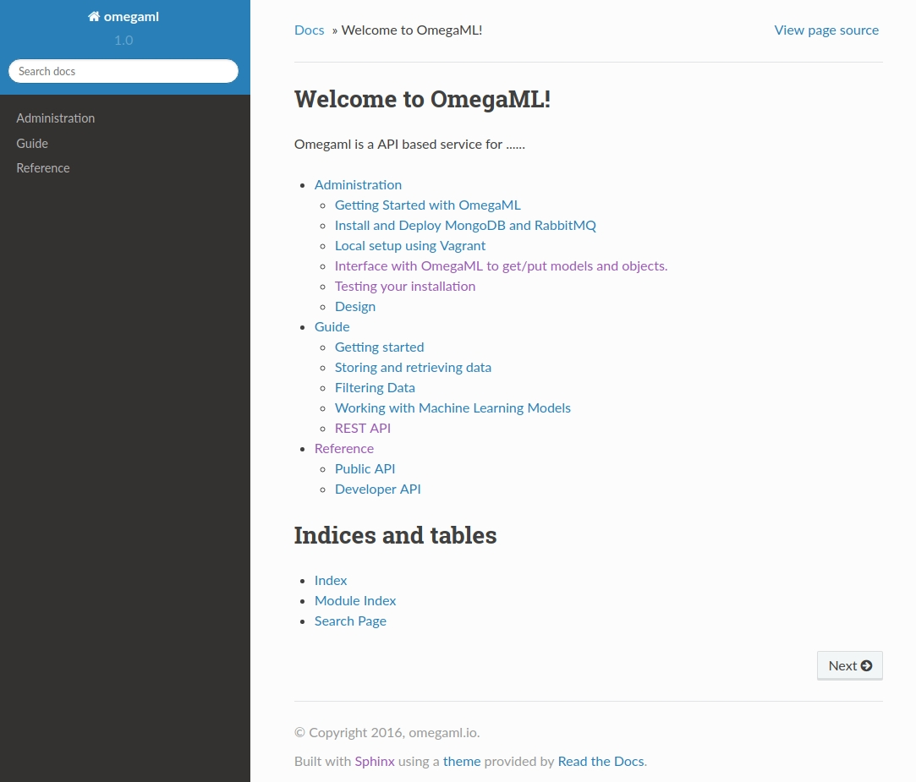
Also available as PDF

REST API documentation

