Lab: Lists Basics
Please, submit your source code solutions for the described problems to the Judge System.

Strange Zoo
You are at the zoo, and the meerkats look strange.
You will receive 3 strings on separate lines, representing the tail, the body, and the head of an animal in that order. Your task is to re-arrange the elements in a list so that the animal looks normal again:
- On the first position is the head;
- On the second position is the body;
- On the last one is the tail.

Example
Input | Output
my tail  my body seems on place  my head is on the wrong end! | ['my head is on the wrong end!', 'my body seems on place', 'my tail']
tail  body  head | ['head', 'body', 'tail']
T  B  H | ['H', 'B', 'T']

Hints
We start by reading the three parts of the body:
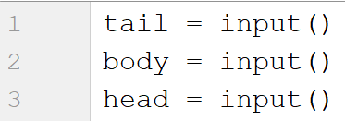
Then, we create a list containing those three elements:
We swap the elements and print the list:

Courses
On the first line, you will receive a single number n. On the following n lines, you will receive names of courses. You should create a list of courses and print it.

Example
Input | Output
2  PB Python  PF Python | ['PB Python', 'PF Python']
4  Front-End  C# Web  JS Core  Programming Fundamentals | ['Front-End', 'C# Web', 'JS Core', 'Programming Fundamentals']

Hints
We read the number n from the console, and we create an empty list:
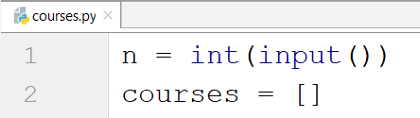
Then, we create a loop that reads each course and adds it to the list:
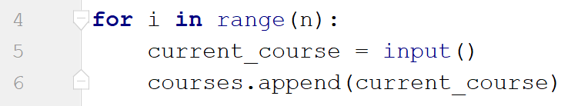
Finally, we print the list:
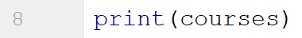

List Statistics
On the first line, you will receive a number n. On the following n lines, you will receive integers. You should create and print two lists:
- One with all the positive (including 0) numbers
- One with all the negative numbers
Finally, print the following message:
"Count of positives: {count_positives}
Sum of negatives: {sum_of_negatives}"

Example
Input | Output
5  10  3  2  -15  -4 | [10, 3, 2]  [-15, -4]  Count of positives: 3  Sum of negatives: -19
6  11  2  35  599  31  20 | [11, 2, 35, 599, 31, 20]  []  Count of positives: 6  Sum of negatives: 0

Hints
We start by reading the number n:
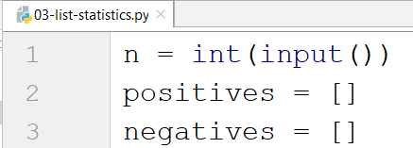
Then, we create a loop that reads the current number and checks if it is positive or not:
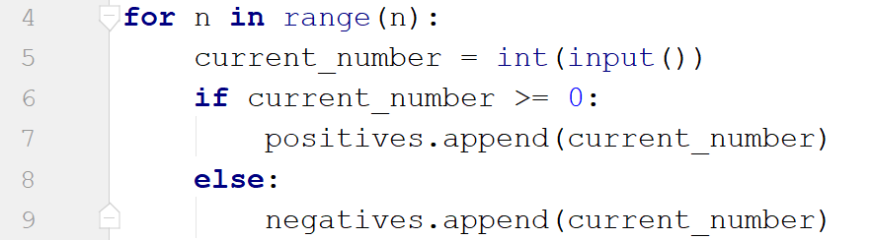
- If it is, we add it to the list of positive numbers.
- If it is not, we add it to the list of negative numbers.
Then we print the three lines:
- To get the count of the positives, we can use the len function.
- To get the sum of the negatives, we can use the sum function.

Search
On the first line, you will receive a number n. On the second line, you will receive a word. On the following n lines, you will be given some strings. You should add them to a list and print them. After that, you should filter out only the strings that include the given word and print that list too.

Example
Input | Output
3  SoftUni  I study at SoftUni  I walk to work  I learn Python at SoftUni | ["I study at SoftUni", "I walk to work", "I learn Python at SoftUni"]  ["I study at SoftUni", "I learn Python at SoftUni"]
4  tomatoes  I love tomatoes  I can eat tomatoes forever  I don't like apples  Yesterday I ate two tomatoes | ["I love tomatoes", "I can eat tomatoes forever", "I don't like apples", "Yesterday I ate two tomatoes"]  ["I love tomatoes", "I can eat tomatoes forever", "Yesterday I ate two tomatoes"]

Hints
We start by reading the number n and the word we would search for. Then, we create our empty list:
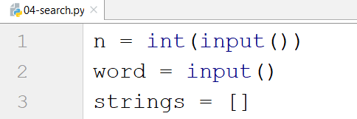
We create a loop that adds all the strings to our list. After that, we print it:
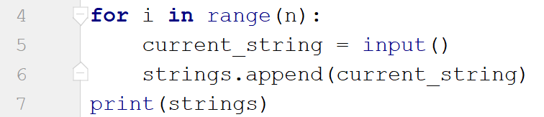
Finally, we create another loop to remove the strings we do not need by iterating through the strings reversed (so we don't skip elements when removing) and print the list again:
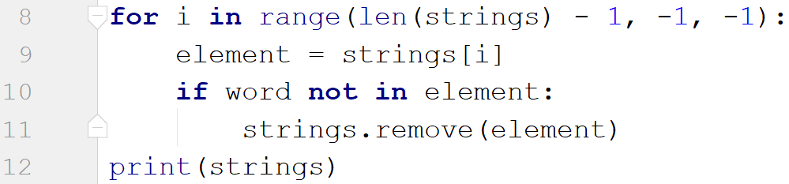

Numbers Filter
On the first line, you will receive a single number n. On the following n lines, you will receive integers. After that, you will be given one of the following commands:
- even
- odd
- negative
- positive
Filter all the numbers that fit in the category (0 counts as a positive and even). Finally, print the result.

Example
Input | Output
5  33  19  -2  18  998  even | [-2, 18, 998]
3  111  -4  0  negative | [-4]

Hints
First, we read the number n. Then, we create the numbers list and the filtered list:
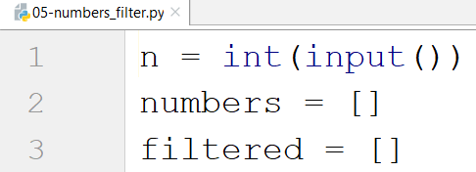
We create a loop that reads all the numbers and adds them to the list:
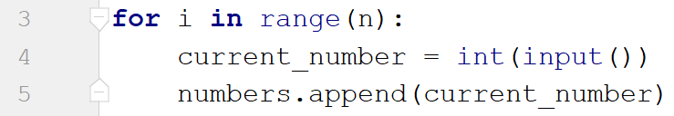
Then, we read the command and check for all the cases:
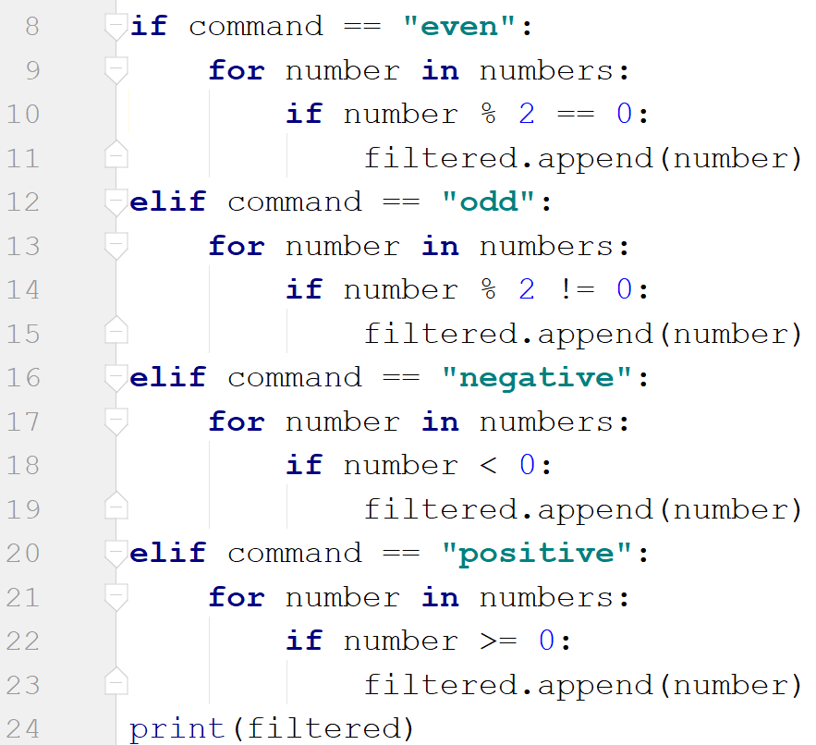
Finally, we print the filtered list.

