Lab: Basic Syntax, Conditional Statements, and Loops
Please, submit your source code solutions for the described problems to the Judge System.

Number Definer
Write a program that reads a floating-point number and:
- prints "zero" if the number is zero
- prints "positive" or "negative"
- adds "small" if the absolute value of the number is less than 1 and it is not 0, or "large" if it exceeds
1 000 000

Example
Input | Output
25 | positive
0.7 | small positive
435247392.921 | large positive
-0.005 | small negative
-103.21 | negative
-358583355123.001 | large negative

Hints
First, we read the number from the console as a float because we are going to receive floating-point numbers:
Then, we write a condition to check if the number is zero:
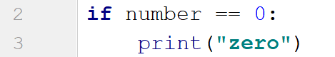
After that, we write a condition to check if the number is positive and add the additional conditions:
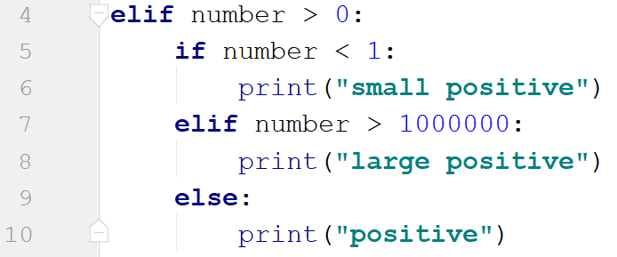
Then, we check if the number is negative. To check if the number is small or large, we use the absolute value of the negative number:
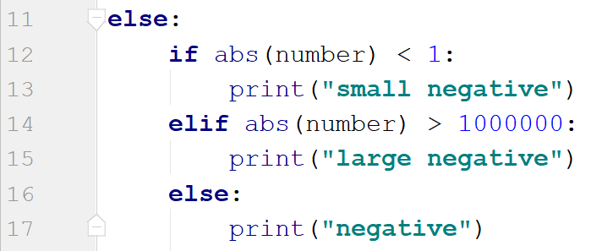

Largest of Three Numbers
Write a program that receives three whole numbers and prints the largest one.

Example
Input | Output
3  -1  5 | 5
0  -1  -2 | 0

Hints
We start by reading the three numbers from the console:
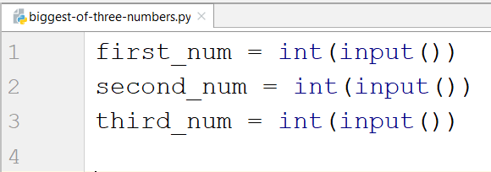
Then we compare them and print the largest one:
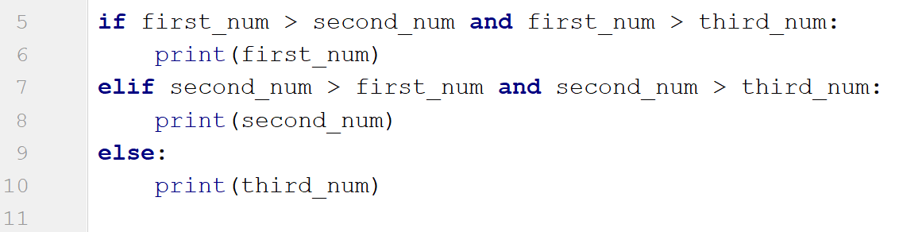

Word Reverse
Write a program that receives a single word, reverses it, and prints it.

Example
Input | Output
Python | nohtyP
banana | ananab

Hints
We read the word from the console:
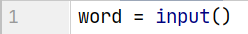
Next, we create a new variable to store the reversed word:
After that, we create a for loop which would iterate backward through the word and add each character to the new word:
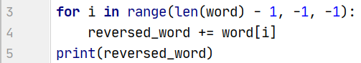
- The starting point value of the loop should be the length of the word minus one position.
- We should loop until we reach the 0 index, so the stop value of the loop should be -1.
- Finally, the step is backward, so the step size is -1.

Even Numbers
Write a program that receives a number n on the first line. On the following n lines, it receives different integer numbers. If the program receives an odd number, print "{num} is odd!" and end the program. Otherwise, if all numbers given are even, print "All numbers are even.".

Example
Input | Output
2  12  286 | All numbers are even.
5  2  9 | 9 is odd!

Hints
We start by reading an integer number:
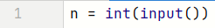
Then, we create a for loop that receives a number and checks if the given number is odd. If the condition is met, the program should print the number and then should break the loop and end:
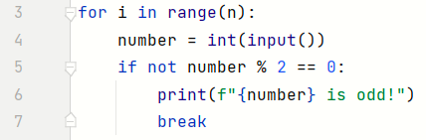
If the condition is not met at all, we enter the else-condition and print the result:
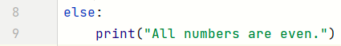

Number Between 1 and 100
Write a program that reads different floating-point numbers from the console. When it receives a number between 1 and 100 inclusive, the program should stop reading and should print "The number {number} is between 1 and 100".

Example
Input | Output
-3  0.9  44 | The number 44.0 is between 1 and 100
0.5  90  -4  101 | The number 90.0 is between 1 and 100

Hints
We start by reading a floating-point number:
Then, we create a while loop that checks if the given number is less than 1 or greater than 100. If the condition is met, the program should enter the body of the loop:
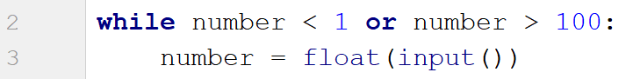
If the condition is not met, we exit the loop and print the result:

Shopping
Write a program that reads an integer number representing a budget. On the following lines, it reads integer numbers representing the prices of each product you should buy until it receives the command "End".
During the iterations, if there is not enough budget left to buy the next product, it prints "You went in overdraft!" and end the program.
Otherwise, if you accomplished to buy all products before receiving "End", it prints "You bought everything needed."

Example
Input | Output
100  5  End | You bought everything needed.
50  25  20  10 | You went in overdraft!

Hints
We start by reading an integer number and the first command:
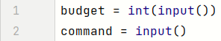
Then, we create a while loop that checks if the given command is not "End". If the condition is met, the program should enter the body of the loop. It defines a variable for the product price and checks if the budget is not enough. If the condition is met, the program should print "You went in overdraft!" and then should break the loop and end. Otherwise, the loop should receive the next command and iterate over the code again:
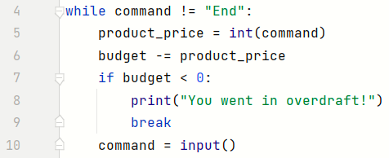
If the condition is not met before we receive the "End" command, we enter the else-condition and print the result:
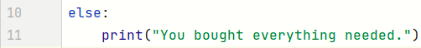

Patterns
Write a program that receives a number and creates the following pattern. The number represents the largest count of stars on one row.
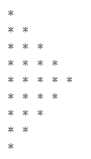

Example
Input | Output
3 | *  **  ***  **  *
5 | *  **  ***  ****  *****  ****  ***  **  *

Hints
First, we read the number from the console:
We create the first loop, which will print half of the pattern until i == number:
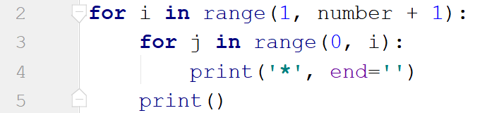
We create the inner loop through the numbers from 0 to i (i is not inclusive). We use end='' to stay on the same line. We print the new line after we draw all the stars for the particular line.
Next, we create the second loop backward as we need to decrease the number of stars with each line. It should draw one line less than the previous one:
