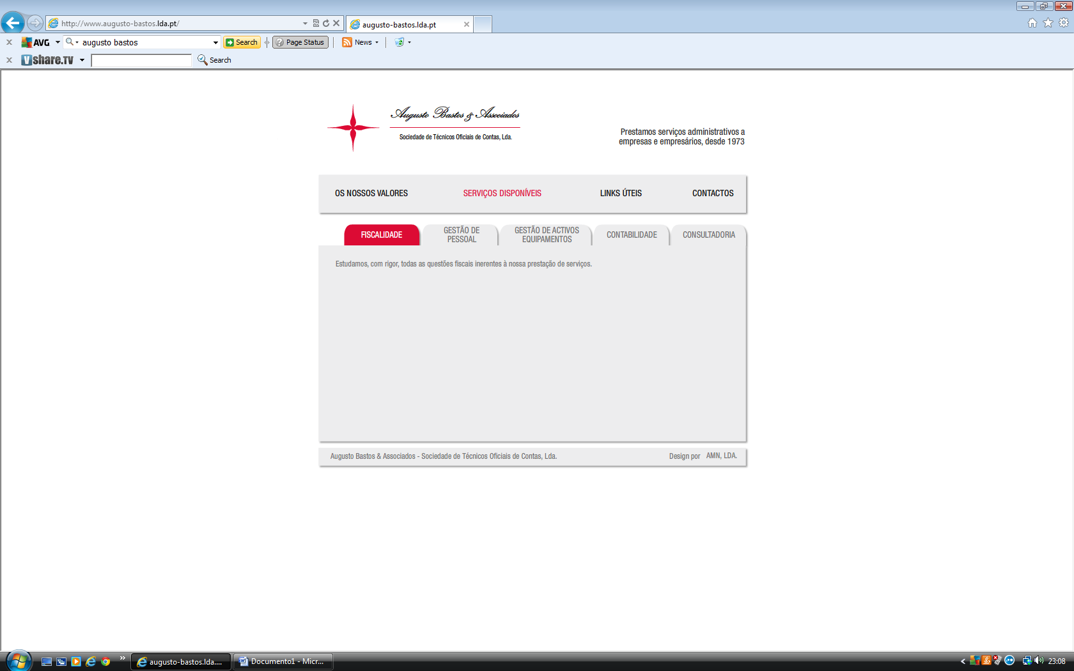

[](http://www.google.pt/imgres?q=Clube+de+Campismo+do+Porto&hl=pt-PT&biw=1680&bih=912&gbv=2&tbm=isch&tbnid=Cf7XizV2y78hvM:&imgrefurl=http://ataxa.no.sapo.pt/interesses.html&docid=WCEccJODVFaChM&w=300&h=399&ei=HRk7TqvMMIX2sgbdw4n_Dw&zoom=1)

[](http://www.google.pt/imgres?q=compro+o+que+%C3%A9+nosso&hl=pt-PT&biw=1680&bih=912&gbv=2&tbm=isch&tbnid=ijrKyzmHHtBmpM:&imgrefurl=http://avomeri.wordpress.com/2011/05/11/comprar-portugues-comprar-o-que-e-nosso/&docid=bfR0-TRHBg0qRM&w=250&h=350&ei=ARo7TtHOGcbesgbW-cUl&zoom=1)

