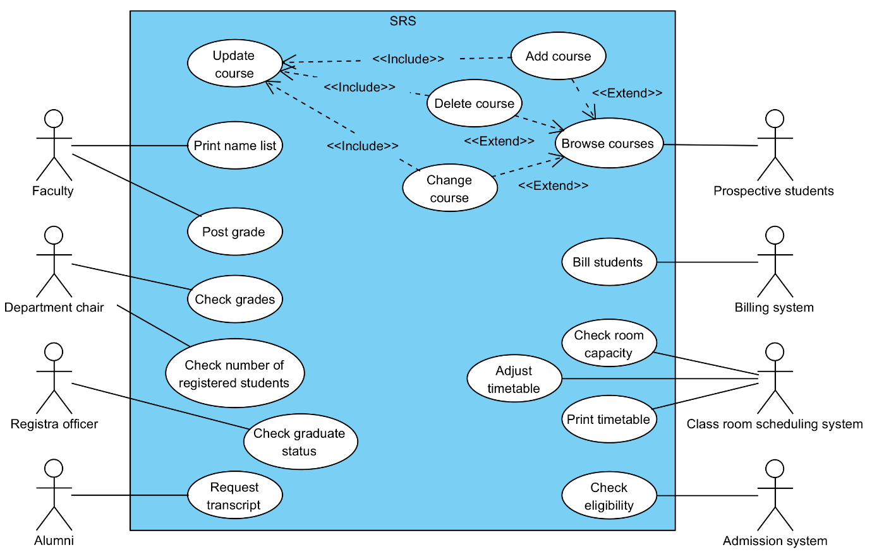**Use case – Add course**

* **Requirements addressed:**
* **Actors**: Perspective students
* **Goal**: Update latest courses
* **Pre-conditions**: Browse courses
* **Main success scenario**

1. Browse courses.
2. System shows all courses for student.
3. User clicks on “Add course” button.
4. User finds the course that he wants to add.
5. Select section for the course.
6. User clicks “Add” button.
7. System shows validation of all courses.
8. User clicks “Confirm” button.
9. System shows summary of updated courses.

* **Alternate scenario A**

5A. System shows the course is full.

6A. User clicks “Cancel”.

* **Alternate scenario B**

5B. System shows the course not found.

6B. User clicks “Cancel”.

* **Post-conditions**: System shows browse courses.