OMEN PIA / issue 1

Technical Documentation

INTRODUCTION

===========

The OMEN PIA kit is a peripheral circuit for the OMEN series computets. It features:

* Motorola MC68B21 PIA
* Two 8bit parallel ports
* four control signals
* Power supply /optional/

ASSEMBLY INSTRUCTIONS

===================

1. Solder sockets for the integrated circuits
2. Test all soldered connections
   1. Test if all pins are well connected
   2. Check if GND is not short connected to Vcc
   3. Check if each IC has properly connected GND and Vcc
3. Solder all passive parts
4. Solder voltage regulator, if necessary
5. Solder RESET invertor for OMEN Alpha
6. Set switches to the proper configuration

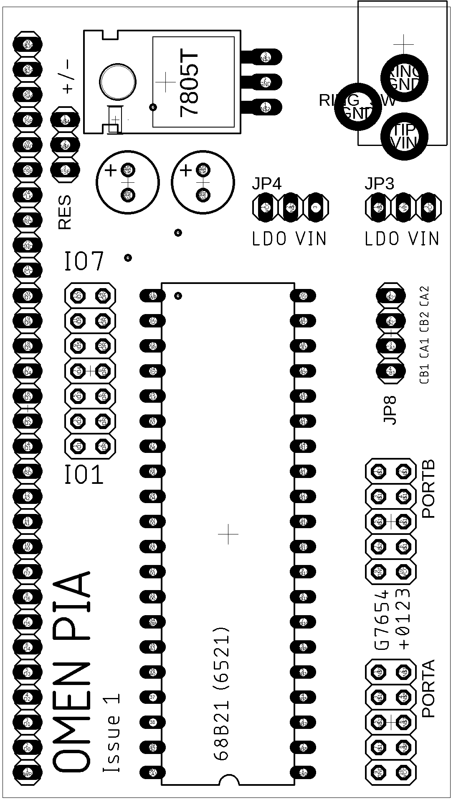

THE BOARD

========

Jumpers and pin headers

--------------------

IO1-IO7: Selects the IO enable signal. OMEN computers has seven free /IO select signals, so you can chose the right one for you.

RES: All OMEN computers /Bravo, Kilo, .../ has /RESET active in log. 0. Only Alpha has a positive RESET, active in log. 1. For Bravo or Kilo just connect pins 1 and 2 - left and middle, marked as “+/” For Alpha connect middle and right, marked “/-“ and solder the SMD invertor 74AHC1G04, or just connect the middle pin to the VCC.

JP3, JP4: Only if you are planning to use the external power supply. Use two jumpers and connect them into the “VIN” position if voltage input is 5 V exactly. In the case you have non\*regulated power supply 7 – 12 V, you have to connect both switches to the “LDO” position. You have to solder a 7805 voltage regulator and two polarized capacitors.

CAUTION  
======

In the case you are using the PIA power supply, please do not connect the OMEN CPU board power supply together.

In the case you do not want to use PIA power supply circuit, just leave the JP3, JP4, C1, C2 and 7805 not connected.

OMEN ALPHA  
=========

When connecting the OMEN PIA to the OMEN Alpha computer, you HAVE TO:

* solder the inverter 74AHC1G04 and connect the RES pins 2 and 3, marked as “slash – minus”

OR

* 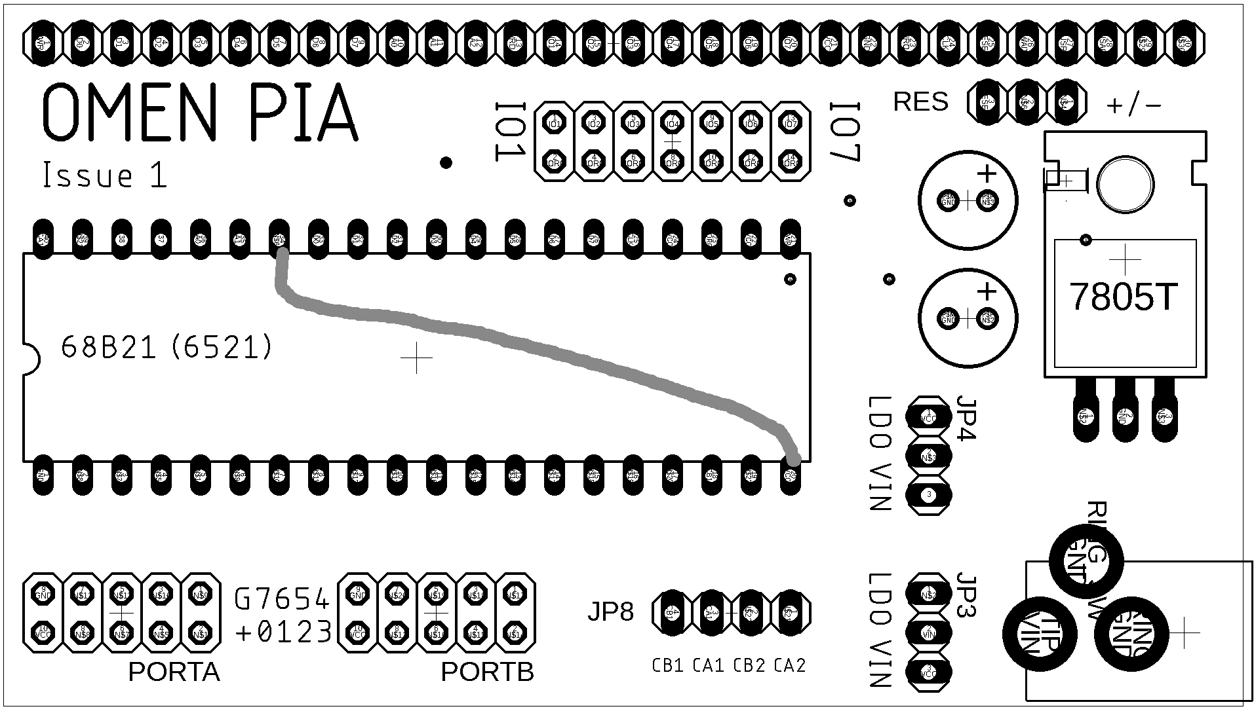connect the PIA pin 34 with the PIA pin 20 and leave RES unconnected. Use the resistor 10k. The resistance is not critical. You can use the simple wire connection too.

SYSTEM APPLICATION CONNECTOR

=========================

This connector is on the right edge of board. Pin 1 is on the upper side, next to the SYSTEM label.

Pins:

1. /WR
2. D0
3. D1
4. D2
5. D3
6. D4
7. D5
8. D6
9. D7
10. A0
11. A1
12. A2
13. /RD Bravo, Kilo Alpha
14. IO1 --- 9000h – 93FFh --- 20h – 27h
15. IO2 --- 8800h – 8BFFh --- 10h – 17h
16. IO3 --- 9800h – 9BFFh --- 30h – 37h
17. IO4 --- 8400h – 87FFh --- 00h – 0Fh
18. IO5 --- 9400h – 97FFh --- 20h – 2Fh
19. IO6 --- 8C00h – 8FFFh --- 10h – 1Fh
20. IO7 --- 9C00h – 9FFFh --- 30h – 3Fh
21. Vcc
22. GND
23. IRQ
24. PHI2
25. /RESET --- see the comment above
26. /WAIT
27. /BUSRQ
28. /BUSACK